Beings and Relationships

Yun hyun bin , Yun hyun il

Abstract

I demonstrate that the explanation of the world in terms of existence and relations leads to an infinite dimension. Existence encompasses everything and forms relationships, and the reverse also holds true. Furthermore, I argue that even time and space are forms of existence, and everything is interconnected.

1. [1]Everything is existence

**<1>[2] Not existing means not being.**  
**[1][3] Even what we call a relationship is existence.**  
**[2] Everything is also a relationship, and the world is made up of relationships (is full of relationships).**  
**[3] Existence can also be divided into relationships.**  
**[4] Relationships can also be divided into existence.**  
**[5] A relationship does not need to be a straight line. The relationship between two entities can also be curved.**

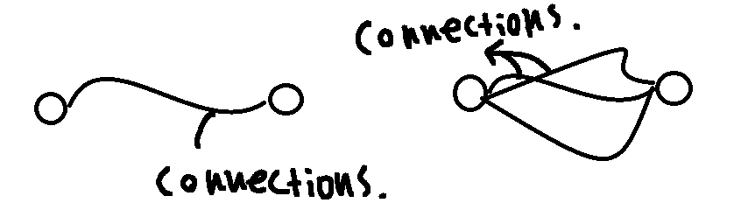  
**[6] Dimensions are infinite.**

**<2> Let us assume that a single entity solely exists.**

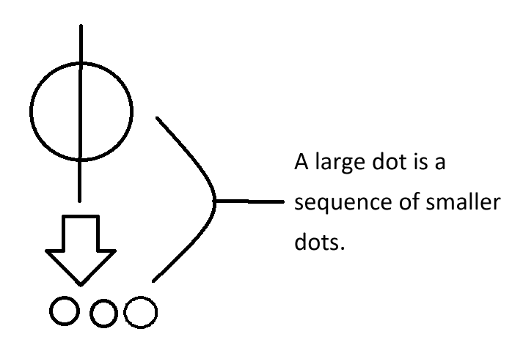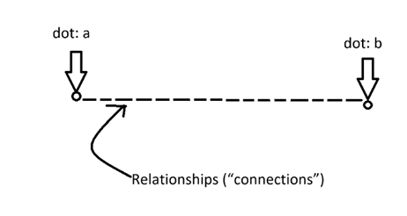

A single existence (point) can be divided (see 3.1), and between the divided existences, there is a relationship (connection) (see 2).

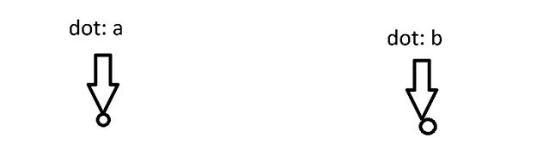

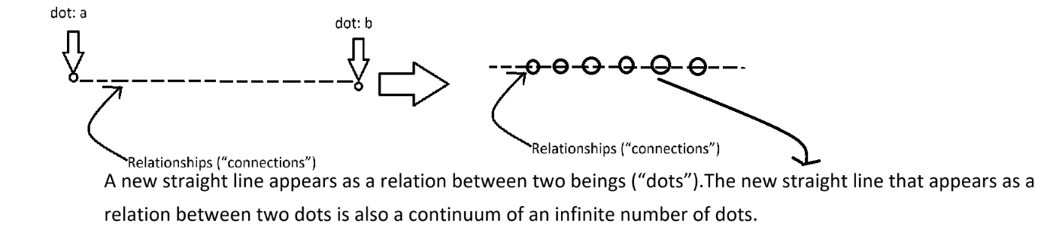

Because even relationships are existences (continuous points, objects), there are countless points between one point (a) and another point (b) that have been divided from a single existence (point), and the points (a and b) divided from a single existence form new relationships (connections) with other points that belong to the relationship (connection) between them.

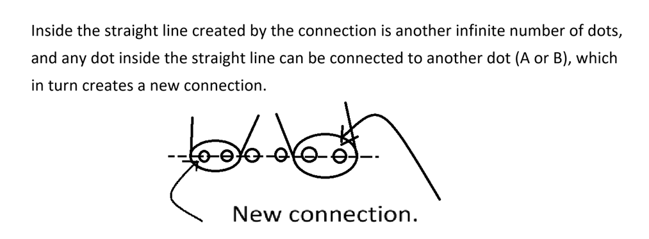

This process can be repeated infinitely. (Let's assume there are two points. Between these two points, there exists a relationship (connection, straight line), and this relationship is the connecting line between the two points.

A straight line is a continuum of points, and between point 'a' and point 'b' there exist countless other points that cannot be enumerated. This is because there is a relationship between point 'a' and point 'b' (refer to 2.). A point 'c' between points 'a' and 'b' can form a new relationship with 'a', and another line is added. Through this method, relationships (lines) continue to be added, the density of points increases indefinitely, and this generates additional dimensions. However, the additional dimension (line) created by the overlapping of infinite points is also composed of points, and the points between the lines created by such overlapping of points can again have countless connecting relationships with the points that make up the lines. This process repeats itself.

This causes the expansion of dimensions, and the existence of one being proves the existence of infinite dimensions. In this process, space becomes filled without any empty spots.

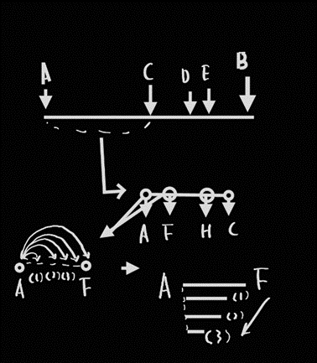

Figure

The density of 'a' increases through its interactions with the points from 'a' to 'f'. (Just as points stack layer by layer to form a line, relationships stack layer by layer to ascend to a higher dimension.)

1. All existence is interconnected (related).

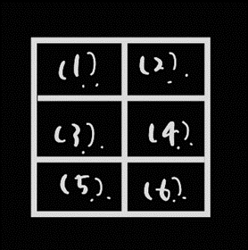

Figure

I can only think of (1) in relation to (2) ~ (6). (It is impossible to consider

[1] To consider an object as complete, everything related to it must be perfect. (To specify one exact state of affairs, one must describe all surrounding states of affairs.)

**<1>** If even a single part of the state of affairs intended to be referred to is incorrectly described (or specified), then, despite accurately describing all other states of affairs, the reference will deviate from the intended one.

(Because space is infinitely vast and there are infinite existences, within space, there can also exist a combination of a single misrepresented state and all other correctly represented states.) More precisely, the entire space can include even a combination where only one state in the entire represented situation is misrepresented, while all other states are correctly represented. The reverse (opposite) is also true.

**<2>** Let us assume there exists a perfect picture. For a picture to be perfect, the pencil used to create it must also be perfect. (A perfect pencil is necessary to draw a perfect picture.) Moreover, even the paper on which the picture is drawn must be perfect. (One cannot draw a perfect picture on imperfect paper, because the paper itself can be considered part of the picture.)

For the paper on which the picture is drawn to be perfect, the process by which the paper is produced must also be perfect. For the pencil to be perfect, the graphite that composes it must be perfect, and the wood that forms it must also be perfect. Through this process, we see that one entity requires all others. This is because existence itself is complete.

In other words, the one is the whole, and the whole is one. Therefore, we can say that existence has no substance, and also that everything cannot be divided into parts. To put it positively, this means that existence exists. (Objects can be viewed individually or as part of a whole.)

1. **A thing (being) is infinitely divisible into smaller things.**

[1] If the size of an object is limited, change cannot occur.

[2] The motion of any object depends on the changes in its parts.

<1> Within a completely filled space, an object cannot change. (Refer to axiom (7.1).) This is because change requires a larger space. Therefore, space is infinite.

(4) Objects (or existences) can be infinitely combined to form larger wholes.

<1> I can combine multiple objects.

(5) The smallest thing exists.

[1] The smallest thing is a point and it is where size begins to exist.

[2] The smallest thing is the point where existence begins.

[3] Even the smallest thing can be further divided, which means there is no limit to smallness.

[4] Everything already exists, and no further existence is added.

[5] All change is already complete, and no further change occurs."

(6) The world is composed solely of existence.

(7) The world is filled with existence. There are no empty parts in the world. Therefore, the world is continuous.

[1] Even a single existence can be called a world.

<1> The reason why even a single existence can become a world is that everything is interconnected, and thus one is related to the whole and all of its parts.

(8) The gathering of existences forms space, and existences coming together also constitute time.

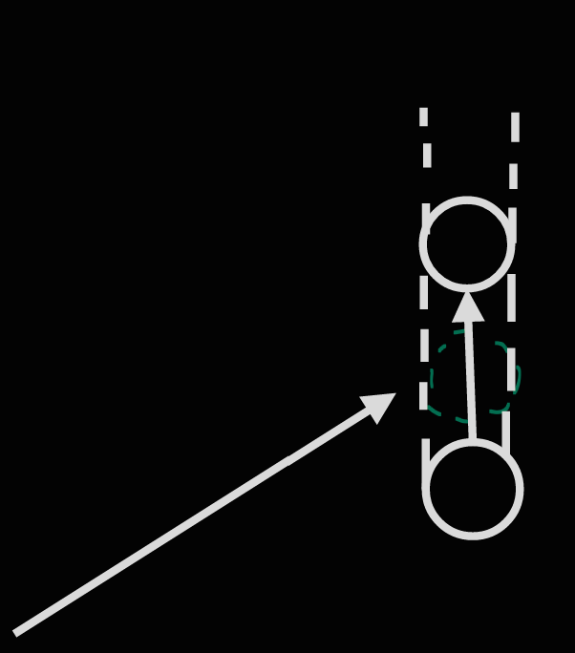

Figure

As seen in the diagram, the area where existence has changed (the part within the green dotted line) is called space, and the change in existence is called time. The directions of time and space are the same. (Time and space are not perpendicular.)

[1] Even space and time are composed of existence.

[2] The change of existence is space and time.

[3] Space arises from the change of existence, and so does time. If existence does not change, time should not flow. (However, this cannot hold true because existence is change.)"

(9) Change is being, and being is change.

**[1]. Being is change. Change is continuous.**

**[2]. Because being is change, all change has already been accomplished.**

**[3]. The world is full of change (direction).**

<1> When a connection is formed between two objects 'a' and 'b', a link is established from 'a' to 'b' and from 'b' to 'a'.

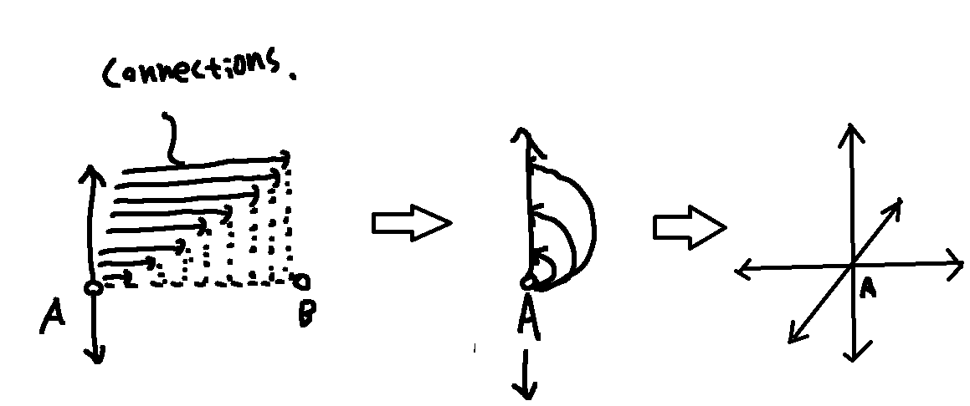

**[4] Change in the infinite does not mean an addition to existence.**

**[5] Change cannot be limited.**

**[6] The existence of order implies the existence of direction.**

**[7] The existence of direction implies the existence of change.**

**<2> The reason the world changes is because it is full of directions.**

1. (n) denotes an axiom in the paper.
2. [m] is a detailed argument for (n). (The argument [m] for (n) is denoted as n.m.)
3. <x> denotes the reason for (n) or [m].