Comparative study to assessment of depression of undergraduate male and female students located in urban area in duration of Covid-19
Ajay bangar ,Dr.YashiJain,Mugdha Shrivastava,Manish Jain

ABSTRACT
This work has done aiming to find out the effect of Covid -19 on the level of Anxiety and level of depression among the undergraduate students who live and study in urban area. As we know that during pandemic situation all classes for schools and colleges has been performed online .This mode of education has come in practice first time in life of students. Hence a level of depression and anxiety may develop in mind of under graduate college going students who have been preparing for graduation and competitive exam. Going through the literature we found that the Hamilton Depression Scale & Hamilton Anxiety scale are suitable to measure Level of anxiety and depression .Both online and offline mode have been used to collect data from male and female candidate .A sample of 50 students male and 50 students have taken from Gwalior and nearby area . Two tailed T test has been done to analyze significant difference between the mean value of level of anxiety and level of depression as well for male and female candidate .Correlation coefficient has been determined to find the relation of variance between level of anxiety and level of depression between male and female students. SPSS software, Microsoft word and excel is use to arrange data, calculation, Tabulation and formation of chart. After data analysis and result and discussion it has concluded that the level of thinking and condition of living standard is almost same for male and female student in urban area .Hence there is no significant difference pertaining to level of anxiety and level of depression between male and female undergraduate student living in urban area. It is also come out that the There is no significance relation in level of anxiety and level of depression between male and female candidate.
As we know that the corona virus has been spread in all over the world and so many people had lost their lives .In view of safety measure the government of India imposed lockdown of around
50 days in each part of country. All college and schools are closed and the final exams have also cancelled and many competitive exams have postponed. During this period of lock down undergraduate students have faced so many problems for continuing their study for their end semester exam and competitive exam as well .Due to uncertainty of their exams and their offline classes they experienced some level of depression and anxiety during this period .This project work is the assessment of level of depression and anxiety induced in male and female undergraduate students staying in urban area

Introduction
Depression: Depression consisting of prolonged periods of excessive sadness. It may be because of persistence of failure in attempt made by us to achieve the desire state of life. We people always expect a level of prosperity, respect, power for the survival of healthy and happy life .But many time there may be much difference between existing and expected state of life. This difference creates a negativity and sadness in our mind. A chain of failure forge stresses which convert in to frustration. According to mental health person try to make it up by performing motivational and spiritual activity. When person fail to mitigate level of frustration, fall in state of depression. Following are the some parameter which has been used to analyze level of depression.
1 Depressed Mood , 2 Feeling of Guilt ,3 Suicide , 4 Insomnia, 5 Activity , 6 Retardation 7 Agitation ,8 Anxiety, 9 Somatic Symptoms ,10 Genital Symptoms ,11 Hypochondriasis
12 Loss of Weight, 13 Insights
Objective:

1 To assess the level of depression and anxiety induced in undergraduate male students located in urban area due to Covid-19
2 To assess the level of depression and anxiety induced in undergraduate female students located in urban area due to Covid-19
3 To compare the level of depression and anxiety induced in male and female undergraduate students located in urban area due to Covid-19
4 To find the relationship between level of depression and anxiety induced in male and female undergraduate students located in urban area due to Covid-19
Hypothesis:

1 There will be no significant difference with reference to depression, induced between undergraduate male and female students located in urban area due to Covid-19

2 There will be no significant difference with reference to anxiety, induced between undergraduate male and female students located in urban area due to Covid-19

3 There will be no significant relationship between depression and anxiety, induced in undergraduate male and female students located in urban area due to Covid-19

Sample Size:

The sample is selected to represent the population which we want to study. Since it is difficult to study the entire population, a sample is selected following different procedure. The sample selection process depends on the objectives and the nature of the sample. Non probability sampling method will be used in the present study. In this, the purposive sampling will be used. Those individuals who are undergraduate, studying for competitive exam and residing in the urban area. The learner will interact students online and collect data through a Google online form .A total of 100 students with age 18 years to 24 years will be taken for the present study. Out of this, 50 will be male and 50 will be female.

Research Design:

Correlation research design in which we assume that everything affects and affected by everything else will be conducted in this project. Correlation design is one in which the researcher collects two or more sets of data from the same group of subjects so that the relationship between the two subsequent sets of data can be determined. This study has the aim to determine the level of depression and anxiety induced because of the restriction implemented by the authorities to avoid the viral (Covid-19) infection among the undergraduate male and female students belonging to urban area. We plan to take sample of 50 students each for male and female . Data will be collected by either by personal visit or by Google form .After receiving the data we analyze it using SPSS software.

Tool: Hamilton Depression Scale & Hamilton Anxiety scale will use to collect data

Statistical Technique:

Parametric statistics will be used. The parametric test are most useful and powerful for testing the significance of computed sample statistics. The data will be analyzed using Correlation, ‘t’ test. Descriptive statistics will be used to organize, classification, and tabulation of data. Inferential statistics will be used for testing of hypothesis.
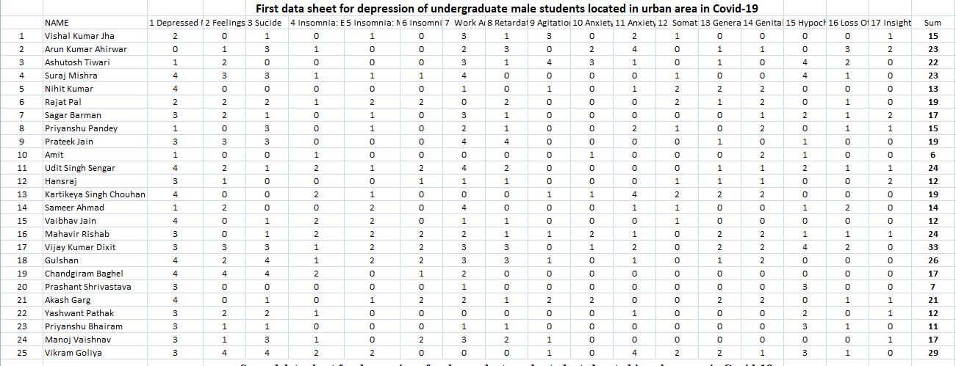

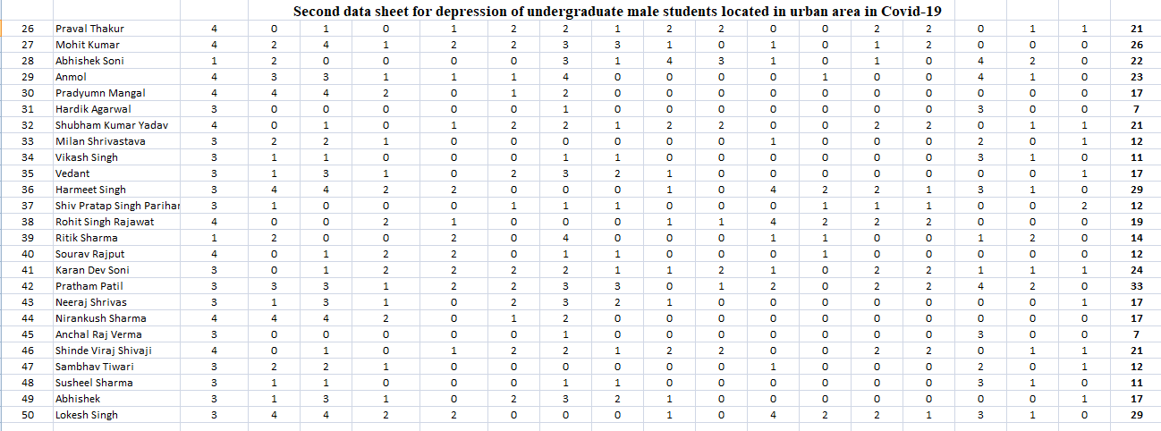
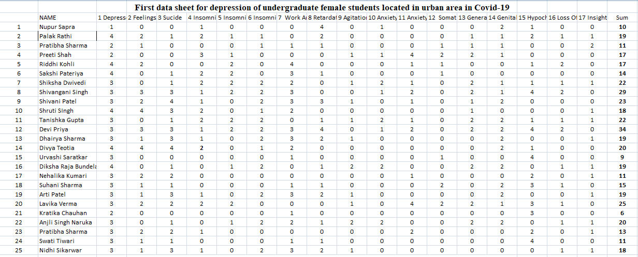

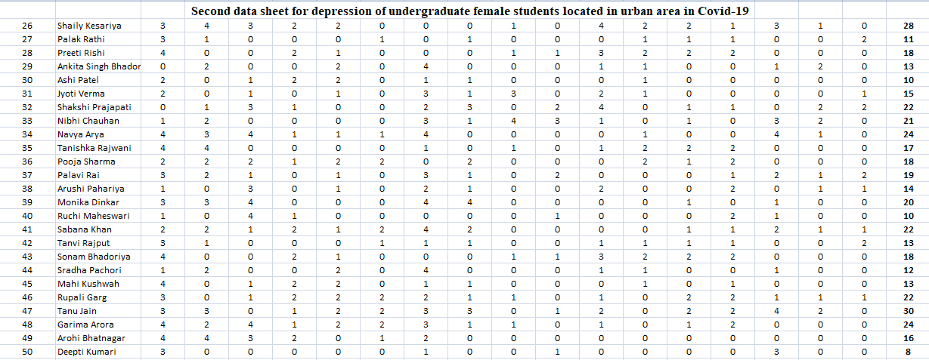

For Depression:-

S.N. | Boys | Girls
1 | 15 | 10
2 | 23 | 19
3 | 22 | 11
4 | 23 | 17
5 | 13 | 17
6 | 19 | 14
7 | 17 | 22
8 | 15 | 29
9 | 19 | 23
10 | 6 | 18
11 | 24 | 22
12 | 12 | 34
13 | 19 | 19
14 | 14 | 20
15 | 12 | 9
16 | 24 | 19
17 | 23 | 11
18 | 26 | 15
19 | 17 | 19
20 | 7 | 25
21 | 21 | 6
22 | 12 | 20
23 | 11 | 13
24 | 17 | 11
25 | 29 | 18
26 | 21 | 28
27 | 26 | 11
28 | 22 | 18
29 | 23 | 13
30 | 17 | 10
31 | 7 | 15
32 | 21 | 22
33 | 12 | 21
34 | 11 | 24
35 | 17 | 17
36 | 29 | 18
37 | 12 | 19
38 | 19 | 14
39 | 14 | 20
40 | 12 | 10
41 | 24 | 22
42 | 33 | 13
43 | 17 | 18
44 | 17 | 12
45 | 7 | 13
46 | 21 | 22
47 | 12 | 30
48 | 11 | 24
49 | 17 | 16
50 | 29 | 8
Mean | 17.82 | 17.58
St.Dev | 6.36 | 6.01
Variance | 40.47 | 36.12
Count | 50 | 50
T Test Value | 0.8466
Dof | 98

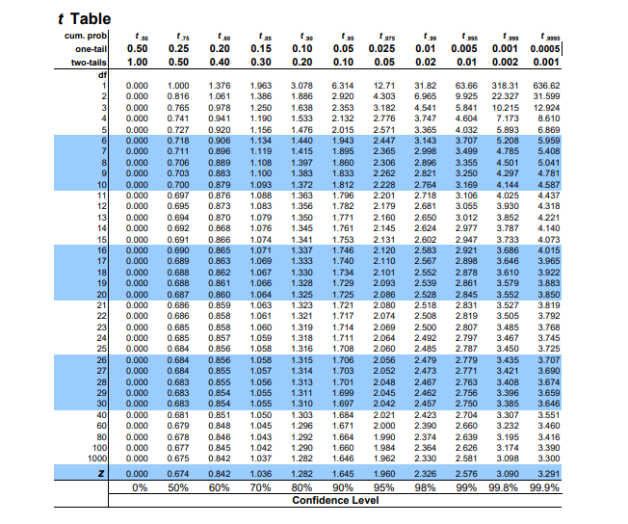

Correlation Coefficient (r)
Boys ( X ) | Girls ( Y ) | ( XY ) | ( X² ) | ( Y² )
19 | 10 | 190 | 361 | 100
36 | 2 | 72 | 1296 | 4
28 | 15 | 420 | 784 | 225
0 | 0 | 0 | 0 | 0
20 | 28 | 560 | 400 | 784
17 | 34 | 578 | 289 | 1156
9 | 23 | 207 | 81 | 529
10 | 5 | 50 | 100 | 25
24 | 21 | 504 | 576 | 441
2 | 1 | 2 | 4 | 1
20 | 9 | 180 | 400 | 81
4 | 6 | 24 | 16 | 36
21 | 41 | 861 | 441 | 1681
6 | 40 | 240 | 36 | 1600
14 | 6 | 84 | 196 | 36
27 | 6 | 162 | 729 | 36
31 | 20 | 620 | 961 | 400
28 | 29 | 812 | 784 | 841
20 | 5 | 100 | 400 | 25
4 | 19 | 76 | 16 | 361
22 | 24 | 528 | 484 | 576
9 | 26 | 234 | 81 | 676
7 | 23 | 161 | 49 | 529
17 | 22 | 374 | 289 | 484
26 | 0 | 0 | 676 | 0
22 | 23 | 506 | 484 | 529
15 | 16 | 240 | 225 | 256
18 | 18 | 324 | 324 | 324
4 | 0 | 0 | 16 | 0
22 | 27 | 594 | 484 | 729
10 | 19 | 190 | 100 | 361
7 | 36 | 252 | 49 | 1296
17 | 28 | 476 | 289 | 784
6 | 10 | 60 | 36 | 100
27 | 17 | 459 | 729 | 289
31 | 20 | 620 | 961 | 400
23 | 14 | 322 | 529 | 196
6 | 12 | 72 | 36 | 144
20 | 25 | 500 | 400 | 625
5 | 9 | 45 | 25 | 81
12 | 22 | 264 | 144 | 484
8 | 9 | 72 | 64 | 81
39 | 23 | 879 | 1521 | 529
37 | 11 | 407 | 1369 | 121
10 | 19 | 190 | 100 | 361
9 | 26 | 234 | 81 | 676
20 | 29 | 580 | 400 | 841
30 | 31 | 930 | 900 | 961
9 | 17 | 153 | 81 | 289
21 | 11 | 231 | 441 | 121
849 | 887 | 15657 | 19237 | 21205

Critical value from T table for 98 Degree of Freedom is 1.962
Calculated value of t for level of anxiety is .71156 which is less than critical value .Hence Null Hypothesis cannot be rejected .
It concluded that There is no significant difference with reference to anxiety, induced between undergraduate male and female students located in urban area due to Covid-19
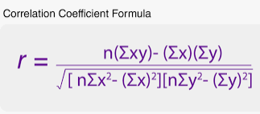

$$r=\frac{50 \left(15657\right)- \left(847\right) (887) }{\sqrt{[\left(50\right)\left(19237\right)-\left(720801\right)][\left(50\right)\left(21205\right)-(786769)]}}$$
r $=0.1229$
Value of correlation coefficient is 0.122 Which is very less. Hence Null Hypothesis cannot be rejected.
It conclude That There is weak significant relationship between anxiety, induced in undergraduate male and female students located in urban area due to Covid-19

CONCLUSION
Following facts have been come out from study
1 There is no significant difference with reference to depression, induced between undergraduate male and female students located in urban area due to Covid-19

2 There is no significant difference with reference to anxiety, induced between undergraduate male and female students located in urban area due to Covid-19

3 There is weak significant relationship between depression and anxiety, induced in undergraduate male and female students located in urban area due to Covid-19

REFERENCE

[1] Feeg, V. D., Prager, L. S., Moylan, L. B., Smith, K. M., & Cullinan, M. (2014).

Predictors of Mental Illness Stigma and Attitudes among College Students: Using

Vignettes from a Campus Common Reading Program. Issues in mental health nursing,

35(9), 694-703.

[2] Gulliver, A., Griffiths, K. M., & Christensen, H. (2010). Perceived barriers and facilitators to mental health help-seeking in young people: a systematic review. BMC psychiatry, 10(1), 113.
[3] Biddle, L., Donovan, J., Sharp, D., & Gunnell, D. (2007). Explaining non-help-seeking amongst young adults with mental distress: a dynamic interpretive model of illness behaviour. Sociology of health & illness, 29(7), 983-1002.
[4] Hinrichsen GA, Emery EE. (2006). Interpersonal factors and late-life depression. Clinical

Psychology: Science and Practice, 12, 264–75.

[5] Barney, L. J., Griffiths, K. M., Jorm, A. F., & Christensen, H. (2006). Stigma about depression and its impact on help-seeking intentions. Australian and New Zealand Journal of Psychiatry, 40(1), 51-54.
[6] MacKian, S., Bedri, N., & Lovel, H. (2004). Up the garden path and over the edge: where might health-seeking behaviour take us?. Health policy and planning, 19(3), 137-146.
[7] Corrigan, P., Markowitz, F. E., Watson, A., Rowan, D., & Kubiak, M. A. (2003). An attribution model of public discrimination towards persons with mental illness. Journal of Health and Social Behavior, 162-179.
[8] Givens, J. L., & Tjia, J. (2002). Depressed medical students' use of mental health services and barriers to use. Academic Medicine, 77(9), 918-921.
[9] Wilson, C. J., Deane, F. P., Ciarrochi, J. V. & Rickwood, D. (2002). Adolescent barriers to seeking professional psychololgical help for personal-emotional and suicidal problems. Suicide Prevention Australia 9th Annual Conference, June 2002 (pp. 1-8).
[10] Brown G.W., Harris T.O. (2001). Social Origins of Depression: A Study of Psychiatric

Disorder in Women. Rutledge

[11] Komiya, N., Good, G. E., & Sherrod, N. B. (2000). Emotional openness as a predictor of college students' attitudes toward seeking psychological help. Journal of counseling psychology, 47(1), 138
.[12] Bandura A. (1998). Self-Efficacy. In: Friedman H. Encyclopedia of Mental Health. San

Diego: Academic Press; 1998

[13] Plomin, R., De Fries, J. C., McClearn, G. E. &Rutter, M. (1997). Behaviour Genetics

(3rd ed.) New York: W. H. Freeman

[14] Kessler, RC. The effects of stressful life events on depression. Annual revue of

Psychology. 1997;48:191–214

[15] Pinto A, Francis G. (1993). Cognitive correlates of depressive symptoms in hospitalized adolescents. Adolescence, 28, 661–72.
[16] Goodwin, F. K. & Jamison, K. R. (1990). Manic depressive illness. New York: Oxford

University Press.

[17] Klerman, G.L., Weissman, M.M., Rounsaville, B.J. & Chevron, E.S. (1984).

Interpersonal therapy of depression. New York: Academic Press.

[18] Seligman, M. (1975). Helplessness: On depression, development and death. San

Francisco, CA, USA: WH Freeman

[19] Seligman, M. E. P. (1974). Depression and learned helplessness. In R. J. Friedman & M. M. Katz (Eds.), The psychology of depression: Contemporary theory and research. Washington, DC: V.H. Winston.
[20] Bowlby, , J. (1969). Attachment and loss (Vol. 1). New York: Basis Books

