ARE THE LEAST TIME PATH PRINCIPLE AND SNELL’S LAW OF REFLECTION EQUIVALENT?

RADHAKRISHNAMURTY PADYALA
#282, DMLO, Yelahanka, Bangalore 560064, India.
Padyala1941@yahoo.com
ORCID: 0000-0001-6029-6155

Abstract

We show in this paper that the answer to the question in the title is in the negative. In modern optics, Snell’s law of reflection is derived using Leibniz’s calculus method that identifies the least time path, chosen by rays of light in going from a given point A, to another given point B, undergoing reflection at a point P on their way. We demonstrate, taking two examples of reflection: (1) at a plane reflector and (2) at elliptical reflector, that Snell’s law of reflection is not a consequence of least time path principle and, that Leibniz’s method of derivation of Snell’s law of reflection is invalid. In (1), we prove that, if a light ray is reflected at point P on a line, along the least time path APB, then at every point P_{i} on that line, rays from A are reflected to point B, satisfying Snell’s law. However, paths, APB and AP_{i}B do not have equal travel times. In (2), we prove that, if a light ray is reflected along the least time path APB, from focus A to focus B incident at point P on an ellipse, satisfies Snell’s law, then points P_{i}, not lying on the ellipse, also reflect light rays from A to B, satisfying Snell’s law. However, the paths APB and AP_{i}B do not have equal travel times. Thus, both examples prove that least time path is not a criterion for reflection and, that Snell’s law of reflection is not a consequence of least time path principle.

Keywords:

Light, Optics, Snell’s Law of Reflection, Equal angles Law of Reflection, Least time path principle, Leibniz’s calculus method, Plane Reflector, Elliptical Reflector
Introduction
The study of reflection and the behavior of light has a long history that dates back to ancient times. Euclid, in his work "Optics," first formulated the law of equal angles, that governs the behavior of light when it reflects off a plane surface¹. His most important result is that, Sun’s rays parallel to the axis of a spherical reflector are concentrated after reflection at its surface, to a unique point, called the burning point of the mirror^{2,3}, at the center of curvature of the reflector.(aside: Diocles analyzed the phenomenon of reflection of light at parabolic and spherical surfaces^{4,5}. He arrived at a result quite contradictory to the result of Euclid with respect to the practically most important method of focusing Sun’s rays to a unique point using spherical reflectors. His results showed that it was impossible to focus Sun’s rays to a unique point using a spherical reflector. The reflected rays pass through points over a range along the axis of the reflector leading to aberration. Diocles result has been accepted as the correct result and is followed ever since in geometrical optics.
Hero of Alexandria extended on Euclid's work⁵. From observations such as sighting stars instantaneously after opening our eyes towards the sky at night, he proposed that light travels with infinite speed and hence follows straight line paths^{6,7}. Using geometrical methods he showed that light follows the least distance path. However, speed of light does not enter his calculations of distances of paths followed. Hero reformulated the equal angles of reflection in terms of the least distance path. It is to be noted that least distance path did not imply least time path. It is clear, therefore, that it is the assumption of finite speed of light that leads to least time path from least distance path. Descartes also used the idea of infinite speed of travel for light.
In the 17th century, Fermat deduced, based on his study of maxima and minima, that light follows the path that takes minimum time to go from any given point A, to any other given point B, not only when it travels directly from A to B, but also when it suffers reflection or refraction on its way from one point to the other⁸. This came to be known as the ‘Fermat’s least time principle’ (FLTP). When light undergoes reflection at a point P, on its way from a point A to another point B, both A and B lie in the same medium. Light follows the broken line path APB, along which the distance of travel and the time of travel have their minimal values assuming constancy of speed for motion of light along the whole path APB.
As a matter of fact, it is difficult to find reliable literature concerning the law of reflection enunciated by Snell. In modern literature, Snell’s law is taken to be the sine law of refraction⁹. This situation shows the negligence of the study of history and importance of the phenomenon of reflection.
Snell made a mathematical study of the phenomena of reflection and refraction. He obtained simple mathematical equations shown below, that govern the two phenomena¹⁰.
$$\frac{sin(i)}{sin(r)}= constant. i = r (Reflection) (1)$$
Where, i and r are, respectively the angles of incidence and reflection with respect to the normal to the surface of reflection, at the point of incidence. This is equivalent to Euclid’s equal angles law of reflection. The only deference is that the angles are measured with respect to the surface of reflection in Euclid’s case where as they are measured by convention, with respect to the normal to the surface of reflection in Snell’s case The complete broken line path of the reflected ray couple lies in one and the same medium.
$$\frac{sin(θ_{i})}{sin(θ_{r})}= constant (Refraction) (2)$$
Where, θ_{i} and θ_{r} are, respectively, the angles of incidence and refraction with respect to the normal to the surface of separation of the two media, at the point of incidence. The end points of the path the ray lie in different media.
Leibniz used his calculus method to derive Snell’s laws. He enunciated his ‘Most Determined Path Principle’ (MDPP) which, essentially is the same as FLTP except for some philosophical aspects regarding the properties/behaviour of light^{11,12}. Leibniz’s calculus method of proof of Snell’s laws became the most popular and standard method, ever since.
Huygens¹³ used his wave theory of light together with FLTP to derive Snell’s laws. Feynman¹⁴, used quantum mechanics to demonstrate the validity of FLTP for the path followed by a reflected ray of light.
Thus, modern theories of light advocate that Snell’s laws are consequences of FLTP. Note that FLTP transforms into least distance path principle in the case of reflection due to the fact that the speed of travel remains constant through the entire path.
We demonstrate in this paper, taking two examples of reflection: (1) at a plane surface and (2) at elliptical surface, that Snell’s law of reflection is not a consequence of least time/distance path principle and, that Leibniz’s method of derivation of Snell’s law of reflection is invalid.

In (1), we prove that, if a light ray is reflected at point P on a line, along the least time path APB, then every point P_{i} on that line reflects rays from point A, to point B, satisfying Snell’s law. However, paths, APB and AP_{I}B do not have equal travel times.

In (2), we prove that, if the reflection of a light ray along the least time path APB, from focus A to focus B incident at point P of an ellipse, satisfies Snell’s law, then points P_{i}, not lying on the ellipse, also reflect light from A to B satisfying Snell’s law. However, the paths APB and AP_{i}B do not have equal travel times.

Thus, both examples prove that least time path is not a criterion for reflection and, that Snell’s law of reflection is not a consequence of least time path principle.
Demonstration of the fallacy in the Leibniz’s calculus proof of the derivation of Snell’s law of reflection.
Let us consider the broken line path APB, of a ray of light from a given point A to another given point B (both A and B lying in the same medium), incident at a point P on a reflector line CD (see Fig. 1). The sum of the lengths of the segments AP and PB can be obtained applying Pythagoras theorem to triangles APC and BPC.
We now move P to any other location P_{i} on CD and obtain the sum of the lengths of the segments AP_{i} and P_{i}B as in the earlier case. We differentiate this sum of the lengths with respect to the location of P_{i} on CD and equate the differential to zero (the condition for extremum). The result leads us to the equality of angles of incidence and reflection¹⁶. This result is taken as the Snell’s law of reflection, and the equivalence of the least distance path principle and Snell’s law of reflection is being validated thus.

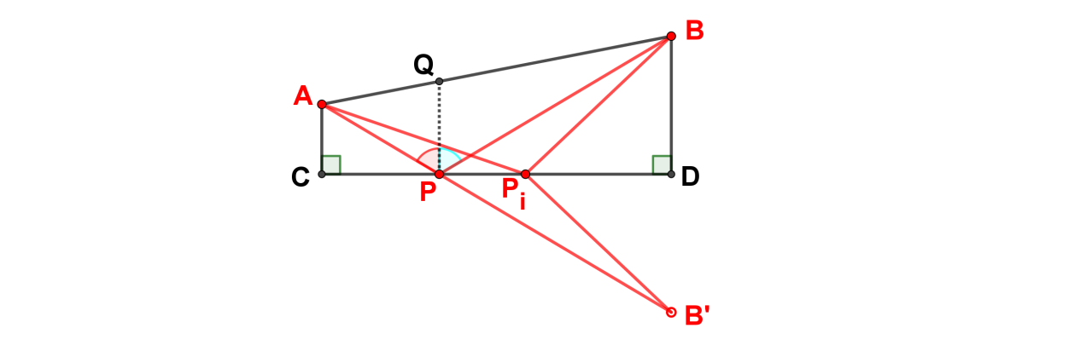
Fig. 1. Figure shows the conventional method of proof of equivalence of the least time path and Snell’s law of reflection of light. Sum of lengths AP and PB is less than sum of lengths AP₁ and P₁B.
Conventional method compares two broken line paths from A to B via a point of incidence P_{i} on CD - one of these two paths is that in which the angle AP_{i}B is bisected by the normal to CD at P_{i}, the other path being one where the point of incidence is chosen arbitrarily on CD (see Fig. 1).
$$(AP+PB)=(AP+PB') =AB'<(AP_{i}+P_{i}B') =(AP_{i}+P_{i}B') (3)$$
B’ is is the reflection of B in CD. P_{i} is an arbitrary point on CD. The sum of the two sides AP_{i} and P_{i}B of triangle AP_{i}B, is greater than the third side AB’. Since P_{i}B’ = P_{i}B and PB’ = PB, we get (AP + PB) < (AP_{i} + P_{i}B), the result shown in Eq. (3).
Leibniz’s method uses Pythagoras theorem to obtain the lengths of the hypotenuses in triangles APC and BPD. The sum of these lengths is differentiated with respect to the location of P on CD and equated to zero to get at the extremum value for the sum of lengths AP and PB. The end result is this: BQ : QA = BP : AP, which means geometrically that QP is the bisector of the angle APB, which in turn implies equality of angle of incidence APQ and the angle of reflection BPQ. This is equivalent to the equal angles law of reflection of Euclid.
In Fig. 2 we show 3 different broken line paths from A to B touching the line of reflection MM₁ at points P_{i} (i=1,2,3). Which of these 3 paths qualifies to be the least distance path?

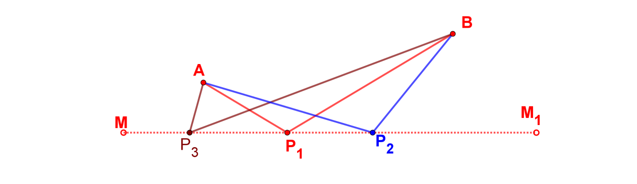
Fig. 2. Figure shows three broken line paths from A to B touching the line of reflection MM₁ at P_{i} (I =1, 2, 3). Which of the paths qualifies to be the least distance path?
To answer this question we take two of the three paths at random (Fig. 3), we show that each of them satisfies the equal angles law of reflection. However, they are not of equal length as explained with reference to Fig. 1 above.
We show below that if any one path say, path APB were to be the path of minimum length, then the second path AP_{i}B also is to be a path of minimum length, as both paths satisfy the equal angles law of reflection..
Demonstration that every broken line path AP_{i}B is of minimum length, if any one path is of minimum length in reflections at a straight line.
Let APB be the path of a reflected light ray from A to B. Let us assume it to be the path of least distance. Let us now consider the path AP_{i}B, where P_{i} is an arbitrary point on CD (see Fig. 3). The ray AP_{i} from A is reflected at P_{i} on C_{i}D_{i} (P_{i} also lies on CD) to go through B, since the ray makes equal angles with C_{i}D_{i}. By the criterion used to prove path length APB is the least, for reflection at P on CD, we see that the path length AP_{i}B is the least, for reflection at P_{i} on C_{i}D_{i}. P and P_{i} lie on the same straight line. Since P_{i} is an arbitrary point on CD, it follows that every path AP_{i}B is a path of reflection.
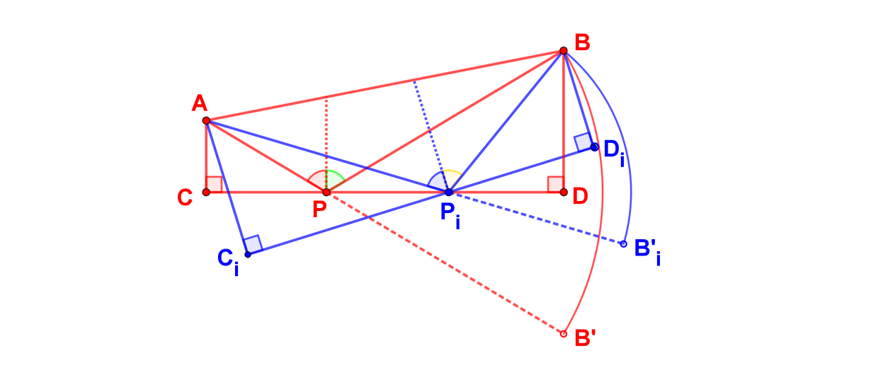
Fig. 3. Figure shows two broken line paths, APB and AP_{i}B, of reflection, where A and B are the end points of the path, and P, P_{i} are respectively, points of incidence on the line CD.
Thus, if every path APiB is a path of reflection, then every path must necessarily be of minimum length according to the least path principle. However, the path lengths APB and AP_{i}B are not equal, but they are all paths of reflection. Hence, we conclude that minimum path length is not a criterion for the reflection of a ray of light at a line (plane surface) reflector .
Since speed of travel is constant throughout the path from A to B, the least distance path is the same as the least time path. Hence it follows that the least time path principle and Snell’s law of reflection are not equivalent.
Demonstration that every broken line path AP_{i}B is of minimum length if any one of them is a path of minimum length, in reflections at an ellipse.
Let us consider an ellipse with A, B as foci and passing through a point C on the axis AB (see Fig. 4). Let P be an arbitrary point on the ellipse. Let the ellipse be a reflector of light. Let a ray of light from one focus, say, A, be incident at P. It is well known from the reflection property of ellipse that the incident ray from one focus passes through the second focus, after reflection at any point on the ellipse. Therefore, AP and PB form a reflection ray couple. Conventionally the path APB is proved to be the

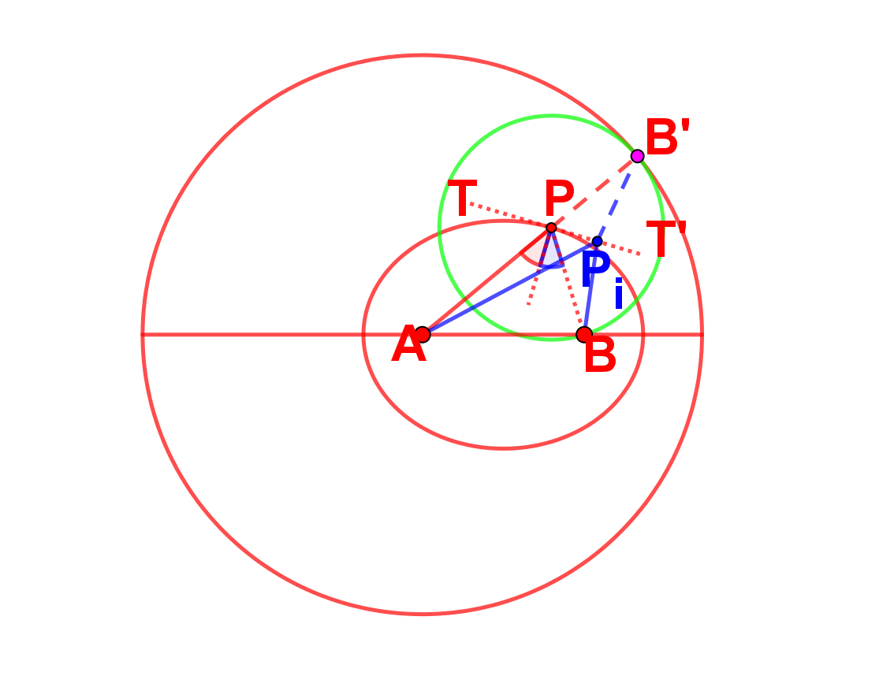
Fig. 4. Figure shows the conventional method of showing the path of reflection of a ray of light from one focus to the other through a point on the ellipse at which reflection occurs, is the least distance path.
path of least length as described below^{7,15}.
Draw the tangent to the ellipse at P. Reflect B in the tangent to get B’. With A as center and AB’ (= R) as radius, draw a circle. Draw the line joining A and P. It intersects the circle at B’ (Eq. 4). Draw a circle with P as center and PB (= PB’) as radius. It passes through B’.
$$(AP+PB)=(AP+PB')=AB' =R=constant (4)$$
Let P_{i} be any point on the tangent through P. Join AP_{i}, P_{i}B and P_{i}B’. We get,
$(AP_{i}+P_{i}B)=(AP_{i}+P_{i}B')>(AP+PB')=AB' (5)$
Length of the path AP_{i}B’ is greater than the length AB’ as seen from Eq. 5. Since P_{i} is an arbitrary point on the tangent, it applies to any point on the tangent. Therefore, it follows that APB is the least distance path. That proves the equivalence of the least distance path and Snell’s law of reflection are equivalent.
We show below that AP_{i}B is a path of reflection for the incident ray AP_{i}.
Draw an ellipse (green) with A, B as foci and passing through P_{i} (see Fig. 5). Draw the tangent to the ellipse at P_{i} . Reflect B in the tangent to get B₁’. With A as center
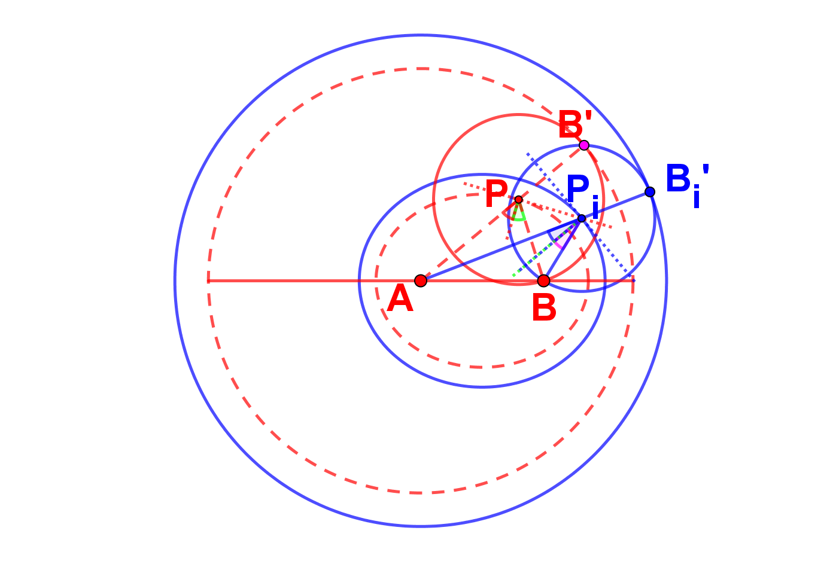
Fig. 5. Figure shows that if APB is a least distance path for a reflected ray of light from one focus to the other focus of an ellipse, then AP_{i}B must also be a least distance path for a reflected ray of light between the same two foci reflected from a point P_{i}, not lying on the ellipse.
and AB₁’ (= R₁) as radius, draw a circle. Draw the line joining A and P_{i}. It intersects the circle at B₁’ (Eq. 6). Draw a circle with P_{i} as center and P_{i}B (= P_{i}B₁’) as radius. It passes B₁’. The ray from the focus A incident on the ellipse (green) at P_{i} passes through focus B, after reflection at P_{i}.
$$(AP_{i}+P_{i}B)=(AP_{i}+PB_{1}^{'})=AB_{1}^{'}=R_{1}=constant (6)$$
Join AP_{i}, P_{i}B₁’ and P_{i}B₁’. We get,
$$(AP_{i}+P_{i}B)=(AP_{i}+P_{i}B_{1}^{'})=AB_{1}^{'}>(AP+PB)=AB^{'} (7)$$
Length A$B_{1}^{'}$ of the path AP_{i}B is greater than the length AB’ of the path APB as seen from Eq. (7). Since P_{i} is an arbitrary point on the tangent,the result applies to any point on the tangent through P. Therefore, it follows that AP_{i}B is the least distance path. However, the path lengths AB’ of the path APB and AB₁’ of the path AP_{i}B are not equal, but they are all paths of reflection. That leads to a paradox. Hence, we conclude that it is impossible to have a path of minimum length from one focus, A, to the second focus, B of an ellipse, with the points of reflection P_{i}, lying on the ellipse.
Since speed of travel is constant throughout the path from A to B, least distance path is the same as the least time path. Hence it follows that the least time principle and Snell’s law of reflection are not equivalent.
Acknowledgement
I thank Mr. Arun Rajaram, Chennai, for his constant unstinting support and encouragement of my research pursuits.
References
Note: References to classical works have been obtained from secondary sources with a view to provide the reader with original works for further study, if interested.
- Euclid. Optics, Ed. J. L. Heiberg, Euclidis opera omnia, vol.7 (Leipzig. Teubner, 1895), pp. 1-121.
- Euclid, Catoptrics, Ed. J. L. Heiberg, Euclidis opera omnia, vol.7 (Leipzig. Teubner, 1895), pp. 285-343.
- Wilbur Knorr, “The geometry of Burning Mirrors in Antiquity”, ISIS 74, (1983), pp. 53-73.
- Diocles, On Burning Mirrors, Ed. and trans. G. J. Toomer, On Burning Mirrors: The Arabic Translation of the Lost Greek Original (Berlin/Heidelberg/ New York: Springer-Verlag, 1975).
- Ptolemy, Optics, trans. A. Mark Smith, Ptolemy’s Theory of Visual Perception: An English Translation of the Optics with Introduction and Commentary, Transactions of the American Philosophical Society 86.2 Philadelphia: (1996).
- Hero of Alexandria, Catoptrics, Ed. and trans. Wilhelm Schmidt, Heronis Alexandrini opera quae supersunt omnia,vol.2: 1 (Leipzig: Teubner, 1900), pp. 301-373.
- Pavlos Mihas, The problem of focusing and real images, Eur. J. Phys. 29 (2008) 539-553. https://doi:10.1088/0143-0807/29/3/0148
- Pierre de Fermat, Study of Maxima and Minima, Original in Latin, This English translation was made by Jason Ross from the French translation in the CEuvres de Fermat vol. 3, (1638) pp. 121-156.
- https://en.wikipedia.org/wiki/Snell%27s_law.
- https://www.britannica.com/science/light/Reflection-and-refraction.
- G. W. Leibniz, “Tentamen Anagogicum: An Anagogical Essay in the investigation of causes,” Ca. 1696. First published in the Acta eruditorum, (June 1682).
- Lamborn, Richard Samuel,”Thinking Nature”,” Pierrie Maupertius and the Charge of Error Against Fermat and Leibniz” (2015). Graduate Theses and Dissertations, pp. 116-119. http://Scholarcommons.usf.edu/etd/5979. Also see, McDonough, Jeffry. “Leibniz on Natural Teleology and the Law of Optics” Philosophy and Phenomenological Research, 78 (3), 2009.
- Huygens C, Complete Works, 20, (1669) pp. 265 -269.
- R. P. Feynman, R. B. Leighton, and M. Sands “The Feynman’s Lectures on Physics”,Reading, penn., Addison-Wesley (1963 -1965).
- D. L. Goodenstein and Judith R. Goodenstein, Feynman’s lost lecture, The motion of the planets around the Sun, Vintage Books, London, (1997).

¹A PPT presetaion of this article was given at the IVMSC 2023.

