Parkinson’s Disease Prediction Using Artificial Neural Network
Ramzi M. Sadek, Salah A. Mohammed, Abdul Rahman K. Abunbehan, Abdul Karim H. Abdul Ghattas, Majed R. Badawi, Mohamed N. Mortaja, Bassem S. Abu-Nasser, Samy S. Abu-Naser
Department of Information Technology,
Faculty of Engineering & Information Technology,
Al-Azhar University - Gaza, Palestine

Abstract: Parkinson's Disease (PD) is a long-term degenerative disorder of the central nervous system that mainly affects the motor system. The symptoms generally come on slowly over time. Early in the disease, the most obvious are shaking, rigidity, slowness of movement, and difficulty with walking. Doctors do not know what causes it and finds difficulty in early diagnosing the presence of Parkinson’s disease. An artificial neural network system with back propagation algorithm is presented in this paper for helping doctors in identifying PD. Previous research with regards to predict the presence of the PD has shown accuracy rates up to 93% [1]; however, accuracy of prediction for small classes is reduced. The proposed design of the neural network system causes a significant increase of robustness. It is also has shown that networks recognition rates reached 100%.
Keywords: Parkinson's disease, Artificial Neural Network, Prediction

Introduction
Parkinson's disease is a lasting worsening syndrome of the central nervous system that mostly smidgeons the motor system [1].The symptoms normally come on gradually over time[1]. In the early stage of the disease, the most obvious are shaking, inflexibility, leisureliness of movement, and trouble with walking [1]. Thinking and behavioral problems might similarly happen [2]. Dementia turns out to be common in the progressive stages of the disease [2]. Depression and anxiety are also common, happening in more than a third of people with PD [2]. Other symptoms comprise sensory, sleep, and emotional difficulties [1]. The crucial motor symptoms are together called "parkinsonism” or a "parkinsonian syndrome" [3].
The cause of Parkinson's disease is normally unknown, but believed to include mutually genetic and environmental factors [3]. Those with a family member pretentious are further likely to acquire the disease themselves [3]. There is also a bigger risk in people exposed to specific pesticides and amongst those who have had previous head damages, while there is a abridged risk in tobacco smokers and those who consume coffee or tea [3]. The motor symptoms of the disease outcome from the death of cells in the substantia nigra, a region of the midbrain[1]. This results in not sufficiently dopamine in these areas[1]. The reason for this cell death is not understood, but includes the build-up of proteinsinto Lewy bodies in the neurons [3]. Diagnosis of distinctive cases is mostly based on symptoms, with examinations such as neuroimaging being used to exclude other diseases[1].
There is no treatment for Parkinson's disease, with treatment directed at improving symptoms [1]. Initial treatment is naturally with the antiparkinson medication levodopa (L-DOPA), with dopamine agonists being used once levodopa becomes less effective [2]. As the disease growth and neurons continue to be lost, these medications turn out to be less in effect while at the same time they create a difficulty marked by instinctive writhing movements [2].Diet and some forms of rehabilitation have exposed some efficiency at refining symptoms [5]. Surgery to place microelectrodes for deep brain stimulation has been used to decrease motor symptoms in severe cases where drugs are ineffective[1]. Indication for treatments for the non-movement-related symptoms of PD, such as sleep disturbances and emotional problems, is less robust [3].
In 2015, PD pretentious 6.2 million people and caused in about 117,400 deaths worldwide [4]. Parkinson's disease naturally occurs in people over the age of 60, of which about 1% are affected [1]. Males are more frequently affected than females at a ratio of around three to two [3]. When PD is seen in people before the age of fifty, it is so-called young-onset PD [6]. The normal life expectancy after diagnosis is between seven and fourteen years [2].The disease is called after the English doctor James Parkinson, who published the first detailed description in An Essay on the Shaking Palsy, in 1817 [7]. Public consciousness campaigns consist of World Parkinson's Day (on the birthday of James Parkinson, 11 April) and the use of a red tulip as the symbol of the disease [8]. People with Parkinson's who have improved the public's awareness of the condition include actor Michael J. Fox, Olympic cyclist Davis Phinney, and late professional boxer Muhammad Ali [9].

THE ARTIFICIAL NEURAL NETWORKS
Artificial neural networks (ANN) or connectionist systems are computing systems vaguely enthused by the biological neural networks that constitute human brains [10]. The neural network is a framework for many different machine learning algorithms to work together and process compound inputs [11]. This type of a system learns to do tasks by examples, normally without being programmed with any task-explicit rules. For example, in image recognition, it may learns to recognize images that contain dogs by considering example images that have been manually labeled as "dog" or "no dog" and using the outputs to recognize dogs in other images. It does this without any previous knowledge about dogs, for example, that they have tails and dog-like faces. Instead, they automatically produce recognizing characteristics from the learned material that it processes.
An ANN is established on a group of connected nodes called artificial neurons, which roughly model the neurons in a biological brain. Each connection, like the synapses in a biological brain, can transfer a signal from one artificial neuron to another. An artificial neuron that gets a signal can do some work on it and then signal further artificial neurons linked to it.
In ANN implementations, the signal at a connection among artificial neurons is a actual number, and the output of each artificial neuron is calculated by a certain non-linear function of the summation of its inputs. The connections among artificial neurons are named 'edges'. Artificial neurons and edges characteristically have a weight that fine-tunes as learning continues. The weight may upsurges or declines the strength of the signal at a connection. Artificial neurons usually have a threshold such that the signal is only referred if the collective signal crosses that threshold. Naturally, artificial neurons are grouped into layers. Layers can perform different types of transformations on the inputs they receive. Signals travel from the input layer (first layer), to the output layer (last layer), perhaps after traversing the layers several times.
The initial goal of the ANN method was to crack problems in the same way a human brain would. But, over time, consideration moved to performing explicit tasks, leading to aberrations from biology. Artificial neural networks have been used on a range of tasks, counting machine translation, computer vision, social network filtering, speech recognition, playing video games, and medical diagnosis.
A main trigger for improved interest in neural networks and learning was Werbos's (1975) back-propagation algorithm that efficiently solved the XOR problem by making the training of multi-layer networks possible and effective. Backpropagation dispersed the error term back up through the layers, by adjusting the weights at each node [12].
In the 1980s, parallel distributed processing turn out to be popular under the name connectionism. Rumelhart and McClelland in 1986 clearly described the use of connectionism to mimic neural processes [13].
Support vector machines and other, much modest methods such as linear classifiers slowly overtook neural networks in machine learning fame. But, using neural networks transmuted some domains, such as the prediction of protein structures [14].
In 1992, max-pooling was presented to help with least shift invariance and tolerance to deformation to aid in 3D object recognition [15]. In 2010, Backpropagation training through max-pooling was accelerated by GPUs and shown to perform better than other pooling variants [16].
The vanishing gradient problem affects many-layered feedforward networks that use backpropagation and also Recurrent Artificial Neural Networks (RANNs) [17]. As errors spread from layer to layer, they shrink exponentially with the number of layers, obstructing the tuning of neuron weights that is based on those errors, mainly affecting deep networks.
To solve this problem, Schmidhuber embraced a multi-level hierarchy of networks (1992) pre-trained one level at any time by unsupervised learning and adjusted by backpropagation [18]. Behnke (2003) depend on only on the sign of the gradient (Rprop)[19] on problems such as image rebuilding and face localization.
Hinton et al. (2006) proposed learning a high-level representation using successive layers of binary or real-valued latent variables with a controlled Boltzmann machine [19] to model each layer. Once adequately many layers have been learned, the deep architecture may be used as a reproductive model by reproducing the data when sampling down the model (an "ancestral pass") from the top level feature activations [20]. In 2012, Ng and Dean shaped a network that learned to identify higher-level concepts, such as dogs, only from viewing unlabeled images taken from YouTube videos [21].
Former challenges in training deep neural networks were positively addressed with methods such as unsupervised pre training, while existing computing power increased through the use of GPUs and distributed computing. Neural networks were set up on a large scale, mostly in image and visual recognition problems. This became known as "deep learning".

METHODOLOGY:
3.1 The dataset of Parkinson’s disease
The data used in this research is a voice recording originally done at University of Oxford by M.A. Little [2]. Furthermore, a detailed presentation was made on the specificities of the recording equipment as well as in what environment the experiment was carried out. The data consists of 195 recordings extracted from 31 people whom 23 are suffering from Parkinson’s disease. The time since first diagnosis of Parkinson’s disease was done 0 to 28 years ago and the age of the subjects ranged from 46 to 85 years and a total of 6 vocal sounds were recorded from each subject.

3.2 The Input Variables
The input variables selected are those which can easily be obtained from previous research. The input variables are as in Little et. al [22] where the exact computations of each measurement is described.

Table 1: the input variables
1 | MDVP:Flo(Hz) | Average vocal fundamental frequency
2 | MDVP:Jitter(%) | measures of variation in fundamental frequency
3 | MDVP: Jitter(Abs) | measures of variation in fundamental frequency
4 | MDVP: RAP | measures of variation in fundamental frequency
5 | MDVP: PPQ | measures of variation in fundamental frequency
6 | Jitter: DDP | Several measures of variation in fundamental frequency
7 | MDVP: Shimmer | Several measures of variation in amplitude
8 | MDVP: Shimmer(dB) | Several measures of variation in amplitude
9 | Shimmer:APQ3 | Several measures of variation in amplitude
10 | Shimmer:APQ5 | Several measures of variation in amplitude
11 | MDVP:APQ | Several measures of variation in amplitude
12 | Shimmer: DDA | Several measures of variation in amplitude
13 | NHR | first measures of ratio of noise to tonal components in the voice
14 | HNR | second measures of ratio of noise to tonal components in the voice
15 | RPDE | First nonlinear dynamical complexity measure
16 | DFA | Signal fractal scaling exponent
17 | spread1 | First nonlinear measure of fundamental frequency variation
18 | spread2 | Second nonlinear measure of fundamental frequency variation
19 | D2 | Second nonlinear dynamical complexity measure
21 | PPE | Third nonlinear measure of fundamental frequency variation

3.3 The output Variable
Table 2 shows the output variable and its meaning.

Table 2: The output variable
S.n. | Variable | meaning
1 | Status | Health status of the subject  (1) - Parkinson's,  (0) - healthy

3.4 Evaluation and analysis
We have 195 samples in the dataset. We divide it into 170 training sample and 25 validating sample then we imported the dataset in Just Neural Network (JNN) environment (as shown in Figure 1). We then trained, validated the ANN model (as seen in Figure 2). We found the most important attributes contributing to the ANN model as shown in Figure 3. The detail of ANN model is shown in Figure 4. The accuracy of the ANN model was 100%.
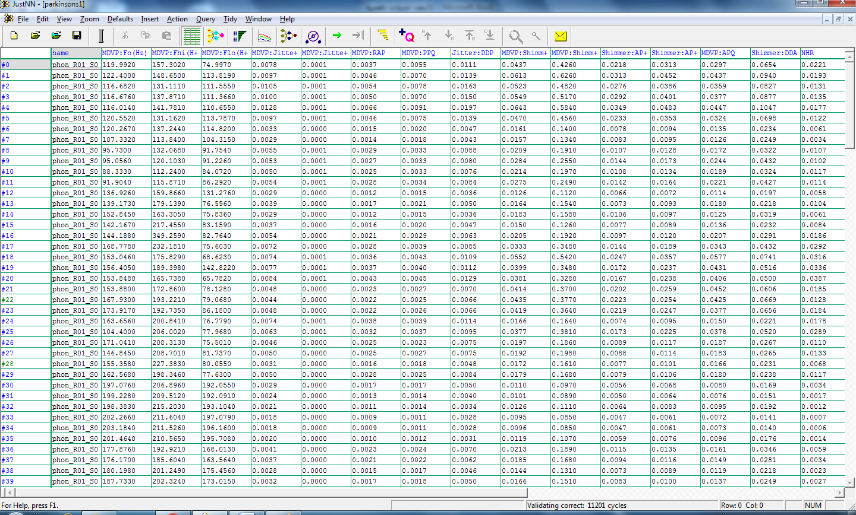
Figure 1: Imported the data set in JNN environment
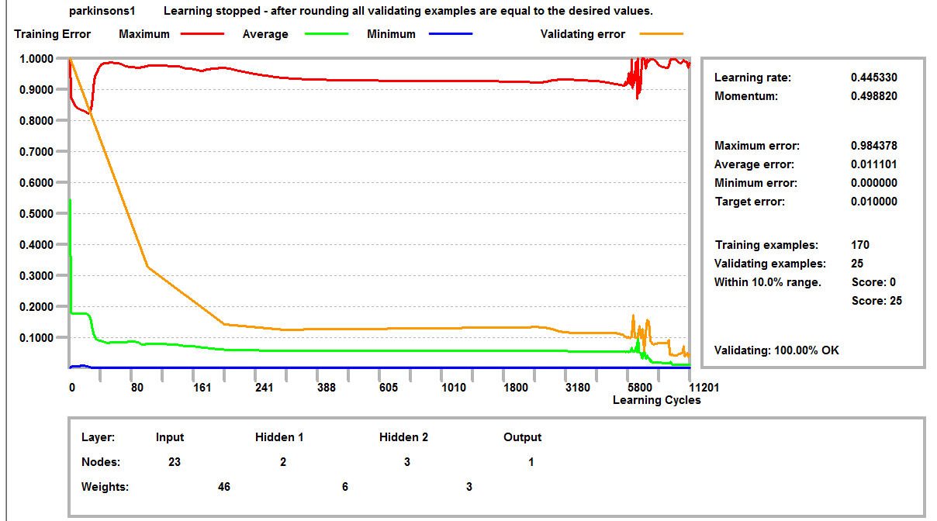
Figure 2: Training and validating of the ANN model in JNN environment
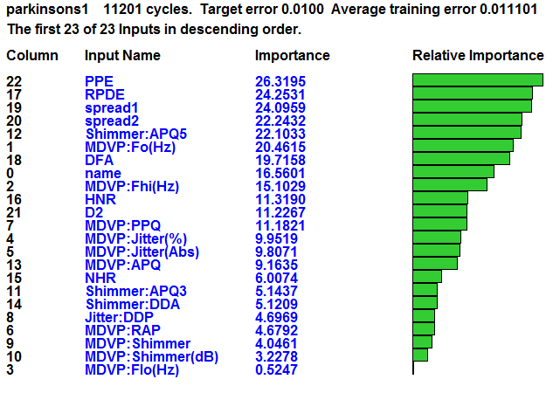
Figure 3: Most important attributes of the ANN model

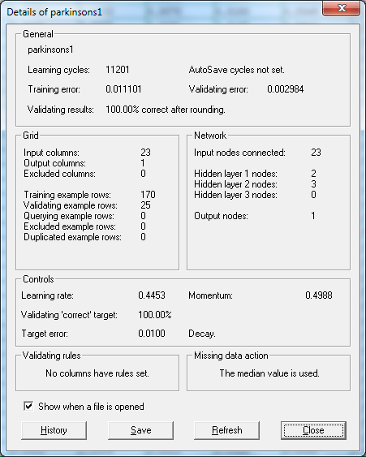
Figure 4: Details of the ANN model
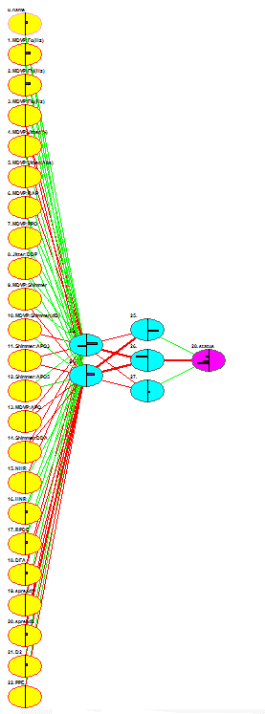
Figure 5: Architecture of the ANN model

CONCLUSION
Parkinson's disease is a long-term degenerative disorder of the central nervous system that mainly affects the motor system. The symptoms generally come on slowly over time. An ANN model was presented for Parkinson’s disease prediction to help specialist in the field. The accuracy we got is 100%.

REFERENCES
- "Parkinson's Disease Information Page". NINDS. 30 June 2016. Archived from the original on 4 January 2017. Retrieved 18 July 2016.
- Sveinbjornsdottir S (October 2016). "The clinical symptoms of Parkinson's disease". Journal of Neurochemistry. 139 Suppl 1: 318–324. Bibcode:2006J Neur..26.9606G. doi:10.1111/jnc.13691. PMID 27401947.
- Kalia LV, Lang AE (August 2015). "Parkinson's disease". Lancet. 386 (9996): 896–912. doi:10.1016/s0140-6736(14)61393-3. PMID 25904081.
- GBD 2015 Disease Injury Incidence Prevalence Collaborators (October 2016). "Global, regional, and national incidence, prevalence, and years lived with disability for 310 diseases and injuries, 1990–2015: a systematic analysis for the Global Burden of Disease Study 2015". Lancet. 388 (10053): 1545–1602. doi:10.1016/S0140-6736(16)31678-6. PMC 5055577. PMID 27733282.
- Barichella M, Cereda E, Pezzoli G (October 2009). "Major nutritional issues in the management of Parkinson's disease". Movement Disorders. 24 (13): 1881–92. doi:10.1002/mds.22705. PMID 19691125.
- Mosley, Anthony D. (2010). The encyclopedia of Parkinson's disease (2nd ed.). New York: Facts on File. p. 89. ISBN 9781438127491. Archived from the original on 8 September 2017.
- "An Essay on the Shaking Palsy". Archived from the original on 24 September 2015.
- Lees AJ (September 2007). "Unresolved issues relating to the shaking palsy on the celebration of James Parkinson's 250th birthday". Movement Disorders. 22 Suppl 17 (Suppl 17): S327–34. doi:10.1002/mds.21684. PMID 18175393.
- Davis P (3 May 2007). "Michael J. Fox". The TIME 100. Time. Archived from the original on 25 April 2011. Retrieved 2 April 2011.
- "Artificial Neural Networks as Models of Neural Information Processing | Frontiers Research Topic". Retrieved 2018-02-20.
- "Build with AI | DeepAI". DeepAI. Retrieved 2018-10-06.
- Werbos, P.J. (1975). Beyond Regression: New Tools for Prediction and Analysis in the Behavioral Sciences.
- Rumelhart, D.E; McClelland, James (1986). Parallel Distributed Processing: Explorations in the Microstructure of Cognition. Cambridge: MIT Press. ISBN 978-0-262-63110-5.
- Qian, N.; Sejnowski, T.J. (1988). "Predicting the secondary structure of globular proteins using neural network models". Journal of Molecular Biology. 202. pp. 865–884. Qian1988.
- J. Weng, N. Ahuja and T. S. Huang, "Cresceptron: a self-organizing neural network which grows adaptively," Proc. International Joint Conference on Neural Networks, Baltimore, Maryland, vol I, pp. 576–581, June, 1992.
- Dominik Scherer, Andreas C. Müller, and Sven Behnke: "Evaluation of Pooling Operations in Convolutional Architectures for Object Recognition," In 20th International Conference Artificial Neural Networks (ICANN), pp. 92–101, 2010. doi:10.1007/978-3-642-15825-4_10.
- S. Hochreiter., "Untersuchungen zu dynamischen neuronalen Netzen," Diploma thesis. Institut f. Informatik, Technische Univ. Munich. Advisor: J. Schmidhuber, 1991.
- J. Schmidhuber., "Learning complex, extended sequences using the principle of history compression," Neural Computation, 4, pp. 234–242, 1992.
- Smolensky, P. (1986). "Information processing in dynamical systems: Foundations of harmony theory.". In D. E. Rumelhart, J. L. McClelland, & the PDP Research Group. Parallel Distributed Processing: Explorations in the Microstructure of Cognition. 1. pp. 194–281. ISBN 9780262680530.
- Hinton, G. E.; Osindero, S.; Teh, Y. (2006). "A fast learning algorithm for deep belief nets" (PDF). Neural Computation. 18 (7): 1527–1554. CiteSeerX 10.1.1.76.1541. doi:10.1162/neco.2006.18.7.1527. PMID 16764513.
- Ng, Andrew; Dean, Jeff (2012). "Building High-level Features Using Large Scale Unsupervised Learning". arXiv:1112.6209[cs.LG].
- Max A. Little, Patrick E. McSharry, Eric J. Hunter, Lorraine O. Ramig (2008), 'Suitability of dysphonia measurements for telemonitoring of Parkinson's disease', IEEE Transactions on Biomedical Engineering.
- Abu-Naser, S., Al-Masri, A., Sultan, Y. A., & Zaqout, I. (2011). A prototype decision support system for optimizing the effectiveness of elearning in educational institutions. International Journal of Data Mining & Knowledge Management Process (IJDKP), 1, 1-13.
- Abu Naser, S., Zaqout, I., Ghosh, M. A., Atallah, R., & Alajrami, E. (2015). Predicting Student Performance Using Artificial Neural Network: in the Faculty of Engineering and Information Technology. International Journal of Hybrid Information Technology, 8(2), 221-228.
- Elzamly, A., Abu Naser, S. S., Hussin, B., & Doheir, M. (2015). Predicting Software Analysis Process Risks Using Linear Stepwise Discriminant Analysis: Statistical Methods. Int. J. Adv. Inf. Sci. Technol, 38(38), 108-115.
- Abu Naser, S. S. (2012). Predicting learners performance using artificial neural networks in linear programming intelligent tutoring system. International Journal of Artificial Intelligence & Applications, 3(2), 65.
- Elzamly, A., Hussin, B., Abu Naser, S. S., Shibutani, T., & Doheir, M. (2017). Predicting Critical Cloud Computing Security Issues using Artificial Neural Network (ANNs) Algorithms in Banking Organizations. International Journal of Information Technology and Electrical Engineering, 6(2), 40-45.
- Abu Naser, S. S., & Al-Bayed, M. H. (2016). Detecting Health Problems Related to Addiction of Video Game Playing Using an Expert System. World Wide Journal of Multidisciplinary Research and Development, 2(9), 7-12.
- Abu Ghali, M. J., Mukhaimer, M. N., Abu Yousef, M. K., & Abu Naser, S. S. (2017). Expert System for Problems of Teeth and Gums. International Journal of Engineering and Information Systems (IJEAIS), 1(4), 198-206.
- Abu Naser, S., & Akkila, A. N. (2008). A Proposed Expert System for Skin Diseases Diagnosis. INSInet Publication. Journal of Applied Sciences Research, 4(12), 1682-1693.
- El Agha, M., Jarghon, A., & Abu Naser, S. S. (2017). Polymyalgia Rheumatic Expert System. International Journal of Engineering and Information Systems (IJEAIS), 1(4), 125-137.
- Abu Naser, S., Al-Dahdooh, R., Mushtaha, A., & El-Naffar, M. (2010). Knowledge management in ESMDA: expert system for medical diagnostic assistance. AIML Journal, 10(1), 31-40.
- Almurshidi, S. H., & Abu-Naser, S. S. (2018). EXPERT SYSTEM FOR DIAGNOSING BREAST CANCER. Al-Azhar University, Gaza, Palestine.
- Abu Naser, S. S., & Alawar, M. W. (2016). An expert system for feeding problems in infants and children. International Journal of Medicine Research, 1(2), 79-82.
- Al Rekhawi, H. A., Ayyad, A. A., & Abu Naser, S. S. (2017). Rickets Expert System Diagnoses and Treatment. International Journal of Engineering and Information Systems (IJEAIS), 1(4), 149-159.
- Abu Naser, S. S., & AlDahdooh, R. M. (2016). Lower Back Pain Expert System Diagnosis and Treatment. Journal of Multidisciplinary Engineering Science Studies (JMESS), 2(4), 441-446.
- Nabahin, A., Abou Eloun, A., & Abu Naser, S. S. (2017). Expert System for Hair Loss Diagnosis and Treatment. International Journal of Engineering and Information Systems (IJEAIS), 1(4), 160-169.
- Abu Naser, S. S., & Alhabbash, M. I. (2016). Male Infertility Expert system Diagnoses and Treatment. American Journal of Innovative Research and Applied Sciences, 2(4).
- Qwaider, S. R., & Abu Naser, S. S. (2017). Expert System for Diagnosing Ankle Diseases. International Journal of Engineering and Information Systems (IJEAIS), 1(4), 89-101.
- Abu Naser, S. S., & Al-Hanjori, M. M. (2016). An expert system for men genital problems diagnosis and treatment. International Journal of Medicine Research, 1(2), 83-86.
- Naser, S. S. A., & Hasanein, H. A. A. (2016). Ear Diseases Diagnosis Expert System Using SL5 Object. World Wide Journal of Multidisciplinary Research and Development, 2(4), 41-47.
- Nassr, M. S., & Abu Naser, S. S. (2018). Knowledge Based System for Diagnosing Pineapple Diseases. International Journal of Academic Pedagogical Research (IJAPR), 2(7), 12-19.
- Abu Naser, S. S., & El-Najjar, A. E. A. (2016). An expert system for nausea and vomiting problems in infants and children. International Journal of Medicine Research, 1(2), 114-117.
- Elqassas, R.,& Abu-Naser, S. S. (2018). Expert System for the Diagnosis of Mango Diseases. International Journal of Academic Engineering Research (IJAER) 2 (8), 10-18.
- Naser, S. S. A., & Hilles, M. M. (2016). An expert system for shoulder problems using CLIPS. World Wide Journal of Multidisciplinary Research and Development, 2(5), 1-8.
- Musleh, M. M., & Abu-Naser, S. S. (2018). Rule Based System for Diagnosing and Treating Potatoes Problems. International Journal of Academic Engineering Research (IJAER) 2 (8), 1-9.
- Abu Naser, S. S., & Hamed, M. A. (2016). An Expert System for Mouth Problems in Infants and Children. Journal of Multidisciplinary Engineering Science Studies (JMESS), 2(4), 468-476.
- Almadhoun, H., & Abu-Naser, S. (2017). Banana Knowledge Based System Diagnosis and Treatment. International Journal of Academic Pedagogical Research (IJAPR), 2(7), 1-11.
- Abu Naser, S. S., & Mahdi, A. O. (2016). A proposed Expert System for Foot Diseases Diagnosis. American Journal of Innovative Research and Applied Sciences, 2(4), 155-168.
- Dahouk, A. W., & Abu-Naser, S. S. (2018). A Proposed Knowledge Based System for Desktop PC Troubleshooting. International Journal of Academic Pedagogical Research (IJAPR) 2 (6), 1-8
- Abu Naser, S. S., & Ola, A. Z. A. (2008). AN EXPERT SYSTEM FOR DIAGNOSING EYE DISEASES USING CLIPS. Journal of Theoretical & Applied Information Technology, 4(10).
- Bakeer, H., & Abu-Naser, S. S. (2017). Photo Copier Maintenance Expert System V. 01 Using SL5 Object Language. International Journal of Engineering and Information Systems (IJEAIS) 1 (4), 116-124.
- Abu Naser, S. S., & Shaath, M. Z. (2016). Expert system urination problems diagnosis. World Wide Journal of Multidisciplinary Research and Development, 2(5), 9-19.
- Khella, R., & Abu-Naser, S. S. (2017). Rule Based System for Chest Pain in Infants and Children. International Journal of Engineering and Information Systems 1 (4), 138-148.
- Abu-Naser, S. S., El-Hissi, H., Abu-Rass, M., & El-Khozondar, N. (2010). An expert system for endocrine diagnosis and treatments using JESS. Journal of Artificial Intelligence; Scialert, 3(4), 239-251.
- Mrouf, A., Albatish, I., Mosa, M., & Abu Naser, S. S. (2017). Knowledge Based System for Long-term Abdominal Pain (Stomach Pain) Diagnosis and Treatment. International Journal of Engineering and Information Systems (IJEAIS) 1 (4), 71-88.
- Abu Naser, S. S., Baraka, M. H.,& Baraka, A. R. (2008). A Proposed Expert System For Guiding Freshman Students In Selecting A Major In Al-Azhar University, Gaza.Journal of Theoretical & Applied Information Technology 4(9).
- Abu-Nasser, B. S., & Abu-Naser, S. S. (2018). Cognitive System for Helping Farmers in Diagnosing Watermelon Diseases. International Journal of Academic Information Systems Research (IJAISR) 2 (7), 1-7.
- Abu Naser, S. S., Alamawi, W. W., & Alfarra, M. F. (2016). Rule Based System for Diagnosing Wireless Connection Problems Using SL5 Object. International Journal of Information Technology and Electrical Engineering 5(6), 26-33.
- Akkila, A. N., & Abu Naser, S. S. (2016). Proposed Expert System for Calculating Inheritance in Islam. World Wide Journal of Multidisciplinary Research and Development 2 (9), 38-48.
- Abu Naser, S. S., & Zaqout, I. S. (2016). Knowledge-based systems that determine the appropriate students major: In the faculty of engineering and information technology, World Wide Journal of Multidisciplinary Research and Development 2 (10), 26-34.
- AbuEl-Reesh, J. Y., & Abu Naser, S. S. (2017). A Knowledge Based System for Diagnosing Shortness of Breath in Infants and Children. International Journal of Engineering and Information Systems (IJEAIS) 1 (4), 102-115.
- Abu Naser, S. S., & Bastami, B. G. (2016). A proposed rule based system for breasts cancer diagnosis. World Wide Journal of Multidisciplinary Research and Development 2 (5), 27-33.
- Abu-Nasser, B. S. (2017). Medical Expert Systems Survey. International Journal of Engineering and Information Systems, 1(7), 218-224.
- Abu Naser, S. S., & ALmursheidi, S. H. (2016). A Knowledge Based System for Neck Pain Diagnosis. World Wide Journal of Multidisciplinary Research and Development (WWJMRD), 2(4), 12-18.
- Azaab, S., Abu Naser, S., & Sulisel, O. (2000). A proposed expert system for selecting exploratory factor analysis procedures. Journal of the College of Education 4 (2), 9-26.
- Abu-Naser, S. S., Kashkash, K. A., & Fayyad, M. (2010). Developing an expert system for plant disease diagnosis. Journal of Artificial Intelligence, 3 (4), 269-276.
- Barhoom, A. M., & Abu-Naser, S. S. (2018). Black Pepper Expert System. International Journal of Academic Information Systems Research, (IJAISR) 2 (8), 9-16.
- AlZamily, J. Y., & Abu-Naser, S. S. (2018). A Cognitive System for Diagnosing Musa Acuminata Disorders. International Journal of Academic Information Systems Research, (IJAISR) 2 (8), 1-8.
- Alajrami, M. A., & Abu-Naser, S. S. (2018). Onion Rule Based System for Disorders Diagnosis and Treatment. International Journal of Academic Pedagogical Research (IJAPR), 2 (8), 1-9.
- Al-Shawwa, M., Al-Absi, A., Abu Hassanein, S., Abu Baraka, K., & Abu-Naser, S. S. (2018). Predicting Temperature and Humidity in the Surrounding Environment Using Artificial Neural Network. International Journal of Academic Pedagogical Research (IJAPR), 2(9), 1-6.
- Salah, M., Altalla, K., Salah, A., & Abu-Naser, S. S. (2018). Predicting Medical Expenses Using Artificial Neural Network. International Journal of Engineering and Information Systems (IJEAIS), 2(20), 11-17.
- Marouf, A., & Abu-Naser, S. S. (2018). Predicting Antibiotic Susceptibility Using Artificial Neural Network. International Journal of Academic Pedagogical Research (IJAPR), 2(10), 1-5.
- Jamala, M. N., & Abu-Naser, S. S. (2018). Predicting MPG for Automobile Using Artificial Neural Network Analysis. International Journal of Academic Information Systems Research (IJAISR), 2(10), 5-21.
- Kashf, D. W. A., Okasha, A. N., Sahyoun, N. A., El-Rabi, R. E., & Abu-Naser, S. S. (2018). Predicting DNA Lung Cancer using Artificial Neural Network. International Journal of Academic Pedagogical Research (IJAPR), 2(10), 6-13.
- Al-Massri, R. Y., Al-Astel, Y., Ziadia, H., Mousa, D. K., & Abu-Naser, S. S. (2018). Classification Prediction of SBRCTs Cancers Using Artificial Neural Network. International Journal of Academic Engineering Research (IJAER), 2(11), 1-7.
- Alghoul, A., Al Ajrami, S., Al Jarousha, G., Harb, G., & Abu-Naser, S. S. (2018). Email Classification Using Artificial Neural Network. International Journal of Academic Engineering Research (IJAER), 2(11), 8-14.
- Metwally, N. F., AbuSharekh, E. K., & Abu-Naser, S. S. (2018). Diagnosis of Hepatitis Virus Using Artificial Neural Network. International Journal of Academic Pedagogical Research (IJAPR), 2(11), 1-7.
- Heriz, H. H., Salah, H. M., Abu Abdu, S. B., El Sbihi, M. M., & Abu-Naser, S. S. (2018). English Alphabet Prediction Using Artificial Neural Networks. International Journal of Academic Pedagogical Research (IJAPR), 2(11), 8-14.
- El_Jerjawi, N. S., & Abu-Naser, S. S. (2018). Diabetes Prediction Using Artificial Neural Network. International Journal of Advanced Science and Technology,124, 1-10.
- Ashqar, B. AM, & Abu-Naser, S. S. (2019). Image-Based Tomato Leaves Diseases Detection Using Deep Learning. International Journal of Academic Engineering Research (IJAER) 2 (12), 10-16.

