An Intelligent Tutoring System for Learning Computer Network CCNA
Izzeddin A. Alshawwa, Mohammed Al-Shawwa, Samy S. Abu-Naser
Department of Information Technology,
Faculty of Engineering and Information technology,
Al-Azhar University, Gaza, Palestine.

Abstract: Networking is one of the most important areas currently used for data transfer and enterprise management. It also includes the security aspect that enables us to protect our network to prevent hackers from accessing the organization's data. In this paper, we would like to learn what the network is and how it works. And what are the basics of the network since its emergence and know the mechanism of action components.
After reading this paper - even if you do not have a general background on networking - you will be able to manage your own network and be able to distribute and control your ip.
Keywords: Network; CCNA; Intelligent Tutoring System (ITS); Tutor

Introduction
Intelligent Tutoring Systems (ITS) are, in many respects, very similar to human tutors. Based on cognitive science and Artificial Intelligence (AI), ITS have proven their worth in multiple ways in multiple domains in Education [1, 2].

Currently, ITS can be found in core Mathematics, Physics, and Language courses in many schools various countries world. ITS are growing in acceptance and popularity for reasons including: i) increased student performance, ii) deepened cognitive development, and iii) reduced time for the student to acquire skills and knowledge [1, 2, 3].

Intelligent Tutoring Systems that tutor and monitor Networking have been developed and evaluated for many years in the field of Artificial Intelligence in Education. In many ways, Networking has been a very productive domain in the evolution of most aspects of the field including student modeling, knowledge representation, and the application of sound pedagogical principles. Effective Networking requires a range of problem solving and diagnostic strategies.

The manner in which a student writes code provides rich insight into the reasoning processes of the student.

As a result, networking provides an interesting domain for studying learning and cognitive processes. The goal of this current research is to bring together recent developments in the fields of Intelligent Tutoring Systems, Cognitive Science, and AI to construct an effective intelligent tutor help students learn to Network in CCNA.

In addition to contributing to understanding the learning process in general, it is hoped that this research will have a positive impact on supporting instructors teaching Networking in their institution. More than ever, this is an important area for institutions where there are more students wishing to learn to CCNA, and where it is difficult to provide personalized instruction that they need [4].

Additionally, since there are a growing number of institutions investing in distance learning, this research will play a significant role to provide appropriate methods of teaching this key subject to students learning remotely.

ITS SYSTEM ARCHITECTURE
In this research we used a tool to build a intelligent tutoring system to learning Networking in CCNA, in this tool allows the administrator to add lessons, examples and question and many general settings that control the form of the network, this intelligent tutoring system consists of four main components: Domain Unit, Teaching Unit, Student Module and User Interface Module.

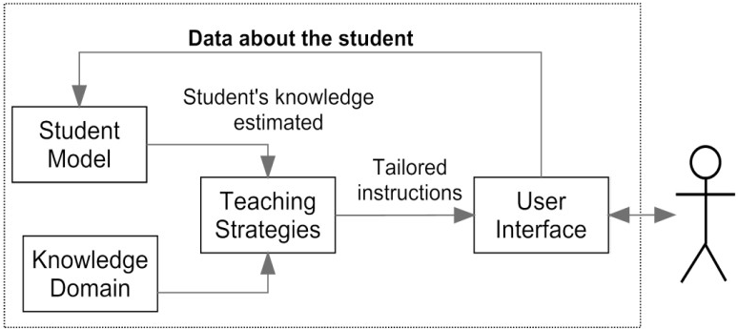
Figure 1: Architecture of an Intelligent Tutoring System.

  - KNOWLEDGE DOMAIN MODULE
In this section we will discuss the topics covered by this system:
- Introduction CCNA: In the introduction to the topic will be talking about networks in general and what are the topologies used in the network system and a simplified explanation on each subject, explaining the shapes and illustrate the types of networks and explain the OSI model.

- Internetworking Basics: explain Address type and network type in details.
- OSI Reference Model: explain all Layers and explain each protocol used, establishing a connection-oriented session and transmitting segments with flow control.

- Ethernet Networking: This part of the paper covers the latest Layer, detailed expansion of the MAC, how it works, and explanation of Ethernet Cabling. In another part, we talk about Wireless Networking and learn about Data Encapsulation.

- TCP: Here, TCP / IP is discussed and each layer is explained with a simple difference with the OSI Model.

- IP address: Explain the IP address and explain the types of classes recognized and learn Subnet Masks and Subnetting and identify the benefits and work to establish also and the importance of NAT in the world of networks and also determining IP Address Problems.

  - STUDENT MODULE
Each student can use this program through his or her own account, and log on to the system through the student's number to learn the lessons and solve the specific exercises in each lesson. Exercises for students in successive grades will be very easy.
If you fail the exercises you will return to the lesson again.
Each student will also have a final mark, when learning the lessons and solving the exercises.

  - TEACHING MODULE
This module as controller that controls operations in ITS, the student can answer questions if has good degree or more he can move to next level, but if he fails he back to exercises of the same level.
The degree of difficulty increases as the student moves from a lower level to a higher level and if the student obtains a higher degree than good.

  - USER INTERFACE
The user interface is divided into two sections for the teacher to add lessons, examples, exercises, modification and deletion, in addition to adding new users to the color adjustment and many settings. The student interface is the one through which lessons are reviewed, exercises are solved and the student's degree is determined. Here some of screenshots of teacher interface and student interface (as shown in figure 2-figure 9).

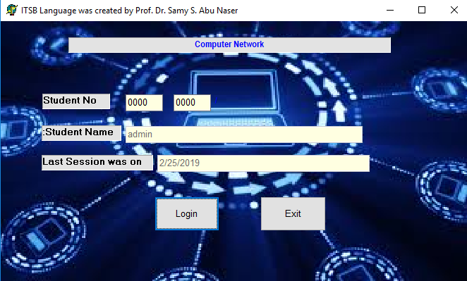
Figure 2: Student Login Form

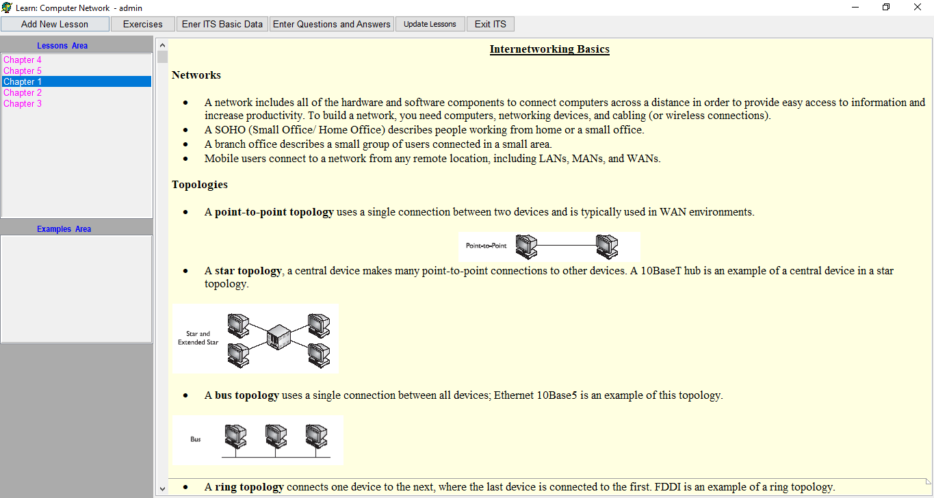
Figure 3: Student lessons and examples form.

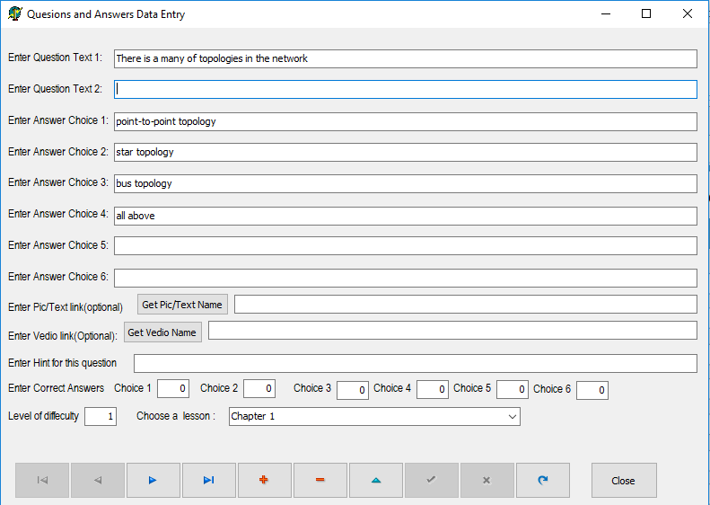
Figure 4: Interface for modifying Fonts of all screens of the system.

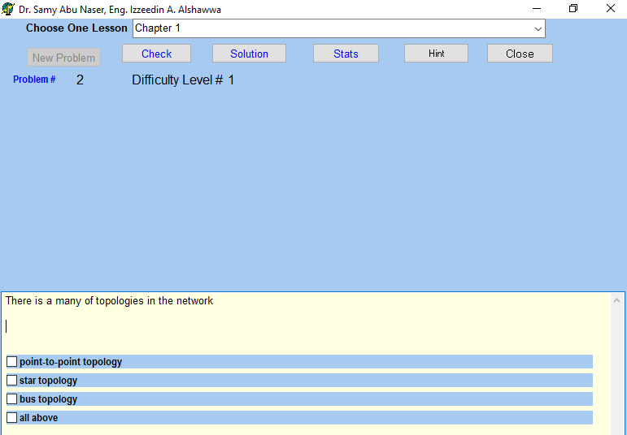
Figure 5: Student Exercises form.

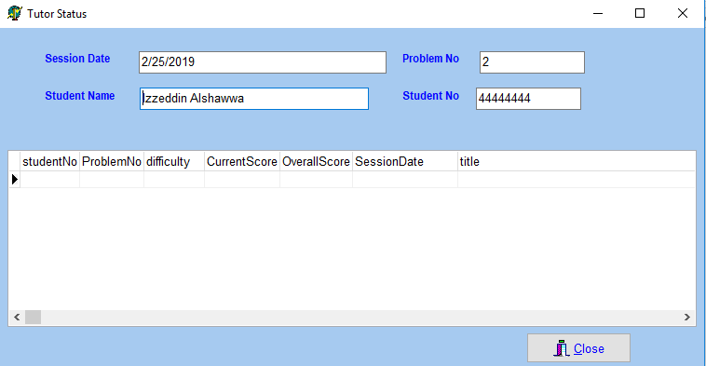
Figure 6: Student statistics form.
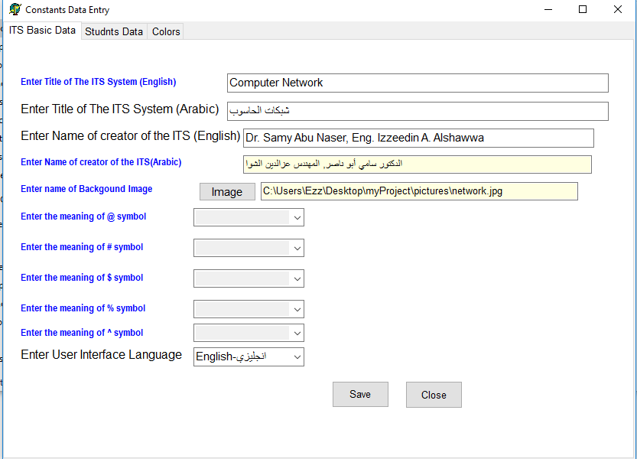
Figure 7: Form for adding ITS Basic Data.

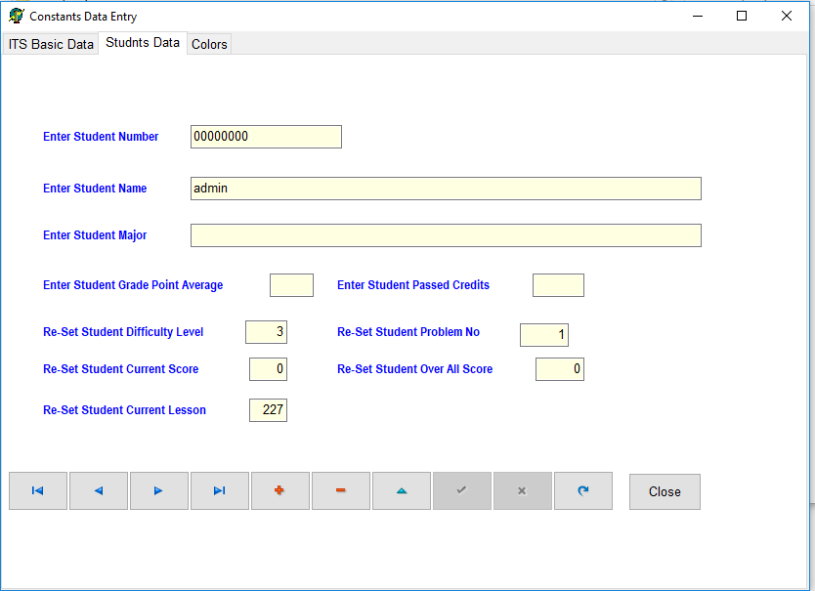
Figure 8: Form for adding Students Data.

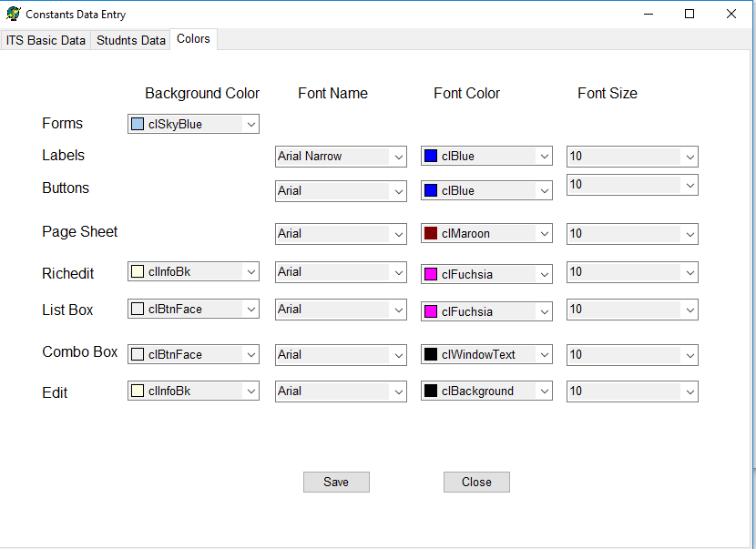
Figure 9: Form for adding questions and answers

Difficulties faced by technicians
The problem and the reasons that led to the work of this paper through the tutoring system, In the world of networks there are many technicians who have expertise but do not have the foundations and concepts of learning, In the sense that they have no solutions to new problems - non-routine - pass them. Hence the idea and application of the tutoring system in the world of networks is to consolidate the basic concepts of those with this domain.

GOAL
As mentioned above, the goal of this paper is to teach the students the concepts and basics in the world of networks through smooth education, test their abilities to learn at different stages and test user comprehension.

DEVELOPMENT ON THE SYSTEM
Detailed explanations were made by means of illustrative videos in a scientific way and linked with the scientific bases shown in the paper. It was found that the understanding and comprehension of the user is through teaching and teaching in any field,
Let's get out of the subject range a bit and illustrate by gaming, the user will not be proficient at the game of the toughest level when playing for the first time Start with levels gradually to master the game and then be able to overcome the advanced stages This has been applied in the system.

CONCLUSION
ITSs are seen as future's mentoring framework and many examinations fulfilled around there. When they are contrasted with customary classroom climate, ITSs are very effective and moderately having instructors' spot, they go up against supporting obligation for understudies. In customary showing condition, understudies' contrasts aren't considered. In this paper, we have designed intelligent tutoring system for student learning Java. The system was created for students who need to think about Java or increment their knowledge in this field easily. The evaluations of the system have been done by teachers and students.

REFERENCES:
- Networking Technologies, cisco network associate.
- CCNA INTRO Wendell Odom, CCIE No. 1624.
- Cisco Networking Academy Program: Engineering Journal and Workbook, Second Edition.
- CCNA, Official Exam Certification Library, Third Edition.
- Abu Ghali, M., Abu Ayyad, A., Abu-Naser, S., & Abu Laban, M. (2018). An Intelligent Tutoring System for Teaching English Grammar. International Journal of Academic Engineering Research (IJAER), 2(2), 1-6.
- Abu Hasanein, H. A., & Abu Naser, S. S. (2017). An intelligent tutoring system for cloud computing. International Journal of Academic Research and Development, 2(1), 76-80.
- Abu Naser, S. S. (2006). Intelligent tutoring system for teaching database to sophomore students in Gaza and its effect on their performance. Information Technology Journal, 5(5), 916-922.
- AbuEloun, N. N., & Abu Naser, S. S. (2017). Mathematics intelligent tutoring system. International Journal of Advanced Scientific Research, 2(1), 11-16.
- AbuEl-Reesh, J. Y., & Abu-Naser, S. S. (2018). An Intelligent Tutoring System for Learning Classical Cryptography Algorithms (CCAITS). International Journal of Academic and Applied Research (IJAAR), 2(2), 1-11.
- Abu-Naser, S., Ahmed, A., Al-Masri, N., Deeb, A., Moshtaha, E., & AbuLamdy, M. (2011). An intelligent tutoring system for learning java objects. International Journal of Artificial Intelligence and Applications (IJAIA), 2(2).
- Abu-Nasser, B. S., & Abu-Naser, S. S. (2018). Cognitive System for Helping Farmers in Diagnosing Watermelon Diseases. International Journal of Academic Information Systems Research (IJAISR), 2(7), 1-7.
- Akkila, A. E.-D. N., & Abu Naser, S. S. (2018). ITS-Tutor for Teaching Rules of Tajweed the Holy Quran. Al-Azhar University, Gaza, Palestine.
- Abu Naser, S. (2008). JEE-Tutor: An Intelligent Tutoring System for Java Expression Evaluation. Information Technology Journal, Scialert, 7(3), 528-532.
- Akkila, A. N., & Abu Naser, S. S. (2017). Teaching the right letter pronunciation in reciting the holy Quran using intelligent tutoring system. International Journal of Advanced Research and Development, 2(1), 64-68.
- Abu Naser, S. S., & Sulisel, O. (2000). The effect of using computer aided instruction on performance of 10th grade biology in Gaza. Journal of the College of Education, 4, 9-37.
- Akkila, A. N., & Abu-Naser, S. S. (2018). Rules of Tajweed the Holy Quran Intelligent Tutoring System. International Journal of Academic Pedagogical Research (IJAPR), 2(3), 7-20.
- Abu Naser, S., Sulisel, O., Alexandrescu, A., Anderson, J., Skwarecki, E., Anderson, J., . . . Brusilovsky, P. (2005). Growth and Maturity of Intelligent Tutoring Systems. Information Technology Journal, 7(7), 9-37.
- Al Rekhawi, H. A., & Abu Naser, S. (2018). An Intelligent Tutoring System for Learning Android Applications Ui Development. International Journal of Engineering and Information Systems (IJEAIS), 2(1), 1-14.
- Abu-Naser, S., Kashkash, K., Fayyad, M., Azaab, S., Riley, M., Williamson, M., . . . Maloy, O. (2005). Expert system methodologies and applications-a decade review from 1995 to 2004. Journal of Artificial Intelligence, 1(2), 9-26.
- Al Rekhawi, H. A., & Abu-Naser, S. S. (2018). Android Applications UI Development Intelligent Tutoring System. International Journal of Engineering and Information Systems (IJEAIS), 2(1), 1-14.
- Abu Naser, S., Al-Dahdooh, R., Mushtaha, A., & El-Naffar, M. (2010). Knowledge management in ESMDA: expert system for medical diagnostic assistance. AIML Journal, 10(1), 31-40.
- Al-Ani, I. A. R., Sidek, L. M., Desa, M. M., Basri, N. A., Burns, J., Bhutani, J., . . . Fashokun, A. (2007). Water pollution and its effects on human health in rural areas of Faisalabad. Journal of Environmental Science and Technology, 5(5), 1-17.
- Abu Naser, S., & Akkila, A. N. (2008). A Proposed Expert System for Skin Diseases Diagnosis. INSInet Publication. Journal of Applied Sciences Research, 4(12), 1682-1693.
- Alawar, M. W., & Abu Naser, S. S. (2017). CSS-Tutor: An intelligent tutoring system for CSS and HTML. International Journal of Academic Research and Development, 2(1), 94-98.
- Abu Naser, S., Ahmed, A., Al-Masri, N., & Abu Sultan, Y. (2011). Human Computer Interaction Design of the LP-ITS: Linear Programming Intelligent Tutoring Systems. International Journal of Artificial Intelligence & Applications (IJAIA), 2(3), 60-70.
- Al-Bastami, B. G., & Abu Naser, S. S. (2017). Design and Development of an Intelligent Tutoring System for C# Language. EUROPEAN ACADEMIC RESEARCH, 6(10), 8795.
- Abu Naser, S. (2008). An Agent Based Intelligent Tutoring System For Parameter Passing In Java Programming. Journal of Theoretical & Applied Information Technology, 4(7).
- Albatish, I., Mosa, M. J., & Abu-Naser, S. S. (2018). ARDUINO Tutor: An Intelligent Tutoring System for Training on ARDUINO. International Journal of Engineering and Information Systems (IJEAIS), 2(1), 236-245.
- Al-Bayed, M. H., & Abu Naser, S. S. (2017). An intelligent tutoring system for health problems related to addiction of video game playing. International Journal of Advanced Scientific Research, 2(1), 4-10.
- Al-Bayed, M. H., & Abu-Naser, S. S. (2018). Intelligent Multi-Language Plagiarism Detection System. International Journal of Academic Information Systems Research (IJAISR), 2(3), 19-34.
- Aldahdooh, R., & Abu Naser, S. S. (2017). Development and Evaluation of the Oracle Intelligent Tutoring System (OITS). EUROPEAN ACADEMIC RESEARCH, 6(10), 8711-8721.
- Alhabbash, M. I., Mahdi, A. O., & Abu Naser, S. S. (2016). An Intelligent Tutoring System for Teaching Grammar English Tenses. EUROPEAN ACADEMIC RESEARCH, 6(9), 7743-7757.
- Abu Naser, S. S. (2001). A comparative study between animated intelligent tutoring systems AITS and video-based intelligent tutoring systems VITS. Al-Aqsa Univ. J, 5(1), 72-96.
- Al-Hanjori, M. M., Shaath, M. Z., & Abu Naser, S. S. (2017). Learning computer networks using intelligent tutoring system. International Journal of Advanced Research and Development(2), 1.
- Abu Naser, S., Zaqout, I., Ghosh, M. A., Atallah, R., & Alajrami, E. (2015). Predicting Student Performance Using Artificial Neural Network: in the Faculty of Engineering and Information Technology. International Journal of Hybrid Information Technology, 8(2), 221-228.
- Almurshidi, S. H., & Abu Naser, S. S. (2017). Design and Development of Diabetes Intelligent Tutoring System. EUROPEAN ACADEMIC RESEARCH, 6(9), 8117-8128.
- Abu Naser, S., & El Haddad, I. (2016). An Expert System for Genital Problems in Infants. World Wide Journal of Multidisciplinary Research and Development (WWJMRD), 2(5).
- Almurshidi, S. H., & Abu Naser, S. S. (2017). Stomach disease intelligent tutoring system. International Journal of Advanced Research and Development, 2(1), 26-30.
- Al-Nakhal, M. A., & Abu Naser, S. S. (2017). Adaptive Intelligent Tutoring System for learning Computer Theory. EUROPEAN ACADEMIC RESEARCH, 6(10), 8770-8782.
- Atallah, R. R., & Abu Naser, S. S. (2014). Data mining techniques in higher education an empirical study for the university of Palestine. IJMER, 4(4), 48-52.
- Atallah, R. R., & Abu Naser, S. S. (2014). Transformation of E-kanban to BPEL Using Information Retrieval Method For Searching. IOSR Journal of Engineering (IOSRJEN), 4(11).
- Bakeer, H., & Abu Naser, S. S. (2017). Photo Copier Maintenance Expert System V. 01 Using SL5 Object Language. International Journal of Engineering and Information Systems (IJEAIS), 1(4), 116-124.
- Chen, R.-S., Tsai, C.-H., Abu-Naser, S., Bishop, A., Bishop, C., Arbaugh, J., . . . Trent, B. (2008). Evaluating structural equation models with unobservable variables and measurement error. Information Technology Journal, 10(2), 1055-1060.
- El Agha, M. I., Jarghon, A. M., & Abu-Naser, S. S. (2018). SQL Tutor for Novice Students. International Journal of Academic Information Systems Research (IJAISR), 2(2), 1-7.
- El Haddad, I. A., & Abu Naser, S. S. (2017). ADO-Tutor: Intelligent Tutoring System for leaning ADO. NET. EUROPEAN ACADEMIC RESEARCH, 6(10), 8810-8821.
- Elnajjar, A. E. A., & Abu Naser, S. S. (2017). DES-Tutor: An Intelligent Tutoring System for Teaching DES Information Security Algorithm. International Journal of Advanced Research and Development, 2(1), 69-73.
- Hamed, M. A., & Abu Naser, S. S. (2017). An intelligent tutoring system for teaching the 7 characteristics for living things. International Journal of Advanced Research and Development, 2(1), 31-45.
- Hamed, M. A., Abu-Naser, S. S., & Abualhin, K. S. (2018). Intelligent Tutoring System Effectiveness for Water Knowledge and Awareness. International Journal of Academic Information Systems Research (IJAISR), 2(4), 18-34.
- Hasanein, H. A. A., & Abu-Naser, S. S. (2018). Developing Education in Israa University Using Intelligent Tutoring System. International Journal of Academic Pedagogical Research (IJAPR), 2(5), 1-16.
- Hilles, M. M., & Abu Naser, S. S. (2017). Knowledge-based Intelligent Tutoring System for Teaching Mongo Database. EUROPEAN ACADEMIC RESEARCH, 6(10), 8783-8794.
- Khella, R. A., & Abu-Naser, S. S. (2018). An Intelligent Tutoring System for Teaching French. International Journal of Academic Multidisciplinary Research (IJAMR), 2(2), 9-13.
- Li, D., Ghosh, M. M. A., Atallah, R. R., & Naser, S. S. A. (2016). A Novel Distributed Index Method for Cloud Computing. Issues(360).
- Li, L., Chen, N., He, C., Lang, F., Li, H., Wang, H., . . . Gong, P. (2011). Hybrid Quantum-inspired genetic algorithm for extracting association rule in data mining. Information Technology Journal, 12(4), 1437-1441.
- Mahdi, A. O., Alhabbash, M. I., & Abu Naser, S. S. (2016). An intelligent tutoring system for teaching advanced topics in information security. World Wide Journal of Multidisciplinary Research and Development, 2(12), 1-9.
- Abu Naser, S. S., Baker, J., Cruz, I., Liotta, G., Tamassia, R., Cooper, M., . . . Feldman, M. (2006). Information Visualization. Information Technology Journal, 7(2), pp: 403-404.
- Marouf, A., Yousef, M. K. A., Mukhaimer, M. N., & Abu-Naser, S. S. (2018). AnIntelligent Tutoring System for Learning Introduction to Computer Science. International Journal of Academic Multidisciplinary Research (IJAMR), 2(2), 1-8.
- Abu Naser, S. S., Atallah, R. R., & Hamo, S. (2015). Building an Ontology in Educational Domain Case Study for the University of Palestine. International Journal of Research in Engineering and Science (IJRES), 3(1), 15-21.
- Mosa, M. J., Albatish, I., & Abu-Naser, S. S. (2018). ASP. NET-Tutor: Intelligent Tutoring System for leaning ASP. NET. International Journal of Academic Pedagogical Research (IJAPR), 2(2), 1-8.
- Abu Naser, S. S., Anderson, J., Corbett, A., Koedinger, K., Pelletier, R., Beal, C., . . . Soh, L. (2005). Adaptation of Problem Presentation and Feedback in an Intelligent Mathematics Tutor. Information Technology Journal, 5(5), 167-207.
- Naser, S. (2009). Evaluating the effectiveness of the CPP-Tutor an intelligent tutoring system for students learning to program in C++. Journal of Applied Sciences Research, 5(1), 109-114.
- Naser, S. S. A. (2016). ITSB: An Intelligent Tutoring System Authoring Tool. Journal of Scientific and Engineering Research, 3(5), 63-71.
- Abu Naser, S. S. (2012). A Qualitative Study of LP-ITS: Linear Programming Intelligent Tutoring System. International Journal of Computer Science & Information Technology, 4(1), 209.
- Ng, S., Wong, C., Lee, T., Lee, F., Abu-Naser, S., El-Hissi, H., . . . James, A. (2010). Ad hoc networks based on rough set distance learning method. Information Technology Journal, 10(9), 239-251.
- Abu Naser, S. S. (2008). Developing visualization tool for teaching AI searching algorithms. Information Technology Journal, Scialert, 7(2), 350-355.
- Owaied, H. H., Abu-Ara, M. M., Qasem, M. M., Fahmy, H., Douligeris, C., Aha, D., . . . Dillon, T. (2009). Using rules to support case-based reasoning for harmonizing melodies. Journal of Applied Sciences, 11(14), pp: 31-41.
- Abu Naser, S. S. (2008). Developing an intelligent tutoring system for students learning to program in C++. Information Technology Journal, 7(7), 1055-1060.
- Qwaider, S. R., & Abu-Naser, S. S. (2018). Excel Intelligent Tutoring System. International Journal of Academic Information Systems Research (IJAISR), 2(2), 8-18.
- Abu Naser, S. S. (2012). Predicting learners performance using artificial neural networks in linear programming intelligent tutoring system. International Journal of Artificial Intelligence & Applications, 3(2), 65.
- Bakeer, H. M. S, & Abu-Naser, S. S. (2019). An Intelligent Tutoring System for Learning TOEFL. International Journal of Academic Pedagogical Research (IJAPR), 2 (12), 9-15.
- Al-Shawwa, M. , Alshawwa I. A., & Abu-Naser, S. S. (2019). An Intelligent Tutoring System for Learning Java. International Journal of Academic Information Systems Research (IJAISR), 3(1), 1-6.

