The Fallacies of Scientific Paradigms
Tathagata Dey ^{a,c*} , Shreyans Chatterjee ^{b,c}
ª Computer Science Department, Government College of Engineering and Textile Technology, Serampore-712201, India
^{b}Microbiology Department, St. Xavier’s College, Kolkata-700016, India
^{c} Centre for Interdisciplinary Research and Education, Kolkata-700068, India
Corresponding Author E-mail: tathagata2403@gmail.com

Abstract
The world of physical sciences and mathematics have been dealing with universal phenomena for a long time. Over centuries, many theories and hypotheses have been formed to explain each of the observed and explainable natural events. All though the truth beyond this is still uncertain. With, upcoming experimental and observed results, the theories get changed over time for multiple turns. Also, the complexity of these theories is another significant aspect. All the theories vary from each other in structure, work of action, notion and expression. This suggests about the heterogeneity of universal events. But is it necessary for nature to act according to so many different principles in different occasions? Indeed, this disturbs the notion of simplicity. We try to discuss this perspective in the following article.

Keywords: Philosophy; Science; Physics; Mathematics; Heterogenicity; Simplicity; Causation; Constants;

Introduction
S
cience has been one of the most powerful tools of mankind to deal with the phenomena of nature and universe. While ancient culture of knowledge and technology was prevalent even in prehistoric times, the evolution of so called ‘science’ began from 12th or 13th century leading to an era of modern science to emerge from 19th century onwards.
One of the significant discoveries in the history of science that changed the path of science afterwards was Newton’s Theory of Gravitation [1]. This theory tells us that gravitational force is a special kind of force that attracts two masses towards each other which is in turn proportional with the product of the masses of the two objects and inversely proportional to the square of distance between them.
$$F_{g}=G∙\frac{M_{1}M_{2}}{r^{2}}$$
Here G is the gravitational constant, $G=6.674×{10}^{-11} m^{3}Kg^{-1}s^{-2}$.
Now a notion may arise here why G is equal to this value? Why not some other? Experimentally this was discovered by Philosopher and Scientist H. Cavendish back in 1797-1798 [2]. But we can form this argument as why did Nature and the universe acted the gravitational force only ‘G’ times of the variables. Science has always been recognised as it’s bold and curious questions through ‘How’ and ‘Why”. But in regard to constant values there is no answer to the question ‘Why’ or ‘How’.
On the other hand, another such significant constant value in the course of science has been lying with the constant of Max Planck [3], which very efficiently provides a link between subatomic world and large mass objects. But the question here is that why we need this hardcoded value here. So again, we fail to justify the preference or efficiency of having this constant value over others.
There are very discrete set of theories we formed to explain the natural incidents. They all have very different applicative cases and conditions. Conditional statements in our scientific theories create sperate permuted cases to consider from the large pool of theories. This also signifies about the notion of heterogeneity of scientific paradigms. Let us talk about this in the next section broadly.

Heterogeneity of Scientific Paradigms
Our discussion begins with the famous article published back in June 30, 1905, named as ‘Zur Elektrodynamik bewegter Korper’, which in turn means, ‘On the Electrodynamics of Moving Bodies’ [4]. This is the famous article of Sir Albert Einstein which introduced the world to the Special Theory of Relativity. He starts the article talking about the similarities between two incidents, moving a coil towards a magnet and moving a magnet towards a coil. In both of the cases, the relative velocity between them generates the same amount of current in the same direction. Although the underlying concept is quite different.
“For if the magnet is in motion and the conductor at rest, there arises in the neighbourhood of the magnet an electric field with a certain definite energy, producing a current at the places where parts of the conductor are situated. But if the magnet is stationary and the conductor in motion, no electric field arises in the neighbourhood of the magnet. In the conductor, however, we find an electromotive force, to which in itself there is no corresponding energy, but which gives rise—assuming equality of relative motion in the two cases discussed—to electric currents of the same path and intensity as those produced by the electric forces in the former case.”
We may start our argument here in the reverse order. Two different observable phenomena with similar relative perspective and similar effect is driven by two different causes. So, our theories deal with separate classes of cause-effect relation. This can be depicted as in figure 1.
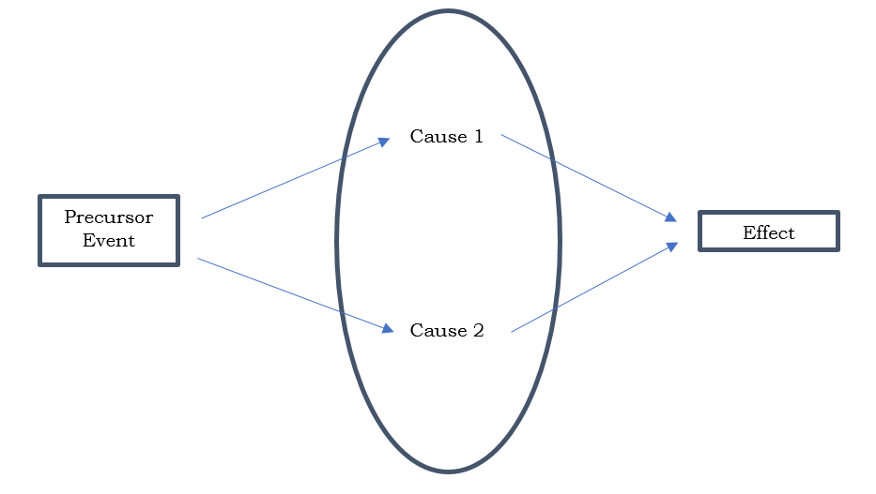
Figure 1: Cause-Effect Relation of Scientific Theories

It is very certain that, once the universe is not homogenous in causation, i.e., there are more than one simultaneous cause for the same effect, then there can be even more causes than two. This in turn infers that either our principles of Deductive Science [5] are valid only unidirectional or there should be a unified theory.
Here comes the role of the importance of conditional statements in our theories. A same precursor event, “presence of non-zero relative velocity between coil and magnet” can be further questioned as which one was particularly in motion. But we know that the velocities can be measured only relative to another frame of reference.
Suppose we conduct an experiment, where a coil and a magnet are placed in space where all the gravitational fields of surrounding objects cancel each other, i.e. having zero gravitational field intensity. Now we make one of them (say the coil) move towards the other (Say the magnet). Then we measure the whole observation from two different points. First, from an object moving with same velocity parallelly to the tool in motion (moving parallelly the coil with same velocity) and second observation is taken from an object at rest w.r.t. the other tool (at rest w.r.t. the magnet). The observations for the cause behind the generation of electricity in the coil, from these two points are different, as for the first one, the magnet is in motion and for the second one, the coil. We see two different cases of the conditional statement and hereby satisfying the two different causes.
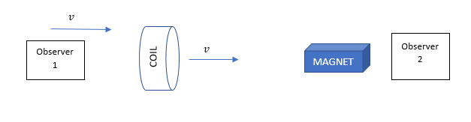
Figure 2: Different Causes of Same Event
Here, the Observer 1, sees that the magnet is moving towards the coil with velocity v, hence an electric current is generated in the coil. In pursuit of curiosity the observer 1 deduces that, due to the motion of the magnet an electric field with definite energy is generated around the coil leading to the generation of current electricity.
While the Observer 2, sees that the coil moves towards the magnet and a current is generated in the coil. Observer 2, decides the cause to be the emf generated in the coil as a result of motion through magnetic field.
We see that, a same event occurring at a definite time, i.e. expressible by definite space-time coordinates with respect to any particular frame, can have different causes with respect to observations of different space-time coordinates.
So, the inference from this can be drawn as,
“An exact same event in universe, expressible through definite space-time co-ordinates, when observed from different frames of references, can conclude to completely distinct and different causation principles when deduced from scientific theories and this happens due to the heterogeneity of scientific paradigms”.
This creates the Causation-Correlation Fallacy. A particular explanation has certainly a causation relation with the effect. While if we pick a random explanation, the effect has only a correlation with the explanation. So, once we change our position, the cause of an effect changes for us. So, if this heterogeneity holds true, one cannot be certain about the cause unless the whole set of possible coordinates are observed. In simple words, the truth of a theory is not absolute. It depends on the frame of reference of our observation. Hence, we cannot be certain about truth of a theory unless we observe all the possible frames or conclude a Theory of Everything.

Notion of Simplicity and Incommensurability
Scholastic philosopher William Ockham stated the famous ‘Ockham’s Razor’ or ‘Principle of Parsimony’, [6] which states that,
“Plurality should not be posited without necessity.”
Which means, “Out of two competing theories, the simple one should be preferred”. But an ambiguity here lies with what exactly is meant by theoretical simplicity?
In ‘The Structure of Scientific Revolutions’, Thomas Kuhn [7] told that scientific paradigms are ‘incommensurable’, i.e. they lack common measure to evaluate different theories. This also goes hand in hand with the heterogeneity argument and hence generates a fallacy. A very simple fundamental question can be raised as what was the need of differentiating this universe in so many conditional partitions and henceforth validating different concepts in different cases. This indeed makes the universe a complicated one and contradicts the notion of simplicity. Questions should be asked here as ‘Does the universe really work so?’ or ‘Why did nature combined so many different theories in different contexts to make this universe?’, ‘What was the need of creating these many concepts?’. These questions are indeed very general and challenges the Ladder of Science. We form different theories, test them to verify. Again, a new dataset is collected, which if can’t be explained fully, initiates generation another set of principles based on the previous one. This keeps the ladder of theories to go on. But not necessarily a theory which explains a dataset need to be the actual cause, as genuine intuition certainly questions about the complexity of universe.
“We understand the distinct theories to explain the natural phenomena of different events, but how many of them does nature understand?”
So, there shouldn’t be different theories based upon, size, radiation, motion, force and have theories in different combination of these properties.
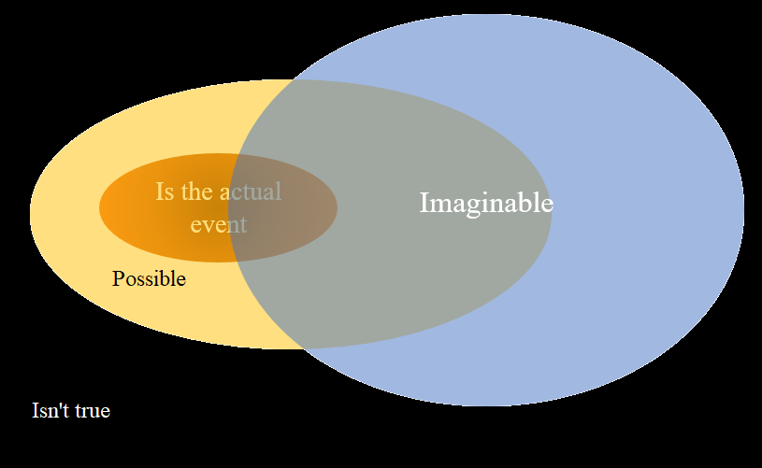
Figure 3:Role of Scientific Theories
This above figure concept is adapted from the lectures of Chris Impey, Professor of Astronomy. With this too much of theories with conditional implications and assumptions, there can be a strong indication that we are steadily leading towards the set of, ( $Imaginable \bigcup{Possible} \bigcup{\overline{is the actual event}}$ ).

Constants
Constants play the most vital roles in the theories of our physical world. The expressions of physics are regulated by these fixed and hardcoded values. Starting from the general theory of relativity which determines the motion of massive objects in the cosmos to ending with the quantum mechanics which describes the motion of the atomic world uses constants for their functions. A significant question may arise here as why those hardcoded values are so what we think? For example, why the gravitational force active between two distinct bodies of mass 1 kg, separated by a distance of 1 m, in a field of zero gravitational intensity is $6.674×{10}^{-11} N$? Why isn’t it some other value or other constant? And very evidently scientific theories fail to answer as why this particular case force value is so. There cannot be sufficient evidence to call e variable as universal constant until it is experimentally verified in the Universe. But the fact is we live in a place which is ${10}^{-21}$ times of the universe and we reached around ${10}^{-15}$ times region of the universe as of 1st February, 2020. Indeed, we explored very less region to define some term as ‘universal’. There can be sufficient argument that the constants are functions of space-time and some other descriptors and the region our experiments are confined in, are sufficiently small enough to show a change in the value.
So, hypothesis may be formed as what if the constants are not absolute constants. What we perceive as a constant in our four-dimensional world may be the projection of a function in some higher dimensions which we being four dimensional objects cannot feel at all. That is, if we consider a constant as a projection of constant value of some higher dimensional function then perception about the world may change.
In terms of simple mathematics, we can write it as
$<e_{α}|f> =k$, where $α$ is {0,1,2,3}
Here f is the higher dimensional function and e_{α} the four-dimensional basis vectors. The inner product of them leads a constant which we perceive in our world. The constant (k) is the component off in our four-dimensional world which is a constant in both the temporal and the spatial coordinates. And the angle (β) that f forms with our 4-dimensional coordinates is
$$\cos{β}=\sqrt{\frac{<e_{α} \left| f> <f \right| e_{α}>}{< e_{α} \left| e_{α}> <f \right| f>}}$$

It means that constants must be expressed as a form of function. In which we regard as,
$$c=f(x,y,z,t,S)$$
Where x, y, z, t are space-time coordinates and S is described as ‘state of nature’. So, we can conclude a new set of rules to deal with constants taking into account their origin which is in the higher dimensions.

Conclusion
In this article we tried to form arguments which contradicts with traditional scientific paradigms. Deducing various arguments, we see how different scientific theories create a fallacy of causation principle and henceforth making the absoluteness of truth invalid. This infers that we cannot be certain about a theory being true as cause is dependent upon observation. Therefore, we come to talk about incommensurability of those paradigms. As a conclusive remark, it is evident to say that, the universe may not work with such conditional cases and making different theories applicable to different cases. It is indicative that we may have formed a more complex system than nature did. This can be the result of misleading interpretation of natural phenomena. Through this approach a significant intuition can be formed which indulges our scientific paradigms to change the way it looks upon nature.

Acknowledgement
We acknowledge the assistance of Mr. Rupak Majumder and Ms. Rani Chatterjee in reviewing the paper.

Conflict of Interest
Authors declare no conflict of interest.
Funding
This research did not receive any funding from any organisation.

References
- Newton, I., 1999. The Principia: mathematical principles of natural philosophy. Univ of California Press.
- Bryson, B. (2003), "The Size of the Earth": A Short History of Nearly Everything, 59–62.
- Prof. Max Planck, For. Mem.R.S.. Nature 141, 720 (1938). https://doi.org/10.1038/141720a0
- Einstein, A., 1905. On the electrodynamics of moving bodies. Annalen der physik, 17(10), pp.891-921.
- Stadler, F., Induction and Deduction in the Philosophy of Science: A Critical Account since the Methodenstreit, Vienna Circle Institute Yearbook book series (VCIY, volume 11), https://doi.org/10.1007/978-1-4020-2196-1_1
- Duignan, B., Occam’s Razor, Encyclopaedia Britannica, https://www.britannica.com/topic/Occams-razor
- Kuhn, T.S., 2012. The structure of scientific revolutions. University of Chicago press.

