Collaborative Research Methodologies: A Quest for Better Engagement and Results Oriented Findings Within the Institutions of Higher Learning
Colby Hetherwick Kumwenda, PhD
Email: myhope164@gmail.com
Mobile: +265 (0) 0992 542 094
University of Livingstonia,
Department of Humanities and Social Sciences
Kaning’ina Campus, P.O. Box 112, MZUZU, MALAWI

ABSTRACT
The expression ‘a university without research is a dignified high school’ is becoming a both local and global concern in the academia. The purpose of this paper is to assess the extent to which collaborative research methodologies can enhance integration of faculties of arts and humanities in the universities in Malawi for knowledge development and transfer. It has been argued over and over that universities are spotlighted by their outstanding work in research, developing and sharing ideas, new inventions and creativity within the spectrum of partnership development. While striving for partnership through collaborative research approaches, research activities still remain an area of concern in institutions that offer diverse tertiary education in Malawi. The question of how can these institutions or faculties engage each other in collaborative research methodologies in the quest of knowledge development and transfer remains crucial and relevant
The study analyzed strengths, weaknesses, threats and opportunities of the existing research methods in Arts and Humanities and how the two disciplines can create a space for amalgamation so that research findings can benefit both disciplines. The study reveals that collaboration in various disciplines is a challenge owing to variations of conceptual analyses and the deficiency of technical no-how of both teaching staff and students as well as tools for data collection and analysis as may be emphasized in each of the areas of study; Arts and Humanities. Furthermore, while other institutions of higher learning have research ethics committees for checks and balances as a collaborative tool, some institutions do not know that this committee plays a crucial role in the field of research. Within this backdrop, there is need to develop research collaborations within an institution or with other institutions of higher learning that have a well-defined research profile for mutual benefits as far as collaborative research methodologies are concerned.

Keywords: academia, collaborative, innovative, institution, methodology, research, universities

- INTRODUCTION
Malawi is slowly shifting contours from Agri-based country to a research innovative country in the process of satisfying Sustainable Development Goals (SDGs). Even though this is a commendable stride to go by, there are a number of challenges that the research industry is facing. These problems, to a larger extent, are generated by both students and lecturers alike. Students graduate from different institutions of higher learning with little knowledge on how research in different faculties and disciplines can conducted. Little do they know about the impact in doing research in a corporative sense so that the nation should benefit from their expertise.
As a matter of fact, institutions of higher learning are in existence to generate new knowledge for innovation, creativity and broadening the horizon of critical thinking. These new innovations come as a result of research activities done in a collaborative way. We need, in the first place, to look at the meaning of collaborative research in which a good number of people look at it ‘research done in partnership.’ Even though the definition of collaborative research is generalized, it makes sense even in the sphere where contextualization of terms is preferred.
Researchers, by all means, require certain skills, principles and practices to avoid compromising with the standards that subsequently affect research outcomes. The challenges with this demand are that to acquire these skills mean paying attention to research details so that desired outcomes are achieved in the end. How to achieve these desired outcomes is a thesis of this reflection as far as collaboration in research is concerned.
Malawi, is flooded with a number of private and public universities offering different diplomas, degrees, masters and doctorates. These institutions try to develop new ideas through research and publications (Mwanalushi, 1995). Researchers have a role in informing people with new knowledge and discoveries that will enable them to have a well-informed knowledge that can address existential challenges. Needless to say, in this regard, that very little has been done where research is done in a jointed form so that an issue is addressed collaboratively. This study therefore looks at the efficacy of doing a collaborative research mainly from Arts and humanities tapestries. Considerable strides have been taken from the study justification, conceptualization, research design & methodology, findings & discussions of results and finally, conclusions & recommendations.
1.1 Study Justification
This study is helpful and useful to scholars in institutions of higher learning in Malawi (and of course beyond) to re-examine, review and evaluate their syllabi and curricula in Arts and Humanities for their relevance, demand driven and suitably within the spectrum of contemporary research challenges and opportunities. It can also spell out gaps and shortfalls of doing research collaboratively. Students that are just joining higher education will find the study relevant and the subject matter will act as an eye opener in exploring new ideas and innovations. Research is not only for the publications but also community awareness about what is going on within the current domain. Furthermore, the study brings together diverse literature for knowledge gain, retention and dissemination. Last by no means least, the study in collaborative research will give institutions of higher a new window to see research issues differently using locally available resources.

1.2 Conceptualized Context of the Study
This study addresses Malawi’s challenges regarding collaborative research approaches. These challenges, to some extent, have contributed to the poor ranking of Malawian universities within Southern Africa Development Community (SADC) countries and beyond. For example, counties like Tanzania, Zambia and South Africa are rated very well in this regional block.
Universities take good positions in their rankings due to a number of factors and benchmarks. One of the benchmarks that make a university to rank well on local and global scene is the nature of research work that the university is carrying out by both students and lecturers. In Malawi, for instance, the University of Malawi (Chanco or College of Medicine) has done a massive research but it does not own results because funders demand copyright ownership of the results; hence, university of Malawi cannot be accredited for such results. For it to be accredited, it needs to partner with another acclaimed university.
Collaborative research assumes that the need to do research activities in a participatory way gives weight and authenticity to the field of study. It also gives confidence in those doing the research thereby safeguarding their institution against poor ranking which later risks a university from attracting credible students and lecturers. Also, collaboration in research is a recipe for quality assurance which gives university a stamina to remain on top of the ranking. These fundamental skills and values do not apply only is ordinary learning but also in critical research writing and data interpretation for better results in the process.
- RESEARCH DESIGN AND APPROACH
The study used qualitative and quantitative approaches within the social-cultural rubric (Cosby, P.C. & Bates, S.C., 2012; Longwe, H., 2018; Kombo, D.K. & Tromp, D.L., 2006). It also used a mini-questionnaire to solicit views from 10 students and 10 lecturers from various institutions and degree programs from various universities in Malawi. Furthermore, views pertaining to collaborative research were sourced from students and lecturers in order to identify the gaps that will later become the basis for decision making.
And finally, the study conducted a research survey on 5 universities in order to find out if collaboration, dissemination and publications are done in attempt to promote research in Arts and Humanities.
- STUDY FINDINGS AND DISCUSSION OF RESULTS
3.1 Involvement of Students in Collaborative Research, Publications and Dissemination
This study analyzed the participation of students, lecturers and institutions of higher learning in a practical sense in order to establish the strengths and weaknesses of collaboration in research. It also responded to the students’ and lecturers’ engagement in collaboration, research and publication.

Table 1: Responses from informants
Participation | Sample Size | Respondents | Variability Test | % in Feedback
Students | 20 | 10 | Research engagement | 50
Lecturers | 15 | 7 | Publication | 46.7
institutions | 5 | 3 | Collaboration in research and dissemination | 60

The table 1 above shows the level of responses from the informants in the study. 10 out of 20 randomly selected students responded that they had basic knowledge of collaborative research methodologies and the benefits of doing it that way. However, the remaining 10 were not sure if their lecturers are conversant with these approaches because they usually learn from their friends from other institutions of higher learning. The other 15 were not sure if language and fine art can together in the sense that the two have different theoretical grounds. More interesting than this was that the literature they are using downloaded from Google Scholar and had no name tag of their lecturers who are busy teaching research methods. Two or three lecturers managed to co-author some articles which had insignificant contribution.
Despite the fact that 7 lecturers (46.7%) responded to the survey conducted, publications in peer reviewed and acclaimed journals show little of their contributions and that most of them have never attended international conferences that discuss working together in the field of arts and humanities. Lack of this exposure, among other things, is attributed to lecturers’ unwilling to participate in these conferences. Some lecturers, to some extent, have no time to do research on their own and unwillingness to partner with other lecturers from other institutions.
A survey conducted in the same line of discovery has shown that 2 institutions out of 3 have no policy documents that talk of research dissemination. One out of three institutions have not research committees that can help in spearheading the process of doing research within faculties of the same institution without necessarily engaging other institutions. In other instances, it was discovered that research in collaborative way whether locally or internationally. It was further observed that some institutions of higher learning had no research centers to conduct public debates and conferences.
3.2 Lecturer-Student and public Opinion about Collaborative Research
Lecturer, student and public opinion on collaborative research are interwoven. Phiri asserts that “theories are developed to formulate a model that can subsequently provide an explanation and understanding of a phenomenon in practice” (Phiri, 2018). The role of the lecturers is that students are grounded into these theories for general knowledge consumption so that they become relevant in the society where they practice that from of research. This entails that collaboration becomes a lecturer’s assignment to students and even to their fellow lectures. For instance, while the interest of doing research is to find out the content of music (art), there is need to find out the implication to the user or dancer (humanity). This therefor means that the two (music and the dancer) go together to complement each other. Artists or musicians sing because their customers are the dancers.
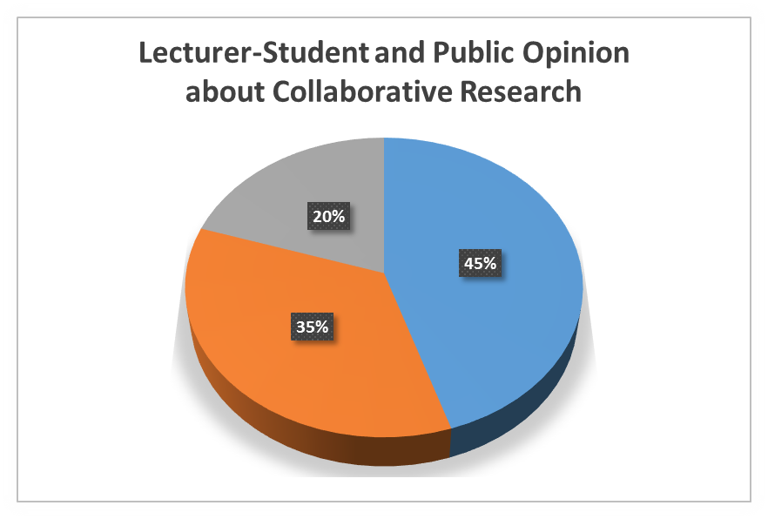
Fig. 1 Lecturer-Student and Public Opinion about Collaborative Research
In collaborative research, as indicated in Fig.1 above, there is need to understand a theory (45%). Technical knowhow (35%) and beneficiaries (20%). The three complement each other. Like a singer in Music studies, there is a direct coloration between a theory to be used, a lecturer as a technocrat and a student as a beneficiary in the triadic chain of knowledge transfer and sharing. Further to this, there must be an element of collaboration between a student and a lecturer for effective results. The pie chart above shows that 45 percent of the theoretical work was a contribution made by lecturers to students. Equally the 35 percent was knowledge deliverable to students by the same lecturers. The 20 percent is a representation of the benefits and proceeds from the research conducted. In most cases though, translatability of knowledge to a realistic outlook on the ground becomes an interesting exposure in collaborative research. This is as a result of research activities conducted elsewhere than the very lectures doing the empirical research which addresses existential realities in their own setting.

3.3 Knowledge of Collaborative Research Technicalities to Conduct Research
The random survey conducted revealed that some students and lectures lacked the basic knowledge of doing research in a collaborative way more especially when it involved results integration into an itemized outcome. This form of disjointedness made participation, to some extent, a non-starter. On the other hand, some students appreciated that the collaborative approach to research was a good model because it brings results together which simplify the action to be taken. Thus, one student argued that “doing a joint research and in form of collaboration works better than doing it independently because it makes results much reliable and dependable than a single approach.”
The study further noted that much collaboration has some benefits, lecturers were still of the view that in some instances, collaboration benefits those that play the role as lead researcher. 7 out of the 15 lecturers interviewed at random from various institutions of higher learning in Malawi, are of the view that collaboration in research is a way to go is research in Arts and Humanities should make sense out of it. Further than that, the study has also revealed that a majority of lecturers have problems of coming up with a collaborative mechanism when carrying out research in jointed way. Some lecturers have consultancy skills but can hardly work in unison with others on reasons explained above. From the survey conducted, some lecturers have potential and will to collaborate with other researchers but resources, to some extent, become a challenge. However, as Phiri ably argues, “there is a potential to rejuvenate the situation by prioritizing or enhancing partnerships with other institutions” (Phiri, 2018).
4. CONCLUSIONS AND SUGGESTED RECOMMENDATIONS
4.1Conclusions
The study has shown that collaboration in research approach as a tool is becoming an important and effective way of doing research across the faculties of Arts and Humanities. Universities (in all divides) are in existence to provide knowledge and awareness for the new innovation, creativity and dynamisms in an attempt to create a platform of working together for consolidated outcomes for a much better results that could not have been realized if done singly. Therefore, universities should encourage a team working spirit both by students and lectures particularly when issues are to do with community as beneficiaries and target groups.
The study has also shown that arts and humanities are inseparable faculties of disciplines. The things which we call them Arts (like arts, dance, music…) are influenced in one way or the other; by the things we label them Humanities (folklore, history, literature, philosophy…). There is that connection and overlap of the two.
Academically, collaboration in research creates a platform for equal partnership between two academic faculties including faculty members as they try to share notes and bring consolidated results. Academicians together with students are citadel of new innovations that can bring a new face in research dissemination and knowledge sharing.
Finally, inter and intra collaborations in Arts and Humanities, more especially those institutions with good research history, promote equal distribution of financial and human resources. Equally, skills development is enhanced. Against this backdrop, there is need to create a better engagement in order to have results that truly reflect the findings of the study within the institutions of higher learning.

4.2 Recommendations
Some of the recommendations from the research include, but not limited to:
- In order to make collaboration in Arts and Humanities work, researchers should not just come together from one institution, but rather, from various institutions so that knowledge sharing is enhanced. They should not just meet but publish their findings as well.
- There is need to have a deliberate research policy that researchers from two or three different universities within Arts and Humanities may work independently but jointly produce a research document that can help all the three institutions
- Tangible collaboration can mean engaging one researcher to contribute to a project while at the same time, the researcher learns new ideas pertaining to the findings. This form of collaboration paves way for contact and dialogue which is a necessary tool in collaboration.
- Looking at an interdisciplinary project where arts and humanities’ students and or lecturers get involved in a problem from different angles but are willing to have at least same or similar results for comparative analysis more especially where collaboration has to do with knowledge transfer of realistic results rather than methodology.
- Collaboration in research should be carefully handled for fear of losing the essence of doing research more especially when there is no clear demarcation between collaboration and agreement. Ideally, there is need to do a thorough homework between researchers and institutions to spell out whether the interaction will lead into an admirable collaboration.

Reference
Cosby, P.C. and Bates, S.C. (2012). Methods in Behavioral Research (11th edn.). New Yolk:
McGraw Hill.
Vyhmeister, N.J. (2008). Your Guide to Writing Quality Research Papers for Students of
Religion and Theology (2nd edn.). Grand Rapids, MI.: Zondervan, 2008.
Kashoki, M.E. (1978). “Indigenous Scholarship in African Universities: The Human Factor.”
A paper presented at the conference ‘Indigenous Anthropology in Non-Western Countries,’ Burg Warternstein Conference Center, Austria, July 15-24.
Kombo, D.K. and Tromp, D.L. (2006). Proposal and Thesis Writing: An introduction. Nairobi:
Pauline Publications.
Longwe, H. (2016). A guide to Academic Research Writing in Theology and Religious Studies.
(Mzuni Texts No. 4) Mzuzu: Mzuni Press.
Msiska, Fred G.W. and Chulu, B. (2006). “Curriculum Reform and Quality Higher Education
in the University of Malawi. A study of the Current State of Affairs,” Zomba, Malawi: Chancellor College, University of Malawi.
Mwanalushi, M. (1995). The Role of the University in National Development: University and
Society. Ndola, Zambia: Mission Press.
Paul Hamlyn Foundation. (1993). National Commission on Education Report: Learning to
Succeed: A Radical Look at Education Today and a Strategy for the Future. London: Willian Heinemann Limited.
Phiri, G. A. (2018). “Research in Private Universities in Malawi: An issue of Academic and
Public Concern”. Nkopola, Mangochi: Malawi’s First International Conference on Higher Education.

