Country-Specific Health Research Paper- Dental Health of Bangladesh
A survey on dental problems and awareness on dental health among Bangladeshi people

By

Md. Majidul Haque Bhuiyan
North South University
Majidul.haque@northsouth.edu

Table of Contents
Page no.
- Geographic Identifiers _____________________________________________ #
- Analysis of Population Demographics _________________________________ #
- Analysis of Indicators of Health Status _________________________________ #
- Analysis of Social System, and Cultural & History ________________________ #
- Health Care System and Resources _____________________________________ #
- Community Health Strategies to Address the Health Problem ________________ #
- Conclusions and Future Directions _____________________________________ #
- References ________________________________________________________ #

List of Figures
Page no.
Figure 1: Map of Bangladesh and its Surrounding Countries _______________________ #
Figure 2: Bangladesh’s Flag-During Liberation War and after Independence ___________ #
Figure 3: Population Pyramid ________________________________________________ #
Figure 4: Graphical Representation of Dental Problems ____________________________ #
Figure 5: Major Causes of Death ______________________________________________ #
Figure 6: Bangladesh Local Government Structure ________________________________ #

- Geographic Identifiers
Bangladesh is a compactly populated country, and most of the people are primarily Muslim. It has many rivers within a total area of 147,570 sq. km. However, Bangladesh is surrounded by Myanmar (Burma) to the Southeast. In contrast, the border to the West and North is by the Indian states of West Bengal, Assam to the north, Meghalaya to the north and northeast, and the Bay of Bengal untie in the Southern part of the country (Husain, S. S., & Tinker, H. R., (2019).
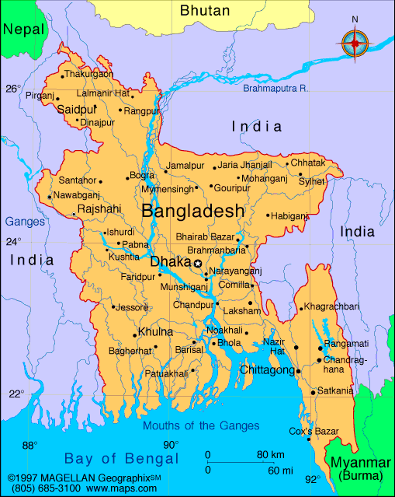
Figure 1: Map of Bangladesh and its Surrounding Countries. Source: Map of Bangladesh.
Now, the climate of Bangladesh has subtropical monsoon weather with extensive seasonal variations concerning humidity, temperature, and rainfall. Furthermore, it has altitudes from 600 to 1000 meters above sea level, whereas, at 1063 m(3,488 ft.) altitude, Saka Haphong at Mowdok range is the highest height in the southern part the hill there (Wasson, R., 2003). Bangladesh is an emerging market as a developing nation where approximately 30% of its GDP comes from agriculture to tell more about the country. However, Bangladesh got its Independence from Pakistan in 1971, after the partition of British India in 1947 by a glorious liberation war. Before Independence, it had its map within a red circle surrounded by a rectangular green shape as the national flag. After Independence, the map got removed. The red circle signifies the blood sacrifice of the martyrs during the liberation war, while the green rectangle is the symbol of the country's green nature (The Endless. 2019).
Figure 2: Bangladesh's Flag- During Liberation War (on Left) and After Independence (on Right). Source: History of National Flag of Bangladesh.
Finally, the 'Bengali' language is the primary language of 98% of Bangladeshi people. Bangladesh has tourist attraction sites with the longest sea beach- Cox's Bazar and Sundarbans's largest mangrove forest.
- Analysis of Population Demographics
Total Population and Annual Growth Rate
The population of Bangladesh and the growth is a significant problem there. In account, the total population of Bangladesh is 159,453,001 (July 2018 est.) (World Fact Book. 2019). Besides, The Annual Growth Rate in Bangladesh is 1% (2017 est.) of the total population. Here, the birth rate is 18.80 births/1,000 population (2017 est.). On the other side, the death rate is 5.40 deaths/1,000 population in Bangladesh. Furthermore, the fertility rate in Bangladesh is 2.17 children born/woman (2017 est.).
The capital city of Bangladesh is Dhaka. It is one of the most compactly populated cities in the world. In the capital, 19.5 million people live within 300 kilometers. Therefore, it is 23,234 people living per Sq. Km. The increasing population in Dhaka is mainly related to migration to that capital which is 2,000 people per day. In Dhaka, there is several people who live in slums, and it is roughly 3.5 million people. Therefore, diseases are common problems there (Lansat., M., 2018). This is not only for Dhaka city but also other cities in Bangladesh with a similar problem. Healthcare consciousness is not ordinary due to the fact. Henceforth, a dental health issue is also misunderstood and disregarded most of the time by the people of Bangladesh. However, the population pyramid below can show how densely populated country Bangladesh is:
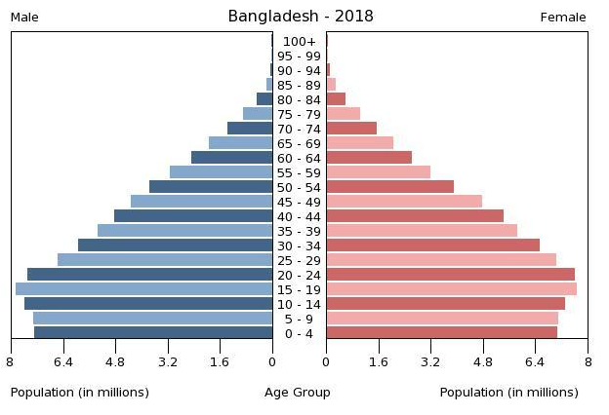
Figure 3: Population Pyramid. Source: CIA World Fact Book.
Now, the breakdown of the age group percentage given below, concerning age and sex, can show the overall scenario of Bangladesh regarding the populations.
  - 0-14 years: 27.29% (male 22,135,349 /female 21,373,470)
  - 15-24 years: 19.14% (male 15,313,674 /female 15,200,861)
  - 25-54 years: 40.07% (male 30,626,005 /female 33,267,339)
  - 55-64 years: 7.09% (male 5,582,450 /female 5,716,763)
  - 65 years and over: 6.42% (male 4,844,612 /female 5,392,478) (2018 est.) (CIA World Fact Book. 2019).

Population Percentage in Rural Area and Literacy rate and GNI
In measurement, population percent in rural areas of Bangladesh was 64.96 % in 2016. As for the education of Bangladeshi people, the Adult Literacy rate is 72.89% for Male 75.7%, and for females, it is 70.09% (UNESCO., 2017 est.). School Enrollment in the Primary level is 98% (2015 est.), and for the Secondary level, it is so low as 54%. This happens due to the reason of the low income of the people. The Gross National Income per Capita(GNI per Capita), Atlas method (current US$) in Bangladesh as per 2016 is only $1,330. So, most people in Bangladesh live under the poverty line, and it is 24.3% (2016 est.) in measurement. Altogether, the data above shows that moral consciousness, the importance of Healthcare, and procedures remain unsolved for most Bangladesh issues.

- Analysis of Indicators of Health Status
Morbidity, Life expectancy and Mortality rate
Morbidity rate:
Bangladesh's morbidity rate for age group 1-4 is around 200 per 1000 people, and for male and female populations of age group, 50-59; it is 220 and 307 people respectively. The maternal morbidity ratio (MMR) is around 450 people per 100,000 live births.
Life expectancy rate:
Bangladesh people of opposite gender percentages in the perspective of average ages for life expectancy is overall 72.7 years (2018 est.), which is for male- 71.1 years and female: 74.4 years (World Health Organization. 2016).
Mortality rate:
The mortality rate for Bangladeshi people aging under-5 (per 1,000 live births) in Bangladesh is 34.20 as of 2016. As for Infant Mortality Rate, it is 90.5 per 1,000 live births. Now, Bangladesh's infant mortality rates per 1,000 live births are 28.18 as of 2017, which is severe. It is a 29% decline from 2016 (Sherpa, A. (2017).
Bangladesh's top 5 causes of death
The leading causes are given below (Sawe., B. E., 2018):
  - Cancer,
  - Lower Respiratory Infections,
  - Chronic Obstructive Pulmonary Disease,
  - Ischemic Heart Disease and
  - Stroke
The top cause of death with a view in Bangladesh is Cancer (13%), whereas the figure below shows Stroke is the leading cause of death overall in all countries. Stroke (5%) is the 5th cause of death in Bangladesh.
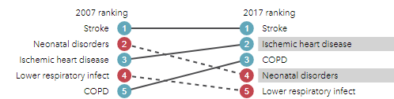
Figure 5: Major Causes of Death. Source: IHME Healthdata -GBD Compare
Cancer and Lower Respiratory Infections contribute to one-fourth of the total deaths in Bangladesh. Necessary and up-to-date technological healthcare equipment to treat these diseases is not readily available in most hospitals in Bangladesh. Due to this reason, these complex diseases contribute more to the deaths of the general people in Bangladesh.

The selected study of this paper is dental health, as most rural areas are moderately ignorant regarding their oral hygiene. Non-communicable diseases (NCDs) are the most vulnerable disease. It affects people throughout their lifetime, causing pain, discomfort, disfigurement, and even death. Dental problems can suffer a patient more than it is taken care of. The selected studies on Dental health problems are:
  - Gingivitis / periodontal disease
  - Dental caries / Tooth decay
  - Oral cancer
  - Fractured teeth/ Orodental disease
Gingivitis is the top problem regarding the dental healthcare system, as the figure below shows-
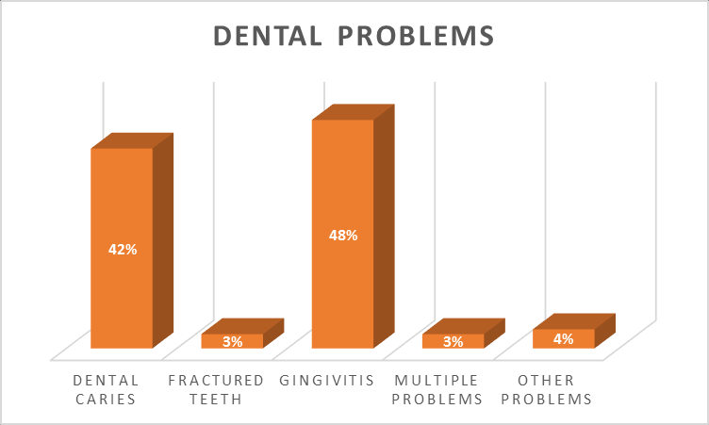
Figure 4: Graphical Representation of Dental problems. Source: Akter, A., Parvin, F. F, (2018).
Gingivitis
Periodontal disease affects the tissues that both surround and support the tooth. This often presents as bleeding or swollen gums (gingivitis), pain, and sometimes bad breath. In its more severe form, loss of gum attachment to the tooth and supporting bone causes "pockets" and loosening of teeth (periodontitis). Severe periodontal disease, resulting in tooth loss, was the 11th most prevalent disease globally in 2016. The leading causes of periodontal disease are:
- Poor oral hygiene
- Sugar
- Tobacco
- Food preference and poor diet
- Improper brushing
- Age

The other common dental disease in Bangladesh are described in the following:

Dental caries (tooth decay):
Dental caries results when microbial biofilm (plaque) formed on the tooth surface converts the free sugars in foods and drinks into acids that gradually dissolve tooth enamel and dentine. With a continued high intake of free sugars, inadequate exposure to fluoride, and without regular microbial biofilm removable, tooth structures are destroyed, resulting in the development of cavities and pain, impacts on oral-health-related quality of life. Theredore, in the advanced stage, tooth loss and systemic infection (WHO, 2018).

Oral cancer:
Oral cancer includes cancers of the lip and all subsites of the oral cavity and oropharynx. The age-adjusted incidence of oral cancer (cancers of the lip and oral cavity) in the world is estimated at 4 cases per 1,00,000 people. However, there is wide variation globally: from no recorded cases to around 20 cases per 1,00,000 people (GBD, 2016). Oral cancer is more common in men, in older people and varies enormously by socioeconomic condition. In some Asian-Pacific countries, the incidence of oral cancer ranks among the three top cancers. Tobacco, alcohol, and areca nut (betel quid) use are among the leading causes of oral cancer.
Oro-dental trauma/ Fractured Teeth:
Oro-dental trauma impacts the teeth and other hard or soft tissues within the teeth and the mouth, resulting in oral cavity. The world prevalence of traumatic dental injuries in either dentition (primary and permanent) is around 20%. Oro-dental trauma can be caused by oral factors (e.g., increased overjet), environmental factors (unsafe playgrounds or schools); risk-taking behavior; and violence.

Finally, Dental health should be selected as the priority health issue because it is a common disease in Bangladesh. More needs to be done to educate members of this society on the importance of healthy food choices and awareness about total oral care.

- Analysis of Bangladesh's Social System, and Cultural & History
Government and History of Politics in Bangladesh
The Constitution of Bangladesh was written in 1972 and has undergone sixteen amendments. A caretaker government was first introduced in 1990 after the resignation of military dictator Lieutenant General HM Ershad. After 1991, the Caretaker government has also held the elections of 1996, 2001, and 2008. Although the first caretaker government was intended to help the transition from authoritarianism to democracy, this system was institutionalized in 1996 by the Sixth Parliament due to rising mistrust between the BNP and Awami League. In 2011 the then ruling party Awami League abolished the caretaker government system. Since then, this has been the most significant cause of dispute between the BNP and the Awami League.
Local Government Structure and Education system
There are eight divisions and 64 districts in Bangladesh. Each district is further subdivided into Upazila. Except for those in metropolitan areas, the area within each subdistrict is divided into several unions, with each union consisting of numerous villages. Direct elections are held for each union (or ward), electing a chairperson and several members. In 1997, a parliamentary act was passed to reserve three seats (out of 12) in every union for female candidates (Panday., P., 2018).
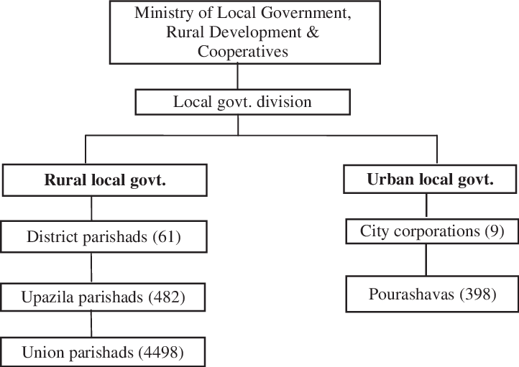
Figure 5: Bangladesh Local Government Structure. Source: International Journal of Public Administration.
Social System of Bangladesh
According to the Human Development Report (HDI) 2010, Bangladesh has made the most outstanding progress in recent decades, as measured by the Human Development Index (HDI). Bangladesh's HDI has increased by 81 percent in the past 30 years. Even with such impressive relative gains, Bangladesh remains a country needing continued and coherent development assistance. Forty percent of the population of Bangladesh is estimated to continue to live below the national poverty line, while the child malnutrition rate is at 41per cent of children under the age of 5. The sex ratio between male and female populations was 19:20 in 2007. More than a third of the total population is under 15 years and more than half between the ages 15 and 59. The demographic dependency ratio is about 76.6 percent. This young age structure creates sustained momentum for population growth, which will continue well into the future – some estimates go as far as until 2060 – even in the case of rapid declines in fertility rates.
Educational System
In Bangladesh, all citizens must undertake twelve years of compulsory education, eight years at primary school level, and six years at high school level. Primary and secondary education is financed by the state and free of charge in public schools. Bangladesh conforms fully to the UN's Education For All (EFA) objectives, Millennium Development Goals (MDG), and other education-related international declarations. Article 17 of the Bangladesh Constitution provides that all children receive free and compulsory education.

V. Health Care System and Resources
A. Financial analysis of the health care system
a. Instruments and updated infrastructures for Healthcare
b. Modernizing of facilities in Hospitals
c. Increased Total GDP expenditure for Healthcare (% and $ amount)
d. Increasing Funding sources-private versus government versus public
B. Health care structure in Bangladesh
a. Health Infrastructures
b. Policies for Maternal Health
c. Health personnel to patient ratios
d. Multilevel interaction at a personal and community level
, e. Family Welfare Assistants, Medical Assistants, and Medical officer
f. Healthcare services organization as NGO's, Private firms and government clinics
g. Sub-division Medical Officers for Upazilla Health Complex
h. Union Health and Family Welfare Centers
i. Outpatient Consultation Center
j. Family Planning Services
C. Key health System Statistics for Bangladesh
a. Acting personnel of the systems
b. Governing body
c. Key personnel of the healthcare management system
d. Medical officer-in-charge for specified timeline with a day
D. An Organogram of Health care Research Organization in Bangladesh

Figure 8: Center for Injury Prevention and Research- CIPRB research organization organogram. Source: CIPRB Website. Retrieved from https://www.ciprb.org/who-we-are/organogram/

E. Strengths and Weaknesses of the overall health care system in Bangladesh: The main strength of Bangladeshis of the overall healthcare system is its population as a massive workforce to engage in the health sector. On the other hand, it can also be a weakness as serving the massive people can be challenging. Implementing the strategies regarding better healthcare service providing will be the critical factor for success in the maintenance of better health of the Bangladeshis.

VI. Community Health Strategies to Address the Health Problem
A. Health interventions and strategies that address the dental to any health problem for Bangladeshi People:
a. Researching for Universal Healthcare and socialized medicine
b. Benefits of polyclinics
c. Benefits of neighborhood doctor/nurse teams (CMF)
d. Community programs to grow carefulness about minor to significant health problems
e. Recruitment of more health care officials
f. Increasing numbers of research and teaching centers
g. Raising awareness of signs and symptoms
h. Resource development and adopting natural and traditional medicine

B. Identification of Intervenes and Strategies to endure to get rid of Dental health problems to other primary health conditions for Bangladeshis:
a. Allocating an increased budget for Healthcare
b. Organizing Cultural structure to address health problems
c. Better quality of education for health professionals
d. Increase in the number of practicing doctors
e. A stronger focus on preventative medicine practices
f. Strong Policies for health education
g. Public awareness through medical staffs
h. Increment of salaries for village doctors
i. Shift focus to community relationships and organizations
j. Increase number of free health checkup points
k. Identification of fake healers and imposing laws against them
l. Specialized care for different age groups
m. Holding Programs and routine health checkups
n. Programs to grow awareness through television and media
o. Focus on prevention, health promotion, rehabilitation, and recovery services
p. Overall simplifying the terms of dental health diseases

VII. Conclusions
A. Bangladesh is still in the developing phase, and implementing the strategies for better health care possibilities should be in the process. Identifying health problems and taking necessary steps should be the primary concern for the government and the people.

B. Engaging in long-term goals and increasing awareness about health issues should be done consistently. The future health programming for Bangladesh should increase healthcare institutions and instructors and educate the masses about the benefits of preventing health problems early.

Discussion
The Culture of Bangladesh is intertwined with the culture of the Bengal region. It has evolved over the centuries encompasses the cultural diversity of several social groups of Bangladesh. The traditional music of Bangladesh is very much the same as that of the Indian sub-continent. At first glance, Bangladesh seems to be a nation with practically no diversity. About 98% of the population identifies with a single ethnicity: Bengali. The Bengali people belong to the Indo-Aryan ethnolinguistic family, giving them ancestral ties to India and Western Asia. They speak the Bengali language, although this language has several distinct dialects across the nation. Nearly all Bengali people in Bangladesh are Muslim, which is interesting because ethnic Bengali in the neighboring nation of West Bengal are predominantly Hindus. This difference comes from the invasion of Arab Muslims in the 13th century that divided the Bay of Bengal region into Islamic and Hindu zones.

- References:

Bibliography:
Alonso, E.B.,(2015). The impact of culture, religion and traditional knowledge on food and nutrition security in developing countries. Food secure for a policy that matters, vol. 30; 2015. p. 35–40. Retrieved from http://www3.lei.wur.nl/WECRGeneral/FoodSecurePublications/30_briones.pdf
Bangladesh. Journal of Health and Research. 5 (1): 1. doi: 10.4103/cjhr_65_17
Bangladeshi people. Daffodil International University. Available at
Bhuiyan, M. M. H., & Faisal, M. (2020). An Agenda of Advancing Health Monitoring System with a Contemporary Arrangement of Digitalized Operable Medical Kits. Southeast University Journal of Science and Engineering (SEUJSE). Volume 15, Issue 1, pp. 21-30
Bhuiyan, M. M. H., (March-April 2022). Challenges Military Couples Face in Raising Their Children, International Journal of Scientific Research in Computer Science, Engineering and Information Technology (IJSRCSEIT), ISSN : 2456-3307, Volume 8 Issue 2, pp. 276-299, doi: https://doi.org/10.32628/CSEIT228252 Journal URL : https://ijsrcseit.com/CSEIT228252
Bhuiyan, M. M. H., (March-April 2022). Challenges Military Couples Face in Raising Their Children, International Journal of Scientific Research in Computer Science, Engineering and Information Technology (IJSRCSEIT), ISSN : 2456-3307, Volume 8 Issue 2, pp. 276-299, doi: https://doi.org/10.32628/CSEIT228252 Journal URL : https://ijsrcseit.com/CSEIT228252
Bhuiyan, M. M. H., (May, 2022). Integration of UAV with manned aircraft: prospects and future options. LAP LAMBERT Academic Publishing. Copyright © Majidul Haque Bhuiyan. Copyright © 2022 Dodo Books Indian Ocean Ltd., member of the OmniScriptum S.R.L Publishing group. ISBN: 978-620-0-32694-2.
Bhuiyan, M. M. H., (May, 2022). Integration of UAV with manned aircraft: prospects and future options. LAP LAMBERT Academic Publishing. Copyright © Majidul Haque Bhuiyan. Copyright © 2022 Dodo Books Indian Ocean Ltd., member of the OmniScriptum S.R.L Publishing group. ISBN: 978-620-0-32694-2.
Bhuiyan, M. M. H., Imam, S. T., & Rakhi, K. (2021). The Use of Modern Technology in English Language Teaching-ELT.
Bhuiyan, M. M. H., Imam, S. T., & Rakhi, K. (2021). The Use of Modern Technology in English Language Teaching-ELT.
Bhuiyan, M. M. H., Sabrina Rahman, Sahib, S. M., (2022, April). Overparenting's Consequences in Bangladeshi Society Child's Intelligence, Growth, and Creativity. In 2022 International Journal of Scientific & Engineering Research Volume 13, Issue 4, pp.1301-1312. ISSN: 2229-5518
Bhuiyan, M. M. H., Sabrina Rahman, Sahib, S. M., (2022, April). Overparenting's Consequences in Bangladeshi Society Child's Intelligence, Growth, and Creativity. In 2022 International Journal of Scientific & Engineering Research Volume 13, Issue 4, pp.1301-1312. ISSN: 2229-5518. https://doi.org/10.14299/ijser.2022.04.01
Bhuiyan, Md Majidul Haque (2021). Case Study on Sri Lankan REM- “How Product Quality can Enhance the Purchasing Behavior of Real Estate Industry”. Available on PhilArchive copy v1: https://philarchive.org/archive/BHUTAOv1
Bhuiyan, Md Majidul Haque (2021). Case Study on Sri Lankan REM- “How Product Quality can Enhance the Purchasing Behavior of Real Estate Industry”. Available on PhilArchive copy v1: https://philarchive.org/archive/BHUTAOv1
Bhuiyan, Md Majidul Haque,(2022). Lecture note on Pakistan Colonial Administration. Available on https://philpapers.org/rec/BHULNO
CIA World Fact Book (2019). Bangladesh Age Structure. Indexmundi Website. Retrieved from https://www.indexmundi.com/bangladesh/age_structure.html
Dalal, A.K., (2007) Folk wisdom and traditional healing practices: some lessons for modern psychotherapies. Foundations of Indian Psychology.; Retrieved from http://www.ipi.org.in/texts/ajit/dalal-folk-wisdom.pdf.
Faisal, M. A., & Bhuiyan, M. M. H. (2020), Contemporary Framework of Technical Challenges in Enactment of Smart Grid. Southeast University Journal of Science and Engineering (SEUJSE). Voume 14. Issue 1. pp.54-61.
Faisal, M. A., & Bhuiyan, M. M. H. (2020), Contemporary Framework of Technical Challenges in Enactment of Smart Grid. Southeast University Journal of Science and Engineering (SEUJSE). Voume 14. Issue 1. pp.54-61.
GBD, (2016) Disease and Injury Incidence and Prevalence Collaborators. Global, regional, and national incidence, prevalence, and years lived with disability for 328 diseases and injuries for 195 countries, 1990-2016: a systematic analysis for the Global Burden of Disease Study 2016. Lancet. 2017;390(10100):1211-1259.
Helman C., (2007). Culture, health, and illness. Oxford: Butterworth-Heinemann; 1995. pp. 101 145. Retrieved from https://scholar. google.com/scholar_lookup?title= Culture,+health+and+illness&author=C+Helman&publication_year =1995&
https:// www.britannica.com/place/Bangladesh
https://www.researchgate.net/figure/Graphical-representation-of-dentalproblems_fig3_3 27230714
Husain, S. S., & Tinker, H. R. (2019). Bangladesh. Encyclopedia Britannica. Retrieved from
Imam, Syeda Tasfia ; Bhuiyan, Md Majidul Haque & Rakhi, Kamrunnahar (2021), An Existing Sculps Human Modelling- The Deviations in Dialect of Indian Standard English from the British Colonial Period to Present Times. Available on PhilArchive: https://philarchive.org/archive/IMAAE
Imam, Syeda Tasfia ; Bhuiyan, Md Majidul Haque & Rakhi, Kamrunnahar (2021), An Existing Sculps Human Modelling- The Deviations in Dialect of Indian Standard English from the British Colonial Period to Present Times. Available on PhilArchive: https://philarchive.org/archive/IMAAE
International Journal of Public Administration. Vol 35. doi - 10.1080
Kleinman A. (1980). Patients and healers in the context of culture. Berkley: University of California Press. pp. 49–57. https://scholar.google.com/scholar_lookup?title=Patients+and+healers+in+the+context+of+culture&author=A+Kleinman&publication_year=1980&
Lansat., M., (2018). Staggering photos show what daily life is really like in Dhaka, the most crowded city in the world. Business Insider. Retrieved from businessinsider.com/dhaka-bangladesh-most-crowded-city-in-the-world-2018-11
Magellan Geographix., (1997). Map of Bangladesh. MAGELLAN GeographixSM (805) 685-3100, Hartford Web Publishing, Retrieved from http://www.hartford-hwp.com/archives/52/062.html
Mahmudur, R. A. H. M. (2018). A review of child and maternal health status of
Nargis, M. (2016). Scaling-up Innovations, Community Clinic in Bangladesh. Additional Secretary & Project Director, Revitalization of Community Health Care Initiatives in Bangladesh.
National Institute of Population Research and Training Ministry of Health and Family Welfare
Panday. P, (2018). Inter-Organizational Coordination and Corruption in Urban Policy Implementation in Bangladesh: A Case of Rajshahi City Corporation.
Petersen PE, Bourgeois D, Ogawa H, Estupinan-Day S, Ndiaye C. The global burden of oral diseases and risks to oral health. Bull World Health Organ. 2005;83(9):661-669.
Plateau, T. P., & Bhuiyan, M. M. H. (2017, February). A heuristic proposition of efficient copper-electrodeposited p-type thin film for CZTS solar cell. In 2017 International Conference on Electrical, Computer and Communication Engineering (ECCE) (pp. 95-99). IEEE.
Plateau, T. P., & Bhuiyan, M. M. H. (2017, February). A heuristic proposition of efficient copper-electrodeposited p-type thin film for CZTS solar cell. In 2017 International Conference on Electrical, Computer and Communication Engineering (ECCE) (pp. 95-99). IEEE.
Plateau, T. P., Islam, M. T., & Islam, N. (2019). Potentiostat Electro-Deposited Cuprous Oxide and Cupric Oxide Thin Films for Photovoltaic Use. International Journal of Automotive and Mechanical Engineering, 16(2), 6624-6633.
Plateau, T. P., Islam, M. T., & Islam, N. (2019). Potentiostat Electro-Deposited Cuprous Oxide and Cupric Oxide Thin Films for Photovoltaic Use. International Journal of Automotive and Mechanical Engineering, 16(2), 6624-6633.
Sawe, B. E., (2018). The 10 Leading Causes Of Death In Bangladesh. World Atlas. Retrieved from https://www.worldatlas.com/articles/the-10-leading-causes-of-death-in-bangladesh.html
Sayeed, M. A. (1997). Effect of socioeconomic risk factors on the difference in the prevalence of diabetes between the rural and urban population of Bangladesh. Diabetes Care. 20: 551-5. (4): 551–555. doi:10.2337/diacare.20.4.551. PMID 9096979.
Shawon, S. I., Bhuiyan, M. M. H., & Plateau, T. P. (2018). An Innovative Construction of Wheelchair for Handicapped Persons. International Journal of Science and Qualitative Analysis, 4(1),13.
Shawon, S. I., Bhuiyan, M. M. H., & Plateau, T. P. (2018). An Innovative Construction of Wheelchair for Handicapped Persons. International Journal of Science and Qualitative Analysis, 4(1),13.
Sherpa, A. (2017). Statistics Canada Deaths and Mortality Rate, 2000-2009. CANSIM Table 102-0552. Retrieved from https://www.silversherpa.net/blog/elderly-person-stroke/stroke-stats/
The Endless. (2019). History of National Flag of Bangladesh. Bangladeshi Culture- Ontaheen. Retrieved from https://www.ontaheen.com/history-of-national-flag-of-bangladesh/
Traditional Medicine(2016), National Encyclopedia of Bangladesh. Banglapedia: Retrieved from https://www.ncbi.nlm.nih.gov/pmc/articles/PMC3974044/
Viz Hub. (2017). IHME Healthdata. GBD Compare. Retrieved from https://vizhub.healthdata.org/gbd-compare/
Wasson, R. (2003). "A sediment budget for the Ganga–Brahmaputra catchment." Current Science. 84 (8): 1041–1047.
WHO traditional medicine strategy: 2014–2023 (2013). Retrieved from http://apps.who.int/iris/bitstream/10665/92455/1/9789241506090_eng.pdf?ua=1.
WHO, (2018).
World Fact Book (2019). People and Society. South Asia: Bangladesh. Retrieved from https://www.cia.gov/library/publications/the-world-factbook/geos/bg.html#People
World Health Organization. (2016). Global Health Observatory (GHO) data. Mortality and global health estimates. Retrieved from https://www.who.int/gho/mortality_burden_disease/en/
Zaman, H. U., Bhuiyan, M. M. H., Ahmed, M., & Aziz, S. T. (2016, January). A novel design of line following robot with multifarious function ability. In 2016 International Conference on Microelectronics, Computing and Communications (MicroCom) (pp. 1-5). IEEE. Bhuiyan, M. M. H., & Faisal, M. (2020). An Agenda of Advancing Health Monitoring System with a Contemporary Arrangement of Digitalized Operable Medical Kits. Southeast University Journal of Science and Engineering (SEUJSE). Volume 15, Issue 1, pp. 21-30
Zaman, H. U., Bhuiyan, M. M. H., Ahmed, M., & Aziz, S. T. (2016, January). A novel design of line following robot with multifarious function ability. In 2016 International Conference on Microelectronics, Computing and Communications (MicroCom) (pp. 1-5). IEEE.

