On the Value of Sad Music

Mario Attie-Picker, Tara Venkatesan, George E. Newman and Joshua Knobe

Abstract

Many people appear to attach great value to sad music. But why? One way to gain insight into this question is to turn away from music and look instead at why people value sad conversations. In the case of conversations, the answer seems to be that expressing sadness creates a sense of genuine connection. We propose that sad music can also have this type of value. Listening to a sad song can give one a sense of genuine connection. We then explore the nature of this value in two experimental studies. The results suggest a striking relationship between music and conversation. People see something distinctively musical in works that express precisely those emotions that they think most create connection within conversation.

1

You are on the bus, looking through the window, when someone sits next to you. You should have pretended to be asleep, you think. He starts talking, saying something about a friend of his. You pretend to be listening, your contributions all monosyllabic: ‘yes’ ‘right’ ‘no.’ But as he keeps talking, you find yourself more engaged. Your answers begin to lengthen. You warm up to him. You are now listening and, before long, you strike up a genuine conversation. His best friend has just died in a motorcycle accident, he says. A great guy. A father. A tear blurs his glasses. He doesn’t know what to do with himself, he says. He just doesn’t know. Before you know it, the bus stops and he gets off. You mutter a goodbye.
The man and his story have really affected you. And yet, despite the sadness, you feel something else. You recognize something important in what just happened—something great about your conversation with the stranger. You have connected with him. You feel it in your bones. No, he didn’t say anything particularly insightful. He wasn’t very eloquent or inspiring or wise. He just opened up to you. And you listened. The stranger’s words and gestures, his emotion, the manner in which he spoke, the way he looked at you, in short his overall expression of sadness as realized in every detail of the conversation, created a feeling, an experience, of being connected. And this connection feels good, even if the sadness doesn’t.
Now consider these grandmothers, singing “Yoy za val(yah)om, valom zelenen’kym,” a Ukrainian folk song about ill-fated love.

The music expresses profound sadness. From the gloomy, recitation-like vocals of Pavlovych Mariya Nykyforvina (second from the left) to the despairing final chant in unison, this song, like many folk songs, can be depressing. And yet, there’s something unmistakably great about it. Listening to this quartet, one can’t shake the feeling that this is what music is all about—that it embodies the true values of music. But what’s so great about it? Why do we value this kind of music?
Our hypothesis is that what's great about the music is what’s great about the conversation. Listening to the Ukrainian folk song makes you feel connected. There is something about the expression of sadness as realized in the music that creates a connection—an experience akin to that arising from a heartfelt conversation. As we shall argue, this is true of sad music in general. And this is, at least in part, why we value it.
Our goal is to offer a novel account of the value of sad music. The paper proceeds as follows. First, we differentiate our proposal from existing accounts. We argue that it is the sadness of the music itself, and not the experience of sadness in the listener, that is important. We then turn to our own positive account. The value of sad music, we propose, lies in the connection it creates: a connection arising from the sadness expressed by the music. Finally, we explore the nature of this value in two experimental studies.

2

The paradox of negative emotions in art is the problem of reconciling the aversion to negative emotions in real life with the widespread attraction to artworks that elicit these emotions. The problem is often understood in motivational terms: why in the world do we seek out art that makes us feel sad or fearful or disgusted? The reply—arising from the confines of philosophy but also from good common sense—is that we seek it because we enjoy it (or because we value it). And then the problem is to account for this “unaccountable pleasure”: how come we enjoy this kind of painful art?
There are by now as many proposed solutions as there are philosophers working on the problem. But most take as their starting point the thought that the value of painful art depends on its being painful. That is, on its eliciting a painful experience in the audience. After all, it does seem evident that we watch melodramas to shed some tears and read thrillers to be in a state of suspense. The puzzle is then to explain why, in the context of art, we enjoy these emotions. And the pervasive assumption is that these emotions must figure in the explanation, whatever it turns out to be.
The disagreement is thus mostly about how the emotions figure in the enjoyment. There are those who think that the negative aspect of the emotion is intrinsic to the enjoyment and those who think it is only instrumental. As an example of the ‘intrinsic’ view, consider Smuts’ (2011) account of sad songs. He argues that we desire to listen to sad songs to deepen our sadness—to make our suffering more acute. By intensifying our sadness, he claims, we come to better understand the significance of what we have lost. The pain is not simply a means to understanding, but constitutive of it. And this, he claims, is an experience we value for its own sake.
To illustrate the ‘instrumental’ position, consider compensatory explanations. These views posit a type of pleasure (or value) that negative emotions make possible and which compensates for the pain of the emotion. But, they insist, the pain is not part of the enjoyment. Take Feagin’s (1983) account. According to Feagin, the pleasures of tragedy lie in the recognition of our ability to respond emotionally to the misfortunes of the world. As she puts it, “We find ourselves to be the kind of people who respond negatively to villainy, treachery, and injustice. This discovery, or reminder, is something which, quite justly, yields satisfaction” (98). Still, our direct responses to the unpleasant events depicted in tragedy are just that—unpleasant. It is the meta-response that brings pleasure.
Notice that, despite their important disagreements, both views take the undergoing of the painful experience as essential. Smuts thinks we value sad songs because they “heighten our suffering” (Smuts, 2011: 146). What we desire, what we are after, is to be (even more) sad. But the feeling of sadness is no less important in Feagin’s theory. For the meta-response, which is after all the object of our enjoyment, depends on the existence of the first-order response—on our actually being saddened by the artwork.
In contrast, the account we shall propose does not place the value of sad music in its ability to make us sad. It is not the feeling of sadness that matters, but something else. Come back to the conversation on the bus. Sure, the stranger’s sadness may have saddened you. But it wasn’t the experience of being sad yourself that you found valuable or enjoyable. It was rather something else—a connection brought forth by the stranger’s sadness as expressed in the conversation. Indeed, in the paradigm case, the parties are not made sad by the conversation, but rather bring their sadness to the conversation. I am sad because my dog died. You are sad because your date didn’t show up. We then go for a drink to commiserate about our misery. The value of such conversations does not lie in making each other sad (we were sad already!), but in expressing our sadness to each other. In the same way, we claim, it is the sadness as expressed in the music, and not as felt in the listener, that really matters.
The value of sad music, that is, resides in the expression, not in the evocation, of sadness. Of course, the relation between expression and evocation is notoriously complex, and has been the subject of great debate (for influential treatments of expression in music, see Davies, 1994; Hospers, 1955; Kivy, 1989; Levinson, 1996: Ch. 6; Ridley, 1995; Robinson, 1994; 2005: Ch. 10-13; Scruton, 1999: Ch. 6. For an overview, see Robinson, 2011). We have nothing to contribute to this discussion. Our point is simply that, regardless of how the relation is ultimately understood, it is what the music expresses, as opposed to what the listener feels, that holds its value.
Now, for this very reason, our view does not account, nor is meant to account, for many of the cases that motivate the more general paradox of negative emotions in art. It would be ridiculous to suggest, for example, that the experience of fear in watching a horror film plays no essential role in our enjoyment of it (the same is true, as we have seen, for thrillers and melodramas). We don’t watch horror films when we are afraid. We watch them to be afraid. But music is different. As Smuts points out, we often seek sad music when we are sad. This suggests that unlike horror films (and many other art forms), we don’t seek sad music to feel sad (for we are sad already). With music, as with conversation, we want something else.
Our view may therefore have no application at all outside music. But this is what we should expect. To give the same explanation to our enjoyment of Beethoven’s sonata ‘Pathétique’ and to Tobe Hooper’s The Texas Chainsaw Massacre is to explain too much. We take it that any plausible explanation of the former would fail completely as an explanation of the latter. So we don’t think of music as a good test case from which we can then generalize to offer a unified, all-encompassing solution. We think of music as requiring its own specific account. And that (but nothing more) is what we offer.
Of course, it might be that actually feeling what the music expresses increases our enjoyment of the music. Or it might be that it doesn’t. Our position does not take sides here and is compatible with both. In any case, it seems that this much is true: one need not be made sad by the music in order to enjoy it. One study found only a small correlation between felt sadness and liking (Vuoskoski and Eerola, 2017) and a different one found no correlation at all (Eerola, Vuoskoski, & Kautiainen, 2016). What’s crucial for our purposes, then, is the claim that the actual emotions of the listener are less important than those expressed by the music.
Some might feel cheated by our approach. Aren’t we just avoiding the crux of the problem, that of the experience of negative emotions in music? We don’t think so. The problem is to explain why we enjoy or value sad music, and that is precisely the question we take on. We simply take the position, in answering that question, that the listener’s sadness is not necessary for the value at issue. One might still wonder whether we are offering a deflationary account. Again we don’t think so. For we are not denying that sad music makes us sad. The claim is that even when it does, there is an important value that is not dependent on our being sad, but only on the music’s expression of sadness.

3

We are now in a position to state our account. We propose that the value of sad music resides in the connection it creates through the expression of sadness and other complex emotions. The musical expression of emotion gives rise to an experience of connection that is hard to articulate but easy to recognize. It is present when listening to the Ukrainian folk song, or to Mozart’s Requiem, or to Tom Waits’ “Innocent When You Dream.” And it is an experience we can understand by analogy to that present in conversations such as the one with which we started this essay.
You might ask: what is this connection? What does it consist in? Now, if what is sought by the question is a definition, an analysis in terms of necessary and sufficient conditions, then we have nothing in terms of an answer. But we think we can illuminate its nature by examining the contexts in which it is most at home. As we have suggested, we think the connection involved in music is very much like that of heartfelt conversations. It is thus instructive, in understanding one, to think about the other. This is what we do in this section.
Consider, then, the conversation with the stranger. Whatever else we may say about it, it is clear that there is a value—the value we take as analogous to music—that does not seem to reside in its possible cathartic or therapeutic or beneficial effects. The stranger might have felt better after talking with you, or he might have felt worse. Or perhaps he felt just as he felt before. And the same is true of you. Regardless, there’s something valuable in his expression of emotion and the way it brings you together. That is, in the connection it creates between the two. This kind of connection often arises when someone opens up to someone else, when one expresses one’s emotions to another. But it can also arise without this sort of shared experience. Suppose the stranger left a diary narrating the death of his friend and his thoughts about it. By reading his dairy, there is a very real sense in which you might connect with him, even though you’ve never met him and never will (even, indeed, if he’s long dead by the time you start reading). The value here is not about the potential for a future relationship or about the shared experience of a meaningful moment. In a way, it is simply about itself. We connect with people who open up and we value this connection for its own sake.
Now consider the experience of listening to Mozart’s Requiem or to “Innocent When You Dream.” It might prove cathartic, or it might sharpen your sadness. Or it might do neither, leaving your feelings alone. Regardless, the music’s expression of emotion— Mozart’s explosive anguish; Waits’ quiet melancholy—creates a connection, a communion between yourself and the music (or through the music to something else), which is valuable for its own sake. The connection, of course, is not with someone who can respond in real time to your own particularities (though it often feels as if that’s exactly what the music is doing). Its value is therefore not the one of shared experience. Nor does it depend on any future benefit the connection might occasion. Mozart can make you a better person. Waits can help you get through the day. But the value of connecting with their music is not hostage to these possibilities. In fact, it does not depend on there being a future at all. One can listen to the Lacrimosa and then die. No matter. The value of the connection would diminish not one bit. What happens after the music stops, just as what happens after the conversation ends, is of no importance.
We have claimed that in music, as in conversation, the connection results from the expression of emotion. But a crucial question arises: which emotion?
It might be helpful to think of conversation first. Clearly, not every emotion is equally conducive to connecting the conversing parties. Small talk is usually expressive of emotion: one expresses annoyance in complaining about the weather and boredom in discussing last night’s board meeting. But small talk, if anything, alienates more than it unites. No one has ever left an elevator in communion with her conversational partner.
This example also helps to rule out an otherwise plausible view. One might have thought that there was something special in the expression of the negative emotions. There is a strong intuition that conversations expressing, for instance, sadness and remorse are unique in the experience of connection they bring out. But if that’s the case, it can’t just be the negative nature of these emotions that does it. The case of annoyance shows this. What else is at play?
At this point, it seems natural to note that remorse is more complex than annoyance and hence that it expresses something deeper about us. It is such complexity, some might think, that is responsible for the experience we are after. The proposal, though reasonable enough, is of little help. Or it’s of help only insofar as we can give an account of emotional complexity that is independently plausible. Otherwise, we would be running in circles, and ‘complexity’ and ‘depth’ would be at most placeholders rather than substantive answers to our question.
In sum, some emotions tend to create connection in conversation and some do not. Remorse does it. Annoyance does not. That is clear enough. What’s missing is a theoretical explanation of this difference.
Let’s now turn to music. The problems here seem structurally identical with those just discussed. As with conversation, it is evident that not any emotion expressed in music would make the listener feel connected. Compare Kanye West’s irritation about his “damn croissants” in “I Am A God” to Leonard Cohen’s proud resignation in “You Want It Darker.” West’s is not necessarily lesser music, but it’s hard to imagine someone listening to “I Am A God” and feeling connected the way we do when listening to Cohen’s confessional, quasi-religious swan song. Irritation seems to lack the connective powers of proud resignation. Why? Again, valence per se can’t be the answer, for both songs express negative emotions. But, again, the disproportionate amount of sad music might suggest that some negative emotions are after all special. Which ones? Terms like ‘complex’ and ‘deep’ are, again, tempting—though not terribly helpful, as we have seen.
What, then, to make of the question? Which emotions have the special sauce? And what does the sauce consist in? What is it about certain emotions that makes their expression something valuable in itself—something that seems to bring people together as if by magic? Alas, we don’t have much of an answer, but we hypothesize that the very same emotions that create connection in conversation are themselves responsible for connection in music.
A different kind of problem arises when thinking about the relation between the connection and the underlying conversation/music. In the case of conversation, the connection seems intimately related with the conversation. Not so with music.
Suppose you have a genuine conversation with the Ukrainian grandmothers and you walk away feeling connected to them. It seems natural to say not only that the conversation leads to or causes the experience of connection, but also that such an experience is, in an important sense, about (or constituted by) the conversation itself. But things seem different in the case of music. Suppose you listen to the grandmothers’ folk song and walk away feeling connected to them. The suspicion arises that the connection is not really about the music—that the music is simply instrumental to it. In other words, if what’s of value in sad music is the experience of connection it affords, we seem to have reduced the music to a means to this further end. Or, put differently, to point to connection as holding the value of sad music is to suggest that its value is not a musical value. It is to leave the music out of the music.
Theories that leave the music out of the music—theories, that is, that point to some extra-musical value in elucidating the value of music—commit, in Budd’s (1985) terms, the ‘heresy of the separable experience’: “the separation of what gives music its value…from the music itself” (123). The worry is that to value the music for an experience “which can be fully characterized without reference to the nature of the work itself” is to value the music for the wrong reasons. It is, to put it simply, to fail to value the music as music.
One option is to deny the claim that the experience of connection we have singled out leaves the music out. To deny, that is, that the experience can be “fully characterized without reference to the nature of the work itself.” This turns on an important issue. When we feel connected in conversation, we feel connected to the person we are conversing with. The nature of this person—in all its idiosyncratic glory—is thus constitutive of the connection we have with her. But whom (or what) are we connected with when we feel connected while listening to music? Two paragraphs back, we described the connection in listening to the Ukrainian folk song as being with the interpreters, with the grandmothers. This gave rise to the suspicion that the music is simply an intermediary tool enabling what’s truly of value: an extra-musical connection between you and them. But if the connection at issue is not with the grandmothers but with their music—not with Mozart the man but with the Lacrimosa of his Requiem—then the nature of the work (like the nature of the conversing party) would figure essentially in the content of the experience. On this view, we enter into communion not with a person existing prior to the music, but with the music itself, perhaps in the form of a ‘persona’ or a ‘view of life’ or a ‘vision’ expressed by the music and constituted solely by the music. If that is the right way of characterizing the connection, then there is no threat of abandoning the music. (See Ridley, 1995: Ch. 8 for a detailed defense of a view along these lines. See also Watt and Ash, 1998 for empirical evidence that listeners often perceive a “virtual person” in the music itself.)
The line of response we develop, though by no means incompatible with the response we have just canvassed, rescues the music in a different way. It contends that the value of the connection is after all a musical value, and so that to value a work for this reason is to value it for musical reasons (it is to value it as music). On this view, what matters is not the claim that the experience of connection is an experience of the music (the emphasis is not in the content of the experience), but rather the claim that giving rise to the connection is somehow essential to what music is in the first place. To this view we turn next.

4

We have argued that the value of sad music lies in the connection it creates. The worry, recall, is that this answer leaves the music out of the music. It points to something extra-musical—the experience of connection—as bearing the value of sad music. We shall argue that this worry is misguided. The value of the connection is after all a musical value—it is, indeed, one of music’s characteristic values. Our argument proceeds in two steps. We first argue that ordinary listeners regard the expression of emotion as one of the characteristic values of music. We then present (in the next section) experimental evidence suggesting a close relation between the emotions whose expression is heard as realizing a musical value and those whose expression create connection in conversation. We argue that this finding supports the claim that connection in music is a distinctively musical value.
What makes a value musical? It’s hard to say, but the following conditional might at first seem intuitive: if a value in a piece of music is a musical value, then its presence ought to contribute to the music being good music. A given work may have all kinds of value, but if one of them does not make the work better qua music then it can’t be a musical value.
Think of a jingle designed to help children learn arithmetic. The jingle might be good in some sense (e.g., it might be a good educational tool), but we would not normally describe it as “good music.” And if it is good in some sense but it’s not good music, one might think that whatever value it might have must be a purely extra-musical value. This same test could then be applied to the phenomenon under discussion here. There does seem to be something of value in music that expresses emotion, but does this value actually involve being good music? If it does not, one might think that the value has to be extra-musical.
But now we face a problem, for it seems that lots of expressive music is bad music. As Kivy puts it (1999): “Lots of music that is somber and melancholy moves me not one whit, because lots of music that is somber and stately and melancholy is not very good music. And to move me by its somber, stately melancholy, music must be beautifully somber and stately and melancholy” (9, emphasis in the original). A piece of music, Kivy thinks, might be quite good at expressing melancholy and yet fail dramatically as music. Of course, one might still value the piece. After all, it is good in some sense (it’s good at expressing emotion). But such value, it would appear, would not be musical in nature.
We think appearances are misleading here. Despite its initial plausibility, the above conditional is false: there are musical values that don’t necessarily contribute to the music being good music. And we take the expression of emotion to be an example. On our view, sad music might be terrible music and yet possess, in virtue of its sadness, a characteristic musical value.
To see how this works, let’s start with an example close to home. Consider the ways in which philosophical thinking can have value. Some philosophical thinking is good philosophy, and some is not, but — and this is the point we really want to emphasize — some philosophical thinking has a distinctively philosophical value even though it is not good philosophy. Take, for example, a child's first philosophical thoughts. Typically, these will not be good philosophy in any ordinary sense, but still, they may have a distinctively philosophical kind of value. Listening to what the child says, we might say: ‘That is what philosophy is really all about.’ Indeed, we might think that children’s philosophical thoughts display this value more fully than a lot of what gets published in top journals, despite the latter’s obvious superiority in virtually all other relevant respects.
This same phenomenon arises in other fields. Consider the different ways in which we might value scientific research. Some research is good science, and some is not. But now imagine a person who has never received any formal training in science, but who nonetheless shows genuine curiosity about the world and an extraordinary willingness to revise even her most cherished beliefs in light of new data. Such a person might not be able to do good science, but still, we might think that this person's work embodies what science is really all about. Indeed, we might think that this person's work more fully displays this value than does the work of many people who have much more training and are therefore far more capable of creating what we would normally regard as good science.
Within previous research, the notion we have been discussing here has been referred to as "characteristic values" (Knobe, Prasada & Newman, 2013; Liao, Meskin & Knobe, 2020). Thus, instead of saying that something embodies "what philosophy is all about" or "what science is all about," we might say that it embodies the characteristic values of philosophy or the characteristic values of science. Recent years have seen a surge of new work on how to understand this notion and on the role it plays in people's conceptual representations (see, e.g., Del Pinal & Reuter, 2017; Knobe et al., 2013; Leslie, 2015; Reuter, 2019). In the present context, we will not need to take a stand on the difficult questions arising within this literature. Instead, we just want to make one very simple point.
Suppose a person values a piece of scientific work. A question arises as to whether she values the work because she appreciates its distinctively scientific value or whether she merely values something extra-scientific about it. Yet this question cannot simply be reduced to the question as to whether she regards the work as good science. There is more than one way in which a work could have distinctively scientific value. One way is to be good science, but another is to embody the characteristic values of science. An analogous point can then be applied to work in numerous other areas, including philosophy, poetry, journalism, and, of course, music.
This leaves us with a very different way of understanding the question regarding what happens when someone values a work of music for its emotional expression. There is a real question as to whether this type of valuing is extra-musical or whether it involves valuing the work for its genuinely musical qualities. However, that question does not simply reduce to the question as to whether this type of valuing involves regarding the work as good music. It is possible to value a work of music for its genuinely musical qualities even without regarding it as good music. One could instead value it because it embodies the characteristic values of music
What are the characteristic values of music? Our hypothesis is that the expression of ‘complex’ emotions is one of them. Our view is that emotionally expressive music is experienced by most listeners (if not by most music theorists) as embodying the characteristic values of music. We think that ordinary music lovers agree with Tolstoy’s often-cited (but worth repeating) dictum that “music is the shorthand of emotion. Emotions, which let themselves be described in words with such difficulty, are directly conveyed to man in music, and in that is its power and significance.” Now, we don’t think that music has to express emotions in order to capture what music is all about. The characteristic values of music are surely not exhausted by emotional expression. The claim is the more modest one that musical expression is one of these values, and so that music that possesses it is heard as embodying an important musical value. And that this remains so even when the music is not good music.
Think again of the Ukrainian folk song. One need not be a musicologist to hear that the grandmothers are no Maria Callas. The performance is not a virtuoso performance. But it is one of great expressive power. Our point is that to value the performance for this reason is to value it for its musical qualities. We hear the song’s expression of despair as capturing what music is all about, and so as possessing a distinctively musical value, even if we also recognize that it doesn’t make the song better music.
The proposal is thus that just as curiosity and epistemic humility are among the characteristic values of science, the expression of emotion is among the characteristic values of music. And so, just as the value of epistemic humility is a scientific value (whether or not its possessor is a good scientist), the value of an expressive work is a musical value (whether or not it’s good music).

5

Our thesis is that the value of sad music lies in the connection it gives rise to through the expression of sadness and other emotions. In the previous section, we argued that emotional expression is a musical value. Indeed, our claim has been that it is one of music’s characteristic values. But we have yet to show that this is true of connection. We complete the argument in this section.
We first present empirical support for the first claim: Study 1 provides evidence that ordinary listeners regard the expression of emotion as one of music’s characteristic values. We then turn to connection. A closer examination of emotional expression, we argue, reveals that connection is a musical value in its own right. The question is the following: which are the emotions whose expression in music is heard as capturing what music is all about? In Study 2 we offer evidence for a surprising answer: the same emotions that make people feel connected in conversation. This result supports the claim that the value of connection is indeed a musical value.

Study 1
In this study, we presented participants with hypothetical vignettes describing different kinds of music. We predicted that the technical proficiency of the music would affect judgments about good music more than judgments about what music is all about. Conversely, we predicted that emotional expression would affect judgments about what music is all about more than judgments about good music.
We asked four hundred and one participants to read a selection of vignettes about some fictional songs. They each received one vignette describing a piece of music that we manipulated to vary in how technically proficient and how emotionally expressive it was. They were then asked to answer a question about either the goodness of the music or the extent to which it embodied what music is all about.
For example, participants assigned to the condition with high emotionality and high proficiency read the following vignette:

You hear a piece of blues music. The singer-songwriter conveys deep and complex emotions in the song. He poured his emotions into his music. It is also musically complex and intricate. It does not contain any errors and is technically flawless. In sum, this music is both emotionally deep and high-quality music.

And participants assigned to the condition with low emotionality and low proficiency read the following vignette:

You hear a piece of blues music. The singer-songwriter does not convey deep or complex emotions in the song. He did not pour his emotions into his music. It is also not musically complex or intricate. It contains lots of errors and is technically very flawed. In sum, this music is emotionally shallow and it is poor quality music.

After reading the vignette, all participants were asked whether they agreed with a statement. In the good music conditions, they were asked whether they agreed with the statement: “This music is good.” In the characteristic values conditions, they were asked whether they agreed with the statement: “This embodies what music is all about.” Participants rated their agreement on a 7-point scale ranging from 1 = strongly disagree to 7 = strongly agree. In other words, we used a 2 (proficiency: high vs. low) x 2 (emotionality: high vs. low) x 2 (question type: good music vs. characteristic values) between-subjects design.
As can be seen in Figure 1, both proficiency and emotionality impacted judgments about both good music and characteristic values. However, the proficiency of the music had a larger impact on judgments about good music than on judgments about characteristic values. Conversely, emotionality had a larger impact on judgments about characteristic values than on judgments about good music. This indicates that people are indeed drawing distinctions between works that embody the characteristic values of music and works that are good music. It further demonstrates that emotional expression, more than proficiency, impacts judgments about whether the work embodies the characteristic values of music. This is best exemplified by the fact that people considered music that was low in proficiency and high in emotionality to embody what music is all about more than music that was high in proficiency but low in emotionality.
In short, the results support our argument that ordinary listeners take the expression of emotion as one of the characteristic values of music. They also provide evidence that a piece of music need not be good music to be heard as embodying a characteristic musical value. Both Mozart and your uncle’s grunge band can embody what music is all about, since doing so is (at least partly) about the expression of emotion and not only about the quality of the music.

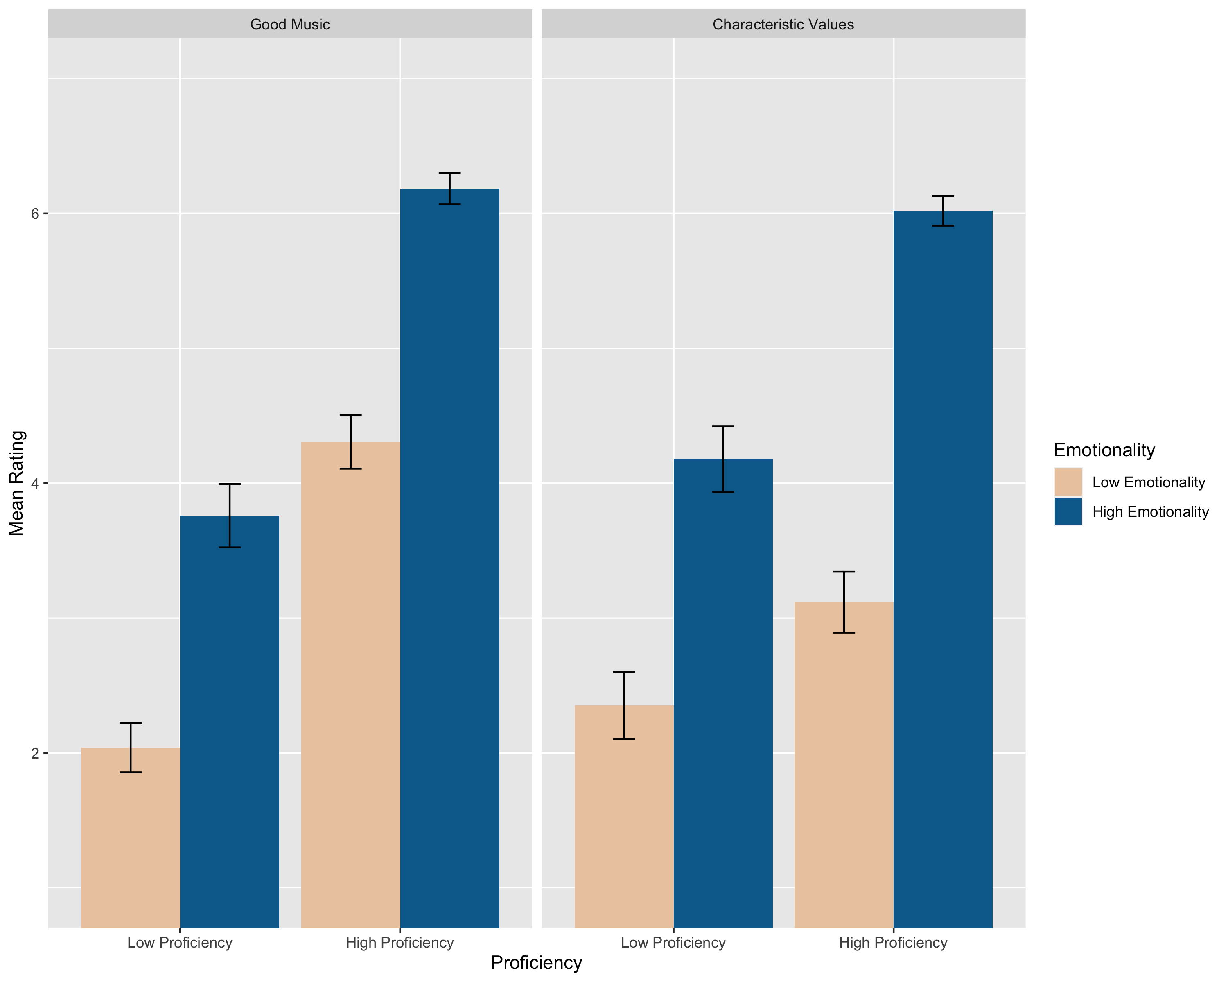
Figure 1: Means by condition for Study 1. Error bars show +/- 1 standard error.

In a separate study (not reported here), we gave participants actual music clips. We successfully replicated the key result of Study 1: emotional expression, more than proficiency, impacted judgments on what music is all about. For a complete report of the methods and results see, https://osf.io/5r7gb/?view_only=6fc1b31fee5241f6af86d58b54ad0b01

Study 2
The question now arises: is connection itself a musical value? We approach this question by exploring emotional expression in more detail. In particular, we ask which are the emotions whose expression in music is heard as capturing a characteristic musical value. We think the answer points to connection. Specifically, our hypothesis is that the emotions whose expression in music is heard as capturing what music is all about are precisely the emotions whose expression in conversation creates feelings of connection. Study 2 was designed to test this hypothesis.
To do so, we asked four hundred and fifty participants to read sentences about 72 different emotions and answer a question about each sentence. Some participants were asked about the characteristic values of music. For these participants, each emotion was introduced with a sentence of the form: “You hear an instrumental music piece that expresses feelings of _____.” They were then randomly assigned to receive one of three statements designed to get at the notion of characteristic values (“I think it embodies what music is really supposed to be about,” “I think it is true music,” “I think this music is soulful”).
Other participants were asked about connection in conversation. For these participants, each emotion was introduced with a sentence of the form: “An acquaintance is talking to you about their week and expresses feelings of _____.” They were then randomly assigned to receive one of three statements designed to get at the notion of connection (“I feel close to this person,” “I find this conversation emotionally engaging,” “I find this conversation meaningful”).
Finally, some participants were asked about the pleasantness of music. For these participants, each emotion was introduced with a sentence of the form: “You hear an instrumental music piece that expresses feelings of _____.” They were then randomly assigned to receive one of three statements designed to get at the notion of pleasant music (“I think this music is pleasant,” “I think this music is enjoyable,” “I would want to listen to this music”). We included this measure with the idea that works that embody what music is all about may not always be pleasant to hear. We wanted to gather data about pleasant music to differentiate between enjoyment and the quality of embodying what music is all about.
In sum, participants were assigned to one of 9 experimental conditions in a between-subjects design. All participants in all of the conditions responded to the questions on a 7-point scale ranging from 1= strongly disagree to 7 = strongly agree.
We found that the three questions for each condition (characteristic values, connection in conversation, and pleasant music) were highly related to each other, so we combined each of the three items to create single measures of Characteristic Values, Connection, and Pleasant Music.

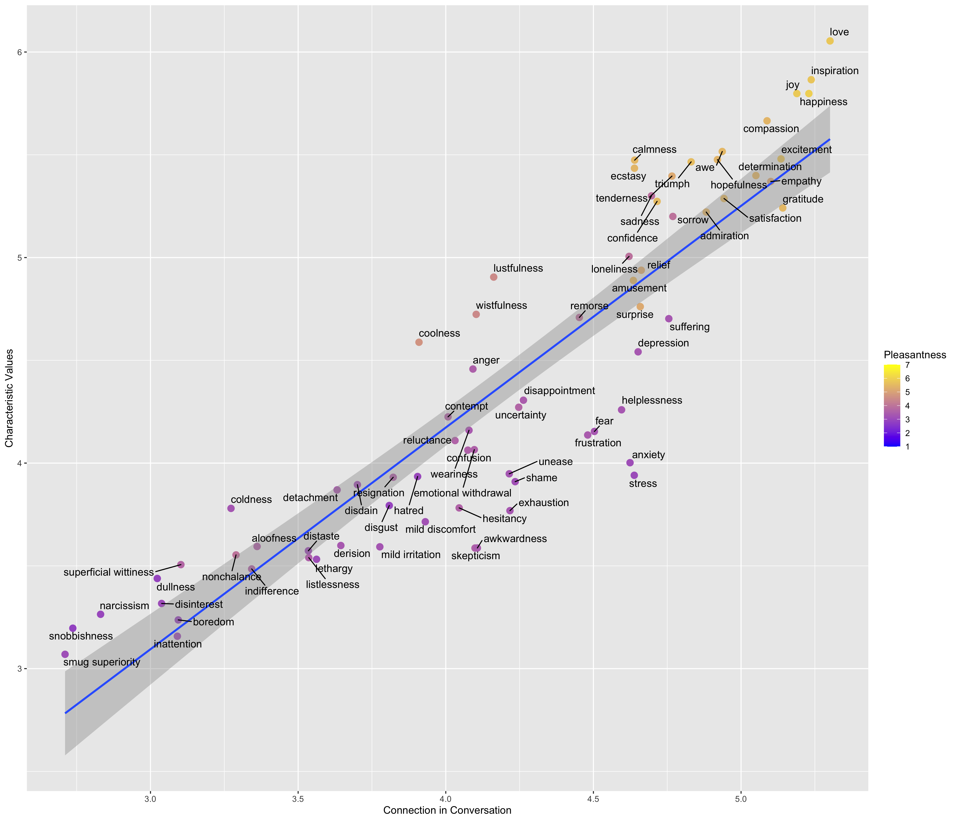Figure 2: Scatterplot showing ratings of Characteristic Values by Connection in Study 2. Colors
show Pleasant Music ratings.

Figure 2 shows the relationship between Characteristic Values and Connection. What we see is that judgments of music’s characteristic values can be predicted by judgments about connection in conversation. Specifically, the results indicate that the emotions that make people feel connected in conversation are also the emotions whose expression in music embodies what music is all about.
We think, of course, that this relation is no coincidence. It is the connective power of these emotions that makes the music that expresses them be heard as embodying music’s characteristic values. Or to put the point differently, we take it that creating this kind of connection is itself one of these values. Connection is thus not simply the causal effect of some forms of music—a non-musical phenomenon that music happens to facilitate—but rather a distinctively musical achievement intimately connected with the nature of music. And this means that to value a musical work for the connection it creates is to value it as music—as possessing a characteristic musical value.
It is worth noting, as we suspected in Section 3, that the relevant emotions are not only negative ones. The relation between Characteristic Values and Connection was also present in emotions such as love, compassion, and inspiration. In fact, these emotions received a higher Characteristic Values rating than emotions like sadness and sorrow. This is exactly what one would expect given the ratings on Connection, for despite the significant connective powers of sadness and suffering, love and inspiration still reigned supreme—people thought that conversations expressing love and inspiration are more connective than those expressing sadness and sorrow.
If we are on to something, and the value of sad music is to be explained by the connection it creates, and other emotions are capable of creating this connection, then the value of sad music would be of a piece with the value of loving and compassionate music. Sad music, that is, does not require a special explanation. Instead, once we see what’s of value in music that expresses love, the value of sad music comes into focus. The expression of sadness, just as the expression of love, makes for the special connection that embodies what music is all about.
Still, there is something special about the negative emotions, something that can be appreciated by looking at Figure 2. The colors of the points indicate how much each emotion makes for pleasant music. If you look at the points in the lower left corner, the results are unsurprising. Music that expresses snobbishness and inattention is unpleasant to listen to and also low on Characteristic Values. On the upper right corner, however, something more interesting emerges. Some of these emotions, like love or gratitude, are predictably the emotions that people find pleasant to listen to and also rated high in Characteristic Values. What is striking is that some emotions are highly unpleasant to listen to but—just as one would predict from their Connection ratings—very high in Characteristic Values. These emotions make for music that is not regarded as pleasant but that people still see as embodying a characteristic musical value. The emotions that have this distinctive property are precisely the ones that have been the focus of this entire paper: sadness, sorrow, loneliness, and so on.

6

We started out with the problem of negative emotion in art. Why do we value artworks that elicit emotions whose experience in most other contexts we disvalue? We argued that music deserves a special answer. In particular, music is different in one crucial respect. The value of sad music—in contrast to, say, that of horror films—does not lie in the experience of the negative emotion. What matters is not the evocation of sadness in the listener, but the expression of sadness in the music.
Our thesis is that music expressive of sadness gives rise to an experience of connection, a connection we can understand by analogy with that present in heartfelt conversations. It is this connection that gives sad music its value. But what kind of value is this? And aren’t we identifying the value of such music with something outside of music, thereby leaving the music behind? We argued that this value is in fact a musical value. Not, however, in the sense that possessing it makes the music good qua music. But rather in the sense that it captures what music is all about.
We presented two experiments in support of this claim. The first suggested that ordinary listeners consider the expression of emotion to be a characteristic musical value, even if the piece is not musically good. The second showed that not all emotions have this special place. That is, what’s distinctively musical is not the expression of any and all emotion, but rather the expression of some emotions in particular. The results suggest that the relevant emotions are those which connect people when expressed in conversation. They support the claim that connection in music is not an extra-musical value, but is rather a musical one. To value a work for the connection it creates is therefore to value it as music.
We value sad music because it connects us. To what exactly is a question for another day. But whether the connection is with other people, with ourselves or with the work of music, it is a connection that lies at the heart of music itself.

References

Budd, M. (1985). Music and the Emotions. Routledge.

Carroll, N. (2000). Art and ethical criticism: An overview of recent directions of research. Ethics, 110(2), 350-387.

Davies, S. (1994). Musical Meaning and Expression. Cornell University Press.

Del Pinal, G., & Reuter, K. (2017). Dual character concepts in social cognition: Commitments and the normative dimension of conceptual representation. Cognitive Science, 41, 477-501.

Eerola, T., Vuoskoski, J. K., & Kautiainen, H. (2016). Being moved by unfamiliar sad music is associated with high empathy. Frontiers in Psychology, 7, 1176, 1-12.

Eerola, T., Vuoskoski, J. K., Peltola, H. R., Putkinen, V., & Schäfer, K. (2018). An integrative review of the enjoyment of sadness associated with music. Physics of Life Reviews, 25, 100-121.

Feagin, S. L. (1983). The pleasures of tragedy. American Philosophical Quarterly, 20(1), 95-104.

Friedman, R. S., Gordis, E., & Förster, J. (2012). Re-exploring the influence of sad mood on music preference. Media Psychology, 15(3), 249-266.

Garrido, S., & Schubert, E. (2011). Individual differences in the enjoyment of negative emotion in music: A literature review and experiment. Music Perception, 28(3), 279-296.

Hospers, J. (1955). The concept of artistic expression. Proceedings of the Aristotelian Society, 55, 313-344.

Huron, D., & Vuoskoski, J. K. (2020). On the enjoyment of sad music: pleasurable compassion theory and the role of trait empathy. Frontiers in Psychology, 11, 1060.

Kawakami, A., & Katahira, K. (2015). Influence of trait empathy on the emotion evoked by sad music and on the preference for it. Frontiers in psychology, 6, 1541.

Kieran, M. (2006). Art, morality and ethics: On the (im)moral character of art works and inter‐relations to artistic value. Philosophy Compass, 1(2), 129-143.

Kivy, P. (1989). Sound Sentiment: An essay on the musical emotions, including the complete text of the corded shell. Temple University Press.

Kivy, P. (1999). Feeling the musical emotions. The British Journal of Aesthetics, 39(1), 1-13.

Knobe, J., Prasada, S., & Newman, G. E. (2013). Dual character concepts and the normative dimension of conceptual representation. Cognition, 127(2), 242-257.

Leslie, S. J. (2015). “Hillary Clinton is the only man in the Obama administration”: Dual character concepts, generics, and gender. Analytic Philosophy, 56(2), 111-141.

Levinson, J. (1996). The Pleasures of Aesthetics: Philosophical essays. Cornell University Press.

Levinson, J. (2006). Contemplating Art: Essays in aesthetics. Clarendon Press.

Levinson, J. (Ed). (2013). Suffering Art Gladly: The paradox of negative emotion in art. Springer.

Liao, S., Knobe, J., & Meskin, A. (2020). Dual character art concepts. Pacific Philosophical Quarterly, 102-128.

Reuter, K. (2019). Dual character concepts. Philosophy Compass, 14(1), e12557.

Ridley, A. (1995). Music, Value, and the Passions. Cornell University Press.

Robinson, J. (1994). The expression and arousal of emotion in music. The Journal of Aesthetics and Art Criticism, 52(1), 13-22.

Robinson, J. (2005). Deeper Than Reason: Emotion and its role in literature, music, and art. Oxford University Press.

Robinson, J. (2011). Expression theories. In T. Gracyk and A. Kania (Eds.), The Routledge Companion to Philosophy and Music (pp. 223-233). Routledge.

Scruton, R. (1998). The Aesthetic Understanding: Essays in the philosophy of art and culture. St. Augustine’s Press.

Scruton, R. (1999). The Aesthetics of Music. Oxford University Press.

Smuts, A. (2009). Art and negative affect. Philosophy Compass, 4(1), 39-55.

Smuts, A. (2011). Rubber Ring: Why do we listen to sad songs? In J. Gibson and N. Carroll (Eds.), Narrative, Emotion and Insight (pp. 131-153). Penn State University Press.

Strohl, M. (2019). Art and painful emotion. Philosophy Compass, 14(1), e12558.

Taruffi, L., & Koelsch, S. (2014). The paradox of music-evoked sadness: an online survey. PloS one, 9(10), e110490.

Tolstoy, L. (1898/1996). What is Art? Penguin Classics.

Vuoskoski, J. K., & Eerola, T. (2017). The pleasure evoked by sad music is mediated by feelings of being moved. Frontiers in Psychology, 8, 439.

Vuoskoski, J. K., Thompson, W. F., McIlwain, D., & Eerola, T. (2011). Who enjoys listening to sad music and why? Music Perception, 29(3), 311-317.

Walton, K. L. (1988). What is abstract about the art of music?. The Journal of Aesthetics and Art Criticism, 46(3), 351-364.

Watt, R. J., & Ash, R. L. (1998). A psychological investigation of meaning in music. Musicae Scientia, 22, 33-53.

Zangwill, N. (2007). Music, metaphor, and emotion. The Journal of Aesthetics and Art Criticism, 65(4), 391-400.

To watch a video of the performance, go to https://www.polyphonyproject.com/hu/song/BMI_UK16050061. The recording is part of the Polyphony Project, an endeavor to “explore, preserve and present the living musical folklore of Ukrainian villages.” See, https://www.polyphonyproject.com/en for further information and recordings.
The problem has traditionally been known as the paradox of tragedy. But philosophers have long recognized that the problem does not concern tragedy alone but extends to all art forms and artworks that tend to evoke negative emotions. The problem has thus come to be known as the paradox of negative emotion in art (Levinson, 2013) or the paradox of painful art (Smuts, 2009; Strohl, 2019).
The label comes from Levinson (2006).
There is some empirical evidence for this claim. In one survey, the majority of participants said they like to listen to sad music when in a negative mood, but only a third said they like listening to sad music when in a positive mood (Taruffi and Koelsch, 2014). Interestingly, experimental data suggest that the aversion to happy music when in a sad mood is stronger than the preference for sad music when sad (Friedman, Gordis, & Förster, 2012).
Smuts disagrees with us here, for he thinks that we seek sad songs to feel sadder.
See, e.g., Scruton (1998: 57).
Indeed, a remarkable pair of recent findings further support this conclusion. On the one hand, researchers have found an association between liking of sad music and the personality trait known as empathic concern, the disposition to feel compassion for the suffering of others. On the other hand, there seems to be no relation whatsoever between liking of sad music and trait personal distress, the disposition to actually feel or mirror what others in distress are feeling. This pattern of results suggests that a disposition to feel what the music expresses is not essential in our enjoyment of it. For the relevant studies, see Eerola et al., 2016; Garrido and Schubert, 2011; Kawakami and Katahira, 2015; Vuoskoski and Eerola, 2017; Vuoskoski et al., 2012. For insightful discussions of these results, see Eerola et al., 2018 and Huron and Vuoskoski, 2020.
For (very different) denials of the claim that sad music can elicit real, full-blown sadness, see Kivy (1989) and Walton (1988).
One can, of course, cherish the connection and delight in it when the music is not playing (or well after the conversation has ended). But even here it is the connection, in and of itself, that is of value.
Is the problem with the emotions typically expressed in small talk (e.g., annoyance, boredom) or with their intentional objects? What if one were to express annoyance for the loss of the American Dream or boredom at the prospect of a frozen, lifeless universe? Our sense is that both things are important: it is not a coincidence that ‘small talk emotions’ are typically about ‘small talk topics.’
Compare this view with what Budd calls expression-transmission theories of art. According to these theories, the artist has an experience she wishes to communicate by transmitting it to her audience. To that end, she creates an object—a painting, a poem, an opera—capable of transmitting (to those with the right sensibilities) her original experience. Such an experience, whose transmission is the purpose of the work, exists prior of, and thus independently from, the work itself. See Tolstoy’s (1899/1996) What is Art? for the locus classicus of expression-transmission views.
It doesn’t follow, of course, that only musical values can contribute to making the music good. Many philosophers have thought, for example, that a moral virtue can be an aesthetic one (see Carroll, 2000; Kieran, 2006 for reviews.) We take no part in that debate. The claim under consideration is simply that musical values necessarily contribute to the goodness of the music qua music.
One might claim that the successful expression of emotion is always a pro tanto virtue of the music, even if the piece is bad overall. Some philosophers hold what Zangwill (2007) calls the ‘evaluative direction thesis,’ the claim that “emotion descriptions of music function as explanation and justifications of judgments of aesthetic value” (396). That is, that calling the music sad is in itself a judgment that it is good. As will become clear, we disagree, though we don’t wish to dispute that emotion descriptions can be used evaluatively. Cf. Levinson’s ‘valuability requirement’ in his analysis of musical expressiveness (1996: 92).
Note that to say that x is a characteristic value of y is not to say that x is valuable (or that it isn’t). Consider: we can agree on what are the characteristic values of the Democratic Party while disagreeing profoundly about whether they are in fact valuable.
Participants recruited from Amazon’s Mechanical Turk (M_{age} = 38.06; 52.87% female). All methods and statistical analyses for this study were preregistered (see https://aspredicted.org/see_one.php?a_id=11462). For data and code for all studies in this paper, see https://osf.io/u3627/?view_only=6fc1b31fee5241f6af86d58b54ad0b01
Results were analyzed using a 2 (proficiency) x 2 (emotionality) x 2 (question type) ANOVA. Significant main effect of proficiency, F (1, 393) = 162.5, p < .001, η_{p}² = .042, and significant main effect of emotionality, F (1, 393) = 211.7, p < .001, η_{p}² = .054. No significant main effect of question type, F (1, 393) = 1.2, p =.280, η_{p}² < .001.
Significant interaction between question type and proficiency, F (1, 393) = 13.3, p < .001, η_{p}² = .003. Smaller effect of proficiency on responses to characteristic values, F (1,199) = 36.80, p < .001, η_{p}²=.022, than on responses to good music, F (1,393) = 154.92, p <.001, η_{p}²= .067.
Significant interaction between emotionality and question type, F (1, 393) = 3.9, p = .049, η_{p}² = .010. Larger effect of emotionality on responses to characteristic values, F (1, 199) = 121.34, p < .001, η_{p}² = .072, than on responses to good music, F (1, 199) = 91.16, p < .001, η_{p}²= .039.
There was also an unpredicted relationship whereby the impact of emotionality was slightly greater in the high proficiency compared to the low proficiency conditions, F (1, 393) = 4.6, p = .032, η_{p}² = .001. There was no significant three-way interaction.
Participants recruited from Amazon’s Mechanical Turk. All methods and statistical analyses for this study were preregistered (https://aspredicted.org/see_one.php?a_id=11462).
Characteristic Values α = .958, Connection α = .927, and Pleasant Music α = .992.
A partial correlation was conducted to determine if Characteristic Values is predicted by Connection while controlling for Pleasant Music. There was indeed a significant partial correlation, r (69) = .784, p < .001. In addition, we conducted a further exploratory analysis, which was not preregistered, to look at whether Characteristic Values is predicted by Connection when not controlling for Pleasant Music. This analysis also yielded a highly significant correlation, r (69) = .899, p < .001.

