The Birth and Death of Beauty in Western Art

(This is a shortened version of my paper “Beauty, Art and the Western Tradition”.)

In any discussion about the nature of art, the word beauty is likely to make an early appearance. If something is beautiful, we don’t necessarily think it is art, but if something is regarded as art, many people assume it must in some way be beautiful. In this sense, art and beauty seem to go hand in hand and if you pick up a modern textbook on aesthetics, chances are you will find that idea popping up very early in the piece.
Why is this the case? Is there really a necessary connection between the two ideas? Or is it perhaps an accident of history – the result of specific historical developments? I think it’s the latter. I think that the link between art and beauty was established during the major cultural revolution we call the Renaissance, and that, since then, the link has been broken by another cultural revolution that we call, for lack of a better term, “modern art”. So, my paper is about two revolutions: the first that conferred a sovereign power on the idea of beauty, the second that took that power away.
That’s a lot to do in twenty minutes but before I begin, one brief caveat. It’s probably true to say that the languages of all cultures, past and present, have included terms that roughly equate to the English term “beautiful”, just as they have doubtless included words roughly equivalent to, say, ugly, brave, dangerous, false, despicable, and so on. So, nothing in what I’ll say today is intended to suggest that Western culture has ever had a monopoly on the idea of beauty in ordinary, everyday senses of the term. All cultures, I assume, have been perfectly capable of expressing ideas roughly equivalent to “beautiful scene”, “beautiful woman”, “beautiful day”, and so on. So, the issue I’ll discuss has nothing to do with that. My concern is a particular idea of beauty – or more accurately, a particular idea for which the word “beauty” came to be used as the conventional label.
My explanation begins in pre-Renaissance times. As we know, the history of European civilization from Constantine until the Renaissance was largely a story of the spread and consolidation of the Christian religion, even if that process sometimes involved acute doctrinal disagreements. The central importance of religion during this period is, as we’d expect, reflected in the painting and sculpture of the times which is dominated by religious subjects. Here (next page) are two representative examples: the austere, commanding figure of the Christ in Majesty at Moissac in France, sculpted around 1100, and the equally impressive image of the Madonna and Child in the Torcello Cathedral in Venice, created a little earlier. Both works are now widely seen as masterpieces, but they also suggest something important about the Christian faith of the times. That faith was strongly dualistic in the sense that its God was wholly supramundane, essentially beyond the reach of human understanding. God was love, and humanity had access to Him through love, but this was sacred love and the ultimate mystery of God’s being remained inviolate.
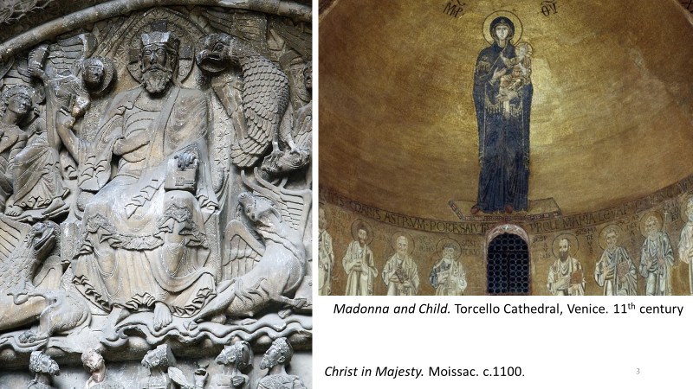
But a change was in the air in the form of a gradual rapprochement between man and God, and one notices it immediately if one compares a painting by Giotto, dating from the early fourteenth century, with the Madonna and Child in Torcello we’ve just considered. Both are powerful images but Giotto’s world, while still retaining the solemnity of a sacred realm, has taken on a human aspect which is absent in the Torcello mosaic. As one critic writes, “[Giotto] discovered a power of painting previously unknown in Christian art: the power of locating a sacred scene without sacrilege in a world resembling that of everyday life … For the first time, sacred scenes related no less to the world of God’s creatures than to the world of God.”
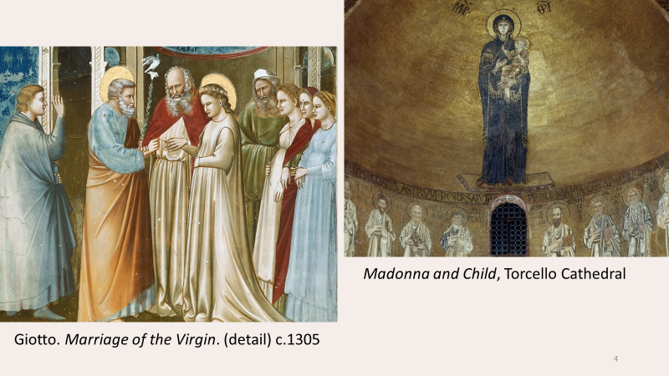
This was a turning-point in European art, with major consequences for the ensuing centuries. By depicting a world which “related no less to the world of God’s creatures than to the world of God”, Giotto had effectively brought the divine onto a plane nearer to man, and opened the door to a world in which humanity itself could share in qualities of the divine. It was the beginning of a new vision of transcendence rivalling that of religion – the discovery of an imaginary realm conveyed to the spectator by a power of the artist, distinct from his power of representing scenes from Scripture in that it no longer called forth veneration, but admiration.
In the course of the fifteenth century, this new vision of transcendence emerged into the full light of day and in exploring it, painting and sculpture also began to call on the mythology of Antiquity whose heroes, gods and goddesses seemed to offer a repertoire of exalted deeds befitting such a vision. For Botticelli, especially in his non-religious works, it was no longer just a question, as it had been for Giotto, of “locating a sacred scene without sacrilege in a world resembling that of everyday life” but now of creating a transfigured earthly realm that openly rivalled that of the sacred.
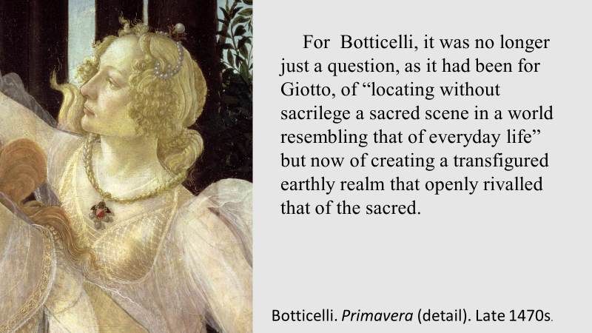

In short, a revolutionary development had taken place. Botticelli’s successors include all the major figures of Western art for the next four centuries – figures such as Raphael, Michelangelo, Titian, Poussin, Tiepolo, Watteau and even Delacroix in the nineteenth century; and common to them all, is the pursuit of a transfigured world which, by common consent, was summed up in the single word “beauty”. It is not necessarily an idyllic world. Sometimes, as in crucifixion scenes, for example, it depicts calamity and tragedy, but it is always a transfigured world – an exalted world pervaded by a sense of nobility, harmony and beauty. Sir Philip Sidney summed up the point in a well-known statement in his Apology for Poetry written in 1580, which I’ll illustrate by a work by Veronese painted coincidentally in the same year: Sidney wrote: “Nature never set forth the earth in so rich tapestry as divers poets have done. Her world is brazen, and the poets only deliver a golden”. And what was true of poetry was also true of visual art. The ambition of the post-Renaissance painter or sculptor was not simply to better mimic the world of appearances – Nature’s world of brass – but to evoke a vision of transcendence – a certain kind of beauty – whose fundamental 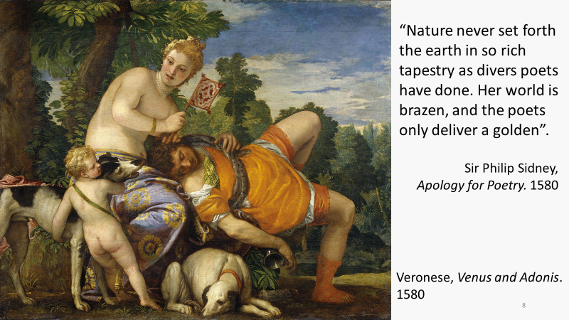inspiration, whether depicting religious scenes or not, no longer stemmed from religious faith but from an imagined “golden” world in which humanity itself was touched by a spark of the divine.
I have one more episode to recount in my highly abridged history of European art, but before I do, I’d like to make one or two broader remarks about what I’ve said so far. The Renaissance, as we’ve seen, saw the emergence of a form of art quite different from the religious works that had preceded it. In fact, the very term “art”, and the special prestige Europe attached to it, owes its emergence to the Renaissance because “art”, or “fine art” was the term that came to signify the new beauteous world that had come into being. There now existed in Europe something called “art” which had never existed before – anywhere or at any time. The word “art” had existed before, but it had never had this meaning. And by the eighteenth century, when Enlightenment philosophers such as Hume and Kant were laying the foundations of a philosophical aesthetics, this concept of art had become so deeply entrenched and widespread that it was simply taken for granted. Art was art because it embodied beauty; taste – a notion dear to the eighteenth century – was taste because it was the capacity to respond to beauty; and the aesthetic pleasure that art was said to evoke was a form of pleasure stimulated by beauty. But beauty in the context of art, one must always bear in mind, was a particular kind of beauty. Byzantine mosaics were not considered beautiful – in fact Vasari in the sixteenth century described them as clumsy, barbaric and grotesque; and mediaeval sculpture, likewise, was not beautiful, and much of it, as we know, was plastered over or destroyed. And of course, any suggestion that the beauty of art, might include a Buddhist statue, a Chinese painting, a pre-Columbian figurine, or an African carving would have been laughed out of court. Art was a special kind of transcendent, golden world – the beauteous world pursued by artists such as Michelangelo, Raphael, Leonardo, Titian, Poussin, Rubens and others in this same tradition; and well into the nineteenth century, painting or sculpture that lacked this attribute simply did not count.
But let me turn now to the final chapter in my very brief history and in so doing bring it up to date – that is, to the period we call modern and contemporary art.
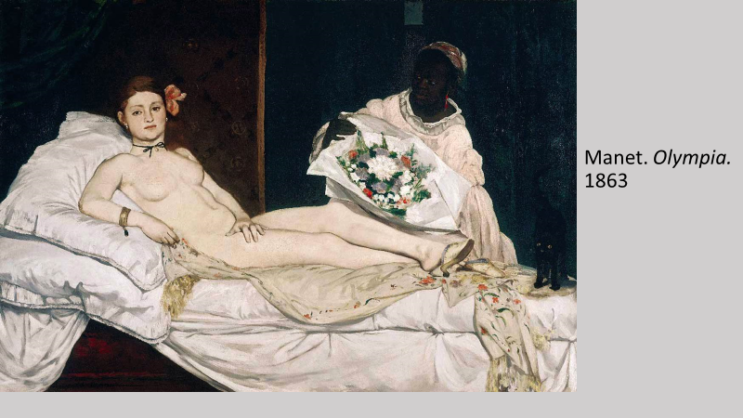
The Enlightenment has been blamed for many things, perhaps too many things, but something for which it is certainly largely responsible is the birth of what, for brevity, I shall call modern art. The effects were a little slow in coming because modern art was not born until the 1860s, sparked above all by Manet’s painting Olympia, painted in 1863 and first exhibited two years later. But the Enlightenment had done the groundwork through its relentless assaults on religion, and its insistence, motivated by the triumphs of science, that the path to truth lay solely through the empirical, observable fact. This new understanding of the world progressively undermined any sense of transcendence – any sense of an exalted “other world” – including the golden world on which art had until then depended. Manet’s painting, as we know, was ridiculed when first exhibited, the most frequent reproach, which I think rather surprises us today, being that it was ugly. To quote just a few contemporary reactions, Olympia was the embodiment of “perfect ugliness”, and “a sort of female gorilla”; her body had the “livid tint of a cadaver”; she was “a sort of monkey”, she was “incomprehensible”, and “never”, wrote one reviewer “has anything so strange been hung on the walls of an art exhibition”. Today these reactions seem rather strange but, seen in context, the sense of shock should not really surprise us. Olympia was a watershed in European art because it signalled nothing less than the death of the art of beauty that had ruled unchallenged since the Renaissance; and this event – “revolution” would be a better word – is readily illustrated by juxtaposing Olympia with Titian’s celebrated Venus d’Urbino, painted some three centuries earlier, to which it quite deliberately refers (next page). Olympia, writes 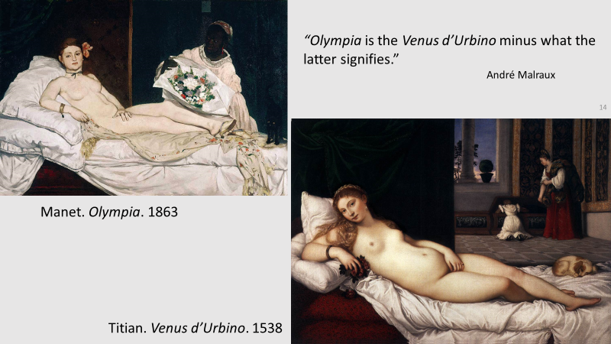one critic is “the Venus d’Urbino minus what the latter signifies” – by which he means that Manet gave birth to a new form of art that no longer aspired to create a golden world – that no longer pursued the beauteous imaginary world of Raphael, Titian, Poussin, Rubens and many others. Which immediately explains why so many of those who first saw Olympia judged it to be ugly and incomprehensible. It was ugly because it was no longer aspired to create an exalted world of harmony and beauty; and it was incomprehensible because that, after all, was what art was, and without that aspiration, there could be no art. For contemporary audiences, in other words, Olympia meant that art itself had been abandoned, and “a sort of female gorilla” had taken its place.
What had Manet substituted for the art of beauty? What new form of art did Olympia inaugurate? Manet had given birth to what we now call “modern art” – the form of art we’ve witnessed for the past century and a half which includes names such as Cézanne, Van Gogh, Chagall, Picasso, together with a host of more recent names we sometimes categorise as “contemporary art”. But what is this “modern art”? Unfortunately, I don’t have time to discuss this question and in any case my topic is the birth and death of beauty, not what replaced it. The key point, however, is that the death of beauty as an ideal did not, as it turned out, mean the death of art, although it did mean that the meaning of that word changed radically. For some five hundred years, the purpose of art had been to create a harmonious, imaginary world and the word “art” in post-Renaissance Europe never had any other meaning. Manet’s Olympia and the art it inspired by painters such as Renoir, Cézanne, Van Gogh and Picasso was not just painting in a different style; it was painting of a fundamentally different kind, as this juxtaposition of a Poussin and a Cézanne indicates (next page). Painting and sculpture of this different kind is still called art because the term has been hallowed by 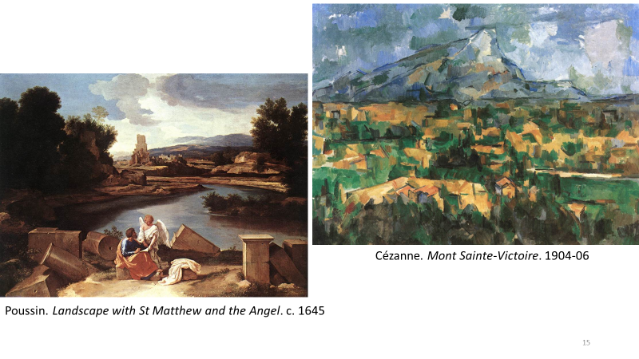centuries of usage and there is no other term available. But the impulse at the heart of this art has ceased to bear any resemblance to the aspirations of the art born with the Renaissance. Manet brought about a true artistic revolution whose consequences are still very much with us.
I’d like to make a few concluding remarks about the implications of all this for modern aesthetics, or to give it its other name, the philosophy of art. As I’ve mentioned, the notion of art as beauty, with attendant ideas such as taste and aesthetic pleasure, was fundamental to the various forms of philosophical aesthetics that emerged in the eighteenth century. And, after all, what else would we have expected? The idea of art-as-beauty was, by this time, firmly established in European culture, and if Enlightenment philosophers were to explain what art was, that idea would naturally be at the forefront of their thinking. As we’d expect, therefore, we encounter it again and again in writers such as Shaftesbury, Francis Hutcheson, Hume, Diderot, and Kant, Kant claiming, for example, in his well-known argument, that the distinctive pleasure underlying what he called judgments of taste is a harmony of the imagination and understanding elicited by the experience of beauty. And although nineteenth-century aesthetics found other fish to fry – especially the notion that art was intimately linked to historical change – it too fully endorsed the traditional association of art with beauty, Hegel for example claiming that Ancient Greek sculpture, which was then often seen as the archetype of great art, presents what he calls pure or “absolute” beauty. None of this is in any way surprising. Whatever philosophers today might like to tell themselves, philosophy is not always impervious to the cultural contexts from which it emerges, and since the notion of art-as-beauty was an unchallenged principle in the eighteenth century and most of the nineteenth, and had several centuries of tradition behind it, one would hardly expect philosophical accounts of art devised during those periods to be based on anything else. The works of Tintoretto, Poussin, Rubens and so many others were art, and art could not conceivably be anything else. This was not one school of thought among others: it was reality itself – the way things really were, and only a fool or an ignoramus could think otherwise.
All that, as I say, is quite understandable. What is less so, however, is that the notion of art-as-beauty still plays a very substantial role among writers in aesthetics today – some 150 years after Manet when so much of our modern world of art no longer bears any resemblance to a “harmonious imaginary world”. Not surprisingly, this situation is creating strains within modern aesthetics, springing in large measure from uncertainties about the importance traditionally placed on the idea of beauty. Some sense of the disarray can be seen in this comment by one of the leading figures in Anglo-American analytic aesthetics, who writes
[philosophical aesthetics] is literally disintegrating [and] what seem to be emerging are semi-autonomous intellectual domains, with their own questions, methods, and reference points, at best only loosely gathered under the heading of aesthetics, at worst barely recognizable as aesthetics at all.
Despite this, however, the influence of the eighteenth-century founding fathers, if I may so term them, remains very strong, and much of the academic discourse among modern philosophers of art continues to be framed around traditional ideas derived from Kant, Hume and their contemporaries. Certain adjustments have been made, of course, and the idea of beauty is now typically described in rather abstract, disembodied ways with little or no connection with the post-Renaissance tradition to which it belongs. At heart, nonetheless, modern philosophical aesthetics continues to see itself as the child of Enlightenment forebears and standardly looks to writers such as Hume and Kant as its seminal thinkers, if not its ultimate authorities. All of which, to my mind, is decidedly odd. In effect, large areas of modern aesthetics are behaving as if nothing fundamental has happened in the world of art over the last hundred and fifty years, as if the art-as-beauty era had never come to an end, and as if no revolutions had ever taken place.
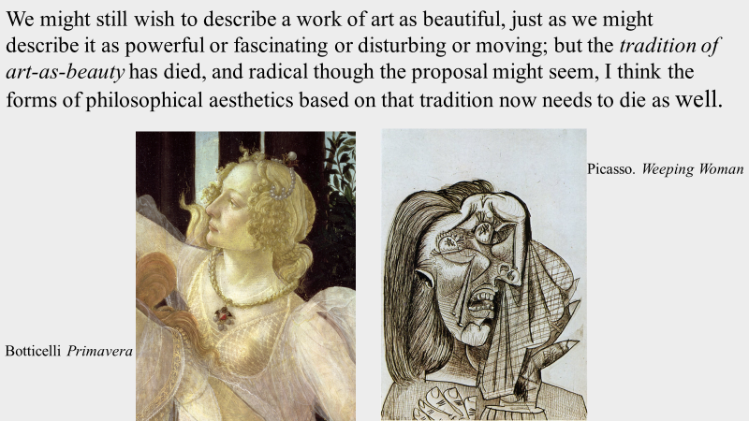

This is not a generalised attack on eighteenth century philosophy. Nor is it an attempt to argue that what Kant and Hume and their contemporaries wrote about art was somehow nonsensical. But it is an attack on the relevance of Enlightenment thinking about art to the world we live in today. The tradition to which that thinking refers – the tradition of art-as-beauty – has died: the life has gone out of it as surely as the life has gone out of the creative forces behind Classical Greek sculpture, or the works of ancient Egypt or Buddhist India. Today, we continue to use the word “art”, hallowed by centuries of cultural prestige, but the meaning of the term has changed radically. We might still, of course, wish to describe a particular work of art as beautiful, just as we might describe it as powerful or fascinating or disturbing or moving; but the tradition of art-as-beauty has died, and radical though the proposal might seem, I think the forms of philosophical aesthetics based on that tradition now needs to die as well.

This does not mean that we have ceased to admire works from these traditions, and many others. But that raises the question of the capacity of art to endure over time, which I have discussed in other papers and in my two books on art.

