Glass Classification Using Artificial Neural Network
Mohmmad Jamal El-Khatib, Bassem S. Abu-Nasser, Samy S. Abu-Naser
Department of Information Technology,
Faculty of Engineering and Information Technology,
Al-Azhar University - Gaza, Palestine

Abstract: As a type of evidence glass can be very useful contact trace material in a wide range of offences including burglaries and robberies, hit-and-run accidents, murders, assaults, ram-raids, criminal damage and thefts of and from motor vehicles. All of that offer the potential for glass fragments to be transferred from anything made of glass which breaks, to whoever or whatever was responsible. Variation in manufacture of glass allows considerable discrimination even with tiny fragments. In this study, we worked glass classification and testing of artificial neural network model created by the JustNN. The aim of the study is help investigator in identifying the type of glass found in arena of the crime. The Neural Network model was trained and validated using the type of glass dataset. The accuracy of model in predicting the type of glass reached 96.7%. Thus neural network is suitable for predicating type of glasses.
Keywords: Neural Networks, type of glass, justnn.

Introduction
Recent studies have indicated that 60% of cases involving glass provided some positive evidence and that in 40% of these cases this evidence was strong. Depending on circumstances, the findings can also refute the allegation that a person was involved in a crime.
For example, when a pane of glass is broken, minute glass fragments can be showered onto the hair, clothing and footwear of people in close proximity – at least 1.5 and possibly up to 3 meters away. The number of fragments transferred decreases rapidly with distance from the breaking pane. Aside from backwards projection of fragments towards the ‘breaker’, fragments can also be acquired, for example, by climbing through a broken window or treading on pieces of broken glass.
Fragments of glass recovered from hair and clothing are generally in the range 0.25 – 1 millimeter (1mm = 0.039). Most glass is lost fairly rapidly – depending on the activity of the wearer and the texture of their clothing. For example, a woolen jumper will tend to retain glass fragments for far longer than a leather jacket, although fragments can be trapped in pockets, in crevices on shoe uppers and remain embedded in shoe soles for long periods of time.
The results of surveys of the numbers and types of glass fragments found on the clothing of people selected at random shows that it is unusual to find more than a few fragments of glass from the same source on someone’s clothing purely by chance.

1.1 How to distinguish different glasses
By and large forensic scientists are interested only in freshly broken glass (clean and sharp-edged fragments) recovered from hair combings or the surfaces of garments, i.e. glass which could have been broken and/or acquired recently. These will be compared and contrasted with reference samples of broken glass, e.g. from the scene, by way of refractive index measurements (a measure of the degree to which the glass bends light) and chemical analysis tests. Refractive Index (RI) is a very accurate test which can distinguish between a large number of different glasses. If the recovered fragments differ in refractive index from a reference glass sample, then they could not have originated from the same piece of glass. Chemical analysis provides detailed information about the chemical constituents of the glass i.e. from the sand and other materials used in its manufacture. Chemical analysis, using, for example, a scanning electron microscope, can be used to distinguish between glass samples which have the same refractive index but different chemical composition.
In addition, the surfaces of glass fragments will be microscopically examined for evidence of the method of manufacture and the type of object from which they came, for example, flat glass and patterned glass (both from window panes) or curved glass (drinking glass or bottle). Further tests may be performed to see if the source was of toughened glass (forming small cubes when broken and typically found in some car windows and in door and window glazing).

1.2 Interpreting what’s found
If the recovered fragments match the reference sample both in RI and chemical composition it is necessary then to discover how rare or otherwise the glass might be. To do this the scientist may consult a computer database containing the combined results of the RI measurements and the chemical analysts results for each and every reference glass sample examined by his lab. This will show how many times a particular type of glass has been encountered, but this is not necessarily a reliable indication of how common it might be. This is because most glass samples submitted to forensic laboratories are from broken windows, although research has shown that glass found on clothing by chance is more likely to have originated from a container (such as a glass or a bottle). Aside from this, there tend to be local pockets of specific types of glass, e.g. from buildings all built at the same time. All this means that information held on the database might be skewed and should be treated with caution.
Aside from databases, the forensic scientist will also need to consider for example, the number and distribution of the glass fragments he has recovered and whether this fits in with the alleged circumstances.
The finding of numerous fragments of glass on a suspect detained within a few hours of windows being broken may be very strong evidence, for example if the glass is unusual and/or there is more than one type of matching glass. On the other hand, less weight would be given to the presence of one or two fragments of a common type of glass found on clothing seized several days after an incident.
Finally, it is often suggested that fragments might be transferred between people who come into contact after the crime has been committed, for example when they travelled side-by-side in a police vehicle. Whilst in theory this is quite conceivable, the results of tests show that only one or two fragments at most are likely to be transferred in this way and only a few remain on the seat occupied by the contaminated person.
We can help forensic scientists in distinguishing between different types of glass using an easier way, Artificial Neural Network. Artificial Neural network is getting popular now-a-days due to its capability of generalization and resistance to the noisy and erroneous data. A lot of research is undergoing to improve the efficiency and accuracy of the modeling and training of the neural network architecture. Although lot of research work has been done but still there is no profound theory about the exact number of size of the data, architecture of the network and the best suitable algorithm for the ANN modeling because selection of these parameters depends on the nature of the data.

Neural Network
Neural Network is the biological structure inspired by the working of human nervous system. Neural Network is being applied widely on different application areas due to its learning ability i.e. capability to extract rules and learn from the data and create a network model which can be used for classification, pattern recognition and forecasting on the data. Most promising feature of the Neural network that other classification techniques do not possess is that it helps to simulate the network and create model which can be used further and applied on the new data which was not previously exposed to the network.
JustNN is a tool which is used for Neural Network modeling. JNN tool helps in creating a neural network model to train and validate the data for classification of the data, find hidden patterns, clustering and future forecasting.

Glass Dataset: Case Study
We have used glass dataset for classification because it can prove to be very useful in crime investigation, behavior of glass material etc. The small pieces of glasses obtained from the crime sites can be very crucial evidence for the investigation purpose. We can create a neural network model and train it on glass data which can further help us to classify the unknown type of glass which was previously not exposed to the model. There are 2014 instances in the glass dataset with 10 input attributes and 1 output attribute (Type of glass).

Attribute Information: (Input attributes)
1) Id number 2) RI: refractive index 3) Na: Sodium 4) Mg: Magnesium 5) Al: Aluminum 6) Si: Silicon 7) K: Potassium 8) Ca: Calcium 9) Ba: Barium 10) Fe: Iron

Type of glass: (output attributes)
- Building_windows_float_processed
- Building_windows_non_float_processed
- Vehicle_windows_float_processed
- Vehicle_windows_non_float_processed
- Containers
- Tableware
- Headlamps

Details of the input and output attributes are explained above. Type of glass will depend on the values of the input attributes and by these values network will be trained and tested to classify that the record will lie in which Type of Glass. In Table 1, sample dataset has been displayed.

Table (1): Sample data of the actual glass dataset
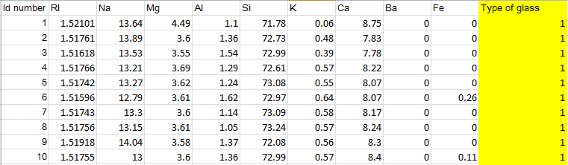

Experimentation
Experiment was performed on the JNN Tool with the glass dataset as explained above. In this experiment that dataset consists of 214 samples. We divided the dataset to 154 training samples and 60 validation samples. We have created the neural network model by the help of the JNN associated with the layers of the network and analyzed its effect on the classification of the type of glass and the average error obtained in the results. The ANN network model consists of input layer with 10 neurons, 3 hidden layers (7 x 1 x 1) neurons and 1 output layer with one neuron.
Figure 1: and Figure 2: are the screen shots taken from the JNN Tool. Figure 1: shows the neural network model created for glass data classification. This figure describes the architecture of the model created and how input parameters are connected to hidden layers and further hidden layers are connected to output layer. Figure 2: Neural Network input importance which is the sum of the absolute weights of the connections from the input node to all the nodes in the first hidden layer.
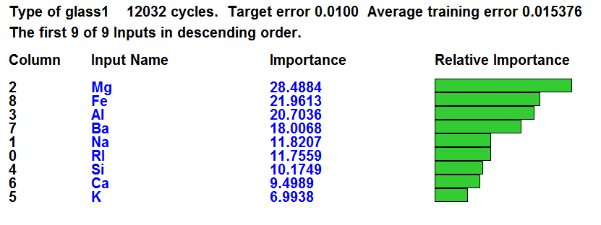
Figure (1): Neural Network input importance.

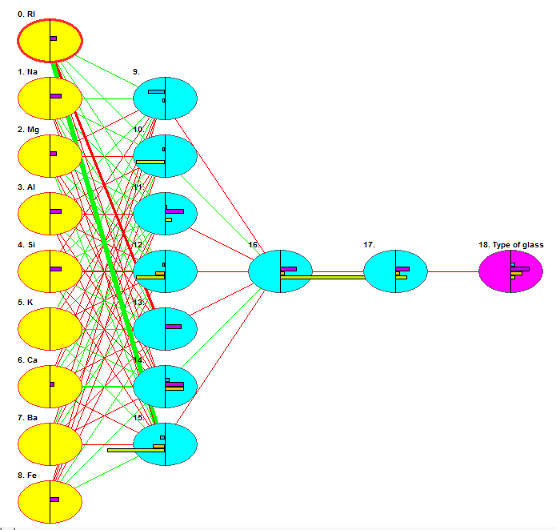
Figure (2): Neural Network Model created by JNN.
We first normalized the dataset then uploaded it in JNN environment. We chose the number of hidden layers, divided the dataset to training and validating samples as discussed above. We trained and validated the ANN Model until we got accuracy 96.70%. The average error was 0.0153. The number of epochs is 12032. The evaluation of the ANN model is shown in Figure 3.

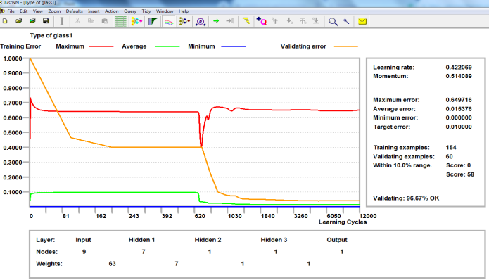

Figure (3): Neural network learning chart

Conclusion
By the above results obtained we have observed that:
- It has been found that as the number of times we train our network model the average error decreases as observed from the results obtained from figure 3.But overtraining may also lead to increase in error.
- ANN is suitable for glass type classification
- The accuracy was 96.7% which promising percentage for glass type classifications.

References
- https://www.forensic-access.co.uk/glass-trace-evidence-forensic/, was retrieved 20/11/2018.
- "Job Description for Forensic Laboratory Scientists". Crime Scene Investigator EDU. Archived from the original on 6 September 2015. Retrieved 28 August 2015.
- "Sections". American Academy of Forensic Sciences. 27 August 2015. Archived from the original on 30 August 2015. Retrieved 28 August 2015.
- Shorter Oxford English Dictionary (6th ed.), Oxford University Press, 2007, ISBN 978-0-19-920687-2
- Schafer, Elizabeth D. (2008). "Ancient science and forensics". In Ayn Embar-seddon, Allan D. Pass (eds.). Forensic Science. Salem Press. p. 40. ISBN 978-1-58765-423-7.
- "Forensics Timeline". Cbsnews.com. Archived from the original on 29 June 2011. Retrieved 2011-12-20.
- A Brief Background of Forensic Science Archived 16 December 2009 at the Wayback Machine.
- Abu-Naser, S., Al-Masri, A., Sultan, Y. A., & Zaqout, I. (2011). A prototype decision support system for optimizing the effectiveness of elearning in educational institutions. International Journal of Data Mining & Knowledge Management Process (IJDKP), 1, 1-13.
- Abu Naser, S., Zaqout, I., Ghosh, M. A., Atallah, R., & Alajrami, E. (2015). Predicting Student Performance Using Artificial Neural Network: in the Faculty of Engineering and Information Technology. International Journal of Hybrid Information Technology, 8(2), 221-228.
- Elzamly, A., Abu Naser, S. S., Hussin, B., & Doheir, M. (2015). Predicting Software Analysis Process Risks Using Linear Stepwise Discriminant Analysis: Statistical Methods. Int. J. Adv. Inf. Sci. Technol, 38(38), 108-115.
- Abu Naser, S. S. (2012). Predicting learners performance using artificial neural networks in linear programming intelligent tutoring system. International Journal of Artificial Intelligence & Applications, 3(2), 65.
- Elzamly, A., Hussin, B., Abu Naser, S. S., Shibutani, T., & Doheir, M. (2017). Predicting Critical Cloud Computing Security Issues using Artificial Neural Network (ANNs) Algorithms in Banking Organizations. International Journal of Information Technology and Electrical Engineering, 6(2), 40-45.
- Abu Naser, S. S., & Al-Bayed, M. H. (2016). Detecting Health Problems Related to Addiction of Video Game Playing Using an Expert System. World Wide Journal of Multidisciplinary Research and Development, 2(9), 7-12.
- Abu Ghali, M. J., Mukhaimer, M. N., Abu Yousef, M. K., & Abu Naser, S. S. (2017). Expert System for Problems of Teeth and Gums. International Journal of Engineering and Information Systems (IJEAIS), 1(4), 198-206.
- Abu Naser, S., & Akkila, A. N. (2008). A Proposed Expert System for Skin Diseases Diagnosis. INSInet Publication. Journal of Applied Sciences Research, 4(12), 1682-1693.
- El Agha, M., Jarghon, A., & Abu Naser, S. S. (2017). Polymyalgia Rheumatic Expert System. International Journal of Engineering and Information Systems (IJEAIS), 1(4), 125-137.
- Abu Naser, S., Al-Dahdooh, R., Mushtaha, A., & El-Naffar, M. (2010). Knowledge management in ESMDA: expert system for medical diagnostic assistance. AIML Journal, 10(1), 31-40.
- Almurshidi, S. H., & Abu-Naser, S. S. (2018). EXPERT SYSTEM FOR DIAGNOSING BREAST CANCER. Al-Azhar University, Gaza, Palestine.
- Abu Naser, S. S., & Alawar, M. W. (2016). An expert system for feeding problems in infants and children. International Journal of Medicine Research, 1(2), 79-82.
- Al Rekhawi, H. A., Ayyad, A. A., & Abu Naser, S. S. (2017). Rickets Expert System Diagnoses and Treatment. International Journal of Engineering and Information Systems (IJEAIS), 1(4), 149-159.
- Abu Naser, S. S., & AlDahdooh, R. M. (2016). Lower Back Pain Expert System Diagnosis and Treatment. Journal of Multidisciplinary Engineering Science Studies (JMESS), 2(4), 441-446.
- Nabahin, A., Abou Eloun, A., & Abu Naser, S. S. (2017). Expert System for Hair Loss Diagnosis and Treatment. International Journal of Engineering and Information Systems (IJEAIS), 1(4), 160-169.
- Abu Naser, S. S., & Alhabbash, M. I. (2016). Male Infertility Expert system Diagnoses and Treatment. American Journal of Innovative Research and Applied Sciences, 2(4).
- Qwaider, S. R., & Abu Naser, S. S. (2017). Expert System for Diagnosing Ankle Diseases. International Journal of Engineering and Information Systems (IJEAIS), 1(4), 89-101.
- Abu Naser, S. S., & Al-Hanjori, M. M. (2016). An expert system for men genital problems diagnosis and treatment. International Journal of Medicine Research, 1(2), 83-86.
- Naser, S. S. A., & Hasanein, H. A. A. (2016). Ear Diseases Diagnosis Expert System Using SL5 Object. World Wide Journal of Multidisciplinary Research and Development, 2(4), 41-47.
- Nassr, M. S., & Abu Naser, S. S. (2018). Knowledge Based System for Diagnosing Pineapple Diseases. International Journal of Academic Pedagogical Research (IJAPR), 2(7), 12-19.
- Abu Naser, S. S., & El-Najjar, A. E. A. (2016). An expert system for nausea and vomiting problems in infants and children. International Journal of Medicine Research, 1(2), 114-117.
- Elqassas, R.,& Abu-Naser, S. S. (2018). Expert System for the Diagnosis of Mango Diseases. International Journal of Academic Engineering Research (IJAER) 2 (8), 10-18.
- Naser, S. S. A., & Hilles, M. M. (2016). An expert system for shoulder problems using CLIPS. World Wide Journal of Multidisciplinary Research and Development, 2(5), 1-8.
- Musleh, M. M., & Abu-Naser, S. S. (2018). Rule Based System for Diagnosing and Treating Potatoes Problems. International Journal of Academic Engineering Research (IJAER) 2 (8), 1-9.
- Abu Naser, S. S., & Hamed, M. A. (2016). An Expert System for Mouth Problems in Infants and Children. Journal of Multidisciplinary Engineering Science Studies (JMESS), 2(4), 468-476.
- Almadhoun, H., & Abu-Naser, S. (2017). Banana Knowledge Based System Diagnosis and Treatment. International Journal of Academic Pedagogical Research (IJAPR), 2(7), 1-11.
- Abu Naser, S. S., & Mahdi, A. O. (2016). A proposed Expert System for Foot Diseases Diagnosis. American Journal of Innovative Research and Applied Sciences, 2(4), 155-168.
- Dahouk, A. W., & Abu-Naser, S. S. (2018). A Proposed Knowledge Based System for Desktop PC Troubleshooting. International Journal of Academic Pedagogical Research (IJAPR) 2 (6), 1-8
- Abu Naser, S. S., & Ola, A. Z. A. (2008). AN EXPERT SYSTEM FOR DIAGNOSING EYE DISEASES USING CLIPS. Journal of Theoretical & Applied Information Technology, 4(10).
- Bakeer, H., & Abu-Naser, S. S. (2017). Photo Copier Maintenance Expert System V. 01 Using SL5 Object Language. International Journal of Engineering and Information Systems (IJEAIS) 1 (4), 116-124.
- Abu Naser, S. S., & Shaath, M. Z. (2016). Expert system urination problems diagnosis. World Wide Journal of Multidisciplinary Research and Development, 2(5), 9-19.
- Khella, R., & Abu-Naser, S. S. (2017). Rule Based System for Chest Pain in Infants and Children. International Journal of Engineering and Information Systems 1 (4), 138-148.
- Abu-Naser, S. S., El-Hissi, H., Abu-Rass, M., & El-Khozondar, N. (2010). An expert system for endocrine diagnosis and treatments using JESS. Journal of Artificial Intelligence; Scialert, 3(4), 239-251.
- Mrouf, A., Albatish, I., Mosa, M., & Abu Naser, S. S. (2017). Knowledge Based System for Long-term Abdominal Pain (Stomach Pain) Diagnosis and Treatment. International Journal of Engineering and Information Systems (IJEAIS) 1 (4), 71-88.
- Abu Naser, S. S., Baraka, M. H.,& Baraka, A. R. (2008). A Proposed Expert System For Guiding Freshman Students In Selecting A Major In Al-Azhar University, Gaza.Journal of Theoretical & Applied Information Technology 4(9).
- Abu-Nasser, B. S., & Abu-Naser, S. S. (2018). Cognitive System for Helping Farmers in Diagnosing Watermelon Diseases. International Journal of Academic Information Systems Research (IJAISR) 2 (7), 1-7.
- Abu Naser, S. S., Alamawi, W. W., & Alfarra, M. F. (2016). Rule Based System for Diagnosing Wireless Connection Problems Using SL5 Object. International Journal of Information Technology and Electrical Engineering 5(6), 26-33.
- Akkila, A. N., & Abu Naser, S. S. (2016). Proposed Expert System for Calculating Inheritance in Islam. World Wide Journal of Multidisciplinary Research and Development 2 (9), 38-48.
- Abu Naser, S. S., & Zaqout, I. S. (2016). Knowledge-based systems that determine the appropriate students major: In the faculty of engineering and information technology, World Wide Journal of Multidisciplinary Research and Development 2 (10), 26-34.
- AbuEl-Reesh, J. Y., & Abu Naser, S. S. (2017). A Knowledge Based System for Diagnosing Shortness of Breath in Infants and Children. International Journal of Engineering and Information Systems (IJEAIS) 1 (4), 102-115.
- Abu Naser, S. S., & Bastami, B. G. (2016). A proposed rule based system for breasts cancer diagnosis. World Wide Journal of Multidisciplinary Research and Development 2 (5), 27-33.
- Abu-Nasser, B. S. (2017). Medical Expert Systems Survey. International Journal of Engineering and Information Systems, 1(7), 218-224.
- Abu Naser, S. S., & ALmursheidi, S. H. (2016). A Knowledge Based System for Neck Pain Diagnosis. World Wide Journal of Multidisciplinary Research and Development (WWJMRD), 2(4), 12-18.
- Azaab, S., Abu Naser, S., & Sulisel, O. (2000). A proposed expert system for selecting exploratory factor analysis procedures. Journal of the College of Education 4 (2), 9-26.
- Abu-Naser, S. S., Kashkash, K. A., & Fayyad, M. (2010). Developing an expert system for plant disease diagnosis. Journal of Artificial Intelligence, 3 (4), 269-276.
- Barhoom, A. M., & Abu-Naser, S. S. (2018). Black Pepper Expert System. International Journal of Academic Information Systems Research, (IJAISR) 2 (8), 9-16.
- AlZamily, J. Y., & Abu-Naser, S. S. (2018). A Cognitive System for Diagnosing Musa Acuminata Disorders. International Journal of Academic Information Systems Research, (IJAISR) 2 (8), 1-8.
- Alajrami, M. A., & Abu-Naser, S. S. (2018). Onion Rule Based System for Disorders Diagnosis and Treatment. International Journal of Academic Pedagogical Research (IJAPR), 2 (8), 1-9.
- Al-Shawwa, M., Al-Absi, A., Abu Hassanein, S., Abu Baraka, K., & Abu-Naser, S. S. (2018). Predicting Temperature and Humidity in the Surrounding Environment Using Artificial Neural Network. International Journal of Academic Pedagogical Research (IJAPR), 2(9), 1-6.
- Salah, M., Altalla, K., Salah, A., & Abu-Naser, S. S. (2018). Predicting Medical Expenses Using Artificial Neural Network. International Journal of Engineering and Information Systems (IJEAIS), 2(20), 11-17.
- Marouf, A., & Abu-Naser, S. S. (2018). Predicting Antibiotic Susceptibility Using Artificial Neural Network. International Journal of Academic Pedagogical Research (IJAPR), 2(10), 1-5.
- Jamala, M. N., & Abu-Naser, S. S. (2018). Predicting MPG for Automobile Using Artificial Neural Network Analysis. International Journal of Academic Information Systems Research (IJAISR), 2(10), 5-21.
- Kashf, D. W. A., Okasha, A. N., Sahyoun, N. A., El-Rabi, R. E., & Abu-Naser, S. S. (2018). Predicting DNA Lung Cancer using Artificial Neural Network. International Journal of Academic Pedagogical Research (IJAPR), 2(10), 6-13.
- Metwally, N. F., AbuSharekh, E. K., & Abu-Naser, S. S. (2018). Diagnosis of Hepatitis Virus Using Artificial Neural Network. International Journal of Academic Pedagogical Research (IJAPR), 2(11), 1-7.
- Heriz, H. H., Salah, H. M., Abdu, S. B. A., El Sbihi, M. M., & Abu-Naser, S. S. (2018). English Alphabet Prediction Using Artificial Neural Networks. International Journal of Academic Pedagogical Research (IJAPR), 2(11), 8-14.
- El_Jerjawi, N. S., & Abu-Naser, S. S. (2018). Diabetes Prediction Using Artificial Neural Network. International Journal of Advanced Science and Technology, 124, 1-10.
- Ashqar, B. AM, & Abu-Naser, S. S. (2019). Image-Based Tomato Leaves Diseases Detection Using Deep Learning. International Journal of Academic Engineering Research (IJAER) 2 (12), 10-16.
- Al-Shawwa, M., & Abu-Naser, S. S. (2019). Predicting Birth Weight Using Artificial Neural Network. International Journal of Academic Health and Medical Research (IJAHMR), 3(1), 9-14.
- Al-Mubayyed, O. M., Abu-Nasser, B. S., & Abu-Naser, S. S. (2019). Predicting Overall Car Performance Using Artificial Neural Network. International Journal of Academic and Applied Research (IJAAR), 3(1), 1-5.
- Afana, M., Ahmed, J., Harb, B., Abu-Nasser, B. S., & Abu-Naser, S. S. (2018). Artificial Neural Network for Forecasting Car Mileage per Gallon in the City. International Journal of Advanced Science and Technology, 124, 51-59.
- Alghoul, A., Al Ajrami, S., Al Jarousha, G., Harb, G., & Abu-Naser, S. S. (2018). Email Classification Using Artificial Neural Network. International Journal of Academic Engineering Research (IJAER), 2(11), 8-14.
- Al-Massri, R., Al-Astel, Y., Ziadia, H., Mousa, D. K., & Abu-Naser, S. S. (2018). Classification Prediction of SBRCTs Cancers Using Artificial Neural Network. International Journal of Academic Engineering Research (IJAER), 2(11), 1-7.
- Sadek, R. M., Mohammed, S. A., Abunbehan, A. R. K., Ghattas, A. K. H. A., Badawi, M. R., Mortaja, M. N., . . . Abu-Naser, S. S. (2019). Parkinson’s Disease Prediction Using Artificial Neural Network. International Journal of Academic Health and Medical Research (IJAHMR), 3(1), 1-8.
- Alkronz, E. S., Moghayer, K. A., Meimeh M., Gazzaz, M., Abu-Nasser, B. S., & Abu-Naser, S. S. (2019). Prediction of Whether Mushroom is Edible or Poisonous Using Back-propagation Neural Network. International Journal of Academic and Applied Research (IJAAR), 3(2).
- Nasser, I. M., & Abu-Naser, S. S. (2019). Artificial Neural Network for Predicting Animals Category. International Journal of Academic and Applied Research (IJAAR), 3(2).
- Al-Shawwa, M., & Abu-Naser, S. S. (2019). Predicting Effect of Oxygen Consumption of Thylakoid Membranes (Chloroplasts) from Spinach after Inhibition Using Artificial Neural Network. International Journal of Academic Engineering Research (IJAER), 3(2).
- Nasser, I. M., Al-Shawwa, M., & Abu-Naser, S. S. (2019). A Proposed Artificial Neural Network for Predicting Movies Rates Category. International Journal of Academic Engineering Research (IJAER), 3(2).
- Nasser, I. M., & Abu-Naser, S. S. (2019). Predicting Tumor Category Using Artificial Neural Networks. International Journal of Academic Health and Medical Research (IJAHMR), 3(2).
- Nasser, I. M., Al-Shawwa, M., & Abu-Naser, S. S. (2019). Developing Artificial Neural Network for Predicting Mobile Phone Price Range. International Journal of Academic Information Systems Research (IJAISR), 3(2).
- Nasser, I. M., Al-Shawwa, M., & Abu-Naser, S. S. (2019). Artificial Neural Network for Diagnose Autism Spectrum Disorder. International Journal of Academic Information Systems Research (IJAISR), 3(2).

