Measuring Perceived Service Quality and Client Satisfaction of the Volunteer Income Tax Assistance (VITA) Program in Rhode Island
2017 Client Satisfaction Study
Anne T. Quinterno, MPA
Executive Summary
Founded during the Nixon administration in 1971, the mission of the Volunteer Income Tax Assistance (VITA) Program is to assist eligible taxpayers in satisfying their income tax responsibilities by providing free income tax return preparation utilizing IRS trained and certified volunteers. One of the focal points of VITA is to raise taxpayer awareness of the Earned Income Tax Credit (EITC) program, which was enacted during the Ford administration, by the Tax Reduction Act of 1975. EITC eliminates the income tax liability for many low-to-moderate-income workers, and is one of the nation’s largest and most effective anti-poverty programs.
The premise for this study was:
IF the Volunteer Income Tax Assistance (VITA) program provides free income tax preparation services that are timely, courteous, and professional, THEN client satisfaction with service timeliness, service courteousness, and professionalism occurs.
In their paper titled, Measuring Customer Satisfaction, King County, Seattle, Washington, states, “The ultimate goals for all customer service should
be ‘service excellence.’ Customer satisfaction results are important to understand service delivery, and will be used to improve service. Customer satisfaction
measurement should focus on the entire customer experience, not just the final result or decision. Every program should strive to obtain scientifically representative and valid data. Customer satisfaction data collection efforts should be proximal, or close in time, to the time of service interaction. Assess customer
satisfaction when a customer’s experience is fresh. Measurement should reflect the various ways (channels or methods) customers access the service.”

Many low and middle-income workers cannot afford to pay a tax professional to prepare an income tax return. This often means they are unaware they may qualify for the EITC, which can put more money directly into the pockets of those who need it most. In New England, the average cost for tax preparation is about $246 per return. For 2017, VITA sites throughout Rhode Island assisted people who earned $55,000 or less in 2016.

For purposes of this study the VITA program (service quality) represents X. The scale that was used for X was found in Measuring Perceived Service Quality Using SERVQUAL: A Case Study of the Croatian Hotel Industry. The scale used for Y (satisfaction) was found in Development of a satisfaction scale for young people attending youth mental health services, Early Intervention in Psychiatry. Each study reported an alpha of .953.
There were 135 completed surveys used in the study with no missing data. The survey had 32 questions, and used a 5-point Likert scale with 5=Agree and 1=Disagree. Age, gender, and race were the intervening variables. Age was taken as a specific number rather a range. 49.6% of respondents were female, and 50.5% were male. There were 68 men and 67 women. Of the 135 respondents, 35.6% were Caucasian, 33.3% were Hispanic, 27.4% were African
American, and 3.7% were Native American. There was no statistically significant difference between groups of male and female in satisfaction or service quality.
Validity and reliability analyses were conducted. The analysis of the completed surveys reported the alpha to be .961 and .967 of Y and X respectively. These alphas exceed the given alphas of .953, and show an improved validity and reliability over the original scales.

The lowest perception item was Question 22, with only 97/135 respondents choosing ‘Agree’. The question was:
“The tax preparation hours are convenient”
The highest perception item was Question 28, with 120/135 choosing ‘Agree’. The question was:
“The VITA volunteers were courteous”

Perceptions of VITA satisfaction are the degree to which clients find various VITA site attributes important in enhancing their income tax preparation experience. The main dimensions of perceived VITA client satisfaction are reliability and accessibility, or service quality. The findings of this study reveal that between the two dimensions (reliability and accessibility); reliability has emerged as the most important predictor of client satisfaction. Therefore, it can be concluded, that the scales chosen are suitable to gain interpretable and reliable data on VITA client’s satisfaction of the service performed.

Program recommendations:
- Expand hours available for tax preparation at each site
- For the convenience of clients, divide the method of seeing clients to both walk-ins and fixed appointments
Volunteer Income Tax Assistance (VITA) Program
2017 Client Satisfaction Study

I. Statement of Program/Policy/Cause and Effect Premise

- If/Then Format of statement
If a Volunteer Income Tax Assistance (VITA) program provides free income tax preparation service, that is timely, courteous, and professional, then client satisfaction with service timeliness, service courteousness, and professionalism will occur.

- Explanation of statement in clear English Language Terms
The measure of client satisfaction, loyalty, and trust occur when the client receives a service that meets or exceeds expectations. Client “satisfaction is dependent on several factors, such as the quality of the product, the quality of the service provided, the atmosphere of the location where the product or service is purchased, and the price of the product or service.” Clients will be satisfied with the service provided by the VITA program if the service is timely, courteous, and professional, and the atmosphere is clean, comfortable, and welcoming.

- Context of Program (physical location, professionals involved)
The mission of the VITA program is to assist eligible taxpayers in
satisfying their tax responsibilities by providing free income tax return preparation. The VITA program places additional emphasis on the Earned Income Tax Credit (EITC) program, which was enacted during the Ford administration by the Tax Reduction Act of 1975. EITC, eliminates the income tax liability for many low-income workers, and is one of the nation’s most effective anti-poverty programs.

During the 2017 VITA season, there were approximately 22 VITA sites in RI, primarily operated by volunteers. All VITA Volunteers must complete the Internal Revenue Service (IRS) Volunteer Standards of Conduct (VSC) certification prior to working at a VITA site. In addition, all tax return preparers and reviewers must complete IRS online tax preparation certifications prior to preparing or reviewing tax returns at a VITA site. A minimum score of 80/100 must be achieved for each certification. These certifications are to be found online at www.irs.gov.

During hours of operation, each VITAsite is staffed at any one time by a site director, a site coordinator, a greeter, and

approximately 6 (more or less) VITA certified volunteer tax preparers and reviewers. Each VITA site operates during various daytime,
evening, and weekend hours, depending on their individual location and clientele served. According to IRS requirements, all sites must be open for several hours during one evening and one weekend day each week to accommodate working people. The VITA sites all provide on-site various community and social services, which are offered to VITA clients during their visit.

During hours of operation, some of the VITA sites offer first-come, first-served, walk-in service, whereby clients will either sign in upon arrival or be given a number in the order of their arrival. Other sites offer appointment-only service, whereby clients would have to call the site in advance to make an appointment. Generally, for each VITA site, upon arrival clients are greeted by a volunteer greeter and are asked to show all of the documents they are required to bring in order to have their taxes prepared. The required documents are as follows:
- Social Security card
- Photo ID
- Copy of previous year’s income tax return
- Child & dependent care expense documentation
- Proof of health insurance

- Bank account and routing information for direct deposit

Once the greeter has checked all documents, clients are provided with a writing implement and clipboard containing an IRS Intake Form in either English or Spanish. This form is filled-out with or without the assistance of a volunteer as needed.

The client will bring their completed Intake form with them when they are called to sit with the tax preparer. The preparer will go over each question on the form with the client, and use the information on the form to assist in completing the online tax return. The Intake form is designed and printed by the IRS to provide the basis for the client’s income tax return. Once the tax return is complete, the client will move on to the final stage of the process to have their return reviewed for accuracy. The review is performed by an advanced trained and certified volunteer income tax preparer. Once the review has been completed, the client will be asked to sign a document allowing permission for the VITA site to electronically file the return with the IRS. The client will be given a copy of their tax return as the final step in the process.

- Literature Definition of Terms
1. Cause - Service
In their paper titled, Measuring Customer Satisfaction, King County, Seattle, Washington, states, “The ultimate goals for all customer service should be ‘service excellence.’ Customer satisfaction results are important to understand service delivery, and will be used to improve services. Customer satisfaction measurement should focus on the entire customer experience, not just the final result or decision. Every program should strive to obtain scientifically representative and valid data. Customer satisfaction data collection efforts should be adapted to and
modified for diverse customer populations. Customer satisfaction measurement should be proximal, or close in time, to the time of service or interaction. Assess customer satisfaction when a customer’s experience is fresh. Measurement should reflect the various ways (channels or methods) customers access the service.” (King County, p.10)

In their 2012 customer satisfaction survey, Stanford University states, “the purposes, methodology, and results of the client satisfaction survey is one means to give a voice to clients. It is a systematic way to identify what is working and what needs to be improved from the clients’

vantage point. The following purposes will help guide the construct and design of the survey:
- To document where clients are satisfied, along with where they are dissatisfied, and to identify what gaps in service cause any disappointment in the client experience.
- To find out what improvements in service are important to clients.
- To use the data to prioritize the continuous improvement initiatives that will make it easier for clients to enjoy the service.
The goal is to provide an excellent client experience. The survey findings can focus efforts to enhance the quality of the client experience.” (McDonald, 2012, p. a1)

- Effect – Customer Satisfaction
“Client satisfaction is defined as clients’ perspectives on aspects of the service transaction important to them. Consequently, the items used in a satisfaction measure define satisfaction for a particular service. The usefulness of client satisfaction measures can be qualified by several methodological problems. Low response rates and response bias are just two of those problems. Client satisfaction data is plagued by low response rates, which casts doubt on the representatives of satisfaction results. The potential for response bias to affect the usefulness of satisfaction evaluations is also of concern. How the instrument is administered, and the format and wording of items has been found to significantly influence the results of client satisfaction studies.” (Harris, and Poertner, 1998, pp. 3-6)

“Models of customer satisfaction come from a vast literature from the marketing research discipline. This pool of research includes models that integrate the concept of customer satisfaction in a network of related concepts, such as value, quality, complaining behavior, and loyalty. These concepts have a special importance for the policy level implications of an organization’s research in customer satisfaction. They give the researcher the strategic context of the design and of the results for a study of customer satisfaction. The research literature extensively covers the elements that make up the concept of customer satisfaction such as disconfirmation of expectations, equity, attribution, affect, and regret. The elements explain the composition of the customer satisfaction concept (or ‘construct’). These enable an analyst to properly operationalize measurements of customer satisfaction, helping to achieve construct validity in the eventual satisfaction survey.” (Huiqun, & Xin, p.360)

- Impact – (Optional)

- Background of Program/Policy/Cause/Effect Premise
- Why the program is important to examine
The Volunteer Income Tax Assistance (VITA) program is an Internal Revenue Service (IRS) program designed to provide free income tax preparation services to low and middle income working taxpayers, and utilizes volunteers who are IRS trained and certified. The VITA concept is to provide a valuable community service that serves millions of taxpayers each year. Many low and middle
income workers cannot afford to pay a tax professional to prepare an income tax return. This often means they are unaware they may qualify for the Earned Income Tax Credit, which can put more money directly into the pockets of those who need it most. In New England, the average cost for tax preparation is about $246 per
return. For 2017, VITA sites throughout Rhode Island will assist people who earned $55,000 or less in 2016.

- Source of the problem with the program
Currently there are no known problems with the program. The purpose of the client satisfaction survey plays a critical role in informing service improvement. It will allow for an understanding of what VITA clients value, how those values vary from client to client, and where action can be taken to improve the future delivery of VITA services. Also, as an element to justify increased funding for program growth, client satisfaction must first be determined.

- Who thinks the program needs to be investigated
In order to determine the effectiveness of the VITA program, and the value of the service to the clients being served, learning the quality of the service from the perspective of those being served is important. In this way we will be able to identify areas that need to be improved, expanded upon, overhauled, eliminated, etc.

- Important Professionals Views on the Program and the Proposed Solution
The important professionals involved with the VITA program are the New England regional manager for the IRS, the RI IRS VITA managers, and the VITA sites in Rhode Island. After consultation with this group, it was unanimously agreed upon that a client satisfaction survey for the VITA program would greatly benefit the future of the program as well as the clients served. It is believed the client satisfaction results will provide the data for directional program growth, as well as a platform for augmented programmatic development.

- Why Measure X

- Cannot Manage What Cannot be Measured
As a management consultant, Peter Drucker once said, ‘if you can’t measure it, you can’t manage it.’ “Drucker means that you can’t know whether or not you are successful unless success is defined and tracked. With a clearly established metric for success, you can quantify progress and adjust your process to produce the desired outcome. Without clear objectives you’re stuck in a constant state of guessing.”

“Management By Objectives (MBO) is a performance management approach developed by Peter Drucker. MBO ‘s approach is one in which balance is sought between the objectives of employees and the objectives of an organization. The essence of Peter Drucker’s basic principle is to determine joint objectives and to provide feedback on the results. Setting challenging but attainable objectives promotes motivation and empowerment. By increasing commitment, managers are given the opportunity to focus on new ideas and innovation that contribute to development and organizational objectives. Strategic organizational objectives are the starting points of MBO. Management By Objectives has been designed to improve performance at all levels within an
organization. A comprehensive evaluation system is therefore essential.”

“Measurement in high performance organizations requires clear goals and measureable objectives, clarity of cause and effect, clarity of measurement scales for x and y and unit of analysis, and customer. Measurement is observation, as Peter Drucker believed
that management, the organization, needs to be aware of itself and its problems.”

- Must Understand Why X Works or Does Not Work
“First, you have to be able to show that your cause (X) happened before your effect (Y). Before you can show that you have a causal relationship you have to show that you have some type of relationship. Considering the syllogism:
If X then Y
If not X then not Y
If you observe that whenever X is present, Y is also present, and whenever X is absent, Y is too, then you have demonstrated that there is a relationship between X and Y. Put into program evaluation terms:
If program then outcome
If not program then not outcome

This provides the evidence that the program and outcome are related. In most applied social research that involves evaluating programs, temporal precedence is not a difficult criterion to meet because you administer the program before you measure effects. Establishing covariation is relatively simple because you have
some control over the program and can set things up so that you have: If X and If not X. This is why research design is such an important issue.”

- Literature Review on Scales Measuring X
- Scale for X, Discussion and Source
The Volunteer Income Tax Assistance (VITA) program is the X. The Scale that will be used for this X was found in:
Measuring Perceived Service Quality Using SERVQUAL: A Case Study of the Croatian Hotel Industry, Markovic, Suzana,
and Raspor, Sanja, Management, Volume 5, Number 3, Fall 2010, p.195-209.

“The purpose of this study was to examine customers’ perceptions of service quality in the Croatian hotel industry. The
aim was to assess the perceived service quality of hotel attributes and to determine the factor structure of service quality perceptions from the perspective of domestic and international tourists.” (Markovic & Raspor, 2010). This study utilized SERVQUAL.

There were 29 hotel attributes used from the SERVQUAL scale, for an overall result equaling a Chronbach’s Alpha of 0.953.
- modern-looking equipment
- visually appealing physical facilities
- neat hotel staff
- visually appealing written materials
- clean and tidy hotel
- appropriate location
- parking area
- performing service in the promised time
- interest in solving guests’ problems
- performing services right the first time
- service without delays
- error-free service
- knowing the exact time when service will be performed
- hotel staff provides prompt service
- willingness to help guests
- hotel staff has time to answer guests’ questions
- hotel staff instills confidence
- courteous hotel staff
- hotel staff has knowledge to answer questions
- feeling safe and secure
- providing individual attention
- convenient opening hours
- hotel staff provides personal attention
- guests’ best interest at heart
- understanding guests’ specific needs
- ease of finding one’s way around the hotel
- available and clear information in the hotel
- offering a variety of facilities
- typical service quality for hotel category

II. Literature Review of Scales Measuring Y
“Development of a satisfaction scale for young people attending youth mental health services,” Early Intervention in Psychiatry, November 2014, Volume 8, Issue 4, pp. 382-386, Simmons, Magenta, Parker, Alexandra, Hetrick, Sarah, Telford, Nic, Bailey, Alan, and Rickwood, Debra.

“This study aimed to develop a comprehensive tool for assessing client satisfaction at a youth mental health service. Ensuring young people are satisfied with mental health services is an important part of service provision and evaluation. Up to the point of this research, there had not been a comprehensive measure to assess all aspects of satisfaction relevant to early intervention services for young people.” (Simmons & Parker, et.al.) This study utilized a 5-point Likert Scale where 1 = strongly agree and 5 = strongly disagree.

There were 16 scale items:
A tangible Chronbach’s Alpha of 0.953 demonstrated excellent internal consistency, and exploratory factor analysis suggested that the scale measures a global construct of satisfaction.
- I felt comfortable at headspace
- The waiting rooms and appointment rooms were welcoming
- I was given enough information about headspace
- I could attend appointment times that suited me
- I felt that headspace staff listened to me
- I felt that headspace staff involved me in decision making
- I felt that I was taken seriously
- I felt that I was able to raise concerns
- I was satisfied with the amount of time available for me
- I got help for the things I wanted to get help with
- I feel that my mental health improved because of headspace
- I feel that other aspects of my life improved
- I feel that I can deal more effectively with my problems
- I feel that I now know more about mental health problems
- I was generally satisfied with headspace
- If a friend needed this sort of help I would suggest headspace

Application and Results
“At the time of the study, headspace National Youth Mental Health Foundation had 45 centers across Australia providing health and mental health care to young people aged 12-25 years. A total of 215 clients completed the satisfaction scale from seven headspace centers across
Australia between November 2011 and January 2012. Chronbach’s Alpha was used to assess internal consistency, and the results demonstrated excellent internal consistency (α=0.953). Following this an exploratory
factor analysis was undertaken to determine if there might be more than one factor identified by the measure. The scree plot demonstrated only

one factor, and communalities were all above 0.5. Therefore, the factor analysis revealed that the scale appeared to measure a single global construct of satisfaction.”

“The Literature and Consumer Views of Satisfaction – While the literature contains significant differences in the definition of satisfaction, all the definitions share some common elements. When examined as a whole, three general components can be identified: 1) consumer satisfaction is a response (emotional or cognitive); 2) the response pertains to a particular focus (expectations, product, consumption, experience, etc.); and 3) the response occurs at a particular time (after consumption, after choice, based on an accumulated experience, etc.). Consumer responses followed a general pattern similar to the literature. Satisfaction was comprised of three basic components, a response pertaining to a particular focus determined at a particular time.

Response: Type and Intensity – Consumer satisfaction as been particularly conceptualized as either an emotional or cognitive response. More recent satisfaction definitions concede an emotional response. The
emotional basis for satisfaction is confirmed by the consumer responses. Both the literature and consumers also recognize that this affective
response varies in intensity depending on the situation. Response intensity refers to the strength of the satisfaction response, ranging from strong to weak. In sum, the literature and consumers both view satisfaction as a summary affective response of varying intensity.

Focus of the Response – The focus identifies the object of a consumer’s satisfaction and usually entails comparing performance to some standard. This standard can vary from very specific to more general standards. The determination of an appropriate focus for satisfaction varies from context to context. However, without a clear focus, any definition of satisfaction would have little meaning since interpretation of the construct would vary from person to person (chameleon effects).

Timing of the Response – It is generally accepted that consumer satisfaction is a post-purchase phenomenon. It has been argued that satisfaction can vary dramatically over time and satisfaction is only determined at the time the evaluation occurs. The consumer responses reinforced this. In addition, the consumers discussed the duration of satisfaction, which refers to how long a particular satisfaction response lasts.

As concluded by the literature review, consumer satisfaction is:
- A summary affective response of varying intensity. The exact type of affective response and the level of intensity likely to be experienced must be explicitly defined by a researcher depending on the context of interest.
- With a time-specific point of determination and limited duration. The researcher should select the point of determination most relevant for the research questions and identify the likely duration of the summary response. It is reasonable to expect that
consumers may consciously determine their satisfaction response when asked by a researcher; therefore, timing is most critical to ascertain the most accurate, well-formed response.
- Directed toward focal aspects of product acquisition and/or consumption. The researcher should identify the focus of interest based on the managerial or research questions they face. This may include a broad or narrow range of acquisition or consumption activities/issues.”

III. Research Design
- Research Design Chosen
The research design chosen will be a Customer Satisfaction Measurement (CSM) Likert rating scale (1-5) survey. This method will
allow the researcher to understand the client’s satisfaction immediately after receiving the service. The survey will take a minimal amount of
time (less than 10 minutes) while imposing a limited (if any) inconvenience to the client.
- Nature of the Comparison
The researcher will conduct the X and Y survey using a Likert (1-5) rating scale to discover if clients are satisfied with services
received during their free income tax preparation appointment with the VITA site. This study will specifically measure the level of client satisfaction of the VITA program to enable a determination of how best to improve the services of, and make positive changes to the VITA program based on the results.
- Why was the Research Design Chosen?
The Likert (1-5) rating scale research design was chosen because this is one of the most popular, familiar, and reliable ways to measure attitudes or behaviors, while affording
maximum anonymity. This method will allow the researcher to uncover degrees of opinion using a small range of possible
responses. The familiarity/comfort with the instrument and its simplicity will facilitate the ease in which the client may complete
the survey while providing valuable and valid results to the researcher.
- Advantages and Disadvantages of the Research Design Chosen
Advantages
The Likert Scale (1-5) survey is common, familiar, and easily understood. Survey responses are easily quantifiable, and allows the respondent to respond in degrees of agreement with the question. Respondents will have been working with the income tax preparer for up to one hour at the point of receiving the survey, and this method is a quick and efficient way to collect data, and the brevity of questions and selection options will prevent respondents from becoming bored, increasing the likelihood of completion.
Disadvantages
While conducting the survey at the conclusion of the service to be measured can be viewed as an advantage, there is always the chance the client will not be completely honest with his/her responses. Rather, the client may respond according to what
they believe may be expected, because the service they received was both free and of value to them. The hope is to
minimize this by keeping the scale options limited to (1-5), and the questions brief and easy to understand.

A. Data Creation
1. Scale Choice of X
The scale chosen for X (reliability and accessibility) is from: Measuring Perceived Service Quality Using SERVQUAL: A Case Study of the Croatian Hotel Industry, Markovic, Suzana, and Raspor, Sanja, Management, Volume 5, Number 3, Fall 2010, pp.195-209.
Content
There were 29 hotel attributes used from the SERVQUAL 7-point Likert scale where a score of 1 represented ‘strongly disagree’ and a score of 7 represented ‘strongly agree’, for an overall perception result equaling a Chronbach’s Alpha of 0.953.
- modern-looking equipment
- visually appealing physical facilities
- neat hotel staff
- visually appealing written materials
- clean and tidy hotel
- appropriate location
- parking area
- performing service in the promised time
- interest in solving guests’ problems
- performing services right the first time
- service without delays
- error-free service
- knowing the exact time when service will be performed
- hotel staff provides prompt service
- willingness to help guests
- hotel staff has time to answer guests’ questions
- hotel staff instills confidence
- courteous hotel staff
- hotel staff has knowledge to answer questions
- feeling safe and secure
- providing individual attention
- convenient opening hours
- hotel staff provides personal attention
- guests’ best interest at heart
- understanding guests’ specific needs
- ease of finding one’s way around the hotel
- available and clear information in the hotel
- offering a variety of facilities
- typical service quality for hotel category

The purpose of this study was to examine customers’ perceptions of service quality in the Croation hotel industry. The aim was to assess the perceived quality of hotel attributes and to determine the factor structure of service quality perception.

“The exploratory factor analysis extracted five factors, which accounted for 65.1% of variance in the data. Since the fifth factor contained only two items it could not be considered as a factor and was not interpreted. Most of the factor loadings were greater than 0.60, implying a reasonably high correlation between extracted factors and their individual items. The communalities of the 29 items ranged from 0.447 to 0.793 indicating that a large amount of variance has been extracted by the factor solution.

The results of the reliability analysis showed that Chronbach’s Alpha coefficients of the factors ranged from
0.785 to 0.917. These values suggest good internal consistency of the factors. The Chronbach’s Alpha value for the overall perception scale is 0.953 and indicates high reliability.

For purposes of the VITA study, this scale was modified for both reliability and accessibility. The questions measuring reliability from the list above were 9, 12, 13, 11, 10, 14, 22, 8, and 3. The questions measuring accessibility were 6, 26, 20, 18, 5, 24, 29, and 15.

Modification
For this project the researcher has also made the following modifications:
- Reliability – solving clients problems and performing satisfactory service (Chronbach’s Alpha – 0.916)
- Accessibility – location and ease of site location (Chronbach’s Alpha – 0.869)

- Scale Choice of Y
The scale for Y is client satisfaction taken from the literature, “Development of a satisfaction scale for young people attending youth mental health services,” Early Intervention in Psychiatry,
November 2014, Volume 8, Issue 4, pp. 382-386, Simmons, Magenta, Parker, Alexandra, Hetrick, Sarah, Telford, Nic, Bailey, Alan, and Rickwood, Debra.”

Content:
The study aimed to develop a comprehensive measurement tool for assessing client satisfaction at a youth mental health facility. “A scale was developed based on existing scale items and by generating new items. A total of 36 items were included in the first list. The scale was then pilot tested in seven enhanced primary care youth mental health services across Australia. A total of 215 respondents completed the scale. A Chronbach’s alpha of – 0.953 demonstrated excellent internal consistency, and exploratory factor analysis suggested that the scale measures a global construct of satisfaction. Items were amended so that responses conformed to a 5-point Likert scale
where a score of 1 represented ‘strongly agree’ and 5 ‘strongly disagree’.” (Simmons, Parker, etal, 2014)

Application
“A total of 215 clients completed the satisfaction scale from seven headspace centers across Australia between November 2011 and January 2012. The final version of the scale was amended to included 16 items covering four domains:

- satisfaction with center; b) satisfaction with staff; c) satisfaction with help provided; and d) general satisfaction. All respondents were able to access the services.

Volunteer Income Tax Assistance Survey

A 5-point Likert scale is used with 1 representing ‘Strongly Disagree’ and 5 representing ‘Strongly Agree’.

- Reliability – Chronbach’s Alpha 0.916
- Satisfaction with tax return preparation service received
2. Accessibility – Chronbach’s Alpha 0.869
- Ease of site location
- Appointment and time

- Customer Satisfaction – Chronbach’s Alpha 0.953
- Satisfaction with overall service received

C. Gathering Data
1. Definitions of Units of Analysis
According to the Sociology Dictionary, the definition of units of analysis are the, who or what that is being studied during research. Almost anything can be a unit of analysis, which typically focuses on the behaviors, norms, and values of individuals and groups. The units of analysis for the Volunteer Income Tax Assistance Survey will be the clients of various VITA sites located in the State of Rhode Island. All participants of the study will be adults over the age of 18. The study will be conducted during the 2017 income tax season.

2. Selection of Units of Analysis
The units of analysis will be the individual income tax preparation clients who visit the VITA sites for purposes of receiving free income tax preparation services. The units of analysis may be considered a circumscribed population insofar as eligibility for the VITA program is restricted to low to middle-income working persons or families whose income did not exceed $55,000 during 2016. For this study, the clients will voluntarily agree to participate in the short survey at the conclusion of receiving the free income tax preparation services provided by the VITA sites. The reviewer will then place the completed survey in a covered box with other completed surveys.

3. Instrument Distribution
Upon a client’s arrival to a VITA site, the researcher or her assistant will provide the client with a paper copy of the Informed Consent Form. If the client agrees to the terms of the study and signs the form, he/she will go through the normal income tax preparation process, and at the conclusion of the final step – which is the review process, the client will be provided with a paper copy of the short survey instrument by the reviewer, for the client to complete.

4. Instrument Collection
Upon signing the consent form, the client will return the form to the researcher. The researcher will place all of the signed consent forms into a covered box aptly labeled. In order to maintain strict
confidentiality, the forms will be kept in a locked closet located at the VITA site. At the end of the income tax preparation review process and upon completion of the survey, the client will return the completed
survey to the reviewer, who will then place the completed survey into a covered box, aptly labeled, and place it into a locked file cabinet located at the VITA site. In order to maintain strict client confidentiality the completed surveys will be secured separately from the signed consent forms.
Upon completion of this portion of the study, the researcher will input all of the collected data into SPSS for the purposes of statistical analysis.

Volunteer Income Tax Assistance (VITA) Program
Client Satisfaction Survey
Informed Consent Form

You are being invited to participate in a research study. The purpose of this study is to determine if a VITA client satisfaction survey is implemented, following the principles of sound survey design, and is conducted at the conclusion of the client’s free income tax preparation appointment, then the Principle Investigator will be able to determine how best to improve VITA services, and make positive program changes based on the results.

This study is being conducted by Anne T. Quinterno, Principle Investigator, This study is being conducted in Spring 2017. There will be approximately 100 to 150 people involved in this study.

This Consent Form will be explained to you during your normal VITA Intake Interview. If you agree to participate in this research you will be asked to sign this consent form. You will then proceed through the VITA tax preparation process as normal. At the conclusion of the VITA tax preparation process you will have your tax return reviewed by a VITA income tax reviewer. At the conclusion of the review you will be asked to complete an anonymous client satisfaction survey. Completion of this survey will take approximately five (5) minutes. The total time for your
participation, including reviewing and signing the consent form, and completion of the anonymous survey, will be approximately ten (10) minutes. This participation will occur one time, at the beginning and again at the completion of your income tax return review. In the event of publication names will not be used.

There are no known risks if you decide to participate in this study, and there are no costs to you for participating in the study. Your participation in this research is confidential, and all of the information you provide will be held confidential. Only the principle investigator and her assistants will have access to information that can be associated with you. The survey is anonymous. Do not write your name on the survey. Your name will not be used, and no one will be able to identify you or your answers.

You will not be compensated for your participation, and your participation is strictly voluntary. There will be no costs, risks, or discomfort to you for your participation. You are free to decline to answer a particular question if you so choose. You are free to withdraw from participation at any time. By completing the survey and handing it back to the VITA Tax Preparation Reviewer, you are voluntarily agreeing to participate.

This is to certify that you consent to or give permission for your participation as a volunteer in this research study, and that you have read this form and understand the content.

Participant’s Signature

This is to certify that I have defined and explained this research study to the participant named above.

Principal Investigator’ Signature

Measuring Perceived Service Quality and Client Satisfaction of the Volunteer Income Tax Assistance (VITA) Program in Rhode Island
Client Satisfaction Survey
Anne T. Quinterno
Spring 2017

- The waiting and tax preparation rooms were welcoming.

Agree Somewhat Agree Neutral Somewhat Disagree Disagree
5 4 3 2 1
- I was given enough information about my income taxes.

Agree Somewhat Agree Neutral Somewhat Disagree Disagree
5 4 3 2 1
- I was able to come at a convenient time for me.

Agree Somewhat Agree Neutral Somewhat Disagree Disagree
5 4 3 2 1
- I felt that the tax preparer listened to me.

Agree Somewhat Agree Neutral Somewhat Disagree Disagree
5 4 3 2 1
- I felt that the tax preparer included me in making decisions about my taxes.

Agree Somewhat Agree Neutral Somewhat Disagree Disagree
5 4 3 2 1
- I felt that I was taken seriously.

Agree Somewhat Agree Neutral Somewhat Disagree Disagree
5 4 3 2 1
- I felt that I was able to raise any concerns I had.

Agree Somewhat Agree Neutral Somewhat Disagree Disagree
5 4 3 2 1
- I was satisfied with the amount of time I had for my appointment.

Agree Somewhat Agree Neutral Somewhat Disagree Disagree
5 4 3 2 1
- I got help with the things I wanted help with.

Agree Somewhat Agree Neutral Somewhat Disagree Disagree
5 4 3 2 1
- I felt that my tax situation improved because of this experience.

Agree Somewhat Agree Neutral Somewhat Disagree Disagree
5 4 3 2 1

- I feel that I am better off because of this experience.

Agree Somewhat Agree Neutral Somewhat Disagree Disagree
5 4 3 2 1
- I feel that I can deal with my taxes better because of this experience.

Agree Somewhat Agree Neutral Somewhat Disagree Disagree
5 4 3 2 1
- I feel that I know more about my taxes now because of this experience.

Agree Somewhat Agree Neutral Somewhat Disagree Disagree
5 4 3 2 1
- I was generally satisfied with my VITA experience.

Agree Somewhat Agree Neutral Somewhat Disagree Disagree
5 4 3 2 1
- I would recommend VITA to a friend.

Agree Somewhat Agree Neutral Somewhat Disagree Disagree
5 4 3 2 1
- I felt the tax preparer was interested in helping me.

Agree Somewhat Agree Neutral Somewhat Disagree Disagree
5 4 3 2 1
- I feel that the service I received here was free of errors.

Agree Somewhat Agree Neutral Somewhat Disagree Disagree
5 4 3 2 1
- It was convenient for me to come here without an appointment.

Agree Somewhat Agree Neutral Somewhat Disagree Disagree
5 4 3 2 1
- I was able to have my taxes prepared without many delays.

Agree Somewhat Agree Neutral Somewhat Disagree Disagree
5 4 3 2 1
- I feel that my tax preparation was done right the first time.

Agree Somewhat Agree Neutral Somewhat Disagree Disagree
5 4 3 2 1

- I feel that the VITA staff provided prompt service.

Agree Somewhat Agree Neutral Somewhat Disagree Disagree
5 4 3 2 1

- The tax preparation hours are convenient.

Agree Somewhat Agree Neutral Somewhat Disagree Disagree
5 4 3 2 1
- I feel the service was performed within a reasonable time.

Agree Somewhat Agree Neutral Somewhat Disagree Disagree
5 4 3 2 1
- The VITA volunteers were neat and professional.

Agree Somewhat Agree Neutral Somewhat Disagree Disagree
5 4 3 2 1
- This VITA location is appropriate for VITA.

Agree Somewhat Agree Neutral Somewhat Disagree Disagree
5 4 3 2 1
- It was easy to find my way here.

Agree Somewhat Agree Neutral Somewhat Disagree Disagree
5 4 3 2 1

- I felt safe and secure here.

Agree Somewhat Agree Neutral Somewhat Disagree Disagree
5 4 3 2 1
- The VITA volunteers were courteous.
Agree Somewhat Agree Neutral Somewhat Disagree Disagree
5 4 3 2 1
- This VITA site is clean and comfortable.

Agree Somewhat Agree Neutral Somewhat Disagree Disagree
5 4 3 2 1

- The VITA volunteers have the clients best interest at heart.

Agree Somewhat Agree Neutral Somewhat Disagree Disagree
5 4 3 2 1

- I feel the service I received here is typical for a VITA site.

Agree Somewhat Agree Neutral Somewhat Disagree Disagree
5 4 3 2 1

- I feel the VITA volunteers are willing to help clients.

Agree Somewhat Agree Neutral Somewhat Disagree Disagree
5 4 3 2 1

AGE __________________

SEX MALE ______ FEMALE ______ TRANSGENDER ______

RACE CAUCASIAN ______ ASIAN ______ HISPANIC ______

NATIVE AMERICAN ______ AFRICAN AMERICAN ______

D. Data Coding (SPSS Variable Page)

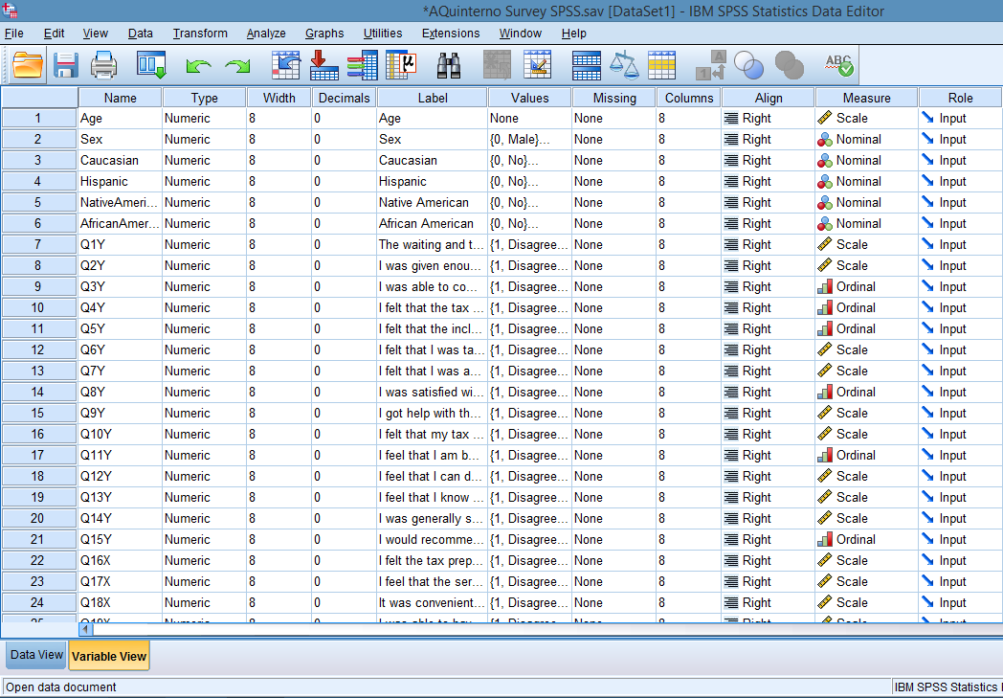

IV. Findings
- Descriptive Data
- Tallies of N (frequency of occurrence)
There were 135 completed surveys used in the study with no missing data.

- Averages on X, Y, and important intervening variables
Using a 5-point Likert scale with 5 = Agree, 4 = Somewhat Agree, 3 = Neutral, 2 = Somewhat Disagree, and 1 = Disagree, the scale for X has a highest possible score of 85 and a low of 17, with a midpoint of 34. The scale for Y has a highest possible score of 75 and a low of 15, with a midpoint of 30. The skewness for X was -4.188, and the kurtosis was 25.116, indicating the data is heavy-tailed and skewed to the left as seen in the histogram for sum service quality. The skewness for Y was -3.712, and kurtosis was 19.459, indicating the data is heavy-tailed and skewed to the left as seen in the histogram for sum satisfaction.

Statistics
SumSatisfaction
N | Valid | 135
 | Missing | 0
Mean |  | 71.0889
Median |  | 75.0000
Mode |  | 75.00
Std. Deviation |  | 7.92264
Skewness |  | -3.712
Std. Error of Skewness |  | .209
Kurtosis |  | 19.459
Std. Error of Kurtosis |  | .414
Range |  | 60.00
Minimum |  | 15.00
Maximum |  | 75.00

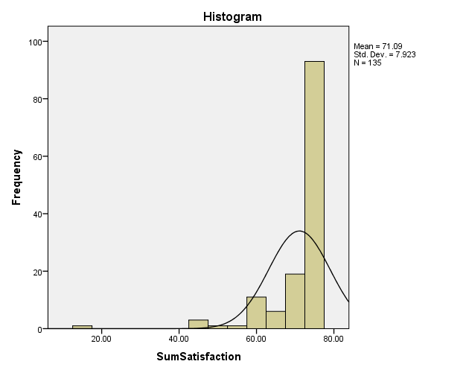

Statistics
SumServiceQuality
N | Valid | 135
 | Missing | 0
Mean |  | 80.9926
Median |  | 85.0000
Mode |  | 85.00
Std. Deviation |  | 8.44605
Skewness |  | -4.188
Std. Error of Skewness |  | .209
Kurtosis |  | 25.116
Std. Error of Kurtosis |  | .414
Range |  | 68.00
Minimum |  | 17.00
Maximum |  | 85.00

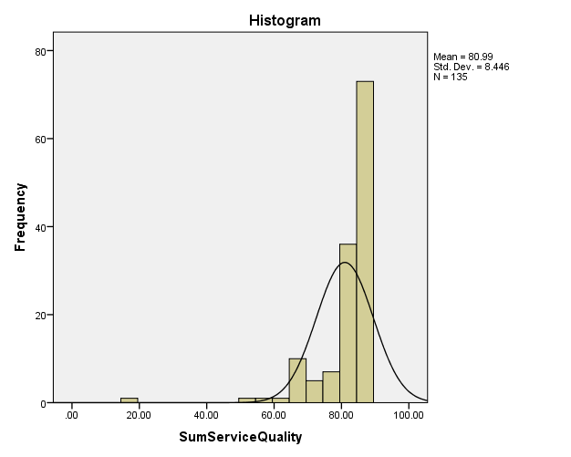

Age, sex, and race were the intervening variables in this study. Age was taken as a specific number rather than a range making it unwieldy, and therefore the table was omitted. 49.6% of respondents were female, and 50.4% were male.

Sex
 |  | Frequency | Percent | Valid Percent | Cumulative Percent
Valid | Male | 68 | 50.4 | 50.4 | 50.4
 | Female | 67 | 49.6 | 49.6 | 100.0
 | Total | 135 | 100.0 | 100.0

Of 135 respondents, 35.6% were Caucasian, 33.3% were Hispanic, 27.4% were African American, and 3.7% were Native American.

Caucasian
 |  | Frequency | Percent | Valid Percent | Cumulative Percent
Valid | No | 87 | 64.4 | 64.4 | 64.4
 | Yes | 48 | 35.6 | 35.6 | 100.0
 | Total | 135 | 100.0 | 100.0

Native American
 |  | Frequency | Percent | Valid Percent | Cumulative Percent
Valid | No | 130 | 96.3 | 96.3 | 96.3
 | Yes | 5 | 3.7 | 3.7 | 100.0
 | Total | 135 | 100.0 | 100.0

Hispanic
 |  | Frequency | Percent | Valid Percent | Cumulative Percent
Valid | No | 90 | 66.7 | 66.7 | 66.7
 | Yes | 45 | 33.3 | 33.3 | 100.0
 | Total | 135 | 100.0 | 100.0

African American
 |  | Frequency | Percent | Valid Percent | Cumulative Percent
Valid | No | 98 | 72.6 | 72.6 | 72.6
 | Yes | 37 | 27.4 | 27.4 | 100.0
 | Total | 135 | 100.0 | 100.0

Based on the one-way ANOVA analyses there was no statistically significant difference between groups of male and female in sum satisfaction and sum service quality ANOVA’s. An ANOVA analysis was not run for race and age because there were too many variations between age and race for accuracy.

ANOVA
SumSatisfaction
 | Sum of Squares | df | Mean Square | F | Sig.
Between Groups | 2.937 | 1 | 2.937 | .046 | .830
Within Groups | 8407.996 | 133 | 63.218
Total | 8410.933 | 134

ANOVA
SumServiceQuality
 | Sum of Squares | df | Mean Square | F | Sig.
Between Groups | 3.265 | 1 | 3.265 | .045 | .832
Within Groups | 9555.728 | 133 | 71.848
Total | 9558.993 | 134

- Cross Tables
SumSatisfaction * Sex Crosstabulation
Count
 |  | Sex |  | Total
 |  | Male | Female
SumSatisfaction | 15.00 | 0 | 1 | 1
 | 46.00 | 0 | 1 | 1
 | 47.00 | 2 | 0 | 2
 | 52.00 | 0 | 1 | 1
 | 54.00 | 1 | 0 | 1
 | 59.00 | 1 | 0 | 1
 | 60.00 | 5 | 2 | 7
 | 61.00 | 1 | 2 | 3
 | 63.00 | 1 | 0 | 1
 | 64.00 | 1 | 0 | 1
 | 65.00 | 1 | 2 | 3
 | 66.00 | 0 | 1 | 1
 | 68.00 | 0 | 1 | 1
 | 69.00 | 0 | 3 | 3
 | 70.00 | 1 | 3 | 4
 | 71.00 | 1 | 3 | 4
 | 72.00 | 4 | 3 | 7
 | 73.00 | 6 | 2 | 8
 | 74.00 | 8 | 8 | 16
 | 75.00 | 35 | 34 | 69
Total |  | 68 | 67 | 135

SumServiceQuality * Sex Crosstabulation
Count
 |  | Sex |  | Total
 |  | Male | Female
SumServiceQuality | 17.00 | 0 | 1 | 1
 | 53.00 | 1 | 0 | 1
 | 56.00 | 0 | 1 | 1
 | 60.00 | 0 | 1 | 1
 | 65.00 | 1 | 0 | 1
 | 66.00 | 2 | 0 | 2
 | 68.00 | 5 | 1 | 6
 | 69.00 | 1 | 0 | 1
 | 70.00 | 0 | 1 | 1
 | 72.00 | 0 | 1 | 1
 | 73.00 | 1 | 0 | 1
 | 74.00 | 0 | 2 | 2
 | 76.00 | 1 | 0 | 1
 | 77.00 | 1 | 1 | 2
 | 78.00 | 2 | 0 | 2
 | 79.00 | 0 | 2 | 2
 | 80.00 | 5 | 0 | 5
 | 81.00 | 2 | 7 | 9
 | 82.00 | 0 | 3 | 3
 | 83.00 | 5 | 4 | 9
 | 84.00 | 6 | 4 | 10
 | 85.00 | 35 | 38 | 73
Total |  | 68 | 67 | 135

- Scale Validity and Reliability
Validity and reliability analyses were conducted. The literature for the X and Y scales reported a Chronbach’s alpha of .953 for each scale. The analysis of the completed VITA surveys reported the Chronbach’s alphas to be .961 and .967 of Y and X respectively. With the alphas being close to 1.0 these alphas exceed the given alpha of .953, and show an improved validity and reliability over the original scales.

Reliability Statistics –
Satisfaction
Cronbach's Alpha | N of Items
.961 | 15

Reliability Statistics –
Service Quality
Cronbach's Alpha | N of Items
.967 | 17

- Correlations
A .931 correlation value using Pearson’s Correlation Coefficient was found between service quality and consumer satisfaction. The .931 correlation was determined to be sizeable enough not to have occurred by chance. The results
indicate there is a strong relationship between the two variables, meaning that changes in one variable are strongly correlated with changes in the second
variable. Using Pearson’s r, we find 86.68% of the completed surveys showed a strong correlation between the X and Y variables, leaving 13.32% unexplained. Controlling for age, gender and race, there is no significant change in the correlation. Since the 2-tailed Sig. of .000 is less than .05, it can be concluded that there is a statistically significant correlation between the X and Y variables.

Correlations
 |  | SumSatisfaction | SumServiceQuality
SumSatisfaction | Pearson Correlation | 1 | .931**
 | Sig. (2-tailed) |  | .000
 | N | 135 | 135
SumServiceQuality | Pearson Correlation | .931** | 1
 | Sig. (2-tailed) | .000
 | N | 135 | 135
**. Correlation is significant at the 0.01 level (2-tailed).

Correlations
Control Variables |  |  | SumSatisfaction | SumServiceQuality
Sex | SumSatisfaction | Correlation | 1.000 | .932
 |  | Significance (2-tailed) | . | .000
 |  | df | 0 | 132
 | SumServiceQuality | Correlation | .932 | 1.000
 |  | Significance (2-tailed) | .000 | .
 |  | df | 132 | 0

Correlations
Control Variables |  |  | SumSatisfaction | SumServiceQuality
Age | SumSatisfaction | Correlation | 1.000 | .931
 |  | Significance (2-tailed) | . | .000
 |  | df | 0 | 132
 | SumServiceQuality | Correlation | .931 | 1.000
 |  | Significance (2-tailed) | .000 | .
 |  | df | 132 | 0

Correlations
Control Variables |  |  | SumSatisfaction | SumServiceQuality
Caucasian | SumSatisfaction | Correlation | 1.000 | .931
 |  | Significance (2-tailed) | . | .000
 |  | df | 0 | 132
 | SumServiceQuality | Correlation | .931 | 1.000
 |  | Significance (2-tailed) | .000 | .
 |  | df | 132 | 0

Correlations
Control Variables |  |  | SumSatisfaction | SumServiceQuality
Hispanic | SumSatisfaction | Correlation | 1.000 | .930
 |  | Significance (2-tailed) | . | .000
 |  | df | 0 | 132
 | SumServiceQuality | Correlation | .930 | 1.000
 |  | Significance (2-tailed) | .000 | .
 |  | df | 132 | 0

Correlations
Control Variables |  |  | SumSatisfaction | SumServiceQuality
Native American | SumSatisfaction | Correlation | 1.000 | .931
 |  | Significance (2-tailed) | . | .000
 |  | df | 0 | 132
 | SumServiceQuality | Correlation | .931 | 1.000
 |  | Significance (2-tailed) | .000 | .
 |  | df | 132 | 0

Correlations
Control Variables |  |  | SumSatisfaction | SumServiceQuality
African American | SumSatisfaction | Correlation | 1.000 | .932
 |  | Significance (2-tailed) | . | .000
 |  | df | 0 | 132
 | SumServiceQuality | Correlation | .932 | 1.000
 |  | Significance (2-tailed) | .000 | .
 |  | df | 132 | 0

- Unexpected Findings
The research provided no unexpected findings.

X. Summary and Recommendations

X - The SERVQUAL Scale has become the most popular instrument for measuring service quality. The model has been applied in various service
industries, and was modified here to measure Client Satisfaction of the VITA program. The results are presented as follows:

1st Respondent’s demographic characteristics were provided

2nd Results of descriptive questions of clients’ perceptions are presented

3rd The results of accessibility and reliability analysis are interpreted

The statistical analysis was conducted on 135 valid surveys/questionnaires. The
Demographic profile of the respondents is:

% Female 49.6 Male 50.4
THE RESULTS OF THE DESCRIPTIVE ANALYSIS OF CLIENTS’ PERCEPTIONS OF THE VITA SERVICE

The range of service quality (X) perceptions items was from:

5 (Agree) - to - 1 (Disagree)

The lowest perception item was Question 22, with 97/135 respondents choosing ‘Agree’:
“The tax preparation hours are convenient”

The highest perception item was Question 28 with 120/135 choosing ‘Agree’:
“The VITA volunteers were courteous”

The overall mean score of clients’ reliability and accessibility perceptions (X) was: 80.9926.

The results of the overall perception/reliability analysis for X showed the Chronbach’s Alpha coefficients was .967, which is considered acceptable as an indication of high scale reliability, and suggesting good internal reliability of the factors. The Alpha for the SERVQUAL Hotel Guest Case Study used was: .953.

Y – The modified version of this scale included 16 items covering four (4) domains:

- Satisfaction with location
- Satisfaction with VITA volunteers
- Satisfaction with income tax services provided
- General satisfaction

Chronbach’s Alpha was used to assess internal consistency, and the results demonstrated a strong internal consistency of .961. The factor analysis revealed that the scale appears to measure the single construct of satisfaction.
The Chronbach’s Alpha for the youth mental health services case study used was: .953.

Perceptions of VITA satisfaction are the degree to which clients find various VITA site attributes important in enhancing their income tax preparation
experience. The main dimensions of perceived VITA client satisfaction are Reliability and Accessibility.

The findings of this study reveal that between the two dimensions (reliability and accessibility) reliability has emerged as the most important predictor of client satisfaction.

It can be concluded that the modified version of the SERVQUAL model is suitable to gain interpretable and reliable data on VITA clients’ satisfaction of the service performed. The recommendations are to:

- Expand the hours available for tax preparation at each site, and
- For the convenience of clients divide the method of seeing clients to half walk-ins and half appointments

2017 VITA Client Satisfaction Survey Results
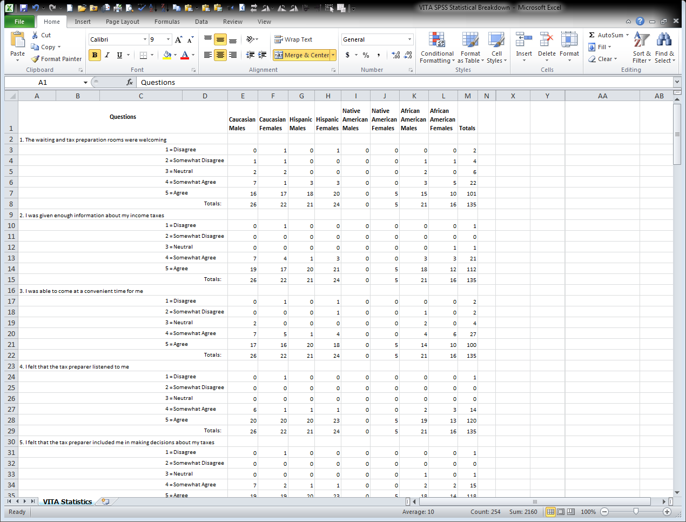
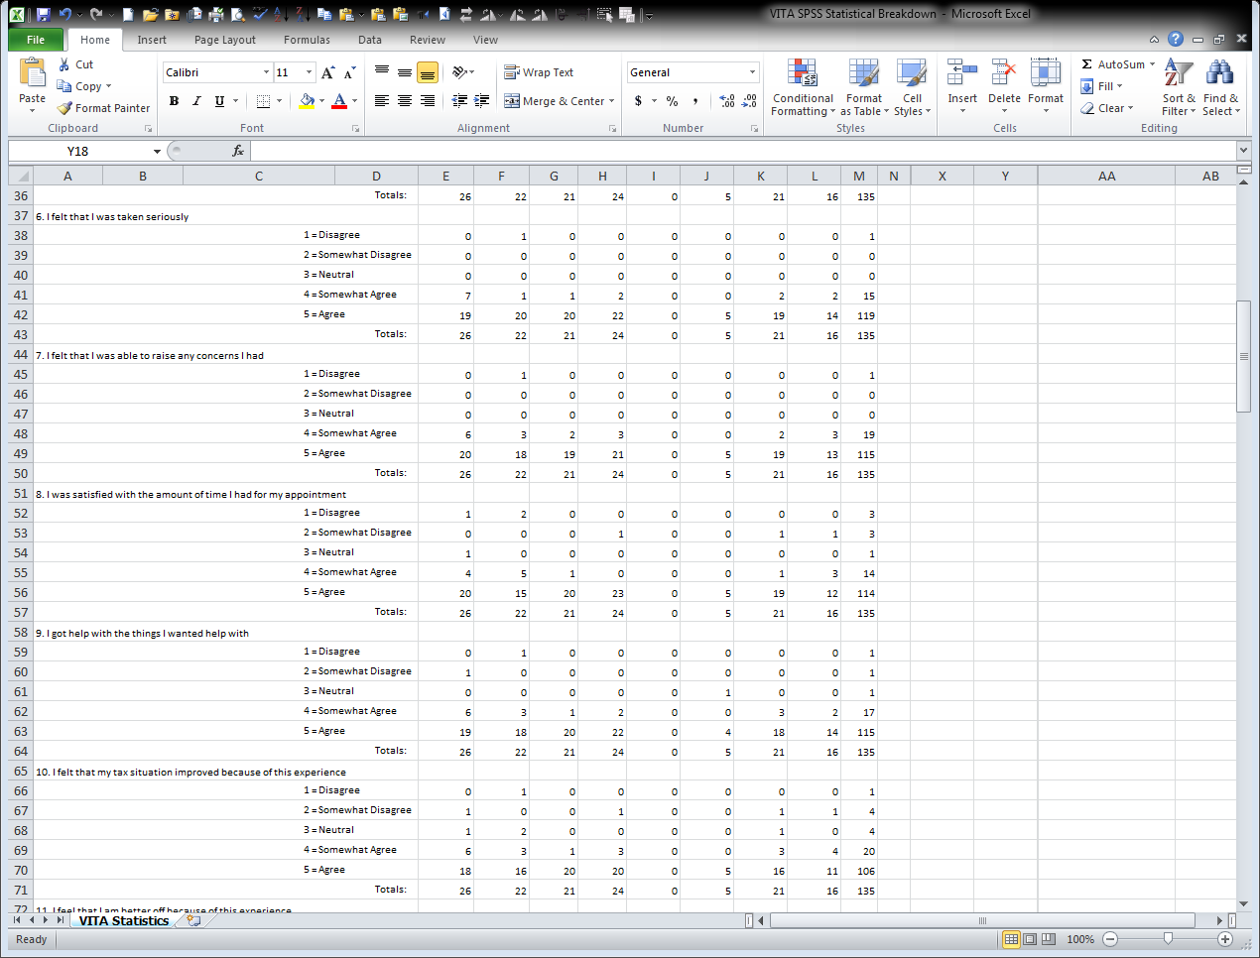
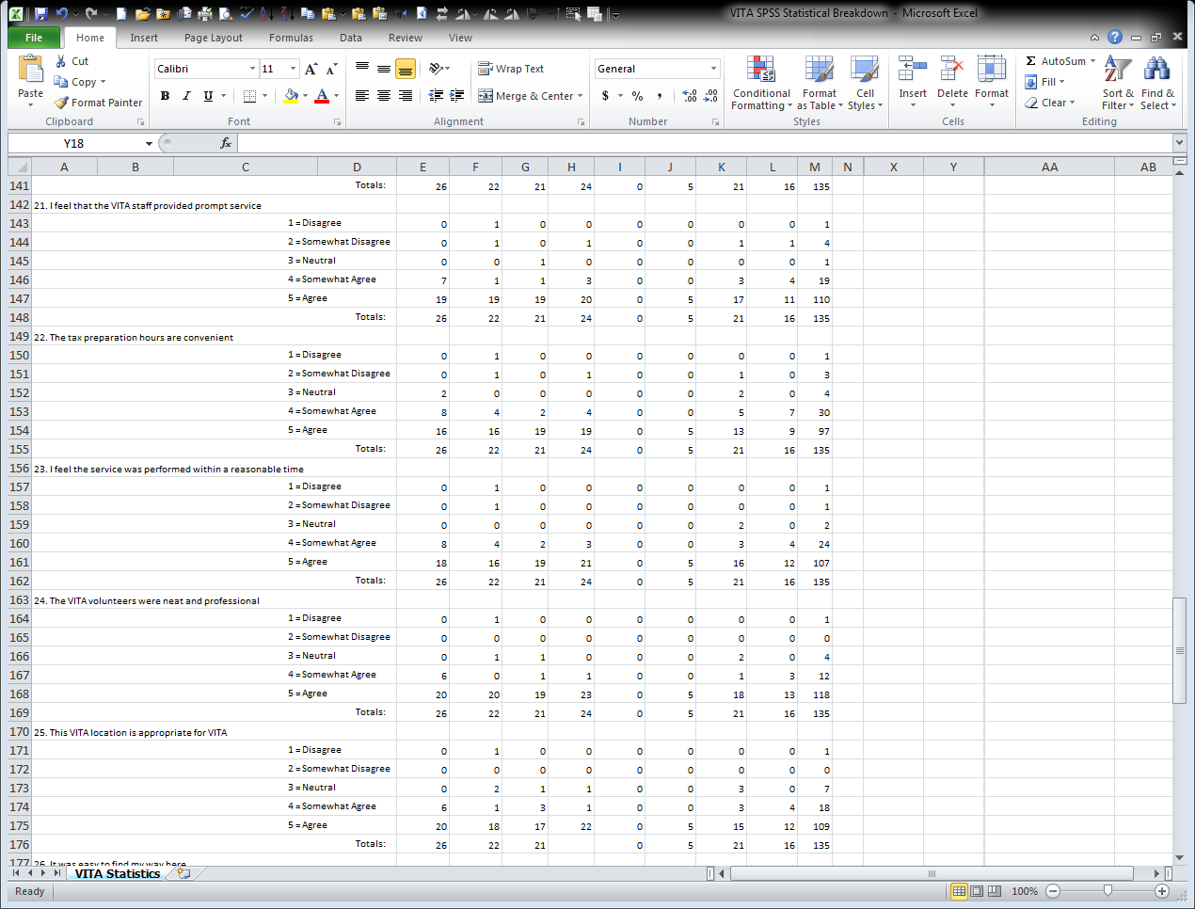

References
http://study.com/academy/lesson/what-is-customer-satisfaction-definition-examples-quiz.html

Measuring Customer Satisfaction, Improving the experience of King County’s Customers, Office of the King County Executive, 401 Fifth Avenue, Suite 800, Seattle, WA 98104

Stanford University, IT Services 2012 Customer Satisfaction Survey, November 2012. Brian McDonald, President, p. a1.

Measurement of Client Satisfaction, Harris, Gardenia, M.S.W., and Poertner, John, D.S.W., School of Social Work, University of Illinois, Urbana, Illinois, 1998. Pp. 3-6.

A Literature Review and Critique on Customer Satisfaction, Huiqun, Liu, and XIN, Zhao, School of Economics, Tianjin University of Commerce, Tianjin, China, p. 360.

Gray MacKenzie, co-founder, http://www.guavabox.com/blog/if-you-cant-measure-it-you-cant-improve-it

Mulder, P. (2010). Management By Objectives (MBO). Retrieved 21 February 2017 from ToolsHero: http://www.toolshero.com/management/management-by-objectives-drucker/

Rodriguez, Nancy, PA590 Spring 2016,Capstone Outline

Copyright 2006, William M.K. Trochim, Establishing Cause and Effect, https://www.socialresearchmethods.net/kb/causeeff.php

Average Tax Preparation Fee in New England in 2015, based on CPA Practice Adviroe, 2015

Development of a satisfaction scale for young people attending youth mental health services, Simmons, Parker, et.al., Early Intervention in Psychiatry, November 2014, Volume 8, Issue 4, p.382-386

Defining Consumer Satisfaction, Giese, Joan L., and Cote, Joseph A., Academy of Marketing Science Review, Volume 2000 Number 1, Copyright 2002.

Measuring Perceived Service Quality Using SERVQUAL: A Case Study of the Croatian Hotel Industry, Markovic, Suzana, and Raspor, Sanja, Management, Volume 5, Number 3, Fall 2010, p.200-203.

Development of a satisfaction scale for young people attending youth mental health services, Simmons, Parker, et.al., Early Intervention in Psychiatry, November 2014, Volume 8, Issue 4, p.382-386

http://sociologydictionary.org/unit-of-analysis/
Copyright © Open Education Sociology Dictionary 2013-2017 and edited by Kenton Bell

https://sites.ualberta.ca/~alejeune/SPSS2.html

The Basics of Social Research, Babbie, Earl, 4th ed., Chapman University, Thomson/Wadsworth, United States, 2008.

Measuring Performance in Public and Nonprofit Organizations, Poister, Theodore, H., Jossey-Bass, San Francisco, CA, 2003.

Measuring Customer Satisfaction, Improving the Experience of King County’s Customers, Office of the King County Executive, 401 Fifth Avenue, Suite 800, Seattle, WA 98104
Average tax preparation fee in New England in 2015, based on CPA Practice Advisor, 2015
Measuring Perceived Service Quality Using SERVQUAL: A Case Study of the Croatian Hotel Industry, Markovic, Suzana, and Raspor, Sanja, Management, Volume 5, Number 3, Fall 2010, pp. 195-209.
Development of a satisfaction scale for young people attending youth mental health services, Early Intervention In Psychiatry, Simmons, Magenta, Parker, Alexandra, Hetrick, Sarah, Telford, Nic, Bailey, Alan, and Rickwood, Debra, November 2014, volume 8, Issue 4, pp. 382-386.
http://study.com/academy/lesson/what-is-customer-satisfaction-definition-examples-quiz.html
Measuring Customer Satisfaction, Improving the experience of King County’s Customers, Office of the King County Executive, 401 Fifth Avenue, Suite 800, Seattle, WA 98104
Stanford University, IT Services 2012 Customer Satisfaction Survey, November 2012. Brian McDonald, President, p. a1.
Measurement of Client Satisfaction, Harris, Gardenia, M.S.W., and Poertner, John, D.S.W., School of Social Work, University of Illinois, Urbana, Illinois, 1998. pp. 3-6.
A Literature Review and Critique on Customer Satisfaction, Huiqun, Liu, and XIN, Zhao, School of Economics, Tianjin University of Commerce, Tianjin, China, p. 360.
Average tax preparation fee in New England in 2015, based on CPA Practice Advisor, 2015
Gray MacKenzie, co-founder, http://www.guavabox.com/blog/if-you-cant-measure-it-you-cant-improve-it
Mulder, P. (2010). Management By Objectives (MBO). Retrieved 21 February 2017 from ToolsHero: http://www.toolshero.com/management/management-by-objectives-drucker/
Rodriguez, Nancy, PA590 Spring 2016,Capstone Outline
Copyright 2006, William M.K. Trochim, Establishing Cause and Effect, https://www.socialresearchmethods.net/kb/causeeff.php
Development of a satisfaction scale for young people attending youth mental health services, Simmons, Parker, et.al., Early Intervention in Psychiatry, November 2014, Volume 8, Issue 4, pp.382-386
Defining Consumer Satisfaction, Giese, Joan L., and Cote, Joseph A., Academy of Marketing Science Review, Volume 2000 Number 1, Copyright 2002.
Measuring Perceived Service Quality Using SERVQUAL: A Case Study of the Croatian Hotel Industry, Markovic, Suzana, and Raspor, Sanja, Management, Volume 5, Number 3, Fall 2010, p.200-203.
Development of a satisfaction scale for young people attending youth mental health services, Simmons, Parker, et.al., Early Intervention in Psychiatry, November 2014, Volume 8, Issue 4, p.382-386
http://sociologydictionary.org/unit-of-analysis/ Copyright © Open Education Sociology Dictionary 2013-2017 and edited by Kenton Bell

