Knowledge Based System for the Diagnosis of Dengue Disease
Aysha I. Mansour, Samy S. Abu-Naser
Department of Information Technology,
Faculty of Engineering and Information Technology,
Al-Azhar University, Gaza, Palestine

Abstract: Background: Dengue Disease is a mosquito-borne tropical disease caused by the dengue virus, symptoms typically begin three to fourteen days after infection. This may include a high fever, headache, vomiting, muscle and joint pains, and a characteristic skin rash. Dengue serology is applied in different settings, such as for surveillance, in health care facilities in endemic areas and in travel clinics in non-endemic areas. The applicability and quality of serological tests in dengue endemic regions has to be judged against a background of potential cross reactivity with other flavi-viruses, difficulties in distinguishing primary from secondary infections and technological problems related to the fact that most dengue endemic regions are relatively poor of resources .Objectives: to help doctors and patients in diagnosing Dengue Disease and give them the information of how to prevent Dengue Disease and to be able to understand the signs and symptoms of Dengue Disease. Methods: We collected all relevant material for Dengue Disease. Then we designed and implemented a knowledge based system for diagnosing Dengue Disease using SL5 Object Language. Results: The knowledge based system was evaluated by a group of Patients and specialized doctors and they found it very friendly and easy to use.
Keywords: Expert System, SL5, Delphi, Dengue, Diseases

Introduction
Dengue is an infectious disease caused by a virus. The virus is transmitted by a type of mosquito (Aedes aegypti) that bites during daylight hours. The dengue virus belongs to the Flaviviridae family of viruses that cause diseases in humans. Dengue is the most common infection caused by viruses transmitted by mosquitoes these are known as arboviral illnesses. Dengue causes severe flu-like symptoms, such as ahigh temperature (fever) of 40C (10F)or over , severe headache muscle and joint pain and facial flushing and skin rash. The growing global health burden of dengue disease and the ongoing challenges in developing vaccines and drugs against this infection have underscored the need for better models to elucidate the mechanism of dengue pathogenesis and evaluate interventions before large field efficacy trials. If successful, a DHIM could be used to study clinical and immunologic pathogenesis, explore virus-vector-host interactions, and inform vaccine and drug developers as they make development decisions. A DHIM could facilitate vaccine immunogenicity assay development and the optimization, qualification, and validation processes required for these assays to support regulatory strategies and product licensing applications. It could also help define a correlate and surrogate of protection, and once drug or vaccine safety and efficacy was proven in field testing in endemic settings, it could assist the process of bridging these data to nonendemic populations who may benefit from a therapeutic[1,2,3].

Expert Systems In Health:

An expert system is a computer system that emulates the decision making ability of a human expert[11-15]. By so doing, it acts in all respects like a human expert, using human knowledge to solve problems that would require human intelligence[16-20]. When patients seek the help of medical experts, they do so for diagnosis and treatment of their various health problems. This can also be to confirm a clinically suspected diagnosis or to obtain more accurate information. For example, in the developing countries where malaria is endemic and commonly associated with the “factor of developing” called poverty, the malaria disease may be suspected by the presence of fever. However, because of the presence of many other diseases causing fever, confirming the diagnosis of malaria may be difficult, unless by the exclusion of other causes of fever on history, physical examination and on microscopic examination of a blood slide[4,5].

Different Mosquito Borne Diseases :
Here we describe the origin of different mosquito born disease. These diseases have some common symptoms with others. Some are viral while other are non-viral. Viral diseases are either due to mosquitos like Yellow fever, Malaria, Dengue and influenza, whereas non-viral are natural diseases such as heart diseases, diabetes and cancer. Unlike non-viral diseases, the viral diseases can spread in short spans of time and are difficult to handle. Fig. 2 expresses hierarchical structure of viral and non-viral diseases [6,7].
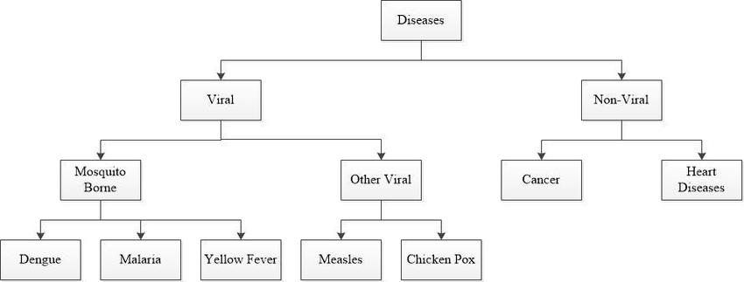
Fig. 1. Viral and non-viral diseases.

A. Diseases Due to Mosquitos
These diseases are caused by viruses that are transmitted by mosquitos. Which includes Dengue, Yellow Fever and Malaria.
In past years’ research shows that there is leap in diseases caused by mosquitos. This motivates researchers and scientists to work to reduce these diseases Fig. 3 presents complete detail of mosquitos borne diseases[1-3].

1)Yellow Fever: It is one of the infectious diseases which is caused by Aedes mosquito that is infected by Flavivirus. This mosquito is usually found in sub-tropical or tropical regions
Signs and Symptoms: Yellow Fever happens due to a virus cause by mosquito. The symptoms appear in 3 to 6 days after mosquito bite. There are three stages of this disease
Stage 1 (infection): The infected person shows following symptoms in first 3 to 4 days, fever, loss of appetite, headache, joint pain, vomiting and jaundice. After day 4 these symptoms become brief
Stage 2 (remission): In this stage, most of the symptoms are gone and people can be recovered but due carelessness the situation can get even worst
Stage 3 (intoxication): In organs such as liver, heart and kidney different problems may occur.

2) Malaria: Malaria is also a disease that happens due to virus by a female mosquito Plasmodium of genus Anopheles carry. If this disease is not treated in time it may lead to complications towards death. There are two types of malaria
in general: simple and severe. Simple malaria is curable if treated within time while severe malaria may lead to death.

Signs and Symptoms :
Simple Malaria: This disease remains for 6 to 10 hours Its symptoms are, cold stage that has sense of shivering, hot stage with headache and vomiting and sweating stage. Attacking schedule is with Tertain parasite, it occurs every second day & with Quartan parasite it occurs every third day. General symptoms are: Fever, Headache, Sweating, Vomiting, Body ache and Chills. The physical impact of malaria can be seen on the infected body that includes, getting sweaty, temperature rise up, mild jaundice, respiration increased and weakness in body .
Severe Malaria: During simple malaria if there arise a complication of infection in any part of body by failure of any organ it may create severe malaria

3) Dengue: Aedes aegypti is certain type of mosquitos that causes of Dengue. It is a viral disease and the virus is single-positive strand RNA virus and commonly found in subtropical and tropical regions.
Signs and Symptoms: Major symptoms of Dengue are high-fever and combination of at least two which are, Pain in joints, Bleeding gums, Rashes on skin, Very low white-blood cells, Pain in bones and severe pain behind eyes. To get better a proper lookout is very necessary because after 3 to 7 days following things can happen, Red spots on body, Pale skin, Drowsiness, Pain in abdomen, Breathing in difficult. Dengue Disease that stays for 2 to 7 days is normally called Dengue Hemorrhagic Fever (DHF). DHF warning appears when after 24 to 48 hours fever suddenly drops and at this time bleeding is started, due to this circulatory system is disturbed and it may lead to death.
World Health Organization (WHO) has worked on the Dengue risk factors that play the pivotal role in the disease diagnosis . Similarly, resources have showed that Dengue is assorted disease, its symptoms are mixed with other diseases that make its detection and diagnosis more difficult .

Dengue is the most important arthropod-borne viral disease of public health significance. Compared with nine reporting countries in the 1950s, today the geographic distribution includes more than 100 countries worldwide. Many of these had not reported dengue for 20 or more years and several have no known history of the disease. The World Health Organization estimates that more than 2.5 billion people are at risk of dengue infection. First recognized in the 1950s, it has become a leading cause of child mortality in several Asian and South American countries.
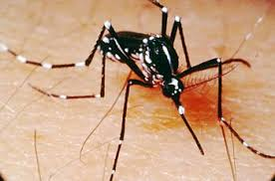
Fig. 2. Mosquitos.

Dengue is the most important arthropod-borne viral disease of public health significance. Compared to nine reporting countries in the 1950s, today the geographic distribution includes more than 100 countries worldwide. Many of these had not reported dengue for 20 or more years and several have no known history of the disease. The World Health Organization (WHO) estimates that more than 2.5 billion people are at risk of dengue infection. Most will have asymptomatic infections. The disease manifestations range from an influenza-like disease known as Dengue Disease (DF) to a severe, sometimes fatal disease characterized by haemorrhage and shock, known as dengue hemorrhagic fever/dengue shock syndrome (DHF/DSS), which is on the increase. Dengue Disease and dengue haemorrhagic fever/dengue shock syndrome are caused by the four viral serotypes transmitted from viraemic to susceptible humans mainly by bites of Aedes aegypti and Aedes albopictus mosquito species. Recovery from infection by one serotype provides lifelong immunity against that serotype but confers only partial and transient protection against subsequent infection by the other three. First recognized in the 1950s, it has become a leading cause of child mortality in several Asian and South American countries[3].
The average number of DF/DHF cases reported to WHO per year has risen from 908 between 1950 and 1959 to 514,139 between 1990 and 1999. The real figure is estimated to be closer to 50 million cases a year causing 24,000 deaths. Of an estimated 500,000 cases of DHF/DSS requiring hospitalisation each year, roughly 5% die according to WHO statistics. Regional distribution of dengue and its serotypes are described elsewhere. In summary, DF/DHF/DSS is an immediate problem in south and southeast Asia and Central and South America. Although DF is present in the African region, there are no cases or outbreaks reported to WHO[1].
Half the world’s population lives in countries endemic for dengue, underscoring the urgency to find solutions for dengue control. The consequence of simple DF is loss of workdays for communities dependent on wage labour. The consequence of severe illness is high mortality rates, since tertiary level care required for DHF/DSS management is beyond the reach of most of the persons at risk.
This paper reviews the changing epidemiology of the disease, focusing on host and societal factors and drawing on national and regional journals as well as international publications. It does not include vaccine and vector issues. Although each one of the issues taken up below merits an independent, in-depth treatment, we have selected only those issues where the literature raises challenges to prevailing views and therefore require further research, particularly given that most of these issues are key for improved service delivery in poor countries[2].

Transmission Cycle of Dengue:
The dengue virus is spread through a human-to-mosquito-to-human cycle of transmission Figure 3 Typically, four days after being bit by an infected Aedes aegypti mosquito, a person will develop viremia, a condition in which there is a high level of the dengue virus in the blood. Viremia lasts for approximately five days, but can last as long as twelve days. On the first day of viremia, the person generally shows no symptoms of dengue. Five days after being bit by the infected mosquito, the person develops symptoms of Dengue Disease, which can last for a week or longer[3,4].
How does an Aedes aegypti mosquito become a dengue vector? After a mosquito feeds on the blood of someone infected with the dengue virus, that mosquito becomes a dengue vector. The mosquito must take its blood meal during the period of viremia, when the infected person has high levels of the dengue virus in the blood. Once the virus enters the mosquito's system in the blood meal, the virus spreads through the mosquito's body over a period of eight to twelve days. After this period, the infected mosquito can transmit the dengue virus to another person while feeding. Does a mosquito infected with the dengue virus only transmit the virus to the next person it feeds on? No, once infected with dengue, the mosquito will remain infected with the virus for its entire life. Infected mosquitoes can continue transmitting the dengue virus to healthy people for the rest of their life spans, generally a three- to four-week period[5].
Both male and female mosquitoes feed on plant nectars, fruit juices, and other plants sugars as their main energy source. Why, then, do mosquitoes bite humans? Female mosquitoes require blood to produce eggs, so they bite humans. Each female mosquito can lay multiple batches of eggs during its lifetime, and often Aedes aegypti take several blood meals before laying a batch of eggs. When a female mosquito is infected with the dengue virus, the virus is present in its salivary glands. How does the virus travel from the mosquito's salivary glands into a human? When taking a blood meal, an infected female mosquito injects its saliva into the human host to prevent the host's blood from clotting and to ease feeding. This injection of saliva infects the host with the dengue virus.
Are mosquito bites the only way the dengue virus can be transmitted to humans? In rare events, dengue can be transmitted during organ transplantations or blood transfusions from infected donors. There is also evidence that an infected pregnant mother can transmit the dengue virus to her fetus. Despite these rare events, the majority of dengue infections are transmitted by mosquito bites[6].
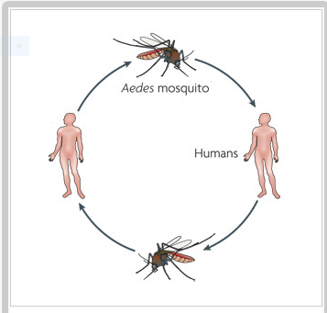
Figure 4 : Dengue transmission

Many studies have reported changing spatial patterns in dengue transmission. The reasons for such changes are related to several factors, ranging from the globalization of travel and trade, which favors the propagation of pathogens and vectors, to climatic changes or modified human behavior. In 2007, the Intergovernmental Panel on Climate Change cautioned that between 1.5 and 3.5 billion people worldwide will face the risk of Dengue Disease infection during the 2080s, owing to climate change. Temperature and precipitation are important climatic factors in mosquito population and disease transmission dynamics. Temperature influences the developmental rates, mortality and reproductive behavior of mosquitoes. Precipitation provides the water that serves as a habitat for larvae and pupae. According to the Intergovernmental Panel on Climate Change, the global average temperature has increased by ~0.6 °C over the past 35 years, and the variation in precipitation has increased. Warm temperatures and high humidity favor increased longevity of the adult mosquitoes and shorten the viral incubation period within the vector and its blood-feeding intervals, thus leading to faster virus replication and increased transmission intensity. The association between weather and dengue varies across geographical locations and socio-environmental strata[7].

LITERATURE REVIEW
Here is a summary of expert systems found in the literature:
- Male Infertility Expert System Diagnoses and Treatment [47] for male infertility diagnosis which helps men to explore everything related to the problems of infertility and infertility diseases such as: Azoospermia, O.T.A syndrome which mean oligo-terato-astheno spermia, Aspermia and Sexual transmitted disease.
- An expert system for diagnosing eye diseases using clips [38] provides the patient with background for suitable diagnosis of a few of the eye diseases.
- An Expert System for Mouth Problems in Infants and Children [50] ask the user to answer the questions about the symptoms of the patient and end up with some information about the disease and some advices telling the user how to deal with the baby.
- Knowledge Management in ESMDA: Expert System for Medical Diagnostic Assistance [41] deals with the design of a prototype expert system that assists patients to diagnose their diseases and offer them the suitable advice.
- Knowledge Based System for Long-term Abdominal Pain (Stomach Pain) Diagnosis and Treatment [61] was made to aid internist physicians in diagnosing numerous of the abdomen diseases for example: gastritis, hiatal hernia, ulcer or heartburn; the proposed expert system offers a summary about abdomen diseases are given, the cause of diseases are drew and the cure of disease when possible is shown up.
- A Ruled Based System for Ear Problem Diagnosis and Treatment [52] was used to classify ear problems into three main sets: a- Inflammation of the inner ear b- Middle ear problems c- External ear problems.
- An expert system for nausea and vomiting problems in infants and children[58] to aid users in getting the right diagnosis of problems of nausea and vomiting in infants and children (Gastro-esophageal reflux, Gastroenteritis, Systemic Infection, Bowel obstruction, Tumors, A bleeding disease, tonsillitis, and Hepatitis pharynx). Additionally, this expert system offers information about the disease and how to deal with it.
- An expert system for feeding problems in infants and children [40] to diagnose feeding problems in infants and children.
- Detecting Health Problems Related to Addiction of Video Game Playing Using an Expert System [43] to assist users in getting the correct diagnosis of the health problem of video game addictions that range from (Musculoskeletal issues, Vision problems and Obesity). Furthermore, this expert system delivers information about the problem and tells us how we can solve it.
- An Expert System for Endocrine Diagnosis and treatments using JESS [70] was developed to help in diagnosing endocrine glands diseases.
- A Proposed Expert System for Skin Diseases Diagnosis [68] was developed using CLIPS(C Language Integrated Production System) to help user diagnose the following skin diseases (Psoriasis, Eczema, Ichthyosis, Acne, Meningitis, Measles, Scarlet Fever, Warts, Insect Bites and Stings).
- Lower Back Pain Expert System Diagnosis and Treatment [45] can be used to positively diagnose low back pain concentration.
- Knowledge Based System for Ankle Diseases Diagnosis [48] recognized seven ankle diseases: Ankle Sprain, Fracture (of Fibula), Rheumatoid Arthritis, Rheumatoid Fever, Gout, and Osteoarthritis (Degenerative Joint) and they developed the expert system for those ankle diseases using SL5 Object Expert System Language.
- An Expert System for Diagnosing Shortness of Breath in Infants and Children [39] for diagnosing infants and children patients with twelve various shortness of breath in infants and children diseases.
- Polymyalgia Rheumatic Expert System [69] outlined an expert system for classification criteria for PMR, recent advances of diagnostic and therapeutic procedures.
- Expert System for Chest Pain in Infants and Children [55] to assist doctors, parents, and care giver in diagnosing chest pain in infants and children.
- Rickets Expert System Diagnoses and Treatment [44] assist doctors to discover everything connected to the problems of rickets.
- Expert System for Hair Loss Diagnosis and Treatment [67] for diagnosing eleven diverse hair loss diseases of the human stages from childhood to adults by asking questions with a Yes or No answer.
- Expert System for Problems of Teeth and Gums [42] assist people with teeth and gums problems to diagnose their problems and receive a recommendation for the treatment. This knowledge based system was developed using SL5 Object language.
- Ear Diseases Diagnosis Expert System Using SL5 Object [36] swiftly diagnoses patient’s condition and proposes a appropriate answer for the problem.
- A Proposed Expert System for Foot Diseases Diagnosis [64] diagnoses eighteen foot problems of all phases of the human life beginning with baby to the grownup by examining with yes/no questions.
- A Knowledge Based System for Neck Pain Diagnosis [50] can diagnose seven neck diseases of different phases of the human life beginning by asking the user many questions according to their pain symptoms.
- An expert system for shoulder problems using CLIPS [62] can help in diagnosing shoulder problems.
- Expert system urination problems diagnosis [66] can diagnose some of the Urination diseases (Pyelonephritis, Kidney Stone, Bladder infection, Prostatitis, Urethritis, Gonorrhea, Interstitial cystitis, Stress incontinence, Trauma in kidney or bladder).
- A Proposed Rule Based System for Breasts Cancer Diagnosis [54] was developed to help people in preventing and early detecting breast cancer; since it is known that this disease does not have medication or cure yet.
- An Expert System for Genital Problems in Infants [56] diagnoses genital problems in infants which is one of the most common problems that need quick intervention in the newly born stage.
- An expert system for men genital problems diagnosis and treatment [49] to assist men diagnose their genital problems and give them the suitable treatment. Genital problems and injuries usually occur through: recreational activities (such as: Basketball, Football, Hooky, Biking), work-related tasks (such as: contact to irritating chemicals), downhill drop, and sexual activities. SL5 Object expert system language was used to develop this expert system.
Even though, there are many expert systems that are developed for diagnosing human problems; there is no specialized expert system for diagnosing the dengue disease available free. The proposed expert system was designed and developed specifically to aid doctors in diagnosing the dengue disease.

MATERIALS AND METHODS:
The current knowledge based system for dengue disease diagnosis is represented with the SL5 Object knowledge format as facts. Objects and rules. As this system is designed in Object Oriented approach through SL5 Object, we can add any new rules and modify existed ones, change and diagnose more dengue disease can be extended easily in future.
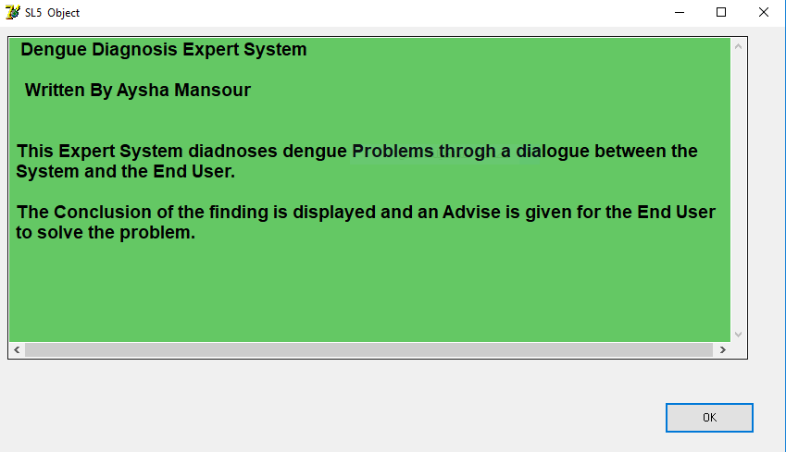
Figure 5: Dengue diagnosis expert system

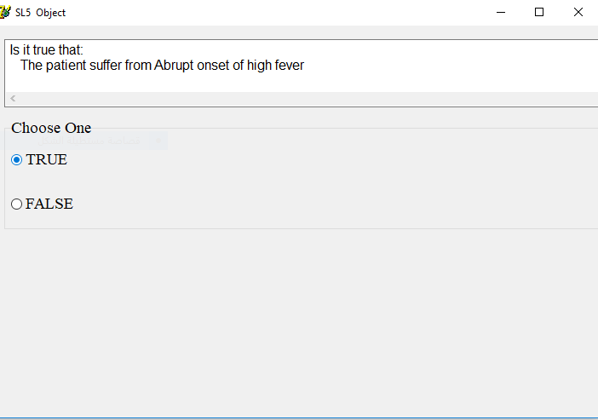
Figure 6 : Dengue diagnosis
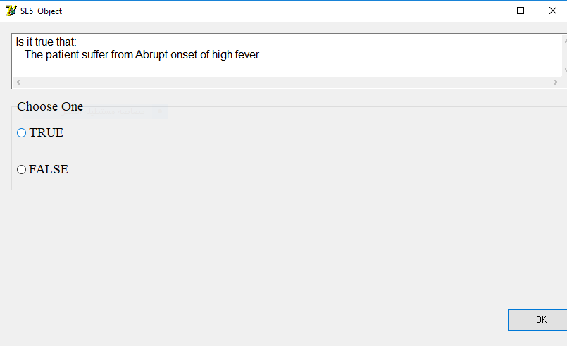
Figure 7 : Dengue diagnosis

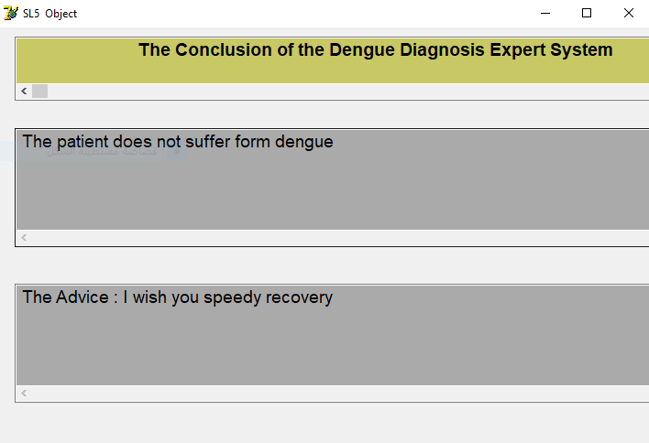
Figure 8 : Conclusion dengue diagnosis expert system

Conclusion:
We collected all relevant material for Dengue Disease. Then we designed and implemented a knowledge based system for diagnosing Dengue Disease using SL5 Object Language. The knowledge based system was evaluated by a group of Patients and specialized doctors and they found it very friendly and

References
- https://www.ncbi.nlm.nih.gov/pmc/articles/PMC4048991//
- https://link.springer.com/article/10.1007/s12652-018-0829-9
- https://jamanetwork.com/journals/jama/fullarticle/1182858?version=meter%20at%20null&module=meter-Links&pgtype=article&contentId=&mediaId=&referrer=&priority=true&action=click&contentCollection=meter-links-click
- https://www.google.ps/imgres?imgurl=x-raw-image%3A%2F%2F%2F26a2fc39c2c70e606d2aafb86f55b801accbdddd8250507c7e70c811d9fce152&imgrefurl=https%3A%2F%2Fthesai.org%2FDownloads%2FVolume8No10%2FPaper_11-Role_of_Expert_System_in_Identification.pdf&docid=wR3FZcsAA07NNM&tbnid=YA7Hwjn8oiY9FM%3A&vet=10ahUKEwjr0Yypu8zhAhWMyIUKHXFECQwQMwg-KAAwAA..i&w=661&h=775&safe=strict&bih=616&biw=1350&q=expert%20system%20agriculture%20dengue&ved=0ahUKEwjr0Yypu8zhAhWMyIUKHXFECQwQMwg-KAAwAA&iact=mrc&uact=8
- https://bmcinfectdis.biomedcentral.com/articles/10.1186/1471-2334-6-13
- https://www.nature.com/scitable/topicpage/dengue-transmission-22399758
- https://www.ncbi.nlm.nih.gov/pmc/articles/PMC5583666/
- Abu-Naser, S. S., Kashkash, K. A., & Fayyad, M. (2010). Developing an expert system for plant disease diagnosis. Journal of Artificial Intelligence ; Scialert, 3(4), 269-276.
- Barhoom, A. M., & Abu-Naser, S. S. (2018). Black Pepper Expert System. International Journal of Academic Information Systems Research (IJAISR), 2(8), 9-16.
- Almadhoun, H. R., & Abu Naser, S. S. (2018). Banana Knowledge Based System Diagnosis and Treatment. International Journal of Academic Pedagogical Research (IJAPR), 2(7), 1-11.
- Akkila, A. N., & Abu Naser, S. S. (2016). Proposed Expert System for Calculating Inheritance in Islam. World Wide Journal of Multidisciplinary Research and Development, 2(9), 38-48.
- AbuEl-Reesh, J. Y., & Abu Naser, S. S. (2017). A Knowledge Based System for Diagnosing Shortness of Breath in Infants and Children. International Journal of Engineering and Information Systems (IJEAIS), 1(4), 102-115.
- Alajrami, M. A., & Abu-Naser, S. S. (2018). Onion Rule Based System for Disorders Diagnosis and Treatment. International Journal of Academic Pedagogical Research (IJAPR), 2(8), 1-9.
- Abu Naser, S. S., Alamawi, W. W., & Alfarra, M. F. (2016). Rule Based System for Diagnosing Wireless Connection Problems Using SL5 Object. International Journal of Information Technology and Electrical Engineering, 5(6), 26-33.
- Almurshidi, S. H., & Abu-Naser, S. S. (2018). EXPERT SYSTEM FOR DIAGNOSING BREAST CANCER. Al-Azhar University, Gaza, Palestine.
- Azaab, S., Abu Naser, S., & Sulisel, O. (2000). A proposed expert system for selecting exploratory factor analysis procedures. Journal of the College of Education, 4(2), 9-26.
- Bakeer, H., & Abu Naser, S. S. (2017). Photo Copier Maintenance Expert System V. 01 Using SL5 Object Language. International Journal of Engineering and Information Systems (IJEAIS), 1(4), 116-124.
- Khella, R., & Abu Naser, S. S. (2017). Rule Based System for Chest Pain in Infants and Children. International Journal of Engineering and Information Systems, 1(4), 138-148.
- Dahouk, A. W., & Abu-Naser, S. S. (2018). A Proposed Knowledge Based System for Desktop PC Troubleshooting. International Journal of Academic Pedagogical Research (IJAPR), 2(6), 1-8.
- Musleh, M. M., & Abu-Naser, S. S. (2018). Rule Based System for Diagnosing and Treating Potatoes Problems. International Journal of Academic Engineering Research (IJAER), 2(8), 1-9.
- Abu Naser, S. S., Baraka, M. H., & Baraka, A. (2008). A Proposed Expert System For Guiding Freshman Students In Selecting A Major In Al-Azhar University, Gaza. Journal of Theoretical & Applied Information Technology, 4(9).
- AlZamily, J. Y., & Abu-Naser, S. S. (2018). A Cognitive System for Diagnosing Musa Acuminata Disorders. International Journal of Academic Information Systems Research (IJAISR), 2(8), 1-8.
- Nassr, M. S., & Abu Naser, S. S. (2018). Knowledge Based System for Diagnosing Pineapple Diseases. International Journal of Academic Pedagogical Research (IJAPR), 2(7), 12-19.
- Abu-Nasser, B. S., & Abu-Naser, S. S. (2018). Cognitive System for Helping Farmers in Diagnosing Watermelon Diseases. International Journal of Academic Information Systems Research (IJAISR), 2(7), 1-7.
- Ashqar, B. A. M., Abu-Nasser, B. S., & Abu-Naser, S. S. (2019). Plant Seedlings Classification Using Deep Learning. International Journal of Academic Information Systems Research (IJAISR), 3(1), 7-14.
- Abu Naser, S. S. (1993). A methodology for expert systems testing and debugging. North Dakota State University, USA.
- Al-Qumboz, M. N. A., & Abu-Naser, S. S. (2019). Spinach Expert System: Diseases and Symptoms. International Journal of Academic Information Systems Research (IJAISR), 3(3), 16-22.
- Abu Naser, S. S. (1999). Big O Notation for Measuring Expert Systems complexity. Islamic University Journal Gaza, 7(1), 57-70.
- Al-Shawwa, M., & Abu-Naser, S. S. (2019). Knowledge Based System for Apple Problems Using CLIPS. International Journal of Academic Engineering Research (IJAER), 3(3), 1-11.
- Abu Naser, S., & Aead, A. M. (2013). Variable Floor for Swimming Pool Using an Expert System. International Journal of Modern Engineering Research (IJMER), 3(6), 3751-3755.
- Ashqar, B. A. M., & Abu-Naser, S. S. (2019). Image-Based Tomato Leaves Diseases Detection Using Deep Learning. International Journal of Academic Engineering Research (IJAER), 2(12), 10-16.
- El_Jerjawi, N. S., & Abu-Naser, S. S. (2018). Diabetes Prediction Using Artificial Neural Network. International Journal of Advanced Science and Technology, 121, 55-64.
- Abu Naser, S. S., & Zaqout, I. S. (2016). Knowledge-based systems that determine the appropriate students major: In the faculty of engineering and information technology. World Wide Journal of Multidisciplinary Research and Development, 2(10), 26-34.
- Abu Naser, S. S. (2015). Sl5 Object: Simpler Level 5 Object Expert System Language. International Journal of Soft Computing, Mathematics and Control (IJSCMC), 4(4), 25-37.
- Nasser, I. M., Al-Shawwa, M. O., & Abu-Naser, S. S. (2019). Artificial Neural Network for Diagnose Autism Spectrum Disorder. International Journal of Academic Information Systems Research (IJAISR), 3(2), 27-32.
- Abu Naser, S. S., & Abu Hasanein, H. A. (2016). Ear Diseases Diagnosis Expert System Using SL5 Object. World Wide Journal of Multidisciplinary Research and Development, 2(4), 41-47.
- Elqassas, R., & Abu-Naser, S. S. (2018). Expert System for the Diagnosis of Mango Diseases. International Journal of Academic Engineering Research (IJAER), 2(8), 10-18.
- Abu Naser, S. S., & Abu Zaiter, O. A. (2008). An Expert System For Diagnosing Eye Diseases Using Clips. Journal of Theoretical & Applied Information Technology, 4(10).
- AbuEl-Reesh, J. Y., & Abu Naser S. S. (2017). An Expert System for Diagnosing Shortness of Breath in Infants and Children. International Journal of Engineering and Information Systems (IJEAIS), 1(4), 102-115.
- Abu Naser, S. S., & Alawar, M. W. (2016). An expert system for feeding problems in infants and children. International Journal of Medicine Research, 1(2), 79-82.
- Abu Naser, S., Al-Dahdooh, R., Mushtaha, A., & El-Naffar, M. (2010). Knowledge management in ESMDA: expert system for medical diagnostic assistance. AIML Journal, 10(1), 31-40.
- Abu Ghali, M. J., Mukhaimer, M. N., Abu Yousef, M. K., & Abu Naser, S. S. (2017). Expert System for Problems of Teeth and Gums. International Journal of Engineering and Information Systems (IJEAIS), 1(4), 71-88.
- Abu Naser, S. S., & Al-Bayed, M. H. (2016). Detecting Health Problems Related to Addiction of Video Game Playing Using an Expert System. World Wide Journal of Multidisciplinary Research and Development, 2(9), 7-12.
- Al Rekhawi, H. A., Ayyad, A. A., & Abu Naser, S. S. (2017). Rickets Expert System Diagnoses and Treatment. International Journal of Engineering and Information Systems (IJEAIS), 1(4), 149-159.
- Abu Naser, S. S., & AlDahdooh, R. M. (2016). Lower Back Pain Expert System Diagnosis And Treatment. Journal of Multidisciplinary Engineering Science Studies (JMESS), 2(4), 441-446.
- Mettleq, A. S. A., & Abu-Naser, S. S. (2019). A Rule Based System for the Diagnosis of Coffee Diseases. International Journal of Academic Information Systems Research (IJAISR), 3(3), 1-8.
- Abu Naser, S. S., & Alhabbash, M. I. (2016). Male Infertility Expert system Diagnoses and Treatment. American Journal of Innovative Research and Applied Sciences, 2(4).
- Qwaider, S. R., & Abu Naser, S. S. (2017). Expert System for Diagnosing Ankle Diseases. International Journal of Engineering and Information Systems (IJEAIS), 1(4), 89-101.
- Abu Naser, S. S., & Al-Hanjori, M. M. (2016). An expert system for men genital problems diagnosis and treatment. International Journal of Medicine Research, 1(2), 83-86.
- Abu Naser, S. S., & ALmursheidi, S. H. (2016). A Knowledge Based System for Neck Pain Diagnosis. World Wide Journal of Multidisciplinary Research and Development (WWJMRD), 2(4), 12-18.
- Sadek, R. M., Mohammed, S. A., Abunbehan, A. R. K., Ghattas, A. K. H. A., Badawi, M. R., Mortaja, M. N., . . . Abu-Naser, S. S. (2019). Parkinson’s Disease Prediction Using Artificial Neural Network. International Journal of Academic Health and Medical Research (IJAHMR), 3(1), 1-8.
- Abu Naser, S. S., & Al-Nakhal, M. A. (2016). A Ruled Based System for Ear Problem Diagnosis and Treatment. World Wide Journal of Multidisciplinary Research and Development, 2(4), 25-31.
- Elsharif, A. A., & Abu-Naser, S. S. (2019). An Expert System for Diagnosing Sugarcane Diseases. International Journal of Academic Engineering Research (IJAER), 3(3), 19-27.
- Abu Naser, S. S., & Bastami, B. G. (2016). A Proposed Rule Based System for Breasts Cancer Diagnosis. World Wide Journal of Multidisciplinary Research and Development, 2(5), 27-33.
- Khella, A. R., & Abu Naser, S. S. (2017). Expert System for Chest Pain in Infants and Children. International Journal of Engineering and Information Systems (IJEAIS), 1(4), 138-148.
- Abu Naser, S. S., & El Haddad, I. A. (2016). An Expert System for Genital Problems in Infants. EUROPEAN ACADEMIC RESEARCH, 4(10).
- Nasser, I. M., & Abu-Naser, S. S. (2019). Predicting Tumor Category Using Artificial Neural Networks. International Journal of Academic Health and Medical Research (IJAHMR), 3(2), 1-7.
- Abu Naser, S. S., & El-Najjar, A. E. A. (2016). An expert system for nausea and vomiting problems in infants and children. International Journal of Medicine Research, 1(2), 114-117.
- Nasser, I. M., & Abu-Naser, S. S. (2019). Lung Cancer Detection Using Artificial Neural Network. International Journal of Engineering and Information Systems (IJEAIS), 3(3), 17-23.
- Abu Naser, S. S., & Hamed, M. A. (2016). An Expert System for Mouth Problems in Infants and Children. Journal of Multidisciplinary Engineering Science Studies (JMESS), 2(4), 468-476.
- Mrouf, A., Albatish, I., Mosa, M., & Abu Naser, S. S. (2017). Knowledge Based System for Long-term Abdominal Pain (Stomach Pain) Diagnosis and Treatment. International Journal of Engineering and Information Systems (IJEAIS), 1(4), 71-88.
- Abu Naser, S. S., & Hilles, M. M. (2016). An expert system for shoulder problems using CLIPS. World Wide Journal of Multidisciplinary Research and Development, 2(5), 1-8.
- Salman, F. M., & Abu-Naser, S. S. (2019). Expert System for Castor Diseases and Diagnosis. International Journal of Engineering and Information Systems (IJEAIS), 3(3), 1-10.
- Abu Naser, S. S., & Mahdi, A. O. (2016). A proposed Expert System for Foot Diseases Diagnosis. American Journal of Innovative Research and Applied Sciences, 2(4), 155-168.
- Dheir, I., & Abu-Naser, S. S. (2019). Knowledge Based System for Diagnosing Guava Problems. International Journal of Academic Information Systems Research (IJAISR), 3(3), 9-15.
- Abu Naser, S. S., & Shaath, M. Z. (2016). Expert system urination problems diagnosis. World Wide Journal of Multidisciplinary Research and Development, 2(5), 9-19.
- Nabahin, A., Abou Eloun, A., & Abu Naser, S. S. (2017). Expert System for Hair Loss Diagnosis and Treatment. International Journal of Engineering and Information Systems (IJEAIS), 1(4), 160-169.
- Abu Naser, S. S., & Akkila, A. N. (2008). A Proposed Expert System for Skin Diseases Diagnosis. Journal of Applied Sciences Research; www.aensiweb.com/JASR/, 4(12), 1682-1693.
- El Agha, M., Jarghon, A., & Abu Naser, S. S. (2017). Polymyalgia Rheumatic Expert System. International Journal of Engineering and Information Systems (IJEAIS), 1(4), 125-137.
- Abu-Naser, S., El-Hissi, H., Abu-Rass, M., & El-Khozondar, N. (2010). An expert system for endocrine diagnosis and treatments using JESS. Journal of Artificial Intelligence; Scialert, 3(4), 239-251.
- Abu-Nasser, B. (2017). Medical Expert Systems Survey. International Journal of Engineering and Information Systems (IJEAIS), 1(7), 218-224

