The unity of science and the unification of all knowledge

Jin Ma (Email: jasonma@depontech.com ) with critiques from an anonymous discussant in Phoenix, AZ, USA
Postal address: 13B, 288 South Zhongshan Rd, Nanjing 210005, China

Abstract

This paper presents The Unity of Science by answering four fundamental concerns about nature: 1) The ultimate property of everything— the intrinsicality of nature is not only logicality, but also logicality’s non-absoluteness; 2) The ultimate impact of everything— the “General Impact of Nature” (GIN) is what can explain mental processes physically; 3) The proto-structure of everything— the “architect of everything” is with two three-point group concepts; 4) One architecture to host everything— the “general model of nature” provided a whole picture of nature by particularly describing what consciousness is. With this unity, we have developed seven points to complete the unification of all knowledge. But all these are structured on reductionism and neutral monism.

Keywords
Logicality; non-absoluteness; coupling; singularity; the intrinsicality of nature; the General Impact of Nature (GIN); the architect of everything; the general model of nature; the holistic view; the well-sealed logic of an entity; the architecture of all knowledge (AOAK); the universal knowledge element (UKE)

- Introduction

The physicist Dr. Erwin Schrödinger (Aug. 12, 1887 – Jan. 4. 1961) noticed the severe diversification of science and worried about the future of science will be under the limits of the human brain. Disciplines will be turned from the god of specializing our knowledge, to the devil of binding our understanding. He said in the foreword of his book What is life: “The unification of all our knowledge is an ultimate goal of our studies”(Schrödinger, 1992).

Today, science is highly specified. However, many closely related disciplines cannot have their essential connections, such as neuroscience, psychology, and cognitive science. Also, because tons of knowledge are sprouting up from thousands of fine fields each week, it makes one scientist looks stupid if he does not focus enough on his own field. So, many fine fields are isolated to an unacceptable extent. We know Schrodinger is right: without the unity of science (Cat, 2021; Kincaid, 1990; Tahko, 2021), science is in serious trouble of The Blind Men with An Elephant now.

The unity of science sounds like an impossible task, but we think the key is to get a higher abstraction of nature. Dr. Douglas R. Hofstadter (Feb. 15, 1945- ) said in his book GEB: “Current hard problems of science can be solved easily with a higher level of abstraction”(Hofstadter, 1980). We found more than one hundred years ago, a physicist Ernst Mach (Feb. 18. 1838- Feb. 19. 1916) had tried to study Nature from all aspects, especially the science of consciousness, then he had his Mach’s principle of “non-absoluteness”(Mach, 1890, 1891, 1892). He believed nothing is absolute and applied the Buddhism philosophy to physics. We tried to understand this and apply this. Then we found all changes of all natural phenomena are in some logical ways, but all their logical ways are not absolute but always under some conditions. So, we got the higher abstraction of nature: “logical and the non-absoluteness of the logic”. Then, we put the unity of science in only two words: “logicality and non-absoluteness”. We have studied this unity of science in many directions, including specifying it with the four fundamental theories of nature; including developing The Unification of All Knowledge. Let us introduce these four theories first, then, review the work of this unity of science and introduce The Unification of All Knowledge in the discussions section.

- The intrinsicality of nature

The intrinsicality of nature

The intrinsicality of nature refers to the fundamental property of nature. As the change of everything can be literarily abstracted in two words: logical and nonlogical, we have discovered that the intrinsicality of nature in science is “logicality and non-absoluteness”. We have used “non-absoluteness” to stand for the physical meaning behind the “nonlogical” phenomena. This is NOT either a hypothesis or an axiom but rather a logical conclusion. This discovery is so powerful and foundational, and it has completed not only the unity of science, but also the unification of all knowledge. Let us explain this step by step.

The Fundamental Law of Nature

The intrinsicality of nature has given us the “Fundamental Law of Nature” that all natural laws have to follow: “The changes of all phenomena follow some types of rules, but all the rules are not absolute, but on some conditions. And all types of conditions are not absolute either, but have their own ranges as well” (Tooley, 1977). In simple words, all laws are not absolute but have their boundary conditions, and those conditions are not absolute but have their own ranges too.

The Fundamental Theory of Science

Scientific theories are our descriptions of natural laws. So, the “Fundamental Law of Nature” has given us the “Fundamental Theory of Science” that all theories have to follow: “Any scientific law in any theory is not absolute, but only valid within its boundary conditions on its variables. And no boundary condition is absolute either, but has a range of itself too.” In simple words, the “Fundamental Theory of Science” is “Any scientific theory shall clearly specify its boundary conditions, otherwise, it is wrong or incomplete.”

In the review, we see that the intrinsicality of nature is the fundamental property of nature, and that property has led to that fundamental law and that fundamental theory naturally.

- The General Impact of Nature

The intrinsicality of nature has implied that nature should be under one ultimate impact. Let us call it the general impact of nature (GIN), because it should be the mother of all forms of impacts in nature, including the four basic types of impacts in physics: gravity, electromagnetic force, strong force, weak force (Peat, 1988) and including anything we do not know yet. We saw all natural phenomena, including conscious phenomena, behave the “sudden reverse and sudden amplification” in common, so we believe that GIN is an oscillating-alike impact. That is why we name GIN is a kind of coupling to represent its physically oscillating property. But this coupling should be beyond space and force, so it is more feasible how it can produce conscious phenomenon, that is still beyond space and force. Space and force are more phenomenal than beyond space and force theoretically in physics. But beyond space and force is beyond all existing theoretical frameworks of modern physics.

We have seen that this postulated GIN’s coupling property has followed nature’s “non-absoluteness” principle, because it is not an absolute impact but with sudden changes on its conditions too. We have called GIN an impact of nature instead of “force”, because “force” is only a man-made impact concept, that is “an absolute impact between two points in space”. This impact concept has been defined in physics, it is based on human feelings and also being limited by human feelings.

- The architect of everything

The unity of science means that all entities, including virtual staffs, should have a common proto-structure. So, based on the intrinsicality of nature, we have managed to establish the “architect of everything” or the proto-structure of everything (Bohm, 1980). The intrinsicality of nature has abstracted the fundamental property of nature into two points: “logicality and non-absoluteness”. We discover that “Logicality” refers to the systematicness of everything; “non-absoluteness” refers to the wholeness of everything. So, the “architect of everything” is as below:

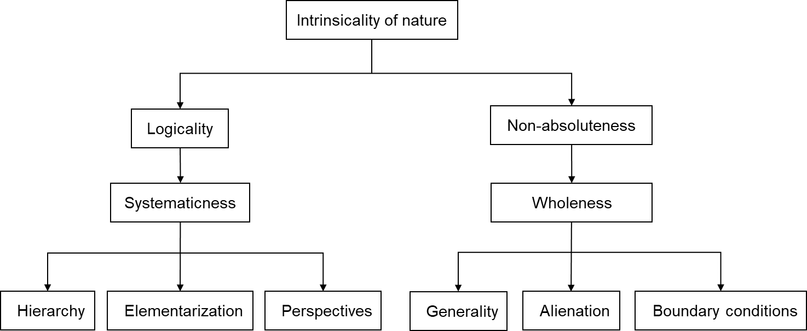

Fig.4.1 The architect of everything

We discover that the systematicness of an object is always in three concerns: “hierarchy, elementarization, and perspectives”. Let us explain what they are below:

- “Hierarchy” is the basic form of systematicness and the primary way to be logical (Elliot & Church, 1997), and it means to describe an object with a hierarchical structure in concepts.

In our study of nature, on getting a whole view of nature by including what consciousness is, we have developed a three-layer hierarchical structure of nature by describing consciousness in particular. The first layer is about the physical essence of nature and life. The second layer is about the biological essence of life and the brain. The third layer is about the essence of the consciousness system in physiology, psychology, and cognitive science. (Detailed in section 5)

- “Elementarization” is the basis to go “hierarchy”, and it means working out the essential concepts of an object for its hierarchical structure.

“Elementarization” generally can be done in two ways: the object’s two opposite characters and its distinct procedural names.

In our study of nature, especially consciousness, we have done the “elementarization” on three levels as below:

- Nature is in two “elements”, material and conscious system, as its two opposite characters;

- The human brain is in two “elements”, the CNS and human consciousness system, as its two opposite characters;

- The human consciousness system is in three “elements”, memory, subconsciousness, and subjective consciousness, as the three distinct procedures of consciousness.

This “elementarization” process is the divide-and-conquer method, and it can break down a difficult research project into studying the target entity’s subsystems and the connections between those subsystems, which usually means a much easier work to do.

- “Perspectives” is the major tactic of “hierarchy” and is about how to divide a hierarchical structure in a systematic way. It means understanding an object’s hierarchical structure from different perspectives and studying the structure from different views.

The primary practice of “perspectives” is to work out the “three aspects” of an object for providing its “well-sealed logic”, and the amazing point of this so-called “well-sealed logic” is: It can test itself. Let us explain how. An object’s “three aspects” refers to its behavior, its structure, and its running mechanism. We see these three things of an entity shall always rigorously match on any aspects and in any derivative way, say any two of them can “give off” the third “aspect” in logic, say “Behave = Structure x Running mechanism”. This is what we defined to be the “well-sealed logic” and why we name it well-sealed, say the “three aspects” of an object are in logical correspondence on any perspective and in any aspect. This means we could always hypothesize an entity’s structure and its running mechanism, from 1 or 2 aspects of its behaviors, then test that hypothesis with its behaviors from other aspects, as much as possible. This “well-sealed logic principle” is powerful and universal in all fields of science. For example, in physics, regarding the impact between two objects, if we abstracted the structure of a two-star system by their mass amount (M₁ and M₂) and their distance (R), and abstracted their running mechanism as the gravity force (F) between those two stars. Then, we shall work on its behavior, say the variation of their distance, for the right equation on the gravity law, which should be worked with math and cosmic observation. And the test of that equation can be vastly sampled in the cosmos. In sum, we see this “well-sealed logic” within the “three aspects” of entities can serve as a new fundamental way in scientific research, and the experiments may serve only as a double-checking option on theories, NOT as a most-valued way of explorations anymore.

FYI, in our consciousness studies, we have done the “perspectives” on three levels. It is the “well-sealed logic” on three levels that have tested our theory of consciousness and made it challenging, otherwise, it is just another speculation on the science of consciousness. And the “well-sealed logic” of processing information, has abstracted the structure of intelligence into four “elements”: intention, cognition, decision, and action. This structure can explain the mechanism of intelligence in an indisputable ultimate way, that may upgrade AI to AGI level naturally.

Besides this primary practice of “perspectives”, there is a secondary way of practicing, it is not to match the “three aspects”, but to match an object’s detail from all perspectives, such as different disciplines. In our consciousness studies, that is why we have kept studying all details of consciousness in physics, biology, psychology, and cognitive science, at all times.

During we understood the systematicness of an object in three concerns, we have also discovered the wholeness of an object is always in three other concerns: “generality, alienation, and boundary conditions” (Bohm, 1980). These three concerns are completely new to science, which are also foundational. Let us explain what they are below:

- “Generality” is the basis for wholeness. It means catching the wholeness of an issue or an entity by having the right sketch of it. This implies that we should focus on the core of the research project or the essence of the problem, and ignore all others. In practice, it means transforming a project into answering 1 to 3 “yes or no” questions. This practice can turn a difficult project (or question) much easier because it has transformed a difficult quantitative work into several “yes or no” identification works.

For example, in our consciousness studies, we have transformed the project into two questions:

- If consciousness is independent of neurons and there is a CNS-independent consciousness system?

- If memory, sub-consciousness, and subjective consciousness are just from the three excitation levels of the consciousness signals?

These two questions have turned consciousness studies into clarifying the relation between neurons and consciousness and the relation between “memory, subconsciousness, and subjective consciousness”, which is much clearer and easier to do.

- “Alienation” is the basic practice of “generality”, and it is to give an object’s all critical ambiguous concerns their independent identities, to secure a holistic view of the object or a not-wrong framework of its whole structure. Please note that “alienation” is a way to get closer to logical perfection, and it can never involve a mistake, though it means more work to do.

For example, in our consciousness studies, that is why we chose the Neutral Monism model to secure a holistic view of nature, because the Physicalism model might not be physically deep enough for modern physics has not been completed yet; that is why we assumed the human brain had a CNS-independent consciousness system to secure a holistic view of the brain or mental processes.

Though “alienation” is a pure virtual concept, we can more easily understand and accept it with a geometrical view, say “alienation” geometrically means to stand far away from your target object for achieving the whole picture of it. For instance, when Newton saw an apple fall on the ground, he did not know whether that apple belongs to the earth or not, but he just considered it as another planet, then he figured out the gravity law.

Let us emphasize the no-mistake of this “alienation” practice again. It is no mistake logically, and it never breaks a theory, but only adds extra clues to test and improve that theory by offering a broader view. For example, the assumption of a CNS-independent consciousness system does not break any pure neural theories of consciousness, but only adds an extra clue to test and improve them.

- “Boundary conditions” is the main practice of “generality”, and it is to examine the edges of an object from all aspects (Bohm, 1980). “Boundary conditions” of an object refers to the thresholds of its “elements” states or the thresholds of the interactions between its two “elements”.

We see that this “boundary conditions” principle is nature’s “non-absoluteness” in practice, and appear to be an unnoticed foundational theory in science. That is why we emphasize that fixing the “boundary conditions” is the key to answering all those difficult “yes or no” questions. In physics, tons of facts have been told about the importance of “boundary conditions”. For example, different frequency ranges have made electromagnetic waves show so differently from radio waves, to visible light, to X-rays. And all physicists know that the Theory of Relativity and Quantum Theory are both incomplete, because they do not have a “boundary conditions” to connect or transform with each other. We see this “boundary conditions” principle as one major outcome of our studies and will be an ultimate issue in science.

In our consciousness studies, that is why we have been focusing on examining the “boundary conditions” between linear thinking and nonlinear thinking, and the “boundary conditions” between healthy nonlinear thinking and unhealthy nonlinear thinking as the theme of our studies.

In sum, this “architect of everything” is the universal proto-structure of everything. It has provided a universal clue to study everything. All high intelligent systems have to use it perfectly as their “principle of cognition-making”, including humans and AGI (artificial general intelligence).

- The general model of nature

The unity of science requires us to develop a whole picture of nature. So, based on the logic framework of Neutral Monism philosophy (Stubenberg, 2018 ), we have applied the “architect of everything” and developed the “general model of nature” by particularly specifying what consciousness is. It is in a three-layer hierarchical structure that has specified consciousness in the view of physics, biology, and the science of consciousness.

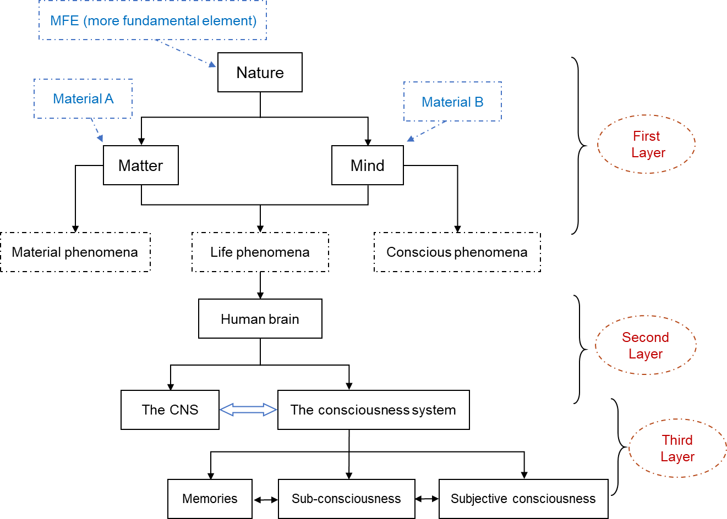

Fig.5.1 The general model of nature

Let us explain the “well-sealed logic” in the three layers of this model below:

- The first layer is about the physical essence of nature and life.

Nature is from the MFEs (more fundamental element) which is a material beyond modern physics. The impact of MFEs, the GIN (General Impact of Nature), is an oscillating-alike impact beyond space called the coupling. The coupling has two types of singularities. The singularity type A makes the MFEs show as Material A which gives off the material phenomena in modern physics; the singularity type B makes the MFEs show as Material B which gives off the conscious phenomena beyond modern physics. And the cross-points of the two types of singularities make the MFEs show as life phenomena. So, the “well-sealed logic” is formed among the structure, behavior, and impact of nature, and the physical essence of nature and life has been explained.

- The second layer is about the biological essence of life and the brain.

The human brain is chosen to be the core of life phenomena, and the brain has two subsystems: the CNS and the consciousness system. This brain structure has turned neuroscience into three independent theories: the theory of the CNS, the theory of the consciousness system, and the theory about the interaction of the CNS and the consciousness system (the theory of NCC: neural correlates of consciousness). There are three different types of impacts within mental processes: the impact among neurons, the impact within the consciousness system, and the impact between the CNS and the consciousness system. We see this well-sealed logic has separated the NCC effect from the pure neuronal activities, while assuming an independent conscious impact, so, we could examine three of them independently.

- The third layer is about the essence of the consciousness system in physiology, psychology, and cognitive science.

First, we have modeled the physical structure of the consciousness system in “elements” that correspond to each piece of our knowledge and ideas. So, the match of structure to informational behavior is completed, and the “conscious information processing” has its physical basis. (We have explained the details in our article about the theory of consciousness to make this article concise.)

Second, we have figured out the three basic types of conscious phenomena as “memory, subconsciousness, and subjective consciousness”, and correspond them to the three excitation states of the consciousness signals which are produced by the consciousness system. So, the basic match of the structure, behavior, and mechanism is formed. These “three aspects” of the consciousness system have given the “well-sealed logic” that can give off the physical models of many types of conscious experiences, such as emotion, personality, intuition, hard memory, etc. (We have explained the details in our article about the theory of consciousness to make this article concise.)

Third, because nonlinear thinking is the most unique behavior of mental processes, we have modeled the impact of consciousness physically nonlinear and beyond space, and pointed out four measurable “linear elements” to quantify it. So, the “well-sealed logic” of the consciousness system has been specified in a critical direction. (We have explained the details in our article about the theory of consciousness to make this article concise.)

Fourth, we have also specified the “beyond-domain concept” as the senior formation of information, and modeled the “consciousness-carried information processing” in four procedures: intention, cognition, decision, and action. This has specified the general intelligence’s essence together with its four “elements”. So, we can understand intelligence on a new level. (We have explained the details in our articles about the theory of consciousness and AGI to make this article concise.)

We see the above “well-sealed logic” has provided us with a new holistic view of nature with a very different understanding of nature, material, consciousness, life, brain, neuron, memory, and intelligence. There are three examples below:

- Nature is from MFE, and the material that we know now is only Material A and there is Material B for conscious phenomena.

- Memory is being given a physical basis, so psychology is materialized. Memory’s two exciting active states correspond to subconsciousness and subjective consciousness for covering all types of mental phenomena. Memory’s processing includes: storing, activating, processing new information, and restoring. The brain does not only have the CNS, but there is also an unknown consciousness system beyond modern science.

- There is a beyond-physics consciousness signal in mental processes, and it is the carrier of the “beyond-domain concept” which is a challenging concept in cognitive science.

In practice, this new view of nature and consciousness has already enabled us on three issues:

- Successfully explained many types of mental phenomena, such as emotion, personality, hard memory, nonlinear thinking, etc.

- Developed the method to measure the content of consciousness with the “real” NCC (neural correlates of consciousness) data by filtering out the “carrier” neural signals.

- Discovered the three keys of the AGI technology.

(To keep this article concise, the above has been explained in detail in our two other articles: The coupling theory of consciousness and The model of AGI.)

- Discussions

6.1 The unity of science

The intrinsicality of nature has done the unity of science because it is the ultimate property of all things. This unity has been specified in four aspects:

- The unity of all theories and the unity of natural laws;
- The unity of all dynamics: The “General Impact of Nature” (GIN) has unified the impact of everything;
- The unity of all entities: The “architect of everything” has unified the structure of everything;
- The unity of nature: The “general model of nature” has unified the reality of everything by providing a holistic view of nature, especially by specifying what consciousness is.

Let us explain the application of this unity in two steps: First, the unifying effects on disciplines and scientific theories; second, a powerful new tool for all scientific research.

- The unity of disciplines

- In physics and cosmology, both the GIN’s coupling property and the “non-absoluteness” of nature, have pointed out that the current gravity law might be an incomplete one, because the gravity force should have its sudden reversing and amplifying effects, with its two types of variables: the distance of two objects and the amount of their mass. In short, GIN theory may stand as a new theoretical basis for both physics and cosmology.

- In life science and biology, a) the “cross-points of two types of singularities of MFE” theory is challenging the cell-based life science and molecule-based biology on the essence of life. b) the consciousness system of the brain may change neuroscience and psychology from their bottom and unify them. In short, the MFE model may stand as the common theoretical basis for all life-related disciplines, including genetics.

- The unity of scientific theories

All natural laws are describing Nature in different fields from different aspects, so, all scientific theories are following the wholeness of reality in a holistic way. So, in practice, we could review all existing theories on the “boundary conditions” of their laws, and beyond one “boundary conditions”, there must be a new set of laws and theories. This is the unity of scientific theories. This has implied any theory that has no “boundary conditions” is a wrong one or an uncompleted one, such as the current gravity law and the current molecule-based gene theory.

- The holistic view and the “well-sealed logic” of everything

- The “general model of nature” has brought us a holistic view of nature, and any entity with its right position in nature will provide us with a holistic view of it. In a research project, we shall study the target with a holistic view and study it from aspects as much as possible, otherwise, our conclusion will always be a totally wrong one or an uncompleted one.

- The “perspectives” part of the “architect of everything” section, has elementarized an entity’s “behavior”, “structure”, and “running mechanism” as its “three aspects”. And since these “three aspects” must be in good correspondence from all perspectives, we have named this relationship to be an entity’s “well-sealed logic”. This “three aspects in well-sealed logic principle” is truly powerful, because we could always postulate an entity’s “three aspects” from 1 to 3 perspectives, then test those hypotheses on all other perspectives. So, we can do research by hypothesizing and testing in a purely logical way, before we do any experiments in the lab. Any apparent contradiction in any perspective of a hypothesis will certainly prove it is a wrong one. This pure logical reasoning way may set our science much free of empiricism, but use theoreticism much more on explorations, while saving time and other resources by not working on basically-wrong hypotheses and not designing experiments for only speculating on their outcomes. We could always design experiments, from multiple perspective-views, with some high-accurate anticipated results, and with the aim of testing a hypothesis instead of for speculative explorations. This procedurally reversal way of developing and testing a theory has theoretically high efficiency and high accuracy for sure. We have been applying this “holistic view and well-sealed logic principle” in our consciousness studies strictly. We have briefly introduced in section 5, how we have followed this in developing The Coupling theory of consciousness and The Method to Measure Consciousness, though their details are in another article to keep this article concise. So, in summary, this “well-sealed logic principle” has brought a pure logic way to scientific research. We hope it can advance research-project methodology fundamentally.

6.2 The unification of all knowledge

One key application of The Unity of Science is to implement The Unification of All Knowledge. We may do this unification in 7 points now.

- The theoretical basis of this unification is what? It is the intrinsicality of nature. Knowledge is also one kind of natural entity, so the ultimate property of all knowledge is “logicality and non-absoluteness”, and this has made this unification theoretically feasible.

- The unification of all knowledge. We can do this unification with an architecture of all knowledge (AOAK) which hosts all knowledge pieces. AOAK is based on the “general model of nature”, because all knowledge pieces are based on entities, including their relevant descriptions and the description of their connections. Each spot of AOAK can be extended hierarchically and interweavingly in an infinite way, because the number of entities is infinite. AOAK is noun-based and other types of words are for colorizing and connecting them vividly, because all meanings are noun-based. The nouns, the descriptions of nouns, and the connections between different nouns are all quantified in a conditioned way that has a flexible range of their own, and this has enabled the AOAK’s center and structure can be highly shiftable to give off any sophisticated meanings in high accuracy. So, the ID of knowledge pieces, interwoven by their flexible connections, this has done the unification.

The total number of knowledge pieces is really huge, but they are in a highly related way. So, we see that there should be a method to compose all knowledge pieces with some unique knowledge pieces, and this is like chemical elements to compose all types of molecules. We may use only 200-2000 pieces of those unique knowledge pieces, so-called universal knowledge elements (UKE), to compose all known knowledge pieces, even though the total number of the UKEs is theoretically still infinite. We can make a unique hierarchical structure of the UKEs to present one knowledge piece, really precise. Though the structure is theoretically from all UKEs, usually 3-7 UKEs can compose most knowledge pieces, for precise enough communications. The structure of one UKE structure is also in the architecture of value-in-range and value quantified in a conditioned way, so a small condition change or the small value change of one UKE may let this structure gives off a completely different knowledge piece. And of course, other basic architecture change of one structure may give off different knowledge pieces for sure. So, in this way, knowledge pieces have been constructed or composed in a very flexible way. So, this UKE system has dramatically up-leveled this unification of all knowledge by providing explicit connecting clues.

In conclusion, this unification of all knowledge is in two ways, all-in-one architecture and all knowledge pieces are composed of the elements of UKEs. We see that this AOAK practice has strictly followed the “logicality and non-absoluteness” principle, so this unification of all knowledge is in a both highly systematic and highly flexible way: systematic in the hierarchical and elementarily way; flexible in a center-and-structure shifting and meaning changing on value-and-conditions’ in-range way.

- The ranking of entities of its kind. The ranking of entities is one major aspect of the unification of knowledge, because it is one of the major interweaving clues. However, based on Nature’s non-absoluteness, we have gotten a fundamental truth knowledge of reality, it is about the ranking of entities, which says the exact opposite of our science today. Science today says that an entity’s ranking is determined by its complexity level. But we see an entity’s “logicality” refers to its basic structure that determines its type, its complexity is only about the derivation from its basic structure; this entity’s “non-absoluteness” refers to its flexibility level that is from its structure and determines the ranking of its kind. In short, “The ranking of an entity of its kind depends principally on its flexibility (non-absoluteness), NOT its complexity (logicality), and this is in the view of both its structure and its running mechanism”. This ranking statement sounds weird and useless, but let us see its power on its implication of how to developing the super-intelligent AI, just as an example: “The uplevel of AI, or the road to super-intelligent AI or AGI, will count on the flexibility level on the formation of information, the architecture of information, and the law of processing information, NOT the complexity level on the volume of information, or the speed and algorithms of processing information”. We shall see flexibility and complexity as totally two different directions of sophistication, especially in developing AGI. This is a highly disputable conclusion, especially when we are introducing it here in a non-disputable theoretical way.

- To clarify the essence and power of mathematics is one other major aspect of the unification of knowledge. By knowing Nature’s non-absoluteness, we know more clearly about the essence of mathematics now. Math is in numbers and it is a way to quantify the “non-absoluteness” of reality in an absolute method. It is not a branch of science, but it is a powerful tool of science. It has not only quantified everything in a meaningful way, but also its theorems can always unveil some deep laws of nature in an incredible way, even though, those revelations can involve the non-absolute aspect of those laws is under questioning still.

- The unification of all knowledge needs a universal and standardized method of studying all new entities and new issues. We have achieved this from the “architect of everything”. This is because the “architect of everything” can serve as the “principle of cognition-making” in the view of examining issues. If this “principle of cognition-making” can be checked and approved by experts finally, it will be the basic theory in cognitive science. For instance, this “principle of cognition-making” shall be one of the basic concerns in developing AGI, and we have also discovered that no known high intelligent systems had not followed this principle in their characterized perfect ways.

- This unification has led us to now be aware that science has long lost its second half of foundation. Science is not only about “logical”, but also about “nonlogical” (non-absolute). In other words, science has kept focusing on “logicality”, but it should also keep focusing on “non-absoluteness”. In practice, we should review all existing theories and laws on their “boundary conditions”, and this is not only for double-checking the existing theories, but also for discovering new theories in a systematic-and-holistic way, say all theories are following the wholeness of reality.

- This unification of knowledge has covered all unknown knowledge already. We cannot get detailed information about them automatically, but we have learned their principles and could follow their principles to dig them out. For example, we do not know the details of consciousness now, but we have seen its position in the “general model of nature” already, and seen its property should follow the “non-absolute” principle and the theory of consciousness should have its “boundary conditions”. The unification of the unknown is essential for real unification.

In short, this unification of all knowledge is a universal one in the Universe and beyond civilizations, and it is identical to all species and all super-intelligent systems, though their awareness and reaction manners are vastly varied. We do hope this unification of all knowledge could be double-checked in all aspects, and may soon be a basic theory for pedagogy, scientific research, and developing civilization.

- Conclusions

Science is to discover natural laws, and the unity of science is to interweave the logic of all laws holistically. The intrinsicality of nature, the “General Impact of Nature”, the “architect of everything”, and the “general model of nature”, are the four new fundamental theories to advance science for getting this unity of science. The Unification of All Knowledge had been specified in 7 points. All disciplines and all knowledge are under one roof now, plus the holistic and well-sealed logic framework for all entities. Now, we are on a new stand for everything, including how to solve the three hard problems in science: a) the theory of everything in physics; b) the theory of consciousness; c) the theory of the super-intelligent AI or AGI.

Acknowledgments
I thank my respected discussant Dr. K.C, and also thank Lian Wang, Bernard Baars, Randal Koene, Pim Van Lommel, Biao Zhao, Xiaohan Tang, Wenwei Yuan, Guihua Yao, Patrizio E. Tressoldi, Philip Goff, James B.Glattfelder, and Robert Karl Stonjek for their critiques and supports.

Conflict of Interests
We declare no conflict of interests.

References

Bohm, D. (1980). Wholeness and the Implicate Order.
Cat, J. (2021). The unity of science The Routledge Handbook of Logical Empiricism (pp. 176-184): Routledge.
Elliot, A. J., & Church, M. A. (1997). A hierarchical model of approach and avoidance achievement motivation. Journal of personality and social psychology, 72(1), 218.
Hofstadter, D. R. (1980). Gdel, Escher, Bach : an eternal golden braid: Gödel, Escher, Bach : an eternal golden braid.
Kincaid, H. (1990). Molecular biology and the unity of science. Philosophy of Science, 57(4), 575-593.
Mach, E. (1890). The Analysis of the sensations: antimetaphysical. The Monist, 1(1), 48-68.
Mach, E. (1891). Some Questions of Psycho-Physics. A Discussion.: Sensations and the Elements of Reality. The Monist, 1(3), 393-400.
Mach, E. (1892). Facts and mental symbols. The Monist, 2(2), 198-208.
Peat, D. (1988). Superstrings and the search for the theory of everything.
Schrödinger, E. (1992). ., What is life?: With mind and matter and autobiographical sketches: Cambridge University Press.
Stubenberg, L. (2018 ). Neutral Monism. The Stanford Encyclopedia of Philosophy.
Tahko, T. E. (2021). Unity of Science: Cambridge University Press.
Tooley, M. (1977). The nature of laws. Canadian journal of Philosophy, 7(4), 667-698.

The UKEs will be detailed in our other article: The UKE system: The buffered language of all languages.
This will be detailed in our other article: The model of AGI.

