Expert System for Castor Diseases and Diagnosis

Fatima M. Salman, Samy S. Abu-Naser
Department of Information Technology,
Faculty of Engineering & Information Technology,
Al-Azhar University, Gaza, Palestine

Abstract: Background: The castor bean is a large grassy or semi-wooden shrub or small tree. Any part of the castor plant parts can suffering from a disease that weakens the ability to grow and eliminates its production. Therefore, in this paper will identify the pests and diseases present in castor culture and detect the symptoms in each disease. Also images is showing the symptom form in this disease. Objectives: The main objective of this expert system is to obtain appropriate diagnosis of the disease. Methods: In this paper, the expert system is designed for the ability of agricultural engineers to detect and diagnose disease of castor like as: seeding blight, alternaria blight, cercospora leaf spot, powdery mildew and wilt. This system presents the disease symptoms, survival and spread, favorable conditions and image for each disease. Clips and Delphi expert system languages are used for designing and implementing the proposed expert system. Results: The expert system in the diagnosis of castor diseases was assessed by farmers and agricultural engineers and they were satisfied and accepted with its quality of performance. Conclusions: The expert system is easy for farmers and people have experience in the plant of castor to detect and diagnosis the symptoms that may face this plant from several disease.
Keywords: Artificial Intelligence, Expert Systems, CLIPS, Delphi, Castor diseases

Introduction
With large leaves, a tropical appearance and granules of exotic seeds, castor bean is a strange addition to the ornamental garden. The only member of the genus, Ricinus communis is in the Spurge Family (Euphorbiaceae). The word ricinus is a Latin word meaning “tick”, and is used for this name due to the superficial similarity of the seeds to a particular type of European tick. Castor belongs to the tropics of East Africa around Ethiopia, but has been naturalized in the tropics and subtropical regions around the world to become grasses in many places, including the Southwestern United States. Plants are usually found in well-drained wet soil in disturbed areas, such as along the riverbed and on the sides of roads, in lush fields or on the edges of cultivated land.

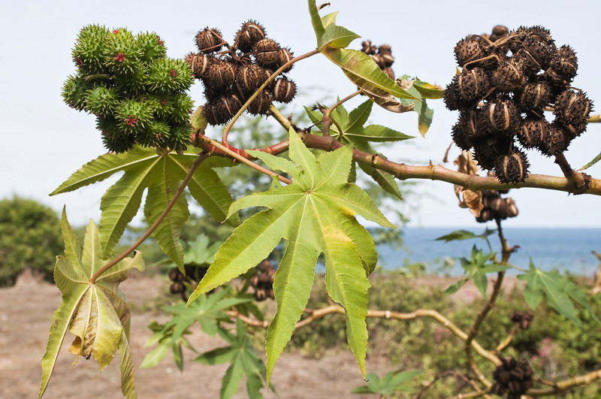

Figure 1: shows castor trees
The castor bean is a large grassy or semi-wooden shrub or small tree. These sturdy perennials can grow to 40 feet, and the evolution of wood logs over a few years in frost-free climates. Due to its rapid and active growth, it is easily grown as a mild season in temperate climates, however rarely exceeds 6-10 feet in one growth season. This fast-growing plant tends to grow straight at first, developing branches later this season to form a bush that is consistent with strong stalks and dense canopy. This fast-growing plant tends to grow straight at first, developing branches later this season to form a bush that is consistent with strong stalks and dense canopy. The plant is killed when the temperature drops below 32F. Unlike many members of the euphorbia family, this plant does not have milky latex sap, but has a watery sap [1].

An expert system is a computer system that emulates, or acts in all respects, with the decision-making capabilities of a human expert. Its main components are: Knowledge base, it’s obtainable from books, magazines, knowledgeable persons, etc. Inference engine, it draws conclusions from the knowledge base [2,14-20]. Figure 2 displays the main components.

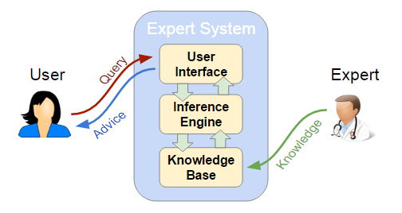
Figure 2: main components of expert system

The Expert system for Castor Diseases Diagnosis was implemented using CLIPS shell and Delphi language. CLIPS is a decent example of an expert system shell, it illustrates many of the concepts and methods used in other expert system shells, it allows the representation of knowledge, and its use for solving suitable problems[21-25].

MATERIALS AND METHODS
The expert system accomplish diagnosis for five castor diseases display in the leaves, can applied by display all symptoms in list and select it to analysis the disease. The expert system will ask the user to choose the symptoms that appear on castor plant from the list[26-30]. Then click analyze button to diagnosis the castor disease name, survival and spread, favorable conditions and snapshot of the disease. The expert system has been designed for change the theme for user interface like font color, background color, font name, and font size. Also it have many form, each form display specific format. For example figure 3 display the basic data for the expert system such as name and image. In the figure 4 display the format of the first user interface include name of expert system and whom designed it and background about the system. In figure 5 display the format of symptoms screen that display all symptoms in the list. In figure 6 display the format of result screen that include all details that diagnosis of the disease. In figure 7 display the format of screen entering details of disease[32-33].

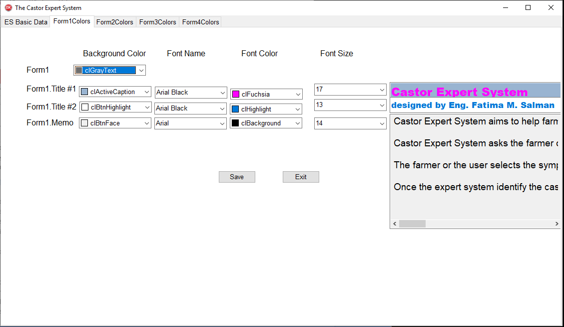
Figure 3: display the basic data for expert system

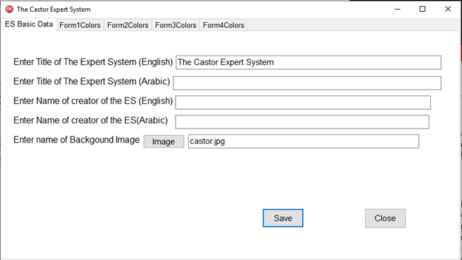
Figure 4: display format of the main page in expert system

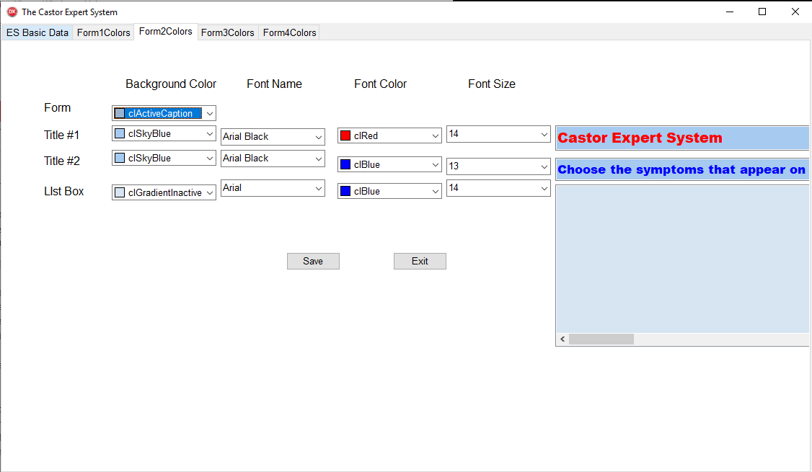
Figure 5: display format of selection symptoms.

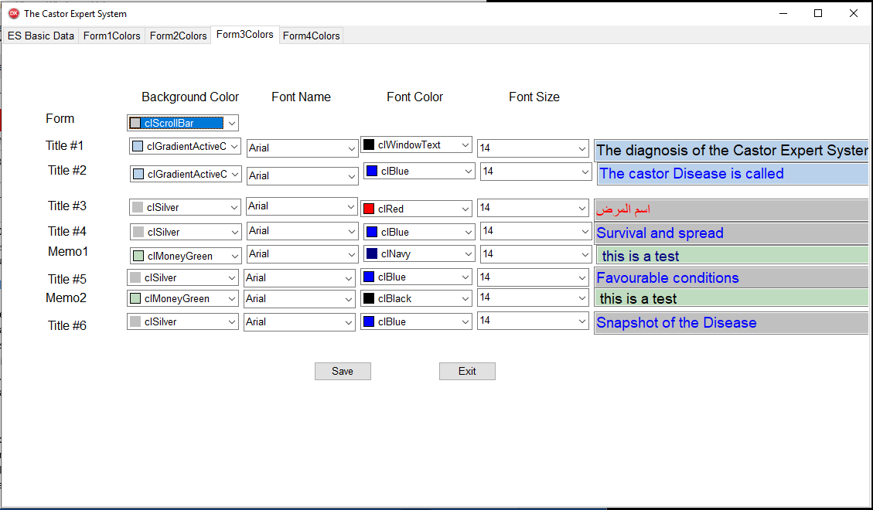
Figure 6: display format of details screen of disease

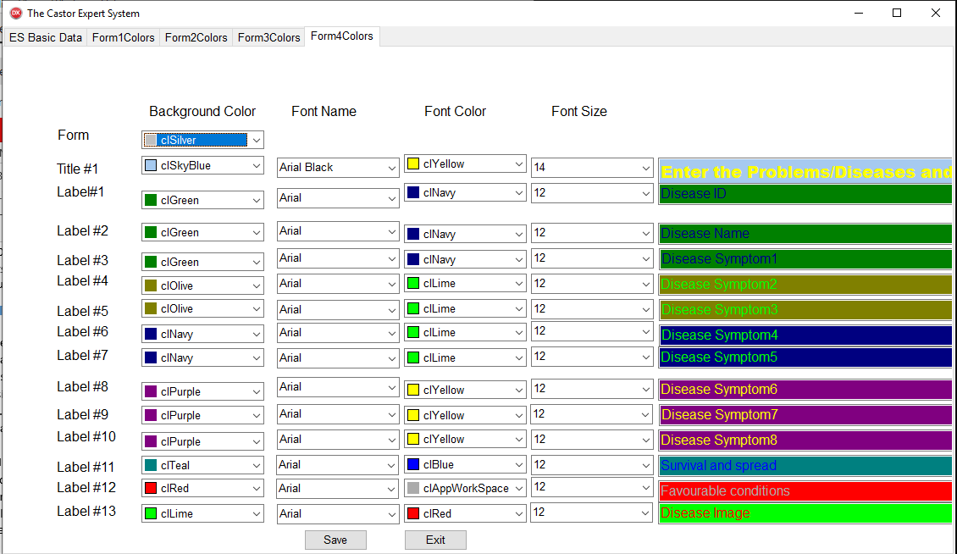
Figure 7: display the format of entering diseases details

In the Figure 8 display the main page of the castor expert system include the details and the important of the castor expert system.

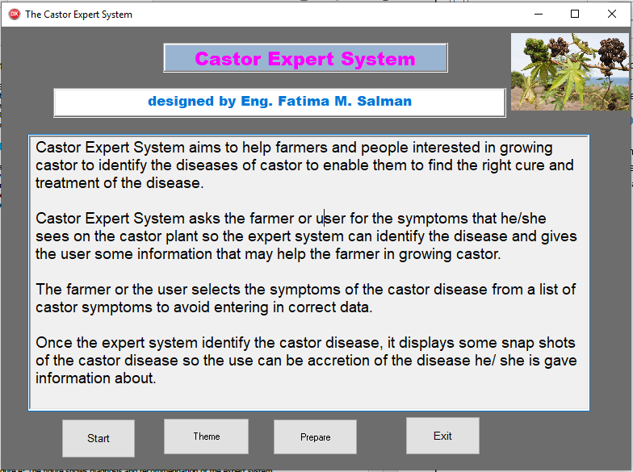
Figure 8: main page of castor expert system

In figure 9 user interface for choosing the symptoms that appear on a castor plant and click in the button analyze to display the details that is displayed in figure 9.
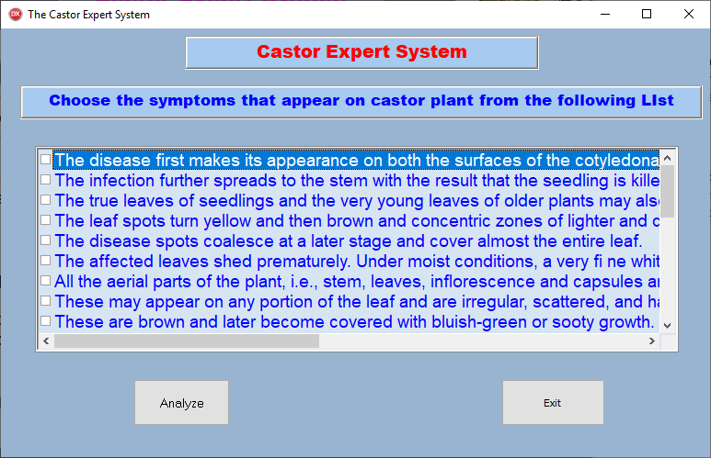
Figure 9: user interface to select the purpose symptoms

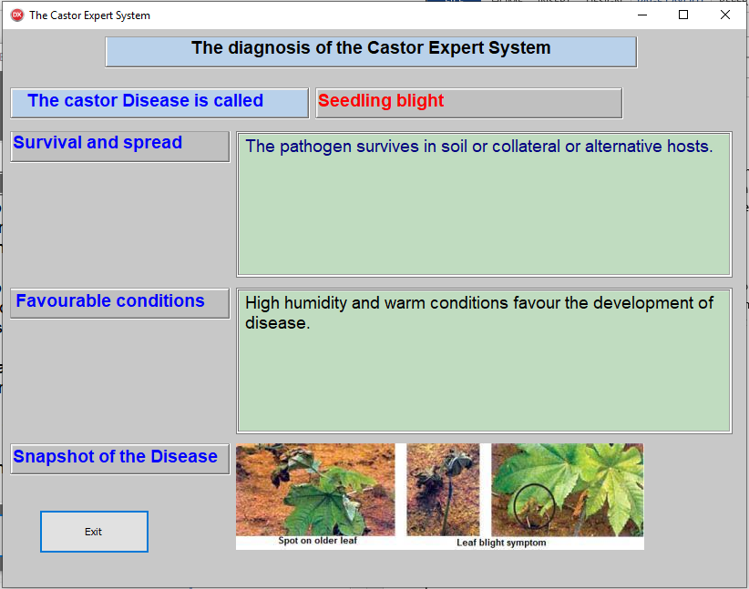
Figure 10: user interface display the details for castor disease

LITERATURE REVIEW
A lot of expert systems that were designed to diagnose human diseases like [35-41, 43-47], expert system which helps farmers and specialists to diagnose and get appropriate advice on plant and trees problem like: general plant [2], mango [11], Black pepper [4], banana [3, 42] onion [5], potato [34], Pineapple [7], watermelon [6], tomatoes [48], seedlings classification[49], and other kinds of diseases. However there no expert system found to diagnosis the castor diseases.

KNOWLEDGE REPRESENTATION
The main sources of the knowledge for this expert system are agriculture and specializes websites for castor diseases. The captured knowledge has been converted into CLIPS Knowledge base. Currently the expert system has a number of rules which cover five castor diseases [7]:

4.1 Seedling blight: It has some of disease symptoms that lead to dead seedling like as The disease first makes its appearance on both the surfaces of the cotyledonary leaves in the form of roundish patch of dull green color which soon spreads to the point of attachment causing the leaf to rot and hang down. The infection further spreads to the stem with the result that the seedling is killed either due to the destruction of growing point or by the collapse of stem. The true leaves of seedlings and the very young leaves of older plants may also be affected; but ordinarily not much injury is caused. The leaf spots turn yellow and then brown and concentric zones of lighter and darker brown color are formed. The disease spots coalesce at a later stage and cover almost the entire leaf. The affected leaves shed prematurely. Under moist conditions, a very fine whitish haze is found on the under-surface of the leaf spots.
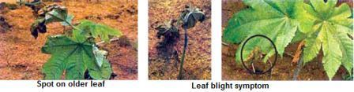
Figure 11: The figure shows the seedling blight diseases effect

4.2 Alternaria blight: It has some of disease symptoms that have Alternaria leaf spot with concentric rings like us, all the aerial parts of the plant, i.e., stem, leaves, inflorescence and capsules are liable to be attacked. These may appear on any portion of the leaf and are irregular, scattered, and have concentric rings. These are brown and later become covered with bluish-green or sooty growth. When the attack is severe the spots coalesce and form big patches resulting in premature defoliation of the plant which gradually wilts away. In one case the capsules, when half mature, wilt suddenly, turn brown and due to collapse of the pedicel the capsules fall or hand down. They are smaller in size and have under-developed and wrinkled seeds with little oil content.
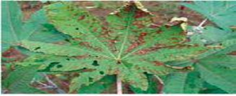
Figure 12: The figure shows the Alternaria blight diseases effect

4.3 Cercospora leaf spot: it has some of disease symptoms like as, the disease appears as minute black or brown points surrounded by a pale green ring. These spots are visible on both the surfaces of the leaf. As the spots enlarge, the center turns pale brown and then greyish-white surrounded by a deep brown band which may be narrow and sharp or broad and diff used. The fructifications of the fungus appear as tiny black dots in the white centre. The diseased spots often occur in great numbers scattered over the leaf and are roundish when young but may become irregularly angular when mature. When the spots are close together, the intervening leaf tissue withers and large brown patches of dried leaf may result.
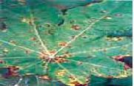
Figure 13: The figure shows the cercospora leaf spot diseases effect
4.4 Powdery mildew: it has some of disease symptoms that have Powdery mass covering entire leaf like as, it is characterized by typical mildew growth which is generally confined to the under-surface of the leaf. When the infection is severe the upper-surface is also covered by the whitish growth of the fungus. Light green patches, corresponding to the diseased areas on the under surface, are visible on the upper side especially when the leaves are held against light.

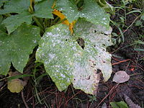
Figure 14: The figure shows the powdery mildew diseases effect

4.5 Wilt: it has some of disease symptoms like as, Leaves droop and drop off leaving behind only top leaves. Diseased plants are sickly in appearance. Wilting of plants, root degeneration, collar rot, drooping of leaves and necrosis of affected tissue and finally leading to death of plants. Necrosis of leaves starts from margins spreading to interveinal areas and finally to the whole leaf. Spilt open stem shows brownish discolouration and white cottony growth of mycelia much prominently in the pith of the stem.

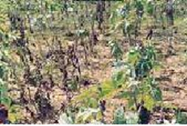
Figure 15: The figure shows the wilt diseases effect

LIMITATIONS
Currently the proposed expert system is specialized in the diagnosis five castor diseases: Seedling blight, alternaria blight, Cercospora leaf spot, Powdery mildew, and Wilt.

SYSTEM EVALUATION
As an introductory evolution, a group of farmers and Agricultural specialists tested this proposed Expert System and they were satisfied with its performance, efficiency, user interface and ease of use.

CONCLUSION
In this paper, a proposed expert system was presented for helping farmers and Agricultural specialists in diagnosing patients with five different possible castor diseases. Agricultural specialists and farmers can get the diagnosis faster and more accurate than the traditional diagnosis. This expert system does not need intensive training to be used; it is easy to use and has user friendly interface. It was using CLIPS and Delphi XE10.2 languages.

FUTURE WORK
This expert system is considered to be a base of future ones; more castor diseases are planned to be added and to make it more accessible to users from anywhere at any time.
REFERENCES
- Susan Mahr, University of Wisconsin – Madison, Castor Bean, Ricinus communis (June 1 2012). Available at https://wimastergardener.org/files/2015/12/Ricinus_communis.pdf
- Paloma Acton, Presentation on theme: "Supporting Business Decisions Expert Systems. Expert system definition Possible working definition of an expert system: –“A computer system with a knowledge." 2016. Available at https://slideplayer.com/slide/4934390/
- Almadhoun, H. R., & Abu Naser, S. S. (2018). Banana Knowledge Based System Diagnosis and Treatment. International Journal of Academic Pedagogical Research (IJAPR), 2(7), 1-11.
- Barhoom, A. M., & Abu-Naser, S. S. (2018). Black Pepper Expert System. International Journal of Academic Information Systems Research (IJAISR), 2(8), 9-16.
- Alajrami, M. A., & Abu-Naser, S. S. (2018). Onion Rule Based System for Disorders Diagnosis and Treatment. International Journal of Academic Pedagogical Research (IJAPR), 2(8), 1-9.
- Abu-Nasser, B. S., & Abu-Naser, S. S. (2018). Cognitive System for Helping Farmers in Diagnosing Watermelon Diseases. International Journal of Academic Information Systems Research (IJAISR), 2(7), 1-7.
- Castor: Diseases and Symptoms [online]. Available at http://vikaspedia.in/agriculture/crop-production/integrated-pest-managment/ipm-for-oilseeds/ipm-strategies-for-castor/diseases-and-symptoms#section-1
- S. Abu-Naser, K. Kashkash, and M. Fayyad, “Developing an Expert System for Plant Disease Diagnosis,” Journal of Artificial Intelligence, vol. 1, no. 2, pp. 78–85, Jan. 2008.
- Nassr, M. S., & Abu Naser, S. S. (2018). Knowledge Based System for Diagnosing Pineapple Diseases. International Journal of Academic Pedagogical Research (IJAPR), 2(7), 12-19.
- http://vikaspedia.in/agriculture/crop-production/integrated-pest-managment/ipm-for-vegetables/ipm-strategies-for-spinach/spinach-diseases-and-symptoms
- Elqassas, R., & Abu-Naser, S. S. (2018). Expert System for the Diagnosis of Mango Diseases. International Journal of Academic Engineering Research (IJAER), 2(8), 10-18.
- http://www.fao.org/3/ae939e/ae939e0b.htm
- Abu Ghali, M. J., Mukhaimer, M. N., Abu Yousef, M. K., & Abu Naser, S. S. (2017). Expert System for Problems of Teeth and Gums. International Journal of Engineering and Information Systems (IJEAIS), 1(4), 198-206.
- Akkila, A. N., & Abu Naser, S. S. (2016). Proposed Expert System for Calculating Inheritance in Islam. World Wide Journal of Multidisciplinary Research and Development, 2(9), 38-48.
- Al Rekhawi, H. A., Ayyad, A. A., & Abu Naser, S. S. (2017). Rickets Expert System Diagnoses and Treatment. International Journal of Engineering and Information Systems (IJEAIS), 1(4), 149-159.
- Abu Naser, S., & Akkila, A. N. (2008). A Proposed Expert System for Skin Diseases Diagnosis. INSInet Publication. Journal of Applied Sciences Research, 4(12), 1682-1693.
- El Agha, M., Jarghon, A., & Abu Naser, S. S. (2017). Polymyalgia Rheumatic Expert System. International Journal of Engineering and Information Systems (IJEAIS), 1(4), 125-137.
- Abu Naser, S., Al-Dahdooh, R., Mushtaha, A., & El-Naffar, M. (2010). Knowledge management in ESMDA: expert system for medical diagnostic assistance. AIML Journal, 10(1), 31-40.
- AbuEl-Reesh, J. Y., & Abu Naser, S. S. (2017). A Knowledge Based System for Diagnosing Shortness of Breath in Infants and Children. International Journal of Engineering and Information Systems (IJEAIS), 1(4), 102-115.
- Abu Naser, S., & El Haddad, I. (2016). An Expert System for Genital Problems in Infants. World Wide Journal of Multidisciplinary Research and Development (WWJMRD), 2(5).
- Abu Naser, S. S., Alamawi, W. W., & Alfarra, M. F. (2016). Rule Based System for Diagnosing Wireless Connection Problems Using SL5 Object. International Journal of Information Technology and Electrical Engineering, 5(6), 26-33.
- Almurshidi, S. H., & Abu-Naser, S. S. (2018). EXPERT SYSTEM FOR DIAGNOSING BREAST CANCER. Al-Azhar University, Gaza, Palestine.
- Abu Naser, S. S., & Alawar, M. W. (2016). An expert system for feeding problems in infants and children. International Journal of Medicine Research, 1(2), 79-82.
- Nabahin, A., Abou Eloun, A., & Abu Naser, S. S. (2017). Expert System for Hair Loss Diagnosis and Treatment. International Journal of Engineering and Information Systems (IJEAIS), 1(4), 160-169.
- Abu Naser, S. S., & Al-Bayed, M. H. (2016). Detecting Health Problems Related to Addiction of Video Game Playing Using an Expert System. World Wide Journal of Multidisciplinary Research and Development, 2(9), 7-12.
- Azaab, S., Abu Naser, S., & Sulisel, O. (2000). A proposed expert system for selecting exploratory factor analysis procedures. Journal of the College of Education, 4(2), 9-26.
- Abu Naser, S. S., & AlDahdooh, R. M. (2016). Lower Back Pain Expert System Diagnosis and Treatment. Journal of Multidisciplinary Engineering Science Studies (JMESS), 2(4), 441-446.
- Bakeer, H., & Abu Naser, S. S. (2017). Photo Copier Maintenance Expert System V. 01 Using SL5 Object Language. International Journal of Engineering and Information Systems (IJEAIS), 1(4), 116-124.
- Abu Naser, S. S., & Alhabbash, M. I. (2016). Male Infertility Expert system Diagnoses and Treatment. American Journal of Innovative Research and Applied Sciences, 2(4).
- Khella, R., & Abu Naser, S. S. (2017). Rule Based System for Chest Pain in Infants and Children. International Journal of Engineering and Information Systems, 1(4), 138-148.
- Abu Naser, S. S., & Al-Hanjori, M. M. (2016). An expert system for men genital problems diagnosis and treatment. International Journal of Medicine Research, 1(2), 83-86.
- Dahouk, A. W., & Abu-Naser, S. S. (2018). A Proposed Knowledge Based System for Desktop PC Troubleshooting. International Journal of Academic Pedagogical Research (IJAPR), 2(6), 1-8.
- Abu Naser, S. S., & ALmursheidi, S. H. (2016). A Knowledge Based System for Neck Pain Diagnosis. World Wide Journal of Multidisciplinary Research and Development (WWJMRD), 2(4), 12-18.
- Musleh, M. M., & Abu-Naser, S. S. (2018). Rule Based System for Diagnosing and Treating Potatoes Problems. International Journal of Academic Engineering Research (IJAER), 2(8), 1-9.
- Abu Naser, S. S., Baraka, M. H., & Baraka, A. (2008). A Proposed Expert System For Guiding Freshman Students In Selecting A Major In Al-Azhar University, Gaza. Journal of Theoretical & Applied Information Technology, 4(9).
- Mrouf, A., Albatish, I., Mosa, M., & Abu Naser, S. S. (2017). Knowledge Based System for Long-term Abdominal Pain (Stomach Pain) Diagnosis and Treatment. International Journal of Engineering and Information Systems (IJEAIS), 1(4), 71-88.
- Abu Naser, S. S., & Bastami, B. G. (2016). A proposed rule based system for breasts cancer diagnosis. World Wide Journal of Multidisciplinary Research and Development, 2(5), 27-33.
- Naser, S. S. A., & Hasanein, H. A. A. (2016). Ear Diseases Diagnosis Expert System Using SL5 Object. World Wide Journal of Multidisciplinary Research and Development, 2(4), 41-47.
- Abu Naser, S. S., & El-Najjar, A. E. A. (2016). An expert system for nausea and vomiting problems in infants and children. International Journal of Medicine Research, 1(2), 114-117.
- Qwaider, S. R., & Abu Naser, S. S. (2017). Expert System for Diagnosing Ankle Diseases. International Journal of Engineering and Information Systems (IJEAIS), 1(4), 89-101.
- Abu Naser, S. S., & Hamed, M. A. (2016). An Expert System for Mouth Problems in Infants and Children. Journal of Multidisciplinary Engineering Science Studies (JMESS), 2(4), 468-476.
- AlZamily, J. Y., & Abu-Naser, S. S. (2018). A Cognitive System for Diagnosing Musa Acuminata Disorders. International Journal of Academic Information Systems Research (IJAISR), 2(8), 1-8.
- Abu Naser, S. S., & Mahdi, A. O. (2016). A proposed Expert System for Foot Diseases Diagnosis. American Journal of Innovative Research and Applied Sciences, 2(4), 155-168.
- Abu Naser, S. S., & Ola, A. Z. A. (2008). AN EXPERT SYSTEM FOR DIAGNOSING EYE DISEASES USING CLIPS. Journal of Theoretical & Applied Information Technology, 4(10).
- Naser, S. S. A., & Hilles, M. M. (2016). An expert system for shoulder problems using CLIPS. World Wide Journal of Multidisciplinary Research and Development, 2(5), 1-8.
- Abu Naser, S. S., & Shaath, M. Z. (2016). Expert system urination problems diagnosis. World Wide Journal of Multidisciplinary Research and Development, 2(5), 9-19.
- Abu-Naser, S. S., El-Hissi, H., Abu-Rass, M., & El-Khozondar, N. (2010). An expert system for endocrine diagnosis and treatments using JESS. Journal of Artificial Intelligence; Scialert, 3(4), 239-251.
- Ashqar, B. A. M., Abu-Nasser, B. S., & Abu-Naser, S. S. (2019). Plant Seedlings Classification Using Deep Learning. International Journal of Academic Information Systems Research (IJAISR), 3(1), 7-14.
- Abu Naser, S. S. (1993). A methodology for expert systems testing and debugging. North Dakota State University, USA.
- Abu Naser, S. S. (1999). Big O Notation for Measuring Expert Systems complexity. Islamic University Journal Gaza, 7(1), 57-70.
- Abu Naser, S. S. (2015). Sl5 Object: Simpler Level 5 Object Expert System Language. International Journal of Soft Computing, Mathematics and Control (IJSCMC), 4(4), 25-37.
- Abu Naser, S., & Aead, A. M. (2013). Variable Floor for Swimming Pool Using an Expert System. International Journal of Modern Engineering Research (IJMER), 3(6), 3751-3755.
- Ashqar, B. A. M., & Abu-Naser, S. S. (2019). Image-Based Tomato Leaves Diseases Detection Using Deep Learning. International Journal of Academic Engineering Research (IJAER), 2(12), 10-16.
- Abu Naser, S. S., & Zaqout, I. S. (2016). Knowledge-based systems that determine the appropriate students major: In the faculty of engineering and information technology. World Wide Journal of Multidisciplinary Research and Development, 2(10), 26-34.
- El_Jerjawi, N. S., & Abu-Naser, S. S. (2018). Diabetes Prediction Using Artificial Neural Network. International Journal of Advanced Science and Technology, 121, 55-64.

