Knowledge Based System for Diabetes Diagnosis Using SL5 Object
Ibtesam M. Dheir, Alaa Soliman Abu Mettleq, Abeer A. Elsharif, Mohammed N. Abu Al-qumboz, Samy S. Abu-Naser
Department of Information Technology,
Faculty of Engineering and Information Technology,
Al-Azhar University - Gaza, Palestine
Abstract: Diabetes is a major public health issue that affects the nations of our time to a large extent and is described as a non-communicable epidemic. Diabetes mellitus is a common disease where there is too much sugar (glucose) floating around in your blood. This occurs because either the pancreas can’t produce enough insulin or the cells in body have become resistant to insulin. The concentration in this paper is on diagnosis diabetes by designing a proposed expert system. The main goal of this expert system is to get the appropriate diagnosing of the illness, dealing with it quickly, and tips for permanent treatment whenever possible is given out. SL5 object expert system language was used for designing and implementing the proposed expert system.
Keywords: Knowledge Based System, Diabetes, SL5 Object, expert system.

Introduction
Diabetes is a condition in which body can’t produce enough insulin to process the glucose in the blood or group of metabolic diseases in which a person has high blood sugar, otherwise known as blood sugar [2]. It is a silent epidemic and according to WHO there are 382 million people in the world living with diabetes as on December 2013. This is almost 8% of the world's adult population. Diabetes is an important 'silent killer disease' as there is usually no early symptom of the disease but the commonest early symptom is feeling thirsty. The major cause of increase in the incidence of diabetes is a sedentary lifestyle. Exercise and diet can either reduce or delay the incidence of diabetes by over 50%. Also, Diabetes is the number one cause of kidney failure in the world. Besides this every year it is responsible for 5% or 5 million blindness in adults and one million limb amputations. Diabetes is also an important cause of heart disease, stroke and cataract [3].
Artificial intelligence (AI) is an area of computer science that emphasizes the creation of intelligent machines that work and react like humans [7]. AI has many branches and one of this branch is expert systems that were developed in the mid 1960's by AI community.
Expert system is a computer program that uses artificial intelligence (AI) technologies to simulate the judgment and behavior of a human or an organization that has expert knowledge and experience in a particular field. [4]. It is mainly developed using artificial intelligence concepts, tools and technologies. An expert system is typically designed to provide capabilities similar to those of a human expert when performing a task. Moreover, it can be used to drive vehicles, provide financial forecasts or do things that human experts do [5-6].
Expert system consists of four major components which are: knowledge base, working memory, an inference engine and a user interface [14]. Figure 1 below represents the structure of an expert system [8].
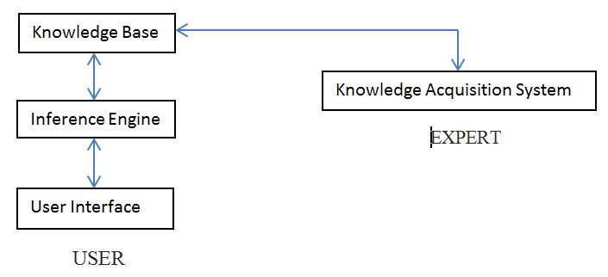
Figure 1: Main components of an Expert System [8]

- knowledge base : contains essential information about the problem domain, often represented as facts and rules
- inference engine: mechanism to derive new knowledge from the knowledge base and the information provided by the user, often based on the use of rules
- user interface: interaction with end users, development and maintenance of the knowledge base
- Working Memory: Which store temporary information that entered from the end user.

MATERIAL AND METHODS
The proposed expert system performs diagnosis for Diabetes disease by asking yes or no questions about the symptoms felt by the patient. The proposed expert system will ask the user to choose the correct answer in each screen. At the end of the dialogue session, the proposed expert system provides if the patient suffer from diabetes or not , and gives some advices based on the result.
The following figures show the program interfaces for the main page, symptoms question page and diagnosis and advice page.
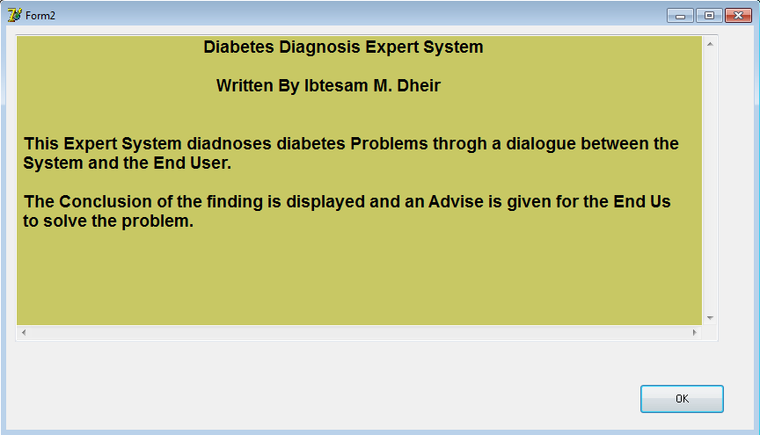
Figure 2 : the main interface of the system and the user system

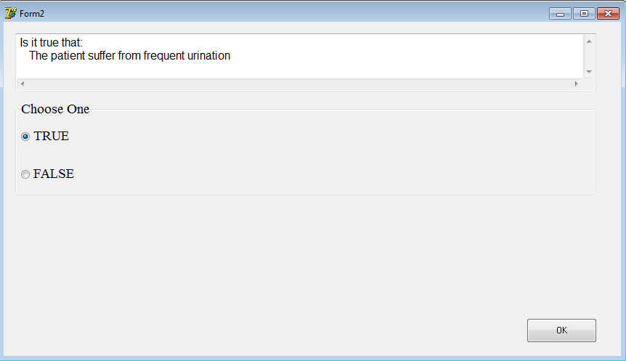
Figure 3: sample dialogue between the expert system and the user.

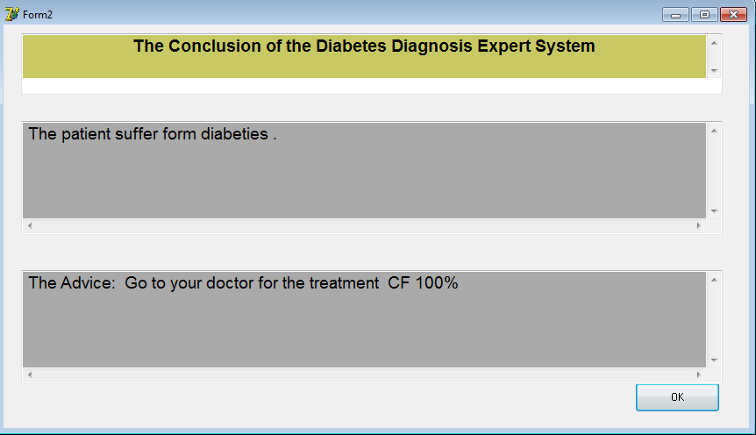
Figure 4: Diagnosis and advice

LITERATURE REVIEW
Good Expert Systems are systems with good knowledge existing inside them. The knowledge transfers to computer from expert person or client feedback, and sometimes knowledge can be acquired directly from the environment. Nowadays, there is a lot of knowledge-based system that treats a special problem or manages a certain domain; However, There is a lot of Expert System that were designed to diagnose human diseases such as:

- Knowledge Based System for Long-term Abdominal Pain (Stomach Pain) Diagnosis and Treatment [56] was made to aid internist physicians in diagnosing numerous of the abdomen diseases for example: gastritis, hiatal hernia, ulcer or heartburn; the proposed expert system offers a summary about abdomen diseases are given, the cause of diseases are drew and the cure of disease when possible is shown up.
- Knowledge Based System for Ankle Diseases Diagnosis [43] recognized seven ankle diseases: Ankle Sprain, Fracture (of Fibula), Rheumatoid Arthritis, Rheumatoid Fever, Gout, and Osteoarthritis (Degenerative Joint) and they developed the expert system for those ankle diseases using SL5 Object Expert System Language.
- An Expert System for Diagnosing Shortness of Breath in Infants and Children [34] for diagnosing infants and children patients with twelve various shortness of breath in infants and children diseases.
- Polymyalgia Rheumatic Expert System [64] outlined an expert system for classification criteria for PMR, recent advances of diagnostic and therapeutic procedures.
- Expert System for Chest Pain in Infants and Children [50] to assist doctors, parents, and care giver in diagnosing chest pain in infants and children.
- Rickets Expert System Diagnoses and Treatment [39] assist doctors to discover everything connected to the problems of rickets.
- Expert System for Hair Loss Diagnosis and Treatment [62] for diagnosing eleven diverse hair loss diseases of the human stages from childhood to adults by asking questions with a Yes or No answer.
- Expert System for Problems of Teeth and Gums [37] assist people with teeth and gums problems to diagnose their problems and receive a recommendation for the treatment. This knowledge based system was developed using SL5 Object language.
- Ear Diseases Diagnosis Expert System Using SL5 Object [31] swiftly diagnoses patient’s condition and proposes a appropriate answer for the problem.
- An expert system for feeding problems in infants and children [35] to diagnose feeding problems in infants and children.
- Detecting Health Problems Related to Addiction of Video Game Playing Using an Expert System [38] to assist users in getting the correct diagnosis of the health problem of video game addictions that range from (Musculoskeletal issues, Vision problems and Obesity). Furthermore, this expert system delivers information about the problem and tells us how we can solve it.
- An expert system for men genital problems diagnosis and treatment [44] to assist men diagnose their genital problems and give them the suitable treatment. Genital problems and injuries usually occur through: recreational activities (such as: Basketball, Football, Hooky, Biking), work-related tasks (such as: contact to irritating chemicals), downhill drop, and sexual activities. SL5 Object expert system language was used to develop this expert system.
- An Expert System for Genital Problems in Infants [51] diagnoses genital problems in infants which is one of the most common problems that need quick intervention in the newly born stage.
- An expert system for nausea and vomiting problems in infants and children[53] to aid users in getting the right diagnosis of problems of nausea and vomiting in infants and children (Gastro-esophageal reflux, Gastroenteritis, Systemic Infection, Bowel obstruction, Tumors, A bleeding disease, tonsillitis, and Hepatitis pharynx). Additionally, this expert system offers information about the disease and how to deal with it.
- A Ruled Based System for Ear Problem Diagnosis and Treatment [47] was used to classify ear problems into three main sets: a- Inflammation of the inner ear b- Middle ear problems c- External ear problems.
- Lower Back Pain Expert System Diagnosis and Treatment [40] can be used to positively diagnose low back pain concentration.
- A Proposed Expert System for Foot Diseases Diagnosis [59] diagnoses eighteen foot problems of all phases of the human life beginning with baby to the grownup by examining with yes/no questions.
- A Knowledge Based System for Neck Pain Diagnosis [45] can diagnose seven neck diseases of different phases of the human life beginning by asking the user many questions according to their pain symptoms.
- An expert system for shoulder problems using CLIPS [57] can help in diagnosing shoulder problems.
- Expert system urination problems diagnosis [61] can diagnose some of the Urination diseases (Pyelonephritis, Kidney Stone, Bladder infection, Prostatitis, Urethritis, Gonorrhea, Interstitial cystitis, Stress incontinence, Trauma in kidney or bladder).
- A Proposed Rule Based System for Breasts Cancer Diagnosis [49] was developed to help people in preventing and early detecting breast cancer; since it is known that this disease does not have medication or cure yet.
- An Expert System for Endocrine Diagnosis and treatments using JESS [65] was developed to help in diagnosing endocrine glands diseases.
- A Proposed Expert System for Skin Diseases Diagnosis [63] was developed using CLIPS(C Language Integrated Production System) to help user diagnose the following skin diseases (Psoriasis, Eczema, Ichthyosis, Acne, Meningitis, Measles, Scarlet Fever, Warts, Insect Bites and Stings).
- Male Infertility Expert System Diagnoses and Treatment [42] for male infertility diagnosis which helps men to explore everything related to the problems of infertility and infertility diseases such as: Azoospermia, O.T.A syndrome which mean oligo-terato-astheno spermia, Aspermia and Sexual transmitted disease.
- An expert system for diagnosing eye diseases using clips [33] provides the patient with background for suitable diagnosis of a few of the eye diseases.
- An Expert System for Mouth Problems in Infants and Children [45] ask the user to answer the questions about the symptoms of the patient and end up with some information about the disease and some advices telling the user how to deal with the baby.
- Knowledge Management in ESMDA: Expert System for Medical Diagnostic Assistance [36] deals with the design of a prototype expert system that assists patients to diagnose their diseases and offer them the suitable advice.

But there is no specialized expert system for the diagnosis of diabetes disease available free and use SL5 Object language. This expert system is easy to use by doctors and patients. This is due to the coordinated application interface.

KNOWLEDGE REPRESENTATION
The main sources of the knowledge for this expert system are doctor and specializes websites for diabetes disease. The captured knowledge has been converted into SL5 Object Knowledge base syntax (Facts, Rules and Object) [14].
Diabetes is a disease that occurs when your blood glucose, also called blood sugar, is too high. The normal process of how the body turns food into energy and the changes that occur when diabetes is present, is explained below [2,17].
- Food is changed into glucose : The stomach changes the food we eat into a fuel called glucose, a form of sugar. Glucose goes into the blood stream and is carried to the millions of cells in the body.
- Glucose gets into the cells : An organ called the pancreas makes a chemical called insulin. Insulin also goes into the bloodstream and travels to the cells. It meets glucose and enables it to enter the cells.
- Cells turn glucose into energy : The cells metabolize (burn) the glucose to give the body energy.

When diabetes is present, the changes that happen are:
- Diabetes makes it harder for the body to get energy from food.
- Food is changed into glucose : The stomach still changes the food we eat into glucose. Glucose goes into the bloodstream. But most of the glucose may not be able to enter the cells because:
- There may not be enough insulin.
- There may be plenty of insulin, but it can’t unlock the receptors.
- There may be too few receptors for all the glucose to get through.
- Cells can’t make energy: Most of the glucose stays in the bloodstream. This is called hyperglycemia (also known as high blood glucose or high blood sugar). Without enough glucose in the cells, the cells can’t make the energy needed to keep the body running smoothly.
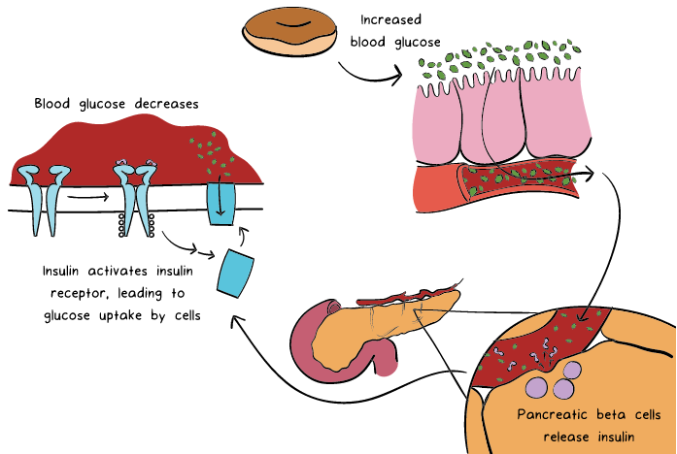

Figure 5: regulate glucose by the body [17].

Types of diabetes
Three major diabetes types can develop: Type 1, type 2, and gestational diabetes.
Type I diabetes: Also known as juvenile diabetes, It is usually caused by an auto-immune reaction where the body’s defense system attacks the cells that produce insulin. Although the exact cause has not been identified, it is clear that the cells which make insulin are destroyed by the body’s own immune system. This occurs due to autoimmunity, a process by which the immune system believes some of the body’s cells are foreign and targets them for destruction [17]. The disease may affect people of any age, but usually develops in children or young adults. People with type 1 diabetes produce very little or no insulin and they are insulin-dependent, which means they must take artificial insulin daily to stay alive. If people with type 1 diabetes do not have access to insulin, they will die[2,15].
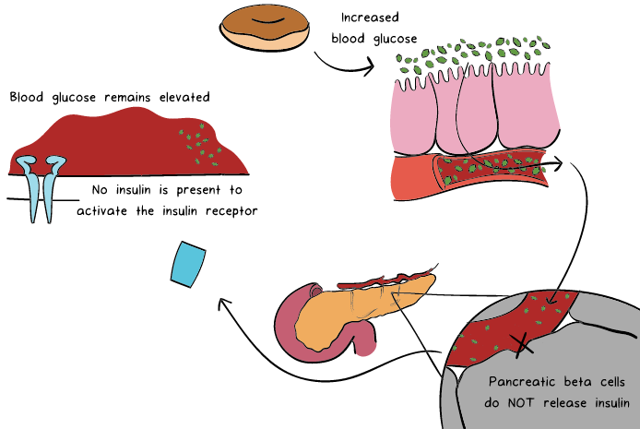
Figure 6: Type 1 diabetes [17]
Type 2 diabetes used to be called non-insulin dependent diabetes or adult-onset diabetes, it affects the way the body uses insulin. While the body still makes insulin, unlike in type I, the cells in the body do not respond to it as effectively as they once did. it accounts for at least 90% of all cases of diabetes. It is characterized by insulin resistance and relative insulin deficiency, either or both of which may be present at the time diabetes is diagnosed. The diagnosis of type 2 diabetes is the most common type of diabetes and can occur at any age. Type 2 diabetes may remain undetected for many years and the diagnosis is often made when a complication appears or a routine blood or urine glucose test is done. It is often, but not always, associated with overweight or obesity, which itself can cause insulin resistance and lead to high blood glucose levels. People with type 2 diabetes can often initially manage their condition through exercise and diet. However, over time most people will require oral drugs and or insulin.
Both type 1 and type 2 diabetes are serious. There is no such thing as mild diabetes [2,15,16].
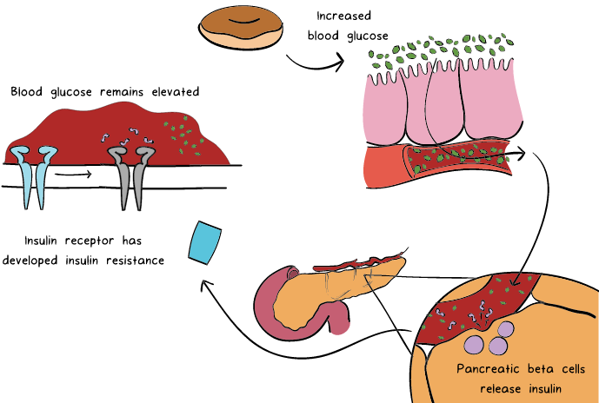
Figure 7: Type 2 diabetes [17]
Gestational diabetes (GDM) is a form of diabetes consisting of high blood glucose levels during pregnancy. It develops in one in 25 pregnancies worldwide and is associated with complications to both mother and baby. GDM usually disappears after pregnancy but women with GDM and their children are at an increased risk of developing type 2 diabetes later in life. Approximately half of women with a history of GDM go on to develop type 2 diabetes within five to ten years after delivery.
Other specific types of diabetes also exist which include monogenic diabetes, which is an inherited form of diabetes, and cystic fibrosis-related diabetes [2,16].

Symptoms of diabetes
Initial symptoms:[17]
Type 1: The classic initial presentation of type 1 diabetes is increased thirst, increased urination, weight loss, hunger due to starvation of cells, and fatigue. As blood glucose levels increase, the body tries to remove excess glucose in the urine and dilute the blood by increasing water intake. However, many patients are initially diagnosed when they come to the hospital very sick in a state called diabetic ketoacidosis. This occurs when cells use alternative energy producing mechanisms, leading to high levels of byproducts called ketoacids. Ketoacids acidify the blood, leading to dangerous acid-base disturbances. Diabetic ketoacidosis causes abdominal pain, nausea/vomiting, and drowsiness and is a potentially life-threatening condition.
Type 2: The symptoms of type 2 DM are similar to type 1, but generally occur later in life and have a more gradual onset. 40% of patients have no symptoms. The other 60% can present with increased thirst and urination, diabetic ketoacidosis, or a condition called hyperosmolar hyperglycemic state, a state of severe dehydration requiring hospitalization.

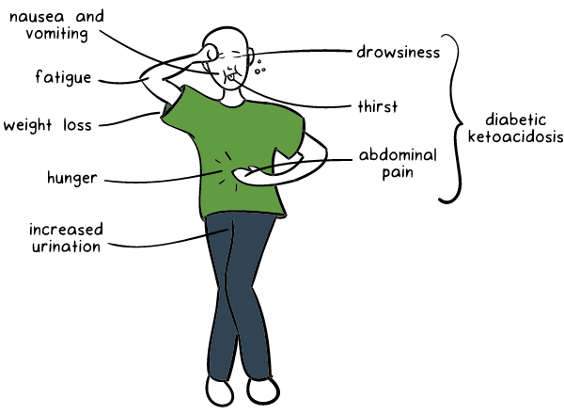

Figure 8: Initial symptoms of diabetes

LIMITATION
The current proposed expert system focus on eleven symptoms of diabetes, which are frequent urination, excessive thirst, increased hunger, weight loss, tiredness, lack of interest and concentration, tingling sensation or numbness in the hands or feet, blurred vision, frequent infections, slow-healing wounds and vomiting and stomach pain.

EVALUATION SYSTEM
As a preliminary evolution, Dr. Majdi Dheir and other Medical students tested this proposed Expert System. They have felt familiar and comfortable with its interfaces, easy usage and simplicity of information. And they were satisfied with its performance and efficiency.

CONCLUSION
In this paper, a proposed expert system was presented for helping doctors, patients, specialists and students in diagnosing diabetes disease. Doctors can get the diagnosis faster and more accurate than the traditional diagnosis. This knowledge-based system does not need intensive training to be used; it is easy to use and has user friendly interface. It was developed using SL5 language.

EXPERT SYSTEM SOURCE CODE
! Written by Ibtesam M. Dheir
!
ATTRIBUTE start SIMPLE
ATTRIBUTE The patient suffer from frequent urination SIMPLE
ATTRIBUTE The patient suffer from Excessive thirst SIMPLE
ATTRIBUTE The patient suffer from Increased hunger SIMPLE
ATTRIBUTE The patient suffer from Weight loss SIMPLE
ATTRIBUTE The patient suffer from Tiredness SIMPLE
ATTRIBUTE The patient suffer from Lack of interest and concentration SIMPLE
ATTRIBUTE The patient suffer from a tingling sensation or numbness in the hands or feet SIMPLE
ATTRIBUTE The patient suffer from Blurred vision SIMPLE
ATTRIBUTE The patient suffer from Frequent infections SIMPLE
ATTRIBUTE The patient suffer from Slow healing wounds SIMPLE
ATTRIBUTE The patient suffer from Vomiting and stomach pain SIMPLE

INSTANCE the domain ISA domain
WITH start := TRUE

INSTANCE the application ISA application
WITH title display := introduction
WITH conclusion display := Conc

INSTANCE introduction ISA display
WITH wait := TRUE
WITH delay changes := FALSE
WITH items [1 ] := textbox 1

INSTANCE textbox 1 ISA textbox
WITH location := 10,10,800,350
WITH pen color := 0,0,0
WITH fill color := 200,200,100
WITH justify IS left
WITH font := "Arial"
WITH font style IS bold
WITH font size := 14
WITH text :="
Diabetes Diagnosis Expert System
Written By Ibtesam M. Dheir

This Expert System diagnoses diabetes Problems through a dialogue between the System and the End User.

The Conclusion of the finding is displayed and an Advise is given for the End User to solve the problem."

INSTANCE Conc ISA display
WITH wait := TRUE
WITH delay changes := FALSE
WITH items [1] := title textbox
WITH items [2 ] := problem textbox
WITH items [3 ] := advise textbox

INSTANCE title textbox ISA textbox
WITH location := 20,10,800,70
WITH pen color := 0,0,0
WITH fill color := 200,200,100
WITH justify IS center
WITH font := "Arial"
WITH font style IS bold
WITH font size := 14
WITH text := " The Conclusion of the Diabetes Diagnosis Expert System"

INSTANCE problem textbox ISA textbox
WITH location := 20,110,800,130
WITH pen color := 0,0,0
WITH fill color := 170,170,170
WITH justify IS left
WITH font := "Arial"
WITH font size := 14
WITH text :=" --===--"

INSTANCE advise textbox ISA textbox
WITH location := 20,280,800,130
WITH pen color := 0,0,0
WITH fill color := 170,170,170
WITH justify IS left
WITH font := "Arial"
WITH font size := 14
WITH text :=" --===--"

RULE R0
IF start
THEN ASK The patient suffer from frequent urination

RULE R1
IF The patient suffer from frequent urination
THEN ASK The patient suffer from Excessive thirst

RULE R2
IF The patient suffer from frequent urination
AND The patient suffer from Excessive thirst
THEN ASK The patient suffer from Increased hunger

RULE R3
IF The patient suffer from frequent urination
AND The patient suffer from Excessive thirst
AND The patient suffer from Increased hunger
THEN ASK The patient suffer from Weight loss

RULE R4
IF The patient suffer from frequent urination
AND The patient suffer from Excessive thirst
AND The patient suffer from Increased hunger
AND The patient suffer from Weight loss
THEN ASK The patient suffer from Tiredness

RULE R5
IF The patient suffer from frequent urination
AND The patient suffer from Excessive thirst
AND The patient suffer from Increased hunger
AND The patient suffer from Weight loss
AND The patient suffer from Tiredness
THEN ASK The patient suffer from Lack of interest and concentration

RULE R6
IF The patient suffer from frequent urination
AND The patient suffer from Excessive thirst
AND The patient suffer from Increased hunger
AND The patient suffer from Weight loss
AND The patient suffer from Tiredness
AND The patient suffer from Lack of interest and concentration
THEN ASK The patient suffer from a tingling sensation or numbness in the hands or feet

RULE R7
IF The patient suffer from frequent urination
AND The patient suffer from Excessive thirst
AND The patient suffer from Increased hunger
AND The patient suffer from Weight loss
AND The patient suffer from Tiredness
AND The patient suffer from Lack of interest and concentration
AND The patient suffer from a tingling sensation or numbness in the hands or feet
THEN ASK The patient suffer from Blurred vision

RULE R8
IF The patient suffer from frequent urination
AND The patient suffer from Excessive thirst
AND The patient suffer from Increased hunger
AND The patient suffer from Weight loss
AND The patient suffer from Tiredness
AND The patient suffer from Lack of interest and concentration
AND The patient suffer from a tingling sensation or numbness in the hands or feet
AND The patient suffer from Blurred vision
THEN ASK The patient suffer from Frequent infections

RULE R9
IF The patient suffer from frequent urination
AND The patient suffer from Excessive thirst
AND The patient suffer from Increased hunger
AND The patient suffer from Weight loss
AND The patient suffer from Tiredness
AND The patient suffer from Lack of interest and concentration
AND The patient suffer from a tingling sensation or numbness in the hands or feet
AND The patient suffer from Blurred vision
AND The patient suffer from Frequent infections
THEN ASK The patient suffer from Slow healing wounds

RULE R9
IF The patient suffer from frequent urination
AND The patient suffer from Excessive thirst
AND The patient suffer from Increased hunger
AND The patient suffer from Weight loss
AND The patient suffer from Tiredness
AND The patient suffer from Lack of interest and concentration
AND The patient suffer from a tingling sensation or numbness in the hands or feet
AND The patient suffer from Blurred vision
AND The patient suffer from Frequent infections
AND The patient suffer from Slow healing wounds
THEN ASK The patient suffer from Vomiting and stomach pain

RULE R10
IF The patient suffer from frequent urination
AND The patient suffer from Excessive thirst
AND The patient suffer from Increased hunger
AND The patient suffer from Weight loss
AND The patient suffer from Tiredness
AND The patient suffer from Lack of interest and concentration
AND The patient suffer from a tingling sensation or numbness in the hands or feet
AND The patient suffer from Blurred vision
AND The patient suffer from Frequent infections
AND The patient suffer from Slow healing wounds
AND The patient suffer from Vomiting and stomach pain
THEN text OF problem textbox := "The patient suffer form diabeties ."
AND text OF advise textbox := "The Advice: Go to your doctor for the treatment CF 100%"
ELSE text OF problem textbox := "The patient does not suffer form diabeties ."
AND text OF advise textbox := "The Advice: Keep the good health "

END

REFERENCES
- https://www.khanacademy.org/science/health-and-medicine/endocrine-system-diseases/diabetes/a/what-is-diabetes-mellitus?utm_account=Grant&utm_campaignname=Grant_Science_Dynamic&gclid=Cj0KCQjw19DlBRCSARIsAOnfRegLrVhHzJflHvFR4fBJ0Ce05U0Yjl72PGmLS7VmP8a4BHACeTnttaIaAhI0EALw_wcB, access-date: 14-4-2019
- http://vikaspedia.in/health/diseases/diabetes/common-diseases#section-1, access-date: 14-4-2019
- http://vikaspedia.in/health/diseases/diabetes/copy_of_common-diseases, access-date: 13-4-2019
- https://searchenterpriseai.techtarget.com/definition/expert-system, access-date: 16-4-2019
- Abu Naser, S. S., & Zaqout, I. S. (2016). Knowledge-based systems that determine the appropriate students major: In the faculty of engineering and information technology. World Wide Journal of Multidisciplinary Research and Development, 2(10), 26-34.
- El Agha, M., Jarghon, A., & Abu Naser, S. S. (2017). Polymyalgia Rheumatic Expert System. International Journal of Engineering and Information Systems (IJEAIS), 1(4), 125-137.
- https://www.techopedia.com/definition/190/artificial-intelligence-ai, access-date: 15-4-2019
- Dheir, I., & Abu-Naser, S. S. (2019). Knowledge Based System for Diagnosing Guava Problems. International Journal of Academic Information Systems Research (IJAISR), 3(3), 9-15.
- Abu-Naser, S., El-Hissi, H., Abu-Rass, M., & El-Khozondar, N. (2010). An expert system for endocrine diagnosis and treatments using JESS. Journal of Artificial Intelligence; Scialert, 3(4), 239-251.
- Abu Naser, S., Al-Dahdooh, R., Mushtaha, A., & El-Naffar, M. (2010). Knowledge management in ESMDA: expert system for medical diagnostic assistance. AIML Journal, 10(1), 31-40.
- Abu Naser, S. S., & Abu Zaiter, O. A. (2008). An Expert System For Diagnosing Eye Diseases Using Clips. Journal of Theoretical & Applied Information Technology, 4(10).
- Abu Naser, S. S., Baraka, M. H., & Baraka, A. (2008). A Proposed Expert System For Guiding Freshman Students In Selecting A Major In Al-Azhar University, Gaza. Journal of Theoretical & Applied Information Technology, 4(9).
- Abu-Naser, S. S., Kashkash, K. A., & Fayyad, M. (2010). Developing an expert system for plant disease diagnosis. Journal of Artificial Intelligence ; Scialert, 3(4), 269-276.
- Abu Naser, S. S. (2015). Sl5 Object: Simpler Level 5 Object Expert System Language. International Journal of Soft Computing, Mathematics and Control (IJSCMC), 4(4), 25-37.
- https://www.medicalnewstoday.com/articles/323627.php, access-date: 10-4-2019
- https://www.cdc.gov/diabetes/pdfs/data/statistics/national-diabetes-statistics-report.pdf, access-date: 11-4-2019
- https://www.khanacademy.org/science/health-and-medicine/endocrine-system-diseases/diabetes/a/what-is-diabetes mellitus? utm_account= Grant&utm_campaignname= Grant_Science_Dynamic&gclid= Cj0KCQjw19DlBRCSARIsAOnfRegLrVhHzJflHvFR4fBJ0Ce05U0Yjl72PGmLS7VmP8a4BHACeTnttaIaAhI0EALw_wcB, access-date: 10-4-2019
- Aldaour, A. F., & Abu-Naser, S. S. (2019). An Expert System for Diagnosing Tobacco Diseases Using CLIPS. International Journal of Academic Engineering Research (IJAER), 3(3), 12-18.
- Barhoom, A. M., & Abu-Naser, S. S. (2018). Black Pepper Expert System. International Journal of Academic Information Systems Research (IJAISR), 2(8), 9-16.
- Almadhoun, H. R., & Abu Naser, S. S. (2018). Banana Knowledge Based System Diagnosis and Treatment. International Journal of Academic Pedagogical Research (IJAPR), 2(7), 1-11.
- Akkila, A. N., & Abu Naser, S. S. (2016). Proposed Expert System for Calculating Inheritance in Islam. World Wide Journal of Multidisciplinary Research and Development, 2(9), 38-48.
- AbuEl-Reesh, J. Y., & Abu Naser, S. S. (2017). A Knowledge Based System for Diagnosing Shortness of Breath in Infants and Children. International Journal of Engineering and Information Systems (IJEAIS), 1(4), 102-115.
- Alajrami, M. A., & Abu-Naser, S. S. (2018). Onion Rule Based System for Disorders Diagnosis and Treatment. International Journal of Academic Pedagogical Research (IJAPR), 2(8), 1-9.
- Abu Naser, S. S., Alamawi, W. W., & Alfarra, M. F. (2016). Rule Based System for Diagnosing Wireless Connection Problems Using SL5 Object. International Journal of Information Technology and Electrical Engineering, 5(6), 26-33.
- Almurshidi, S. H., & Abu-Naser, S. S. (2018). EXPERT SYSTEM FOR DIAGNOSING BREAST CANCER. Al-Azhar University, Gaza, Palestine.
- Azaab, S., Abu Naser, S., & Sulisel, O. (2000). A proposed expert system for selecting exploratory factor analysis procedures. Journal of the College of Education, 4(2), 9-26.
- Bakeer, H., & Abu Naser, S. S. (2017). Photo Copier Maintenance Expert System V. 01 Using SL5 Object Language. International Journal of Engineering and Information Systems (IJEAIS), 1(4), 116-124.
- Khella, R., & Abu Naser, S. S. (2017). Rule Based System for Chest Pain in Infants and Children. International Journal of Engineering and Information Systems, 1(4), 138-148.
- Dahouk, A. W., & Abu-Naser, S. S. (2018). A Proposed Knowledge Based System for Desktop PC Troubleshooting. International Journal of Academic Pedagogical Research (IJAPR), 2(6), 1-8.
- Musleh, M. M., & Abu-Naser, S. S. (2018). Rule Based System for Diagnosing and Treating Potatoes Problems. International Journal of Academic Engineering Research (IJAER), 2(8), 1-9.
- AlZamily, J. Y., & Abu-Naser, S. S. (2018). A Cognitive System for Diagnosing Musa Acuminata Disorders. International Journal of Academic Information Systems Research (IJAISR), 2(8), 1-8.
- Nassr, M. S., & Abu Naser, S. S. (2018). Knowledge Based System for Diagnosing Pineapple Diseases. International Journal of Academic Pedagogical Research (IJAPR), 2(7), 12-19.
- Abu-Nasser, B. S., & Abu-Naser, S. S. (2018). Cognitive System for Helping Farmers in Diagnosing Watermelon Diseases. International Journal of Academic Information Systems Research (IJAISR), 2(7), 1-7.
- Ashqar, B. A. M., Abu-Nasser, B. S., & Abu-Naser, S. S. (2019). Plant Seedlings Classification Using Deep Learning. International Journal of Academic Information Systems Research (IJAISR), 3(1), 7-14.
- Abu Naser, S. S. (1993). A methodology for expert systems testing and debugging. North Dakota State University, USA.
- Al-Qumboz, M. N. A., & Abu-Naser, S. S. (2019). Spinach Expert System: Diseases and Symptoms. International Journal of Academic Information Systems Research (IJAISR), 3(3), 16-22.
- Abu Naser, S. S. (1999). Big O Notation for Measuring Expert Systems complexity. Islamic University Journal Gaza, 7(1), 57-70.
- Al-Shawwa, M., & Abu-Naser, S. S. (2019). Knowledge Based System for Apple Problems Using CLIPS. International Journal of Academic Engineering Research (IJAER), 3(3), 1-11.
- Abu Naser, S., & Aead, A. M. (2013). Variable Floor for Swimming Pool Using an Expert System. International Journal of Modern Engineering Research (IJMER), 3(6), 3751-3755.
- Ashqar, B. A. M., & Abu-Naser, S. S. (2019). Image-Based Tomato Leaves Diseases Detection Using Deep Learning. International Journal of Academic Engineering Research (IJAER), 2(12), 10-16.
- El_Jerjawi, N. S., & Abu-Naser, S. S. (2018). Diabetes Prediction Using Artificial Neural Network. International Journal of Advanced Science and Technology, 121, 55-64.
- Nasser, I. M., Al-Shawwa, M. O., & Abu-Naser, S. S. (2019). Artificial Neural Network for Diagnose Autism Spectrum Disorder. International Journal of Academic Information Systems Research (IJAISR), 3(2), 27-32.
- Abu Naser, S. S., & Abu Hasanein, H. A. (2016). Ear Diseases Diagnosis Expert System Using SL5 Object. World Wide Journal of Multidisciplinary Research and Development, 2(4), 41-47.
- Elqassas, R., & Abu-Naser, S. S. (2018). Expert System for the Diagnosis of Mango Diseases. International Journal of Academic Engineering Research (IJAER), 2(8), 10-18.
- AbuEl-Reesh, J. Y., & Abu Naser S. S. (2017). An Expert System for Diagnosing Shortness of Breath in Infants and Children. International Journal of Engineering and Information Systems (IJEAIS), 1(4), 102-115.
- Abu Naser, S. S., & Alawar, M. W. (2016). An expert system for feeding problems in infants and children. International Journal of Medicine Research, 1(2), 79-82.
- Abu Ghali, M. J., Mukhaimer, M. N., Abu Yousef, M. K., & Abu Naser, S. S. (2017). Expert System for Problems of Teeth and Gums. International Journal of Engineering and Information Systems (IJEAIS), 1(4), 71-88.
- Abu Naser, S. S., & Al-Bayed, M. H. (2016). Detecting Health Problems Related to Addiction of Video Game Playing Using an Expert System. World Wide Journal of Multidisciplinary Research and Development, 2(9), 7-12.
- Al Rekhawi, H. A., Ayyad, A. A., & Abu Naser, S. S. (2017). Rickets Expert System Diagnoses and Treatment. International Journal of Engineering and Information Systems (IJEAIS), 1(4), 149-159.
- Abu Naser, S. S., & AlDahdooh, R. M. (2016). Lower Back Pain Expert System Diagnosis And Treatment. Journal of Multidisciplinary Engineering Science Studies (JMESS), 2(4), 441-446.
- Mettleq, A. S. A., & Abu-Naser, S. S. (2019). A Rule Based System for the Diagnosis of Coffee Diseases. International Journal of Academic Information Systems Research (IJAISR), 3(3), 1-8.
- Abu Naser, S. S., & Alhabbash, M. I. (2016). Male Infertility Expert system Diagnoses and Treatment. American Journal of Innovative Research and Applied Sciences, 2(4).
- Qwaider, S. R., & Abu Naser, S. S. (2017). Expert System for Diagnosing Ankle Diseases. International Journal of Engineering and Information Systems (IJEAIS), 1(4), 89-101.
- Abu Naser, S. S., & Al-Hanjori, M. M. (2016). An expert system for men genital problems diagnosis and treatment. International Journal of Medicine Research, 1(2), 83-86.
- Abu Naser, S. S., & ALmursheidi, S. H. (2016). A Knowledge Based System for Neck Pain Diagnosis. World Wide Journal of Multidisciplinary Research and Development (WWJMRD), 2(4), 12-18.
- Sadek, R. M., Mohammed, S. A., Abunbehan, A. R. K., Ghattas, A. K. H. A., Badawi, M. R., Mortaja, M. N., . . . Abu-Naser, S. S. (2019). Parkinson’s Disease Prediction Using Artificial Neural Network. International Journal of Academic Health and Medical Research (IJAHMR), 3(1), 1-8.
- Abu Naser, S. S., & Al-Nakhal, M. A. (2016). A Ruled Based System for Ear Problem Diagnosis and Treatment. World Wide Journal of Multidisciplinary Research and Development, 2(4), 25-31.
- Elsharif, A. A., & Abu-Naser, S. S. (2019). An Expert System for Diagnosing Sugarcane Diseases. International Journal of Academic Engineering Research (IJAER), 3(3), 19-27.
- Abu Naser, S. S., & Bastami, B. G. (2016). A Proposed Rule Based System for Breasts Cancer Diagnosis. World Wide Journal of Multidisciplinary Research and Development, 2(5), 27-33.
- Khella, A. R., & Abu Naser, S. S. (2017). Expert System for Chest Pain in Infants and Children. International Journal of Engineering and Information Systems (IJEAIS), 1(4), 138-148.
- Abu Naser, S. S., & El Haddad, I. A. (2016). An Expert System for Genital Problems in Infants. EUROPEAN ACADEMIC RESEARCH, 4(10).
- Nasser, I. M., & Abu-Naser, S. S. (2019). Predicting Tumor Category Using Artificial Neural Networks. International Journal of Academic Health and Medical Research (IJAHMR), 3(2), 1-7.
- Abu Naser, S. S., & El-Najjar, A. E. A. (2016). An expert system for nausea and vomiting problems in infants and children. International Journal of Medicine Research, 1(2), 114-117.
- Nasser, I. M., & Abu-Naser, S. S. (2019). Lung Cancer Detection Using Artificial Neural Network. International Journal of Engineering and Information Systems (IJEAIS), 3(3), 17-23.
- Abu Naser, S. S., & Hamed, M. A. (2016). An Expert System for Mouth Problems in Infants and Children. Journal of Multidisciplinary Engineering Science Studies (JMESS), 2(4), 468-476.
- Mrouf, A., Albatish, I., Mosa, M., & Abu Naser, S. S. (2017). Knowledge Based System for Long-term Abdominal Pain (Stomach Pain) Diagnosis and Treatment. International Journal of Engineering and Information Systems (IJEAIS), 1(4), 71-88.
- Abu Naser, S. S., & Hilles, M. M. (2016). An expert system for shoulder problems using CLIPS. World Wide Journal of Multidisciplinary Research and Development, 2(5), 1-8.
- Salman, F. M., & Abu-Naser, S. S. (2019). Expert System for Castor Diseases and Diagnosis. International Journal of Engineering and Information Systems (IJEAIS), 3(3), 1-10.
- Abu Naser, S. S., & Mahdi, A. O. (2016). A proposed Expert System for Foot Diseases Diagnosis. American Journal of Innovative Research and Applied Sciences, 2(4), 155-168.
- Abu Naser, S. S., & Shaath, M. Z. (2016). Expert system urination problems diagnosis. World Wide Journal of Multidisciplinary Research and Development, 2(5), 9-19.
- Nabahin, A., Abou Eloun, A., & Abu Naser, S. S. (2017). Expert System for Hair Loss Diagnosis and Treatment. International Journal of Engineering and Information Systems (IJEAIS), 1(4), 160-169.
- Abu Naser, S. S., & Akkila, A. N. (2008). A Proposed Expert System for Skin Diseases Diagnosis. Journal of Applied Sciences Research; www.aensiweb.com/JASR/, 4(12), 1682-1693.
- Abu-Nasser, B. (2017). Medical Expert Systems Survey. International Journal of Engineering and Information Systems (IJEAIS), 1(7), 218-224

