Expert System for Chest Pain in Infants and Children

Randa A.Khella, Samy S. Abu Naser
Department of Information Technology,
Faculty of Engineering & Information Technology, Al-Azhar University, Gaza, Palestine abunaser@alazhar.edu.ps

Abstract: Chest pain is the pain felt in the chest by infants, children and adolescents. In most cases the pain is not associated with the heart. It is mainly recognized by the observance or report of pain by the infant, child or adolescent by reports of distress by parents or care givers. Chest pain is not unusual in children. Lots of children are seen in ambulatory clinics, emergency rooms and hospitals and cardiology clinics. Usually there is a benign cause for the pain for utmost children. Certain patients have conditions that are serious and perhaps life-threatening. Chest pain in pediatric patients needs careful physical examination and a detailed history that would point to the possibility of a serious cause. Researches of pediatric chest pain are scarce. It has been difficult to create evidence-based guidelines for evaluation. In this paper we propose an expert system to help doctors and parents, and care giver in diagnosing chest pain in infants and children. This expert System is design and implemented in SL5 Object language.

Keywords: Expert System, SL5, chest pain, Knowledge base

- INTRODUCTION

Chest pain in children is usually assessed in cardiology clinics and in emergency rooms. It can be stressful for parents and children. Pediatric chest pain varies from chest pain in adults because it is frequently unconnected to the heart. The causes of pediatric chest pain differ according to the organ or tissue in the child that causes the pain. Normally, muscular skeletal pain, which
comprises costochondritis, is the purpose for the emergency room visit. Pain that is felt in the chest but is due to muscular skeletal inflammation or an unknown cause and accounts for 7% and 69% visits. Muscular skeletal pain is labeled and well-defined differently as a diagnosis of exclusion or is recognized as being related with idiopathic causes. Asthma and other respiratory
symptoms are the second most communal presentation. Respiratory related causes constitute 13% to 24% of pediatric chest pain
symptoms. Gastrointestinal and psychogenic symptoms reported by parents and patients occur less than 10% of the time. Cardiac causes of pediatric chest pain are found rarely and are not recognized more than 5% of the time. Unknown causes were assessed to account for 20% to 61% of the final diagnosis given. Patients who receive a diagnosis of cardiac disease are more
suitable to have acute pain. This pain frequently awakes them from sleep or presents with fever or abnormal observations found
during the physical examination. Trauma can also be a cause for chest pain and has been found to be related with the pain in 5% of the patients. Children can present with chest pain can have a sudden onset related to vital physical activity and coughing. These symptoms seem to be closely associated with asthma. Infection with Haemophilus influenzae can cause chest pain[8-9,11-12].

- EXPERT SYSTEM

An expert system is a computer system is a PC framework that imitates the basic leadership capacity of a human master. Expert Systems are intended to take care of complex issues by thinking about information, spoke to for the most part as if–then guidelines instead of through ordinary procedural code. The main Expert Systems were made in the 1970s and after that multiplied in the 1980s. Expert Systems were among the first genuinely fruitful types of computerized reasoning (AI) programming[2,6].

Expert System Definition

The Expert Systems are the PC applications created to take care of complex issues in a specific space, at the level of additional normal human knowledge and aptitude. Expert Systems (ES) are one of the unmistakable research spaces of AI [1,2].

Expert Systems Architecture

The expert systems are a branch of AI designed to work within a particular domain. As an expert is a person who can solve a problem with the learning in hands it ought to have the capacity to take care of issues at the level of a human master. The wellspring of learning may come originate from a human master or pareaotentially from books, magazines and web. As information assumes a key part in the working of Expert Systems they are otherwise called learning based frameworks and information based Expert Systems. The master's learning about taking care of the given particular issues is called information area of the master. See Figure 1 for points of interest[2].

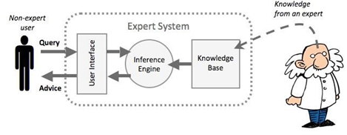
Figure 1: Expert System Architecture

Knowledge Base

Contains the area information which is utilized by the derivation motor to make inferences. The deduction motor is the nonexclusive control component that applies the aphoristic information to the errand particular information to touch base at some conclusion. At the point when a client supplies certainties or significant data of question to the Expert System he gets guidance or ability accordingly. That is given the certainties it utilizes the surmising motor which thusly utilizes the learning base to construe the arrangement [2,6].

THE SL5 OBJECT LANGUAGE

SL5 Object a conventional case of a specialist framework Language administer based, forward-affixing framework, it shows a large number of the ideas and strategies utilized as a part of different ES Languages, it permits the portrayal of information, and its utilization for taking care of reasonable issues[6].

SL5 Object at a glance

The SL5 Object dialect is for the most part a definitive dialect - that is, a SL5 Object program is comprised of an arrangement of proclamations about the world, instead of a rundown of orders to execute. Truth be told, since SL5 Object is a run based framework, these announcements about the world are actualities, principles or Objects. SL5 Object stands for Simpler Level 5 Object [6].

- LITERATURE REVIEW

There re may expert system that specializes in diagnosing human diseases like: male infertility, eye, shoulder, neck, ear, hearing problems, skin, and others.[1,7,10,13-40].

- MATERIALS AND METHODS

In this Expert System there are four fundamental ailments and one of them is separated into a few cases (infection):

The present Expert system requires the client to answer the question shown on the screen (see Figure 2-4 for a depiction screen of the Expert System), beginning with the main question (Does your child have a fever a cough that produces mucus and shortness of breath?) and consummation with the conclusion of the infection and a proposal of the treatment. This Expert System not just shows to the client the analysis of the sickness yet the fitting treatment likewise toward the finish of the discourse between the end client and the Expert System.

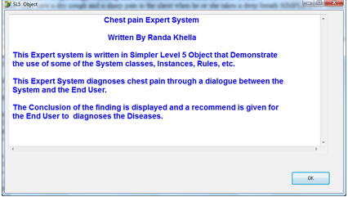
Figure 2: starting screen of the expert system

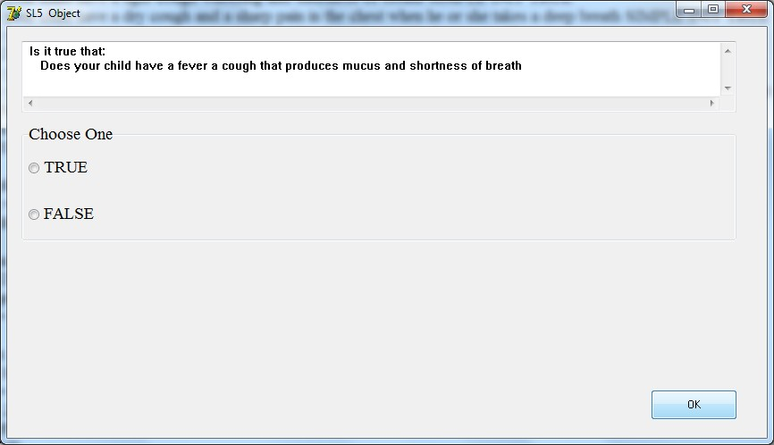
Figure 3: Dialogue between the user and the expert system

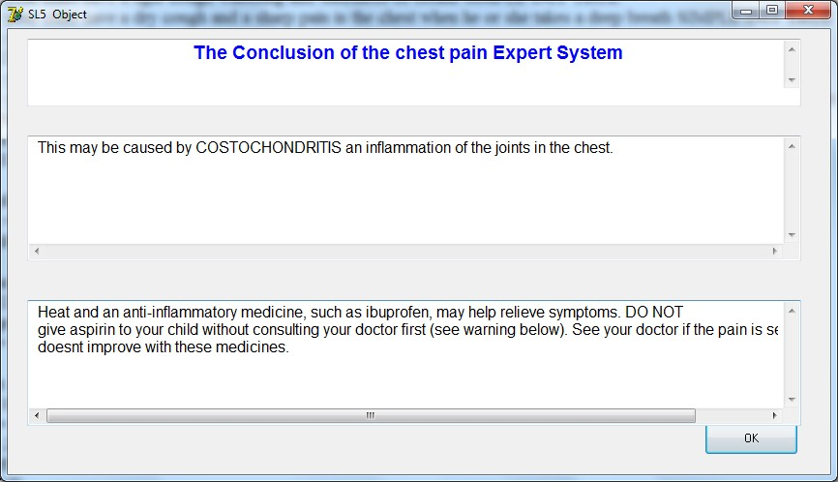
Figure 4: Conclusion of the expert system

- KNOWLEDGE REPRESENTATION

The principle wellsprings of the information for this Expert System are Podiatric doctor and practices sites for feet sicknesses. The caught learning has been changed over into SL5 Object Knowledge base linguistic structure (Facts, Rules and Object) currently the Expert System.

What is chest?

Chest is any uneasiness that a youngster feels in their upper middle or trunk territory. It might include a throb, soreness or uneasiness in their:

- Chest divider (the skin, muscles or ribs)
- Trachea (windpipe) and lungs
- Esophagus or stomach
- Nerves and spinal rope.

The torment can be an unpalatable physical or enthusiastic feeling and is typically unique for every tyke.

On the off chance that a kid has trunk torment, they may once in a while think that its hard to state or show precisely where it is. This is on the grounds that the nerves from various parts of the trunk traverse each other and enter the spine at various levels. Here and there the wellspring of the agony is not identified with the trunk by any stretch of the imagination.

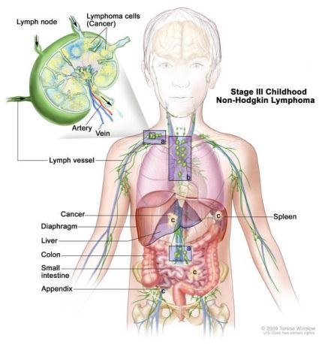
Figure 5: Chest

Common causes of chest pain, Chest pain can have many causes, including:

  - Costochondritis (pain or swelling between a rib and the breast bone)
  - Muscle strain or injury
  - Exercise-induced asthma
  - Acute bronchitis
  - Pain from coughing
  - Pain from repeated vomiting
  - Gastroesophageal reflux (acid reflux).

Teens can sometimes experience functional or anxiety-related pain. Symptoms include hyperventilation (fast breathing), light- headedness and numbness or tingling around the lips and in the hands or feet. Despite not having a clear cause, this pain is still real.

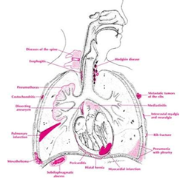
Figure 6: Chest pain starts out in between breast bone

How is the cause of chest pain diagnosed?

A doctor will usually diagnose the cause of chest pain based on description of the pain and by examining your child.

Although rare, the doctor may order some tests, such as an electrocardiogram (ECG), a chest X-ray or blood tests, to help reach a diagnosis.

Be sure to tell your doctor about any family history of:
- sudden, unexplained deaths
- early heart disease
- exercise intolerance
- asthma, eczema or allergies
- inflammatory or rheumatic diseases.

Chest pain can be caused by anything from muscle pain to a heart attack and should never be ignored.

Common causes of chest pain

Most chest pain is not heart-related and isn't a sign of a life-threatening problem.

This information should give you an idea of whether these conditions may be causing your chest pain, but you should always seek medical advice to make sure you get a proper diagnosis.

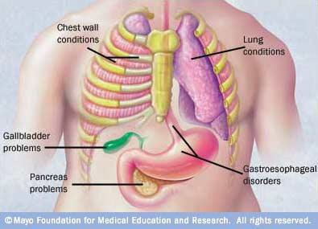
Figure 7: Common causes of chest pain

Some common causes of chest pain include:

Gastro-oesophageal reflux disease (GORD) – a common condition where acid from the stomach comes up into the oesophagus (gullet), causing heartburn and an unpleasant taste
- A strained muscle in your chest wall – which can be surprisingly painful, but with rest the pain should ease and the muscle will heal in time
- Costochondritis – inflammation of the cartilage that joins the ribs to the breastbone; symptoms include pain, swelling and tenderness around your ribs, and the pain is made worse by lying down, breathing deeply, coughing or sneezing
- An anxiety or panic attack – which tends to last up to 20 minutes and may also cause symptoms such as heart palpitations, sweating, breathlessness and dizziness
- Lung conditions such as pneumonia or pleurisy – which often cause sharp chest pain that gets worse when you
breathe in and out, and are accompanied by other symptoms such as a cough and breathlessness.
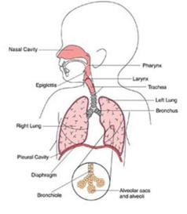
Figure 8: Pediatric Chest Pain

There are many other potential causes of chest pain, including:
- Shingles – a viral infection of a nerve and the area of skin around it, which causes a painful rash that develops into itchy blisters
- Mastitis – pain and swelling of the breast, which is usually caused by an infection, most commonly during breastfeeding
- Acute cholecystitis – inflammation of the gallbladder, which can cause a sudden sharp pain in the upper right side of your tummy that spreads towards your right shoulder
- Stomach ulcers – a break in the lining of the stomach, which can cause a burning or gnawing pain in your tummy
- A pulmonary embolism – a blockage in the blood vessel that carries blood from the heart to the lungs, which can cause sharp, stabbing chest pain that may be worse when you breathe in, as well as breathlessness, a cough and dizziness
- Pericarditis – inflammation of the sac surrounding your heart, which can cause a sudden, sharp and stabbing pain in your chest, or more of a dull ache; the pain usually worsens when lying down.

Some of these conditions can be very serious. Make sure you seek medical advice so you can be correctly diagnosed and treated.
- DECISION TREE FOR THE KBS OF CHEST PAIN IN INFANTS AND CHILDREN

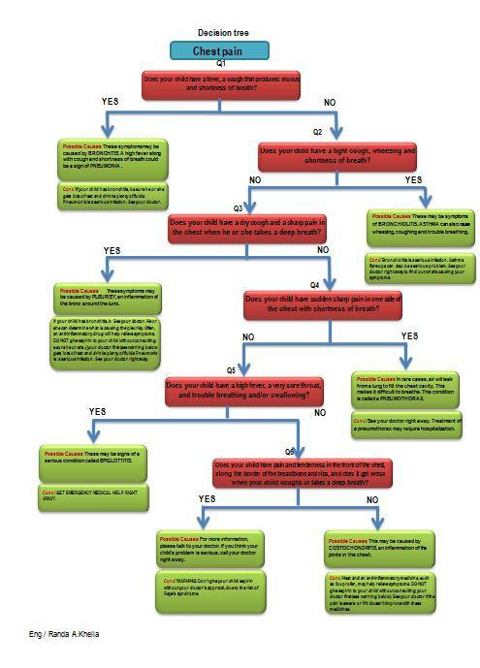
Figure 9: Decision tree for Chest Pain in Infants and Children

- CONCLUSION
Chest pain in children is the pain felt in the chest by infants, children and adolescents. In most cases the pain is not associated with the heart. It is primarily identified by the observance or report of pain by the infant, child or adolescent by reports of distress by parents or caregivers. Chest pain is not uncommon in children. Many children are seen in ambulatory clinics, emergency departments and hospitals and cardiology clinics. Most often there is a benign cause for the pain for most children. Some have conditions that are serious and possibly life-threatening. Chest pain in pediatric patients requires careful physical examination and a detailed history that would indicate the possibility of a serious cause. Studies of pediatric chest pain are sparse. It has been difficult to create evidence-based guidelines for evaluation.

- FUTURE WORK
This expert system is considered to be Chest pain are planned to be added to the expert system for future work and add more enhancement to the system based on the patients’ needs.

- EXPERT SYSTEM SOURCE CODE

! Written By Randa Khella
ATTRIBUTE Does your child have a fever a cough that produces mucus and shortness of breath SIMPLE INIT TRUE ATTRIBUTE Does your child have a tight cough wheezing and shortness of breath SIMPLE INIT TRUE
ATTRIBUTE Does your child have a dry cough and a sharp pain in the chest when he or she takes a deep breath SIMPLE INIT TRUE
ATTRIBUTE Does your child have sudden sharp pain in one side of the chest with shortness of breath SIMPLE INIT TRUE
ATTRIBUTE Does your child have a high fever a very sore throat and trouble breathing and/or swallowing SIMPLE
INIT TRUE
ATTRIBUTE Does your child have pain and tenderness in the front of the chest along the border of the breastbone and ribs and does it get worse when your child coughs or takes a deep breath SIMPLE INIT TRUE
ATTRIBUTE start SIMPLE
INSTANCE the domain ISA domain WITH start := TRUE
INSTANCE the application ISA application WITH title display := introduction
WITH conclusion display := Conc INSTANCE introduction ISA display WITH wait := TRUE
WITH delay changes := FALSE WITH items [1 ] := textbox 1 INSTANCE textbox 1 ISA textbox WITH location := 10,10,800,350
WITH pen color := 0,0,0 WITH fill color := 255,0,0 WITH justify IS left WITH font := "Arial" WITH font style IS bold WITH font size := 14 WITH text :="
Chest pain Expert System
Written By Randa Khella
This Expert system is written in Simpler Level 5 Object (SL5 Object) that Demonstrate the use of some of the System classes, Instances Rules etc.
This Expert System diagnoses chest pain through a dialogue between the System and the End User.
The Conclusion of the finding is displayed and a recommend is given for the End User to diagnoses the Diseases." INSTANCE Conc ISA display
WITH wait := TRUE
WITH delay changes := FALSE WITH items [1] := title textbox WITH items [2 ] := diagnosis textbox
WITH items [3 ] := recommend textbox
INSTANCE title textbox ISA textbox WITH location := 20,10,800,70 WITH pen color := 0,0,0
WITH fill color := 255,0,0 WITH justify IS center WITH font := "Arial" WITH font style IS bold WITH font size := 14
WITH text := " The Conclusion of the chest pain Expert System" INSTANCE diagnosis textbox ISA textbox
WITH location := 20,110,800,130

WITH pen color := 0,0,0 WITH fill color := 255,255,255 WITH justify IS left
WITH font := "Arial" WITH font size := 12 WITH text :=" --===--"
INSTANCE recommend textbox ISA textbox WITH location := 20,280,800,130
WITH pen color := 0,0,0
WITH fill color := 255,255,255 WITH justify IS left
WITH font := "Arial" WITH font size := 12 WITH text :=" --===--" RULE R0
IF start
THEN ASK Does your child have a fever a cough that produces mucus and shortness of breath RULE R1
IF Does your child have a fever a cough that produces mucus and shortness of breath = TRUE
THEN text OF diagnosis textbox := " These symptoms may be caused by BRONCHITIS A high fever along with cough
and shortness of breath could be a sign o Does your child have a fever a cough that produces mucus and shortness of breath of PNEUMONIA "
AND text OF recommend textbox := "If your child has bronchitis be sure he or she gets lots of rest and drinks plenty of fluids Pneumonia is a serious infection. See your doctor right away "
ELSE NOT Does your child have a tight cough wheezing and shortness of breath RULE R2
IF NOT Does your child have a tight cough wheezing and shortness of breath
THEN ASK Does your child have a dry cough and a sharp pain in the chest when he or she takes a deep breath RULE R3
IF Does your child have a dry cough and a sharp pain in the chest when he or she takes a deep breath = TRUE AND NOT Does your child have a dry cough and a sharp pain in the chest when he or she takes a deep breath THEN text OF diagnosis textbox := " These may be symptoms of BRONCHIOLITIS.
ASTHMA can also cause wheezing, coughing and trouble breathing."
AND text OF recommend textbox := " Bronchiolitis is a serious infection Asthma flare-ups can also be a serious problem. See your doctor right away to find out what’s causing your symptoms. "
ELSE NOT Does your child have a dry cough and a sharp pain in the chest when he or she takes a deep breath RULE R4
IF NOT Does your child have a dry cough and a sharp pain in the chest when he or she takes a deep breath THEN ASK Does your child have sudden sharp pain in one side of the chest with shortness of breath RULE R5
IF Does your child have a dry cough and a sharp pain in the chest when he or she takes a deep breath
= TRUE
AND NOT Does your child have a dry cough and a sharp pain in the chest when he or she takes a deep breath
THEN text OF diagnosis textbox := " These symptoms may be caused by PLEURISY an inflammation of the lining around the lung."
AND text OF recommend textbox := " See your doctor. He or she can determine what is causing the pleurisy Often an anti-inflammatory drug will help relieve symptoms. DO NOT give aspirin to your child without consulting your doctor first (see warning below)."
ELSE NOT Does your child have sudden sharp pain in one side of the chest with shortness of breath RULE R6
IF Does your child have sudden sharp pain in one side of the chest with shortness of breath?
= TRUE
AND NOT Does your child have sudden sharp pain in one side of the chest with shortness of breath? THEN NOT aaa
ELSE NOT Does your child have a high fever a very sore throat and trouble breathing and/or swallowing
RULE R7
IF Does your child have a high fever a very sore throat and trouble breathing and/or swallowing?
= TRUE
AND NOT aaa
THEN text OF diagnosis textbox := " These may be signs of a serious condition called EPIGLOTTITIS." AND text OF recommend textbox := GET EMERGENCY MEDICAL HELP RIGHT AWAY "
ELSE NOT Does your child have a high fever a very sore throat, and trouble breathing and/or swallowing RULE R8
IF Does your child have a high fever, a very sore throat, and trouble breathing and/or swallowing = TRUE
THEN text OF diagnosis textbox := " For more information please talk to your doctor If you think your child’s problem
is serious call your doctor right away ."
AND text OF recommend textbox := " WARNING: Don’t give your child aspirin without your doctor’s approval due to the risk of Reye’s syndrome."
ELSE NOT Does your child have pain and tenderness in the front of the chest along the border of the breastbone and ribs and does it get worse when your child coughs or takes a deep breath
RULE R13
IF Does your child have pain and tenderness in the front of the chest along the border of the breastbone and ribs, and does it get worse when your child coughs or takes a deep breath = TRUE
THEN text OF diagnosis textbox := " This may be caused by COSTOCHONDRITIS, an inflammation of the joints in the chest. "
AND text OF recommend textbox := " Heat and an anti-inflammatory medicine such as ibuprofen may help relieve
symptoms. DO NOT give aspirin to your child without consulting your doctor first (see warning below). See your doctor if the pain is severe or if it doesn’t improve with these medicines."
AND text OF recommend textbox := " " END

REFERENCES
- Abu Naser, S. S., & Akkila, A. N. (2008). A Proposed Expert System for Skin Diseases Diagnosis. Journal of Applied Sciences Research; www.aensiweb.com/JASR/, 4(12), 1682-1693.
- James G., Expert System: Principles and programming. 4t ed. United State of America: Course Technology; 2004.
- Janine A. Flanagan HBArtsSc, MD, FRCPC 1/21/2015 http://www.aboutkidshealth.ca/En/HealthAZ/ ConditionsandDiseases/Symptoms/Pages/ChestPain.aspx.
- http://www.webmd.com/pain-management/guide/whats-causing-my-chest-pain#1.
- http://www.nhs.uk/conditions/chestpain/Pages/Introduction.aspx.
- Abu Naser, S. S. (2015). Sl5 Object: Simpler Level 5 Object Expert System Language. International Journal of Soft Computing, Mathematics and Control (IJSCMC), 4(4), 25-37.
- Abu Naser, S., Ahmed, A., Al-Masri, N., & Abu Sultan,Y. (2011). Human Computer Interaction Design of the LP-ITS: Linear Programming Intelligent Tutoring Systems, International Journal of Artificial Intelligence & Applications, 2(3).
- http://store6.up-00.com/2017-05/14962243028981.jpeg.
- http://store6.up-00.com/2017-05/149622521739751.jpg
- Abu Naser, S. S., & Mahdi, A. O. (2016). A proposed Expert System for Foot Diseases Diagnosis. American Journal of Innovative Research and Applied Sciences, 2(4), 155-168.
- Myoclonic http://www.mayoclinic.org/ , date visited April 11, 2017
- Family Doctors https://familydoctor.org/symptom/ankle-problems/ , date visited February 15,2017
- Abu Naser, S. S., & AlDahdooh, R. M. (2016). Lower Back Pain Expert System Diagnosis And Treatment. Journal of Multidisciplinary Engineering Science Studies (JMESS), 2(4), 441-446.
- Akkila, A. N., & Abu Naser, S. S. (2016). Proposed Expert System for Calculating Inheritance in Islam. World Wide Journal of Multidisciplinary Research and Development, 2(9), 38-48.
- Abu Naser, S. S., & Abu Zaiter, O. A. (2008). An Expert System For Diagnosing Eye Diseases Using Clips. Journal of Theoretical & Applied Information Technology, 4(10).
- Mrouf, A., Albatish, I., Mosa, M., & Abu Naser, S. S. (2017). Knowledge Based System for Long-term Abdominal Pain (Stomach Pain) Diagnosis and Treatment. International Journal of Engineering and Information Systems (IJEAIS), 1(4), 71- 88.
- Abu Naser, S. S., & Alawar, M. W. (2016). An expert system for feeding problems in infants and children. International Journal of Medicine Research, 1(2), 79-82.
- Azaab, S., Abu Naser, S., & Sulisel, O. (2000). A proposed expert system for selecting exploratory factor analysis procedures.
- Abu Naser, S. S., & Al-Bayed, M. H. (2016). Detecting Health Problems Related to Addiction of Video Game Playing Using an Expert System. World Wide Journal of Multidisciplinary Research and Development, 2(9), 7-12.
- Almurshidi, S. H., & Abu Naser, S. S. (2017). Design and Development of Diabetes Intelligent Tutoring System. EUROPEAN ACADEMIC RESEARCH, 4(9), 8117-8128.
- Abu Naser, S. S., & Alhabbash, M. I. (2016). Male Infertility Expert system Diagnoses and Treatment. American Journal of Innovative Research and Applied Sciences, 2(4).
- Abu Naser, S. S., & Al-Hanjori, M. M. (2016). An expert system for men genital problems diagnosis and treatment. International Journal of Medicine Research, 1(2), 83-86.
- Abu Naser, S. S., & El Haddad, I. A. (2016). An Expert System for Genital Problems in Infants. EUROPEAN ACADEMIC RESEARCH, 4(10).
- Abu Naser, S. S., & El-Najjar, A. E. A. (2016). An expert system for nausea and vomiting problems in infants and children. International Journal of Medicine Research, 1(2), 114-117.
- Abu Naser, S. S., & Hilles, M. M. (2016). An expert system for shoulder problems using CLIPS. World Wide Journal of Multidisciplinary Research and Development, 2(5), 1-8.
- Qwaider, S. R., & Abu Naser, S. S. (2017). Expert System for Diagnosing Ankle Diseases. International Journal of Engineering and Information Systems (IJEAIS), 1(4), 89-101.
- Abu Naser, S. S., & Shaath, M. Z. (2016). Expert system urination problems diagnosis. World Wide Journal of Multidisciplinary Research and Development, 2(5), 9-19.
- Abu Naser, S. S., & Zaqout, I. S. (2016). Knowledge-based systems that determine the appropriate students major: In the faculty of engineering and information technology. World Wide Journal of Multidisciplinary Research and Development, 2(10), 26-34.
- Abu Naser, S. S., Alamawi, W. W., & Alfarra, M. F. (2016). Rule Based System for Diagnosing Wireless Connection Problems Using SL5 Object. International Journal of Information Technology and Electrical Engineering, 5(6), 26-33.
- Abu Naser, S. S., Baraka, M. H., & Baraka, A. (2008). A Proposed Expert System For Guiding Freshman Students In Selecting A Major In Al-Azhar University, Gaza. Journal of Theoretical & Applied Information Technology, 4(9).
- Abu Naser, S., & Aead, A. M. (2013). Variable Floor for Swimming Pool Using an Expert System. International Journal of Modern Engineering Research (IJMER), 3(6), 3751-3755.
- Abu Naser, S., Al-Dahdooh, R., Mushtaha, A., & El-Naffar, M. (2010). Knowledge management in ESMDA: expert system for medical diagnostic assistance. AIML Journal, 10(1), 31-40.
- Abu-Naser, S., El-Hissi, H., Abu-Rass, M., & El-Khozondar, N. (2010). An expert system for endocrine diagnosis and treatments using JESS. Journal of Artificial Intelligence; Scialert, 3(4), 239-251.
- Abu-Naser, S., Kashkash, K., & Fayyad, M. (2010). Developing an expert system for plant disease diagnosis. Journal of Artificial Intelligence; Scialert, 3(4), 269-276.
- Abu Naser, S. S. (2016). ITSB: An Intelligent Tutoring System Authoring Tool. Journal of Scientific and Engineering Research, 3(5), 63-71.
- AbuEl-Reesh, J. Y., & Abu Naser S. S. (2017). An Expert System for Diagnosing Shortness of Breath in Infants and Children. International Journal of Engineering and Information Systems (IJEAIS), 1(4), 102-115.
- Bakeer, H. M., & Abu Naser, S. S. (2017). Photo Copier Maintenance Expert System V.01 Using SL5. International Journal of Engineering and Information Systems (IJEAIS), 1(4), 116-124.
- Abu Naser, S. S., & Abu Hasanein, H. A. (2016). Ear Diseases Diagnosis Expert System Using SL5 Object. World Wide Journal of Multidisciplinary Research and Development, 2(4), 41-47.
- El Agha, M., Jarghon, A., & Abu Naser, S. S. (2017). Polymyalgia Rheumatic Expert System. International Journal of Engineering and Information Systems (IJEAIS), 1(4), 125-137.
- Abu Naser, S. S., & Bastami, B. G. (2016). A Proposed Rule Based System for Breasts Cancer Diagnosis. World Wide Journal of Multidisciplinary Research and Development, 2(5), 27-33.
- Al Rekhawi, H. A., Ayyad, A. A., & Abu Naser, S. S. (2017). Rickets Expert System Diagnoses and Treatment. International Journal of Engineering and Information Systems (IJEAIS), 1(4), 149-159.
- Abu Naser, S. S., & Al-Nakhal, M. A. (2016). A Ruled Based System for Ear Problem Diagnosis and Treatment. World Wide Journal of Multidisciplinary Research and Development, 2(4), 25-31.
- Nabahin, A., Abou Eloun, A., & Abu Naser, S. S. (2017). Expert System for Hair Loss Diagnosis and Treatment. International Journal of Engineering and Information Systems (IJEAIS), 1(4), 160-169.
- Abu Naser, S. S., & ALmursheidi, S. H. (2016). A Knowledge Based System for Neck Pain Diagnosis. World Wide Journal of Multidisciplinary Research and Development (WWJMRD), 2(4), 12-18.
- Abu Ghali, M. J., Mukhaimer, M. N., Abu Yousef, M. K., & Abu Naser, S. S. (2017). Expert System for Problems of Teeth and Gums. International Journal of Engineering and Information Systems (IJEAIS), 1(4), 198-206.
- Abu Naser, S. S., & Hamed, M. A. (2016). An Expert System for Mouth Problems in Infants and Children. Journal of Multidisciplinary Engineering Science Studies (JMESS), 2(4), 468-476.
- Abu Naser, S. (1993). A methodology for expert systems testing and debugging. (Ph.D.), North Dakota State University, USA, USA.
- Abu Naser, S. S. (1999). Big O Notation for Measuring Expert Systems complexity. Islamic University Journal - Gaza, 7(1), 57-77.

