THE EPISTEMOLOGY OF MAPS

Introduction: Value-laden maps

We all enjoy rolling our eyes at bad maps; there are entire Facebook groups and Twitter accounts devoted to them, with hundreds of thousands of followers. Bad maps misrepresent and mislead. They skew and hide important truths and misdirect our attention. Often, they are self-serving, promoting the values of their makers. The problem is, it is by no means easy to delineate standards for what counts as a good map, or to explain how they contrast with bad maps. A seemingly simple answer is that a bad map is one that misrepresents, while a good map represents accurately. But what counts as misrepresentation? Roads are not literally black lines; the earth is not literally marked by political borders; all maps use nonliteral representational conventions. Maps are never exact copies of what they map. It is a substantial epistemological problem to demarcate the difference between nonliteral, distorted, and partial maps that serve legitimate epistemic ends and those that irresponsibly mislead. Merely insisting that a map must be accurate will not help us much in distinguishing good from bad maps. Another seemingly simple answer is that bad maps are constructed by biased map-makers who encode their values into their maps, whereas good maps are objective and value-neutral. But we will also see that map-making is necessarily value-driven all the way down; there is no such thing as a value-neutral map. A good map generates correct and helpful inferences rather than incorrect or misleading inferences when it is used. But as we will see, even the best maps risk misleading us and misdirecting our attention.
Consider two familiar maps in Figure 1 and Figure 2.

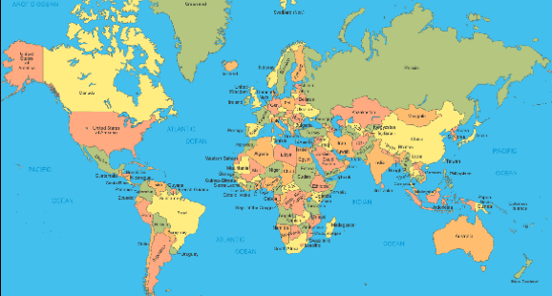
Figure 1: Standard Mercator map of the world

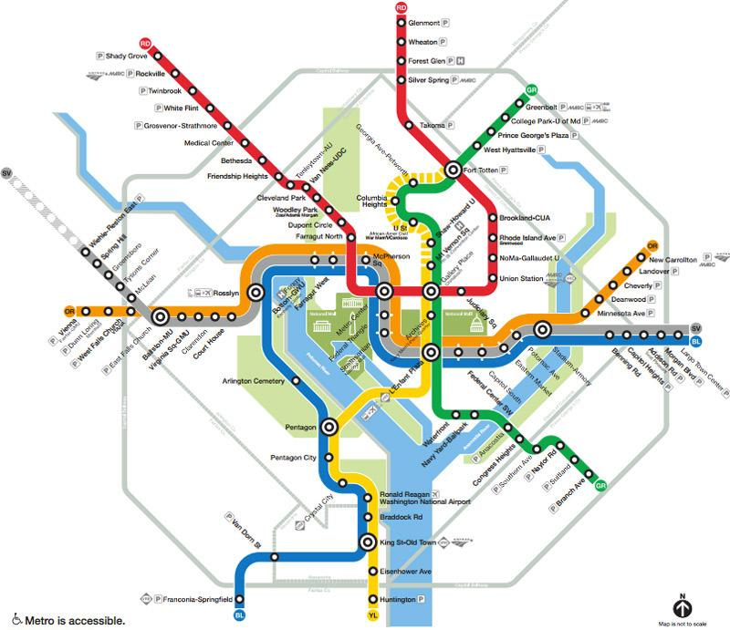

Figure 2: Official WMATA map of the Washington, DC area metro

Any projection map – that is, any two-dimensional map of a curved surface – cannot simultaneously preserve relative size, shape, relative distance, and direction, with respect to the shapes that it represents. Different projection systems compromise different combinations of these four parameters, but as a matter of mathematical necessity, each must compromise some of these parameters to preserve others. The Mercator map of the world in Figure 1, familiar to most of us from the walls of our middle school geography classroom, preserves direction at the cost of shape and – especially – relative size. The map is accurate, as long as you understand its representational conventions. The reason this map preserves direction is because it was designed for navigational purposes. Those of us seeing the map, however, are overwhelmingly not using it to navigate, and it has well-known distorting effects upon our understanding of the world that are far from politically neutral. It centers Europe, and magnifies the white-dominated global north while shrinking the global south, infamously making Greenland and Africa look comparable in size. It was also used to visually magnify the threat of communism during the Cold War (Monmonier 2018, 109). Not only do these effects scaffold racist and xenophobic narratives and understandings of space, but the original map was racist in its inception, since it was literally designed for colonizers to help them start at the ‘center’ and make their way efficiently to colonizable spaces. Hence this is plausibly a bad map because it in effect misinforms and skews our understanding, and it does so because of poor value-laden choices in its construction. But its badness does not lie in its inaccuracy.

Meanwhile, the second map, of the Washington, DC metro system, is often heralded as an example of a good, useful map, because it serves the purposes of users very well, clearly marking points of exchange, order of stops, and city boundaries. Its bold colors and thick lines make it easy to read and use. It makes navigating the city easy. But it is in many senses a wildly inaccurate map, most noticeably in being dramatically not to scale. It is also very minimal in the information it contains. If someone were to try to use the map to find their way around DC by foot, or to try to extrapolate how suburbanized different areas will be, or for any number of other purposes, the map would prove misleading or useless. So the goodness of this map does not depend on its accuracy, or on its immunity from misleading. Nor does it depend on its ability to live up to any value-free standards of objectivity.

Philosophers of science have argued for the ineliminable role of values and interests in the design, methodology, implementation, and communication of scientific research, across a wide range of disciplines. The ‘value-free ideal’ has, according to an increasingly mainstream discourse, proven mythological in disciplines including medicine, biology, climate science, toxicology, neuroscience, pharmacology, and more. But a careful examination of the roles of values and interests in knowledge production, and the corresponding challenge to the value-free ideal, has not been extended to cartography and geographic information systems (GIS) – that is, to the production of visual representations of spatial information. I will argue that maps, like other scientific knowledge products, are ineliminably structured by value-driven choices at multiple stages. But, I will also claim, they raise specific epistemic challenges of their own.

The new demarcation problem, as defined by Bennett Holman and Torsten Wilholt in the introductory essay in this issue (Holman and Wilholt 2021), is the problem of determining when values and interests play a distorting role in knowledge production and when they play a legitimate role, taking it as given that their role is not eliminable. Maps raise their own distinctive versions of the new demarcation problem. This distinctiveness comes from three sources: First, a map serves simultaneously as evidence for future inferences, as a knowledge product in its own right, and as the communication of knowledge. Hence wherever values play a role in the production of maps, they affect all three of these inseparable functions. Second, maps, like models and like other visual representations of data, are representations rather than collections of inferences. The knowledge product, in the case of a map, is not a set of conclusions about hypothesis acceptance or rejection, as in the case of the traditional type of scientific knowledge that has been the focus of the values in science literature. It is instead a representation of information. The value-laden balancing of epistemic risks in representation production looks different than the value-laden balancing of epistemic risks in scientific inference. Third, maps are inherently aesthetic products. There is, in the most literal sense, no separation of the aesthetic choices that go into map production from the map itself; the map is individuated in part by its sensuous, aesthetic dimensions. Thus the aesthetic choices we must make in map-making constitute a whole layer of value-laden decision-making that doesn’t arise for scientific inference and theory choice, which are abstract and medium-independent.

It is in some ways obvious that value-laden choices must be made over the course of map production. Making a map requires choosing everything from the colors and thickness of the lines, the symbology, the scale, the projection system, the data sources, the categories into which data will be divided, and the parameters the map will represent. There is no neutral default for any of these choices; each choice represents and communicates some information while omitting, distorting, or hiding other information, as map makers themselves routinely acknowledge. Maps in their essence simplify, schematize using representational conventions, and ignore detail. This is how they communicate. A map that simply reproduced reality would not be a map at all, and given that it has to simplify and select what it shows, choices as to how to do so are inevitable. As James Scott puts the point, “A city map that aspired to represent every traffic light, every pothole, every building, and every bush and tree in every park would threaten to become as large and as complex as the city that it depicted. And it certainly would defeat the purpose of mapping, which is to abstract and summarize. A map is an instrument designed for a purpose. We may judge that purpose noble or morally offensive, but the map itself either serves or fails to serve its intended use” (Scott 2020, 87).

Despite the inescapable value-ladenness of map production, cartography and GIS have been governed by their own version of the value-free ideal. Up until World War II, geography as a discipline was focused on observing and documenting practices in local regions. It had little claim to producing generalizable knowledge and was looked down upon by the ‘real’ sciences. After the war, there was a revolution in academic geography, as people invented techniques for encoding elaborate statistical spatial information into maps. With the rise of GIS, the capacity to do this grew enormously. Geography reinvented itself as a “spatial science,” whose central purpose was to translate quantifiable, perspective-independent, value-neutral spatial patterns and relationships in Newtonian space into visual representations. This was hailed as the advent of objectivity in geography (Cresswell 2012, Pavlovskaya 2018). Some vocal geographers such as Openshaw (1991) influentially argued that the only hope for geography to establish scientific bona fides was for it to become an objective and quantitative science, by focusing entirely on the production of such representations. The visual representation of statistical spatial information was to be the primary epistemological method for both collecting and communicating knowledge in geography. The advent of ‘spatial science’ and GIS in particular turned out to save dying academic geography departments, who now earn their institutional keep by training GIS technicians, who are sought after by city planning, transportation, public health, and police departments, and other such practical fields that require spatial information. The image of proper spatial science as objective and perspective-neutral is central to the discipline’s claims to practical usefulness and scientific credibility, as a matter of sociological fact. The institutional survival of geography departments depends on sustaining this image of objective, scientific map-making. This image sits in uneasy, unresolved, and mostly unexamined tension with the straightforward ways in which map making involves value-laden choices.

In the remainder of this paper, I first discuss the kinds of epistemic risks involved in map making – risks that are unavoidable, and that must be managed and balanced in light of values and interests. I identify three distinctive kinds of epistemic risk that are ineliminable in map making, and whose management is necessarily value-laden. It is not hard to identify some bad maps that communicate in distorted and misleading ways by abusing each of the three types of risk. But in each of the three cases, I examine in detail examples of good maps – maps that legitimately impart true, useful knowledge and were produced with no deceptive intent – and I show that these good maps are still at risk of producing distortions in knowledge, and that these risks must be managed via value-laden choices. Returning to the demarcation problem, I argue that it has no straightforward solution in the domain of maps. However, I claim that we should be particularly suspicious of maps that aesthetically present themselves as objective and neutral – that is, the very maps most prized as epistemically valuable by geographers. Finally, I look at a trend in GIS to produce maps that wear their value-laden, interested character on their sleeve, and argue for the potential distinctive epistemic value of such maps.

Representational Risk

The most well-developed literature around the role of values in science concerns inductive risk. The exact definition of inductive risk is under contest and varies from author to author (see for instance Rudner 1953, Douglas 2000, Biddle and Kukla 2017, Elliot and Richards 2017). The clearest definition of inductive risk for my purposes is the risk of a false negative or false positive that we accept in making a non-deductive inference from evidence to the acceptance or rejection of an empirical consequence of that evidence. Most paradigmatically, we assume inductive risk when we accept or reject a hypothesis on the basis of statistical evidence. But any time that we make an uncertain inference from empirical evidence to an empirical consequence, we assume the risk of accepting something false or rejecting something true. And, as many philosophers have shown in creative ways, we cannot decide what the correct epistemic threshold is for making such an inference – for balancing the risk of a false negative against the risk of a false positive – without bringing values to bear.

But as Stephanie Harvard and Eric Winsberg (2021) have pointed out, there are unavoidable epistemic risks involved in representing, which similarly must be managed using values, and which are not inductive risks as thus defined. When we make decisions about how to represent a state of affairs – whether through a map, a model, a taxonomy, or a visual diagram, for example – we must choose which aspects of the world to include in our representation, how to categorize those aspects, and with what symbology we will represent them. The resulting representation will help shape which inferences are made in light of it. Some representations are inaccurate, in that they misrepresent reality by their own representational conventions; these are not especially epistemically interesting. More interesting is how representations that are accurate given their own conventions may mislead by encouraging incorrect inferences; by discouraging or distracting us away from important correct inferences; or by skewing our sense of salience so that we focus our inferences on the wrong things and leave important inferences unexplored. In other words, representations may lead people to adopt false beliefs or to fail to adopt important true beliefs. Because all representations are partial and involve choices about how and what to represent, all representations come with this representational risk of misleading. This epistemic risk built into representation is not inductive risk. As Harvard and Winsberg point out, the choice to represent in a certain way is not itself a choice to make an inference to an empirical consequence. Representations, as they put it, are not true or false, but adequate or inadequate to purpose (Ibid.). Thus the epistemic risk to be managed is not the risk of a false positive or negative, as in the inductive risk case, but the risk of distorting the reasoning of those who use the representation (including its own producer).

Maps raise representational risks of at least three kinds, corresponding to three necessary stages in the map-making process. I name these aesthetic risk, categorization risk, and simplification risk. Maps are inherently aesthetic, categorizing, and simplifying. In no case can any of these three types of risk be avoided; they can only be managed, in light of our values and interests, which govern how we want the map to be used and what sort of knowledge we want it to convey. And in each of the three cases, there is no ‘safe’ or neutral answer to the question of how to manage the epistemic risks involved.

Aesthetic risk: Maps are perceivable particulars, and they are inseparable from their own aesthetic features. Aesthetic risk is the epistemic risk introduced by making necessary aesthetic choices about representational conventions, which will necessarily make some information salient at the cost of other information, and shape users’ attention to and interpretation of the map. There is no ‘true’ or ‘neutral’ set of aesthetic conventions; all aesthetic choices must be made on the basis of values and purposes.

Categorization risk: Of necessity, maps introduce representational conventions where symbols stand for categories of objects or data. For instance, solid black lines may stand for all roads with conventional intersections, while double lines may stand for all controlled access freeways; this groups roads together by how they are accessed. Or, a map representing median income by neighborhood may divide income by quartiles, quintiles, standard deviations, or infinite other ways, but since it cannot represent each of the infinitely many possible incomes a different way, it must pick some categorization system or other. Reality does not hand itself to us pre-categorized, and so these categorization choices must be made on the basis of values and interests. In turn, they shape what patterns the map reveals and what patterns it hides, which in turn directs how people make inferences from the map.

Simplification risk: Maps do not represent spatial reality in all its full complexity, but rather selected parts of this complexity. Map-makers must choose which parameters to include on their map; a map is individuated not just by the area it maps, but by what features of that area it represents. Maps that include more details may have more nuance and contain more information, but they risk communicating less as they become visually incomprehensible. Communicative tradeoffs of this sort are inevitable; leaving off a parameter or feature risks making it invisible and unsalient to readers of the map, while including extra features clutters the map and reduces its communicative power. Either way, the map can mislead.

Aesthetic choices and choices about categorization and simplification are essential, unavoidable parts of map-making. In none of the three cases is there a value-neutral answer written into nature as to how these choices should be made. In the following three sections, we will see how complex the role of values in making all three sorts of choices can be. We also see how maps that are ‘good’ in the sense that they are accurate and communicate important truths also have the real potential to mislead because of these choices. Because representations are inherently communicative, the risk that they mislead is a risk that should be considered internal to the process of representing, and not just a separate piece of moral luck. Methodological choices in representation are inextricable from communicative choices. And because the user of a map may not have the same needs or values as the maker of a map, even the best designed map according to the standards appropriate to its original purpose might end up misleading its users, as we saw in the case of the Mercator map. Thus there is no simple way of solving the new demarcation problem by simply using the possibility of misleading as the measure of a map’s legitimacy.

Aesthetic risk

Producing a visual representation of spatial information is never a matter of mechanically processing data. Rather, it requires making aesthetic choices that govern which spatial patterns will be made salient and communicated. Unlike when we represent knowledge or evidence in propositions, maps necessarily have a visual, aesthetic form. In producing a map, aesthetic choices aren’t external to the content, like picking the font for a book; they are part of what individuates the map. There is no abstract map independent of its symbology: the colors it uses, the thickness of its lines, the contrast between figure and ground, the shape of its nodes. Crucially, these choices directly affect what information the map makes salient and how the viewer will interpret and use it. For example, contrasting colors, up to a point, make information stand out and allow for quicker processing. Thus color contrast can be used to shape what the map makes salient and what it hides (Fu, et al, 2013). But too many colors become difficult to process, and have the opposite effect, lessening how much information the map effectively communicates. A map literally tells us different things depending on these kinds of aesthetic choices, even holding the information strictly contained in the map constant.

Maps, like all representations, are communicative entities. There is no such thing as a map that just serves as a knowledge container and not a communicative representation. While a map with an aesthetic look of officiality and objectivity may present itself as a transparent conveyer of spatial information, maps always require interpretation on the part of the user, and the aesthetic choices will always help control that interpretation. There is no objectively correct aesthetic look for a map; which aesthetic choices we should make depends upon what the map is supposed to emphasize, which patterns it is trying to make salient. Any set of aesthetic choices thus comes with aesthetic risk – the risk that aesthetic choices that make some patterns salient and enable some inferences will hide other patterns, in ways that can mislead.

An exhibit at the Pratt Institute in October 2017, entitled “You Are Here NYC: Art, Information, and Mapping,” featured artworks that used geospatial data to produce representations designed to give aesthetic insight into New York City as a human place. It included Doug McCune’s piece, “Data Sketch: Routes” (2017), which used GIS data to create a map of New York City with a three-dimensional double wall around its boundaries. The height of the taller wall indicates the number of immigrants to the city who arrived from that compass direction, while the height of the second surrounding wall indicates how many of these immigrants were children (see Figure 3).

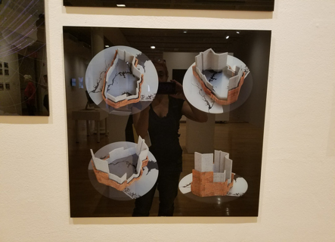

Figure 3: McCune, “Data Sketch: Routes”

It also included Xingying Du, Michelle Htar, and Jessica Silverman’s “Journeys Disconnected – Reconnected” (2017), which used colored yarn to track the migration patterns of 66 people who were buried at Hart Island, which served as a prison, a psychiatric institution, a sanatorium, and a boys’ reformatory. The artists used spatial representation to make vivid how the island served as a terminus for complex global stories (see Figure 4).

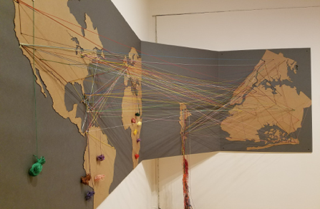
Figure 4: Du, Htar, and Silverman, “Journeys Disconnected -- Reconnected”

Neither work is inaccurate according to its own representational conventions; they do not distort scale, or include features that don’t correspond to anything real, for instance. Such artworks are, in fact, just GIS maps. They are quantitatively accurate representations of spatial data. The main thing that distinguishes them from traditional GIS products is that their makers are self-reflective about the aesthetic choices that go into producing such representations, and about how the representations are designed to make certain spatial patterns with human significance salient. Their aesthetic choices are specifically designed to encourage particular interpretations and responses to the spatial information they portray. The aesthetic features of these works are not overlain on top of regular maps, nor are these artworks instead of regular maps. Instead, I take it that both reveal the extent to which every map is a product of necessary value-driven aesthetic choice points.

A more standard immigration map, shown in Figure 5, lets us extrapolate some of the same information communicated by McCune’s work. It has the look of objectivity rather than art. However, its makers also had to choose its color scheme and symbology. They chose to make different patterns salient. The choice to make a map with the look of stark neutrality – one that seems to depend on no investments in a specific interpretation – is itself a value-laden aesthetic choice. The look of withholding this kind of interpretation is a look that we choose because of specific interests. The key is that it is no more or less epistemically fecund or representationally accurate because it does this. In no obvious sense can it be said to have any special epistemological priority over maps where the use of aesthetics to govern interpretation is clear. Whether the makers of this map were as deliberate and thoughtful about the downstream effects of their aesthetic choices or not, they had to choose all the same, and their choices affect what the map communicates, and which inferences it stimulates and which it discourages.

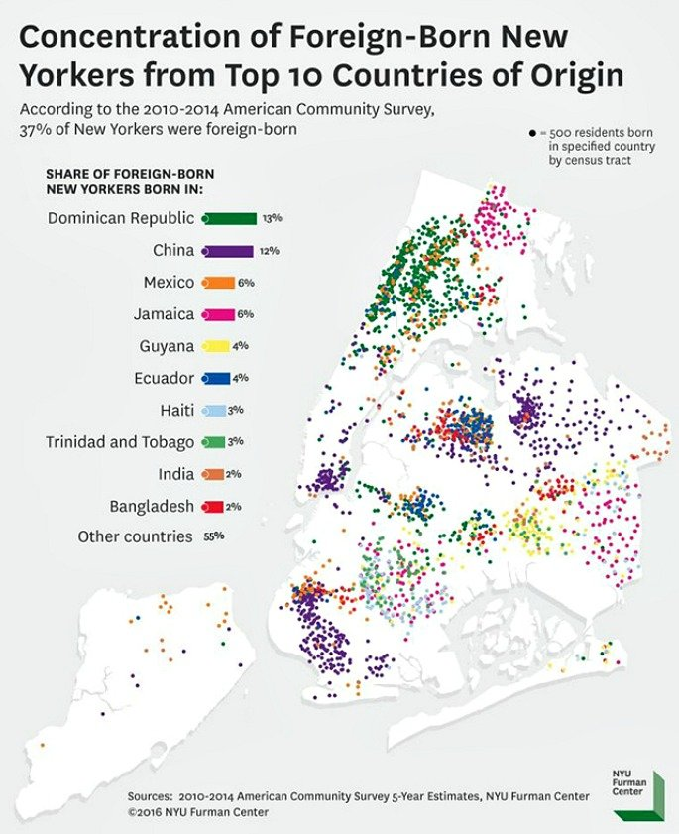
Figure 5: Immigration patterns in New York City. NYU Furman Center, available at https://www.6sqft.com/map-shows-where-foreign-born-new-yorkers-live/

All three maps are good maps. That is to say, all of them are, as far as we can tell, accurate given their own representational conventions and goals, and they reveal and make salient important truths about migration, borders, and the kind of place that New York City is. McCune’s map is based on quantitative data but it conveys a qualitative sense of place and of the meanings of immigration that are absent in the more “objective”-looking map. Du, Htar, and Silverman’s map brings the distances traversed to life as lived journeys. The Furman Institute map is good at conveying where there are ethnic neighborhoods in the city, but it evokes no sense of place or journey. We might think that because it is an ‘objective’, quantitative map, it is not its job to convey anything as humanistic as a sense of place or journey. But the other two maps prove that even without anything beyond the representation of spatial data, maps can do this. Whether they do or not depends not on the objective correctness of the map, but on the aesthetic choices that go into it. Thus all three maps manage epistemic risks in different ways, making different choices based on which patterns they care about conveying and what sorts of inferences they care about stimulating. So far, there are no grounds for saying that values play a more or less appropriate role in any of the cases. All three maps manage aesthetic risks, since their aesthetic choices make some meanings and patterns salient while thereby directing attention away from others.

Categorization risk

A map will not be readable unless it categorizes its data; that is, if it represents like things the same way. This might be as simple as two-lane roads being symbolized in one way and highways in another. Or it might be a matter of breaking data for income, temperature, or some other continuous variable into quartiles, quintiles, or deciles on a choropleth map. Or it might involve breaking up data using racial or gender categories. These categorizations are necessary, because not every data point can have a unique symbol, otherwise the map will not reveal spatial patterns any more vividly than does the world itself. But these categorizations are also choices, which are not written into nature. How a map maker chooses to categorize their data will directly affect which patterns the map reveals and which it hides. Mark Monmonier writes, “A single set of numerical data can yield markedly dissimilar maps. By manipulating breaks between categories of data to be shaded on a choropleth map, for instance, a mapmaker can often create two distinctly different spatial patterns...Wary map users must watch out for statistical maps carefully contrived to prove the points of self-promoting scientists, manipulating politicians, misleading advertisers, and other propagandists” (Monmonier 2018, 153). He gives the example of two choropleth maps of phone coverage in the American Northeast, one of which makes it look like New England has a systematic problem with phone coverage and the other of which makes it look like it doesn’t, based on different choices of data bins (see Figure 6).

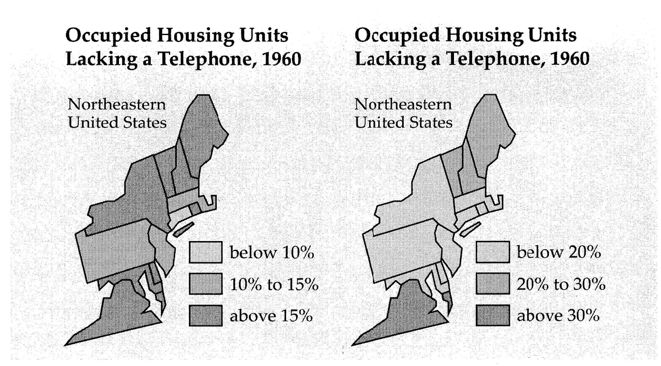
Figure 6: Different categorizations yielding different patterns and interpretations, from Monmonier 2018.

Monmonier warns about unscrupulous and irresponsible map-makers bending maps to their own ends through categorization systems, but there is no correct categorization system built into nature. One may be more or less helpful for the purposes for which a map will be used, but all come with representational risk, as all hide some patterns while revealing others. His warnings about unscrupulous map-makers trying to prove a point suggest that there exist, in contrast, honest and disinterested categorization systems, but it is unclear what these would be or by what standards we would determine them.

Consider a map showing the spatial location of the residence of people of different races. Such a map requires that we decide how to categorize people by race. This means choosing a racial categorization system, and also deciding what to do with people who are of a mixed race or an unknown race. It also requires that we decide what counts as residing in a location; we must decide how to represent people with multiple homes, no home, or an unstable home. Figure 7 shows a dotmap of Detroit, produced at the University of Virginia, which used census data to represent the racial demographics of all major American cities, with one racially color-coded dot for every person deemed a resident.

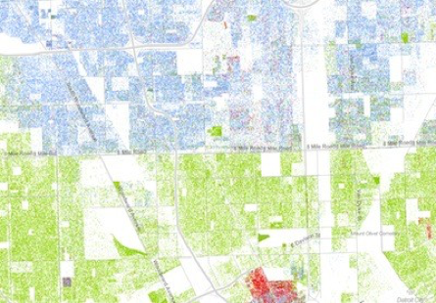
Figure 7: Racial demographics of Detroit

In this map, one can vividly see the stark segregation of the city, with 8 Mile Road a sharp dividing line between white and Black. This map is a good map, in that it uses categorization and symbology to (presumably) accurately and vividly reveal an important truth about the city of Detroit; it makes a pattern lucid for us in a way that a list of statistics never could. When you look at this map, the boundary created by 8 mile takes on hard reality. We can see segregation at work! This map encourages correct and important inferences that would not otherwise be salient.

But the map is a product of a series of categorization choices that simultaneously hide other patterns. For instance, the project folded all Middle-Eastern and Arab people into the ‘white’ category. It thereby made it impossible to see one of the most vulnerable and vexed groups in the country. Indeed, the Detroit greater area has among the largest Muslim populations in the United States (or the largest, depending upon the source and the exact definition of the metro area). This is an important fact about the spatialized racial politics of the city, which is obscured by the map. The map also folds together all Asians, despite important cultural and phenotypic differences between groups from different parts of the continent. This means that one cannot see, from this map, the physical isolation of Detroit’s beleaguered Hmong community, which again is an important feature of the spatialized racial politics of the city (Yang 2003). So, it is an objective flaw in the map that it used categorization systems that occluded these spatial patterns? No, because using a more fine-grained racial categorization system would have muddied the pattern that did emerge, which is a real and important pattern. The map as it stands is not wrong or flawed, but what it reveals and what it hides is based on value-laden choices that vanish under the veneer of stark objectivity that the visual representation suggests.

This map was made using census data, which means that the racial categorizations, as well as the residence categorizations, were inherited pre-packaged from those used in the census. We cannot know whether the map makers thought explicitly about the impact that using the census categorizations would have on their maps. However, it is clear that making use of a secondary source of data like the census provides concrete benefits in map-making, allowing us access to vast data sets that would be impossible to recreate as an individual researcher. Hence the value-laden choices were already baked into the technological infrastructure available to the researchers who produced the maps. The researchers here made another kind of epistemic tradeoff: they accessed a large data set which would have more power than any they could produce on their own, at the cost of offloading the burden of reflecting on racial categorizations and their downstream significance.

The visual representation that results from these choices affects what we see as real boundaries and divisions in the city. In turn, this affects not just what theoretical inferences we draw, but also our practical decisions. Maps like this influence investors’ and developers’ choices about where to buy and build property, individuals’ choices about where to live or just take a walk; policy decisions concerning things like transportation infrastructure, and more. Thus which patterns we reveal and which we hide in maps concretely impact the world we live in. The map in Figure 7 is, by any reasonable measure, a good map, which reveals useful and important truths, but it is not free of representational risk. We need to read it with a critical eye, aware of what sorts of patterns it may be occluding.

Simplification risk

Maps necessarily simplify the spatial complexity of the area that they map; any map must select which spatial features, parameters, and relationships it will represent. In the last section, we saw that we need to choose how to sort individual data points into categories, which is also a form of simplification. But before we even get to categorization, we need to pick what will be represented in a map at all, abstracting away from the indefinitely rich particularity of any space. Including more parameters on a map increases nuance and detail, but lowers its communicative power and inferential fecundity.

There has been a strong bias, within GIS culture, in favor of representing simple quantitative relationships and features. GIS maps achieve their veneer of scientific legitimacy and objectivity partly by sticking to measurable, visually clean spatial relationships and data points. There is also a bias in favor of including parameters for which we have large data sets, as this increases the statistical power of the map. But here, representational risk comes in, because both biases mean that we are less likely to represent and communicate more complex relationships and non-quantitative spatial phenomena, which means that those patterns are occluded, and don’t show up as part of our visual canon of objective spatial truths. In other words, what it is easiest to map effectively unsurprisingly impacts what we map, and in turn this shapes our understanding of spatial reality, with the easily-mappable parts showing up as objective features of the world, and other patterns left invisible.
Consider, for example, commuting maps. Geographers love to make maps that represent commuting patterns, perhaps divided by gender, or race, or by income bracket, for example. It is worth exploring why we make so many commuting maps, and which patterns and relationships are revealed and hidden when we use GIS to represent commuting patterns. I want to highlight what commuting maps tell us about what kinds of motion and whose motion are essential to understanding the dynamics of a city, as well as what kinds of motion and whose motion become invisible when we see commuting maps as representing city movement.
Why do our maps of motion through cities so often focus on home-work trips? On the one hand, we tend to think of these as the ‘main’ trips that define someone’s day, geographically speaking. On the other, we have the best data sets for this kind of motion. Commuting data is easily available, because we keep track of where people live and where they work, but we do not have any immediate access to the other ways in which people move through space. These are connected facts: This data is more easily available partially because we take home and work to be the two main places where people belong, the places it is worth collecting data about. What we don’t easily have the data to map includes movement through space to visit family, care for a parent, go to church, pick children up through school, go to the doctor, socialize, and so forth. In fact, only about 25% of our vehicle trips are commuting trips (Tsafos 2019). That figure predates COVID, so it is very likely that the current number is even smaller. Thus a map of commutes will give a highly distorted picture if we see it as a representation of city movement.
Whose lives are centered and privileged by these maps, and what aspects of those lives are taken as essential? First off, it centers people who have one single work location, as opposed to those who have other kinds of jobs or who are not traditionally employed. This leaves out artists, contract workers, adjuncts teaching at multiple universities, many sorts of tradespeople like plumbers, and so forth, and privileges white-collar office workers and blue-collar manufacturing workers. It also leaves out very young and very old people and many disabled people. It is more likely to leave out women than men. Meanwhile, policy and transportation decisions, such as where to place bus routes and bike lanes, are made on the basis of these maps, thereby making commuting trips easier, but perhaps making other sorts of motion through a city more difficult. Thus the map encodes whose lives and what dimensions of those lives are privileged, while in turn contributing to the development of infrastructure that further privileges those lives and life dimensions.
Consider the map of (pre-COVID) commuting patterns in central Washington, DC in Figure 8:
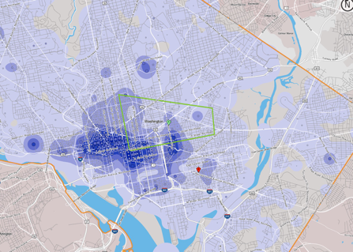
Figure 8: The commuting patterns in central Washington, DC. Map created by author based on data from census.gov, 2018.

This is a map that I generated using census data, which shows where people who live in the fastest growing part of Washington DC (inside the central polygon) work. Looking at the map, you can see a clear commuting direction and path: people who live in the center of the city tend to travel to the west and southwest on their commute. Most people living in this central polygon are young white professionals who have fairly recently migrated to the city. For those familiar with Washington, DC, this map will not be surprising; the dark areas representing heavy employment for those living within this heavily gentrified area include medical facilities and governmental organizations such as the World Bank in Foggy Bottom, and political offices and lobbying and law firms along K Street NW, as well as Georgetown University and George Washington University. I originally created this map in order to demonstrate the case for adding bike lanes leading from the most rapidly growing part of the city to the areas to the west and southwest, and the map is effective at demonstrating this need. Parts of central Washington show up on this map as areas to be passed through by commuters. Since many young professionals move to the city partly in order to rid themselves of car dependence, and since biking is a healthy, cheap, and environmentally sustainable mode of transportation, the case for bike lanes appears transparent from this map.

But there is a second story that this map not only fails to tell, but occludes. The area in the center of the city that shows up requiring bike lanes for commuters is also one which elderly Black residents, who have managed to stay as the area gentrifies, move within in order to go to one of several local, longstanding Black churches and to visit family and neighbors. It is also an area that Black people displaced by gentrification, who have moved out to public transportation-starved, car-dependent Prince George’s County, Maryland, travel into, in order to see elderly relatives and to go to church. None of this motion shows up on the map. Thus this map makes the area look like one to be passed through, rather than one to come into or move around in. This deeply shapes the place-meaning of the space that we are seeing, and in turn shapes decisions about what sorts of infrastructure the area needs. For instance, it turns out that bike lanes through this area will likely disrupt much-needed parking for Black churches and other key Black community institutions. This commuting map thus encourages further gentrification and destruction of the at-risk ecology of the area, if it is taken on its own. It bears the representational risk of being interpreted as a map of motion in general, or all motion that matters to infrastructural decision-making.
What I wanted to do, in principle, was to make maps showing both kinds of motion, so as to portray the nuanced and contradictory mobility needs of the neighborhood. But this proved impractical, because the technology available to me at census.gov itself privileged home-work trips. I would have had to collect information on people’s movement around and into the neighborhood person by person, and the results would have been unreliable and have had much less statistical power than the giant census data sets. Thus our privileging of some kinds of motion over others is built into our institutions and technology, and reflected in our maps.
The commuting map is not inaccurate; it represents what it claims to represent. But it is very hard not to see commuting as a proxy for motion in general through the city. On the basis of this and countless other such commuting maps, we understand the city as a set of flows that require various kinds of infrastructural support, thereby hiding the lives, motions, values, and needs of those whose motions are not organized around a traditional home-work commute. A mismatch between what this map actually encodes and what it communicates is highly likely, given the background assumptions that frame its look and its uptake. It lends itself to misuse, if this misuse isn’t actively blocked by further communication and framing, or by a countermap that is hard to produce. Thus here again we have a good map, in that it is not inaccurate according to its own representational conventions and can communicate important and useful truths about spatial patterns. But it runs the risk of misleading and occluding as it is taken up in inference.

Back to the New Demarcation Problem

A map that by design directs attention in ways that are epistemically damaging is a bad map, even if it is accurate. The problem is that many maps that are well-designed to be epistemically illuminating will at the very same time not just leave out but occlude other important patterns, and do other kinds of epistemic damage. It is not terribly hard to identify some bad maps – inaccurate maps, or maps that are designed to prevent important or salient inferences from being made. But it is hard to identify good maps, or to specify exactly why they count as good, given the representational risks they run. What I have tried to show is that any map production is riddled with ineliminable representational risks, including what I have called aesthetic, categorization, and simplification risks, so that the values we use to manage these risks will always affect which real patterns the map communicates and which it hides. There are no neutral, value-free choices to be made about aesthetics, categorization, or simplification. Once we recognize that every map occludes and reveals, and that value-laden choices at multiple stages determine how it does this, we can lose our handle on what counts as a good map. A good map, one would think, should be epistemically helpful and fecund, rather than epistemically inhibiting. But I have argued that even well-constructed, epistemically helpful and fecund maps are also epistemically inhibiting. There doesn’t seem to be any straightforward way to classify maps as inherently epistemically sound or distorting. Whether a map is epistemically helpful or obstructionist depends on our values, not only in constructing it, but in using it.

Geographer Mark Monmonier’s classic book, How to Lie with Maps, shows many ways in which map-making requires value-laden choices, and warns that maps that are not made with ‘knowledge’ and ‘honesty’ will be distorted and misleading. However, he does not take on the problem of what counts as a good, undistorted map, given the ineliminability of these choice points: it is not clear what standards an honest and knowledgeable map-maker could use to achieve undistorted objectivity, or what they are supposed to be honest about. Monmonier says that we should “be wary of cartographic manipulators” who make the representational choices “that best prove their point” (2018, 159). But this is complicated by the fact that maps are communicative devices, so we use them to support what we want to say; of course we use them to prove our point; there is no neutral representation.

Part of the reason why maps are so likely to occlude important patterns for their users is that, even though they are all produced through a series of value-laden choices as we have seen, they often have the visual look of neutrality and transparency. Many maps present visual data in a way that makes us feel like we are seeing straight through to the objective truth about spatial data. This is partly just because we find visual representations powerful, but it is also because we have entrenched a specific aesthetic that signals scientific accuracy and value-neutrality in our maps (Ferdinand 2019). Maps that present the world as neutrally calculable, measurable, statistically analyzable, and representable are prized, for institutional reasons that we saw at the start of this essay; they give geography its institutional claim to legitimacy and scientific bona fides. However, they also hide their own representational risks and discourage critical distance from their message. Arguably, maps that aesthetically display their own value-laden production and perspective are epistemically superior, not inferior. We might think that maps that display their specific perspective and value choice points, as do the artworks in Figures 3 and 4, are actually epistemically better maps. These definitely had a point of view they were trying to communicate. But they seem more honest in their open use of aesthetic choices to make this point than do many more ‘neutral’ looking maps, and they are at least as informative. In other words, maps have the power to present themselves as transparent windows into spatial reality, but maps that disrupt that transparency may be epistemologically superior.

Critical GIS is the small but flourishing literature and practice devoted to revealing how GIS is not a neutral tool. Critical GIS theorists bring this critical perspective, while critical GIS practitioners promote uses of GIS that are openly grounded in values such as social transformation and revealing marginalized and hidden spatial patterns whose visibility has political value (Pavlovskaya 2006, 2018). Critical GIS theorists and practitioners push back against the institutional privileging of statistics-rich maps that represent the kinds of relationships that are easy to quantify. These maps often have the look of scientific objectivity, but, as we saw in the case of commuting maps, they systematically occlude other sorts of spatial patterns, including those that could only be revealed through qualitative inquiry.
For instance, in 2008, Mei-Po Kwan conducted an already-classic study of Muslim women’s felt danger and safety as they moved around their city, using GIS technology to create phenomenological maps (see Figure 9). Each map required the curation of a great deal of individual qualitative data. Such qualitative maps are laborious to produce. The maps and their framing reveal clearly that their maker is invested in unearthing a specific spatial perspective that she takes to have value; she is not revealing the neutral truth about the organization of space. Such maps balance representational risks as much as any other, but they do so in ways that push against dominant trends in scientific map-making. They sacrifice some epistemic values like statistical power in order to promote others such as revealing spatial patterns and phenomena that are hidden by standard quantitative methods. Of course, these cannot supplant traditional maps, as they also fail to reveal relevant and important patterns. But they have special epistemic value insofar as they reveal real patterns without encouraging the viewer to see these patterns as complete or neutral.

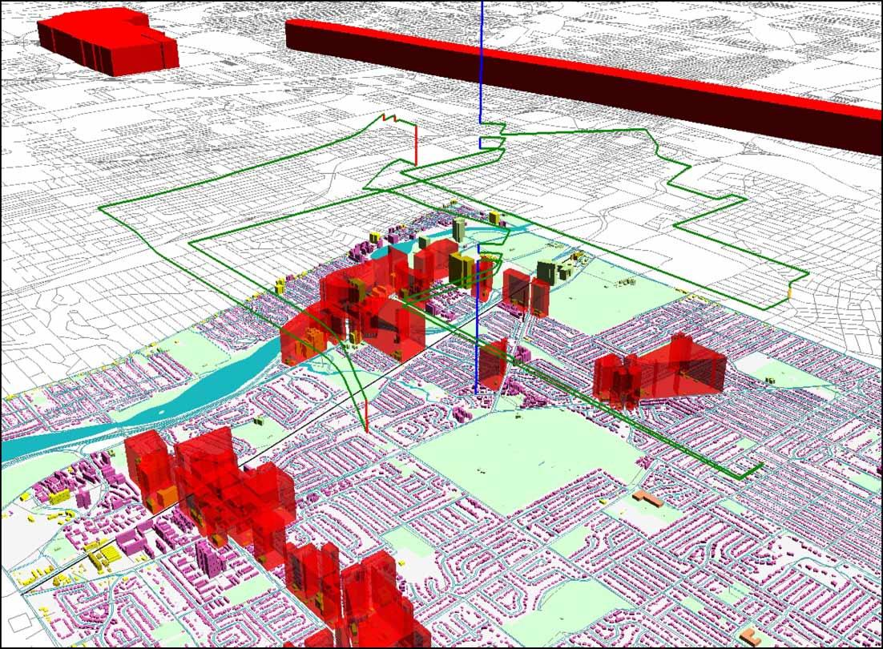
Figure 9: From Mei-Po Kwan 2008. One Muslim woman’s phenomenological map of danger and safety as she moves through her city after September 11, 2001.

I have proposed no solution to the new demarcation problem when it comes to maps, but instead I have tried to show exactly how map-making raises this problem. Map-making requires a dense and ineliminable series of value-laden choices that balance epistemic risks. The resulting representations are communicative entities that always have the potential to mislead and misdirect attention, depending upon the needs of the interpreter, as they always hide some patterns in order to reveal others. There are no such things as neutral maps. Maps that use tropes that suggest their own neutrality and transparency may be more at risk of misleading, since they do not invite reflection upon the values and purposes that guided their creation, or upon on the patterns that they occlude. There is some irony in this, since these are the maps most highly institutionally prized as science rather than art.

References

Biddle, Justin B., and Rebecca Kukla. "The geography of epistemic risk." Exploring inductive risk: Case studies of values in science (2017): 215-237.

Cresswell, Tim. Geographic thought: a critical introduction. John Wiley & Sons, 2012.

Douglas, Heather. "Inductive risk and values in science." Philosophy of Science 67, no. 4 (2000): 559-579.

Elliott, Kevin Christopher, and Ted Richards, eds. Exploring inductive risk: case studies of values in science. Oxford University Press, 2017.

Ferdinand, Simon. Mapping beyond measure: art, cartography, and the space of global modernity. U of Nebraska Press, 2019.

Fu, Keren, Chen Gong, Jie Yang, Yue Zhou, and Irene Yu-Hua Gu. "Superpixel based color contrast and color distribution driven salient object detection." Signal Processing: Image Communication 28, no. 10 (2013): 1448-1463.

Harvard, Stephanie, and Eric Winsberg, “The epistemic risk in representation,” unpublished manuscript (2021), available at http://philsci-archive.pitt.edu/18576/

Holman, Bennett, and Torsten Wilholt. “The new demarcation problem.” Studies in the History and Philosophy of Science (2021).

Kwan, Mei-Po. "From oral histories to visual narratives: Re-presenting the post-September 11 experiences of the Muslim women in the USA." Social & Cultural Geography 9, no. 6 (2008): 653-669.

Monmonier, Mark. How to lie with maps. University of Chicago Press, 2018.

Openshaw, Stan. "A view on the GIS crisis in geography, or, using GIS to put Humpty-Dumpty back together again." Environment and Planning A 23, no. 5 (1991): 621-628.

Pavlovskaya, Marianna. "Theorizing with GIS: a tool for critical geographies?." Environment and Planning A 38, no. 11 (2006): 2003-2020.

Pavlovskaya, Marianna. "Critical GIS as a tool for social transformation." The Canadian Geographer/Le Géographe Canadien 62, no. 1 (2018): 40-54.

Rudner, Richard. "The scientist qua scientist makes value judgments." Philosophy of Science 20, no. 1 (1953): 1-6.

Scott, James C. Seeing like a state: How certain schemes to improve the human condition have failed. Yale University Press, 2020.

Tsafos, Nikos. “The slowly changing U.S. commute.” Center for Strategic and International Studies, 2019.

Yang, Kou. "Hmong diaspora of the post-war period." Asian and Pacific Migration Journal 12, no. 3 (2003): 271-300.

