Why art is never representation – even when it represents
This is a slightly edited version of a paper I delivered a conference at the Australian National University in December 2017. The images are from the PowerPoint presentation that accompanied the paper.
The question of whether or not art is essentially a representation of reality has long been a bone of contention among philosophers of art – especially in the major branch of that discipline called the analytic philosophy of art, or analytic aesthetics. Some philosophers are convinced that art is essentially representation, although as you can imagine, they’re forced to resort to some rather tortuous reasoning when it comes to music or non-figurative visual art, both of which on the face of it don’t usually seem to represent anything in any normal sense of the word. Other philosophers of art, apparently struggling for a compromise solution, argue that while literature and visual art are essentially representative arts, music is not – a move that, unhappily, begs a basic question: if, as the proposition suggests, there are both “representative arts” and “non-representative” arts, what do they have in common, fundamentally, that authorises us to call them both “art”? So, we are back to square one: What is the nature of art? Is it essentially representation? Or something else?
I don’t want to lead you down the highways and byways of these debates. They’ve been going on, more or less fruitlessly, for decades now and are, in my view, among the more tedious and arid areas of analytic aesthetics which, at the best of times, tends, regrettably, to be a rather tedious and arid affair anyway. Yet I suppose we do have to admit one thing. There is a tendency for many of us to assume, more or less unthinkingly, that art – especially visual art and literature – does somehow, in some ill-defined way, “represent the world”. We struggle to apply the proposition to art forms such as music of course – with the doubtful exception of so-called program music – but it’s nonetheless hard to rid ourselves entirely of the belief that paintings like the Mona Lisa, or Titian’s Man with a Glove, for example, “represent” certain people, or that novels like War and Peace or Balzac’s Père Goriot – “represent” life in a certain place at a certain period of history. And from there, it seems just a short step to assume that representation is what art is really about.
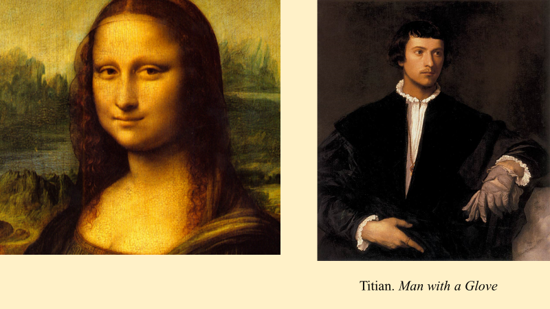
Nevertheless, it is this belief – that art is essentially representation – that I want to question today, building my case on an excellent analysis by André Malraux in one of his major works on the theory of art – Les Voix du silence – a work, incidentally, that writers in aesthetics, both here in Australia and overseas, almost never read, and whose very existence they often seem quite unaware of. Malraux does not, of course, argue that art – visual art for example – never represents anything. Such a claim would obviously not be sustainable. But he does argue – and argue quite passionately – that the essential purpose of art is not to represent the world, whether or not, as in the case of the two paintings I have just mentioned, something is obviously represented. Malraux’s analysis here, as this implies, is not about individual works, but about the fundamental nature and purpose of art – the general function it performs in human life – whether we’re speaking of visual art, literature or music. I won’t have time to explain his position in full, but I do want to comment on certain aspects of his argument that are relevant to our conference’s topic.
Let me begin in a quite practical way by showing three images – in this instance of horses. The one at top left, as you no doubt know, comes from the caves of Lascaux and was painted some 19,000 years ago; the one on the right is a spectacular baroque fantasy of St George and the Dragon by Rubens, painted in the seventeenth century; and the other is a fairly unremarkable photograph of a horse that I happened to find on the internet.
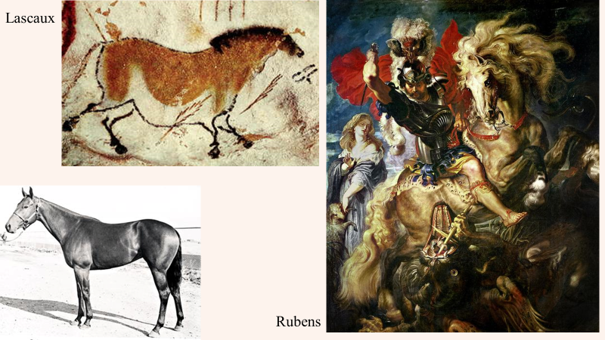

Now, at one level, it seems perfectly reasonable to say that these three images are all representations of horses, in each case in a different style – the style of an unknown Palaeolithic cave painter, the style of Rubens, and the style of a photograph. And if that seems a reasonable thing to say, one inference we might feel inclined to draw is that each image is a different stylistic rendering of an underlying, stylistically neutral representation of a horse – that is, an underlying representation that is free not of only of these three styles, but of any specific style – a basic, style-less image, so to speak. Seen in this light, the notion of style would, as André Malraux points out, be understood as “successive varieties of ornament added to an immutable substratum” – that is, a kind of “added layer” which, in theory at least, could be jettisoned altogether if the artist so desired. This tempting idea is what Malraux calls “the fallacy of a neutral style”. In visual art, he writes, “it has been assumed for centuries that there exists a styleless, ‘photographic’ kind of drawing (though we know now that every photograph has its share of style) which would serve as the foundation of a work, style being something added. This is the fallacy of a neutral style.”
Now, I must in all honesty confess that before I started to think seriously about these issues, I myself probably subscribed to a view something like the one Malraux describes, and perhaps I am not only one who has done so? After all, the proposition seems plausible enough on the surface, does it not? Don’t we often tend to assume that the specific style in which an object is portrayed is something “added” as Malraux writes – so that Rubens, for example, adds a rather more flamboyant style to his horse than the Lascaux painter and the camera? And don’t we often tend to assume, even if in a vague sort of way, that if we were to somehow to remove this something “added”, we would be left with a basic, style-free image of the object – an “immutable substratum” to borrow Malraux’s phrase? I suspect I had a definite tendency to think that way – and if I am ruthlessly honest, I suspect I thought about literature in a similar way, assuming that each novelist, for example, adds his or her particular style to a kind of underlying neutral, “purely objective” style which, as Malraux says, would serve as the foundation for the various final products.
As he so often does, however, Malraux encourages us to examine our assumptions more carefully. The basis of the idea of the neutral style, he writes, is the idea that a living model can be copied “without any interpretation or expression”. But, in reality, he points out,
No such copy has ever been made. In drawing, this notion can be applied only to a small range of subjects [such as] a standing horse seen in profile…Can one imagine a drawing of a rearing horse, seen from in front, in a style that is not that of any school, or of any innovator?
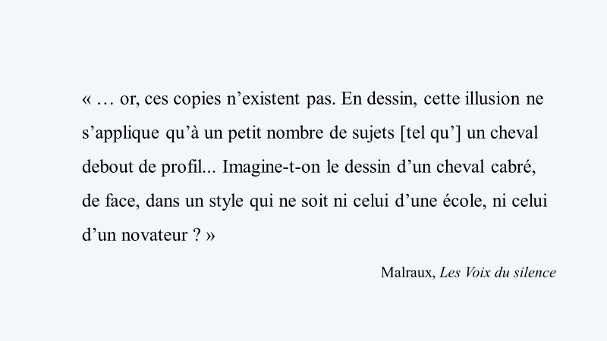
The notion of a style-less drawing, he writes,
springs in large measure from the idea of the silhouette: the basic neutral style in drawing would be the bare outline. But any such method, if strictly followed, would not lead to any form of art, but would stand in the same relation to drawing as an art as the bureaucratic style stands to literature.
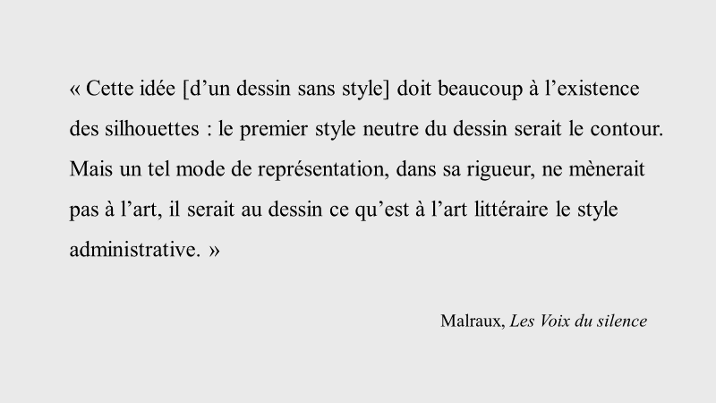
The argument is intriguing, but is it correct? Well, one can test it fairly easily. My photoshopping abilities are unfortunately rather limited but I’ve managed to reduce the photograph of certain object to its silhouette. (I would have included a bare outline as well but that proved to be beyond my capacities.) Here is that object. What exactly is it, I wonder?
Well, with a little imagination we can probably manage to make out what it is. I took my cue from Malraux’s statement and chose a photograph of a rearing horse, seen from in front – though I wasn’t able to find one taken from exactly in front.
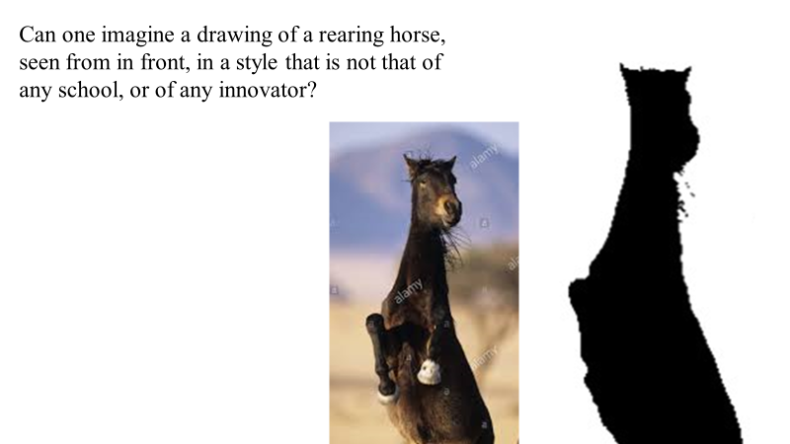
The silhouette makes perfect sense once we see the photograph, but without it, we struggle a little, do we not? – and we’d struggle even more, I suspect, with a silhouette or outline from directly in front. The silhouette or the bare outline shows us an image “without any interpretation or expression”, to borrow Malraux’s words: and in this case, we don’t even have the interpretation or expression afforded by a photograph. But the result is not the readily recognisable image of a horse executed in a “neutral style”: it is not a “style-less” image of a horse – an immutable substratum; it is merely an image that, in a case such as this, borders on the unintelligible – something not terribly far from a meaningless blob.
Now, already we can perhaps see that Malraux’s analysis poses a major threat to the proposition that art is essentially a form of representation. Philosophers of art define the idea of representation in various ways, not all of which are very helpful, but at their core, most definitions imply a close and direct relationship between the work of art and what one might loosely call “the outside world” or “reality”. If art is essentially representation, the arguments imply, its function relies heavily on a presumed capacity to reflect that world – to hold a mirror up to nature in Hamlet’s words. Seen in this light, the essential task of the artist is to effect a kind of transposition or transcription of the outside world, or “reality”, onto the surface of a canvas or into the pages of a novel. And not surprisingly, this thinking often goes hand in hand with the familiar claim – quite understandable in this context – that a prime virtue of the true artist is “faithfulness to reality”. And going on from there, taking what seems to be the next logical step, one might even argue that a neutral style, that would transcribe reality with maximum faithfulness to nature and minimum “interference” by the artist’s style, or even none at all, might be a real possibility.
Malraux’s analysis suggests that thinking of this kind rests on a basic misunderstanding. To the extent that it is even conceivable, a neutral style would not be pure, unalloyed realism but a form of depiction that had in fact abandoned all but the last vestiges of the procedures available to art. In visual art, it would, as we have seen, be at best the bare outline or the silhouette. In literature, it would, as Malraux suggests, lead merely to the commercial or bureaucratic style where, in a similar way, language tends towards a limited range of standard, “lifeless” forms. To the extent it is conceivable, in other words, a neutral style would result at best in the sign – that is, to those limited uses of visual forms or language that merely suggest, or “point to”, living forms – as a silhouette of a standing horse might be used to indicate the presence of horses – but it would stop well short of portraying any such form, as Rubens and our Palaeolithic painter do. Which is why, incidentally, Malraux gives scant support to semiotic theories of art. He is happy to agree that art sometimes makes use of signs, but in itself, he argues, the sign is at best only an embryonic form of art. `
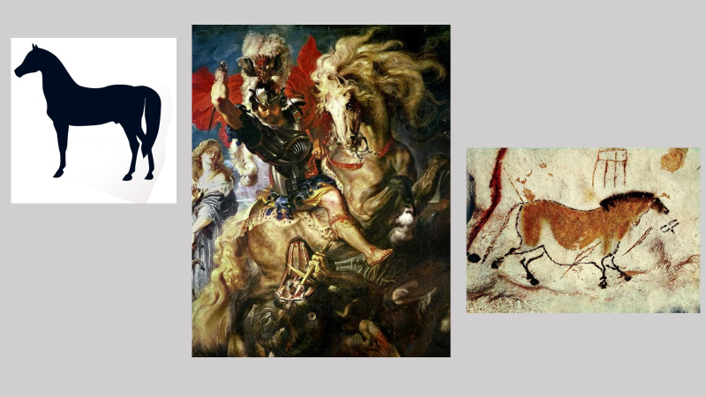
But if art is not essentially representation, what is it? To explore Malraux’s answer, I’d like to approach our topic from a slightly different angle. In the same section of Les Voix du silence I’ve been discussing, Malraux reminds us of an obvious point that we – or at least I – often tend to forget. He points out that painting (like the photograph) always involves a process of reduction – that is, a process by which the painter reduces a world of three dimensions to one of two dimensions. This being so, the painter’s task inevitably requires a process of selection, exclusion, and re-ordering – in short, a process of transformation – a process in which, even if the aim is to create an illusion of a three-dimensional reality (as in Renaissance art for example), the painter is not transcribing or transposing the outside world, but transforming it, that is, quite literally creating another world, a world different in kind from the world in which we live and move.
One might perhaps object that this argument does not hold good for sculpture since, in that case, the artist is not obliged to reduce three dimensions to two, and exact replicas of real objects are quite possible. But Malraux’s rejoinder is that sculpture too involves a process of reduction – a reduction of “movement, implicit or portrayed, to immobility”. And although, he writes, “we can imagine a still life carved and painted to look exactly like its model, we cannot conceive of its being a work of art. Imitation apples in an imitation bowl are not a true work of sculpture”. Which is why, he adds interestingly, “colours applied to sculpture so rarely imitate those of the real world; and why everyone feels that wax figures (the only forms in our time that are completely illusionist) have nothing to do with art”.
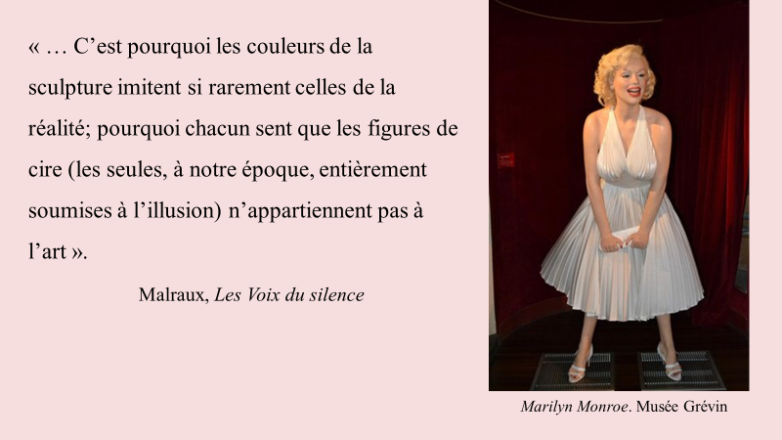
Transformation – and not representation – is, in other words, no less essential in the case of sculpture. One can see fairly readily, also, how the idea of reduction applies to literature, since here we are inevitably dealing not with a mere transcription of real-life events – as in a tape recording, for example – but with a selection of incidents, kinds of characters, vocabulary etc. And although Malraux does not explore the idea in relation to music, it’s not difficult to see how it applies there as well. Music “reduces” the world of sounds to its separate constituents – pitch, rhythm, tempo etc and in doing so enables the creation of “another world” of sound.
Some critics, including several art historians, have misread all this and claimed that Malraux’s argument is in fact intended as an attack on representational art and that he has a bias against it– a claim which, incidentally, reveals that the critics in question cannot have read Malraux with any care, given his enormous admiration for works ranging from medieval and Buddhist sculpture, to Titian and Rembrandt, to modern painters such as Van Gogh and Renoir, and many more. But in any case, the issue, as I have said, is not about individual works, or whether art that represents might somehow be better or worse than art that doesn’t – questions that Malraux would have doubtless regarded as absurd; the issue here is the quite different matter of the fundamental nature and purpose of art. And in that context, Malraux’s argument is that representation, in the simple sense of including in a picture forms resembling real objects, is simply one of the tools or techniques available to art – like the varied uses of line or colour. As a form of endeavour – as a certain kind of human achievement – he is contending, art is never essentially representation. (“It is for the non-artist, not the artist,” he writes, “that painting is only a form of representation”.) Art always involves the creation of another world – a rival world, as he often says, a world that depends for its very existence on a process of transformation of bare “reality” or “the outside world”. 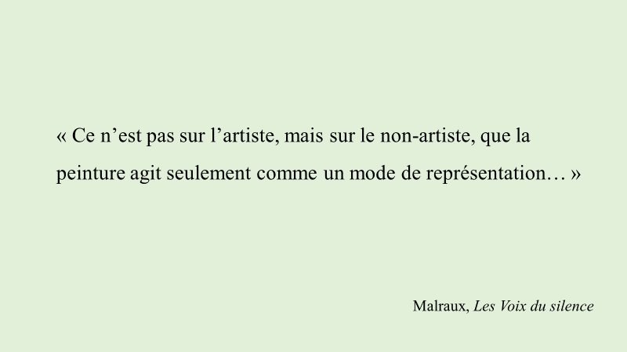
A theory of this kind, it is worth noting, offers a much clearer and more coherent explanation of the notion of style than the theory that art is essentially representation. If the goal of art is simply to represent – to transcribe the outside world into a novel or onto a canvas as faithfully as possible – what after all, is the function of style? Style in that case begins, as we have seen, to look suspiciously like a potential source of interference – perhaps of distortion – and it’s no accident, I think, that writers in aesthetics who claim that art is essentially representation typically skirt around the question of style, or fall back on variants of the idea that it is, to borrow Malraux’s words again, something “added” or “successive varieties of ornament”. The proposition that art exists to create another world, however, gives a clear and decisive meaning to the idea of style. Styles are the very fabric of art; they are the different ways in which the artist accomplishes the transformation that creates a rival world. In some cases, those means might include the representation of real objects; in others, they may not. But in all cases, style is never simply something “added”; it is the essential, indispensable means through which the artist creates another world, “no less necessary”, Malraux writes, “when the artist is aiming at unlikeness than when he aims at life-likeness”. The role of representation itself then becomes quite clear. “We are beginning to understand,” he writes, “that representation is one of the devices of style, instead of thinking that style is a means of representation”.
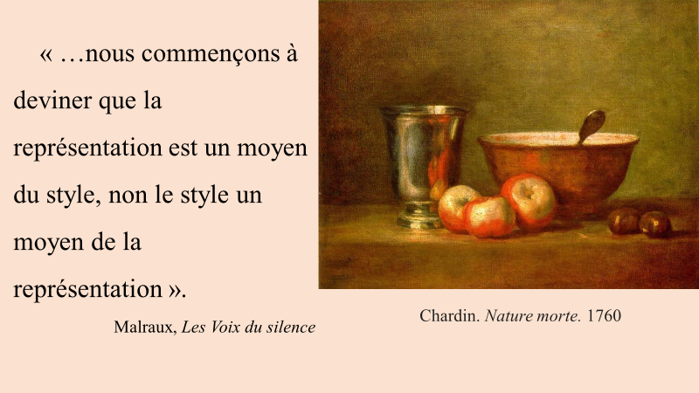 The key to an understanding of the function of art is, in short, that it always sets out to transform not to represent, and this remains true even if we are speaking of so-called “realistic” styles such as that of Chardin. “Great artists,” Malraux writes, summing up this view, “are not transcribers of the world; they are its rivals”.
There is much more to say about Malraux’s theory of art. If art is the creation of a rival world, what is the purpose of that world? What function does it perform in human life? These questions go to the heart of Malraux’s theory of art and explain many of its fascinating features – including his revolutionary claim, whose importance is still widely unrecognised, that art does not endure timelessly as the West has believed for so many centuries, but through an endless process of metamorphosis. But those are questions for another day because my time has now expired.

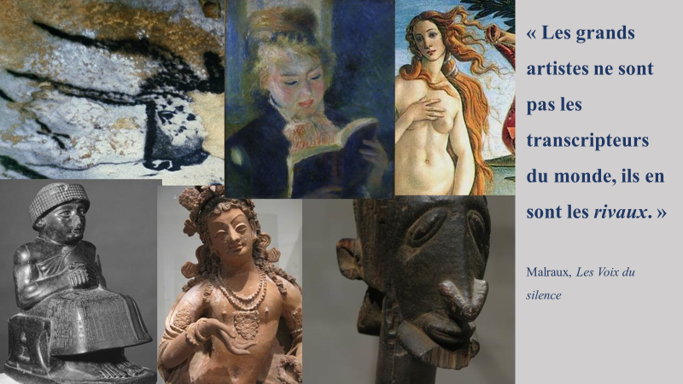

Les Voix du silence, 540.
See Les Voix du silence, 534, 543, 544.
Ibid. This would not of course preclude certain real objects – “objets trouvés” – being regarded as art, either as parts of a sculpture or as the “sculpture” itself. A piece of driftwood displayed as art is not viewed as a representation of a piece of driftwood (as a wax model is of a particular person).
Les Voix du silence, 538.
Les Voix du silence, 491.
Ibid., 553.
Ibid., 698. Emphasis in original. Malraux uses this same statement as the epigraph for his final volume on art, L’Intemporel. Cf. also: “Like the painter, the writer is not the transcriber of the world; he is its rival.” L’Homme précaire et la littérature, 152.

