In the Beginning Was Binary

The binary number system, in which all numbers are represented by 0 and 1, is the cornerstone of modern computing and digital technology. But did you know that if its inventor had not imagined it having religious value, it might never have been made public at all? Here is the story.

Binary arithmetic was the brainchild of the German polymath Gottfried Wilhelm Leibniz (1646–1716), who invented it in the late 1670s, a few years after inventing the calculus. Leibniz quickly undertook an intensive mathematical investigation of binary, even designing two different machines that could calculate using binary arithmetic. However, despite his advances, he was reluctant to inform others of his invention because he could not see any benefit that binary could bring. This changed almost twenty years later when Leibniz arrived at the view that binary arithmetic was of great importance to theology.

In a moment of epiphany, Leibniz came to believe that binary arithmetic was a perfect symbol of the doctrine of creation from nothing by the one God. Taking 1 as the symbol for God and 0 as the symbol for nothing, Leibniz took the origination of all numbers from 0 and 1 in binary as a reflection of the doctrine that all created things originate from God and nothing, or creation ex nihilo. To better understand his thinking here, note that in his philosophy all created things contain the same perfections as God (namely, power, wisdom, goodness), just not to the same degree, because, as created things, they have limitations. In this sense, all created things originate both from God, the source or principle of their perfections, and from nothing, the source or principle of their limitations. Thus, as Leibniz saw it, ‘creation from nothing’ involved God divesting a finite portion of his essence to a creature and then stopping, the stopping point marking the limit of the creature.

Leibniz was so taken with the idea that he started informing mathematicians and theologians of both the mathematics of binary and how binary served as a symbol of creation. He even commissioned several designs for a memorial coin or medallion, such as this one:

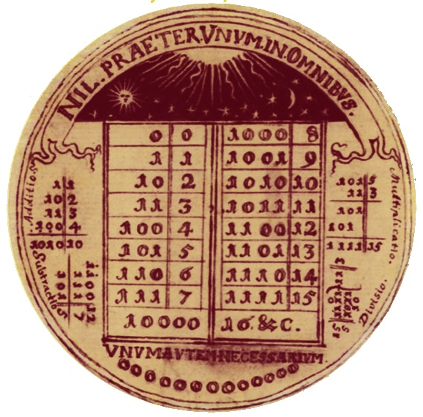

In this sketch, the centrepiece is a table of numbers 0–15 expressed in binary, with examples of addition, subtraction, multiplication, and division in binary arranged either side. The Latin inscription reads ‘Nothing except one in all things. But one thing is necessary.’ The final part of the inscription is a quotation from the Vulgate version of Luke 10.42: ‘But the Lord answered her, “Martha, Martha, you are anxious and troubled about many things, but one thing is necessary.”’ The idea of binary as a symbol of creation is captured at the top of the medal by an image of rays of light shining on what looks to be the watery deep, recalling the description of creation from the first book of Genesis.

Leibniz firmly believed that presenting binary as a symbol of creation had the potential to make the Christian doctrine of creation intelligible and even plausible to non-Christians. This prompted him to pass on details of it to Jesuit missionaries in China in the hope it would assist with their efforts to win converts. One such missionary was Joachim Bouvet, who was immediately struck by the similarity between binary arithmetic and the mysterious 64 hexagrams of the Yijing, or Book of Changes, an ancient Chinese divinatory text. Each of the hexagrams consists of a broken line (representing yin) or an unbroken line (representing yang). The 64 hexagrams have been traditionally arranged in different ways, but in the particular arrangement Bouvet sent to Leibniz, the first 16 are:

䷁ ䷖ ䷇ ䷓ ䷏ ䷢ ䷬ ䷋ ䷎ ䷳ ䷦ ䷴ ䷽ ䷷ ䷞ ䷠

Let’s start with the component lines of each hexagram. Bouvet equated—albeit without justification—the broken lines with 0 and the unbroken lines with 1. If we replace the lines with binary digits in the way Bouvet suggested, the hexagrams are converted like this:

000000 | 000001 | 000010 | 000011 | 000100 | 000101 | 000110 | 000111 | 001000 | 001001 | 001010 | 001011 | 001100 | 001101 | 001110 | 001111

Rotating the digits 90º clockwise gives us (from left to right) the decimal numbers 0–15 in binary notation, leading Bouvet to suggest that the hexagrams might actually be nothing more than Leibniz’s binary system in alternative form. Leibniz took little convincing that Bouvet’s theory was right. And what it meant, he realised, was that he had not so much discovered binary arithmetic as rediscovered it. Leibniz was so excited by the idea that he had unlocked a piece of ancient Chinese wisdom that he decided to make his (re)discovery public without further delay. Within a week he had written a short paper – ‘Explanation of binary arithmetic’ – and sent it to an important scientific journal. The first half of the paper explained how binary arithmetic worked, while the second half outlined Bouvet’s theory that the Chinese had been aware of it thousands of years before.

As it happens, Bouvet’s theory is wrong: the Chinese did not use the hexagrams as numbers or intend them to represent numbers, and there is no basis for equating the broken line with 0 and the unbroken line with 1. Nevertheless, the theory generated a great deal of discussion in the eighteenth and nineteenth centuries, as did Leibniz’s suggestion that binary could serve as a symbol of creation. The two ideas together kept the binary system from falling into obscurity long enough for mathematicians and engineers to find a different use for it, as the basis for the logic gates in modern digital circuitry, thus making possible the computer revolution of the twentieth century.

