Dynamics Between Climate Change Belief, Water Scarcity Awareness, and Water Conservation in an Arid Region of the USA

Quan-Hoang Vuong ¹, Minh-Phuong Thi Duong ^{2,}*, Ni Putu Wulan Purnama Sari ³, Dan Li ⁴, Minh-Hoang Nguyen ^{1,5}
¹ Centre for Interdisciplinary Social Research, Phenikaa University, Yen Nghia Ward, Ha Dong District, Hanoi 100803, Vietnam
² Faculty of Social Sciences and Humanities, Ton Duc Thang University, Ho Chi Minh City, Vietnam
³ Faculty of Nursing, Widya Mandala Surabaya Catholic University, East Java, Indonesia.
⁴ College of Educational Science, Yan’an University, Yan’an, Shaanxi, China
⁵ A.I. for Social Data Lab (AISDL), Vuong & Associates, Hanoi, Vietnam
* Corresponding: Minh-Phuong Thi Duong; Email: duongthiminhphuong@tdtu.edu.vn
Date: February 5, 2024 (v2)

“Lately, it had been raining a lot, the plants were lush, and the ponds were full of fish and shrimp. Birds from everywhere flocked to live here. The population of the Bird Village increased sharply.”.
- In “Kindness Policy”; The Kingfisher Story Collection (2022).
Abstract
As climate change continues to pose global challenges, understanding how individuals perceive and respond to its effects is crucial for informed policymaking and community engagement. Conducting the Bayesian Mindsponge Framework (BMF) analysis on a dataset of 1,831 water users in Albuquerque, New Mexico, the study explores the intricate dynamics between climate change belief, awareness of water scarcity, and water conservation behaviors. Results reveal a complex relationship wherein residents with increased awareness of water scarcity demonstrate intensified water conservation behaviors, particularly when believing in climate change’s negative impacts on water supply. The moderating role of water scarcity awareness introduces complexity, suggesting that the correlation between residents' belief in climate change and their engagement in water conservation behaviors depends on their awareness of local water challenges. This study highlights the importance of appropriate interventions that consider both psychological and contextual dimensions in promoting sustainable water management practices. Policy recommendations emphasize integrated awareness campaigns, developing an eco-surplus mindset, and incorporating sustainability principles aligned with the Sustainable Development Goals.
Keywords: Climate change belief, water scarcity awareness, Mindsponge theory, sustainable water management, water conservation behaviors, eco-surplus mindset

1. Introduction
The intersection of climate change and water scarcity is a global concern with extensive consequences. Recent research by (Abbass et al., 2022) and Mishra et al. (2021) brings attention to the global issue of the intricate relationship between climate change and water scarcity, emphasizing the substantial impact of climate change on water supply dynamics. Contributing factors to this complex issue, including escalating temperatures, altered precipitation patterns, and increased occurrences of extreme weather events, highlight the challenges involved. For example, climate change exacerbates water scarcity and related hazards, disrupting precipitation patterns and intensifying floods and droughts (Khedun & Singh, 2014).
Significant implications for both human and natural systems arise from changes in observed and projected water cycles, adding complexity to climate-induced challenges (Weiskopf et al., 2020). The increased water stress constitutes a significant threat to community health and global development as a whole (Ebi et al., 2021). In addition, Dolan et al. (2021) explore the complex and dynamic economic impact of water scarcity, influenced by both climate change and basin-level water resources. Particularly, in areas vulnerable to the impacts of climate change on water resources, there is a persistent struggle to navigate complex challenges in water resource management during changing environmental conditions (Howard et al., 2016). This challenge is exacerbated by factors like urbanization, population growth, socioeconomic shifts, and evolving energy requirements (Mishra et al., 2021).
Water insecurity, identified as a significant obstacle to achieving Sustainable Development Goals, particularly in global drylands (Stringer et al., 2021), is compounded by projections highlighting freshwater’s vulnerability to climate change. These projections highlight the urgency for adaptive strategies to address seasonal variations and climate-induced shifts impacting water storage. In a broader context, climate change poses a significant and multifaceted challenge to water resources globally, requiring effective management to address the complex and evolving impacts on water systems (Tsakiris & Loucks, 2023).
In the context of responding to climate change, the focus is not only on major transformations but also on minor adjustments, which are significant. A fundamental aspect of this endeavor involves encouraging people to conserve water (IPCC, 2022). People's ability to adapt, including behavioral shifts, will significantly contribute to addressing both climate change and water conservation, whether through small adjustments or substantial changes in the functioning of systems (Dilling et al., 2023).
Insights from Australian studies, exemplified by (Fielding et al., 2012) and (Dolnicar & Hurlimann, 2010), provide a valuable understanding of the multifaceted factors influencing behaviors associated with adapting to water insecurity. These studies contribute across socioeconomic, psychological, and cultural dimensions, offering perspectives that add to the broader understanding of water conservation behaviors (Singha et al., 2022; Torres-Bagur et al., 2020). Simultaneously, other research in the field underscores the significance of understanding a diverse range of individual characteristics influencing water-saving behaviors, including aspects such as community involvement and social capital (Dean et al., 2021; Sanchez et al., 2023). Moreover, several research studies highlight critical determinants shaping water-saving behaviors, including income levels, access to water-saving technologies, and cultural attitudes. These studies contribute to understanding the factors that play an important role in shaping water conservation behaviors (Addo et al., 2018; Callejas Moncaleano et al., 2021; Shahangian et al., 2022).
The city of Albuquerque, located in the arid landscapes of New Mexico, faces vulnerability to water scarcity (Morante-Carballo et al., 2022). With an annual rainfall of merely 9.5 inches, this 300-year-old desert community stands at the intersection of the arid Southwest. The existing challenges are exacerbated by climate change, increasing the risks and hazards to the region's water resources (Hurd & Coonrod, 2008). Understanding the impact of prolonged droughts and increased evaporation on residents' lives in this area becomes crucial, emphasizing the urgency for local adaptation, community engagement, and effective conservation measures (Hargrove & Heyman, 2020).
Despite increasing awareness, comprehending the factors that shape individual conservation behaviors remains challenging. This complexity can be attributed to variations in responses among different communities, shaped by differences in their levels of awareness and belief in climate change. Recognizing the importance of local context and awareness in shaping water conservation behaviors is crucial; the emphasis on contextual sensitivity is essential for developing effective policies and interventions customized to the unique challenges of different regions.
Within the arid conditions of the Albuquerque region, there is a need for a study to explore the intricate relationship between residents’ awareness of water scarcity, their beliefs about climate change, and their water conservation behaviors in the area. Through a detailed exploration of individual behaviors, household determinants, and the distinct environmental context of Albuquerque, this study will offer valuable insights intended to inform sustainable water management practices - a critical need in arid regions.
In this context, our study seeks to address these gaps using the Mindsponge theory, which outlines how individuals perceive and process information. The study employs the Mindsponge Bayesian Framework (BMF) analysis on a dataset consisting of 1831 residents in Albuquerque, New Mexico, USA. The study aims to explore the interplay among climate change, water scarcity, and conservation behaviors, with the following objectives:
- To examine how residents’ perceived impact of climate change on water supply is associated with their water conservation behaviors.
- To examine how residents’ awareness of water scarcity is associated with their water conservation behaviors.
- To explore whether residents’ awareness of water scarcity in New Mexico moderates the relationship between the perceived impact of climate change on water supply and water conservation behaviors.
This study enhances regional resilience and contributes to broader knowledge about the complex relationship of psychological and contextual factors influencing environmentally responsible behaviors.

2. Methods

2.1. Theoretical Foundation
This study utilizes the mindsponge theory (MT) as the theoretical foundation (Vuong, 2023). MT uses the human mind’s information-processing approach to explain various mental products, e.g., belief and awareness, and complex human behavior, e.g., water conservation behaviors. MT helps explain psychological phenomena in terms of their temporal dimension about the information process associated with the natural renewal of human psychology and society, which can explain and help address complex psychological and behavioral problems (Nguyen et al., 2022). MT views the human mind as an information collection-cum-processor that helps explain how humans think, perceive, believe, behave, and establish social constructs (Vuong, 2023).
MT considers the human mind’s filtering system of new information/value/idea/technology to be the key factor (Mantello et al., 2023). In filtering new information or values, subjective cost-benefit judgments play an important role, and these may be influenced and be meaningful only if considering the sociocultural context of the individuals (Vaughn, 2019). Subjective cost-benefit judgments involved in the absorption-ejection processes of new information/value/idea/technology have formed the core of MT, the mindsponge mechanism (Vuong & Napier, 2015). The information filtering process can be energy- and time-consuming, so the human mind may trust information sources to catalyze new information reception and interpretation (Le et al., 2022). The trust mechanism allows the individuals to assess the absorbed information with a less stringent subjective cost-benefit evaluation process.
The new information may be absorbed into the human mind and form a new mindset (updated from the previous mindset) if the results of subjective cost-benefit judgments are positive, meaning benefit over cost in perception. MT views mindset as a set of highly trusted information stored in the human mind (Vuong, 2023). Suppose new information is subjectively judged as better or more reliable or ensures perceived benefit. In that case, this new information will become a new component of the mindset, replacing the old one.
From the mindsponge lens, human behavior is viewed as an outcome of an information process based on the evaluation of available information and estimated consequences, whether beneficial (benefit judgmental) or costly (cost judgmental) for the individual. For a behavior to get into action, the information-related behavior must exist in the human mind, and the individual should evaluate it with beneficial judgment. This subjective evaluation is mainly driven by the value system shaped by the mindset and the observed information available in the infosphere or environment on time in need.
In this study, for the residents to conduct water conservation behaviors, the intention to implement such behaviors needs to exist in residents’ minds and is judged as beneficial subjectively. Beliefs in the mindset significantly shape the individual’s value system, influencing human behavior. Therefore, climate change beliefs may shape the individual value system, which makes the water conservation behaviors deemed beneficial to be conducted. If climate change phenomena are perceived as a threat to human existence on earth (costly judgmental), then individuals will be eager to search for more and absorb climate change-related information from various sources available online or offline, especially from the social environment, to reduce the negative consequences of climate change phenomena on water supply. As a result, it provides the basic conditions for water conservation information to emerge in humans’ thinking and influence their behaviors (Nguyen et al., 2023; Nguyen & Jones, 2022).
Previous studies found that experiencing water shortage strongly predicts water conservation behaviors (Callison & Holland, 2017; Hannibal et al., 2019). From the mindsponge lens, the awareness of the water scarcity issue may exist if water scarcity-related information exists in the human mind. However, awareness of water scarcity may not always make people think this issue is persistent. There is a possibility for people to think that the water scarcity issue is temporary or not an issue at all; it depends on the situation. The thinking of temporary water scarcity can be changed if climate-change-related information exists in mind and makes residents acknowledge the persistence of scarcity due to water uncertainty in the future.
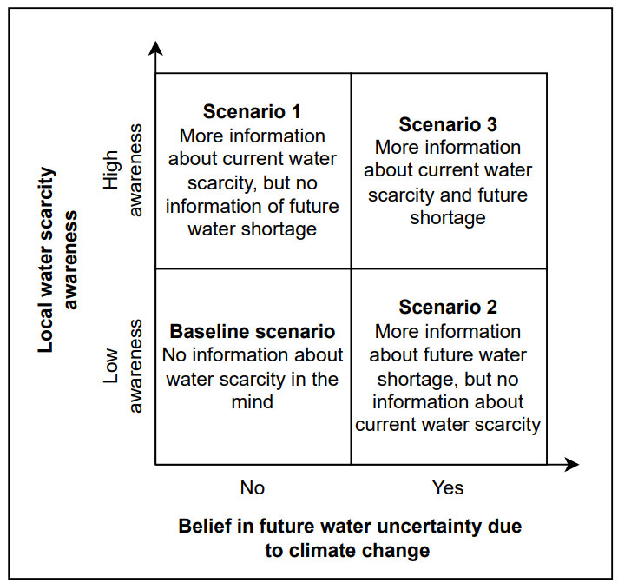
Figure 1. Four scenarios associated with water scarcity information in the mind
Based on the reasoning above, three scenarios can be associated with water scarcity information in the mind (see Figure 1). In each scenario, the residents will base their decision on different types and amounts of information to consider their perceived benefit of an action: water conservation behavior.
In the first scenario, residents do not believe in the future water uncertainty caused by climate change but are aware of water scarcity-related information (i.e., local water scarcity). Water is the fundamental factor that maintains humans’ survival, so water scarcity-related information in mind (or even the mindset) will increase the perceived benefits of water shortage solutions, including water conservation behaviors. As a result, people in the first scenario are more likely to absorb and integrate water-conservation information into the mindset, which subsequently drives their water-conservation behaviors. Therefore, we expect residents in this scenario to be more likely to conduct water conservation behaviors than those in the baseline scenario.
In the second scenario, residents are unaware of local water scarcity but believe in future water shortages induced by climate change. In such a scenario, we expect the residents are also more likely to conduct water conservation behaviors but with lesser intensity than in the first scenario because they do not experience the pressure to act immediately.
In the third scenario, residents know about local water scarcity and believe in future water shortages induced by climate change. The willingness to absorb and internalize water-conservation information in this scenario is expected to be higher than in scenario 1, as the residents do not experience the pressure to change immediately but also find no hope that the water can be replenished.
We constructed models in the following subsection to test our assumptions of these three scenarios.

2.2. Model Construction

2.2.1. Dataset Description
The dataset used in this study results from a large-scale online survey on 4,000 water-utility account holders in Albuquerque, New Mexico, USA. The survey was conducted by Distler and Scruggs (2020b) in collaboration with the Albuquerque Bernalillo County Water Utility Authority (ABCWUA), the sole supplier of water and wastewater services to the broader Albuquerque metropolitan region with over 600,000 water users. Several studies have employed this dataset to study recycled water usage willingness (Distler, 2018; Distler & Scruggs, 2020a; Distler et al., 2020).
The dataset has been peer-reviewed and published in Data in Brief:
https://www.sciencedirect.com/science/article/pii/S2352340920301839
The survey was about water knowledge, consumption habits, attitudes toward water-related issues, and demographic data. The survey was available in four versions, with the only difference being on page five: Version 1 was the control and had no additional content, whereas the other three versions each had a different collection of educational materials on page five since specific sorts of educational materials are thought to alter perceptions and views relating to water reuse. Versions 2, 3, and 4 supply information on “Water Sources and Reliable Supplies”, “Environmental Benefits of Water Reuse,” and “The Urban Water Cycle,” as defined in the codebook and survey instrument, respectively.
Prior to the survey, eight focus groups and 12 debriefing sessions were conducted with individual members of the studied population for study conception. Eight 90-minute focus groups with 7-10 individuals each help test prototype survey questions to improve the survey content. Participants had to be at least 18 years old and ABCWUA account holders to be selected as participants. Distler and Scruggs (2020b) tested the draft survey on 12 individual members of the sample population in a series of one-on-one survey debriefing sessions halfway through and after the focus group completion. Debriefings helped researchers to check that survey questions and materials were accurately evaluated and comprehended, as well as assess how long it would take to finish the survey.
A random sample of 4,000 accounts was drawn from a database of over 180,000 residential accounts maintained by ABCWUA. Customer names were removed from the sample to safeguard respondent’s privacy, and addresses were deleted once data analysis was completed. Each potential survey participant was assigned a unique random code for anonymous tracking of responses. The sample proportions in each quadrant were compared to those in the customer accounts log to confirm that the sample and population proportions matched (within 1%). The survey was collected through mail and Survey Monkey (online). The database also supplied information regarding the city quadrant where each customer resided. The sample’s quadrant proportions closely matched those in the overall customer accounts database (within a 1% margin). The survey was administered by mail due to the availability of physical addresses, although respondents were offered the option to complete it online using Survey Monkey through a mailed invitation. A preliminary test was conducted on 200 water utility customers randomly selected to validate the survey instrument. The pretest had two purposes: it estimated the expected response rate for the main survey and evaluated the efficacy of survey administration techniques. Based on the pretest’s results, the survey instrument and administration process were refined and sent to a random sample of 4,000 ABCWUA account holders. Eventually, 1831 responses were obtained, with a response rate of 46%.

2.2.2. Variable Selection and Rationale
For constructing the model, three variables were generated from the dataset, namely: SCARCITY_AWARE, CLIMATE, and WATER_CONSERVATION. SCARCITY_AWARE reflects the respondents’ awareness level of the local water scarcity issue. CLIMATE reflects the respondents’ belief in the negative impacts of climate change on water supply. SCARCITY_AWARE and CLIMATE variables were retrieved directly from the original dataset without any modification, and both variables were considered direct predictors of WATER_CONSERVATION in this study.
WATER_CONSERVATION is the outcome variable representing the number of water conservation behaviors the respondents conducted at home. The variable was generated by summing six variables, namely: 1) CONSERVE_XERI (i.e., xeriscaped land/yard), 2) CONSERVE_YARD (i.e., do not water land/yard), 3) CONSERVE_FIXTURES (i.e., use water saving fixtures, like faucets, toilets, etc.), 4) CONSERVE_APPLIANCES (i.e., use water-efficient appliances, like dishwasher, washing machine, etc.), 5) CONSERVE_RAINWATER (i.e., practice rainwater harvesting), and 6) CONSERVE_SIMPLE (i.e., use simple conservation measures, like turning off water when brushing teeth, etc.). The higher the number, the more water conservation behaviors were conducted at home.
Table 1 below explains the detailed descriptions of these three variables.
Table 1. Variable Description
Variable | Description | Data type | Value
SCARCITY_AWARE | Awareness of water scarcity issues | Numerical | 1 = Not at all aware  2 = Slightly aware  3 = Moderately aware  4 = Very aware  5 = Extremely aware
CLIMATE | Belief in the impact of climate change on the water cycle would negatively affect the water supply in the region in the next 10-40 years | Binary | 0 = No  1 = Yes
WATER_CONSERVATION | The number of water conservation behaviors that the respondent was doing at home at the time of being surveyed | Numerical | Min = 1  Max = 6

2.2.3. Analytical Model
For testing the corresponding water conservation behaviors with three scenarios associated with water scarcity information, we constructed Model 1 as follows:
$WATER_CONSERVATION \sim normal\left(μ,σ\right)$ (1.1)
$μ_{i}=β_{0}+β_{1}*{SCARCITY_AWARE}_{i}+ β_{2}*{CLIMATE}_{i}{+ β}_{3}*{SCARCITY_AWARE}_{i} {*CLIMATE}_{i}$ (1.2)
$β \sim normal(M,S)$ (1.3)
The probability around the mean $μ_{i}$ is determined by the shape of the normal distribution, where the width of the distribution is specified by the standard deviation of $σ$. 𝜇_{𝑖} indicates the level of water conservation behaviors that respondent 𝑖 conducts at home; ${SCARCITY_AWARE}_{i}$ indicates the respondent $i$’ awareness level of water scarcity issue; ${CLIMATE}_{i}$ indicates the respondent $i$’ belief in future water shortage induced by climate change. The model has an intercept of $β_{0}$, coefficients of $β_{1}$-$β_{3}$, and the standard deviation of the “noise”, 𝜎. The coefficient values are normally distributed around the mean denoted 𝑀 with the standard deviation denoted 𝑆. The logical network for Model 1 is presented in Figure 2 below.
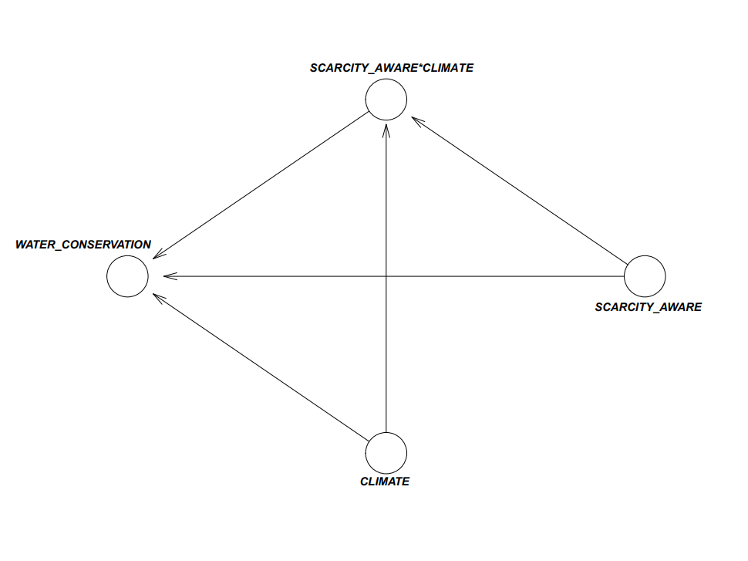
Figure 2. Analytical Model

2.3. Analysis and Validation
Bayesian Mindsponge Framework (BMF) analytics was employed in data analysis (Nguyen et al., 2022; Vuong et al., 2022). We employed BMF analytics for some reasons. First, the analytical method of BMF analytics integrates the logical reasoning capabilities of MT with the inferential advantages of Bayesian analysis, exhibiting a high degree of compatibility (Nguyen et al., 2022). Second, Bayesian inference is a statistical approach that treats all the properties (including the known and unknown ones) probabilistically (Csilléry et al., 2010; Gill, 2014), enabling reliable prediction of parsimonious models. Nevertheless, utilizing the Markov chain Monte Carlo (MCMC) technique still allows Bayesian analysis to deal effectively with various intricate models (Dunson, 2001). Third, Bayesian inference has various advantages in comparison to the frequentist approach. One notable advantage is the ability to utilize credible intervals for result interpretation instead of relying solely on the dichotomous decision based on p-values (Halsey et al., 2015; Wagenmakers et al., 2018).
In Bayesian analysis, selecting the appropriate prior is required during the model construction process. Due to the exploratory nature of this study, uninformative priors or a flat prior distribution were used to provide as little prior information as possible for model estimation (Diaconis & Ylvisaker, 1985). The Pareto-smoothed importance sampling leave-one-out (PSIS-LOO) diagnostics was employed to check the models’ goodness-of-fit (Vehtari & Gabry, 2019; Vehtari et al., 2017). LOO is computed as follows:
$$LOO=-2{LPPD}_{loo}=-2\sum_{i=1}^{n}{\log{\int{p\left(y_{i} | θ\right)p_{post\left(-i\right)}(θ)dθ}}}$$
$p_{post\left(-i\right)}(θ)$ is the posterior distribution calculated through the data minus data point 𝑖. The k-Pareto values are used in the PSIS method for computing the LOO cross-validation in the R loo package. Observations with k-Pareto values greater than 0.7 are often considered influential and problematic for accurately estimating LOO cross-validation. When a model’s k values are less than 0.5, it is typically regarded as being fit. If the model fits well with the data, we will proceed with the convergence diagnoses and result interpretation.
In the current study, we validated the convergence of Markov chains using statistical values and visual illustrations. Statistically, the effective sample size (n_eff) and the Gelman–Rubin shrink factor (Rhat) can be used to assess the convergence. The n_eff value represents the number of iterative samples that are not auto-correlated during stochastic simulation, while the Rhat value is referred to as the potential scale reduction factor (Brooks & Gelman, 1998). If n_eff is larger than 1000, it is generally considered that the Markov chains are convergent, and the effective samples are sufficient for reliable inference (McElreath, 2018). As for the Rhat value, if the value exceeds 1.1, the model does not converge. The model is considered convergent if Rhat = 1. Visually, the Markov chains’ convergence was validated using trace plots, Gelman–Rubin–Brooks plots, and autocorrelation plots.
The Bayesian analysis was performed on R using the bayesvl open-access package, which provides good visualization capabilities (La & Vuong, 2019). Considering the issues of data transparency and the cost of reproduction, all data and code snippets of this study were deposited onto an Open Science Framework (OSF) server (Vuong, 2018): https://osf.io/7b3pw/

3. Results
Before interpreting the results, it is necessary to assess Model 1’s goodness of fit with the data. As seen in Figure 3, all the estimated k-values are below the 0.5 threshold, indicating a good signal of fit between the model and the data.
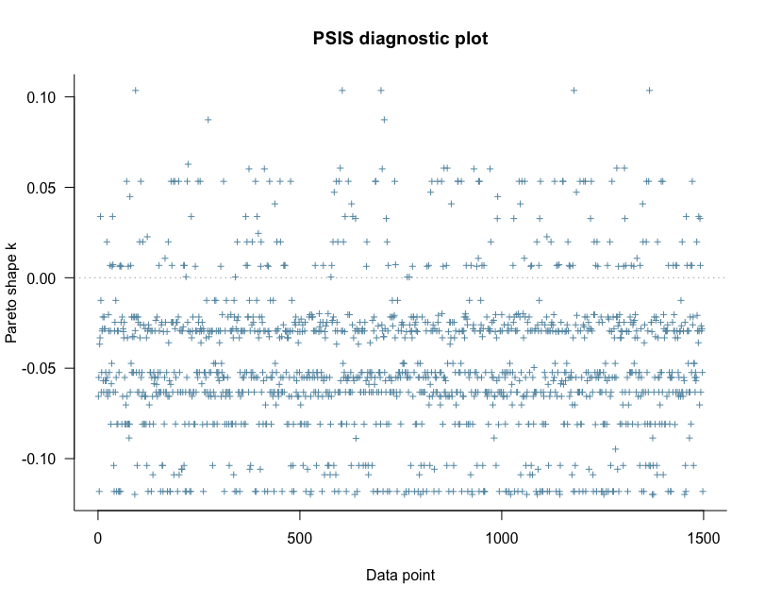
Figure 3. Model 1’s PSIS-LOO diagnosis

The statistics of Model 1’s posterior distributions are shown in Table 2. All the n_eff values are larger than 1000, and Rhat values are equal to 1, so it can be deemed that Model 1’s Markov chains are well-convergent. The convergence of Markov chains is also reflected through the trace plots in Figure 4. Specifically, all the chains’ values fluctuate around a central equilibrium after the 2000th iteration.

Table 2: Estimated results of Model 1
Parameters | Mean | SD | n_ff | Rhat
Constant | 2.00 | 0.24 | 2489 | 1
CLIMATE | -0.19 | 0.27 | 2642 | 1
SCARCITY_AWARE | 0.25 | 0.07 | 2448 | 1
SCARCITY_AWARE*CLIMATE | 0.09 | 0.08 | 2515 | 1

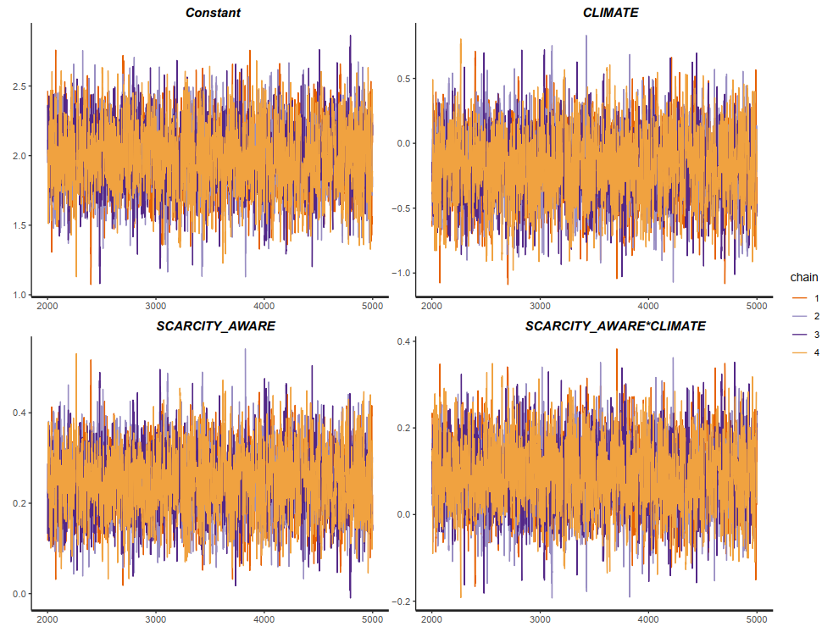
Figure 4. Model 1’s trace plots
The Gelman-Rubin-Brooks and autocorrelation plots also signify the good convergence of Markov chains. The Gelman-Rubin-Brooks plots are used to assess the ratio between the variance between Markov chains and the variance within chains. The y-axis illustrates the shrink factor (or Gelman-Rubin factor), while the x-axis demonstrates the iteration order of the simulation. In Figure 5, the shrink factors of all parameters drop rapidly to 1 before the 2000th iteration (within the warmup period). This manifestation suggests that there is no divergence among Markov chains.
The Markov property refers to the memoryless property of a stochastic process. In other words, the iteration values must not be autocorrelated with the past iteration values. The autocorrelation plots are employed to evaluate the autocorrelation levels among iteration values. The charts in Figure 6 show the average autocorrelation of each Markov chain along the y-axis and the lag of the chains along the x-axis. Visually, all the Markov chains’ autocorrelation levels decline swiftly to 0 after a few lags (before 5), suggesting that the Markov property is held and the Markov chains are well-convergent.
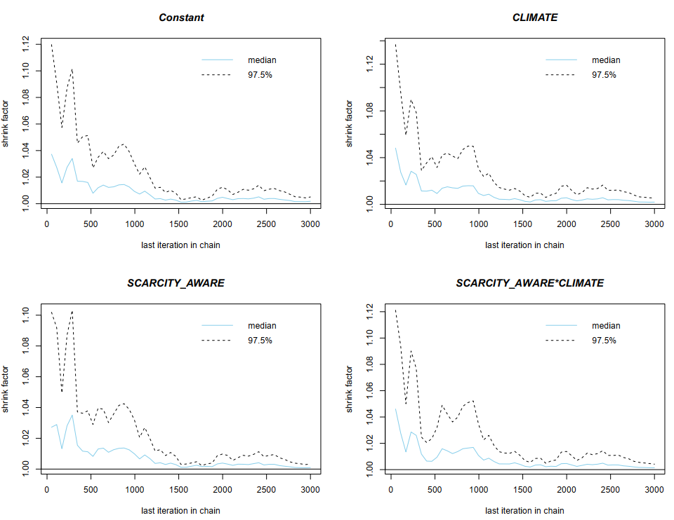
Figure 5. Model 1’s Gelman-Rubin-Brooks plots
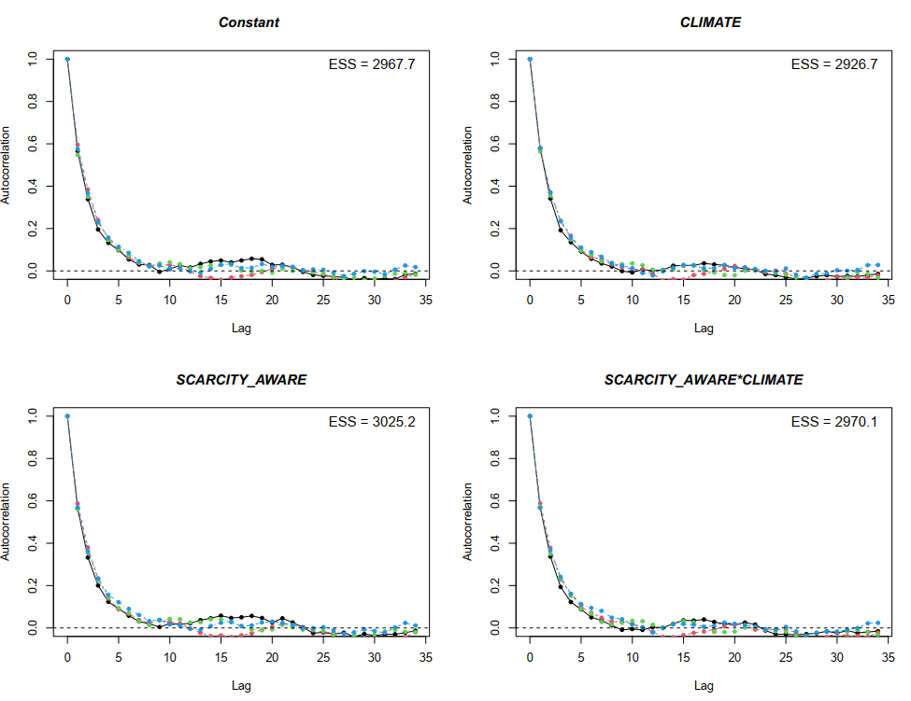
Figure 6. Model 1’s autocorrelation plots
Since all the diagnostics confirm the convergence of Markov chains, the simulated results are eligible for interpretation. The estimated results of Model 1 show that the residents’ belief in future water shortage due to climate change is negatively associated with their water conservation behaviors, but the association is weakly reliable ( $M_{CLIMATE}= -0.19$ and $S_{CLIMATE}=0.25$). Meanwhile, the awareness of local water scarcity is positively associated with water conservation behaviors and positively moderates the relationship between the belief in future water shortage due to climate change and water conservation behaviors ($M_{SCARCITY_AWARE}= 0.25$ and $S_{SCARCITY_AWARE}=0.07$; $M_{SCARCITY_AWARE*CLIMATE}= 0.09$ and $S_{SCARCITY_AWARE*CLIMATE}=0.08$). The posterior distribution of $SCARCITY_AWARE$ lies entirely on the positive side of the x-axis, suggesting the high reliability of its association with water conservation level. A large proportion of $SCARCITY_AWARE*CLIMATE$ lies on the positive side. However, some of its distribution is still located on the negative side, so the association can only be deemed moderately reliable (see Figure 7).
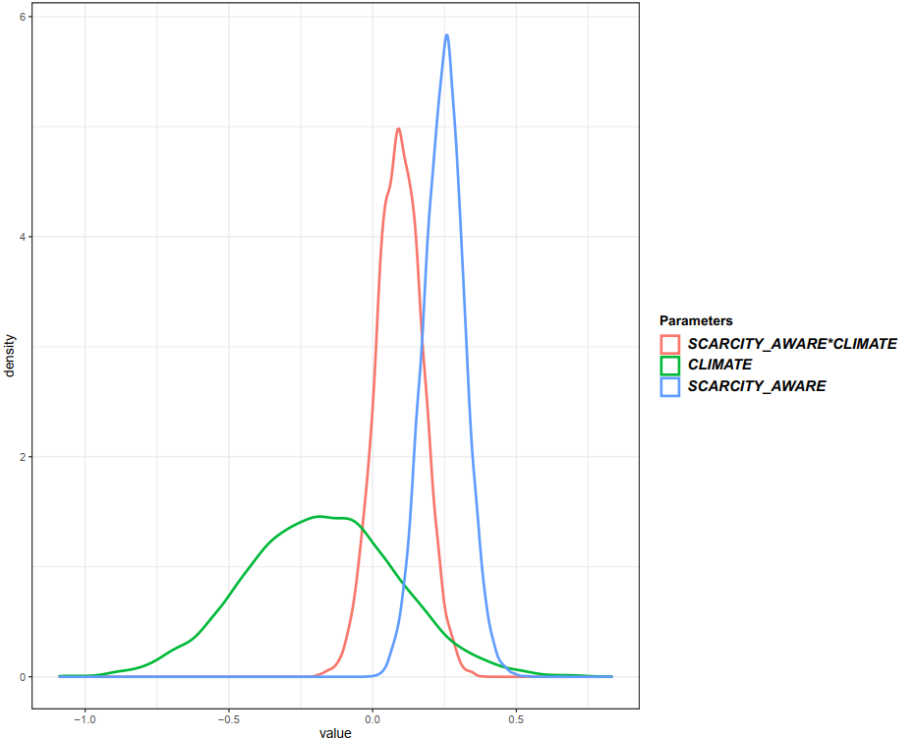
Figure 7. Model 1’s posterior distributions
To better interpret Model 1, the mean values of the coefficients were employed to calculate the residents’ water conservation behavior level. The mean values were chosen because they are the values that have the highest possibility to occur. The calculated probability is shown in Figure 8. As can be seen, people with a higher awareness of local water scarcity tend to have higher levels of water conservation behaviors. On the contrary, the effect of belief in future water shortage due to climate change on water conservation behavior is conditional on the residents’ awareness level. Specifically, for residents with no or low awareness (i.e., slightly aware of the issue) of the water scarcity issues, the belief in future water shortage due to climate change does not affect or slightly reduce the number of water conservation behaviors conducted at home. Nevertheless, residents with high awareness (i.e., moderately, very, or extremely aware of the issue) tend to conduct more water conservation behaviors at home when they believe climate change will negatively affect the water supply in the future.

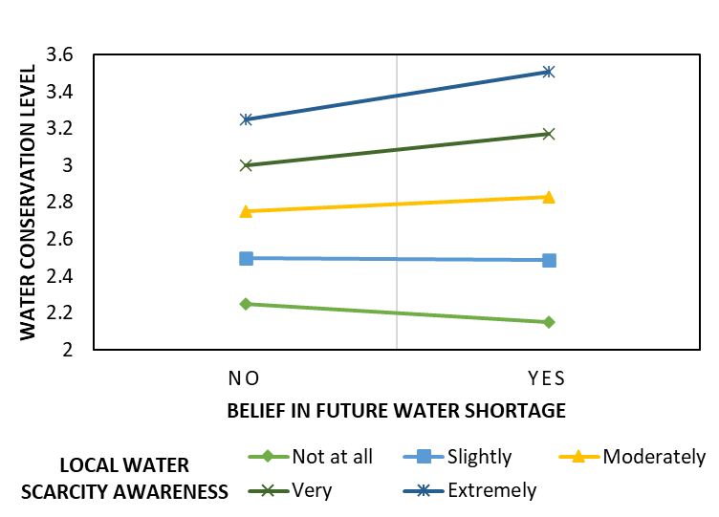
Figure 8. Estimated probability of conducting water conservation behavior

4. Discussion
Using Bayesian Mindsponge Framework (BMF) analytics, this study investigates the interplay between belief in the impact of climate change, awareness of water scarcity, and sustainable water conservation practices. The analysis explores the relationship between residents' awareness of water scarcity and their conservation behaviors in response to perceived climate change impacts on water supply. This emphasizes the necessity of appropriate interventions considering both psychological and contextual dimensions.
Firstly, residents categorized as moderately, very, or extremely aware of water scarcity exhibit a preference for heightened water conservation behaviors at home, especially when they believe in the negative impact of climate change on water supply. This result confirms our assumption of the third scenario, aligns with previous studies and contributes to the growing literature recognizing awareness as a critical factor in fostering positive environmental actions. For example, Wolters and Steel (2021) highlight that increased awareness motivates individuals to adopt water conservation practices in reaction to belief in the impacts of climate change. Building on this, the studies conducted by Fenitra et al. (2022) and Wang et al. (2023) shed light on how increased awareness not only drives water conservation but also contributes to broader ecological sustainability efforts. This acknowledgment highlights the interconnected nature of individual actions and their collective impact on the environment. It aligns with the principles of positive psychology and environmental sustainability integrated into comprehending individual behaviors (Ronen & Kerret, 2020).
Secondly, our findings reveal that among residents with minimal to no awareness of water scarcity issues, the perceived impact of climate change on water supply does not significantly influence, and it may even slightly decrease the number of water conservation behaviors they engage in at home. This indicates that the link between individuals’ belief in the negative impact of climate change and their involvement in water conservation behaviors is conditional on their awareness of local water challenges. The result also contradicts our second scenario assumed above. Such contradiction might be explained by the tragedy of the common (Cashore & Bernstein, 2022; Corral-Verdugo et al., 2002; Feeny et al., 1990). When people are not aware of the occurring water scarcity in the region but can foresee the future water shortage induced by climate change, they might tend to maximize their perceived benefits by using as much water as their comfort or priorities before they cannot do so anymore due to the foreseeable water shortage. This explanation is worth further study for validation and elaboration.
This finding goes beyond the conventional understanding that increased awareness leads to increased conservation efforts (Wolters & Steel, 2021). Instead, it identifies specific conditions under which awareness plays a significant role in shaping individual behaviors, together with the belief in water shortage induced by climate change. The moderating role of water scarcity awareness in this study adds complexity to the relationship, indicating that the correlation between climate change beliefs and water conservation behaviors depends on residents' awareness of local water challenges. This highlights the complexity of dynamics shaping individual responses to environmental challenges.
Moreover, the study sheds light on the concept of psychological distance – how individuals perceive the proximity of climate change impacts on their daily lives. This understanding of psychological distance proves essential in obtaining interventions to make environmental challenges more relevant and pressing, thereby fostering behavioral change (Maiella et al., 2020). The study suggests that individuals may be more motivated to engage in water conservation when they perceive a closer connection between climate change and local water challenges. Understanding this perception becomes important in obtaining a comprehensive understanding and underscores the significance of acknowledging the link between individual psychology, cognition, and context in crafting effective interventions. Additionally, studies by Kousar et al. (2022) and Si et al. (2022) consistently highlight the role of awareness in shaping environmentally responsible behaviors, emphasizing the need to consider psychological and contextual aspects in sustainable environmental strategies.
In synthesis, our findings highlight the interplay between psychological factors and contextual awareness in understanding and promoting environmentally conscious actions. This intricate interaction forms a personalized lens through which individuals interpret and act upon environmental challenges. Consequently, it emphasizes the necessity of considering both psychological aspects and contextual awareness. In light of these insights, the study's results highlight the crucial need for a comprehensive and context-specific approach to promoting sustainable water management practices, recognizing the diverse influences shaping individual responses to the complex landscape of climate change and water conservation.

5. Policy implications
The research contributes to a broader understanding of individual responses to environmental challenges. It emphasizes the necessity of considering both psychological aspects and contextual awareness, promoting an appropriate approach to environmental stewardship. This understanding forms the basis for a comprehensive set of policy recommendations designed to acknowledge and actively address the factors that shape individuals' environmental attitudes and behaviors, facilitating well-informed and precisely targeted interventions in sustainable water management practices.
Based on these insights, policymakers can develop more informed and targeted policies to address water conservation by integrating awareness and climate change beliefs as crucial factors. This, in turn, contributes to the broader goal of achieving sustainable development. Recommendations include targeted awareness campaigns addressing both climate change and water conservation that prioritize educational efforts for positive behavioral changes (Addo et al., 2019; Q.-H. Vuong, 2020; Vuong & Nguyen, 2023). Collaborative initiatives with local communities, policymakers, and water management authorities are important for designing effective awareness strategies (Jackson et al., 2019).
Furthermore, integrating sustainability principles in managing water security and scarcity is crucial, emphasizing economic, social, and environmental dimensions in managing water security and scarcity. Incorporating sustainability principles into water management initiatives is crucial for addressing environmental challenges. This involves aligning initiatives with the Sustainable Development Goals (SDGs) to ensure a comprehensive and integrated approach. Additionally, integrating smart solutions into these initiatives enhances their effectiveness in addressing environmental tradeoffs (Mariani et al., 2022; Mensah, 2019). Smart solutions may include advanced technologies, data-driven decision-making, and innovative approaches that optimize resource use and minimize negative environmental impacts. By adopting such measures, water management practices can contribute to environmental sustainability and broader economic and social goals outlined in the SDGs.
Lastly, we recommend promoting the development of an eco-surplus mindset, which advocates for an environmental conservation approach extending beyond mere responses to climate change (Nguyen & Jones, 2022; Vuong, 2021). This concept encourages residents to cultivate eco-surplus practices actively, emphasizing that awareness plays a pivotal role in understanding contextual factors. The practical implications of our study underscore the essential role of targeted awareness campaigns in sustainable water management, fostering an eco-conscious culture. This integrated approach ensures that initiatives to nurture an eco-surplus mindset are grounded in a profound understanding of local contexts and the psychological factors shaping conservation behaviors. This, in turn, contributes to the overall effectiveness of conservation efforts by encouraging residents to exceed the minimum requirements for eco-friendly practices.
When investigating the intricate relationship between climate change and water supply in Albuquerque, it is crucial to acknowledge several research limitations (Q. H. Vuong, 2020). The study’s local specificity, rooted in Albuquerque's unique climate, geography, and socioeconomic context, may limit the generalizability of findings to other regions. Additionally, assessing the effectiveness of adaptation measures and evaluating the success or failure of implemented strategies may prove complex. Temporal considerations must be taken into account, acknowledging the dynamic nature of climate change impacts over time. Furthermore, understanding and predicting individual and community behaviors related to water conservation may be limited in capturing the complete range of psychological and cultural factors.
Acknowledging these limitations is crucial for researchers to interpret findings cautiously, and policymakers should consider the contextual boundaries of the research when applying recommendations to address climate change and water scarcity in Albuquerque or similar regions. For future research, exploring socioeconomic and cultural aspects is important to better understand the complex relationship between climate change beliefs and water conservation behaviors. Building on insights from existing studies can provide a solid foundation for these investigations, and exploring the role of cultural and economic factors in diverse regions may reveal previously unexplored influences.

References
Abbass, K., Qasim, M. Z., Song, H., Murshed, M., Mahmood, H., & Younis, I. (2022). A review of the global climate change impacts, adaptation, and sustainable mitigation measures. Environmental Science and Pollution Research, 29(28), 42539-42559.
Addo, I. B., Thoms, M. C., & Parsons, M. (2018). Barriers and drivers of household water-conservation behavior: A profiling approach. Water, 10(12), 1794.
Addo, I. B., Thoms, M. C., & Parsons, M. (2019). The influence of water-conservation messages on reducing household water use. Applied Water Science, 9, 1-13.
Brooks, S. P., & Gelman, A. (1998). General methods for monitoring convergence of iterative simulations. Journal of computational and graphical statistics, 7(4), 434-455.
Callejas Moncaleano, D. C., Pande, S., & Rietveld, L. (2021). Water use efficiency: a review of contextual and behavioral factors. Frontiers in Water, 3, 685650.
Callison, C., & Holland, D. (2017). Impact of political identity and past crisis experience on water attitudes. Journal of Contemporary Water Research & Education, 161(1), 19-32.
Cashore, B., & Bernstein, S. (2022). Bringing the environment back in: Overcoming the tragedy of the diffusion of the commons metaphor. Perspectives on Politics, 21(2), 478-501. https://doi.org/10.1017/S1537592721002553
Corral-Verdugo, V., Frias-Armenta, M., Pérez-Urias, F., Orduña-Cabrera, V., & Espinoza-Gallego, N. (2002). Residential water consumption, motivation for conserving water and the continuing tragedy of the commons. Environmental Management, 30, 527-535. https://doi.org/10.1007/s00267-002-2599-5
Csilléry, K., Blum, M. G., Gaggiotti, O. E., & François, O. (2010). Approximate Bayesian computation (ABC) in practice. Trends in Ecology and Evolution, 25(7), 410-418. https://doi.org/10.1016/j.tree.2010.04.001
Dean, A. J., Kneebone, S., Tull, F., Lauren, N., & Smith, L. D. (2021). ‘Stickiness’ of water-saving behaviours: What factors influence whether behaviours are maintained or given up? Resources, Conservation and Recycling, 169, 105531.
Diaconis, P., & Ylvisaker, D. (1985). Quantifying prior opinion. In J. M. Bernardo, M. H. DeGroot, D. V. Lindley, & A. F. M. Smith (Eds.), Bayesian Statistics (Vol. 2, pp. 133-156). North Holland Press.
Dilling, L., Daly, M. E., Travis, W. R., Ray, A. J., & Wilhelmi, O. V. (2023). The role of adaptive capacity in incremental and transformative adaptation in three large US Urban water systems. Global environmental change, 79, 102649.
Distler, L. N. (2018). Potable water reuse in Albuquerque, NM: A large scale community survey to understand public perceptions and the impact of educational materials on acceptance The University of New Mexico]. https://digitalrepository.unm.edu/cgi/viewcontent.cgi?article=1050&context=arch_etds
Distler, L. N., & Scruggs, C. E. (2020a). Arid inland community survey on water knowledge, trust, and potable reuse. I: Description of findings. Journal of Water Resources Planning and Management, 146(7), 04020045. https://doi.org/10.1061/(ASCE)WR.1943-5452.0001218
Distler, L. N., & Scruggs, C. E. (2020b). Survey data on perceptions of water scarcity and potable reuse from water utility customers in Albuquerque, New Mexico. Data in brief, 29, 105289. https://doi.org/10.1016/j.dib.2020.105289
Distler, L. N., Scruggs, C. E., & Rumsey, K. N. (2020). Arid inland community survey on water knowledge, trust, and potable reuse. II: Predictive modeling. Journal of Water Resources Planning and Management, 146(7), 04020046. https://doi.org/10.1061/(ASCE)WR.1943-5452.0001219
Dolan, F., Lamontagne, J., Link, R., Hejazi, M., Reed, P., & Edmonds, J. (2021). Evaluating the economic impact of water scarcity in a changing world. Nature communications, 12(1), 1915.
Dolnicar, S., & Hurlimann, A. (2010). Australians’ water conservation behaviours and attitudes. Australasian Journal of Water Resources, 14(1), 43-53.
Dunson, D. B. (2001). Commentary: practical advantages of Bayesian analysis of epidemiologic data. American Journal of Epidemiology, 153(12), 1222-1226. https://doi.org/10.1093/aje/153.12.1222
Ebi, K. L., Vanos, J., Baldwin, J. W., Bell, J. E., Hondula, D. M., Errett, N. A., . . . Spector, J. (2021). Extreme weather and climate change: population health and health system implications. Annual review of public health, 42(1), 293-315.
Feeny, D., Berkes, F., McCay, B. J., & Acheson, J. M. (1990). The tragedy of the commons: twenty-two years later. Human Ecology, 18(1), 1-19. https://doi.org/10.1007/BF00889070
Fenitra, R. M., Premananto, G. C., Sedera, R. M. H., Abbas, A., & Laila, N. (2022). Environmentally responsible behavior and Knowledge-Belief-Norm in the tourism context: The moderating role of types of destinations. International Journal of Geoheritage and Parks, 10(2), 273-288.
Fielding, K. S., Russell, S., Spinks, A., & Mankad, A. (2012). Determinants of household water conservation: The role of demographic, infrastructure, behavior, and psychosocial variables. Water Resources Research, 48(10).
Gill, J. (2014). Bayesian methods: A social and behavioral sciences approach (Vol. 20). CRC press.
Halsey, L. G., Curran-Everett, D., Vowler, S. L., & Drummond, G. B. (2015). The fickle P value generates irreproducible results. Nature Methods, 12, 179-185. https://doi.org/10.1038/nmeth.3288
Hannibal, B., Sansom, L., & E. Portney, K. (2019). The effect of local water scarcity and drought on water conservation behaviors. Environmental Sociology, 5(3), 294-307. https://doi.org/10.1080/23251042.2018.1519882
Hargrove, W. L., & Heyman, J. M. (2020). A comprehensive process for stakeholder identification and engagement in addressing wicked water resources problems. Land, 9(4), 119.
Howard, G., Calow, R., Macdonald, A., & Bartram, J. (2016). Climate change and water and sanitation: likely impacts and emerging trends for action. Annual review of environment and resources, 41, 253-276.
Hurd, B. H., & Coonrod, J. (2008). Climate change and its implications for New Mexico's water resources and economic opportunities.
IPCC. (2022). Chapter 4: Water.
Jackson, M., Stewart, R. A., & Beal, C. D. (2019). Identifying and overcoming barriers to collaborative sustainable water governance in remote Australian indigenous communities. Water, 11(11), 2410.
Khedun, C. P., & Singh, V. P. (2014). Climate change, water, and health: a review of regional challenges. Water Quality, Exposure and Health, 6, 7-17.
Kousar, S., Afzal, M., Ahmed, F., & Bojnec, Š. (2022). Environmental awareness and air quality: The mediating role of environmental protective behaviors. Sustainability, 14(6), 3138.
La, V.-P., & Vuong, Q.-H. (2019). bayesvl: Visually learning the graphical structure of Bayesian networks and performing MCMC with'Stan'. The Comprehensive R Archive Network (CRAN). https://cran.r-project.org/web/packages/bayesvl/index.html
Le, T., Nguyen, M., & Vuong, Q. (2022). Chapter 4: Trust in mindsponge: A new perspective on information reliability. Q.-H. Vuong, V.-P. La, & Mi.-H. Nguyen, The mindsponge and BMF analytics for innovative thinking in social sciences and humanities, 67-86.
Maiella, R., La Malva, P., Marchetti, D., Pomarico, E., Di Crosta, A., Palumbo, R., . . . Verrocchio, M. C. (2020). The psychological distance and climate change: A systematic review on the mitigation and adaptation behaviors. Frontiers in Psychology, 11, 568899.
Mantello, P., Ho, M.-T., Nguyen, M.-H., & Vuong, Q.-H. (2023). Machines that feel: behavioral determinants of attitude towards affect recognition technology—upgrading technology acceptance theory with the mindsponge model. Humanities and Social Sciences Communications, 10, 430. https://doi.org/10.1057/s41599-023-01837-1
Mariani, L., Trivellato, B., Martini, M., & Marafioti, E. (2022). Achieving sustainable development goals through collaborative innovation: Evidence from four European initiatives. Journal of Business Ethics, 180(4), 1075-1095.
McElreath, R. (2018). Statistical rethinking: A Bayesian course with examples in R and Stan. Chapman and Hall/CRC Press.
Mensah, J. (2019). Sustainable development: Meaning, history, principles, pillars, and implications for human action: Literature review. Cogent social sciences, 5(1), 1653531.
Mishra, B. K., Kumar, P., Saraswat, C., Chakraborty, S., & Gautam, A. (2021). Water security in a changing environment: Concept, challenges and solutions. Water, 13(4), 490.
Morante-Carballo, F., Montalván-Burbano, N., Quiñonez-Barzola, X., Jaya-Montalvo, M., & Carrión-Mero, P. (2022). What do we know about water scarcity in semi-arid zones? A global analysis and research trends. Water, 14(17), 2685.
Nguyen, M.-H., Duong, M.-P. T., Nguyen, M.-C., Mutai, N., Jin, R., Nguyen, P.-T., . . . Vuong, Q.-H. (2023). Promoting stakeholders’ support for marine protection policies: Insights from a 42-country dataset. Sustainability, 15(16), 12226. https://doi.org/10.3390/su151612226
Nguyen, M.-H., & Jones, T. E. (2022). Building eco-surplus culture among urban residents as a novel strategy to improve finance for conservation in protected areas. Humanities & Social Sciences Communications, 9, 426. https://doi.org/10.1057/s41599-022-01441-9
Nguyen, M.-H., La, V.-P., Le, T.-T., & Vuong, Q.-H. (2022). Introduction to Bayesian Mindsponge Framework analytics: an innovative method for social and psychological research. MethodsX, 9, 101808. https://doi.org/10.1016/j.mex.2022.101808
Ronen, T., & Kerret, D. (2020). Promoting sustainable wellbeing: Integrating positive psychology and environmental sustainability in education. International journal of environmental research and public health, 17(19), 6968.
Sanchez, C., Rodriguez-Sanchez, C., & Sancho-Esper, F. (2023). Barriers and Motivators of Household Water-Conservation Behavior: A Bibliometric and Systematic Literature Review. Water, 15(23), 4114.
Shahangian, S. A., Tabesh, M., Yazdanpanah, M., Zobeidi, T., & Raoof, M. A. (2022). Promoting the adoption of residential water conservation behaviors as a preventive policy to sustainable urban water management. Journal of Environmental Management, 313, 115005.
Si, W., Jiang, C., & Meng, L. (2022). The Relationship between Environmental Awareness, Habitat Quality, and Community Residents’ Pro-Environmental Behavior—Mediated Effects Model Analysis Based on Social Capital. International journal of environmental research and public health, 19(20), 13253.
Singha, B., Eljamal, O., Karmaker, S. C., Maamoun, I., & Sugihara, Y. (2022). Water conservation behavior: Exploring the role of social, psychological, and behavioral determinants. Journal of Environmental Management, 317, 115484.
Stringer, L. C., Mirzabaev, A., Benjaminsen, T. A., Harris, R. M., Jafari, M., Lissner, T. K., . . . Tirado-von Der Pahlen, C. (2021). Climate change impacts on water security in global drylands. One Earth, 4(6), 851-864.
Torres-Bagur, M., Ribas, A., & Vila-Subirós, J. (2020). Understanding the key factors that influence efficient water-saving practices among tourists: A Mediterranean case study. Water, 12(8), 2083.
Tsakiris, G., & Loucks, D. (2023). Adaptive Water Resources Management Under Climate Change: An Introduction. Water Resources Management, 1-13.
Vaughn, L. (2019). Psychology and culture: Thinking, feeling and behaving in a global context. Routledge.
Vehtari, A., & Gabry, J. (2019). Bayesian Stacking and Pseudo-BMA weights using the loo package. In (Version loo 2.2.0) https://mc-stan.org/loo/articles/loo2-weights.html
Vehtari, A., Gelman, A., & Gabry, J. (2017). Practical Bayesian model evaluation using leave-one-out cross-validation and WAIC. Statistics and Computing, 27(5), 1413-1432. https://doi.org/10.1007/s11222-016-9696-4
Vuong, Q.-H. (2018). The (ir)rational consideration of the cost of science in transition economies. Nature Human Behaviour, 2, 5. https://doi.org/10.1038/s41562-017-0281-4
Vuong, Q.-H. (2020). From children’s literature to sustainability science, and young scientists for a more sustainable Earth. Journal of Sustainability Education, 24(3), 1-12. http://www.susted.com/wordpress/content/from-childrens-literature-to-sustainability-science-and-young-scientists-for-a-more-sustainable-earth_2020_12/
Vuong, Q.-H. (2021). The semiconducting principle of monetary and environmental values exchange. Economics and Business Letters, 10(3), 284-290. https://doi.org/10.17811/ebl.10.3.2021.284-290
Vuong, Q.-H. (2022). The kingfisher story collection. https://www.amazon.com/dp/B0BG2NNHY6
Vuong, Q.-H. (2023). Mindsponge Theory. De Gruyter. https://books.google.com/books?id=OSiGEAAAQBAJ
Vuong, Q.-H., & Nguyen, M.-H. (2023). Kingfisher: Contemplating the connection between nature and humans through science, art, literature, and lived experiences. Pacific Conservation Biology. https://doi.org/10.1071/PC23044
Vuong, Q.-H., Nguyen, M.-H., & La, V.-P. (2022). The mindsponge and BMF analytics for innovative thinking in social sciences and humanities. De Gruyter. https://books.google.com/books?id=EGeEEAAAQBAJ
Vuong, Q. H. (2020). The limitations of retraction notices and the heroic acts of authors who correct the scholarly record: An analysis of retractions of papers published from 1975 to 2019. Learned Publishing, 33(2), 119-130. https://doi.org/10.1002/leap.1282
Vuong, Q. H., & Napier, N. K. (2015). Acculturation and global mindsponge: An emerging market perspective. International Journal of Intercultural Relations, 49, 354-367. https://doi.org/10.1016/j.ijintrel.2015.06.003
Wagenmakers, E.-J., Marsman, M., Jamil, T., Ly, A., Verhagen, J., Love, J., . . . Epskamp, S. (2018). Bayesian inference for psychology. Part I: Theoretical advantages and practical ramifications. Psychonomic Bulletin Review, 25(1), 35-57. https://doi.org/10.3758/s13423-017-1343-3
Wang, Z., Nie, L., Jeronen, E., Xu, L., & Chen, M. (2023). Understanding the environmentally sustainable behavior of Chinese university students as tourists: an integrative framework. International journal of environmental research and public health, 20(4), 3317.
Weiskopf, S. R., Rubenstein, M. A., Crozier, L. G., Gaichas, S., Griffis, R., Halofsky, J. E., . . . Muñoz, R. C. (2020). Climate change effects on biodiversity, ecosystems, ecosystem services, and natural resource management in the United States. Science of the Total Environment, 733, 137782.
Wolters, E. A., & Steel, B. S. (2021). Environmental efficacy, climate change beliefs, ideology, and public water policy preferences. International journal of environmental research and public health, 18(13), 7000.

