Linking Aceidemice learning to praciste

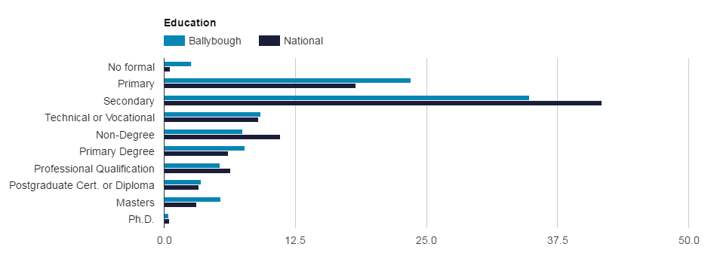

Looking from the employment and education statisticsfrom above . you can get a sence when you look at the statisices that the area are low in achieving vocation prospects. for relating my practise with theroy i will compared two scondary schools in the Area of ballybough . futhermore camparing the grades and the profomace of students in these two schools. The theroy I will link to my practise and what I expecienced in my placement will be grasic theroy on hegomony.

Hegemony means the ideas and the norms that one class ueses to dominate or proform better than the other classes in society . This makes them the shining example to rún the institutions of civil society . This is then accepted by society as a norm where these dominent attittudes are internalised and accepted as common sense and there by it creats limittaions in the minds of the people. While we think it is us who are making the rules for our own lives they really being influenced by the most high and powerful in society. Their agenda and thinking becomes our agenda because it is persumed to be the best way of thinking. The control of society is not achived through force but through persuading people that the views and the ideas of the most powerful in society are the most reasonable and sensible . Coercion is practised through the the political process, the media and many of the instutions therein. (ITB Leacture Notes)

For the first example i will look at two schools in the area and question why these two schools have such varying outcomes in terms of the result the students acheiv . One school in the area called Ó Connells. This school targets designated areas which have high unempolyment rates and many soical issuses. The people in the area are not policialy active, this results in these areas being having less of a voice. Below are some statisices on young people in the Ballybough area:

Ó'Connells school completin the leaving cert and junior 2015
junior certificate numbers : 60.
leaving certificate numbers :86

Holy-faith-secondary-school 2015

Total sitting Leaving Cert 2015: 103.

St Declans collage

Total sitting Leaving Cert 2014: 106.

Why are these two groups of young people in the same locallity reciving the same education and one gruop is over proforming and the other are not.

Unemplyment rates
Having low educational attainment is more likely to lead to unemployment. Children that go to better schools have more of a chance of serviving and getting jobs because they have a good education behinde them and they also have connections they are also more likely to attend collage and gain the skills needed in modern ireland.

(The state will support the ruling class and pass laws to reinforce their economic power and control.) (ITB Leacture notes). In terms of education Borudieu (1986) examined the ways in which , culture is passed ón through the family and the schools and argued that priviled children came into the education already prepared to be more succseful. : whilst to the working kid educational area appares as an alien enviroment often leading to what bourdieu terms self exclution ( cited Ball, 2010,p.52)

During the celtic tiger years there was a dramatic shift in educational trends . the construction industry was booming and there was a great demand for labours . These jobs did not acquier much education in terms of emplyment this accomdated areas in the inner city like Ballybough.for many young people living in ballybough this was a chance of getting training , full time job which would give security for a number of years . in 2006 there was only 5% of ealry school leavers were unemployed. For people living in this area , droping out of school and gaining employment seemed to be the trend.(www.youth.ie)

in ballybough a lot of the working class in paticular . The flat complexes whould have engaged in more manual type jobs when recession came they would have had less opportunities for work in pariclar as the nature of work in ireland has changed to a more services sector i.e. Banking and insurance ireland is now a hub , in additon ireland also ecels in areas of advanced technology and highly skilled workes with the growth of compaines the shared knowledge within these communites translates into a network of guidance and support in terms of the best schools that provide the best educational outcomes. Middle class children are therfore , furnished with the best resoruces to enable them to compete in labour markets and maintain their advantage positions.

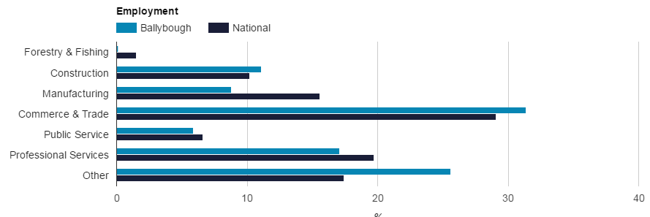

Early school leavers and anti-soical behaviour

when you look at the anti-soical behaviour within areas that are deprived or non- affulent. You see that there is a underlineing idealogy of the need to survive.because the cycle of poverty brings its own belife systems and mental states. the people are left with nó resouces that are common to civil society. People are focued to make decistions that will not benifit them , but it whats expected of them and its what is commonly know. People living in deprived areas are more likley to breck the law to end the circle of poverty.
The inner in which I have undertaken my work placement city has the biggest scale and most intense levels of concentrated destitution and poverty in Ireland. The financial development and investment in urban renewal that has happened in city centre over the previous two decade has exacerbated the divisions between the poor and rich. The dangers of early school leaving have been highlighted in a number of studies. Research has indicated a strong correlation between early school leaving as a contributing factor in unemployment, drug misuse and anti-social behaviour (National Drugs strategy 2001 - 2008; Morgan 2001; Downes 2003).
From my experience and the research that was carried out People from these areas are educational disadvantaged when you look at the IFSC they offer jobs that acquire high education levels therefore community with high rates of ESL are automatically marginalised.

The impact of early school leaving can be very disruptive to a young person's development. it can have a detrimental effect on their socio-economic standing in the future.(Youth.ie)
As when a young person leaves school early, they are not only missing out on literacy skills and educational attainment that would be required to function in the labour market. This impacts seems to filer down into social and Personal aspect of young people.
Leaving school early may prevent the development of specific skills that will allow a person to 'Function within certain environments'.(www.Youth.ie). For instance for most jobs in modern society a basic education is a pre requisite to any form of employment , even the most basic jobs today require a minimum of junior cert certificate. In terms of further education or developing ones skills there are no options when your uneducated. It stands to reason therefore that many young people who can not compete remain unemployed and marginalised. This leads to falling into situations which may lead to their participation in anti-social as evidenced by (Johnson W) Expression of both genetic and non shared environmental vulnerabilities unique to antisocial behaviour was greater among those with low GPA than among those with higher GPA.

