The Observer
A Rigorous Description of the Universe Where Subjective Observership Plays a Causal Role in Generating Objective Reality
Charlie Dawson

The hard problem of consciousness is generally approached from the distinct avenues of materialism, dualism or monism. We will examine the structure that is at the core of all matter that exists in the universe. This dynamic, mathematical description of the specific type of field oscillation that generates all particles that have any tactile substance to them amazingly seems to be a physical manifestation of the most fundamental aspects of the experience of being a conscious agent. By adopting this novel description of consciousness where there is a quantum of potential for consciousness intrinsic to all matter particles, the distinctions between materialism, dualism and monism become an arbitrary matter of how this mechanism is described rather than distinct ideologies, competing against one another in a winner-take-all race to the bottom of consciousness.
- Introduction
We begin by reexamining what we hope to answer if we were to solve the hard problem. The problem has been stated, ‘Why is it that there is something that it is like to be me?’ Taken literally the question is easy to answer. There is something that it is like to be me because I have a conscious experience. We then ask, ‘What is a conscious experience?’ A conscious experience is the action of consciousness. Based on evidence available through subjective observation of our own conscious experience it would seem that being, or being an experience, is the only action that consciousness can take. This leads us to ask the question that we are really seeking an answer for when we consider the hard problem. ‘What is consciousness?’
We are immediately aware of one instantiation of consciousness: our own, unique consciousness. When we ask, ‘What is consciousness?’ we answer by pointing to ourselves. Really, what we are pointing to is not consciousness, generally. Rather, what we are pointing to is a consciousness. Herein lies the meta problem of consciousness: we only have our own conscious experience which we can study to learn about consciousness.
I am my conscious experience, but that doesn’t mean that my experience is synonymous with consciousness. My conscious experience is consciousness performing the act of being the experience that I think of as myself, from my unique perspective. My experience is an instantiation of consciousness, but it is not consciousness, generally.
So, the question remains, ‘What is consciousness?’ Being that we can only answer this question by pointing to our own manifestation of consciousness, we should reconsider what questions could have answers that would be the most beneficial in narrowing the scope of what the ontological nature of consciousness might possibly be.
Asking what consciousness is while only being able to observe our own consciousness is like playing ‘Guess Who?’ by only looking at the card that you’ve drawn and asking questions about the traits of the character on that card. ‘My person is Alfred. Does your person have facial hair that is exactly the same as Alfred’s? Does your person have glasses that are exactly like Alfred’s? Is your person wearing a hat that is exactly like Alfred’s?’ This can only give us a very limited amount of information about the other person’s card, unless the other person’s card is also Alfred.
In practice, this is exactly what we do, and it works to an extent because the questions that we ask about consciousness, while only looking at our own consciousness, that get answered by somebody else looking at their own consciousness, are from agents that are looking at very similar instances of consciousness. ‘Does your consciousness have cognition? Does your consciousness have intelligence? Is your relationship with space primarily generated by your visual experience? Is your consciousness self-reflective?’ We can ask ‘What’s it like to be you?’ but anybody who replies is also looking at a ‘Guess Who?: Consciousness Edition’ card for ‘Human Consciousness.’ There must be something that is like to be a bat, but if you ask a bat ‘What is it like to be you?’ you aren’t likely to get a response.
We can start partitioning off the possibility of what consciousness might be by asking questions that are tangential to the question, ‘What is consciousness?’ We should ask: ‘What is the role of consciousness in the universe?’ ‘Why is consciousness included in the universe?’ ‘What aspects of my observable consciousness are fundamental to anything else that might rightly be called “consciousness” and what characteristics of my own consciousness might be unique to this instance of consciousness or ones like it?’
Whether we are asking outright ‘What is consciousness?’ or asking questions to zero in on the nature of consciousness, our goal is the same; we are seeking solutions to the hard problem of consciousness. Being that we have reconsidered what questions to ask, we should also reconsider what sorts of answers we might expect.
The hard problem has been partitioned into specific problems for each broad category of consciousness theory: materialism, dualism and monism/panpsychism/idealism. The materialist is tasked with explaining how phenomenal conscious experience emerges from inanimate components. The dualist is tasked with closing the causal loop to explain how the immaterial mind can affect the material universe. The panpsychist is tasked with solving the combination problem, explaining how fundamental consciousness combines to give rise to conscious experience like our own.
I suggest that approaching the hard problem from the assumptions of a category of consciousness, with all the assumptions and biases of that category in tow, at least this early in the game, is a mistake, and that the answer to any specific hard problem should be debated after a generalized mechanism has been proposed. Then the specific hard problem can be debated with the assumption that the mechanism being proposed is the definitive mechanism responsible for conscious experience.
This proposition probably warrants an entire paper on its own. For the sake of brevity, we can look to a real-world example, as we can see this being done with IIT. The founders of the theory and many neuroscientists that accept it as a plausible solution to the hard problem do so through the lens of materialism. IIT is often included in panpsychist explanations of consciousness to support the idea that a fundamental form of consciousness is present in the fundamental components of the material brain, and when the system develops neural networks it endows that system, already impregnated with the potential for consciousness, with the higher-level aspects of consciousness, such as self-reflection, that we are immediately aware of by observing our own consciousness. It’s not a stretch to imagine a dualist theory where the feedback loops of information present in neural networks is proposed as a mechanism that enables the immaterial to affect the material, closing the causal loop, and consistent with the tenements of IIT.
By adopting this approach, we can stop treading water in our search for consciousness, by debating the merits of mechanisms for consciousness, and test the mettle of materialism, dualism or monism within frameworks of theories that are already doing the heavy lifting of the hard problem.
It’s worth noting that what I’m suggesting is not just putting the easy problem before the hard problem. The easy problem, as I understand it, is geared towards explaining the neural network of the brain. This is a distinct problem that will certainly give us a better understanding of human consciousness, and consciousnesses like human consciousness. Perhaps by better understanding human consciousness we will have insight to better understand consciousness in general. If there is a proposed mechanism for consciousness that comes to light in pursuit of the easy problem, then that mechanism should be debated in the specific avenues of consciousness philosophy. I’m saying that debating materialism vs. dualism vs. panpsychism outside of the framework of a proposed mechanism for introducing conscious experience is putting the cart before the horse. The easy problem is a different cart and a different horse that happen to be heading in the same direction.
This paper is a philosophical work confronting the hard problem of consciousness. The intended audience is intimately familiar with the hard problem. With this in mind, a significant part of this paper will be devoted to superficial explanations of the prerequisite math and physics, in a language that will lend itself to constructing a clear picture of the proposed mechanism of consciousness.
I will discuss excitable media, excitations described as oscillations, quantum field theory and specifically the standard model of particle physics, variations of oscillations of excitable media that can exist in 3 dimensions, how particles are represented as mathematical objects and the insights that we can gain from comparing these representations to field oscillations that generate particles, topological knot theory, and hemihelices. We will conclude by using the superficial understandings of the relevant ideas that we will have discussed at this point to construct a conceptual, yet thorough understanding of how field oscillations that generate particles of matter so profoundly parallel the fundamental aspects of being a conscious agent.
Our purpose in this is to explore the inner structure of fermion particles. We will describe these particles as a unique type of oscillation of the quantum fields. At the core of this oscillation, we will find a phase singularity with a particular type of structure, and we will propose a novel view of consciousness that is rooted in this structure.
We are seeking to solve the hard problem of consciousness. To this end, we will propose a fundamental mechanism for consciousness. The mechanism will come into focus as a plausible, realistic candidate to be the mechanism that introduces consciousness into the universe. As this comes into focus the distinctions between materialism, dualism and monism will be blurred. By the end of this paper, we will have described a mechanism that plays a causal role in generating phenomenal consciousness at the most fundamental possible level, but whether this mechanism describes a materialist, dualist or monist consciousness will be up for interpretation.

- Seeking the fundamental traits of consciousness
In seeking insight into consciousness, we must first determine what it is that we are hoping to gain a better understanding of. Consciousness is unique in the manner that it’s studied; empirical knowledge of conscious experience is inherently subjective. The only way to observationally study consciousness is by immediate awareness of our own consciousness. However, if we approach observation of our own consciousness with the understanding that we are looking at one instance of consciousness, and that this instance of consciousness is the perhaps the most complex form of consciousness that exists on the planet, we can attempt to identify aspects of conscious experience that are likely to be universal.
What parts of our consciousness are so structurally significant to our experience that they must be fundamental to all consciousness? What aspects of conscious experience must be universal to any consciousness for that phenomenon to be called consciousness? What parts of our consciousness could not be divorced from our experience without fundamentally changing our experience to something that could no longer be considered consciousness?
Our conclusions identify what is at the core of our own consciousness. These are fundamental aspects of our experience:
- Consciousness endows the agent with some ability for reflection on, or an awareness of, oneself. For any experience of consciousness, there must be some awareness of the experience. Any conscious agent must be immediately aware of its own state.
- Consciousness endows the agent with a perspective that is uniquely prescribed to that agent. Consciousness is a view from within, simultaneously looking inward, at a sort of mental reflection of oneself, and outwards, from the vantage point of being oneself.
Any novel ideas that might further our understanding of phenomenal consciousness should account for these aspects of conscious experience. Ideally, we should provide a mechanistic explanation of these aspects of conscious experience. This is what we are proposing; a mechanism at the quantum scale of our material universe whose structure appears to parallel fundamental aspects of the experience of being a conscious agent.
- Excitable Media
Excitable media is the medium which scroll waves can propagate through by changing characteristics of the substance facilitating the oscillator’s self-propagation. By contrast, a sound wave might be the result of a piano. A piano key is pressed, causing a hammer to strike a piano string, causing that string to vibrate. As these waves move through the string, it pushes and pulls against the air immediately surrounding it. The air molecules directly affected by the string’s oscillating push and pull against molecules immediately surrounding them. This causes small fluctuations in localized air pressure. These pressure waves disperse in all directions, moving away from the piano. When these pressure waves cause fluctuations in the air next to our ear drums, we interpret these changes in air pressure as the sound of a piano.
Through this whole process the air becomes more or less dense, but the composition of the air remains unchanged. There is nothing that is different about the molecules of air in either the presence or absence of a pressure wave from a piano.
Oscillations in excitable media don’t act on the media so much as they act in the media. They change something about the thing that they are oscillating in. It’s as if they flip something on or off in the medium. After the oscillation flips the media on at a given location the wave moves to the next part of the media that is off and flips it on. For the media to be flipped on it must be in an off state. If the oscillation flips all the available media on before it has time to reset, then the wave burns itself out and the oscillation ceases to propagate.
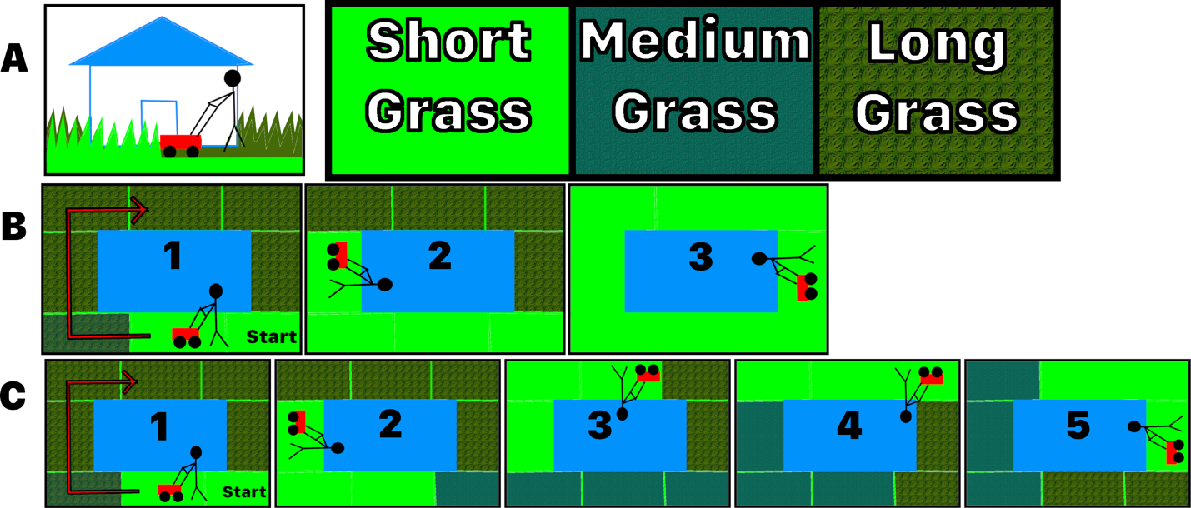 Figure 3.1
We can use an analogy of a person mowing a quick growing lawn to conceptualize the idea of an oscillation exciting a medium. In Figure 3.1, Row B shows a person mowing their lawn. As they make their way around their house the lawn behind them is cut short. As a result, when they have completed one full revolution around their house, they will have cut all the grass and there will be none left to mow.
If their lawn were to grow sufficiently fast, when they returned to their starting location the lawn would have regrown, and they could keep mowing around ad Infinium, shown in Row C. As they mow, the grass behind them begins to grow back. Before they complete one full revolution, the grass at their starting location has already regrown. In this analogy the lawn is the excitable medium, the person mowing is the oscillation propagating through the medium, long grass is medium in a ground state, and grass cut short is medium in a state of excitement. So long as the medium returns to ground state before the oscillation comes around, the wave continues self-propagation.
- 2-dimensional spiral waves
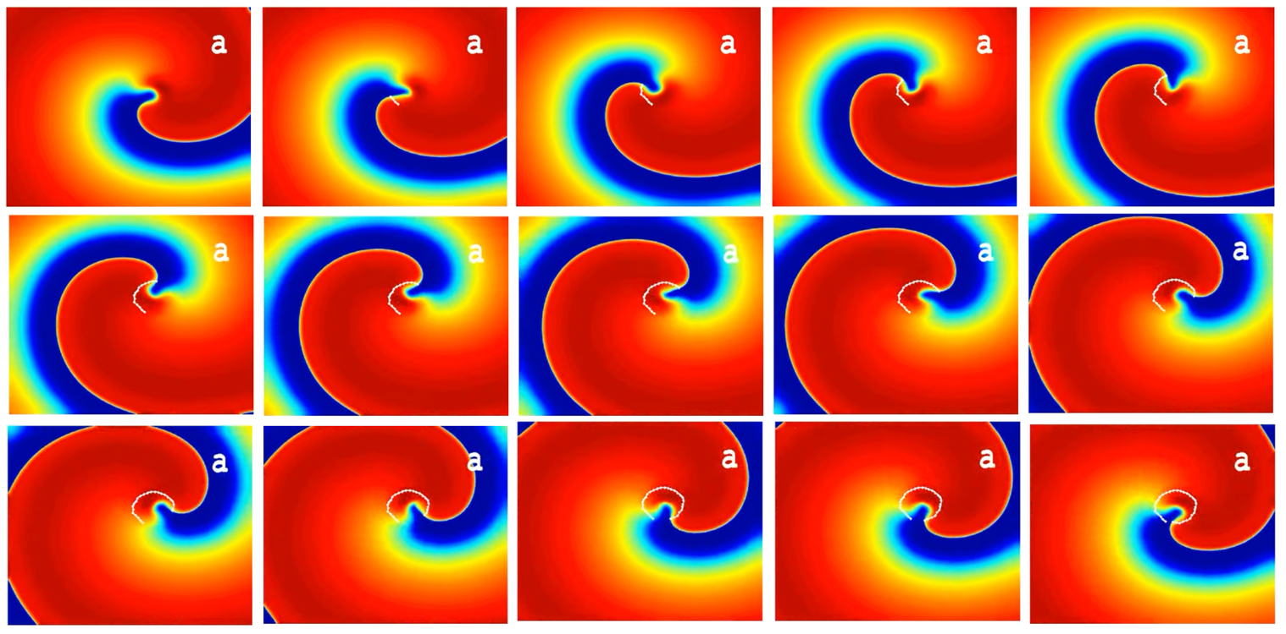 Figure 4.1
At the center of the 2-dimensional spiral wave in Figure 4.1 is a phase singularity, called the core. (‘Core’ for 2-dimensional spiral waves, ‘filament’ for 3-dimensional scroll waves.) The core’s path, shown by the white line, dictates the wave’s behavior. This core follows a very even trajectory, resulting in a uniform spiral wave.
A wave is an oscillating dynamic disturbance that propagates through something. We have discussed how sound waves make a disturbance in air pressure, likewise ocean waves make a disturbance in the displacement of water. Here the substance that the spiral wave is disturbing isn’t affected spatially like the air or water; there is a chemical reaction taking place. The core is the single point from which the wave propagates, but it is the entire yellow band that is the wave front.
As the wave propagates the chemical chain reaction at the front of the wave affects the media directly in front of it, causing it to undergo the same chemical change. This reaction takes time before the medium is completely excited. This change can be seen by looking at the bands of color in the spiral wave. The medium in its ground state is red. As the chain reaction propagates through the medium and reaches some part in its ground state, it turns the medium yellow. This is the front edge of the spiral wave. As that medium more completely undergoes the chemical change it goes from yellow, to green, to light blue, until it has completely undergone a change, becoming maximally excited, and that part of the medium can no longer propagate the chemical chain reaction. This is the part of the spiral wave that is dark blue.
However, this chemically altered state of the medium is not stable, and will naturally return to its ground state. This is happening in the band at the back edge of the spiral wave. After the medium has returned to its ground state, it remains in its ground state until the spiral wave propagates back around to that region, once again exciting the medium and repeating the cycle.
Spiral waves are 2-dimensional versions of 3-dimensional scroll waves. I’ve introduced the idea as spiral waves because oscillators in excitable media become much, much more complicated when another spatial dimension is involved. More than that, there are many more ways to arrange 3-dimensional scroll waves than there are 2-dimensional spiral waves. With so many more ways that the scroll waves can be structured, they become much more difficult to conceptualize.

- Quantum Field Theory and The Standard Model of Particle Physics
Quantum Field Theory
Quantum Field Theory, or QFT, is a theory that describes the universe as a collection of fields. These fields are everywhere all at once, all throughout the universe. An easy but imperfect analogy is that of a fish in water. The water is so foundational to the experience of the fish that the fish is unaware of the presence of the water, because the fish has no state of being absent of water to compare it to. Water is the medium of the fish’s existence.
The fields are like the water in the sense that they are everywhere in the universe, occupying everything that the universe occupies, all the time. The universe is synonymous with the set of all the quantum fields. The fields are unlike the water in the sense that the fish is distinct from the water. In QFT, everything in the universe owes its existence to the fields. Anything that exists is a part of the quantum fields, so the only things that exist are the fields.
The fields are also unlike the water in that the water seems somehow to be an objectively real substance, and the quantum fields, although they are just as objectively real as anything else in the universe, are also a method of mathematically describing observable reality.
For instance, there is an electron field. Electrons are fundamental particles. They are the smallest, quantized amount of electron that can exist in the universe. Electrons are, by that definition, a quantum particle, and so there is a quantum field, the electron field, associated with that particle.
Electrons are objectively real. We can observe them. We can observe their behavior. We can measure them. We know that electrons are real and therefore the electron field is real. However, cupcakes are also real. We can observe cupcakes. We can measure properties of cupcakes. There is no quantum value of cupcake that is possible in the universe, because cupcakes are not fundamental the same way that electrons are, but they are still real. It would be an impossibly difficult undertaking, but there is presumably some way to develop a mathematical field that describes every condition that must be satisfied for the existence of a cupcake, and in that case, you could describe the cupcake field as generating cupcakes. If you had a LaPlace’s Demon understanding of the universe, there are no logical inconsistencies that prevent a mathematically rigorous cupcake field.
This difference becomes a little more tangible if we consider something less outlandish than a cupcake field. There are field theories that describe fields for composite particles. There are mathematically rigorous descriptions of the proton field, for example. Protons are very real, but protons are not fundamental. This begs the question, ‘Is the proton field real?’ The easy answer is that the proton field is a mathematical tool that is used to quantify something that is real. Extending this notion to fields for the fundamental particles is where the answer becomes less clear. Protons are made of quarks. Quarks are fundamental. They are not made of anything besides a quark. The proton field is a mathematical construct that describes the conditions met when quarks are arranged to form a proton. The proton field describes structures formed by quarks. Quark fields describes structures formed by…? Quarks are excitations, aka oscillations in the form of knotted scroll wave rings, of the quark field.
The question being posed here is ‘What is the substrate of the universe?’ I am not proposing an answer to this question. I bring it up only to highlight the temptation to confuse a mathematical description of something that is real with thing itself, particularly when the ontological nature of that thing is elusive.

Fundamental particles understood as localized excitations of the quantum fields
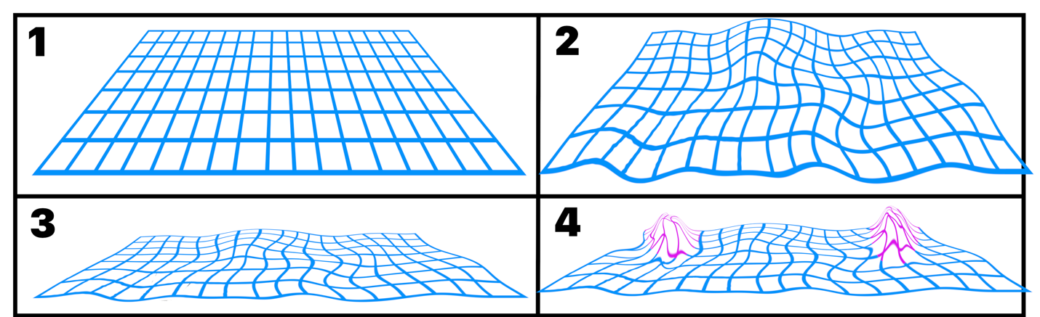
Figure 5.1
QFT describes all particles as localized excitations, or oscillations, of the quantum fields. The fields are the excitable media, and the localized excitations are the oscillations that self-propagate in the excitable media.
Even absent the presence of a particle, these quantum fields are not static. There is some baseline energy undulating the fields, called the vacuum energy. An ‘empty’ quantum field isn’t the sort depicted in Frame 1, but the dynamic vacuum of a fluctuating field in Frame 2. Frame 3 shows the same zero-particle vacuum state. In Frame 4 the pink mounds are particles generated in the field.
These are quantum fields because these excitations only happen in discreet, quantized amounts of energy. This is why all electrons are identical. There are no half-electrons, or smaller or larger electrons. This is true for all quantum fields.
The Standard Model of Particle Physics
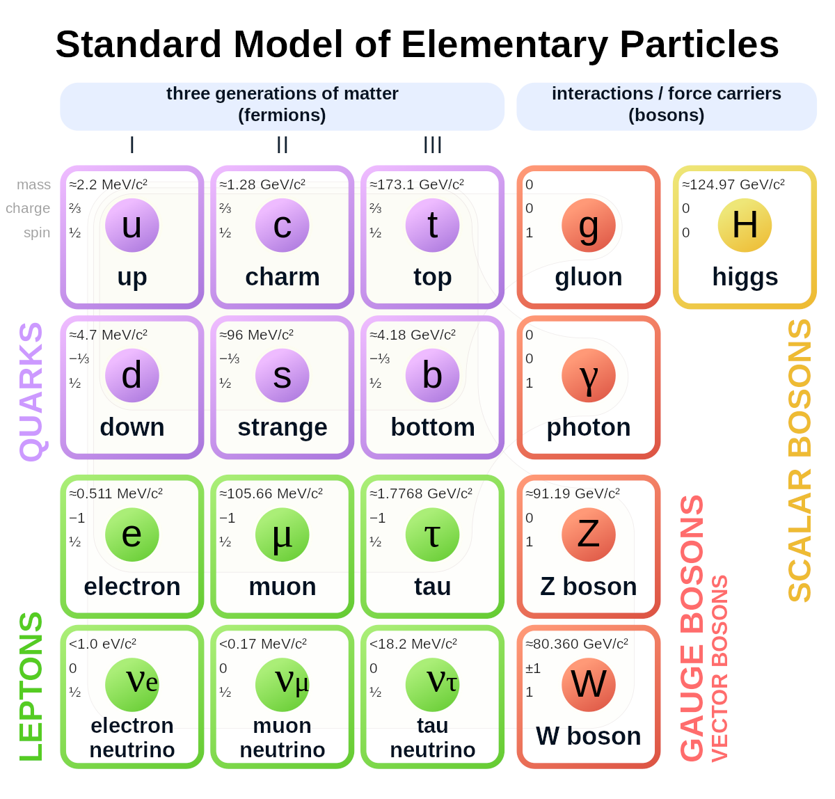
Figure 5.2
The Standard Model is the collection of fundamental particles in the universe.
Bosons
Bosons are force carrier particles. They are not substantial, or tactile, the same way that matter is. They facilitate interactions of the fundamental forces. For example, the photon is the force carrier of the electromagnetic force. When you turn your kitchen light on and a yellow banana is revealed to you, the light bulb filament is energized and photons are emitted, which reflect off the banana toward your eyes. The light bulb filament, the skin of the banana and the retina in your eye are all made of matter. Matter doesn’t directly interact with other matter. The photons interact with the matter particles, which facilitates matter interacting indirectly. Bosons serve as a means of communication between matter particles.
Fermions
Fermions are the particles that matter is made of, and the particles of particular interest in our exploration of phenomenal consciousness.
Fermions divided into quarks and leptons and subdivided into different kinds of quarks and leptons. The subdivisions of fermions won’t be of any particular importance for us. For context, matter that we interact with is made of molecules. Molecules are collections of atoms bound together. Atoms are made of protons, neutrons and electrons. Electrons are fundamental and thus cannot be divided into component parts. Protons and neutrons are both made of different arrangements of up and down quarks. Once we get to electrons and quarks, we’ve reached the threshold where it’s just turtles all the way down.

- Particles Represented as Mathematical Objects
Through observations of objective reality, we have determined that there are quantized, fundamental particles in the universe. A way of describing the universe as a collection of these fundamental particles that has proven to be incredibly accurate is a collection of quantum fields. With this in mind, we won’t become too concerned with how much ‘realness’ we should attribute to the quantum fields, or the mathematical objects used to describe the particles generated by those fields.
Because QFT has proven to be a useful, accurate, mathematical description of the universe, it seems reasonable to wonder if QFT might articulate aspects of reality in the language of mathematics, which may provide insight into the ontology of the universe. Exploring these logical possibilities led to the conclusion that phenomenal consciousness might be rooted in the structure of oscillations of the quantum particle fields.
I am not suggesting that consciousness is any mathematical object. From my perspective as a conscious agent, I’m suggesting there is something undeniably familiar about the mathematical description of certain types of particles, when considering the parallels between the mathematical description of the fundamental, physical components of one’s material self and the most fundamental aspects of the experience of being oneself.
Types of particles represented by different mathematical objects
There are 3 types of mathematical representations of standard model particles, each representing particles having that same spin number. The Higgs boson is a spin 0 particle and is the only particle that is represented as a scalar value. A scalar is a value that the field has at a coordinate. A familiar scalar value is temperature. You can imagine a room with a field describing the temperature in the room. A thermometer placed somewhere in the room will measure the temperature, or the scalar value of the temperature field, at that location.
All other bosons, vector bosons, have a spin number of 1 and are represented mathematically as vectors. Vectors are mathematically useful arrows. As where a scalar value can only give a single measurement, describing a single degree of freedom, a vector has 2 degrees of freedom. A vector gives the direction, indicated by the direction the arrow is pointing, and magnitude, indicated by the size of the arrow.
Fermions have a spin integer of ½. The mathematical object used to represent spin ½ particles is a spinor. Spinors are counterintuitive because if a spinor is oriented in some direction, after the spinor is rotated 360°, the spinor would be facing the opposite direction. A spinor needs to be rotated 720° to complete 1 full revolution and be reoriented in its starting configuration.
Spinors and insights regarding the nature of fermion particles
In the next pages we will look at mathematical objects and sequenced rotations of mathematical structures that are being used to explain what a spinor is. Try not to become overly concerned with how accurately these may or may not adhere to the technical definition of a spinor. Each of the examples provided is meant to describe a characteristic of spinors. What we are ultimately after is an intuitive understanding of the oscillations that generate fermions. Spinors are a convenient conduit for building that intuition. The objects in these graphics are not spinors, and spinors are not fermions. The utility in these graphics, just like the utility in spinors, is in their ability to contribute to an intuition of knotted scroll wave rings.
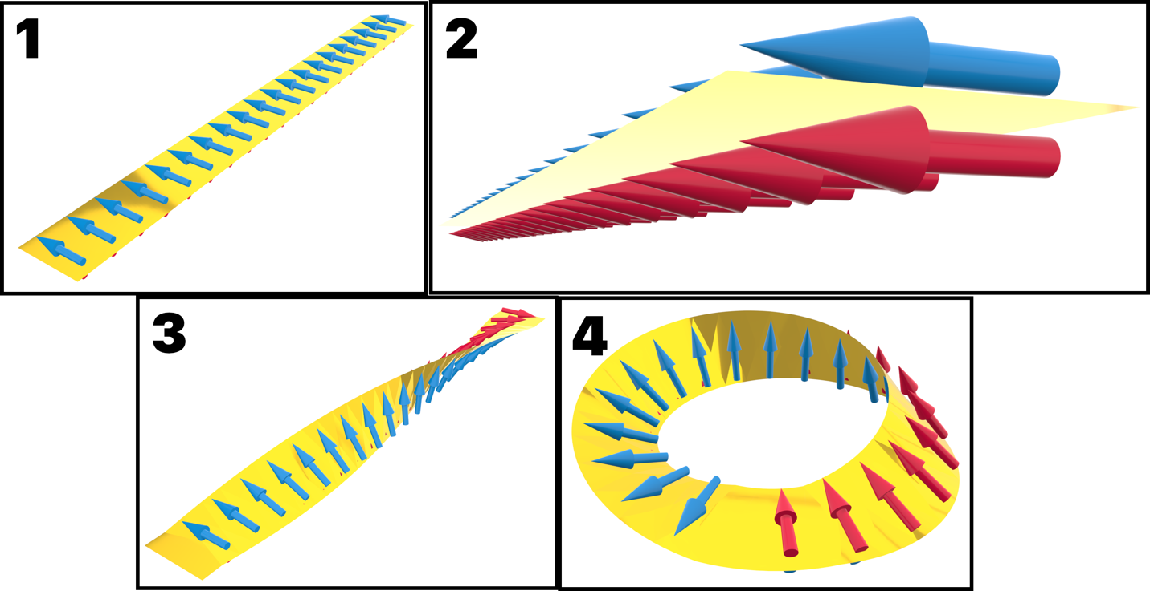
Figure 6.1
A Mobius strip, pictured in Figure 6.1, is a 2-dimensional strip that is twisted by 180° along its length axis, then curled around so that its ends connect. The result is a strip that has only a single edge. In frames 1 and 2 all the arrows are pointing to the same edge. In frame 3 the strip is twisted 180° along its length axis. In the view from above, the arrows end up pointing in opposite directions. To an embedded observer the arrows are still pointing in the same direction, towards a single edge of the strip. In frame 4 the strip is curled into a ring so the 2 short ends connect. Imagine placing your finger on the edge of the strip directly in front of the first blue arrow tracing the edge of the Mobius strip. After you trace around the ring once, your finger will be directly behind the blue arrow you started in front of. After going around twice, your finger will be back where it started.
This is the first idea we want to add to our concept of spinors as mathematical representations of fermion field oscillations. There is a sort of embedded rotation that isn’t intuitively translated to 3 spatial dimensions. Rotations that might appear unique from the outside looking in might appear identical from the inside looking out.
Scalars, vectors and spinors are, in a sense, hierarchical. Scalars only specify a magnitude. Vectors give 2 pieces of information; magnitude and direction. It is comparatively simple to understand the progression from scalar values to vectors. The information added to a vector that scalar values lack is a specified direction.
Direction is a familiar concept. When continuing that progression from vectors to spinors, the change is a less familiar concept. Spinors are sometimes described as being the square of a vector, although that description falls short of being entirely accurate. What this description is hinting at is that spinors specify the way they rotate relative to the environment. Without this specification there ends up being more than 1 equivalent way to reorient a vector. For example, if you are looking at a clock and the hour hand is pointing to the 12, there are 4 different ways that it can be rotated so that the hour hand is pointing to the 3. The hour hand can be rotated 90° clockwise, the hour hand can be rotated 270° counterclockwise, the hour hand can stay in place and the rest of the clock can be rotated 90° counterclockwise, or the hour hand can stay in place and the rest of the clock can be rotated 270° clockwise.
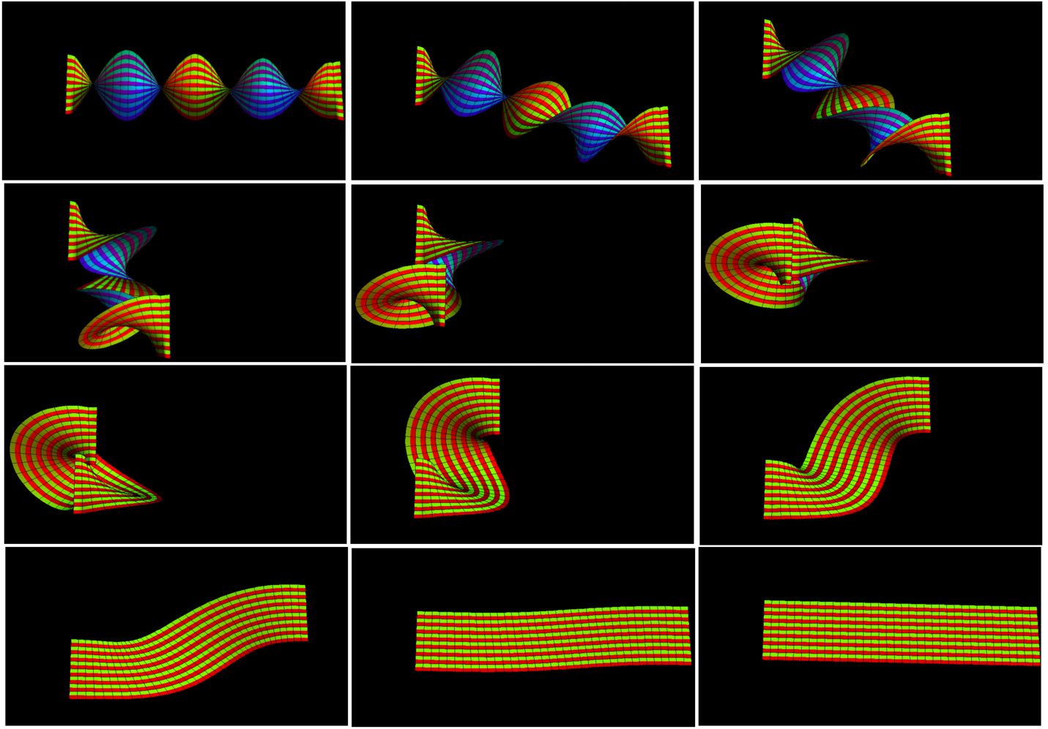
Figure 6.2
This idea is often taught by showing what’s called ‘Dirac’s belt trick.’ If you take a belt, put 2 twists in it, or 720° of rotation, there are 2 different ways the twists can be removed. The most obvious is by keeping one end still and flipping the other around twice. The other way keeps both ends of the belt parallel and brings one end around the other, shown in Figure 6.2.
What the belt trick is getting at is the 2nd aspect of spinors that we should apply to our concept of fermions; spinors are coupled to local space they occupy.
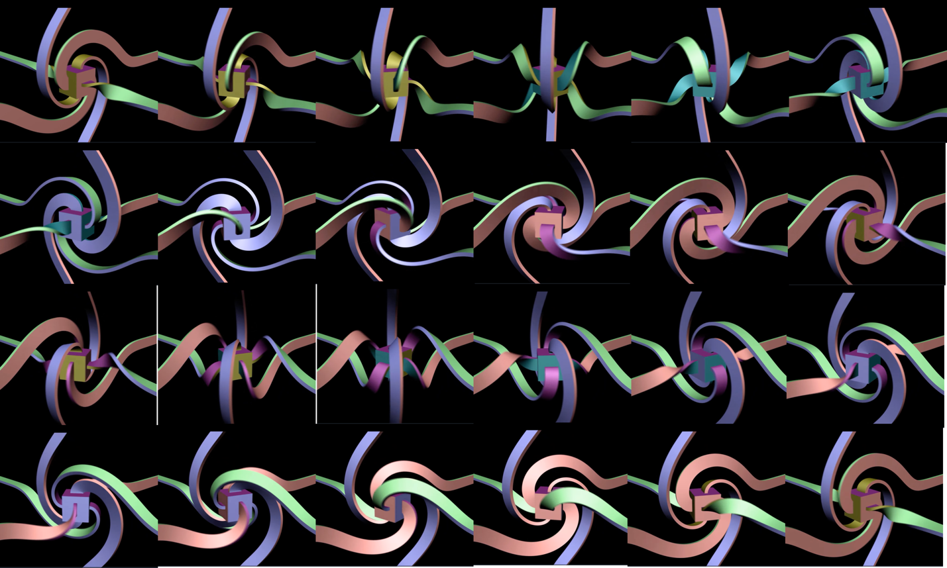
Figure 6.3
The series of images in Figure 6.3 illustrates the way that an object and its local environment can be coupled. There are ribbons connected to each of 6 sides of the cube. As the cube rotates the ribbons never become entangled because they distort and move around one another. The cube is coupled to space in such a way that the cube’s movement distorts the surrounding space so the object maintains a consistent relationship with its immediate environment.
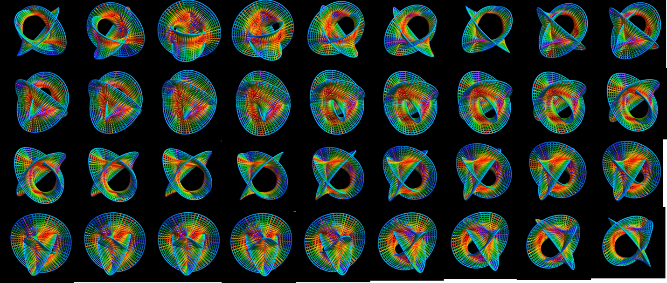
Figure 6.4
Bringing this concept to the limits of logical extension results in a continuous coupling of space, not just ribbons connected to a cube, but every single point connected in all directions to the continuum of its surroundings. The object isn’t so much coupled to the surrounding space as the space occupied by the object is coupled to itself. Figure 6.4 helps visualize this idea.
- Scroll Waves
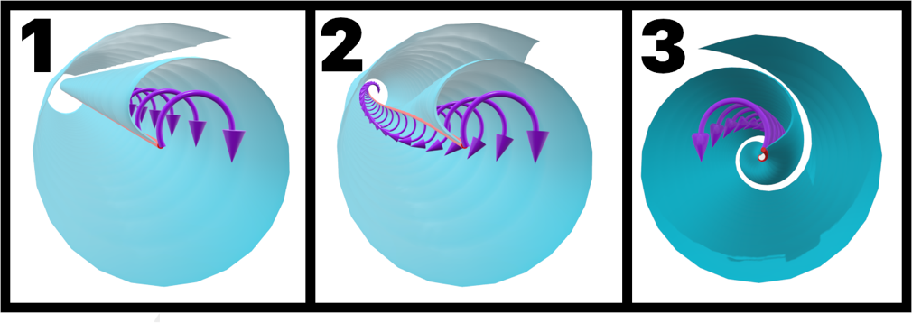
Figure 7.1
An oscillation that propagates through an excitable medium in 3-dimensions is a scroll wave. Scroll waves are 3-dimensional versions of 2-dimensional spiral waves. A scroll wave changes the state of the excitable media in the shape of a paper scroll unwinding from a wooden dowel.
Scroll waves propagate from a phase singularity called the filament. Whereas the dowel is a tactile object that the paper scroll is wound around, the filament is a mathematical construct the oscillation propagates from.
It’s useful to think of the filament as a string running through the center of the scroll wave, with the oscillation sort of ‘unrolling’ from it. The structure, behavior and dynamics of this string have all the causal power in determining the properties of the scroll wave.
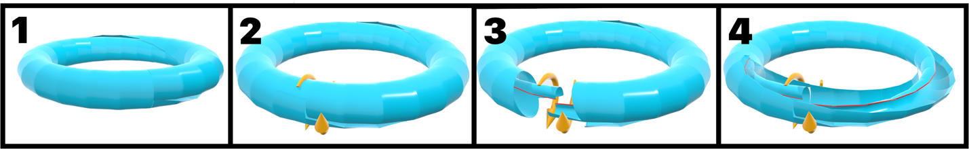
Figure 7.2
If the filament is straight, the wave will propagate in a flat, even manner. If the filament curls around so that the 2 ends of the string connect with each other, it is a scroll wave ring.

- Topological Knot Theory
Topological knots are closed curves in 3-dimensional space. A less rigorous definition is that knots are rings that are contorted in such a way that they cannot be unwound without cutting the ring or passing it through itself.
Figure 8.1
The simplest is the trefoil knot, shown in Figure 8.1. There are 2 versions of the trefoil knot. The left-handed trefoil knot, on the left, and the right-handed trefoil knot, on the right.
Topological knots are specific to 3 dimensions. In 2 dimensions a circle can’t pass in front of or behind itself, and in 4 or more dimensions a knot will always be able to move through a higher dimension to unwind itself.
Knot theory is of interest because knotted filaments can result in oscillations that can find stability in self-propagation, which fermions require to exist over time.

- Knotted Scroll Wave Rings
Scroll wave rings propagating in excitable media create a very dynamic, turbulent environment. These systems become very complicated, very quickly. The easiest way to look at the system of the scroll wave and the excitable medium is by focusing on the scroll wave’s filament. Without a filament, there is no scroll wave, and the state of the filament largely determines the behavior of the scroll wave.
These systems are not exempt from the 2nd law of thermodynamics, and as such there are many, many more ways that a scroll wave can break up and die out than there are for the system to find stability.
These systems can achieve a sustainable oscillating state if the filament becomes knotted, with a chiral mismatch along the filament so each half of the scroll wave propagates in the opposite direction of the other. This is exactly the type of oscillation that can be attributed to fermion generation, and this is the structure at the heart of the theory of consciousness being proposed.

- Hemihelices
To get a better understanding of the forces acting on the filament of the scroll wave, we can look to a structure called a hemihelix. A hemihelix is a helix with a perversion in it, so that the chirality of the helix is reversed at the perversion.

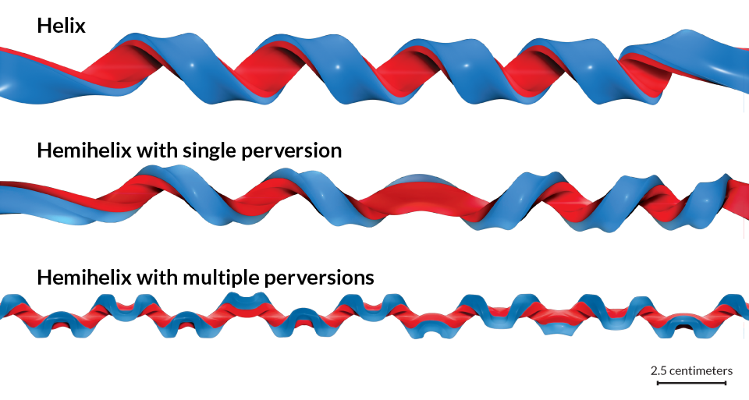
Figure 12.1
Filaments are 1-dimensional and cannot be hemihelices. Hemihelices are introduced to build a useful concept of knotted scroll wave filaments that reverse chirality. The filament can be thought of as a 1-dimensional line running through the middle of the hemihelix, and the wave front would be propagating in the direction of the hemihelix at every point along that line.

- Introducing the quantum of consciousness potential
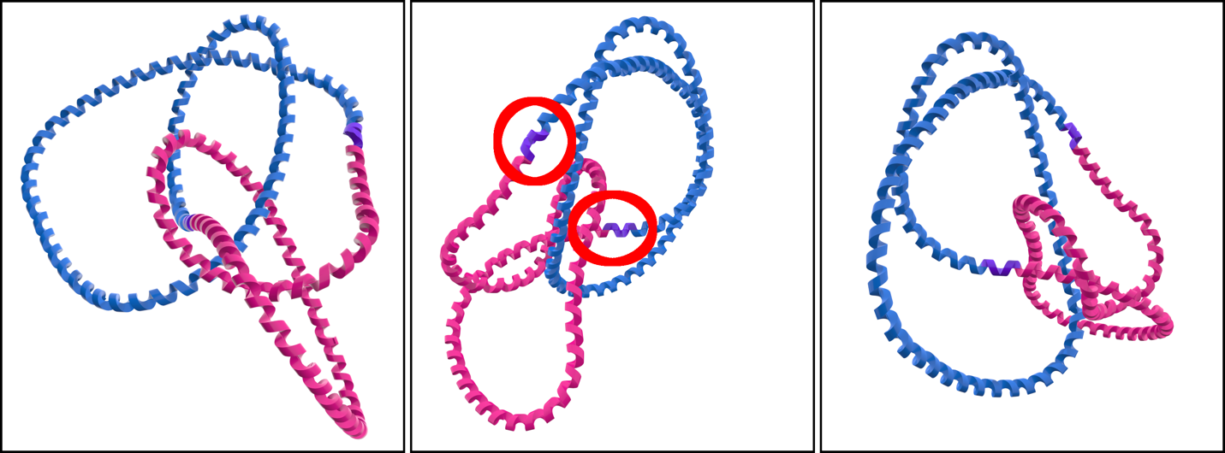
Figure 13.1
A scroll wave filament is not a tactile object. It is a mathematical construct describing a continuous set of coordinates in 3-dimensions where the phase of oscillation of excitable media is a singularity. In other words, the filament is a line that runs through the middle of the oscillation, and the wave pushes out from this line. This line necessarily twists around and forms a knot, threading through its own center.
The filament is an accurate, mathematical description of a necessary characteristic of something tactile, a particle, that occupies space and interacts with the material universe. You can (theoretically) hold a particle in your hand. A particle is a real, tactile entity, which exists as part of the objective, material universe. You cannot hold just a filament in your hand. A scroll wave filament is a mathematical description of a part of an oscillation. Since the excitable medium in the context that we are discussing is a quantum particle field, the field oscillation is a particle. The real particle can be equivalently described as localized excitation of a quantum fermion field. The particle really exists; therefore, the excitation of the fermion field really exists. The excitation cannot exist without a filament; therefore, the filament really exists. However, the filament does not exist independent of the oscillation, or independent of the particle, or independent of the field, which is itself a mathematical construct.
This is the extent to which we can attribute some degree of ‘realness’ to the filament. Particles are real. Everything else; the fermion field, the oscillation, the filament, is a mathematical construct that accurately describes different parts of the system that produces a particle. Since the particles this system describes are real, there must be some degree of realness that should be attributed to these mathematical ideas. Whatever arbitrary degree of ‘realness’ can be attributed to the filament is sufficient to describe a theory of consciousness, which we know to be real, where these filaments are granted a causal role in phenomenal consciousness. The filament is an accurate description of something that can be attributed to something that is real.
The filament is an accurate description of a necessary attribute of something that is real. This isn’t a very bold assertion, but it will serve as a foundation that we can build upon.
A particle is real. You can hold the particle, but the particle is fundamental. You cannot hold only part of the particle without holding the entire particle. You cannot hold only the particle’s filament.
The something that is real is a fundamental quantum of what could possibly exist as a part of the objectively real universe.
The quantum fermion fields are described as 3-dimensional excitable media. When fermion fields are excited to a sufficient value to generate a particle, that excitation is a 3-dimensional scroll wave. For the oscillation to be sustainable the filament must have a structure which requires it become knotted, coupling the oscillation to the medium occupied by the oscillation. This knotted filament must have at least 2 points where the chirality of the scroll wave reverses itself.
The filament is structured as a mirror image of itself, each half of the filament being a reflection of the other. The filament has a dualistic nature baked into its very existence. By extension, there is a dualistic nature baked into the existence of every fermion.
The oscillation couples to itself, the filament threads through its own center before forming a closed loop. There is a dualistic nature of the filament that is vital to the survival of the oscillation. This is how the oscillation finds stability out of turbulence. Any property of the filament on one half must be accounted for on the other half. Each half of the filament must immediately adjust itself, counterbalancing any changes in the other half. The essential balance of this constantly changing, dynamic, turbulent system seems to require that each half of the filament be immediately aware of the state of the other half.
The oscillation that propagates from a filament like this is a knotted scroll wave ring. Without each half of the filament behaving as a reflection of the other half, the scroll wave would be an unstable oscillation which couldn’t sustain its existence. The dualistic nature of the filament allows the particle to exist. The filament’s behavior as a dynamic reflection of itself appears to require that each half of the filament is somehow aware of the dynamic behavior of the other half. The existence of the particle requires this awareness. There is a sort of awareness baked into the existence of all fermions.
The real leap here is embodied in using the word ‘aware’ to describe the state of the scroll wave filament as it evolves, adapts and finds balance to continue propagation. To be sure, this is a physical mechanism. It can be entirely described by physical, cause and effect dynamics. Still, the symbiotic, dualistic behavior of this physical mechanism appears as though it could rightly be described as necessitating a sense of ‘awareness’. Using the term ‘awareness’ to describe a vital attribute of this mechanism implicitly personifies the mechanism. It doesn’t feel right to personify an electron, but it also doesn’t feel right to say the oscillator’s ability to behave as a dynamic reflection of itself should be described by something less than ‘awareness’.
There is a paradoxical feeling of simultaneously desiring to withhold personification from and feeling compelled to grant awareness to an entity. It is the same paradoxical uneasiness one gets when trying to make sense of the role that observation plays in the double slit experiment, or being reluctantly pushed by the rigors of logic to the conclusion that Schrödinger’s cat is in a superposition of being both alive and dead. I suggest that the remedy might be to allow some liberty in what entities we should grant the sort of awareness necessary to play the role of an observer. This is the necessary leap.
Empirical data about consciousness is solely found by observing our own consciousness. This does a perfect job of informing us what our own consciousness is, but it is problematic when we need to generalize ideas to account for all consciousness. Since we are unable to observe which aspects of our own conscious experience are universal to other forms of consciousness, we must make logical deductions about consciousness in general from empirical observations of our own consciousness.
Our sensory organs are receptors of information about the material environment, information that is radiating via photon emission, pressure waves in air, thermal radiation, etc. They intercept information, causes a brain state, and that influences our mental state. Our consciousness experience is occupied by an immediate awareness of that mental state, which is informed by the state of our material environment. It would be conceivable to have an identical mental state if you were having a very convincing dream. This brain state wouldn’t be informed by sensory organs, but there would still be a brain state informing a mental state. At the very core of this is an immediate awareness of one’s own mental state.
This begs the question, ‘What is a mental state without an immediate awareness of the mental state?’. Your present conscious experience is, arguably, synonymous with your present mental state. It’s more accurate to say that one’s present conscious awareness is entirely occupied by one’s present mental state. By differentiating between ‘present conscious awareness’ and ‘present mental state’ it becomes clear that mental states do not add anything to the system. Mental states are the product of a physical system that is also a conscious agent being immediately aware of its own state. The physical system is a brain. Since the system is also a conscious agent, this system plays the role of an observer. Observership grants the agent an immediate awareness of the state of the observer’s environment. Since the observer’s environment includes the observer, the conscious agent is immediately aware of its own state. When the conscious agent is also the physical system of a brain, the agent’s immediate awareness of its own state is an immediate awareness of a brain state. An immediate awareness of a brain state from the perspective of a conscious agent materially embodied as that brain is a mental state. Mental states are conscious awareness being directed to a brain state, from the subjective point of view. Mental states are a higher order construction of a phenomenon which is, fundamentally, conscious awareness. The fundamental aspect of mental states is an immediate awareness. Awareness is a fundamental aspect of consciousness.
Awareness on its own doesn’t paint the whole picture. Consciousness requires an awareness that plays an active role as an observer. The kind of observership that is required for consciousness is the same kind of observership that sparks decoherence in quantum mechanics. This observership entails an immediate awareness of the observer’s environment and dictates that the observer is part of the environment it is immediately aware of. It is the unique perspective of an observer being immediately aware of their own state.
We can reason that the fundamental aspects of consciousness are:
- An immediate awareness.
- A unique perspective that compels the conscious agent to an immediate awareness of the agent’s own state.
Awareness is a fundamental attribute of consciousness. Fundamental consciousness is awareness combined with the perspective of a unique observer. Any conscious agent is endowed with a unique perspective of having the experience of being that conscious agent. Fermions are spatiotemporally unique in any observed system. Fermions have an awareness baked into their existence, and a spatiotemporally unique perspective. A sort of fundamental consciousness should be attributed to any fermion particle. Fundamental particles of matter have a type of fundamental consciousness baked into their existence. A quantum of fundamental consciousness should be attributed to every fundamental quantum particle of matter.
Returning to the necessary leap in using the word ‘aware’ to describe the dualistic, dynamic behavior of the scroll wave filament:
I am not suggesting that a fermion is aware in the same sense that I am. I don’t know exactly what the ‘awareness’ attributed to a fermion is like relative to my own sense of awareness. The word ‘observership’ has been used to describe something like I imagine this type of awareness to be. My inability to describe what it is I imagine this awareness might be like is, to some degree, due to an inherent anthropocentric bias in the concept of awareness. I only know what it’s like to be me. I couldn’t begin to imagine what any sort of fundamental awareness that might be attributed to the internal, mathematical description of a fermion might be like.
Any anthropocentric bias in the term ‘awareness’ or ‘observer’ seems to be rooted in the degree of precision for the concept of consciousness. In some sense it doesn’t seem possible to have a vague concept of consciousness. Awareness is experiencing conscious states that we are immediately aware of. How could there be any ambiguity about my conceptual idea of what it is like to be me, when having that conceptual idea is part of the conscious experience of being me? The problem is that this forces a reductive definition of a complicated type of consciousness that is entangled with cognition, intelligence, a historical sense of self, linear experience of time, etc. Taking the possibility of any mechanistic consciousness seriously will force us to reconsider what consciousness fundamentally is, and likely develop terminology to distinguish my conscious experience from the kind of observership that quantum mechanics has been begging us to define for more than a century.
It feels like a leap to attribute awareness to anything that doesn’t feel like it should be personified. If the hard problem is solvable, that leap needs to be made somewhere. Interjecting fundamental consciousness at the level of fundamental particles seems like a logical place.

The filament is an accurate description of a necessary attribute of something that is real. The something that is real is a fundamental quantum of what could possibly exist as a part of the objectively real universe. The filament is structured as a mirror image of itself, each half of the filament being a reflection of the other. The filament has a dualistic nature baked into its very existence. By extension, there is a dualistic nature baked into the existence of every fermion. The oscillation that propagates from a filament like this is a knotted scroll wave ring. Without each half of the filament behaving as a reflection of the other half, the scroll wave would be an unstable oscillation which couldn’t sustain its existence. The dualistic nature of the filament allows the particle to exist. The filament’s behavior as a dynamic reflection of itself appears to require that each half of the filament is somehow aware of the dynamic behavior of the other half. The existence of the particle requires this awareness. There is a sort of awareness baked into the existence of all fermions. Awareness is a fundamental attribute of consciousness. Fundamental consciousness is awareness combined with the perspective of a unique observer. Any conscious agent is endowed with a unique perspective of having the experience of being that conscious agent. Fermions are spatiotemporally unique in any observed system. Fermions have an awareness baked into their existence, and a spatiotemporally unique perspective. A sort of fundamental consciousness should be attributed to any fermion particle. Fundamental particles of matter have a type of fundamental consciousness baked into their existence. A quantum of fundamental consciousness should be attributed to every fundamental quantum particle of matter.

Works Cited
Beckman, Milo. (2022). Math without numbers. Dutton, an imprint of Penguin Random House LLC.
Boyle, Latham. (2019). CITA 875: CPT-Symmetric Universe. YouTube. CITA. Retrieved June 9, 2023, from https://www.youtube.com/watch?v=s9J-SUaq65o.
Boyle, Latham., & Turok, Neil. (2021). Two-Sheeted Universe, Analycity and the Arrow of Time. arXiv. https://doi.org/https://doi.org/10.48550/arXiv.2109.06204
Boyle, Latham., Finn, K., & Turok, Neil. (2018). CPT-Symmetric Universe. Physical Review Letters, 121(25). https://doi.org/10.1103/physrevlett.121.251301
Butler, David. (2021, September 29). Classroom aid - weak force W and Z bosons. YouTube. https://www.youtube.com/watch?v=WTpQgihoVx4
Chalmers, David. (2014). How Do You Explain Consciousness? YouTube. TED. Retrieved June 10, 2023, from https://www.youtube.com/watch?v=uhRhtFFhNzQ.
Chalmers, David. J. (1997). The conscious mind. Oxford University Press.
The Cogito. (2021d). Criticisms of Materialism (Philosophy of Mind). YouTube. Retrieved June 9, 2023, from https://www.youtube.com/watch?v=dwiB4RJJ0DY.
Cree, Sam., & Fraser, Alec. (2016). Understanding Antimatter: CPT Symmetry. YouTube. YouTube. Retrieved June 8, 2023, from https://www.youtube.com/watch?v=qolK5dDO5O0.
Curvo, Rodrigo. C., & Maier, Alexander. (2022). The Math of Consciousness (Integrated Information Theory). YouTube. Astonishing Hypothesis. Retrieved June 10, 2023, from https://www.youtube.com/watch?v=Sp9B7raW_O4.
Deepa, Sankar. (2020a). Fascinating Phase Singularities Physics JCE. YouTube. Retrieved June 9, 2023, from https://www.youtube.com/watch?v=LqdKH8xMMgQ.
Dähmlow, Patricia., Alonso, Sergio., Bär, Markus., & Hauser, Marcus. J. (2013). Twists of opposite handedness on a scroll wave. Physical Review Letters, 110(23). https://doi.org/10.1103/physrevlett.110.234102
Farias, Carlos. (2021a). Hopf Fibration Explained Better than Eric Weinstein on Joe Rogan. YouTube. Retrieved June 9, 2023, from https://www.youtube.com/watch?v=PYR9worLEGo.
Feynman, Richard. P., Leighton, Robert. B., & Sands, Matthew. (2013). The Feynman lectures on physics. Pearson India Education Services Pvt Ltd.
Francis, George., Kaufmann, Lou., & Sandin, Dan. (2019). Air on the Dirac Strings. YouTube. evltube. Retrieved June 9, 2023, from https://www.youtube.com/watch?v=8r0EfxHTbwQ.
Goff, Philip. (2020). Galileo’s error: Foundations for a new science of Consciousness. Vintage Books.
Hertog, Thomas. (2023). On the origin of time: Stephen Hawking’s final theory. Torva.
Houston-Edwards, Kelsey. (2017). Your Brain is Eight-Dimensional - Your Brain as Math Part 3 | Infinite Series. YouTube. Houston-Edwards, K. Retrieved June 9, 2023, from https://www.youtube.com/watch?v=akgU8nRNIp0.
Keener, James. P., & Tyson, John. J. (1992). The dynamics of scroll waves in excitable media. SIAM Review, 34(1), 1–39. https://doi.org/10.1137/1034001
Let’s Code Physics. (2020b). Scalar and Vector Fields. YouTube. Retrieved June 9, 2023, from https://www.youtube.com/watch?v=ybNSE8JzJQs.
Numberphile. (2013). Fermat’s Last Theorem - Numberphile. YouTube. Retrieved June 10, 2023, from https://www.youtube.com/watch?v=qiNcEguuFSA&t=321s.
Oizumi, Masafumi., Albantakis, Larissa., & Tononi, Giulio. (2014). From the phenomenology to the mechanisms of consciousness: Integrated information theory 3.0. PLoS Computational Biology, 10(5). https://doi.org/10.1371/journal.pcbi.1003588
O’Dowd, Matt. (2015). The Higgs Mechanism Explained. YouTube. PBS Space Time. Retrieved June 10, 2023, from https://www.youtube.com/watch?v=kixAljyfdqU.
O’Dowd, Matt. (2017a). Feynman’s Infinite Quantum Paths. YouTube. PBS Spacetime. Retrieved June 9, 2023, from https://www.youtube.com/watch?v=vSFRN-ymfgE&list=PLjEkbiQLspjWrp_o4s9wofLa6EYw6VC6f&index=1.
O’Dowd, Matt. (2017b). The Nature of Nothing. YouTube. PBS Space Time. Retrieved June 9, 2023, from https://www.youtube.com/watch?v=X5rAGfjPSWE.
O’Dowd, Matt. (2018a). Hawking Radiation. YouTube. PBS Space Time. Retrieved June 10, 2023, from https://www.youtube.com/watch?v=qPKj0YnKANw.
O’Dowd, Matt. (2018b). The Black Hole Information Paradox. YouTube. PBS Space Time. Retrieved June 10, 2023, from https://www.youtube.com/watch?v=9XkHBmE-N34.
O’Dowd, Matt. (2018c). The Misunderstood Naure of Entropy. YouTube. PBS Space Time. Retrieved June 10, 2023, from https://www.youtube.com/watch?v=kfffy12uQ7g.
O’Dowd, Matt. (2020, November 18). The arrow of time and how to reverse it. YouTube. https://www.youtube.com/watch?v=QkWT-xMTm1M
O’Dowd, Matt. (2022, April 27). How the Higgs Mechanism Give Things Mass. YouTube. https://www.youtube.com/watch?v=G0Q4UAiKacw
O’Dowd, Matt., & Gossel, G. (2018). Quantum Physics in a Mirror Universe. YouTube. PBS Spacetime. Retrieved June 9, 2023, from https://www.youtube.com/watch?v=UyTqgnKD3sw.
Physics Explained. (2021b). Quantum Field Theory: What is a Particle? YouTube. Retrieved June 9, 2023, from https://www.youtube.com/watch?v=QPAxzr6ihu8.
Poppro. (2021c). What is the Hopf Fibration? YouTube. Retrieved June 9, 2023, from https://www.youtube.com/watch?v=nsHcKO7HvFY.
Randall, Lisa. (2006). Warped passages: Unraveling the mysteries of the universe’s Hidden Dimensions. Harper Perennial.
Roussel, Alessondro. (2020). Quantum Field Theory Visulaized. YouTube. ScienceClic. Retrieved June 9, 2023, from https://www.youtube.com/watch?v=MmG2ah5Df4g.
Sanderson, Greg. (2018). Using topology to solve a counting riddle | The Borsuk-Ulam theorem and stolen necklaces. YouTube. 3Blue1Brown. Retrieved June 10, 2023, from https://www.youtube.com/watch?v=yuVqxCSsE7c.
Sanderson, Greg. (2019). Bayes Theorem, The Geometry of Changing Beliefs. YouTube. 3Blue1Brown. Retrieved June 10, 2023, from https://www.youtube.com/watch?v=HZGCoVF3YvM.
The Science Asylum. (2018). Is EVERYTHING an Inverse Square Law? YouTube. Retrieved June 9, 2023, from https://www.youtube.com/watch?v=2FMx2GDqMo4.
Serious Science. (2016). Hard Problem of Consciousness - David Chalmers. YouTube. Retrieved June 9, 2023, from https://www.youtube.com/watch?v=C5DfnIjZPGw.
Snoswell, Mark. (2010, June 23). New spinor composition - electron concepts. YouTube. https://www.youtube.com/watch?v=YKLpz025vYY
Strogatz, Steven. (2015). Sync: How order emerges from Chaos in the universe, nature, and daily life. Hachette Books.
Strogatz, Steven. (2020). Infinite powers: How calculus reveals the secrets of the universe. Houghton Miffilin Harcourt.
Susskind, Leonard. (2009). The Black Hole War: My battle with Stephen Hawking to make the world safe for Quantum Mechanics. Little, Brown.
Susskind, Leonard. (2016). Lecture 2: Black Holes and The Holographic Principle. YouTube. MRTP. Retrieved June 10, 2023, from https://www.youtube.com/watch?v=_3Z8RxXmoWU.
Tan-Holmes, Jade. (2018). Intro to Information Theory. YouTube. Up and Atom. Retrieved June 10, 2023, from https://www.youtube.com/watch?v=_PG-jJKB_do.
Tononi, Giulio. (2015). Integrated Information Theory Explained. YouTube. Akhlaghpour, H. Retrieved June 10, 2023, from https://www.youtube.com/watch?v=-TP49-l46EU.
Weingard, Daniel., Steinbock, Oliver., & Bertram, Richard. (2018). Expansion of scroll wave filaments induced by chiral mismatch. Chaos: An Interdisciplinary Journal of Nonlinear Science, 28(4), 045106. https://doi.org/10.1063/1.5008274
Weinstein, Eric. (2020c). Roger Penrose-Do We Understand Spinors? YouTube. Retrieved June 9, 2023, from https://www.youtube.com/watch?v=_EasLq6IQIw.

I am not proposing an answer to this question, yet. A forthcoming paper will be devoted to exactly this question. For the time being, we can move on and focus on the particles that are generated from this substrate.

