THE SPECTACLE OF REFLECTION: ON DREAMS, NEURAL NETWORKS AND THE VISUAL NATURE OF THOUGHT

In its original form, when it was given to men by God himself, language was an absolutely certain and transparent sign for things, because it resembled them. (...) This transparency was destroyed at Babel as a punishment for men. (...) There is only one language that retains a memory of that similitude, because it derives in direct descent from that first vocabulary which is now forgotten.

Seeing is believing - and so, knowing and thinking. This is attested both by linguistic practice and by a long philosophical tradition beginning with the Greeks, who were the first to systematically consider human understanding and whom we credit with crafting the vocabulary for describing thought. Their choice of words for this purpose overwhelmingly revolved around tropes connecting reflection to vision: ‘understanding’ (noeomai) originally meant visual perception; ‘theory’ comes from the word ‘observation’ (theoria), while the term ‘idea’ (eidos) used to signify an imagined design before Plato made it represent the object of reflection - to name just a few examples of said metaphors. But the list goes on, and in fact one could point to so many instances of similar tropes in Greek vocabulary for describing thought that Hannah Arendt even believed that “our whole mental terminology is based on metaphors drawn from vision's experience”.
While this claim might involve a slight exaggeration, it remains a fact that not just the vocabulary but also the very model of reflection we have inherited from the Greeks is largely based on such comparisons. The canonical figures of this system of metaphors are well-known as the basis of what is probably history’s most famous depiction of thought: Plato’s metaphor of the cave, which renders the act of understanding using chiaroscuro. Through the visual contrast of bright lights and shadows the acquisition of knowledge is pictured as enlightenment: a flight from the darkness of ignorance, imagined as the obscure abyss of the cavern, towards the brightness of a clear, distinct vision, granted by the spark of fire and by sunlight - sources of light and thus, understanding. This powerful image is completed with meaningful details: exiting the cave is not only an escape from darkness, but also an act of widening previously limited horizons, a liberation from the narrow-mindedness of seemingly obvious ideas, which in turn are presented as visions, either clear sights or shadows representing their imperfect copies; both figuring reflection, i.e. an optical image depicting the process of thinking.
All of these metaphors are deeply familiar, even to those who have never studied Plato’s writings - they are ingrained in our language and thinking and constantly recur in their history: countless thinkers and poets compared understanding to seeing or insight, discovering the truth to enlightenment, the truth itself to the apparent or the clear and distinct. One could rather doubt whether any of those who reflected on the nature of cognition has managed to avoid such imagery, as it is so omnipresent and so enshrined in linguistic usage that it is usually employed quite unknowingly: ‘the predominance of sight is so deeply embedded in Greek speech and therefore in our conceptual language that we seldom have any consideration bestowed on it, as though it belonged among things too obvious to be noticed.’ Here, however, lays the paradox of the comparison of knowing to seeing: that even though it seems so widely accepted and present in our language since times immemorial, very few among the classical philosophical models of cognition use it knowingly - most philosophers don’t actually believe thoughts are images and knowing is seeing. Some may indeed consider cognition to be a representation of sensory input - a reflection of reality or at least perception; others might base their accounts of thinking around concepts derived from visual experience, but when they talk of ‘images’, ‘the mind’s eye’ or ‘seeing’, they usually employ these expressions metaphorically. And even if some thinkers treat such comparisons very seriously, hardly anyone understands concepts to be images in the literal sense of sights, perceived by the intellect like the eye perceives things in its cone of vision. A much more common belief, perhaps even more widespread than the comparison of knowing to seeing, is that reflection is invisible - a paradoxical, invisible vision.
This belief seems quite obvious and consistent with our everyday experience of thinking. After all, our thoughts do not occur to us as visions, but are present primarily in the form of words, arranged into streams of sounds flowing silently through our consciousness. Moreover, this verbal reflection differs greatly from what it reflects: concepts, as opposed to objects of perception, oftentimes are general or abstract, and we can manipulate them, combining and separating freely, without even lifting a finger in physical space. We can also use them to travel in time: to recall the past or picture the future. Because of all this, the reality of ideas, bound in language, seems properly metaphysical - liberated from the limitations of matter and the narrow horizon of the here and now. It is thus doubly distant from the world of objects reflected in our eyes: not only invisible, but indeed immaterial, present among tangible things only as an echo of sounds fleeting and transparent like ghosts, which transport the listener to the realm of reflection, a reality of the spirit that transcends the sensual.
It is thus unsurprising that images and thoughts are often considered parts of different orders: the sphere of tangible matter and that of otherworldly, transcendent ideas. Hannah Arendt described this imposing conclusion as “the theory of two worlds”, and while she saw the error of such a perspective, she emphasized/stressed that it is not simply mistaken, but rather constitutes philosophy’s fundamental problem:
Was it not precisely the discovery of a discrepancy between words, the medium in which we think, and the world of appearances, the medium in which we live, that led to philosophy and metaphysics in the first place? (...) The difficulties to which the "awesome science" of metaphysics has given rise since its inception could possibly all be summed up in the natural tension between theoria and logos, between seeing and reasoning with words.
The obscurity of verbal reflection contrasts with the sensory visibility of the world, and thus demands explanation: what are these sounds that express our insights, and what is their relation to the things they speak of? This question is hard to answer, as the difference which provokes it - the “gap” between the experience of an object and its reflective echo - makes it exceptionally difficult to pin down their liaisons. Faced with this problematic lack of correspondence between reality and its supposed reflection, philosophy in effect developed a contradictory, fractured idea of thinking understood in terms of ‘invisible vision’ - a strange paradox which dates back just as far as the comparison of seeing and knowing. Plato, who so eagerly painted the world of ideas in pictures full of visual metaphors, was also the first proponent of the ‘two worlds theory’ as described by Arendt - he categorically divided the realms of thought and perception and not only excluded images from the heaven of forms - the sphere of ideas - but even banished them, together with painters, from his ideal, yet earthly republic.
This text is an attempt to solve this old puzzle - to confront and, ultimately, to reconcile these two views of cognition: the knowing-is-seeing model (theoria) with thought seen as immaterial discourse (logos). I will be primarily interested in the former of these two perspectives, however. While the fact that reflection takes the shape of discourse is essentially indubitable—thought, as far as we know it, is only apparent in form the words—the extent to which it can be equated with vision is not at all clear. Hence, in order to ascertain the relations of linguistic reflection and cognitive insight, we must first determine what the latter stands for: is it just metaphorically that we speak of vision when describing thinking, when in fact we are only trying to convey the notion that our knowledge is mostly and primarily dependent on seeing, and, as such, constitutes a reflection of the world around us, a sort of ‘mirror image’, but more of an ‘echo’, as in fact this reflection is purely linguistic? Or perhaps our cognition is not solely verbal, but also consists of reflective visions: general images, pictorial abstractions, visual ideas and logical schemas? Perhaps knowing is seeing just as it is speaking, and the words that express it are themselves full of visions waiting to be seen?

Reflective visions

In trying to answer these questions I will mostly rely on the works of a thinker who was neither a philosopher nor a theorist of images, but whose contributions to our understanding of knowing-as-seeing are perhaps far greater than those of others who discussed this topic. In the long history of the said idea, Sigmund Freud was the first to convincingly show that all this talk of reflective vision is not just mere metaphors: that aside from the form of language - invisible and thus quite mysterious, though at the same time perfectly familiar - reflection takes on likewise a visual form, one which is just as familiar, but no less mysterious, as it is unconscious: that of the spectacle which unfolds before us on a nightly basis, when our heavy eyelids obscure the perception of the outside world. While our thoughts keep flowing in surrounding darkness, after a few brief moments, often before we even fully sever our connection to the here and now, our mind’s eye starts perceiving images that are not sensations, though they are oftentimes experienced as such. As Freud notes, this alone is enough to make them seem uncanny:
One experiences many things in the dream, and believes in them, while one really has experienced nothing (...). One experiences them predominantly in visual images; feelings may also be interspersed in the dream as well as thoughts; the other senses may also have experiences, but after all the dream experiences are predominantly pictures. A part of the difficulty of dream telling comes from the fact that we have to transpose these pictures into words. "I could draw it," the dreamer says frequently, "but I don't know how to say it." That is not really a case of diminished psychic activity, like that of the feeble-minded in comparison with the highly gifted; it is something qualitatively different, but it is difficult to say wherein the difference lies. G. T. Fechner once hazarded the conjecture that the scene in which dreams are played is a different one from that of the waking perceptual life. To be sure, we do not understand this, do not know what we are to think of it, but the impression of strangeness which most dreams make upon us does really bear this out.
This sensation of strangeness comes from the fact that dreaming is very distinct from daytime consciousness. And even if, as Freud notes, we find it difficult to exactly pinpoint this distinction, we cannot fail to take note of it, as entering the oneiric vision involves a radical reorientation of all epistemological coordinates, a total inversion of the normal order of cognition. When awake, the images we see render vistas of external world, which our mind conceives of using language and this verbal produce seems to be the essence of its workings, while seeing belongs to a separate, essentially receptive area of perception. When we dream however, what our mind produces are no longer words, but visions: we can say nothing, hear nothing, and even feel nothing, we become sight itself, though “in reality we experience nothing”. The vistas spreading before us are our artifacts, the products of our own mental apparatus.
Just as the external world, however, this inner horizon is marked by sovereignty regarding the viewer: we are not the authors of this strange spectacle - just like sights, oneiric visions appear and disappear before us without minding our interests and wishes. Yet while the spontaneity of our waking vistas can be explained by the independence of the world they mirror, dream images lack this kind of physical substratum and thus present us with a pressing question of what lies beneath them. Freud’s answer to this question is in many ways counterintuitive, but at the same time perfectly logical: provided that the view is blocked by lowered eyelids, while surrounding sounds are muted by the silence of the bedroom, the dreamer’s outlook is reduced to what goes on within him, and hence, as Freud supposes, the images appearing underneath his eyelids can only constitute a reflection of his inner workings: desires and thoughts.
This idea is of tremendous importance for the philosophical issue we seek to settle, that of the gap separating perception from thought. If Freud is correct here, then the dream is like the missing link between the domain of the senses and the world of forms: just like sensory experience, dreams take the form of visions, but unlike plain sights they do not belong to the silent, non-referential order of existence, but rather to the meaningful realm of pictographic symbols - a space that has no place within the “two worlds” of visual experience and verbal reflection, but is situated outside both their boundaries, laying before us an unknown horizon where thoughts appear as scenes and images. As Freud explains:
The dream-content (...) is expressed as it were in a pictographic script, the characters of which have to be transposed individually into the language of the dream-thoughts. If we attempted to read these characters according to their pictorial value instead of according to their symbolic relation, we should clearly be led into error. Suppose I have a picture-puzzle, a rebus, in front of me. It depicts a house with a boat on its roof, a single letter of the alphabet, the figure of a running man whose head has been conjured away, and so on. (...) Obviously we can only form a proper judgement of the rebus if (...) we try to replace each separate element by a syllable or word that can be represented by that element in some way or other. The words which are put together in this way are no longer nonsensical but may form a poetical phrase of the greatest beauty and significance. A dream is a picture-puzzle of this sort and our predecessors in the field of dream interpretation have made the mistake of treating the rebus as a pictorial composition: and as such it has seemed to them nonsensical and worthless.
What allows us to make sense of oneiric visions and how they mirror our inner horizon is the discovery that, unlike views but similar to language, they are symbolic and ought to be deciphered like a rebus puzzle - Freud’s original contribution to their understanding was finding the method of cracking their code, which he describes in detail in The Interpretation of Dreams, presenting a set of rules for translating images to words, based on an extensive collection of material from his own dreams and those of his patients. This makes his theory quite exceptional as a study of visual thinking, since he does not consider it from the perspective of visual experience - as those who attempted to derive thought from sensation or reduce it to observation - nor place it in the wider context of analyzing various visual artifacts such as works of art or the symbols found in myths and poems. Instead, he approaches the issue directly: what The Interpretation of Dreams is concerned with are the real reflective visions perceived by the inner eye of our mind. We can scarcely imagine a better object of consideration when it comes to the study of knowing-as-seeing.
Because of all of this, although the author did not intend The Interpretation of Dreams as a study of visual thinking - the visual form of reflection interests Freud much less than its content, which he believes to be the disclosure of unconscious drives - we can build on his observations in sketching a theory of reflective vision, as long as we accommodate these insights somewhat. Firstly, we need to make an appropriate selection: the goals of our inquiry require us to consider oneiric visions separately from Freud’s concept of desire underlying dream imaging, focusing instead on purely formal aspects of the genesis of reflective image. Moreover, a thus abstracted theory of visual cognition needs to be supplemented with philosophical insight in order to determine its relation to the categories of waking reflection: concepts, abstractions, universals, logical connections and assertions. Detailing the relationship between cognitive vision and discourse will allow us to confront a series of questions provoked by Freud’s discovery of thoughts clad in pictures: are dream images merely a different way of expressing of the same essential content as linguistic media? Or are we dealing with a fundamentally distinct way of thinking, autonomous from waking reflection? Or perhaps the two are really connected? If so, is one of these forms original and the other derivative? And, most importantly from the philosophical perspective: does this discovery change anything fundamental in our understanding of knowledge and thought?

The rudiments of cognition

In order to resolve these doubts and solve the mystery of oneiric vision, we first need to address a certain incoherence in Freud’s theory of this phenomenon. His remarks on the problem are far from consistent and his judgement of the dream’s work of thought is ambivalent: he sometimes calls it primitive, regressive and fundamentally derivative, at other times pointing out its refinement and creativity, and delighting in the artful innuendo, allusions and riddles it creates while composing “beautiful and meaningful poetry”. This ambivalence could already be discerned in the previously quoted fragment, where Freud, while considering the unusual nature of oneiric vision, inserts in passing a comparison of the mind of a dreamer to that of a fool. It seems somewhat incidental, as he is otherwise contrasting oneiric vision not with brilliance, but the normal state of wakefulness; he cannot, however, resist dropping this critical remark. And although he openly denies that dreaming is a lesser form of thinking, referring to it instead as “something qualitatively different”, here, and likewise in other places, he inadvertently betrays his rather uncharitable opinion of the dreaming mind.
There exists a number of good reasons to consider the oneiric vision as inferior to waking reflection as the thoughts of a fool and those of a genius, or better yet, a scientific treatise and a picture book - dream’s visual riddles as described by Freud somewhat resemble a cross between a comic and a rebus. He also often compares them to pictograms and describes the whole notion of expressing what you think in pictures as a major drawback: in order to get an idea of [the] difficulties [of this process] you must pretend that you have undertaken the task of replacing a political editorial in a newspaper by a series of illustrations, that you have suffered an atavistic return from the use of the alphabet to ideographic writing. Thus, although the visual expression of thought found in dreaming does have, all its uncanny features notwithstanding, some models in the familiar waking world, all of them seem essentially regressive: pictograms and ideograms are ancient systems of writing, while illustrated stories - a throwback to childhood. The dream, which Freud groups together with these, as he calls them “primitive forms of expression”, also constitutes an “atavistic return”, but takes us back even further - the picture book and the logographic sign seem like fresh innovations compared to the primal nature of oneiric visions. As the author of The Interpretation of Dreams suggests, this nightly spectacle is not something old, but familiar, like a memory of a time that passed - the dream is a forgotten, prehistoric form of cognition:
Our thoughts were developed from such psychic images; their first material and the steps which led up to them were psychic impressions, or to be more exact, the memory images of these psychic impressions. Only later were words attached to these and then combined into thoughts. The dream-work therefore puts the thoughts through a regressive treatment, that is, one that retraces the steps in their development.
This de-evolution undergone by cognition when we fall asleep is also the reason why our oneiric thoughts appear as images - as Freud explains, aligning himself with a long tradition of empiricist and sensualist philosophies, this is because reflection evolved from sensations and their recollection. Due to the primacy of sight over other senses, these memories of impressions are predominantly visual in nature, and while during daytime we recall them and reflect on them using language, at night we literally reflect them - oneiric visions bring reflection back to its basic meaning of a mirror image, a visual representation of the world.
Yet the fact that dreams unveil the roots of cognition, laying bare its most primal and sensory core, does not entail that our minds, while sleeping, go back in time or regress to some preverbal, prehistoric form. Oneiric reflection, though appearing in the form of visions, is the product of intelligence accustomed to language, which creates certain problems for this visual mode of representation. As Freud notes:
[The dreaming mind is] a complex of thoughts and memories of the most intricate possible structure (...). They are not infrequently trains of thought starting out from more than one centre, though having points of contact. Each train of thought is almost invariably accompanied by its contradictory counterpart, linked with it by antithetical association. The different portions of this complicated structure stand, of course, in the most manifold logical relations to one another. They can represent foreground and background, digressions and illustrations, conditions, chains of evidence and counter-arguments. When the whole mass of these dream-thoughts is brought under the pressure of the dream-work (...) the question arises of what happens to the logical connections which have hitherto formed its framework. What representation do dreams provide for ‘if,’ ‘because,’ ‘just as,’ ‘although,’ ‘either—or,’ and all the other conjunctions without which we cannot understand sentences or speeches? In the first resort our answer must be that dreams have no means at their disposal for representing these logical relations between the dream thoughts. For the most part dreams disregard all these conjunctions, and it is only the substantive content of the dream-thoughts that they take over and manipulate.
Thus, the way oneiric vision presents our reflection appears to be deeply flawed. As Freud points out, one substantial problem is that it fails to account for logical relations, but this is just one of the issues it faces - continuing the analogy between dream work and translating a political text into pictures, he further notes that “whatever persons or concrete events occur in this article you will be able to replace easily by pictures, (...) but you will meet with difficulties in the representation of all abstract words and all parts of speech denoting thought relationships, such as particles, conjunctions, etc.”. In effect “these constituent parts of the text will therefore be lost in your translation into images. In the same way, the dream-work resolves the content of the dream thought into its raw material of objects and activities”: a chaotic mass of thought-provoking sensory impressions which constitute the basic element around which our reflection is built.
The difficulties with translating thoughts to images seem to stem from the shortcomings of the visual form of representation: all the lost expressions do not refer to experienced perceptions, but to ideas, which cannot be captured in pictures - as Freud comments on the restraints imposed by the medium, “the plastic arts of painting and sculpture labour, are indeed under a similar limitation as compared with poetry, which can make use of speech”. Thinking in images seems therefore to significantly cripple our cognitive skills and indeed resembles “a fool’s reduced mental activity”: the result of a dream’s work gives the impression of a primitive, incomplete translation or a poorly crafted carbon copy of discursive thought. Perhaps, as Freud is tempted to conclude at times, the visions that appear before our sleeping mind’s eye do not really constitute reflection, but a poor imitation of thinking, devoid of “critical cognitive work”: they are nothing more than recalled perceptions, incapable of transcending the manifest and revealing what cannot be seen - abstractions, generalizations, logical connections, i.e. real concepts which comprise cognition in the true sense of this word. Maybe the image never rises to the level of ideas, neither in dreams, nor in waking thought: it remains forever separated from reflection as captured in discourse, incapable of transcending the impassable border stretching between sensation and thought.

Images of words

The above described model of oneiric reflection is not complete nor fully accurate, however, as Freud’s writings deliver an alternative account of oneiric visualization, one which transcends the limits of an imperfect, regressive translation of thoughts into recollected sensory impressions - the latter interpretation of this nightly spectacle would not be, frankly speaking, worthy of consideration nor very convincing, even to a layperson, since, as we know from our own lived experience, dreams are not comprised of reminiscing. Although they frequently feature familiar visions of people, places and situations, they no less often exhibit deeply odd scenarios entirely transgressing everything familiar: shattering the order of real life events, destroying the neatness of social decorum, breaking the rules of logic and the laws of physics as well as pushing and bending the boundaries of spacetime. Freud’s theory of dreams would not be noteworthy if it did not provide an explanation of all the uncanny, fanciful creations that populate the realm of oneiric visions, which of course it does: The Interpretation of Dreams offers an in-depth analysis of the imaginative prowess of our internal factory of phantasms and identifies several crucial mechanisms responsible for generating the fantastic scenery of this nightly spectacle.
The first cause of the oddities or, as Freud calls them, “distortions” occurring in dream life is the fact that, although the mind does experience some difficulties in visualizing expressions that refer to ideas rather than to objects, it does not simply abandon the task altogether and omit abstract concepts comprising reflection. Rather, as it pursues the end of creating a faithful image of what we are thinking, it strives for the seemingly impossible and does everything to represent the invisible and substitute “a colourless and abstract expression in the dream-thought (...) for a pictorial and concrete one”. To achieve this effect, our unconscious mind will “use all sorts of artifices”: it might “for instance, try to change the text (...) into different words which may sound unusual, but whose components will be more concrete” - the distortions and oddities of oneiric visions are the price to pay for such methods.
The first of said “artifices” consists in „recasting unadaptable thoughts into a new verbal form”: i.e. replacing terms which are difficult to visualize with others, similar in meaning but more corporeal - it is easier to present ‘the abstract’ if we picture it as ‘separated’ or ‘the universal’ as ‘widespread’ or ‘sweeping’. Another trick is the common rebus, “a plastic concrete perversion that is based on the sound of the word”: ‘the general’, for instance, might be substituted for ‘the universal’, and henceforth imagined in the form of a commander of an army. The way these methods are applied in dreamlife is well illustrated by one patient’s simple, short oneiric vision: “his brother is in a box”. This seemingly odd, enigmatic image acquires clear meaning if we put it into fitting words: as Freud relates, in the dreamer’s narrative, "the first association replaces a box with a closet [der Schrank], the other gives an explanation: the brother is limiting himself [sich einschränken]" . The vision thus turns out to be a rebus, which exploits phonetic simile to replace the invisible with a concrete image - a box and a closet are both confined spaces which serve as physical counterparts to the mental barriers the dreamer sees as limiting his brother. The echoes of somewhat similar metaphors can be also traced in the English language, where “coming out of the closet” pertains to the liberating act of disclosing one’s sexual orientation - here, the enclosing object stands for the secretive confinement of an information - and in the Polish language, where “the box” (pudło) is a slang term for prison, the larger form of enclosure depicted by smaller.
The dream is thus quite proficient in finding homonyms and synonyms which allow it to replace expressions representing ideas which are hard to picture for easily imagined, concrete words and phrases, and, without much ado, to “create substitute formations for a great number of abstract thoughts”. The linguistic “artifices” it uses for this purpose contribute greatly to the overall strangeness of oneiric visions: oftentimes the images they render do not immediately translate to source phrases which express the thoughts which are thus imagined, but instead envision scenes and props deriving from other expressions, evoking the originals by virtue of similar phonetics or partial overlapping of semantic range. Because of this, although the reflections which trigger the visions are perfectly suited for good verbal phrasing, their visual translation is often unfaithful, nonsensical even, presenting sights as absurd as words turned to monkeys from a dream of one of Freud’s patients:
A lady had the following dream: A servant girl was standing on a ladder as if she were cleaning a window, and had a chimpanzee with her and a gorilla-cat (the dreamer afterwards corrected this to an angora cat). She hurled the animals at the dreamer; the chimpanzee cuddled up to her, which was very disgusting. This dream achieved its purpose by an extremely simple device: it took a figure of speech literally and gave an exact representation of its wording. ‘Monkey,’ and animals’ names in general, are used as invectives; and the situation in the dream meant neither more nor less than ‘hurling invectives.’

Visual concepts

Verbal tricks distorting the oneiric image of reflection are not, however, the most crucial reason for the strangeness of these nightly visions. Despite the impression created by the comparison of dreams to pictograms, the latter are not simply visual translations of discourse, and wordplay is only one aspect of what Freud calls the “dream-work” - the production and direction of this nightly spectacle - the crucial part of which takes place on the plane of visions, consisting, quite literally, in transfiguration: the images procured from words and impressions are processed and transformed into something different, “turned about, broken into fragments and jammed together—almost like pack-ice”. The final product does not usually resemble a waking phenomenon or a recollection, but rather builds on them in order to deliver something “comparable to a Breccia stone, produced by the fusion of various minerals in such a way that the markings it shows are entirely different from those of the original mineral constituents”.
The dream sight is therefore often a synthetic vision, in which the images that populate our memory and imagination “fuse into a whole” - Freud describes this fusion, which he denotes as a “condensation”, as “a sort of new and fleeting concept or formation, with the common element as its kernel. This jumble of details that has been fused together regularly results in a vague indistinct picture, as though you had taken several pictures on the same film”. I.e., an image resembling a composite photo, popularized at the time of Freud by Francis Galton - as he explains elsewhere, the oneiric processing of visions indeed adopts “the procedure by means of which Galton produced his family portraits: namely projecting two images on to a single plate, so that certain features common to both are emphasized, while those which fail to fit in with one another cancel one another out and are indistinct in the picture”.
Galton himself was the creator of eugenics and the cousin of Darwin, and he used composite photography in his studies of supposedly heritable physiognomic features, ranging from obvious family resemblances to types of countenance which he believed to be indicative of mental disorders - he was essentially trying to procure a scientific method of judging the character solely based on looks. In one of his best known studies he hoped to discover the facial features typical for violent culprits - some sort of ‘villainous irregularities’, as he himself puts it - by creating composite photographs of inmates. The results were unanticipated: rather than the expected ‘criminal countenance’, the synthetic portraits emphasized the most universal, with the most common features repeating most often and thus standing out clearly against all deviations. Even more surprisingly, the alignment of features and the cancelling out of the deviations created an effect of exceptional symmetry, which, far from being an average, common facial feature, significantly affects our perceptions of beauty. Hence, paradoxically, no matter how unattractive the component faces, the resulting composite presents an ideal - a face with incredibly regular, balanced features - which represents all they have in common, while clearly not reflecting the singular models.
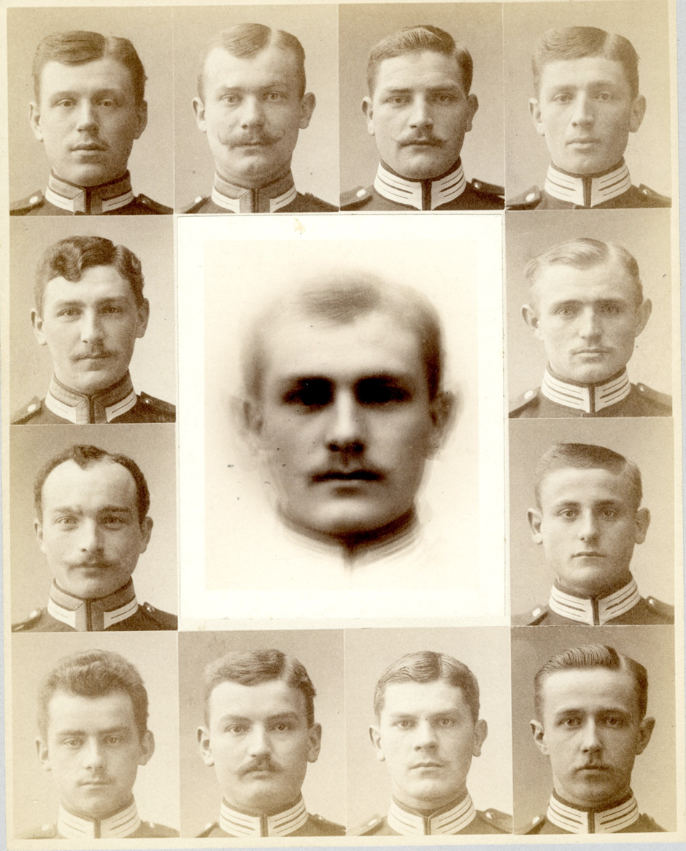
Fig. 1. H.P. Bowditch, composite photograph of Saxon soldiers, c. 1982.
This mind-boggling result was of course rather contrary to Galton’s predictions and undermined his search for ‘criminal features’, as he himself concluded in a report on the experiment:
It will be observed that the features of the composites are much better looking than those of the components. The special villainous irregularities in the latter have disappeared, and the common humanity that underlies them has prevailed. They represent, not the criminal, but the man who is liable to fall into crime.
However unhelpful in determining a criminal profile, the composite portraits are nonetheless very telling for our investigation of spectacular reflection, as they cast doubt on all of Freud’s proclamations about the fundamental limitations of the image as a medium supposedly incapable of going beyond the concrete, suited solely for the repetition of visual impressions. The composite eludes such a description, being neither a perception nor a recollection but, as Galton puts it, “a generalized picture; one that represents no man in particular, but portrays an imaginary figure possessing the average features of any given group of men”. The importance of this insight cannot be overstated: what follows is that we are dealing with a general concept captured in an image - the beauty of composite faces immediately calls to mind the Platonic intuition of kinship between ideas and ideals. The difference being, however, that this general schema is in no way imposed on nor pre-dates the senses, but constitutes an ideal born out of impressions or, to be precise, their mechanical counterparts: an image generated beyond the domain of spirit, but otherwise fully fitting the profile of what philosophy knows as universals, concepts or ideas.
Firstly, by dint of possessing a nature not quite real, but more one of a template or of an ideal - one of the basic features that differentiate concepts from impressions. Rather than being faithful copies of the world around us, our thoughts have a tendency to deviate from reality and strive towards perfection and refinement: to seek after beauty and order, harmony and proportion, to design grand utopias and ideal models. This divergence of reflection from sensory data accounts for philosophy’s forever unfailing search for an otherworldly source of our ideas in the pre-established kingdom of eternal schemas or the sovereign domain of the human reason. Nonetheless, the example of composite visions suggests there is no need for positing this sort of transcendence in order to account for the detachment of ideas from experiences, as their inherent idealism might have roots more mundane, being simply a byproduct of merging perceptions, covering reality with an extra layer of emergent, idealized generalizations, built upon impressions and their recollection.
The second important feature of composite visions which they share with concepts is general nature - the fact that they reduce the diversity of referenced objects to the unity of a single figure. Just like the tendency towards idealization, the effect of generalization is a byproduct of the procedure of image synthesis, which can be easily observed by repeating condensation in controlled conditions - i.e. by merging and comparing different sets of portraits. As such an experiment shows, any two composites will be remarkably similar even when the constituent faces are completely distinct. What is more, the larger the number of synthesized portraits, the more the resulting image tends towards the same universal schema.
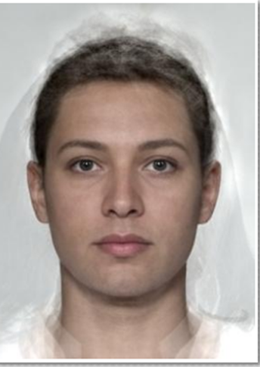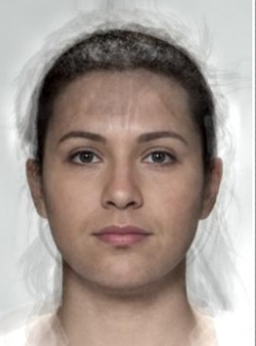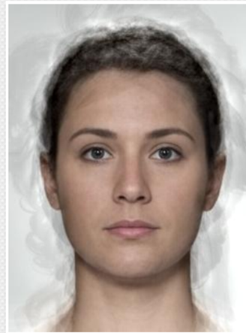
Fig. 2. Composites generated in Java Psychomorph (see: B. Tiddeman, M. Stirrat, D. Perrett, Towards realism in facial prototyping: results of a wavelet MFR method, in: Theory and Practice of Computer Graphics, June 2005), from the faceresearch.org database: http://faceresearch.org/demos/average. The above portraits were composed from three different sets of 10 photos (rows 4 and 3 shown for the first and second composite respectively).
This tendency of diverse individual faces to merge into one and the very same image, which stands before us like a Platonic ideal hidden behind the veil of sensory variation, seems at first like a trick or gimmick that defies common sense and all expectations. In the case of ideas, however, this effect is very familiar: the unifying character of conceptual thinking is nothing strange to us when we consider how easily we can be united under the common notion of a “human”, even if seeing this unity in the form of a concept-image feels rather uncanny.
Though perhaps this sight seems strange only in the daylight; for if Freud is to be believed, at night such composites populate our dream life whenever we encounter unfamiliar people, as well as places and objects we have never witnessed. The dream crafts such strangers by combining images from our recollections, condensing them together into these blank figures of everymen with no distinctive features, resembling everyone and no-one specific, which indeed bring to mind the nondescript, universal faces from composite photos. The Interpretation of Dreams offers countless descriptions of specific instances of such condensations - we will soon consider one famous example - but no philosophical diagnosis of these “concepts (...) formed from a number of individual perceptual images”. In light of what has just been said here about the images created by Galton it is not very difficult, however, to arrive at a hypothesis explaining their function: it seems clear that by generating condensed images of people and objects, our mind grasps common features uniting individuals into genres and species, and thus creates visual universals.
However fairly straightforward, this conclusion is also quite daring, as in crafting such visual concepts, our internal factory of phantasms does something that has not been dreamt of in our philosophy - at least not consciously - which largely upholds that reflective objects, such as universals, are by they their very nature invisible, if not non-sensory. This belief has rarely been questioned and is so well-entrenched in tradition, that even thinkers who have held the senses in largest esteem, never went so far as to claim that thinking is actually seeing, nor believed in experiencing the universal as visual sensation. The reasons for this distrust in the existence of visible ideas seem quite understandable and in line with logic: after all, our conscious perception presents us with nothing but individual instances and beings, making the whole idea of general vision seem like a hypothesis without any basis in experience. Furthermore, for some types of objects a general image seems difficult to imagine - the dog is one frequently referenced example serving as go-to evidence of the non-sensory nature of our notions. A species so familiar, yet at once quite extraordinary, as its breeds are so vastly diverse in appearance that it is hard to pinpoint what they have in common: is there anything that unites the slim, graceful and long-snouted greyhound, the stocky, flat-faced bulldog and the tiny, bug-eyed chihuahua? This diversity of canine appearance, pushed ad absurdum by human invention and pure-breeding practice, stands in stark contrast with the unity of the concept - the differences between breeds are almost as many as the forms of wax that once led Descartes to conclude that the idea which brings them together must be a purely intellectual, non-sensory construct.
Nonetheless, Freud’s discovery of oneiric condensations suggests that regardless of the challenges posed by more diverse categories of objects, in simpler cases our minds experience no problems with creating generalized images of the world around us. What is more, there are many good reasons to consider such visions something more than just whims of imagination, executed solely for the purpose of creating transient, brittle landscapes of our nightly dream life, and to recognize their more important, fundamental function: that of notions and of universals, the elementary units of reflection. Apart from their obvious kinship with what philosophy describes as ideas, another crucial incentive to approach these phantasms in all seriousness comes from a more recent field of investigations into the nature of thinking: that of research connected to artificial intelligence. The ongoing quest to emulate and mechanize the workings of the mind has recently demonstrated that the sort of images encountered in dream life can also be generated by neural networks designed to provide machines with the ability to generalize, which, as it turns out, makes them also capable of hallucinating - the visions thus rendered bear a striking resemblance to oneiric phantoms. In order to fully understand and appreciate the significance of this fact as well as the light it sheds on Freud’s discovery of visual thinking, we must first briefly examine the workings of such programs.

The Mechanics of Imagination

The neural networks in question were created to address the most primary and hence fundamental problem leading to the genesis of general concepts, one occurring below the level of thinking, on the plane of perception - the most basic use of universals takes place within this domain and consists in the ability to recognize things as such: people as people, tables as tables, cats as cats etc. Although seemingly trivial, the recognition of objects is really a complex task which requires us to see the world in general terms: to go beyond the mere perception of particular things, to compare them with one another or even themselves - recognition always involves reference and search for common features. It thus rests on the ability to create simple, categorical concepts - only seen through the prism of universals things appear to us “as such”, rather than as random aggregates of colours and lines: the capacity for this sort of outlook has long been the blind spot of mechanic vision, which registered the world not as a set of objects, but rather as a collection of pixels, which became meaningful and figurative solely in the eyes of human spectators tracing their resemblance to familiar objects, places, people, events etc.
The creation of machines capable of general vision is definitely a milestone in the ongoing journey towards the development of an artificial mind, as apart from most mundane uses, such facial recognition performed by digital cameras or the algorithms found on social media, the competence in question serves a purpose much more fundamental - generalizing is one of the preconditions for understanding words, and thus for reflection and intelligence. In order to master language one needs to comprehend the generality of linguistic reference, i.e. the fact that similar things can be described with one, common name, such as “dog” or “human”. Which is why only a program capable of tracing similarities between things is also able to verbally describe them. And although this might seem trivial from our perspective, for artificial intelligence it constitutes a liberating breakthrough: an escape route from the confined spaces of the Chinese Room, where mechanical minds have long been incarcerated not unlike the prisoners locked in Plato’s cave - as Searle’s famous metaphor showed, the use of language by computer programs was long limited to manipulation of purely verbal, referenceless shadows of ideas, making their understanding and communication comparable to that of a person conducting a conversation in a foreign language using a list of instructions specifying how its obscure phrases correspond to and succeed each other. In this form, mechanical use of language had nothing to do with human understanding, as it was limited to operating on symbols abstracted from any reference to reality; the invention of networks capable of seeing reality in general terms, however, has paved the way towards liberation from this abstract snare: for a machine that on top of processing words is also capable of identifying objects which they name, the void once gaping in the heart of the speech is filled with sight: the hitherto blind mechanical eye opens up onto new, uncharted horizons.
Regardless of the technical complexity of this enterprise, its implementation is surprisingly simple. To teach a program to perceive the world in general terms, a network modelled on the visual cortex - the neural structure responsible for processing visual stimuli - is presented with hundreds of images of particular types of things, for instance dogs or cats, labelled accordingly. With enough time and input, the network grasps the similarities between them and is able to correctly label a new image - just like the design of the network, and the learning process is modelled on the way humans learn to recognize and classify things. It should not be surprising that the resulting generalized image is also quite akin to human ideas, but nonetheless the researchers were somewhat astounded when they found that the networks can not only recognize a presented image, but are also capable of generating their very own visions, strikingly reminiscent of human dreams and hallucinations. With the aim of designing a mechanism for generalization, the researchers incidentally created a mechanical equivalent of imagination.
And it is indeed an extremely interesting invention, not in the least because the very idea sounds contradictory, as intuitively we tend to oppose the mechanical and creative powers: the former are thought to be repetitive and predetermined, the latter unique, unscripted and emancipated. Perhaps that is why, despite all the progress in the field of automatic thinking, nobody really expected the discovery of artificial imagination: it was born spontaneously as a side effect of research on mechanical generalization. This coincidence, however, brings to light something quite profound and not at all incidental, namely the unbreakable unity of cognitive powers: conceptual thought and imagination. And this unity is absolutely crucial for our considerations of the role of images in thinking - the fact that visions generated by the neural networks trained in object recognition and generalization are so similar to our dreams and other products of imagination simultaneously unveils the real function of these images and the true face of the universal: its secret identity of an oneiric condensation.
What is also important, the programs in question provide invaluable insight into the nature and genesis of visual notions, allowing for a more direct and intersubjective encounter than the transient and subjective realm of our nightly dreamscapes. In fact, by studying neural networks we can actually see their general concepts and determine what kind of an image lies beneath verbal labels such as “cat”, “human” or even find the elusive, ever-changing “dog” form. As seen from the perspective of the Deep Dream network on the classic depiction of dogs playing poker, in spite of the limitations of our imagination, a generalized portrait of these diverse pets is not that difficult to imagine: the composites created by the program all have very similar, slightly blurry snouts, which represent a dog’s most model appearance - essentially canine and at once devoid of breed-specific or individual features - decorated with halos of strange phantom ears, which reflect the spectrum of different positions they assume among different breeds.
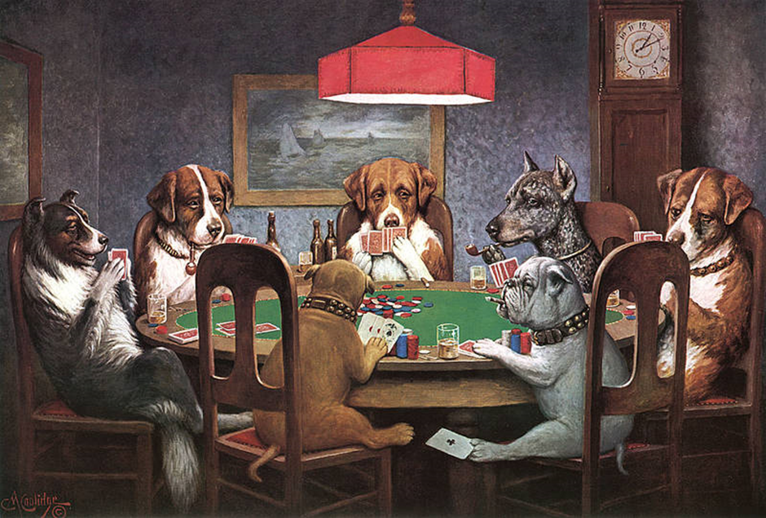.
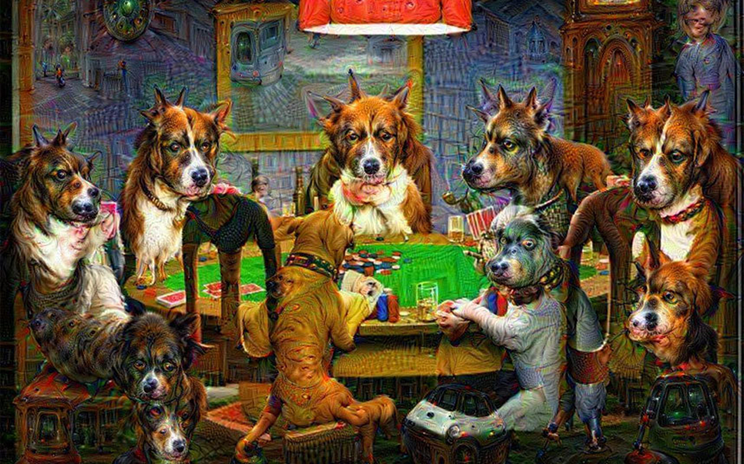
Fig. 3. C.M. Coolidge, Dogs Playing Poker, A Friend in Need 1903
Fig. 4. The painting Dogs Playing Poker processed by the Google Deep Dream algorithm, as shared by @brdskggs, Twitter, 5 July 2015: .https://twitter.com/brdskggs/status/617154800455696384
The typical features of concepts and condensations are even more striking if instead of processed photographs or paintings we consider images directly depicting the general schema created by a network based on its experience of various stimuli. Take for instance a generalized idea of dumbbells (fig. 5), which features a surprising bonus in the form of a muscular arm permanently welded to the handle - a mistake of this sort could only have been made by a disembodied imagination eyeing images of self-absorbed bodies. But despite the slightly humorous distortion this mechanical condensation looks like the never published illustration of all philosophical disputes about concepts: the hand attached to the weight serves as a pointed reminder of their empirical origins, while the fact that the dumbbells are simultaneously captured from all angles immediately brings to mind the Husserlian notion of an insight. Finally and most importantly, the mechanical generalization is very similar to the visions studied both by Freud and Galton: regardless of whether it is generated by the human mind, in the darkroom or among the digital synapses of a neural network, the generalized image is blurry, nonspecific and lacking in detail, as it only retains common features reflecting similarities between objects.
Fig. 5. A general image of dumbbells generated by Google Deep Dream.
A general concept created by a neural network has all the essential qualities of an idea as defined by the philosophical tradition, the only key difference being that it is generated without the participation of a subject - conscious or unconscious - by means of a purely mechanical procedure. The significance of this fact cannot be overstated, for at least two reasons. Firstly, the appearance of such visual generalizations as derivatives of categorical perception serves as yet another argument in favor of the theory of visual thinking - one wholly independent of easily ignored oneiric hallucinations - while the fact that the two are so similar reinforces the idea that the images appearing in our dreams are actually concepts. What is more, it also casts new light on these seemingly entirely subjective and irrational products of the human mind, pointing out their unbreakable connection to objectivity and the rational - for if our argument is correct, condensations are not some sort of weird, fantastical distortions or purely subjective products of our unconscious, but the elementary building blocks of conceptual thought based on the connections between objects. But before we further explore this idea and find out how these purely visual formations allow the dreaming mind to reflect, judge and argue, we need to first consider yet another important type of image-based notions identified by Freud in his study of oneiric language.

Rorschach test

Everything we have said so far about condensations applies as well to other visual formations known from psychoanalytic theory and practice: dreams, hallucinations and free associations all derive from the mechanism of generalization and constitute different types of concepts scattered around the axis of resemblance. Apart from rough-hewn generalizations based on global similarity between members of a type or species, both human minds and artificial neural networks manufacture images based on much more fragmentary, unstructured connections typical of what we usually expect of imagination - the sort of visions that appear before us in the most emblematic setting for all fantasies, lazily staring at the clouds and letting the mind wander to turn the roiling mass of steam into different objects: a mass of towering buildings, a flying bird, a dog’s head, a fish. The perception of such farfetched couplings involves yet another crucial mechanism of concept formation identified by Freud in his analyses: displacement, “the replacing of some one particular idea by another in some way associated with it”. Alongside condensation, displacement is one of the primary means of expression and another basic type of notion in the visual language of reflection - in fact on the level of form, these two mechanisms are all is needed to account for all visual formations occurring in dreams and generated by imagination.
In essence, the procedure in question consists in substituting people, objects, places for other people, objects, places etc. - any similarity or vague association, however partial or idiosyncratic, can serve as the basis of such a displacement. Since Freud’s perspective on dreams is of course affected by his general theory of the human psyche, as well as by the historical moment which reflects upon it, in analyzing such image he devotes most of his attention to sexual content - in light of his theory, oneiric visions are primarily the expression of hidden, unconscious desires, while displacements serve the purpose of allowing for the phantasmatic gratification of these repressed wishes by disguising them in innocent costumes, inoffensive to the essentially Victorian sensibilities of Freud and his patients. Thus, instead of pornographic visions the dreams of the society of this era present awkward scenes riddled with phallic and vaginal symbols: a rod, a cane, a spear, a riding crop, or any other elongated item serving as an allusion to the penis, while purses, caves, holes and other concave objects substitute the female vagina. As Freud himself notes, while considering an example of this sort of imagery: “the ugliest as well as the most intimate details of sexual life may be thought and dreamt of in seemingly innocent allusions.”
The accuracy of Freud’s interpretation of the function and mechanism of displacement is something we will need to reconsider shortly, but before we do this, we should note that artificial neural networks are also capable of producing visions based on this procedure. In order for a program to create images, it needs to be subjected to a kind of a Rorschach test which sets off a cascade of free associations and leaves the network behaving much like a human being staring at the clouds or rather, to be precise, one under the influence of psychedelic drugs or in the throes of schizophrenic psychosis: based on photographs, drawings, and even pure visual noise, the algorithms hallucinate fractal associations and every detail of transformed images seems to acquire new, surprising meanings. But while such visions in many ways resemble the paintings and hallucinations of addicts and madmen, and just like these images and dreams they involve the mechanism of displacement, there are also some noteworthy differences between them. For one, the artificial networks display a very different bias in their choice of substituted objects - while, if Freud is to be believed, the metamorphosis of images in our imagination is dominated by erotic themes computer algorithms have their own obsessions: Google Deep Dream, for instance, is much more into cats and dogs than sex and genitalia. The reason for this is of course quite simple - its initial training in object recognition was primarily conducted with pictures of animals. Thus, when capturing and amplifying the visual echoes that it recognizes, the network naturally works on previously acquired material.
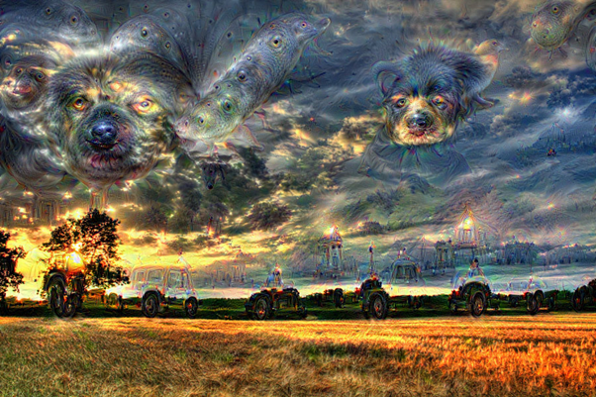
Fig. 6. An image processed by Google Deep Dream. Author: Jansen van Dok.
The crucial difference, however, between human dreams and computer generated visions is that the latter don’t have any meaning. They are simply the byproduct of the categories acquired by the network and some superficial resemblances between them: the overlapping of shapes and distant echoes of patterns such as clouds billowing and sheep wool, pointy leaves and animal ears, haystacks round like the wheels of vehicles or trees resembling high towers. In short, purely visual reflections of resemblance, which represent nothing but the visible similarity of relevant objects. Meanwhile, the displacements occurring in dreams, although also based on objective simile, have an added, subjective dimension: a false bottom where meanings are hidden. The key to unearthing the message they carry lies in understanding how visions can constitute judgements — because displacements, even though they may at first glance seem like whimsical vagaries of imagination, are actually concepts which allow the dream’s work to nonverbally express opinions and statements.

Visual statements

As everything we established so far indicates dreams seem to be displays of spectacular reflection - i.e. thoughts expressed as purely visual ideas which are neither depictions of linguistic statements nor simple reflections of the world, perceptions and recollections. In order to fully understand this mode of cognition, we must now consider how image-based concepts, displacements and condensations, translate into visual judgements expressing beliefs and descriptions without the mediation of language. Although at first sight puzzling, as fractal hallucinations and generalized faces seem quite distant from discursive statements, the answer to this question is easily found in The Interpretation of Dreams, which is largely devoted to deciphering the language of oneiric visions and illustrated with guiding examples: dreams whose enigmatic, visual form has been subjected to thorough analysis and translated into verbal statements. Let us consider this example, drawn from the author’s own famous dream:
The principal figure in the dream-content was my patient Irma. She appeared with the features which were hers in real life, and thus, in the first instance, represented herself. But the position in which I examined her by the window was derived from someone else, the lady for whom, as the dream-thoughts showed, I wanted to exchange my patient. In so far as Irma appeared to have a diphtheritic membrane, which recalled my anxiety about my eldest daughter, she stood for that child and, behind her, through her possession of the same name as my daughter, was hidden the figure of my patient who succumbed to poisoning. The same ‘Irma’s’ recalcitrance over opening her mouth brought an allusion to another lady whom I had once examined (...). None of these figures whom I lighted upon by following up ‘Irma’ appeared in the dream in bodily shape. They were concealed behind the dream figure of ‘Irma,’ which was thus turned into a collective image.
The oneiric character of Irma is therefore a condensation, but one which does not resemble the nondescript figures of Galton’s composites. Instead, it seems to represent a perfectly real person, one well known to the dreamer, which suggests that this image is not as general as the universals discussed earlier - just as waking thought cannot be reduced to general notes, oneiric reflection is not a mere collection of generalizations, but rather a “statement” on a given topic or, as in this case, a specific person. Irma, the dream’s point of interest, is thus represented in person, but nonetheless also functions as a condensation recalling behaviors and events that the dreamer associates with other people, which places the dreamed-of figure in a more general category - since all of them are either Freud’s patients or suffer from some disease, the condensation in question acts as a description: by grouping her with these people the dream pictures Irma as someone ill and in need of medical care. This fact is furthermore rendered in the form of a metonymic displacement, as the oneiric vision presents a situation of medical examination: Freud inspects Irma’s throat, which suggests that the sort of therapy her condition demands is of course psychoanalysis - the throat is part of the speech apparatus and psychoanalytic therapy is administered as conversation, by dint of which it’s sometimes jokingly referred to as the “talking cure” after a turn of phrase used by one of Freud’s patients.
The meaning of this whole scene is not exhausted, however, by simply describing Irma as someone in need of therapy. When combining many people into a synthetic subject, the dream also conducts a series of comparisons which are meant to express an opinion. As Freud explains when analyzing the meaning of this condensation:
Thus I had been comparing my patient Irma with two other people who would also have been recalcitrant to treatment. What could the reason have been for my having exchanged her in the dream for her friend? Perhaps it was that I should have liked to exchange her: either I felt more sympathetic towards her friend or had a higher opinion of her intelligence. For Irma seemed to me foolish because she had not accepted my solution.
The synthetic vision of Irma is thus a visual judgement, which portrays the patient as unwilling to accept Freud’s treatment, and thus foolish - the dream expresses a wish that she should be different by contrasting her with other, in his opinion more reasonable persons. The normative character of the image in question rests on the very same ground as its descriptive value: it is by dint of condensing - and therefore comparing - that one is able to judge and generalize. But also to capture and highlight particular traits: condensation, like a Galton photograph of the soul, allows to bring out the characters’ common features and thus to define them - the women compared here with Irma are also in need of therapy but “recalcitrant” to accept Freud’s treatment. This resistance is in fact depicted by a double symbol: once as condensation, where the feature in question remains somewhat unspoken and presumptive, and once as displacement, which gives it a more open form: since therapy is presented as the examination of the throat, allowing for a visual abbreviation to present the slow, long process of psychoanalysis in a momentary scene, resistance, in however many forms it may be encountered, boils down into one single gesture: refusing to open the mouth.
The use made by the dream of both these formations to convey the very same sense - the need for therapy and the reluctance to accept the cure - provides a great illustration of their kinship as well as divergence. Both rely on similitude as their basic tool - be it the similarity of condensed characters or examined organs - nonetheless, there is also a subtle difference between condensation and displacement as means of description: while the former combines the characters leaving the interpreter with the task of guessing what they have in common, the latter actually shows it’s their need for therapy and recalcitude. The reason for this has to do with an important structural difference between these two types of concepts - a difference in scale, as one stands for the whole, like the character, while the other represents a fragment, like an organ - which results in their varied function in creating visual statements. In order to fully grasp this distinction and its consequences we need to move back a step to the basic level of perception, however.
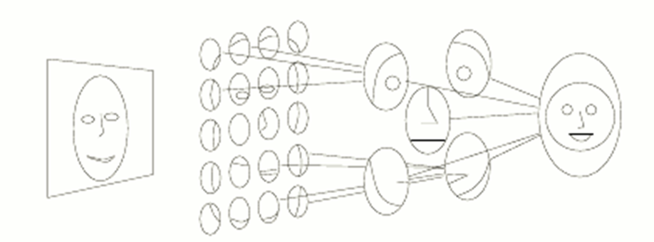
Fig. 7. An outline of the layers of a neural network.
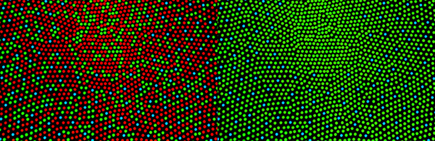
Fig 8. The cone mosaic in the human eye.
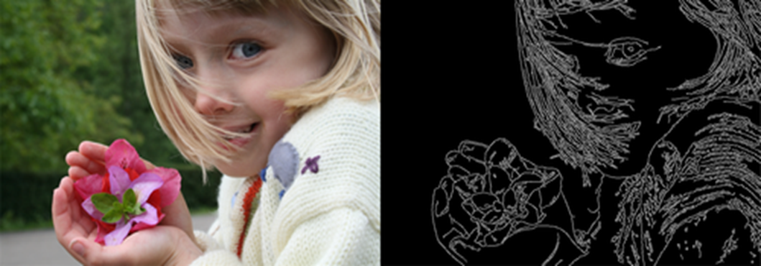
Fig. 9 Abstraction of contrasts.
The human visual cortex, as well as a neural network, perceives reality as a hierarchy of visual concepts arranged somewhat like a reversed history of painting: beginning with abstract points forming lines and curves, which gradually become the building blocks of shapes, first simple and fragmentary up to the most complex and complete gestalts (fig. 7). Thus, our perception is arranged in layers: first, the pixel-like structure of the cone mosaic onto which the reflection of the world is cast (fig. 8), next the lowest levels which comprehend contrasts and thus notice lines (fig. 9), which then form intersections and thus basic shapes, which further comprise more and more complicated structures. What this implies is that concrete objects, which we perceive as the most basic element of our field of vision, are in fact end products occupying the summit rather than the basis of the pyramid of impressions, built upon simpler visual concepts which comprise all images - like lines, angles, edges - i.e. the sort of notions we normally associate with abstraction in art and mathematics.
The visual formations which transcend perception, like oneiric concepts and hallucinations, operate on and transform impressions, and hence they incorporate and mimic their structure: condensations begin their work on the upper end of the spectrum and combine gestalts into general schemas, while displacements synthesize and generalize more fragmentary patterns which belong to the intermediate layer, somewhere between the freely flowing abstract line and the full object in its rich concreteness. This difference in composition of the images they generalize naturally translates into a difference in ensuing notions: whereas condensations create general categories of type, displacements typically reflect more partial simile, i.e. instead of notions such as “dog” or “human”, which capture the whole, they operate on ideas such as “elongated”, which describes both the riding crop and the male reproductive organ, “pointy” for leaves and animal ears, and “swirling” for clouds and wool. The concepts in question are often much more general than those produced via condensations, as their partial character creates a much wider field of comparison, but at the same time their fragmentary focus enables displacements to perform a descriptive function - whereas condensations capture things in their entirety, which makes them perfect ideas of type, substitutions are more useful for pointing out features and describing detail. Thus, in visual cognition these two types of concepts play roles analogous to, respectively, nouns and adjectives encountered in discourse.
The dream is in fact just as good as language at expressing judgments, opinions and wishes through visual means - that is by dint of the oneiric formations identified by Freud, displacements and condensations, which are inasmuch concepts as they are propositions, suitable for describing and evaluating. Such an interpretation conflicts somewhat with Freud’s own perspective, which presents these visual structures as deceitful distortions: tools of internal censorship, designed to protect our consciousness from inconvenient truths about ourselves. And although instances of such self-deception most certainly occur in our psyche, the reason our mind employs substitutions and condensations — instead of, shall we say, speaking its mind by simply reproducing a certain recollection or imagining a scene of wish fulfillment — does not necessarily lie in the supposed need to conceal what we would rather not remember. A much more crucial cause lies in the fact that the dream is not just a reminiscence or a wish fulfillment, but an expression of thought, and reflection is something quite different from remembering and from fantasizing.
Although this difference is certainly multilateral, on a certain fundamental level it boils down to the fact that reflection, as opposed to fantasy and to recollection, is not about the production or the reproduction of appearances - rather than recalling or generating an image of an object, it refers to it by means of a symbol, which in waking life is usually verbal, while in dreams takes on a visual form. And just like a word, a symbolic image is not the same as what it represents, despite, or rather besides, being also somehow similar: after all, if it were a faithful reflection of the thing represented, it would not be a symbol, but an illustration, merging with and dissolving in its designation. Thus, the simile which connects the symbol to its reference must necessarily be partial: a symbolic image must be alike but different, as the likeness allows it to refer to the object and “name” it, while the divergence maintains it as separate. Most importantly, however, the interplay of similarity and difference transforms an image from a simple copy of an object into an idea or thought on the subject: the condensation of things similar-yet-different unearths their common features, giving rise to the generality of cognition, while the focused and abstract character of displacement allows for their description - thoughts, unlike photographs, represent objects from a narrow angle. Thus for instance the dream about Irma is not her detailed depiction, but rather a metaphorical impression of a certain detail which bothers the dreamer, namely the fact that she needs therapy but is reluctant to accept Freud’s treatment. Similarly, in another one of his oneiric visions, his acquaintance is condensed with his uncle, known in his family as utterly foolish - here again instead of a faithful representation of the friend in question, the vision presents a distorted image which allows for expressing an unflattering opinion about the acquaintance, or, more plainly speaking, calling the man stupid. The same is true for other typical displacements, including Freud’s ever-favorite genital images: the riding crop, for example, doesn’t show the penis, but presents „the most striking characteristic of a phallus, its extensibility”. In fact, each of these oneiric visions distorts reality, but that is exactly how it describes it: rather than being an illustration of an object X, a symbolic image abstracts and emphasizes particular features, and thus becomes a statement that can be translated into a proposition like “X does/is Y”, e.g. “Irma needs therapy” or “my friend is stupid”. In effect, these images do not distort the truth but rather express it: displacements and condensations are meaningful symbols that capture and describe their references, and their divergence from what they represent is not an act of censorship, but a means of representation.

Waking dreams

As we have established, the spectacle of dreams is beyond doubt the staging of genuine visual reflection, perfectly capable of replacing its linguistic version: oneiric images are clear and self-sufficient concepts and expressions, often offering penetrating insights into the most inapparent issues and capable of envisioning not only the concrete, but also of grasping abstract and general problems. It thus seems that the spectacular model of reflection is no way inferior to discourse, especially since dream visions can be easily expressed in language and translated into verbal statements, which underpins the entire practice of psychoanalytic dream interpretation. What remains to be investigated is the relationship between these two models of cognition and representation: are words and images different sorts of concepts, each belonging to a wholly distinct mode of thinking, or perhaps merely different means of expressing the very same contents, sometimes echoed in the sounds of language, at times captured on the canvas of our shut eyelids?
Freud’s work provides no unambiguous answer to this question - after all, the idiosyncrasies of oneiric thinking are not his main focus, and even when he correlates dream images with discourse, he does not aim to systematically compare and contrast them nor to thoroughly analyze their relations. Thus, his thoughts on the topic are more of a loose collection of stray observations. In one of them he suggests that „there is no necessity to assume that any peculiar symbolizing activity of the mind is operating in the dream-work, but (...) dreams make use of any symbolizations which are already present in unconscious thinking”. He does not indicate, however, where to search for them, which is precisely the most pressing question, as in waking cognition the objects of thought don’t appear in the form of visual symbols. Which does not necessarily mean that such images are not present somewhere, after all they might be concealed by the visual orientation of our perception - as our eyes are occupied with immediate vistas, reflection understood as the recollection and processing of visions inevitably disappears behind the scenes of sensory impressions. But perhaps just as words can be found under the guise of oneiric visions, so too during daytime images are hidden beneath discourse? Perhaps we do not only dream while sleeping, but also while awake and thinking in language, as behind the veil of perception and the verbal stream of consciousness there is a parallel succession of unconscious visions that mirror our statements?
Such a supposition, however quite tempting, seems nonetheless too simplistic, for if we imagine reflection as a double current with a stream of visions flowing alongside a sequence of language, we are modelling our concept of thought on that of a sentence, while in fact verbal and visual symbols cannot be simply equated: they are distinct both in respect to form as well as relation to content. Images are spatial and hence occupy at least two dimensions, whereas language seems purely temporal and forms a linear, one-dimensional sequence. But what is even more striking is how much they differ as means of creating meaning: the sense of visual symbols rests on their simile to referenced objects, making their mutual connections quite tight and revealing, while linguistic signs are purely arbitrary and establish themselves upon difference. Its two key dimensions find their most known formulation in de Saussure’s theory, wherein he compares the sign to a double-sided piece of paper or a playing card with a signified concept on one of the sides and a verbal signifier on the other: unlike a pictogram the signifier does not signify by means of simile, but remains unconnected to its reference, like the rank or suit whose value and meaning arises only as a function of distinction from the other ranks and has nothing to do with the image - typically an abstract pattern - found on the back of the deck. The same seems to be the case for language, where a word is in no way similar to what it signifies, but rather, like a rank in cards, signifies insofar as it is differentiated from other verbal signs, with differences in phonemes translating into different meanings (as for e.g. the difference between n and m creates the distinction between night and might). In de Saussure’s opinion, this differential view of verbal symbolism is the only possible explanation of the mystery of meaning, given the arbitrary character of language:
Since one vocal image is no better suited than the next for what it is commissioned to express, it is evident, even a priori, that a segment of language can never in the final analysis be based on anything except its noncoincidence with the rest. Arbitrary and differential are two correlative qualities.
Thus, what results is the notion that “a linguistic system is a series of differences of sound combined with a series of differences of ideas” - a doctrine which is central to the understanding of language and meaning not just for de Saussure, but also various other 20th century traditions ranging from cybernetics and the theory of information to structuralist and poststructuralist theories of discourse. But while this vision of language is certainly an accurate description of its verbal layer, it hardly unravels the mystery of meaning, for if the system of symbols relied on pure difference, it would be doomed to perform a properly Sisyphean, never-ending labor of differentiating between infinitely multiplying senses in order to reflect the entire diversity of the world it captures - the difference-centered perspective on symbolic systems implies a strange discourse consisting of proper names only and a futile quest to recreate in language the rich tapestry of the real down to every detail. Such a vision of language seems both impossible and simply erroneous - our speech does not differentiate ad infinitum, on the contrary, it is capable of capturing a great diversity of experiences in a much more limited, easily grasped system: the vocabulary of an average speaker consists of about 5000 words, an absolutely miniscule figure next to the number of stimuli processed, estimated to be about 11 million per second.
Hence, it seems clear that the claim that in language “there are only oppositions”, and that sense is essentially a question of difference, does not account for a crucial aspect of the genesis of meaning: namely, the creation of general concepts, which underpins the existence of general terms and thus creates the conditions for the rise of language - the majority of words that comprise it are after all various common names, combining a multitude of concrete objects or experiences under the umbrella of a single term. Neither differences between sounds nor between ideas can explain or found this generality of vocabulary, since what allows a word to describe a multitude of objects is hardly a difference, but rather the similarity of referenced objects: language, this system of arbitrary differences, would not be able to function without grounding in real similes. Thus, despite the gulf separating the waking and dreaming orders of representation, there are many reasons to presume that one assumes the other and bases itself on it - just despite Freud’s positing of dream images as poor copies of verbal expressions, it is in fact language that seems derivative and depends on visions. Its ability to contain the rich tapestry of reality in a comparatively poor vocabulary, a limited set of differences, is mediated by objective similarities and their condensation into general concepts.
This conclusion challenges some of our most rooted ideas concerning the nature of reflection - from the perspective of dreams, thought looks very different than when it is heard of: it is simultaneously more fantastical, more akin to hallucination, and more real, more truly objective. The imaginary visions which comprise reflection bridge over the gap between mind and matter, being as much the works of the subject as they are derived from actual objects, their features and relations, which perhaps is best illustrated by typical universals, like concepts of species’: a generalization grounded in genetics, this mental representation of real-life copies once fooled Plato into thinking ideas are at once intelligible concepts of the common and ontogenetic forms, responsible for the creation of similar things. As we know now, however, real-life reproductions are in no way copies of transcendent ideals, but in fact unfaithfully copy one another, while the ideal image is a creation of the mind. These two poles: the fantastical, imaginary character of the concepts, and the reality of similar objects, define our reflection, which as much an image of the real as its transformation. Thus, the line of kinship between things and ideas that our dreams reveal, although it certainly brings thought closer to the object, does not make it its faithful reflection, but rather decentralizes cognition, moving it further away from the subject and opening it up to the external world: a network of sights and patterns that connect them. And this is what Freud’s discovery of oneiric thinking, along with the resulting possibility of penetrating the black box of thought - the seeing of concepts - adds to our understanding of reflection: when considered through the prism of oneiric visions, thought turns out to be an image of the world seen through the closed eyes of a dreaming subject.

Michel Foucault, The Order of Things, (New York: Routledge, 2002), 40.
Hannah Arendt, The Life of the Mind / Thinking (San Diego: Harcourt, 1981), 76.
Ibid., 110.
The former are primarily sensualist doctrines that derive concepts from sensations and analytic philosophies that reduce them to representations of sensory data (e.g. the theories of Locke, Hume, Wittgenstein, the proponents of the Vienna Circle, to name just a few doctrines falling within the scope of understanding cognition as representation of empirical experience). The most important examples of the latter are, besides Plato, the theories of Husserl and Descartes. More on the history of conceptualizing reflection as sight in: The Noblest of Senses: Vision from Plato to Descartes and Dialectic of EnLIGHTment in: M. Jay, Downcast Eyes. The Denigration of Vision in Twentieth Century French Thought (University of California Press, 1993)
There are some exceptions to this rule: a handful of concepts that admit images a certain, albeit often indirect or even inferior, importance in thinking. Two of the most renown figures in the history of philosophy that ought to be mentioned in this context are Kant and Nietzsche: the former for considering imagination as a force that mediates between sensory material and concepts, the latter for seeing ideas as afterimages of the visuals that bore them, metaphors congealed and forgotten. It is 20th century philosophy, however, that constitutes a breakthrough in seeing the image as part of reflection, with the emergence of theories postulating the existence of a sphere of visual reflection separate from discourse: this idea is developed on the one hand by researchers influenced by the discoveries of anthropology (such as Gaston Bachelard and Gilbert Durand), who find its expression in the symbolic language of mythology; and on the other hand by philosophizing art historians and theorists of visual culture, who view art as a vehicle of thought different from, but equal to verbal reflection (like Gottfried Boehm, a representative of Bildwissenschaft, the German “study of images”) or even as the key to understanding the latter (like Rudolf Arnheim, the author of Visual Reflection).
Arendt, The Life of the Mind / Thinking, 8 & 120.
Sigmund Freud, A General Introduction To Psychoanalysis, tr. G. Stanley Hall (Project Gutenberg digital edition based on New York: Livewright, 1920), 69
Sigmund Freud, The Interpretation of Dreams, tr. J. Strachey (New York: Basic Books, 2010), 296.
According to Freud, oneiric visions are not merely insights, but something similar to daydreams we sometimes indulge in - virtual wish fulfillments, projections of experiences satisfying desires - and this is the true point of focus of his inquiry into dreams, as well as into the workings of the human psyche in general.
Freud, A General Introduction to Psychoanalysis, 145
Ibid., 149
As are our oneiric visions: “visual images constitute the principal component of our dreams. The contributions from the other senses, except for that of hearing, are intermittent and of less importance”. Freud, The Interpretation of Dreams, 64.
Ibid., 328.
Freud, A General Introduction to Psychoanalysis, 145
Freud, A General Introduction to Psychoanalysis, 146
Freud, The Interpretation of Dreams, 328.
Freud, The Interpretation of Dreams, 354.
Freud, A General Introduction to Psychoanalysis, 145
Freud, The Interpretation of Dreams, 358.
Freud, A General Introduction to Psychoanalysis, 97
Ibid., 96. Translator’s note: retranslated as the English version cited distorts the original wordplay.
Ibid.
Ibid., 97.
Freud, The Interpretation of Dreams, 415.
Freud, The Interpretation of Dreams, 328.
Freud, A General Introduction to Psychoanalysis, 150
Freud, A General Introduction to Psychoanalysis, 142.
Ibid., 142.
Freud, The Interpretation of Dreams, 311.
F. Galton, Inquiries into Human Faculty and its Development, first digital edition 2001, based on the second edition (Macmillan 1892), 224.
Ibid., 222
It needs to be noted that this unifying feature of reflection receives varied appraisals. It is admired by some as the ability to capture universal forms and criticized by others as false unity artificially forced onto the world by cognition, violently imposing identity where, in reality, variety prevails. An interesting critique of the universalizing pretensions of visual concepts, referring precisely to Galton’s composites, was put forward by Leszek Brogowski in the article On the ideal turned into a joke. Francis Galton’s composite photography and its reverberations (L.Brogowski, O ideale obróconym w dowcip. Fotografia kompozytowa Francisa Galtona i jej oddźwięki., Dyskurs nr. 15, 2013]). Quoting, among others, Kant, Wittgenstein and Freud, all of whom analyze such images in their works, Brogowski question their epistemic value - that is, Galton’s belief that composite portraits capture the characteristic traits of a type: a criminal, a member of a race or family - as well as their aesthetic value. His criticism of the tradition of understanding and viewing human beings through the prism of a common, universal ideal, is based on the belief in the existence of a multitude of ideals that ultimately comes down to the multitude of beings, and the conviction that all attempts to unify and reduce this variety to a common pattern are fundamentally oppressive - Brogowski takes the side of a tradition decisively critical of metaphysics, to which any “craving for generality” is in fact a “contemptuous attitude towards the particular case” [L.Wittgenstein, The Blue and Brown Books (1958), as quoted by: L.Brogowski, O ideale obróconym w dowcip. Fotografia kompozytowa Francisa Galtona i jej oddźwięki., Dyskurs nr. 15, 2013]. His analyses, although certainly interesting and ethically valid, are not as convincing from an epistemological perspective, however, as composite images or general concepts seem to be absolutely crucial for reflection - we will consider their functions in more detail in the following sections. But before we turn to these considerations, it is worth noting that Galton’s method, considered pseudoscience for decades, is now undergoing a renaissance thanks to the research of the psychologist Michał Kosiński, who uses it to assess sexual proclivities. The difference is that where Galton mostly improvised his assessment method, Kosiński uses neural networks, which are able to predict the sexual preferences of an individual based on a single photo with an accuracy of 81% for men and 74% for women. [More on this in the article: P. Lewis, ‘I was shocked it was so easy': ​meet the professor who says facial recognition ​​can tell if you're gay, The Guardian, 7 July 2018] Though this whole research project is at the very least morally dubious - much like Kosiński’s other research projects, implicated in the electoral interference scandals related to the Brexit referendum and the 2016 US Presidential election - the effectiveness of his method certainly makes one think, as it shows we cannot easily dismiss the epistemic value of visual generalizations, even in a field as seemingly absurd as judging one’s character, desires and preferences by appearance.
This process does not apply only to human figures, but also all objects appearing in our dreams, because “one can make a compound formation of events and of places in the same way as of people, provided always that the single events and localities have something in common which the latent dream emphasizes” (Freud, A General Introduction to Psychoanalysis, 142).
Freud, The Interpretation of Dreams, 340
This is true of both empiricists, convinced of the purely sensory genesis of all ideas, as well as the representatives of the transcendental tradition, who emphasized the significance of perception and imagination for human cognition. Hume, for instance, although he believed that “all ideas are derived from impressions, and are nothing but copies and representations of them”, was also convinced that “all general ideas are nothing but particular ones, annexed to a certain term”. [David Hume, A Treatise on Human Nature, Section VII: Of abstract ideas (Digital edition based on: Oxford: Clarendon Press, 1896)] Husserl, on the other hand, did believe in the intellectual perception of universals - in eidetic seeing - but nonetheless did not consider it seeing in the literal sense of this term: “the intuition of essence has as its basis a principal part of intuition of something individual, namely an appearing, a sightedness of something individual, though not indeed a seizing upon this nor any sort of positing as an actuality; certainly, in consequence of that, no intuition of essence is possible without the free possibility of turning one’s regard to a “corresponding” individual and forming a consciousness of an example — just as, conversely, no intuition of something individual is possible without the free possibility of bringing about an ideation and, in it, directing one’s regard to the corresponding essence exemplified in what is individually sighted; but this in no respect alters the fact that the two sorts of intuition are essentially different” [E. Husserl, Ideas pertaining to a Pure Phenomenology and to a Phenomenological Philosophy, trans. F. Kersten, MARTINUS NIJHOFF PUBLISHERS, Hague / Boston / Lancaster 1983]. One exception to this general disbelief in the visual experience of universals can be found, however, in Kant’s philosophy. As an extremely insightful observer of the human mind, Kant discovered and described condensations even before the invention of photography: in the Critique of Judgment we find a description of complex images generated by imagination, which Kant defines as ideas of the norm, assigning them a purely aesthetic function of templates or ideals. As he notes, these visions are created from the congruence of most images of the same kind it arrives at an average that serves as the common standard for all of them. For instance: Someone has seen a thousand adult men. If now he wishes to make a judgment about their standard size, to be estimated by way of a comparison, then (in my opinion) the imagination projects a large number of the images (perhaps the entire thousand) onto one another. If I may be permitted to illustrate this by an analogy from optics: in the space where most of the images are united. and within the outline where the area is illuminated by the color applied most heavily, there the average size emerges, equally distant in both height and breadth from the outermost bounds of the tallest and shortest stature; and that is the stature for a beautiful man. [I. Kant, Critique of Judgment, tr. W.S. Pluhar (Indianapolis: Hackett, 1987), 82] The acknowledgement of the existence of such visions, along with other visual aesthetic ideas, did not, however, significantly affect Kant’s theory of cognition, according to which concepts are purely discursive entities. And although Kant did ascribe to imagination, operating on what he termed “schema”, the important function of mediating between the generality of concepts and concrete experience, he did not consider the latter images. Thus, the transformation of sensual experiences into categories and notions proved for him an ultimately mysterious operation: “This schematism of our understanding with regard to appearances and their mere form is a hidden art in the depths of the human soul, whose true operations we can divine from nature and lay unveiled before our eyes only with difficulty.” [Immanuel Kant, Critique of Pure Reason, tr. P. Guyer, A.W. Wood (Cambridge: Cambridge University Press, 1998), 273]
René Descartes, Discourse On Method and Meditations on First Philosophy (Indianapolis: Hackett Pub. Co., 1993).
Some of the insights concerning the similarity of images produced by neural networks and oneiric visions contained in this chapter have already been put forward in an article of mine published elsewhere (references removed for the purpose of anonymity).
John Searle, Minds, Brains and Science (Harvard University Press, 1984)
Consider as an example the first conversational bot, Eliza, built at MIT in the mid-1960’s by researcher Joseph Weizenbaum. The name of the program obviously alludes to the heroine of Shaw’s Pygmalion, whom the upper-class protagonists taught “proper” speech patterns, having made a bet as to whether she could fool members of the “elite” into believing she belonged to the higher classes. Alan Turing proposed a similar challenge for computers, suggesting that a program that could trick a human into thinking they are talking to a real person deserves to be credited with intelligence. The mechanical Eliza takes a rather quirky approach to this challenge, as the program was created as a parody of the psychotherapist Carl Rogers, famous for his minimalistic therapeutic method which consisted in simply listening to his patients and occasionally echoing their statements in the form of questions - Eliza likewise converts any given statement into a question. By means of this simple method she is able to hold a conversation without any knowledge of supralinguistic reality, basing her whole discourse solely on a script for converting declarative sentences into interrogatives. Interestingly, the program performs quite well on the Turing test: Weizenbaum’s secretary, who first tested it, asked the researcher to leave the room after just a few minutes of a conversation, as her chat with Eliza had delved into deeply personal topics. None of this, however, changes the fact that the bot in question comprehends speech about as well as a human applying its script could be considered to understand a foreign language - i.e. not at all, as the script provides no insight into meaning, describing solely the syntactic rules for transforming statements: the language the program operates on is entirely self-referential. For more on Weizenbaum’s program see Adam Curtis’s film Hypernormalisation (Hypernormalisation, directed by Adam Curtis, BBC, UK 2016).
For more on the detailed workings of object recognition by neural networks see for e.g. Alex Krizhevsky, Ilya Sutskever, Geoffrey E. Hinton, ImageNet Classification with Deep Convolutional Neural Networks, available at: https://papers.nips.cc/paper/4824-imagenet-classification-with-deep-convolutional-neural-networks.pdf accessed 29/10/2019. For a more popular account, see: C. Koch, Do Androids Dream?, Scientific American Mind, November/December 2015.
It is worth noting, however, that the fact that these concepts are somehow similar does not mean they are identical: mechanical visual concepts differ in many ways from categories created by the human cognitive apparatus. Neural networks may erroneously classify abstract patterns as concrete images, and for example recognize a bus in a patch of colors typical for such vehicles. As the authors of the article Deep Neural Networks are Easily Fooled: High Confidence Predictions for Unrecognizable Images suggest, such mistakes show that the categorial concepts of neural networks are typically based on more detailed characteristics rather than general structure. Nonetheless, differences of this sort do not lessen the significance of the similarities between neural networks and the human mind. [see: A. Nguyen, J. Yosinski, J. Clune, Deep Neural Networks are Easily Fooled: High Confidence Predictions for Unrecognizable Images, Computer Vision and Pattern Recognition (CVPR ’15), IEEE, 2015].
A. Mordvintsev, C. Olah, M. Tyka, Inceptionism: Going Deeper into Neural Networks, Google AI Blog, 17 June 2015, Creative Commons Attribution 4.0 International License: https://creativecommons.org/licenses/by/4.0/: https://ai.googleblog.com/2015/06/inceptionism-going-deeper-into-neural.html
Freud, The Interpretation of Dreams, 354.
Ibid., 388.
Ibid., 360. This comment is of course followed by an example of a typical dream of this sort recounted by one of his patients, an ageing spinster: “I will now append the ‘flowery’ dream dreamt by one of my women patients (...). I have indicated in small capitals those elements in it that are to be given a sexual interpretation. The dreamer quite lost her liking for this pretty dream after it had been interpreted: (..) she was holding a BIG BRANCH in her hand; actually, it was like a TREE, covered over with RED BLOSSOMS, branching and spreading out. There was an idea of their being cherry-blossom; but they also looked like double CAMELLIAS, though of course those do not grow on trees. As she went down, first she had ONE, then suddenly TWO, and later again ONE. When she got down, the lower blossoms were already a good deal FADED. Then she saw, after she had got down, a manservant who—she felt inclined to say—was combing a similar tree, that is to say he was using a piece of wood PIECE OF WOOD to drag out some THICK TUFTS OF HAIR that were hanging down from it like moss. Some other workmen had cut down similar branches from a GARDEN and thrown them into the road, where they lay about, so that A LOT OF PEOPLE TOOK SOME. But she asked whether that was all right—whether she might TAKE ONE TOO. A young MAN (someone she knew, a stranger) was standing in the garden; she went up to him to ask how branches of that kind could be TRANSPLANTED INTO HER OWN GARDEN. He embraced her; whereupon she struggled and asked him what he was thinking of and whether he thought people could embrace her like that. He said there was no harm in that: it was allowed.” (Ibid., 361).
Free association performed by a neural network consists in emphasizing all similarities noticed by the program in a given image, no matter how distant or partial, and can be performed either freely - wherein the network decides what associations will be strengthened - or in a controlled manner, where the human operator chooses the displacements.
Freud, The Interpretation of Dreams, 310
Ibid., 145
A.Zucconi, Understanding Deep Dreams, www.alanzucconi.com 6 July 2015, accessed on 11 August 2019: https://www.alanzucconi.com/2015/07/06/live-your-deepdream-how-to-recreate-the-inceptionism-effect/
M. Fairchild, CC BY-SA 3.0 https://creativecommons.org/licenses/by-sa/3.0/, accessed on 11 August 2019: http://rit-mcsl.org/fairchild/WhyIsColor/images/ConeMosaics.jpg
JonMcLoone, Edge Detection Applied to a Photograph, CC BY-SA 3.0 https://creativecommons.org/licenses/by-sa/3.0/, accessed on 11 August 2019: https://commons.wikimedia.org/wiki/File:Ääretuvastuse_näide.png
Ibid., 163
Freud, The Interpretation of Dreams, 391.
Additional support for such an interpretation of displacement and its role in dreaming comes from the fact that, according to Freud himself, even in cases of issues that should not be censored, e.g. non-sexual physiological stimuli, the dream “seeks to represent the stimulus-producing organ by means of objects resembling it”, and so “does not simply reproduce the stimulus, but it elaborates it, it plays upon it, places it in a sequence of relationships, replaces it with something else” [Freud, A General Introduction to Psychoanalysis, 74].
The problem of abstract visual concepts has hardly been mentioned, as this topic is extremely complex and requires thorough explanation, impossible to contain within the word limit of this article - it is discussed in detail in the thesis on which this article is based, however. Nonetheless, some of the oneiric visions considered earlier contain abstract images: for instance, the dream image of Freud’s patient’s “brother sitting in a box or closet” constitutes a visual metaphor of invisible, mental limitations. As I try to show in the aforementioned thesis, similar displacements comprise most of our abstract concepts which appear regularly not only in dream life, but also in its discursive reflection. Such images can easily be traced in etymological connections between concrete and abstract terms - such as, for example, the already mentioned terms which describe cognition as vision or sight: i.e. reflection, theory, idea. Moreover, they are also prevalent on the more complex level of phrasal expressions, like for instance “coming out of the closet”, or various metaphors which describe the passage of time as movement: flowing, running, passing. The most exhaustive study of such metaphors fixed within our language can be found in the works of Lakoff and Johnson. [see: e.g. George Lakoff and Mark Johnson, Metaphors We Live By (University of Chicago Press, 2003)]. Abstract concepts which use concrete images taken from our everyday experience - such as running, seeing or closet - in order to capture invisible processes, are not the only kind of abstract visual notions, however. Our reflection also contains a level of purely abstract images: namely, the most basic concepts which comprise our vision - points, lines and simple patterns, perceived by the lowest layers of the optical cortex. As I try to show in the aforementioned thesis, images of this kind are in fact the concepts which comprise the most abstract of all sciences: mathematics.
Freud, The Interpretation of Dreams, 363.
Ferdinand de Saussure, Course in General Linguistics, tr. W. Baskin (New York: The Philosophical Library, 1959), 113
Ibid., 118.
Ibid., 120
Ibid., 121
This decentering of reflection is all the more striking when we consider its visual than discursive form, whose arbitrary and artificial character effectively masks the fact that it is not simply the work of the subject. Thus, it is most clearly visible is dreams, which come neither from without nor from within and surprise the dreamer himself, even though they are born within him: this mysterious and spontaneous process is what Freud described as the unconscious and Lacan as the automaton - both terms, each in its own way, indicate that we are dealing with autonomous self-regulation that neither needs nor accepts control from consciousness. The fact that visual concepts can also be produced mechanically provides an even more striking illustration of the autonomy of cognition, suggesting that thinking requires far less participation from the subject than usually believed, being in certain ways something akin to reality with its stubborn independence from our own pretensions to agency.

