Fintech: Creative Innovation for Entrepreneurs
Youssef M. Abu Amuna¹, Samy S. Abu-Naser², Mazen J. Al Shobaki ³, Yasser A. Abu Mostafa ⁴
^{1,2,3}Department of Information Technology, Faculty of Engineering and Information Technology, Al-Azhar University, Gaza, Palestine
⁴Head of Business Administration Department, Faculty of Business and Management, Palestine University, Gaza, Palestine
Email: ¹yabuamuna@gmail.com, ²abunaser@alazhar.edu.ps, ³mazen.alshobaki@gmail.com, ⁴y.mostafa@up.edu.ps
Abstract: The article studies the impact of Fintech on entrepreneurship in Arabic region by using Crowdfunding platforms as the field of study. The article focuses on Arabic Crowdfunding platforms. The population of (12) platforms consist of: individuals, entrepreneurs, investors, employees at Crowdfunding platforms. Descriptive and quantitative approach used in this article, and a questionnaire used as a tool to collect primary data. The results indicate an impact for Fintech on entrepreneurship in general and obvious obstacles to use it widely in Arabic region cause of legislations or e-payments. The article recommended more awareness for innovative products and services such as Fintech, Crowdfunding and adopting the culture of e-business models. Also the article promoting the process of developing regulations that organize e-business models, especially Fintech and Crowdfunding, the use of modern communication technology to serve the development of society, more interest to innovation and creativity as a key factor for entrepreneurial success.
Key words: Fintech, Crowdfunding, entrepreneurship, e-payments.

Introduction
Entrepreneurship is one of the most important issues in the economies and growth of countries and is the real engine of social and economic development. Entrepreneurship remains the best hope for any country to prosper. As societies seek to meet their operational requirements, the importance of caring for a new generation of entrepreneurs, both from employers and those with entrepreneurial spirit, is crucial.
Governments have become increasingly interested in the entrepreneurial trend in economic revitalization, which has led to an increase in the number of government and international institutions to sponsor and assist entrepreneurs. Those institutions provide special financial and technical support to entrepreneurs to enable them to establish their own projects, leading to an increase in the number of Entrepreneurial projects, reducing the unemployment rate, developing creativity and innovation and achieving real economic development. [1]
Project financing remains one of the major constraints facing innovators, inventors and entrepreneurs who want to grow and expand. This problem is considered the most important obstacle to the owners of projects in third world countries in general, and the Arab region in particular. [2]
The decentralized nature of the Internet and the growth of social media have revolutionized financing around the world. Online fundraising efforts are freed from the strict limits and hierarchies imposed by traditional institutions and donors and the power of local and global networks is used to obtain financial support for projects and ideas.
This type of shift in contemporary finance is called Crowdfunding, one of the most important factors influencing the spread of this contemporary type of finance is the availability of contemporary Internet-based financial technology, which allows easy exchange and transfer of funds [3].
Fintech, which is known as financial technology is one of the most creative innovations to facilitate transferring money through internet. This new tool raised more than (109$) billion between (2009-2017).
The objective of this study is to determine the Fintech using in Arabic region, how far this tool is exist and how entrepreneurs benefit from it. In view of the literature review, the study raises the question of:
Q1. How far Fintech used in Arabic region?
Q2. What is the impact of Fintech on entrepreneurs?
Q3. How can benefit from Fintech in Crowdfunding campaigns?

2. Literature Review
2.1 Fintech innovation
Fintech platforms use Web 2.0 technologies and applications from the Web 2.0 (interactive generation) that allows users to create their own content, control their data, share and interact freely. Previously, the first-generation Web 1.0 logo was "people taking information" while Web 2.0 worked on data editing and abandoned the first-generation data-control principle, such as Netskype. [4]
Web 2.0 has influenced many areas such as media, commerce, e-learning and all aspects of life related to the use of the Web. This term was first introduced in 2004 by Tim O'Reilly and Dale Dougherty, who used the term to describe modern technology trends and defined a set of characteristics like: interactivity, collaboration and user participation. Mchaney & Sachs (2016) define it as "widespread social networks that include a range of participatory applications and tools" [5]
Bottigli & Pichler (2016) summarize these characters as following: [6]
1- Works in integrated manner with Web 1.0 technology.
2- Representing different geographical areas.
3- Ability to design effective web pages.
4- Flexibility and ease of use.
5- Low cost.
6- Interactive multimedia due to the modern technology used.
7- Use data from other sites such as Google Maps and social networks like Facebook and Blogs.
8- More connected digital tools and applications on the Internet.
The current technological focus of Financial Institutions needs to follow the trends that Fintech companies are setting. Currently, financial institutions are concentrating on updating their legacy systems with a strong focus on data analytics and mobile technology.
While most incumbents are struggling to consolidate and manage data and to offer digital customer-service experiences, Fintech companies are putting their spotlight on emergent technologies. Innovators excel at providing products that make existing user experiences better. These developments include technologies such as enhanced biometric security, natural language searches, and chatbots. As they adopt these solutions, they are not only focusing on enhancing client service but also on improving efficiency, reducing costs, increasing security, and making processes more agile. Blockchain, AI, and Biometrics and Identity Management are high on their priority list.
Fintech companies are driving market changes by focusing on emergent technologies that will provide a renewed experience for their customers. As incumbents adapt to the market and begin to concentrate on these technologies, they will be able to move closer to Fintech, make use of the technologies to swiftly adjust to the fast-changing environment and regulations, and ultimately provide a better consumer experience.
Financial technology is defined as "Technology-based products and services to improve the quality of traditional financial services and to provide new financial solutions, which are faster, cheaper, easier and more accessible. In most cases these services and products are developed by emerging companies". [7]
Laws regulating financial technology (Fintech) are the key to the success of e-business models. Emerging companies in Fintech are small, emerging companies that seek to expand by creating new markets or acquiring a significant share of existing markets by offering value propositions and promises to improve retail and corporate banking in cooperation or competition with existing financial service providers. [8]
Innovation in the financial field was adopted lately in comparison to the fields of media, trade and communications. However, 7,500 startup companies in the field of financial technology received investments of more than $ 109.8 billion during the period between 2009 and 2017. The rise in investment in financial technology is due to several centers: Silicon Valley, New York, London, Berlin, Bangalore and Singapore. The evolution of global financial technology companies can be divided into three phases: [9]
1. Innovative incubator environment: Most startups in the field of financial technology are still in the early stages, corporate finance is slowly taking place, as entrepreneurs try to deal with laws, acquire customers and form partnerships.
2. Emerging incubating environment: The first group of emerging companies in the field of financial technology is acquiring a large customer base and high annual investment rates, and increases the strategic imperative of the cooperation of the stakeholders with the new companies.
3. Advanced incubator environment: up to saturation, less deals but larger volumes, focusing on high-value companies and Unicorn companies (estimated at more than $ 1 billion) and growth in investment on a slow annual basis. Today only the top movers of the market, such as the United States and parts of Europe, have reached this stage.
All regions of the world now exist at one of the three stages of the financial technology cycle as shown in the following figure. [10]

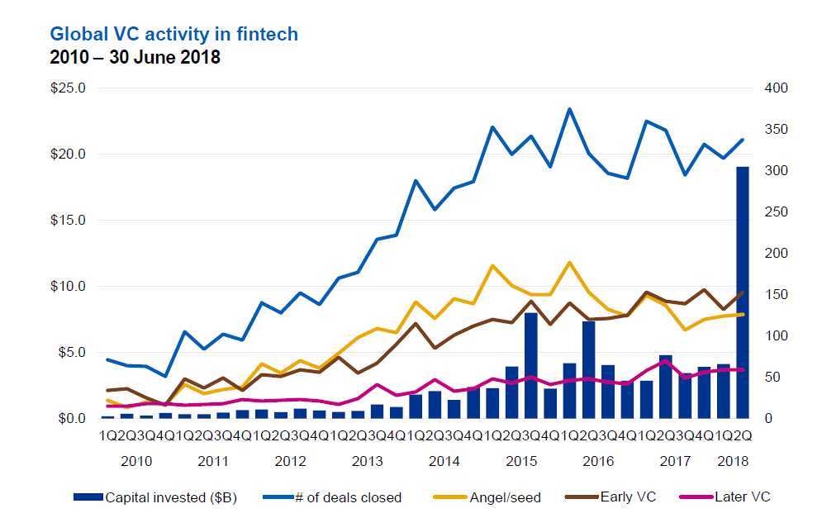

Fig. 1 Global Growth of Fintech Stages
Source: Pulse of Fintech (2018). Global Analysis of Fintech, KPMG International: p.9.
Intriguingly, the trends for overall VC activity in Fintech differ substantially from those seen across the venture landscape on the whole. By and large, angel and seed financing volumes have steadily declined for some time across the industry, while within Fintech, such activity has only trended up and stayed steady for some time, albeit with some volatility. Late-stage VC has only trended upward slowly and stayed strong on the other hand. Fintech popularity among VCs at all stages speaks to its core attributes: well-defined market opportunities in its major segments, long-developing innovation cycles and significant growth opportunities amid the best-developed segments.
In the Mena region, Fintech is still in the first stage of growth. According to Clifford (2019) report, Across the Middle East, Fintech is driven by technology-enabled innovation that improves existing financial services, but also provides routes for unbanked populations to access financial services. Government support and tech developments, together with high smartphone penetration, have contributed to the development of start-ups in the Middle East and the GCC in particular.
As of December 2017, Fintech investment in the Middle East remains a small proportion of the massive amounts being invested globally, and total Fintech startups in the Middle East and North Africa were valued at $66.6 million. The majority of investments/ startups have been in the UAE. However, by 2022, the Fintech market is estimated to reach a value of US$2.5 billion across the broader MENA region. [11]
Table (1) shows most important Fintech companies in Mena region according to a study conducted by Wamda (2017). [12]
Table 1: Fintech companies in Mena region
No. | Company | Country | Service | Year
1 | Beam | UAE | Investment | 2012
2 | Democrance | UAE | Insurance | 2015
3 | Bitoasis | UAE | Digital Wallet | 2014
4 | Now Money | UAE | Digital Bank | 2016
5 | Fawry | Egypt | Payment | 2014
6 | Paymob | Egypt | Payment | 2014
7 | Feloosy | Egypt | Investment | 2015
8 | Aman | Egypt | Payment | 2017
9 | Madfoo3at | Jordan | Payment | 2011
10 | Palpay | Plaestine | Payment | 2010
Source: Wamda (2017). ). Fintech in Mena Unbundling the Financial Services Industry, Wamda Research Lab, UAE, P. 41.
2.2 Entrepreneurship
Entrepreneurship is one of the primary purposes for which human efforts is heading to, every day trying to find new and innovative ways to earn his living, start a new project or take advantage of an idea.
There are various patterns of entrepreneurs between peddlers to creators of advanced technology, and these all are united by the desire to exploit their talents and resources in the best way possible, while distinguishes them is the success rate in achieving the ambitions that depend on the environment in which they work. [14]
Entrepreneurship requires innovation and change that might take different forms, where the Arab world is full of young talented and creative ideas. But those ideas often do not see the light for several reasons including lack of financial support from relatives, government agencies, or business men.
Today, entrepreneurship is gaining global attention in the media, political debates, the entertainment industry such as movies and TV series, education at various levels, academic studies and research. It also focuses on youth and gender in a wide range, both in developed and developing countries. [14]
In view of the vital role of entrepreneurship, countries are enacting supportive and caring laws and legislation for the SME sector, as they represent the true embodiment of entrepreneurship.
Many countries have made remarkable progress in this area and have had distinctive experiences in entrepreneurship through their support and encouragement to the small and medium-sized businesses.
On another hand, entrepreneurship contributes in economic savings and growth of projects and gives them competitive advantage and stability against fluctuations and obstacles through the formation of permanent assets beyond simple dreams to build a large fortune in short periods of time. [15]
The economic impact for entrepreneurship can be summarized as the following:
1. Operates in many activities covering a large share of local and global market needs.
2. Participate in solving the problem of unemployment.
3. An essential component of the global production and economic structure.
4. Develop production technology leading to competitive advantage.
5. Assimilation of modern technology and adherence to international standards.
6. Achieving a regional balance in the process of economic development.
7. A tool for economic and social development in all countries and not only for developing countries.
8. Preparing the pioneers and increasing their percentage in society, especially among the youth of both genders.
To achieve success, entrepreneurship requires a supportive ecosystem of interrelated factors ranging from infrastructure to access to financial services. Decision-making institutions play a very important role in the entrepreneurial ecosystem. [16]
The basic feature of entrepreneurship as a socio-economic phenomenon is its diversity, which poses a major challenge to researchers in determining the dimensions of entrepreneurship. On the other hand, it is very important for decision makers to know the diversity of entrepreneurship and entrepreneur leaders and to allow them to influence more effectively in the development of the enterprise sector. These dimensions are influenced by multiple factors, so it is important to pay attention to the multidimensional factors that may be a competitive advantage for some or may be monopoly for one country in terms of laws. [17]

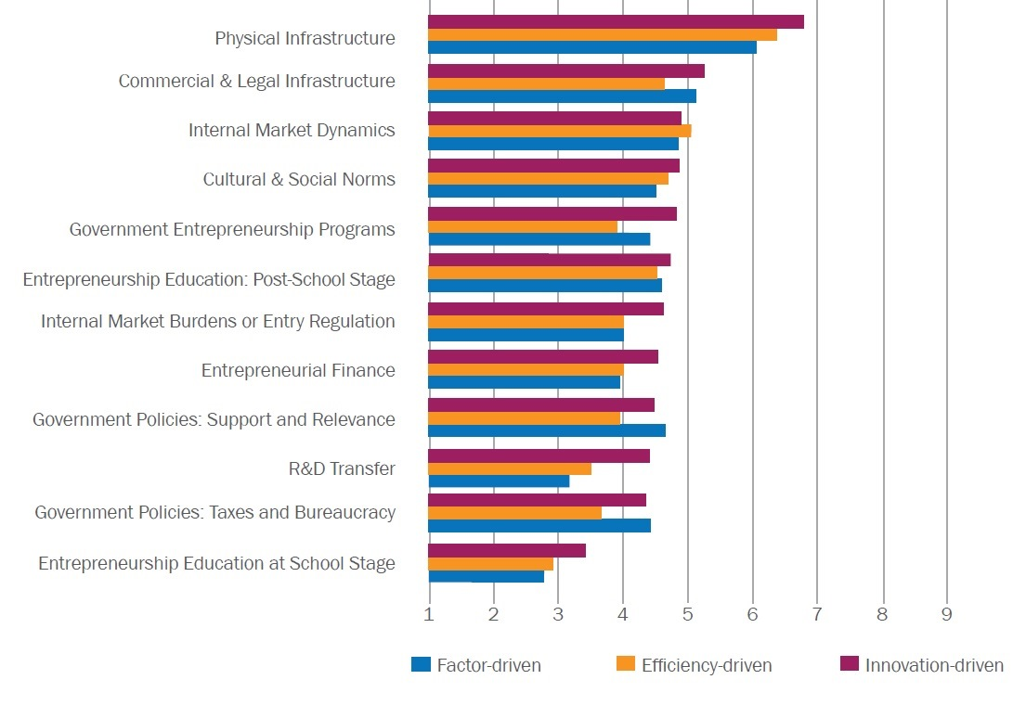

Fig. 1. Entrepreneurship ecosystem
Source: Global Entrepreneurship Monitor (2017). Global Report 2016/2017, Global Entrepreneurship Research Association (GERA), London Business School, UK, P. 32.
Crowdfunding as a modern field of finance depends on the existence of a culture of entrepreneurship in the country. Studies on this topic show that factors such as culture, the legal environment and economic incentives have an impact on the development and success of entrepreneurship.
These factors either restrict or enable entrepreneurial initiatives, and governments should encourage a culture of entrepreneurship by supporting business initiatives, business incubators and business accelerators. Government organizations may enhance or hinder the success of entrepreneurship by determining the level of risk to them. On the other hand, leadership behavior is influenced by the laws and procedures of the country.
To achieve success, entrepreneurship requires a supportive ecosystem of interrelated factors ranging from infrastructure to access to financial services. Decision-making institutions play a very important role in the entrepreneurial ecosystem. [18] [19]
Entrepreneur characteristics include a set of knowledge, skills, abilities and behaviors that a person must possess until he becomes an entrepreneur. Some of these traits are inherited and some are acquired by learning and training. In general, entrepreneurship researchers link entrepreneurship to innovation, risk, the ability to make good use of modern technology and its applications, long hours of work, self-confidence, managerial skills and communication skills. [20]
2.3 Crowdfunding and Fintech
It is one of the most important funding resources in internet era which contributes to the activation of the sources of funding for economic foundation, especially start-up projects. Also it is considered an alternative to bank financing that does not fit often with the status of small and medium enterprises at the beginning of the evolution of its activity. [21]
Crowdfunding defined under different terms, from different points of view. In simple term, Crowdfunding relies on the meeting of non-professional investors and entrepreneurs via internet platforms. [22]
The World Bank defines Crowdfunding as "enabling companies and business organizations relying on the Internet to collect the necessary funds, whether voluntary or investment by many individuals". [23]
Crowdfunding is characterized by its flexibility on the one hand, and its ability to adapt to environmental changes around it to fit with the objectives and policies of each country, and with the patterns of entrepreneurial projects prevailing in each country.
In general, there are four main models of Crowdfunding: Equity, Debt or Peer to Peer lending (financial models), Reward and Donation based Crowdfunding (non-financial models). [24]
1. Equity based: In this model, the investors have share of property rights or participate in the profits or management, as previously agreed with the owner of the project. Sharing profits model called royalty.
2. Lending based: This model also (Peer-to-Peer). The idea behind this type of Crowdfunding is to cut out the mediators and get cheaper loans or as an investor, get better interest rates.
3. Reward base: This type of financing is common in financing a product or project which is still being developed. A form of compensation for the investor is having the right to pre-order the product or get the product sent when it is finished.
4. Donation based: In this model, individuals donate to the project without expecting any financial return or percentage from the project owner.
Crowdfunding is one component of Fintech technology solutions, and is often used to promote innovation and social change, breaking down the traditional barriers of financial investment. According to the Framework for European Crowdfunding, "the rise of crowdfunding in the last ten years derives from the proliferation and the emergence of web applications and mobile services, conditions that allow entrepreneurs, businesses and creatives of all kinds to be able to dialogue with the crowd to get ideas, collect money and solicit input on the product or service they intend to offer ». [25]
Crowdfunding is an important source of exponential increases in financing estimated in the near future, millions of billions by 2020. Crowdfunding, which finds all the elements to be able to unleash its potential in web 2.0 concepts such as Fintech, bitcoin, crowdfunding enter the language of the banking business.
The first wave of financial technology has relied on payments and lending solutions, drawing on the major thrusts of the emerging Internet economy: the participatory economy, social networking and e-commerce. [26]
Fintech has also facilitated the emergence of startups that offer an alternative source of financial services. Fintech lenders, including equity crowdfunding, invoice and supply chain financing and marketplace lending, are beginning to challenge traditional business models in a number of ways — not only by bringing competition to the corporate market, creating efficiencies and competition that reduces on-line risk, but also making SMEs more profitable.
In particular, app-based companies are emerging everywhere. They challenge and disrupt incumbents, such as traditional banks, by supporting a wide range of financial services, namely marketplace lending platforms, equity crowdfunding platforms, insurance services, algorithm-driven robo-advisors offering smarter more personalized financial advice and blockchain-based cryptocurrency and payment systems. This trend is borne out by the investment data. Since around 2010, more and more investment is being made into Fintech. And even though deal activity has slowed over the last year, there is little evidence indicating that Fintech is likely to permanently stall or collapse. [27]
In the presence of modern financial technology, the finance market has changed in several areas:
1. Technology banks: such as data management, analysis and security.
2. Payment Services: Provide payment solutions such as PayPal.
3. Encrypted electronic currencies: such as Betcoin, Etherium, Doge Coin and Blockchain.
4. Business Finance: such as P2P, P2P.
5. Lending to individuals: Personal loan platforms (P2P).
6. Substantial Alternatives: Electronic Banks (Payeer, Perfect Money, Pyza, Solid Trust Pay).
From previous literature review, the following hypothesis in this research can be written as:
H0: There is a statistically no significant effect for Fintech on entrepreneurship.
3. RESEARCH DESIGN
3.1 Study population and sampling
This study conducted at (12) Arabic Crowdfunding platforms with total members (47.697). A pilot sample of (53) units was used to study the tools of the study, to verify the validity and stability of these tools. The research sample consist from (545) unit from all platforms as shown in table (2).
Table 2: Study population
No. | Platform | Country | Members No, | Registration
1 | Eureeca | UAE | 21226 | UAE
2 | Pi-slice | UAE | 681 | UAE
3 | Beehive | UAE | 8400 | UAE
4 | Zoomaal | Lebanon | 11967 | Lebanon
5 | Buildpalestine | Palestine | 332 | Palestine
6 | Yomken | Egypt | 1500 | Egypt
7 | Share-crowd | Palestine | 100 | Palestine
8 | Liwwa | Jordan | 502 | Jordan
9 | Smalaandco | Morocco | 1207 | Morocco
10 | Cotizi | Morocco | 1067 | Morocco
11 | Afineety | Morocco | 228 | Morocco
12 | Jaribha | Kuwait | 487 | Kuwait
 | Total Members |  | 47697
3.2 Research Mythology
Since the nature of hypothesis and the variables involved are the ones that control the selection of the appropriate tool, accordingly, the researchers have prepared a measure for that study commensurate with its objectives and requirements, the elements of Crowdfunding sponsors and entrepreneurship.
The process of designing and preparing the study scale has gone through several stages. Review the literature of crowdfunding, and previous studies on the subject of the current study. After that collecting and define scale paragraphs. And formulation of the standard expressions according to the study sample.
Then setting and modify the meter instructions and correct it. Also authors conduct the stability and honesty of the scale.
The first dimension referring to Fintech prepared by the authors from (6) paragraphs. The second dimension of the instrument which measure entrepreneurship was developed depending on Global Entrepreneurship Index (GEI) and consist from (20) paragraphs.
Also Trustees validity has been conducted by a group of expert in Crowdfunding and entrepreneurship field. Those statements were further revised and modified by the experts in a subsequent stage before drafting the final version of the questionnaire.
A five-point Lekert scale of agreement was used for measurement, running from “Strongly Agree” to “Strongly Disagree”, with a Neutral category for scale midpoint.
Several statistical tools were used for data analysis and hypothesis testing, including reliability Correlation using Cronbach’s alpha, “ANOVA”, Simple Linear Regression.
3.3 Validity and reliability assessment
The study adopted Cronbach’s α and Split half methods to measure the internal consistence reliability of the questionnaire. The results showed that Cronbach’s α valueS for all dimensions were > (0.5). It indicated that the design of the questionnaire had a high internal consistency as shown in table (3). Split half method show that correlation is 0.670 for Fintech and 0.853 for Entrepreneurship which are high value and indicate that both had strong reliability. Those results shown in table (4).
Table 3: Coefficients of Alpha Cronbach
Field | No. of paragraphs | Alpha-Cronbach stability
Fintech | 6 | 0.726
Entrepreneurship | 20 | 0.828

Table 4: Split Half Methods
Field | No. of paragraphs | R | Adjusted R
Fintech | 6 | 0.670 | 0.800
Entrepreneurship | 20 | 0.853 | 0.921

3.4 Data analysis and discussion of results

Descriptive analysis for independent variable (Crowdfunding sponsors) to determine weighted average and rank for paragraphs are shown in table (5).

Table 5: Descriptive analysis for Fintech
NO. | Field | Mean | Dev. | Weight | Rank
1 | Internet coasts are acceptable | 3.14 | 1.334 | 78.5% | 3
2 | There are restricts in using social media | 3.42 | 1.232 | 85.5% | 1
3 | Banks providing electronic transfer systems for money via internet | 2.93 | 1.368 | 73.3% | 6
4 | There are various e-banks (Wallets) services | 2.29 | 1.314 | 76.3% | 5
5 | There are restricts on electronic transfer via internet | 3.23 | 1.374 | 80.8% | 2
6 | Money transfer agents provide safe methods to transfer money via internet | 3.09 | 1.430 | 77.3% | 4

According to previous table (5), the relevant importance can be shown as following:
1. Using social media is restricted according to respondents data which infer that Crowdfunding financing tool might been not used in an effective manner.
2. Also results shown that Fintech technology not used cause of government regulations and extremely control on money transfer.
3. Respondents agree about the fair costs of internet according to their income level and the availability of Information and communications technology.

Entrepreneurship descriptive analysis as dependent variable is shown in table (6) to determine weighted average and rank for the total field.

Table 6: Descriptive analysis for Entrepreneurship
Field | No. of paragraph | Mean | Dev. | Weight
Entrepreneurship | 20 | 3.19 | 8.20 | 79.75%

According to previous table (6), the relevant importance can be shown as following:
1. The respondents agreed on the importance of Crowdfunding as a tool for marketing and promoting entrepreneurship projects.
2. The respondents agreed that they are practicing entrepreneurship with 79.75 %.
3. The respondents agreed that type of projects differentiates with modernity and creativity.
Simple linear regression used to test whether there is an impact for one independent variable (Fintech) on a dependent variable (Entrepreneurship). The results are shown in Table (7) and table (8).

Table 7: Anova Test
Field |  | Model | Sum of means | DF | Mean squares | F
Entrepreneurship |  | Regression | 20.694 | 1 | 20.694 | 158.702
R | R² | Resident | 70.805 | 543 | 0.130 | Sig .
0.476 | 0.225 | Total | 91.498 | 544 |  | 0.000

Table 8: Linear Regression
Field | Model | B | Beta | T | Sig.
Entrepreneurship | constant | 1.876 |  | 18.252 | 0.000
 | Fintech | 0.424 | 0.476 | 12.598 | 0.000

The results of the Anova test in table (7) indicate that sig. is less than (0.05) for independent variable (Fintech), which mean that there is significant statistically effect for independent variable (Fintech) on entrepreneurship.

Pearson coefficient and regression coefficient sign for independent variable was positive. This result means whenever the value of independent variables increase, there will be increase in entrepreneurship aspirations.

Changes in the independent variable is responsible for the interpretation of a rate (r2= 22.5%)) of all the changes that occur in entrepreneurship, and there is a rate (100 - r2) due to other factors specific to the other independent variables and other factors not mentioned in the model, in addition to the random error.

Table (8) reveals that the findings of significance level are less than (0.05), which means that we can rely on the previous model and circulating the sample results on research community.

Therefore, the results of the analysis proved the existence of a relationship between the independent variable and the dependent variable. According to that, we accept hypothesis H1 and refuse H0. The H1 hypothesis can be written as:

H1: There is a statistically significant effect for Fintech on entrepreneurship.

Table (8) determines the figure of linear regression equation for the impact of Crowdfunding sponsors on entrepreneurship. This equation can be written as follow:

Entrepreneurship = 1.876 + (0.424 * Fintech)

4. CONCLUSION
Crowdfunding, which allows a large number of individuals to collectively finance a new business venture through a technology platform, has risen rapidly as a popular way of financing a wide range of activities including business ventures, personal loans, and charity projects. The modern crowdfunding business mode consists of three types of players: the project proposers who provide the original idea/blueprint/project that requires external finance, potential investors who are interested in the idea, and an internet platform that brings all parties alongside to kick-start the new business venture.
Fintech, an abbreviation of financial technology, started being used broadly to refer to the influx of technology tools, platforms, and ecosystems that make financial services or products more accessible, efficient, and affordable. The crowdfunding activity is just one of many aspects of Fintech. Fintech today refers to not one, but a lot of technologies that broadly impact the way financial payment, funding, lending, investing, financial services, and currencies are conducted. These include, for instance, digital payments, crowdfunding, Robo-advisors, crypto currencies and markets/services enabled by crypto currencies.
Fintech and Crowdfunding as shown from the article are related together even in startup Fintech projects or in providing creative methods of paying. Arabic region suffer from week interest in both tools even in investments or legislations.
The article recommended more awareness for innovative products and services such as Fintech, Crowdfunding and adopting the culture of e-business models.
Also the article promoting the process of developing regulations that organize e-business models, especially Fintech and Crowdfunding, the use of modern communication technology to serve the development of society, more interest to innovation and creativity as a key factor for entrepreneurial success.

References
- Abu Naser, S. S., Abu Amuna, Y. M., El Talla, S. A. & Al Shobaki, M. J. (2018). Crowdfunding Role in Boosting the Entrepreneurial Creativity of University Students, International Journal of Academic Management Science Research (IJAMSR), vol.2, issue 4, pp. 1-12.
- Abu Amuna, Y. M., Al Shobaki, M. J., & Abu Naser, S. S. (2017). Crowdfunding as One of the Recent Trends in Financing Emerging and Small Projects in the Arab World, International Journal of Business Engineering and Management Systems, vol. 1, issue 1, pp. 1-16.
- Minnick, M. (2016). Critical Evaluation of Entrepreneurship Curriculum Development for a Private Two-Year College, PHD Desseration, Wilmington University, USA: P. 5.
- Abu Amuna, Y. M. (2018). the Electronic-Crowd Funding and its Impact on the Entrepreneurship: A Field Study, PHD Dissertation, Suez Canal University, Egypt: p. 51.
- Mchaney, R., Sachs, D. (2016). Web 2.0 and Social Media: Business in a Connected World, 3 rd Ed., eBbook, Bookboon: P. 14.
- Bottiglia, R., Pichler, F. (2016). Crowdfunding for SMEs, eBook, Palgrave Macmillan: P. 48
- Tsai, C., Peng, K. (2017). The FinTech Revolution and Financial Regulation: The Case of Online Supply-Chain Financing, Asian Journal of Law and Society,vol. 4, issue 1, pp. 109-132.
- Capgemini (2018). World FinTech Report 2018, Paris, France: p.45.
- Puschmann, T. (2017). Fintech, Bus Inf Syst Eng, vol. 59, issue 1, pp. 69-76.
- Source: Pulse of Fintech (2018). Global Analysis of Fintech, KPMG International: p.9.
- Clifford (2019). Fintech in the Middle East Developments across Mena, Clifford chance, London, UK: P. 3.
- Wamda (2017). Fintech in Mena Unbundling the Financial Services Industry, Wamda Research Lab, UAE, P. 41.
- Abu Amuna, Y. M. (2019). Entrepreneurship, Crowdfunding Platforms and Sponsors Interaction, International Journal of Academic Management Science Research (IJAMSR), vol. 3, issue 1, pp. 53-60.
- Abu Naser, S. S., El Talla, S. A., Abu Amuna, Y. M., & Al Shobaki, M. J. (2017). Technical Education and its Role in Promoting Entrepreneurship in the Gaza Strip, Second Scientific Conference on Sustainability and enhancing the creative environment of the technical sectorPalestine Technical College - Deir Al Balah, Gaza, Palestine, pp. 1-40.
- Al Omoush, K., Al-Qirem, R., Al Hawatmah, Z. (2017). The Degree of e-Business Entrepreneurship and Longterm Sustainability: an Institutional Perspective, Information Systems and e-Business Management, vol. 15, issue 2, pp. 1-28.
- Abu Amuna, Y. M. (2019). Crowdfunding Financing Model effect on Entrepreneurship Aspirations, International Journal of Academic Accounting, Finance & Management Research (IJAAFMR), vol. 3, issue 1, pp. 53-60.
- Cieslik, J. (2017). Entrepreneurship in Emerging Economies, eBook, Palgrave Macmillan: p. 41.
- Al Shobaki, M. J., Abu Naser, S. S., Abu Amuna, Y. M. & El Talla, S. A. (2018). Availability of Crowdfunding Elements among Palestinian University Students, International Journal of Academic Management Science Research (IJAMSR), vol. 2, issue 2, pp. 1-15.
- Abu Naser, S. S., El Talla, S. A., Abu Amuna, Y. M., & Al Shobaki, M. J. (2017). Social Networks and their Role in Achieving the Effectiveness of Electronic Marketing of Technical Colleges, Second Scientific Conference on Sustainability and enhancing the creative environment of the technical sectorPalestine Technical College - Deir Al Balah, Gaza, Palestine, pp. 1-42.
- El Talla, S. A., Abu Naser, S. S., Abu Amuna, Y. M., & Al Shobaki, M. J. (2017). Technical Colleges as Smart Organizations and their Relationship to Sustainability, Second Scientific Conference on Sustainability and enhancing the creative environment of the technical sectorPalestine Technical College - Deir Al Balah, Gaza, Palestine, pp. 1-29.
- Sharma, S., Lertnuwat, L. (2016). The Financial Crowdfunding with Diverse Business Models, Journal of Asian and African Social Science and Humanities, vol. 2, issue 2, pp. 74-89.
- InfoDev (2014). Crowdfunding as Potential for the Developing World, Finance and Private Sector Development Department. Washington, DC: World Bank.
- Davis, B., Hmieleski, K., Webb, J., Coombs, J. (2017). Funders' Positive Affective Reactions to Entrepreneurs' Crowdfunding Pitches: The Influence of Perceived Product Creativity and Entrepreneurial Passion, Journal of Business Venturing, vol. 23, pp. 90-106.
- El Talla, S. A., Al Shobaki, M. J., Abu Naser, S. S., & Abu Amuna, Y. M. (2017). The Effectiveness of a Training Program in Increasing Crowdfunding Awareness, International Journal of Advanced Educational Research, vol.2, issue 1, pp. 31-37.
- Biancone, P., Secinaro, S. & Mohamed, K. (2018). Crowdfunding and Fintech: business model sharia compliant, University of Turin, Italy, pp. 1-15.
- Schueffel, P. (2016). Taming the Beast: A Scientific Definition of Fintech, Journal of Innovation Management, vol. 4, issue 4, pp. 32-54.
- ECGI (2018). Fintech and the Financing of Entrepreneurs: From Crowdfunding to Marketplace Lending, Tilburg University, School of Law, Netherlands, p. 7.

