Doctor Tal Slutzker

The map of professions

Third Essay in the Philosophy of Masculinity: The Flow of Subjects

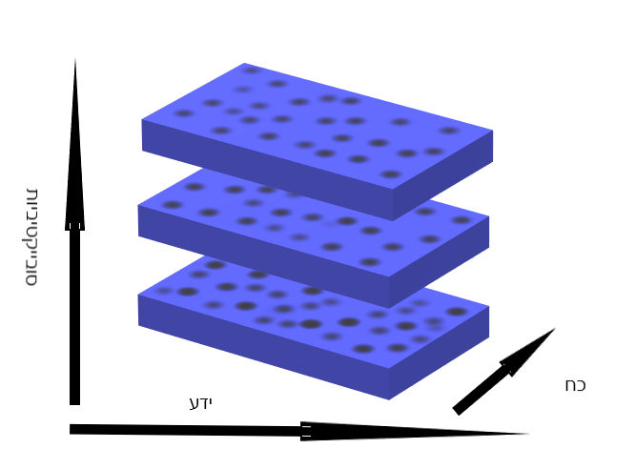

This is a graph of knowledge, power and subjectivity. The dots drawn on the floors indicate subjects located on maps of power knowledge, arenas where these form grow upwards and change matter from water to other materials including finally metals. The deeper the subject is on the map into the power zone, the more of it he has and the more right he is in the direction of the arrow, the more knowledge he has. Thus the different subjects experience different amounts of forces and information from subject to subject. The subjects located on the more left side of the map have less power knowledge while those on the more right side with the direction of the arrows experience more. As the subject changes floors, he experiences more types of knowledge and powers (the subjects move across the map up and down and within it, each subject in his own direction) and accumulate more with the studies of the professions and the theoretical study of them.

This is a theory map, and the floors are the floors of a building. The professions are located on the map even if they are not visible in the drawing, for example let's say that medicine is at the bottom right, or that art is at the top in the center. When the subjects move between professions their position on the map changes and with the position their powers also accumulate and change along the dimension of time, the floors are in motion and move closer and further away from each other and thus the relationship between the professions and the subjects passing between them, the professions are not lost, the subjectivity gains something from each of them when the subject stays at a certain point. The theoretical subject is emptied and filled with its encounter with different cases and with texts.

He may feel full after reading Kant or relatively empty after encountering a theoretical medical case. As the person rises, he accumulates more positions on the map and therefore more data accumulates as well as constructs and bases. The professional knowledge is a construct to which the former is exposed, which changes his personal experience. The map contains depth, width, height and time, and the experience is that of the university knowledge centers, but the same map can also be a map of a hospital to the same extent, where there are both sick and healthy people. Those in charge of knowledge pass it forward, withhold it, or distribute it according to their role, profession, and the function they fulfill in terms of personal and professional ambitions. A lecturer, for example, spreads it while a psychiatrist also prevents its transfer unless he teaches or publishes theoretical literature, so his role is twofold, transferring the knowledge and preventing it from those whom he does not want to receive it. With recent developments in the academy, the mad are on the map of knowledge, for example in a field of studies called MAD STUDIES whose departments have already been opened in English-speaking countries and there is professional literature of the studied subject. This development places the Mad in positions they have been excluded from for centuries. Now the exclusion exists but it is not complete exclusion from the institutions of knowledge as it was in the previous centuries. This is a field that started in the 2000s. The position of the subject in relation to psychiatry changes its fullness or emptying, and this is also a matter of texts and bodies, but also of the body and form and the functions that are marked in language, what language does to subjects. This map can also be read as a library with floors and departments and the readers are in the midst of reading in the various fields, and the texts change them in the layer of sensory markers. In the case that this is a library, of course the floors do not move and it is a stable building.

The person climbing the elevator in the library changes his position in the tangle of academic subjects organized in an orderly architectural pattern. Existence in this network changes with the changes of the times and so do the feelings and identities of the readers. Identity is also a certain experience that is related to religion, origin, and has a plurality. Sometimes the reader feels a multiplicity of his own identities and these unite and separate filling and emptying the being there like postmodern ghosts.

