A plea for epistemic ontologies
Gilles Kassel∗
Modelling, Information and Systems (MIS) Laboratory, Jules Verne University of Picardie, Amiens, France

Abstract. In this article, we advocate the use of “epistemic” ontologies, i.e. systems of categories representing our knowledge of the world, rather than the world directly. We first expose a metaphysical framework based on a dual mental and physical realism, which underpins the development of these epistemic ontologies. To this end, we refer to the theories of intentionality and representation established within the school of Franz Brentano at the turn of the 20th century and choose to rehabilitate the notion of a ‘representation object’, as theorized by Kasimir Twardowski. We therefore propose that the categories of epistemic ontologies correspond to ‘general representation objects’. Secondly, we apply these proposals to the treatment of technical artefacts, material qualities of objects and events (notably as a continuation of our previous work on events). This leads us to sketch out a foundational epistemic ontology.
Keywords: Applied ontology, foundational ontology, metaphysics, intentionality, Brentano, Twardowski, mental representation object, mental (and social) entity vs physical entity
Aside from our knowledge of ourselves as psychically active beings,
we have no directly evident knowledge of facts. Franz Brentano (1928 [1981], p. 5)
- Introduction

The ontologies developed in the discipline of Applied Ontology are catalogs of categories or classes of objects provided with being. These catalogs are structured by means of different relations (e.g., subsumption, parthood, and dependency). A common and strongly encouraged approach to establishing this catalog consists of using theories of philosophical ontology (metaphysics), i.e. inventories of categories considered to be fundamental for classifying all that is, to organize the ontology’s top level as a small set of abstract categories, referred to as a “foundational” ontology. Several decisions shape the definition of these foundational ontologies; one must not only decide on the scope of the ontology (in terms of domains covered), the grain or the level of description of the entities considered but also – as a separate decision – the entities’ modes of being (or existence).
For each human being, existence is a common-sense notion rooted in our relationship with our environment. Experience teaches us that inanimate objects and living beings with which we interact come into existence but also cease to exist. In metaphysics, modes of existence are recognized, and one commonly admits a main distinction between concrete and abstract entities: concrete entities are physical entities that enjoy a spatiotemporal existence independent of all human thought, whereas abstract entities are either mental and social entities that depend on human minds for their existence or ideal entities (such as mathematical entities) with an objective (but neither spatial nor temporal) existence.
In metaphysics, and taking the example of the foundational ontology developed by Gary Rosenkrantz and Joshua Hoffman (1991) (Fig. 1), the distinction between concrete and abstract entities commonly acts as the first structuring principle for an ontology. Nonetheless, Rosenkrantz & Hoffman consider that this distinction (albeit very useful) does not rest on well-established, indisputable metaphysical bases (ibid., fn 9):
The distinction between concrete entities and abstract entities that we are employing is an intuitive one. The intuitive distinction may be difficult to analyze, but it is serviceable nonetheless. The distinction in question seems indispensable in ontology, and is presupposed by realists and antirealists in their debates about the problem of universals.

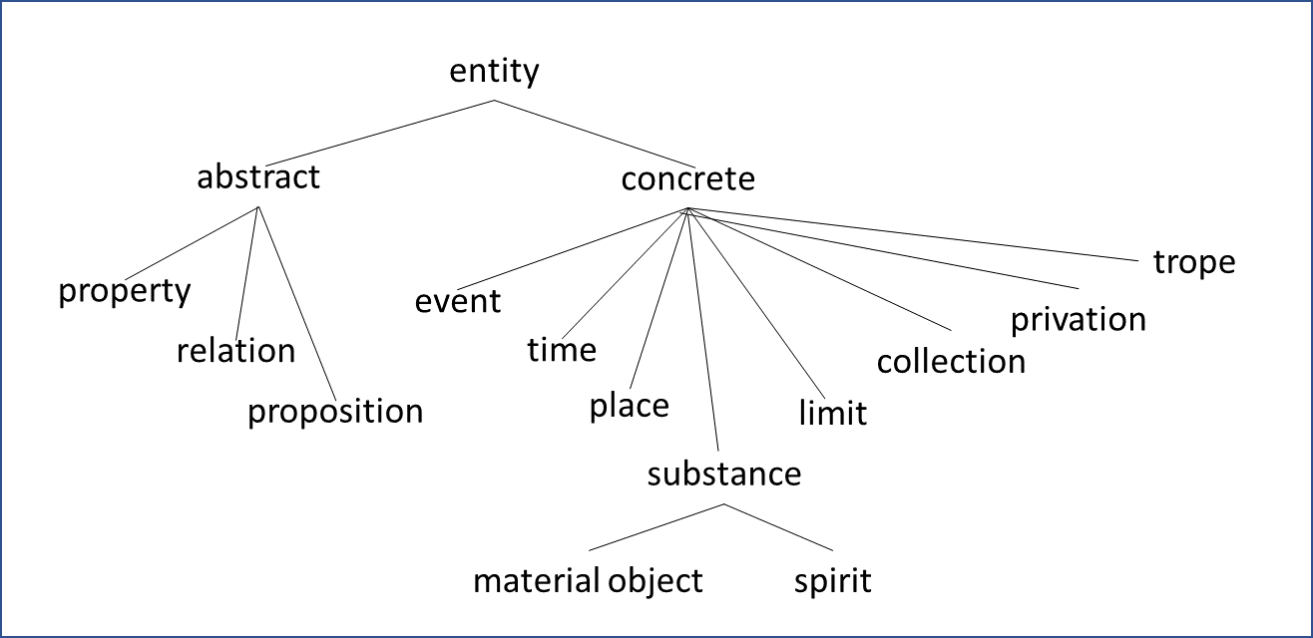
Fig. 1: A foundational ontology, taken from (Rosenkrantz & Hoffman, 1991, p. 839)

R&H emphasize that along with an intuitive partition of the world between concrete and abstract entities comes the “problem of universals” concerning the recognition (or the denial) of existence of generic entities that allow us to explain resemblances between individual entities. We will have the opportunity to address this issue.
In Applied Ontology, the situation is different: one can identify several strategies. While GFO recognizes four first-level domains of entity (physical, mental, social, and ideal) on the basis of distinct modes of existence, a commonly implemented first structuring principle consists in distinguishing between endurants (continuants) and perdurants (occurrents). This is particularly the case for DOLCE (of which Fig. 2 presents an extract of the main categories) and BFO. One such distinction concerns how entities persist over time, which indirectly reflects distinct modes of existence. In short, endurants are three-dimensional entities existing in their full identity at every moment of their existence, while perdurants are four-dimensional entities that derive their existence from gaining parts over time. Returning to the distinction between concretes and abstracts, we note that DOLCE contains an Abstract category subsuming Facts, Sets and Regions, in particular spaces of magnitudes of qualities Space Regions made up of atomic magnitudes Qualia (Quale in the singular). The authors of DOLCE define an abstract entity as being neither spatial nor temporal, which reminds the usual characterization of ideal objects in metaphysics. We also note the presence of the Non-Physical Object category, which subsumes Mental Objects and Social Objects (including Concepts).

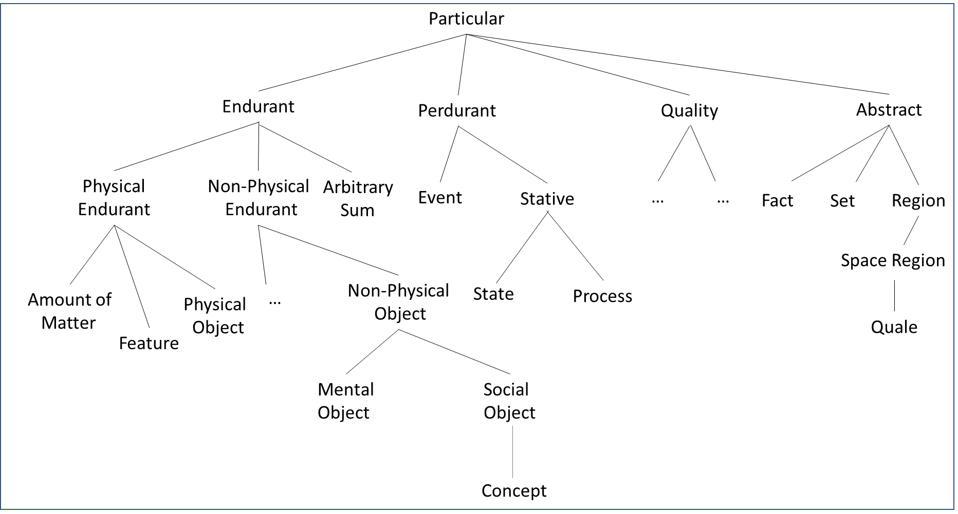
Fig. 2: An extract from the DOLCE foundational ontology (Borgo et al., 2022a)

Going beyond the differences in the way the world is partitioned, let us look at the common features of the current foundational ontologies and notably their ontological commitments. Following Borgo et al. (2022b), we can abstract a metaphysical thesis (MT) and a semantic thesis (ST) underlying the definition of these ontologies. We distinguish these theses from the methodological principle (MP) adopted for the design of these artifacts that are ontologies.
(MT) – In each domain, there exist singular and also generic entities – universals, classes or concepts – of which the singular entities are instances, members or share a salient set of common properties.
(ST) – Terms used to express common-sense beliefs or scientific theories directly or indirectly (via mental mediator entities) denote domain entities. More specifically:
(STsing.) – Singular terms, such as “John”, “John's skin lesion”, “John's bacterial infection”, etc., refer to an individual.
(STuniv.) – General terms, such as “human being”, “skin lesion”, “bacterial infection”, etc., refer to a universal or a class.
(MP) – The ontological categories correspond to universals or classes, or concepts; these generic entities are identified by experts in the fields concerned; the role of ontologists is to identify these classes or universals and organize them into a catalog structured by means of subsumption links.
The MT refers to the notion of “domain”. As mentioned above, today’s foundational ontologies partition the world into broad domains but in different ways (i.e. on the basis of different philosophical principles). However, all the ontologies have some common features, such as a claim to commit to “physical realism”: a physical world exists independently of whether we think about it or not. This metaphysical thesis is distinct from the methodological principles that most current ontologies put forward and thus complement the MP.
This is the case for BFO, whose authors defend a principle of “ontological realism”, as recently emphasized by Otte et al. (2022, p. 18):
The goal of an ontology is to describe reality. Scientific investigation is concerned with general features of reality and relations among them. Consequently, BFO consists fundamentally of representation of reality rather than language, concepts, or mental representations about reality.
We interpret this principle as giving priority to physical entities in the development of artifact ontologies. The validity of this principle was the subject of a debate in 2010 between Gary Merrill (2010) on one hand and Barry Smith and Werner Ceusters (2010) on the other. This debate then opened into a metaphysical discussion about the existence of universals, with Merrill championing the nominalism of universals. One of the issues with this type of doctrine is deciding what ontological categories correspond to (i.e. what they represent). Merrill’s nominalism of universals prompted him to opt for categories that correspond to concepts; he therefore advocated the development of conceptualist ontologies. On the other hand, BFO’s authors point out that their categories mainly represent universals (some specific categories, like Medical doctor or Dog or cat, are classes defined on the basis of universals).
Ever since the DOLCE ontology was first developed, its authors (Masolo et al., 2003) have claimed cognitive bias in how reality is apprehended (as recalled by Borgo et al. (2022a, p. 45)):
DOLCE is inspired by cognitive and linguistic considerations and aims to model a commonsense view of reality.
This principle advocates that the criteria for selecting categories should take into account of the way in which language and human conceptions (especially common sense) shape our divisions of reality. This prompted DOLCE’s authors to favor “descriptive” ontologies over “referentialist” ones (Masolo et al., 2003):
We do not commit to a strictly referentialist metaphysics related to the intrinsic nature of the world: rather, the categories we introduce here are thought of as cognitive artifacts ultimately depending on human perception, cultural imprints and social conventions (a sort of « cognitive » metaphysics).
DOLCE is thus an ontology of particulars with a cognitive imprint; that is the meaning we give to the term “descriptive”. It is also worth noting that, unlike BFO, there is no precise metaphysical commitment to the nature of the generic entities represented by the categories, the meaning of the categories being fixed by the formal axiomatics of the ontology.
For their part, the authors of GFO developed the principle of “integrative realism” to underpin their ontology (Burek et al., 2020, pp. 34-35):
GFO postulates the existence of a reality that is independent of the mind. Integrative realism is determined by two features. First the subject has access to real and independent entities of the world only through concepts, being part of the mind. Secondly, there is a law-like correspondence between the subjective phenomena of the mind and the independent reality. This approach leads to a new understanding of the relation between ontology and epistemology, because both cannot be separated. Ontology is directed at the independent objects of the world, though these appear to the subject through the knowledge (involving perception and concepts) that the subject has about them. This leads, we believe, to a new interpretation of works by G. Frege, B. Russell, and K. Twardowski.
In this excerpt, GFO’s authors begin by acknowledging the thesis of physical realism. The principle of “integrative realism” is then stated as two psychological theses: (i) our access to physical reality is only mediated by concepts (here, we note a proximity with the notion of descriptive ontology put forward by DOLCE’s authors, except that, as we already pointed out, the latter is not based on a particular psychological thesis); and (ii) psychic phenomena correspond closely to physical reality (this thesis concerns our knowledge of reality without, however, specifying which part of reality is reflected by our knowledge). In fact, GFO’s authors use these psychological theses as a pretext for re-evaluating the articulation between epistemology and ontology.
In the present article, we shall follow exactly the path suggested by GFO’s authors. It will lead us to define a new class of ontology that we call epistemic – a kind of conceptualist ontology. As we shall see below, an epistemic ontology is an ontology of particulars (like BFO, DOLCE and GFO). It differs from a descriptive ontology in that the particulars in its domain are mental objects of thought; in other words, they are conceptual in nature. Our approach to definition consists in favoring the ontology of the mind and in placing “knowledge objects” in our inventory of the furniture of the world.
To understand the relationship between the mental and physical domains, we choose to focus on intentionality, that is to say our ability to think and to refer to extramental entities. This ability has been one of the central questions in philosophy and metaphysics since antiquity and is covered by Aristotle's treatise of psychology known as De Anima in Latin. For the purposes of this study, we choose to refer to work performed at the turn of the 20th century in the Brentanian school. Franz Brentano is unanimously recognized as the philosopher who reintroduced the concept of intentionality into the contemporary philosophical debate. His main disciples – Husserl, Meinong and Twardowski – are known to have elaborated (in agreement with or in opposition to their master) various theories of the intentional object, which continue to drive contemporary research in philosophy. For reasons that we will specify below and that are intended to reconcile psychological, epistemic and ontological theses, we selected Kasimir Twardowski’s theory of the representation object or the knowledge object. In the first part of this manuscript (§ 2), we present this theory in general and the distinction between singular and general objects of knowledge in particular. We also specify our metaphysical and semantic commitments through the following two theses and principle.
(MT)’ – Singular and general objects of thought exist; these allow conscious subjects to represent singular and general aspects of the world.
(ST)’ – Terms expressing common sense beliefs or scientific theories refer indirectly to domain entities; the reference is mediated by objects immanent in thought.
(MP)’ – Ontological categories correspond to general objects of thought. Ontologies are thus knowledge representation systems; the role of ontologists is to identify and organize them by means of generality links.
The (MP)’ principle consecrates our notion of an epistemic ontology. These are ontologies whose categories correspond to general objects of thought or knowledge. The notion of an epistemic ontology is based on a metaphysical framework that acknowledges the existence of specific mental objects representing extramental entities, as expressed by the thesis (MT)’. Consideration of (MT)' prompts one to investigate the frontier between the mental world and the physical world. In the second part of this manuscript, we build on our previous work on the nature of physical processes and events (Kassel, 2019, 2020, 2022) and investigate three domains of entities – technical artifacts (§ 3), material qualities of physical objects (§ 4), and events (§ 5) – which leads us to outline an epistemic foundational ontology.
- The mental intentional object
In this section, we provide a general metaphysical framework for intentional phenomena (i.e., acts or states of thought directed towards an object). To this end, we return to the work carried out at the interfaces between psychology, metaphysics and semantics in the Brentanian school. We start by recalling the bases of Brentano’s doctrine of intentionality (§ 2.1). We then present the developments provided by Twardowski (in particular his theory of the “representation object” (§ 2.2)) and describe how the latter differs from the theories of the intentional object developed by Husserl and Meinong (§ 2.3). Lastly, we specify the metaphysical and semantic commitments linked to our adoption of Twardowski’s representationist theory (§ 2.4).
2.1. Brentano’s doctrine of intentionality
Brentano’s doctrine of intentionality is known to us primarily from his (1874 [1973][1995]) Psychology from an Empirical Standpoint. With the goal of founding the field of psychology, Brentano characterized phenomena (or acts) of thought as “referring to a content” or “being directed towards an object”. Each type of act (presentation, judgment, and emotion) had its own type of content. We note that Brentano’s metaphysical model of intentionality has three terms: act / mental “content-object” / extramental thing. The presence of quotation marks around the expression “content-object” is explained by the fact that Brentano continued to question the nature of this entity all his life by testing different conceptions. Moreover, his theories have been interpreted in many different ways – particularly with regard to the distinction between mental (psychic) content and object.
Let us consider a person thinking about a physical material object. According to Brentano, this thought involves a basic act of presentation (Vorstellung) directed towards a mentally in-existent object. When thinking about an object involves an external perception of the environment, several presentations are involved. Brentano thus distinguishes between intuitive presentations (pertaining to the senses) and abstract presentations (pertaining to the intellect). It should be noted that any abstract presentation of an object is accompanied by a judgment directed (according to Brentano) towards that same object. Below, we clarify the nature of these two types of acts. To this end, it is useful to remember two important positions in the development of Brentano's thought: (i) a break with the Aristotelian psychological theory of perception (described in De Anima) and (ii) the adoption of the scholastic notion of entity of thought (ens rationis) by making it play the role of intentional correlate of an act of thought.
According to Aristotle, the perception of a substance by a subject consists of a new actualization of the substance’s form in the subject’s soul. “New actualization” means that exactly the same form actualizes in the soul of the subject; there is no duplication. To illustrate this conception, it is customary to say that when a subject perceives a red object, his/her soul becomes red. Brentano was tempted for a time by this conception but came to favor an analysis of the relational nature of the act, based on the scholastic theories of relations (themselves inherited from Aristotle in the Categories). According to almost all of the medieval philosophers, the mental meaning of sentences expressing relations like “Paul is taller than Mary” or “Paul is married to Mary” is polyadic (as defined by modern logic) and is verified by relational situations in which the relata (substances) carry monadic properties or “relative” accidents (directed towards something). Thus, on the metaphysical level, a relation consists of a pair of correlative accidents directed towards each other. What we have just described corresponds to a paradigmatic relationship. In contrast, there are relations (e.g., “Paul is next to the statue”) for which the relational situation cannot consist of a pair of correlatives: the fact that Paul is next to the statue is intuitively extrinsic to the statue and therefore cannot correspond to an accident of the statue. An intentional relationship like “Paul thinks of Mary” also falls into this category: the fact that Mary is being thought about by Paul is extrinsic to her. In these non-paradigmatic cases, the relational situation is reduced to a single relative which, in the case of a relation of reason (relatio rationis), corresponds to an entity of reason (ens rationis). Thus, in the case of Paul thinking about Mary, Paul's soul bears an accident corresponding to his thought about Mary.
As mentioned above, Brentano appropriates the notion of the ens rationis, an entity to which he gives a true ontological status - considering that the ens rationis is more than just a way of speaking. He then adopts the scholastic conception of the act of thought or intentional relation, considering that any act of thought about an intentional transcendent object is accompanied by the mental inexistence of an intentional correlate referred to by the term Thought-of A (vorgestelltes Objekt). This correlate or formal Thought-of A object corresponds to an aspect or profile (Abschattung) according to which the material thing A is apprehended. In the notations used, the same letter 'A' is used for both the correlate and the transcendent object. However, Brentano ensures to indicate that the Thought-of A does not necessarily reflect the material thing A. On this occasion, Brentano expresses an epistemic skepticism that we would qualify today as non-naive realism: a hypothesis whereby perception shows us things as they are is not absurd but is just improbable.
Let us now turn to judgment (Urteil), as another kind of psychic act. According to Brentano, the basic judgment (to which more complex judgments boil down) is expressed as “A exists” (to be understood more precisely as “Thought-of A exists”), like the emblematic judgment “God exists”. Brentano breaks with the traditional (or at least Aristotelian) doctrine of judgment as the association of a subject and a predicate and, following John Stuart Mill, sees judgment as the place in which the object is accepted or rejected. The term “exists” in the aforementioned expression does not therefore correspond to a predicate attributed to an external object A, but to an immanent object Thought-of A. The notion of existence invoked here is to be understood within the framework of a theory of truth founded on a principle of correspondence (adaequatio rei et intellectus) between an external thing and a mental content-object. A positive judgment such as “A exists” amounts to admitting or acknowledging (anerkennen) A, in other words, considering that object Thought-of A corresponds to a thing that really exists. Conversely, a negative judgment like “A does not exist” amounts to rejecting or denying (verwerfen) A, in other words to consider that object Thought-of A does not correspond to a real thing. The object of the judgment remains the object of presentation, only the intentional modality vis-à-vis this object changes. A categorical judgment such as “A is B” (e.g., “the tree is green”) corresponds to a multiple judgment: recognize A, recognize property B (e.g., identify a real, effective quality), and recognize a link between these effective entities. According to Brentano, polarity (linked to the opposition between acceptance and rejection of an object) is a specific characteristic of judgment and one that distinguishes judgment from presentation. This polarity is complemented by the judgment’s “true” or “false” character of truth – a quality of the judgment that depends on the evidence considered when accepting or denying the object.
Let us summarize the highlights of Brentano's doctrine of intentionality. We have an act of presentation that provides objects for other psychic acts, and notably judgment. Brentano confined himself to a descriptive psychology and did not explain the genesis of objects or why objects represent extramental entities (which was bitterly reproached by Husserl). The act of presentation corresponds to an internal, conscious perception of the object. The object is thought of independently of its existence or non-existence; this latter notion is understood as a correspondence with the concrete, material reality. Establishing this correspondence (i.e. recognizing or denying the object) is a matter of judgment – deciding whether something is true or not.
This doctrine is accompanied by Brentano's commitment to the existence of the ens rationis – a thesis that he would question in his reist period. Starting in 1894, Twardowski developed this doctrine but chose to reinforce the ontological status of the object of presentation. This led him to develop an ontology of representation objects covering the domain of the “thinkable” or “representable” in general.
  - Twardowski’s representation object
We now look at Twardowski, whose theory of intentionality – along the lines of Brentano’s – is known to us mainly through his thesis (1894 [1977]) On the Content and Object of Presentations (CO) and his short but important treatise (1911 [1979]) Actions and Products, (both of which were positioned in the field of psychology by their author). While claiming to be a disciple of Brentano, Twardowski differs from his master in two respects. Firstly, Twardowski defended the mental existence of an object for any (re)presentation – including (re)presentations of “non-existent” objects. Secondly, he suggested extending the domain of the object of judgment in several directions. The term “(re)presentation” that we use in fact designates two distinct entities: on the one hand, representation as the product or result of an act of representation; the thesis defended is that all representation comprises an intrinsic object; on the other hand, the presentation to consciousness, as a basic act of internal perception, of this representation object.
In the essay CO, Twardowski has one main objective: To distinguish the content of the representation from the object of the representation and to defend the thesis whereby each representation has an object. The content consists of marks/determinations/properties attributed to the object. We can compare the content to the Fregean modes of presentation, except that the latter are ideal and contents are mental. Moreover, Twardowski takes the opposite view of Brentano's reist phase and gives the object a broad domain: the object may be non-existent; it may be complex by formally depending on other objects (e.g., ‘an apple being ripe’, ‘Aristotle being a disciple of Plato’); it may also be general (e.g., ‘the lion’, ‘the philosopher’, etc.) or individual (e.g., ‘Simba’, ‘Socrates’).
The analysis of Bolzanian anobjectual representations (having no reference) gives Twardowski the opportunity to defend his thesis that every representation has an object. These anobjectual representations include representations that do not refer to any entity encountered so far (such as [the golden mountain]) and representations that comprise contradictory determinations (such as [the round square]). Twardowski’s decisive act was to consider that these representations have content relating to a “non-existent” object. The argument is as follows: when we think of a golden mountain or a round square, we are indeed thinking of something and this something cannot be the content of the representation (we do not think that the content of the representation is a mountain and that it is made of gold). We are therefore indeed thinking about a ‘golden mountain’ object and a ‘round square’ object which need to be given a “thought object” ontological status. Twardowski's domain of objects becomes the domain of something, and this something includes non-referring objects. The latter “do not exist” in the Brentanian sense of the existential judgment according to which they do not represent anything concrete. However, conferring non-referring objects with a mental existence makes it possible to admit that they are the object (for example) of the judgment “Pegasus does not exist” – a judgment which has every reason to be considered as true. Twardowski thus installs a model of the representation with four terms: act / mental content / mental object / external thing.
To clarify the meaning given to the term “object” in the expression “representation object” and to distinguish it from the object taken as a material (physical) object, Twardowski (CO, § 8) evokes two species of objects of presentation, namely things (Dinge) and affairs (Sache). The latter is illustrated by the examples: a murder, an epileptic seizure, and a tranquility of soul.
Shortly after the publication of CO, Twardowski tackled the theory of judgments by focusing on relational judgments expressed by sentences like “the apple is ripe” or “Paul loves Mary”. Twardowski stated that these judgments are indeed about a particular apple, a particular Paul or a particular Mary but that their main object is respectively the affair ‘the ripeness of the apple’ and the affair ‘the love Paul has for Mary’. The analytical framework is still the Brentanian doctrine of judgment, consisting of accepting or rejecting its object. The judgments are analyzed respectively as “The ripe being of the apple exists” and “Paul’s love for Mary exists”; existence boils down to checking whether the thought affairs do indeed correspond to effective states of affairs. It is important to note that these affairs turn out to be distinct from relations and also from propositions because they do not carry a truth value. In fact, the propositions [the apple is ripe] and [the apple is not ripe] have the same affair as main object. It should also be noted that Twardowski is led to consider judgments like “the round square is round” or “Paul thinks of Aristotle” (where the object is an affair constituted by a non-existent object) to be true.
Lastly, let us discuss a theory of the general object as an important extension of the domain of the object. The general object – the mental analogue of a Platonic general idea – is (like the singular object) a unity and not a plurality. On a metaphysical level, the general object (e.g., ‘the triangle’, ‘the lion’, ‘the hepatitis’, and ‘the non-smoker’) possesses determinations shared by a plurality of singular objects that it subsumes. Two characteristics of the general object must be highlighted here. Firstly, a general object is an abstraction of singular objects, rather than a singular object or even a prototypical singular object. Its determinations are distinct from those of a singular object: a triangle in general (such as that considered in mathematical proofs) is neither rectangular, equilateral, nor isosceles, and the lion in general does not have a determined age. Secondly, the abstract general object constitutes a common (and therefore unrepeated) part of several singular objects (CO, 1977, p. 100): “The object of the general presentation is part of the object of a subsumed presentation, a part which stands in relation of equality to certain parts of other individual presentations”. On a psychological level, singular objects being connected to one or more general objects, this leads to an efficiency in presentations; in contemporary terms, one would speak of the inheritance of properties. Lastly, on a logical level, the general object is the subject of specific judgments, e.g. the sum of the internal angles of a triangle is 180°, the lion is carnivorous, hepatitis is an inflammation of the liver, and the non-smoker is less likely to develop heart and lungs diseases than the smoker. These judgments have a value (both logical and epistemic) that is distinct from judgments bearing on singular objects.
As we have just seen, Twardowski and Brentano before him contemplated (at one stage of their work on intentionality) granting true metaphysical status to the representation object, as distinguished from the representation content. The representation object has a mode of being that corresponds to the fact of being thought or being represented. It becomes then possible to consider an ontology of the thought object in general, i.e., any object.
  - Different theories of the intentional object: a short, reasoned presentation
As mentioned above, various theories of the intentional object have been defended in the Brentanian school. These theories continue to drive distinct research programs in the philosophy of mind and the philosophy of language. In this section, we briefly mention two of such theories (those of Husserl and Meinong) that are representative of contemporary options in metaphysics. By mentioning these theories, we shall justify our choice of Twardowski's theory and shall refer the reader to reference articles that highlight the key points in this debate.
Historically, the most virulent criticism of Twardowski's theory (and that of the young Brentano) came from Husserl, in his (1894) Intentionale Gegenstände. The point known as the “theory of the double object” is denounced by Husserl, as can be seen in this famous passage (ibid. [1979], p. 305):
It is the same Berlin that I picture, which also exists, and it is the same one that would no longer exist if a punishment broke out like in Sodom and Gomorrah.
According to Husserl, there is no justification for the existence of two intentional objects, namely the intentional object immanent to the mind and the extramental intentional object. As for non-existent objects (whether mythical or fictional), they simply do not exist. An analogous deflationary thesis of the mental intentional object is supported contemporaneously by Tim Crane in his (2013) The objects of thought. Crane admits that true judgments can be made about non-existent objects, provided that the judgments refer to ‘pleonastic’, non-substantive properties. Thus, it is true to say that Pegasus is a ‘mythical horse’ and that Sherlock Holmes is a ‘fictional detective’. In contrast, it is false to say that Pegasus is a (real) ‘horse’ and that Sherlock Holmes is a (real) ‘detective’. Let us go back to the case of existing, concrete objects that would come to cease to exist, which corresponds to the situation mentioned by Husserl in the quote above. Chrudzimski (2013) mentions this situation by taking the example of a person who, having picked a poisonous mushroom and placed it in his refrigerator, thinks about the mushroom at night without knowing that someone else had taken it out of the refrigerator and had destroyed it. Although the mushroom has ceased to exist, the picker continues to think about this object and its color, shape and scent. The properties with which the picker endows the non-existent mushroom are indeed “substantial” properties. Like Chrudzimski (according to the view he expresses in his (2015) work), we advocate the recognition of the immanent intentional object in our furniture of the world to be the bearer of identical properties, regardless of whether the object exists or not.
Another alternative to the intentional object is that advocated by Meinong. Historically, Meinong began by espousing the Twardowskian representation object and referring to a “pseudo-object” in his (1899 [1978]) On Objects of Higher Order; this “pseudo-object” had a diminished existence, when compared with effective entities. However, in his treatise (1904 [1960]) Theory of objects, Meinong changes his perspective by de-psychologizing the pseudo-object and making it a “pure object” beyond being and non-being. A contemporary neo-Meinongian theory is that of Edward Zalta's “abstract objects” (1983). Our main reason for rejecting the Meinongian option is the avoidance of calling on a Platonic world of objects that are pre-given to the mind and are independent of it. On one hand, these objects do not need to be thought about to exist; on the other, they must be capable of being grasped mentally by subjects. Meinong suggested accounting for the mental seizure of these objects by an ideal relation of adequacy between a psychic state and an object transcending the mind. Marek (2008) admits that this relationship remains mysterious and emphasized Meinong's resigned tone in quotes from his 1910 works (ibid., p. 152):
As to how it happens that the relation of adequacy between content and object obtains in a case where there is such great similarity and in another case where there is such great dissimilarity, I admit I can give no answer at present.
In conclusion, and duly noting distinct contemporary metaphysical orientations, we note that the arguments put forward are not conclusive. The choice of a theory depends fully on broad philosophical preferences, and this is the case here. By choosing to privilege Twardowski's theory of the immanent intentional object, we are aiming at an objective – to psychologize intentionality and, beyond that, logic – in the opposite direction to the options adopted by Husserl and Meinong and pursued by their contemporary followers. Today, a similar objective lies at the heart of a current of research in philosophy of language and mind around the notion of the mental file (Murez & Recanati, 2016). Literally, a mental file is conceived as a collection of information relating to an object, such a collection serving the subject to refer to the external world. The notion of epistemic ontology that we are about to deploy in the remainder of the paper can be seen as an ontology of the objects indexing such files.
2.4 Our commitments
In order to build our epistemic ontologies, we thus choose to start from Twardowski’s representationist theory of intentionality. In this section, we specify our metaphysical framework of reference before defining our concept of epistemic ontology.
Fig. 3 summarizes the entities involved in an act of (abstract) thinking about an object. The subject's consciousness is directed towards an object immanent to thought (rel IMM). This intentional immanent object is the object of a representation, characterized by a set of properties – the content of the representation. When the subject conceives this object as transcendent to his mind, he conceives the object as representing an external entity (rel REPR) to which he refers (rel REF). The entity transcending the subject's mind can be physical or mental (and more specifically social since it is thought of by other subjects). In the case where the object is conceived as not representing a transcendent entity, the aiming stops at the immanent object (the dotted arrows in our diagram mean that the corresponding entities need not exist). Fig. 3 explicitly shows three of the four terms in the Twardowskian model of the act of thought: the representation object, the representation content, and transcendent entities. The Figure should be seen as a global representation of the fourth term, i.e., the act of thought itself. It should also be noted that the mechanisms of representation and reference are identical in cases where the subject thinks about an object immanent to his mind, for example when his representations in turn become objects of (meta)-representations. The term “conceive” we have used reflects the fact that the representation object is anchored in the subject's belief system (it is therefore the result of an existential judgment in Brentano's sense). To account for this epistemic dimension, we use the terms “representation object” and “knowledge object” synonymously in the remainder of the text.
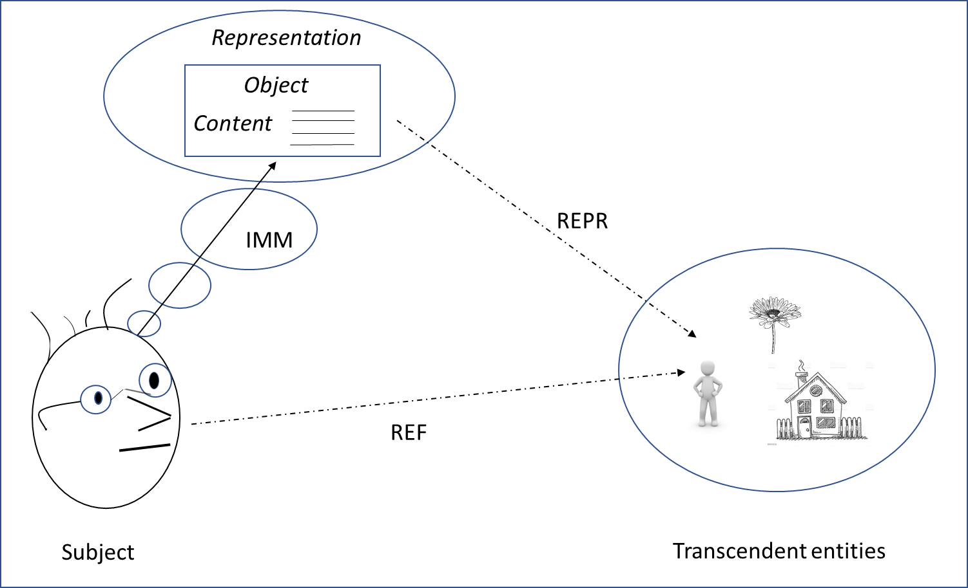
Fig. 3: A metaphysical schema of the act of thinking about an object
This theory of intentionality leads us to adopt metaphysical and semantic theses distinct from those adopted by today’s foundational ontologies (cf. theses (MT) and (ST) that we recalled in § 1). In particular, on a metaphysical level, we adopt the following thesis (MT)’:
(MT)’: singular and general knowledge objects exist; these allow conscious subjects to represent singular and general aspects of the world.
The knowledge objects in question are the representation objects, as characterized by Twardowski. As we saw in § 2.2, the latter include singular objects and general objects. It should be noted that in addition to objects, we consider other mental entities: properties/relations and propositions. In the present article, we shall not go further into the nature of these entities. However, we draw the reader's attention to the fact that if properties/relations are considered to be constituents of mental contents, these constituents must also be conceptual and mental in nature.
The objects are endowed with properties corresponding to the content of the representations or (to use a Meinongian term) their “being-such”: the object is such that it bears such and such a property. The lion in general is a carnivorous mammal with a fawn-colored coat. The singular lion Simba is a young male lion (i.e., with a mane) and weighs 150 kg. It is important to note that these attributions of properties stem from psychic acts which for a subject amount to a representation of knowledge about the world. This explains why these objects may be indeterminate with regard to carriage of a specific property, including physical property. The principle of excluded middle (according to which ‘For all F, the object carries F or not F’) does not apply. These objects are incomplete (to use a Meinongian term once again). The Simba object – the knowledge object, not the concrete living object in Africa – may not have any age-related properties (e.g., is it less than three years old or not?). Furthermore, it should be noted that some types of properties cannot be held by the object. Since Kant, it has been accepted that the predicate ‘to exist’ does not correspond to a property of the object. It does not play the same role as ‘being red’, ‘being round in shape’, ‘being made of wood’, etc. In the Meinongian school, this intuition led scholars to distinguish between nuclear and extra-nuclear properties. This distinction has been defined in a number of ways. Our interpretation is that nuclear properties relate to the knowledge object by determining it (and thus distinguishing it from other objects, in particular), while the extra-nuclear properties (e.g., ‘to exist’, ‘to be co-referential with’, and ‘to be incomplete’) deal with representation itself, playing in turn the role of knowledge object (the subject judges, for example, that one representation is co-referential with another).
It can be seen that (MT)’ concerns only the domain of the mind. In previous work dealing more specifically with the nature of processes and events (Kassel, 2019, 2020), we were led to make some general commitments. This is notably the case for (MT_i)' and (MT_ii)' below, which complement (MT)’:
(MT_i)’ – Each ‘entity’ (a term that we mean to indicate existence), whether physical or mental and with the exception of space and time, is in time.
This thesis consecrates a partition of the world into physical and mental entities. This partition excludes the atemporal Platonic ideas and leads us to consider that both fictitious entities (e.g., mythological entities and characters in novels) and ideal entities (e.g. numbers and geometrical figures) are mental entities (social entities, more particularly).
(MT_ii)’ – Each entity is a particular.
This thesis means that we adopt a nominalism of universals. As mentioned above, universals were introduced historically to explain similarities between entities in the world. Thus, the resemblance between (for example) human beings or sparrows is explained by the fact that an identical universal (‘human being’ or ‘sparrow’, respectively) is present in each individual of the same type. The question of the existence of universals started with a quarrel that can be traced back to the 11th century and continues to be debated in contemporary metaphysics. We choose to refute the existence of universals, for the following reason. Twardowski's theory of general objects makes it possible to account for the resemblance of singular objects at the mental level by assuming that general objects account for determinations shared by pluralities of singular objects and are (mereologically speaking) repeating parts of individual objects. Of course, this mentally conceived resemblance must have a counterpart in the physical world; however, the parsimony principle tells us not to introduce a new entity unnecessarily – especially a confusing entity that repeats itself identically in many other objects.
Let us now turn to our basic semantic commitments with the thesis (ST)':
(ST)’: terms expressing common sense beliefs or scientific theories refer indirectly to domain entities; the reference is mediated by immanent objects in thought.
In his 1894 essay CO, considering a dialogue between two interlocutors, Twardowski gives three functions to the noun. One locutor’s use of a noun indicates that he/she is presenting something to him/herself – he/she is carrying out an act of presentation. In return, the interlocutor performs a psychic act of the same type – he/she confers meaning by activating a representation associated with that noun. The hypothesis is that to ensure good communication, the two interlocutors are referring to the same extramental entity. This hypothesis is due to the third function of the noun: that of identifying entities (e.g., people, places, and organizations, for proper nouns) and thus ensuring that we can speak of the same entity. Concerning the relation between content and referent entity, Twardowski moreover notes that “mutual” representations with different contents can refer to the same entity (e.g., [the winner of the battle of Jena], [the loser of the battle of Waterloo]).
The relations between content and referent entity that we have just mentioned correspond to the exploitation of a 3-term model of the act of representation (act / mental content / extramental entity). This triadic model evokes the Fregean semantic triad (expression / meaning (Zinn) / reference (Bedeitung)), which makes it possible for several meanings to be coreferential. We should bear in mind, however, that the Fregean meaning corresponds to a Platonic ideality. In fact, the triadic model is closer to the semiotic triangle of Ogden and Richards (1923). These authors placed the act of reference at the core of their semantic theory; their triadic model (symbol / referent mental idea / referent extramental thing) was aptly named the “triad of reference” or (in its graphic presentation) the “triangle of reference”. This model corresponds to the coupling of two causal relations of reference: the symbol (e.g., a noun) evokes an idea in the subject’s mind; in turn, the idea evokes an extramental entity. The referent of any symbol is therefore mediated by an idea.
Let us now place ourselves within the framework of a 4-term model of the act of representation (act / mental content / mental object / extra-mental entity) and consider its contributions. As a preamble, it should be noted that the distinction between singular objects and general objects is in line with the current use of nouns: proper nouns name individual objects, while common nouns name general objects.
Taking account of the representation object first provides an epistemic advantage: a subject may not know that some of his/her representations are mutual, in which case information like ‘the winner of the battle of Jena’ = ‘the loser of the battle of Waterloo’ will extend his/her knowledge system by introducing a coreference relation between these objects or by merging them. Moreover, taking account of the representation object and combining it with other elements sheds light on the hypothesis of reference to the “same” entity by two or more interlocutors. These other elements were provided by Saul Kripke’s (1980) theory of a causal chain of attributions of social properties. This chain begins with a baptism – for example, the individual Aristotle is named “Aristotle” – and this reference is then shared between people and perpetuated from one generation to another. An analogous chain holds for the common nouns conventionally assigned to general objects. Returning to the proper noun, a community of speakers ensures that it refers to the same entity by attributing the same social property of nomination to the object or objects representing Aristotle. The noun is a description, that is a linguistic expression whose meaning corresponds to the properties of an object, allowing it to be referred to and thus identified. More generally, descriptions can also use properties other than the noun to refer to entities – for example, Aristotle could be identified (depending on the subjects’ level of knowledge) as ‘the disciple of Plato’, ‘the preceptor of Alexander The Great’ or ‘the author of Metaphysics’.
Let us now turn to the methodological principle underlying our notion of epistemic ontology:
(MP)’ – Ontological categories correspond to general knowledge objects; the role of ontologists is to identify and organize them by means of generality links.
An epistemic ontology (like the one shown in Fig. 4) is thus a system of knowledge representations. More precisely, an epistemic ontology is a taxonomy of general knowledge objects, as indicated by the root Knowledge object. More broadly, an epistemic knowledge base is a set of general objects (an ontology) supplemented by singular knowledge objects, e.g., Paul, Living room table, Displacement of the living room table, representing the way a subject conceives a singular individual of type Person, Table and Event. It is important to note that no representation category directly represents a concrete physical object. To account for the fact that a thought physical object represents an existing object, the property of existence is attributed to the representation (e.g., Rep_{Paul}) instance of the general object Representation. This representation has for representation object the singular object Paul which is further characterized by properties attributed to it (the representation content): ‘Paul is a person, is 40 years old, has Mary as a friend’. To better understand the content of an “epistemic knowledge base”, we'd like to add a few details.
As a first point, we emphasize that an epistemic knowledge base, while relative to one subject, makes it possible to account for knowledge objects thought about by several subjects. Work on mental files in philosophy of language and mind assumes that subjects have not only their own mental files, but also files that they attribute to other subjects (Recanati, op. cit.). For example, considering a statement such as “Mary told Paul that she hates Peter”, an explanation in terms of Mary's and Paul's informational systems consists in assuming that (i) Mary has a representation of Peter, e.g.: ‘Peter is proud, unpleasant, etc.’; and (ii) Paul has both a representation of Mary and a representation of how Mary represents Peter to herself. In terms of an epistemic knowledge base (ii) amounts to considering that Paul maintains a representation Repr[Paul]_{Mary} having for object Mary[Paul] (we index in square brackets the representation by the subject that maintains it) but also a representation Repr[Paul]_{Peter[Mary]} of the way Mary represents Peter to herself. With these examples, we simply wanted to evoke the scope of an epistemic knowledge base. Developing such a model of multi-subject representations, however, is beyond the scope of this article.
Secondly, we're referring to the fact that subjects, while having private representations, possess common knowledge that they acquire and share by communicating with each other. This knowledge, corresponding to the contents of knowledge objects, is both common-sense knowledge (due to the fact that we interact with the same physical world) and, depending on the subjects, scientific knowledge. As the role of ontologies in Applied Ontology is to act as reference conceptualizations for user communities, we amend our principle (MP)' by specifying that the role of ontologists, beyond identifying shared knowledge objects, is also to identify the knowledge shared by said user communities. Furthermore, in the introduction to this article, we pointed out the specific role of foundational ontologies in helping to structure application ontologies. We can transpose the same requirement to epistemic ontologies, namely that the distinctions made for abstract categories should be based on established principles of metaphysics. In this sense, we have defined the outline of a foundational epistemic ontology shown in Fig. 4. At the first level, the distinction between Physical object and Mental object confirms our thesis of a bipartition between physical and mental entities (MT_i)'.
In the following sections, we deepen our metaphysical framework, which is defined and constrained by the above-mentioned theses (MT)', (MT_i)' and (MT_ii)'. We have chosen to focus on the physical world and our knowledge of it, with the ambition of considering both its static and dynamic aspects. This will lead us to address the domains of objects, processes and events. The dogmatic introduction of a partition of worldly entities into mental and physical entities raises a challenge: case-by-case studies (depending on the entity’s domain) of what belongs to the physical world or, in contrast, to our knowledge of the physical world. This is what we will do in the remainder of this article by investigating technical artefacts (§ 3), material qualities of physical entities (§ 4), and events (§ 5). These considerations prompt us to sketch out the epistemic foundational ontology presented in Fig. 4.
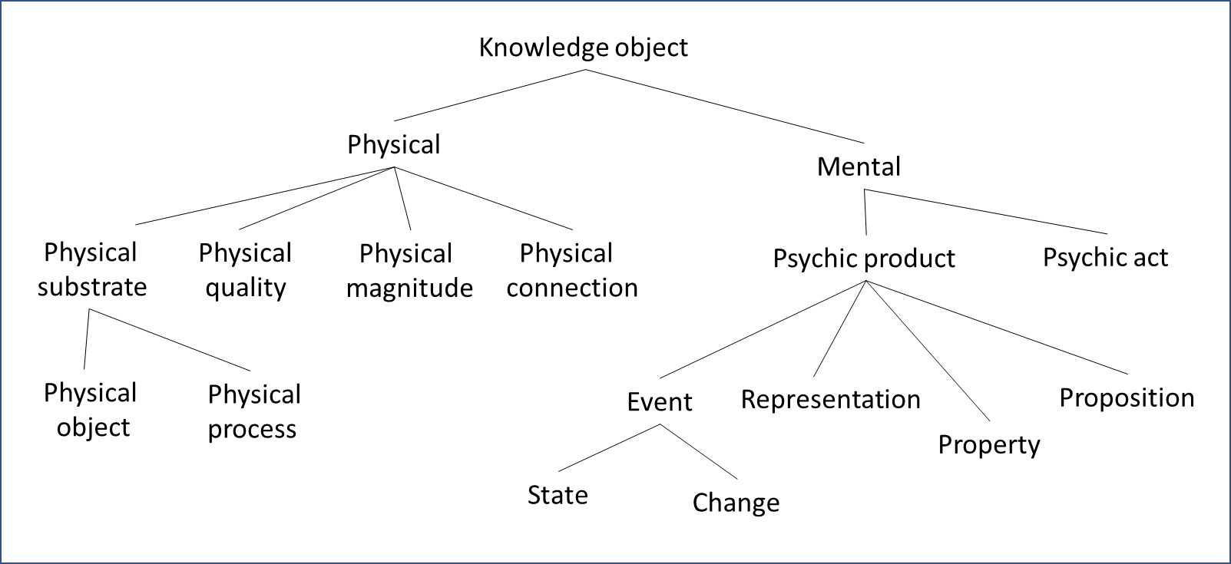
Fig. 4: Outline of an epistemic foundational ontology
- Technical artifacts
We shall begin our study with artifacts, given the strategic role they play in positioning the boundary between the physical and the mental. Like John Searle (1995), we consider that the notion of artifact is based on the attribution of a function to an entity, and that this attribution corresponds to the first step in the construction of social reality. In fact, we need to distinguish between two categories of social entities. Firstly, concrete social entities (e.g., a bottle, a paperweight, and a screwdriver) play the role of Y in the Searlian constitutive rule (ibid.) “X counts for Y in the context C”; the X is the concrete entity to which a function is attributed. Secondly, there are abstract social entities (e.g., a law, a currency, and a trade union) for which the Searlian rule does not apply, for lack of being able to exhibit an X on which a social fact would (directly) occur. In this section, we focus on concrete social entities. We seek to account for how properties such as functions supervene on physical objects, which is the case for technical artifacts. More particularly, as physical objects, we consider the objects of daily life with which we interact and that we use to carry out actions (also known as “Spelke” objects (Spelke, 1990)).
To illustrate the treatment of artifacts, let us take a “surgical knife” or “surgical scalpel” (in French: “bistouri”) and a “dissecting scalpel” (in French: “scalpel”) as examples. Knowing that these artifacts correspond to identical physical objects, the conceptual distinction that we retain is functional and depends on the context of use: surgical scalpels are used to cut living tissue while dissecting scalpels are used to cut dead tissue.
On an ontological level, let us specify which entities exist in the situation, for example, where a physician uses a surgical scalpel. The theory of representation objects leads us to distinguish two entities: the physical object on one hand, and the representation object corresponding to the conceptualization of the physical object by the physician on the other. A singular representation object Surgical knife_{#i} is thought by the physician as being both a physical object and an artifact (it combines the properties) and this object represents a physical object. If the physician were to use the same object as a dissecting scalpel in a different context, we would have a new Dissecting scalpel_{#j} object representing the same physical object. This situation is illustrated in Fig. 6.
In an epistemic ontology and knowing that a category corresponds to a general representation object, we find the categories Surgical scalpel and Dissecting scalpel as more specific to the category Physical object (cf. Fig. 5). The latter, it should be remembered, represents our general knowledge of physical objects.
Physical object
Spelke-object (Cohesion, solidity, continuity, contact)
Technical artifact (Function)
Surgical scalpel (Cutting, living)
Dissecting scalpel (Cutting, dead)
Fig. 5. An ontology of technical artifacts
The situation in which a physician conceives the same physical object in turn as a surgical and a dissecting scalpel is illustrated in Fig. 6. The singular objects Surgical scalpel_{#i} and Dissecting scalpel_{#j} are instances of the general objects Surgical scalpel and Dissecting scalpel.
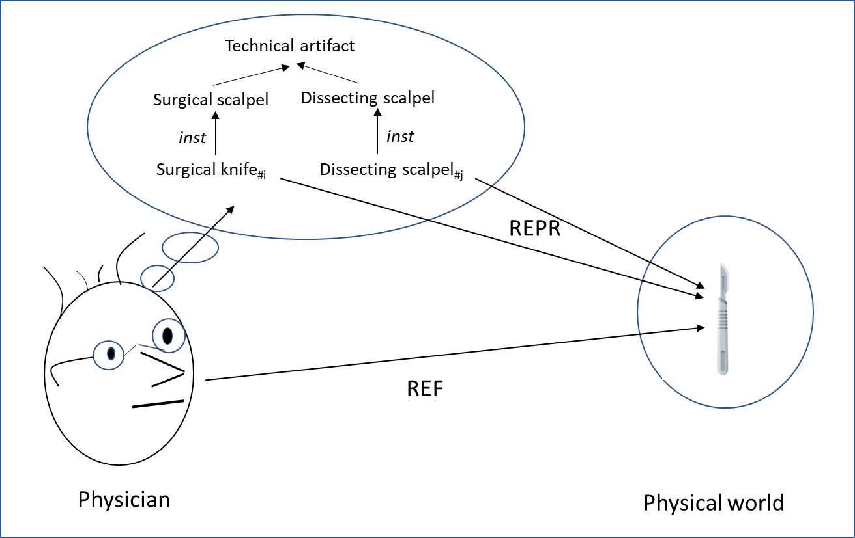
Fig. 6. The singular objects Surgical knife_{#i} and Dissecting scalpel_{#j} represent a same physical object.
An important point to note about our ontological commitments to physical objects is that we don't distinguish, on the side of the physical world, a sub-domain of artifacts. In fact, we consider that artifacts are distinguished from non-artifacts not by their physical properties but by other properties – functional ones, in this case. The Technical artifact category accounts for this distinction at the cognitive level. In other words and referring to the theory of levels mentioned in the Introduction, the artifact does not complete the chain of atom-molecule-cell-organism levels according to a homogeneous relationship of constitution. The existing relationship between mental objects conceived as artifacts and material entities in this chain is the relationship of representation.
This question of whether artifacts are physical or mental is key in the recent exchange between Smith and Searle (2003) concerning Searle's theory of social reality. Searle clarifies his conception of social objects in general as follows (ibid., p. 302):
The notion of a social object seems at best misleading because it suggests that there is a class of social objects as distinct from a class of non-social objects. But if you suppose that there are two classes of objects, social and non-social, you immediately get contradictions of the following sort: In my hand, I hold an object. This one and the same object is both a piece of paper and a dollar bill. As a piece of paper it is a non-social object; as a dollar bill, it is a social object. So Which is it? The answer, of course, is that it is both. But to say that is to say that we do not have a separate class of objects that we identify with the notion of social object. Rather, what we have to say is that something is a social object only under certain descriptions and not others (…)
We have one reservation and one objection with regard to this conception. The reservation is that Searle conceals the social objects described as being abstract by Thomasson (op. cit.) and for which descriptions do not occur directly on concrete objects. The objection concerns the treatment of concrete social objects. Although we agree that the subject holds only one physical object in his hand – a piece of paper – we hold that the subject’s consideration of the physical object as carrying non-physical properties corresponds to the existence of another object (a mental object this time) – a dollar bill. According to our conception, representational objects representing physical objects carry both physical and non-physical properties and some of these attributions of properties or mental facts acquire the status of social facts by being shared by a community of subjects. This is the case for an artifact such as a surgical knife because a community of subjects attributes to their general object Surgical knife (so named) the function of incising the body of the living.
In Applied Ontology, if we take as a reference the treatment of artifacts by DOLCE and BFO, we find that the non-physical and purely conceptual dimension of the function is not taken into account, to the point of identifying the artifact, as we propose, with a mental entity. In DOLCE, the artifact is identified with a physical object to which an agent assigns a specific capacity. However, the artifact remains a physical object, since the Physical Artifact(_DOLCE) category is subsumed by the Physical Object(_DOLCE) category. A physical object Dollar Bill(_DOLCE)_{#i} is distinct from its realization, another physical object Piece Of Paper(_DOLCE)_{#j}. In BFO, we note that the authors chose deliberately to deny the social dimension of the artifact and the function. In view of these analysis (and given that the ontologies’ authors did not comprehensively address the question of mental entities), we consider that entities within the scope of our knowledge are wrongly positioned in the physical stratum.
- Material qualities of physical objects
We continue our study of the value of making room in our ontologies for mental knowledge objects by tackling the domain of material qualities of physical objects - color, mass, temperature, texture, shape, etc. In fact, we argue that it's better to speak of two sub-domains, one mental, the other physical. To demonstrate this, we undertake a cognitive reading of the theories of “particular properties” or “tropes” as elaborated by its founding fathers (notably Donald C. Williams and Keith Campbell). We then compare this analysis with recent data from the color sciences, in particular the psychology of perception, which we extrapolate to material perceptible qualities in general. This leads us to consider that the “qualities” constituting a judgment expressed by a sentence like “this car is red”, namely the color of the car that we conceive as inherent to the car, corresponds to a model of physical reality rather than physical reality itself.
According to the standard theory developed by Williams (1956) and that was taken up by Campbell (1980), tropes are properties that depend specifically on their bearer (i.e. they cannot be exchanged between bearers). It is this redness of a rose, this hardness of a piece of metal, this sweetness of a lollipop, this triangularity of a cookie, etc. A common point of the theories is that tropes (or at least those corresponding to certain material qualities) are the immediate objects of perception. This point is important because it underlines the influence of perception and more generally of cognition in the establishment of the abstract character of tropes, as Williams points out in a psychological analysis (ibid., p. 176).
Among the many processes called “abstraction” only the most primitive quite deserves the name: the distinct awareness of the abstractum itself which occurs at the sensory and even the animal level. Hardly higher is a rudimentary generalization, the propensity to treat similar abstracta similarly; but the offices of conception are needed for awareness either that a given abstractum is abstract (and belongs to a concurrence sum) or that it exemplifies a universal (an belongs to a similarity set).
By referring to abstraction and generalization as psychic acts, Williams explicitly invokes the conceptual level and emphasizes its determinant role in characterizing the nature of tropes. This makes it legitimate to consider (according to our metaphysical framework) that abstract particular properties are knowledge objects representing physical phenomena. In any case, this is tantamount to considering that trope theory conjures up both the physical and mental levels.
In contemporary, multidisciplinary studies of color (in physics, physiology and psychology), one finds analyses that cautiously distinguish between the physical and mental levels. In their benchmark article (2003) Color realism and color science, Alex Byrne and David Hilbert formulate the following proposition. During a true experience of viewing an object, one can distinguish between two “colors”:
(1) In physical terms, the object has a property – the physical color – causally involved in a phenomenon of reflectance of the light illuminating the surface of the object.
(2) In mental terms, the subject is in a representational state having as content the proposition “the object is red”; this proposition corresponds to the phenomenal color.
Physical color corresponds to the characterization of the trope as a concrete particular independent of context and thus persisting in the object. Byrne and Hilbert make physical color a dispositional property by defining it as “the proportion of incident light the object is disposed to reflect at each wavelength in the visible spectrum” (ibid., p. 9). Phenomenal color corresponds to the characterization of the trope as an abstract particular. One can consider that it corresponds to the notion of quale (qualia in the plural) used by philosophers to refer to the phenomenal aspects of our mental life. Byrne and Hilbert also tell us about our common sense knowledge of material qualities. For each quality, we distinguish magnitudes. For example, for color, we distinguish between the hue (the quality itself) and its nuances (its magnitudes). Experimentally, and as reported by Byrne and Hilbert, we note that subjects who are asked to estimate the shades of color of a certain variety of tomato answer: 40 percent red, 60 percent yellow. Furthermore, subjects are able to affirm that one object is “more blue” and “less red” than another.
We therefore agree that we are dealing with two qualities, one physical, the other mental. We will now clarify the respective roles they play in a judgment involving a quality such as (1a).
(1) a “The car is red”
b [‘the being red of the car’ occurs]
Semantically, (1b) indicates that the meaning of (1a) corresponds to an existential judgment of an affair (according respectively to the Brentanian and Twardowskian notions presented in § 2). To resume Twardowski's analysis: the principal object of (1a) is neither the particular car, nor the particular quality of color, but the affair ‘the being red of the car’ whose existence is asserted. The affair is technically a complex object made up of a simple object corresponding to the car and a simple object corresponding to the car's color quality - Red_Color_{Car}. As for the nature of this entity, we opt for the phenomenal color, for several reasons.
The first reason has to do with the nature of perception as evidence for a judgment such as (1b). Like Byrne and Hilbert (ibid.), many philosophers of perception support intentionalist or representationalist theses, according to which perceptual states have a content that relates to the world. This thesis is defended by psychologist Rainer Mausfeld in some of his publications, notably in his (2011) The perception of material qualities and the internal semantics of the perceptual system. According to Mausfeld, the standard theory equating perception with the “rediscovery” or “reconstruction” of an external scene has two major flaws. Firstly, it is based on very naive – overly naive – realist metaphysics, according to which entities in the external world are the decal of our percepts. Secondly, it diverts the theorists of perception from the task of explaining how perception makes it possible to elaborate such semantic models from proximal sensory inputs (i.e., physical spatiotemporal energy patterns). Thus, our percepts of quality (conceptual or nonconceptual) are not directly related one-on-one to physical entities. A century later, Mausfeld agreed with Brentano, whose theory of external perception and epistemic skepticism he praised.
The second reason reinforces the first and relates to science explanations of the physical realities at the origin of our percepts of quality. For many qualities attributed to a physical object, these explanations call on 1:n relationships with lower-level entities (according to the theory of levels of material reality mentioned in § 1) constituting the said object: a body’s temperature depends on the movements of its molecules or atoms; the fluidity of water depends on the geometric organization of the water molecules associated with molecules of other substances; the smell of an object depends on the hundreds of thousands of particles emanating from the object and that bind to receptors in our nasal mucous membranes. Temperature, fluidity, odor, etc. are all part of our representations of the physical world. In fact, the statement whereby perceptual qualities “inhere” in their bearer (in the sense that they are in their bearer) illustrates the limitations of our common-sense knowledge.
A third reason relates to the importance of distinguishing between two distinct acts in perceptual judgment carried out by two distinct subsystems, namely perception and judgment. Both are abstract acts of constructing a model of the world, although the abstractions achieved differ in nature. Perception uses intermediate, non-conceptual, sensory representations to produce conceptual percepts. Taking the example of color again, these sensory representations discriminate between thousands of shades that are abstracted into a conceptual percept among the hundred percepts currently available to any subject. Judgment then seizes these conceptual percepts and pursues the abstraction. At this level, a subject can decide to consider that a car is red even if some parts of it (probably those considered to be less important) are of another color. Similarly, based on a thermometer reading, a subject may consider that a room is of a certain temperature even when the room contains several air masses with different temperatures.
For all these reasons, we propose identifying the material qualities of physical objects and their magnitudes with representational objects. The latter represent dispositional properties of physical objects. Thus (cf. Fig. 7), the singular object Color_{#i} inherent in the singular object Apple_{#j} represents a disposition giving rise to a process of reflectance of ambient light on the object existing in the physical world.
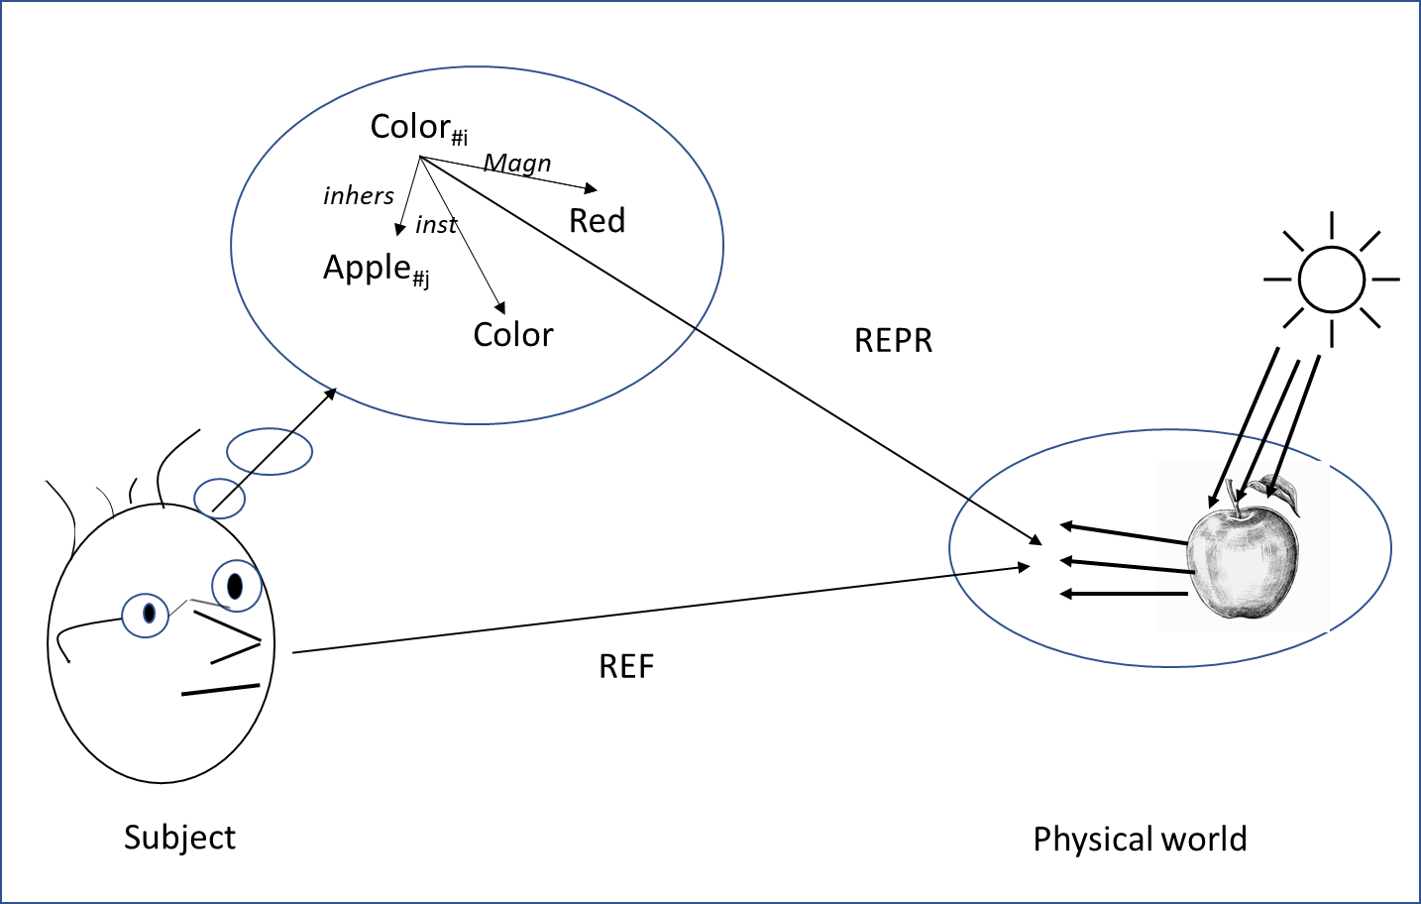
Fig. 7. The fact that material qualities are inherent in a physical object corresponds to a model of the physical world.
The Color object is a general representation object. In the ontology (cf. Fig. 8), the Color category is of type Physical object quality. Note that the qualities of physical objects and processes are distinguished.
Physical
Physical substrate
Physical object
Physical process
Physical quality
Physical object quality
Physical process quality
Physical magnitude
Fig. 8. Ontology of physical entities and their qualities and magnitudes
This ontology of qualities can be extended in several directions. In particular, it is possible to recognize complex qualities made up of simple qualities, like a color made up of a hue, a brightness and a saturation. It is generally accepted that these primary qualities represent distinct physical phenomena: a wavelength for the hue, a luminance for the brilliance, and a purity for the saturation. Moreover, as suggested by Nicola Guarino (2013), applications may require the consideration of global and local qualities of an object or may even require more detail by considering fields of qualities. It is important to note that we consider these options to be choices of granularity of our models of the world, depending on the knowledge we have of the world.
- Physical processes and events
To finalize our study, in this section we turn to the dynamics of the physical world. To account for this, we are about to use processes as well as physical states of affairs. We also use events, but rather than having them play a direct role in the dynamics of the world, we consider them to be mental entities that account for the history of these dynamics. In this way, we show that, as objects of knowledge of the world's evolutions, events illustrate - particularly - the contribution of an epistemic ontology.
The notions of dynamicity and change are closely linked. Commonly in metaphysics, temporal change on the scale of an object O is characterized by the fact that the object bears a property at one time and a different property at another time: O is F at t and O is F' at t'. Let us take a closer look at the dynamics of the physical world. An elementary temporal physical change (on the scale of an object O) can be characterized by the fact that a quality Q of O has a magnitude M at t and M' at t'. However, following the commitments we have just made with regard to the nature of material qualities, this type of characterization corresponds to our (common-sense) knowledge of physical change. Hence, to ensure that we capture a mind-independent dynamic of the world, rather than speaking of "qualities", we go back to the use of the term "physical property".
Distinguishing the physical from the mental is precisely what we set out to do in previous work aimed at clarifying the nature of entities described as “occurrents” and which led us to identify three main entities (Kassel, 2019, 2020). On the physical level, processes are enacted by objects and are causally responsible for changes in properties carried by the objects. Again on a physical level, these changes in properties correspond to homogeneous instantaneous facts that follow each other in time. On the mental level, subjects construct events that reflect the history of these evolutions. Thus, in the physical world, we recognize the existence of a dynamics of objects (but also of processes) that is independent of all thought. Now on the mental level, we situate narration as the main source of (abstract) knowledge of the dynamics of the world. By "narration", we mean a cognitive activity that consists in selecting a set of facts in a spatiotemporal region and then abstracting them into an event (such as a fight, a shipwreck, a conference, or a revolution). In this section, and after briefly summarizing our characterization of these entities, we discuss the epistemic role and the semantic behavior of events.
As a reminder of our commitments concerning these entities, let us consider the emblematic example of continuous movement (as a kind of spatial change) defined by Bertrand Russell (1903) as follows: “Motion consists merely in the occupation of different places at different times”. According to Russell, the continuous movement of an object O is nothing more than a series of facts corresponding to the occupation Loc by the object O of different positions Pos_{i} at successive instants I_{j}:
<Loc, O, Pos₁, I₁>, <Loc, O, Pos₂, I₂>, …
Let us summarize the limitations of this conception (which led us to the introduction of the process) and our characterization of the physical process. This conception accounts only partially for the continuous movement of O. Indeed, it accounts for the fact that to pass from one position to another distant position, O has to pass through intermediate positions. It also accounts for the fact that this “passage” requires existing localization facts to cease to exist so that new localization facts can arise: when located in position Pos₂, O is no longer located in position Pos₁. However, this conception is limited because it does not really account for the dynamics of movement; that is to say, an explanation of what leads O to pass from one position to another. The existence of the physical process is then posited to play this explanatory role: a specific activity or process – the realization of an object's disposition to move – triggers the series of localization facts. The explanation is not specific to movement: in general, changes in the magnitudes of qualities are explained by the activity of ad hoc processes. We attribute these processes with a mode of endurance over time that is analogous to the endurance of objects. During an episode of continuous change, a single process exists; however, this process may change over time (in speed and direction, for example). Let us add a few words about how knowledge of the process is gained. The process, like the object, can be perceived through some of its qualities. While the object is perceived visually through its shape and color, the process is perceived through its spatiotemporal shape. Galton (2018) defines this shape as a pattern of occurrence involving (for common processes like walking) a repeating pattern. An individual pattern corresponds to the enaction of a process on a bounded spatiotemporal region. To identify different types of process, a subject has general patterns of walking, running, jumping, etc.
As mentioned above, the thesis of the existence of the physical process makes it possible to account for the fact that a moving object passes from one state to another, i.e. the dynamics of movement. This being so, we still have not done justice to the existence of movement per se, movement to which we attribute the property of having lasted a certain period of time. The question of the mode of existence of movement, and of change in general, then arises. Change is commonly defined as a kind of event and (as we indicated above) we attribute a mental existence to events. The thesis that we defend is that movement and (more generally) change are mental entities that account for the evolutions of the world in a 1:n relationship with instantaneous facts. Fig. 9 illustrates this overall conception through the example of an episode of continuous walking. On the physical side, a person undergoes a walking process, which leads him/her to change his/her location. These occupations of different positions correspond to successive states of the world at distinct instants: in other words, the content of the world changes at successive instants in time. On the mental side, a subject aggregates and abstracts these successive states into a walking event – Walk_{#i} – in which the person – Person_{#j} – participates.
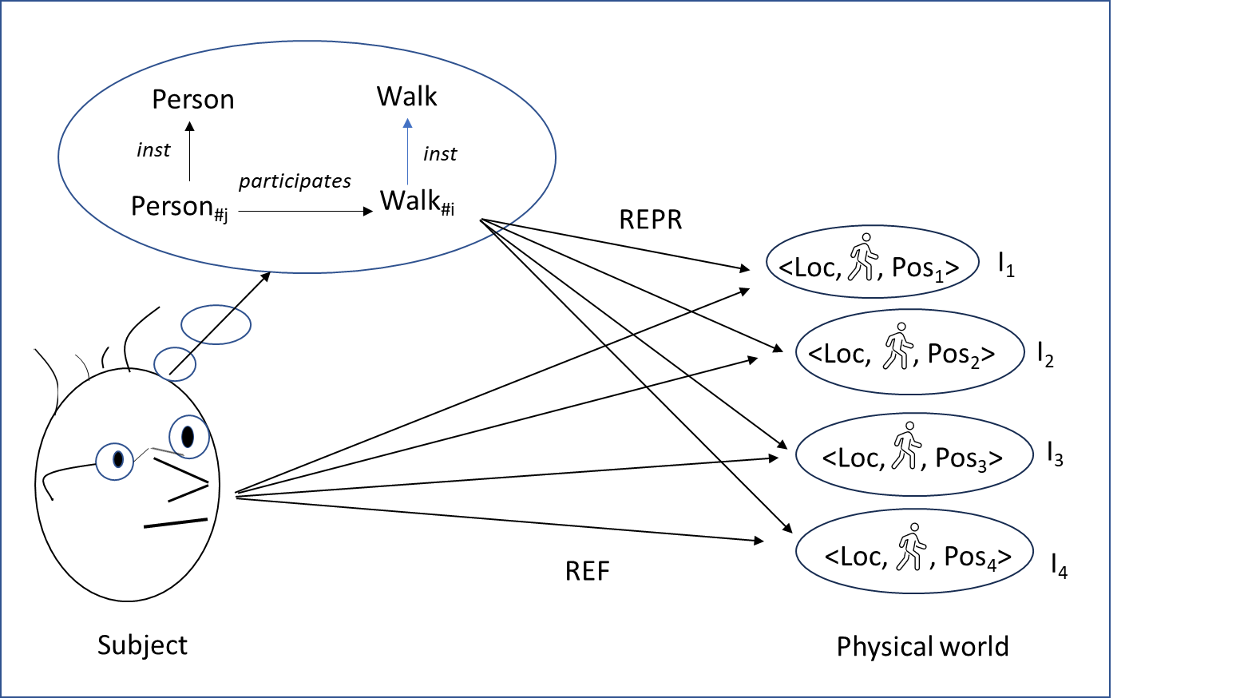
Fig.9. The Walkk_{#i} event represents a series of location facts existing in the world at successive instants.
In the rest of this section, we shall provide further details of the nature of events.
By considering the example of a state of color (which we consider to be a kind of event) in the previous section (§ 4), we revealed our first commitments to these entities. We thus identify events with knowledge objects – more precisely Twardowskian affairs – that also play the role of objects of existential judgments. In the case of an event e, a judgment has as its content the proposition [e occurs]. For an event, to occur means intuitively that the event happens, in the sense that facts exist by which this occurrence can be judged. The event ‘sinking of the Titanic’ is not only an idea of thought; facts intervened and enable one to judge that the event took place.
Let us specify the mode of knowledge of events when the latter are constructed from a perception of the world. The field of temporal perception – that is the ability of perception to deal with the passage of time – has been extensively studied. Here, we retained Christopher Peacocke’s theory (2019) for the emphasis put on the metaphysical dimension. According to this theory, three distinct types of temporal intentional content are involved. The first (referred to as “δP/δt”) accounts for the current dynamics of the world. When translated into representational objects, this ‘present time content’ corresponds to a slot that accompanies each property attributed to the object (e.g., its color, its temperature) and specifies whether the property is constant or changing. The second and third temporal contents (referred to as “happening-now” and “trailing envelope”, respectively) correspond to our notion of an event. The psychic mechanism at work amounts to grouping facts together into a unit that accounts for what is happening now or happening over a longer period of time. An example of “happening-now” content is an auditory perception of several knocks on a door in quick succession; the sequence of knocks is constructed by grouping auditory facts together. An example of “trailing envelope” content is a visual perception of a person crossing a road. Again, a road crossing is constructed as a cluster of spatial facts of a person's location. According to Peacocke, these mechanisms are primarily subpersonal. These intentional contents therefore initially correspond to proto-concepts that are to be transformed into concepts. For example, the sequence of knocks on the door is subsequently identified as a sequence belonging to a known person. Based on this theory, we consider that events (as we define them) are built of facts. More particularly, movement is obtained by grouping location facts together.
So far, we have given a broad range of illustration examples of events. Although it is possible to classify these events schematically into two main species (states and changes, depending on whether stabilities or transformations of the (physical) world are narrated), these events vary significantly according to the spatiotemporal region and facts involved. Based on the size of this region and the number of facts considered, we can distinguish between simple events involving a small number of physical entities (objects and processes) and complex events involving a multitude of entities. We can cite the following examples, in the order of increasing complexity: a hug between two people, a fight involving a group of people, a seminar, a shipwreck, and a revolution. To this complexity of events corresponds a complexity of judgments of existence, which we will not attempt to characterize in the present article. We would have to introduce a mereology of events and define a salience of facts to account for their relative importance in the identification of an event. In contrast, for simple events, it remains possible to identify approximately the occurrent-maker facts to be taken into account by a subject. Below, we give some examples of occurrence judgments of simple events involving processes and that illustrate their semantics.
The judgment expressed by (2a) can be assimilated to an occurrence judgment of a walking state of Paul (2b) - such a state corresponds to the Walk_{#i} event shown in Fig. 9. The occurrence of this state is due to the fact that Paul enacts (is the seat of) a walking process (2c) - this Walking_{#j} process is to be distinguished from the Walk_{#j} event. The judgment expressed by (3a) corresponds to the judgment of the existence of a speed state for Paul's walking process (3b). The occurrent-maker facts are facts corresponding to the inherence of a speed quality with a rapid magnitude in the process (3c). Lastly, (4a) expresses a judgment of the occurrence of a more complex event involving both a process enacted by Paul Proc_{#i} (the type of which is not specified), a movement process enacted by the table Move_{#j} and a causal perpetuation of one process by the other.
(2) a “Paul walks”
b [‘a walk of Paul’ occurs]
c {<Enacts, Paul, Walking_{#j}, I₁>, <Enacts, Paul, Walking_{#j}, I₂>, …}
(3) a “Paul's walk is fast”
b [‘a rapid being of Paul’s walking process’ occurs]
c {<Inheres, Walking_{#j}, Rapid_{Walking#j}, I₁>, <Inheres, Walking_{#j}, Rapid_{Walking#j}, I₂>, …}
(4) a “Paul moves the table”
b [‘a table move by Paul’ occurs]
c {<Enacts, Paul, Proc_{#i}, I₁>, <Enacts, Paul, Proc_{#i}, I₂>, … ;
<Enacts, Table, Move_{#j}, I₁>, <Enacts, Table, Move_{#j}, I₂>, … ;
<Perpetuates, Proc_{#i}, Move_{#j}, I₁>, <Perpetuates, Proc_{#i}, Move_{#j}, I₂>, …}
Note that the series of facts (i.c) {Fact1, Fact2, ...} correspond to finite sets. Their cardinality depends on the facts taken into account by a subject to decide on the occurrence of events (i.b). In contemporary metaphysics, the existence of such physical facts is questioned, on the pretext that they are made up of entities of a hybrid nature, i.e., a universal relation and particulars. For our part, we justify the existence of these facts by considering that the terms ‘Loc’, ‘Enacts’ and ‘Perpetuates’, usually designating relations, represent in this case particular physical phenomena connecting properties to their bearer. In Fig. 4, these facts correspond to the Physical connection category alongside the Physical substrate, Physical quality, and Physical magnitude categories.
In summary, and on the ontological level, a unique singular thought event (regardless of its complexity) finds itself representing a multitude of facts. Take the example of an impersonal statement like “it is raining”, for which the endless explanation advanced for veracity is “it is true that it is raining because it is raining”. The second occurrence of “it is raining” refers to a concrete Davidsonian event. What one gains by mentalizing the event is a more intuitive explanation of a judgment based on the existence of a multitude of drops of water falling: “it is true that it is raining ['a rain' occurs] as many drops of water are falling”.
- Conclusion
In this paper, we have defined a type of conceptualist ontology called an epistemic ontology. The latter’s categories correspond to general objects of knowledge representing the world. We have also developed a metaphysical framework for the development of epistemic ontologies. By opening our inventory of the furniture of the world to the mind, and taking care to distinguish rigorously between the physical and the mental, this framework turns out to be different from those of common foundational ontologies. It illustrates a nominalism of universals and platonic ideal entities. Moreover, by identifying events with mental entities, the framework supports a new epistemic thesis, stating that stabilities and changes are parts of the history of the world but are not in the world as it unfolds. Lastly, an epistemic ontology is an ontology of temporally enduring particulars. The distinction between endurants and perdurants present in BFO and DOLCE is no longer relevant. This is essentially due to the fact that events are conceptualized as mental endurants.
The question of the value of the metaphysical framework then arises. In this respect, we have tried to show that the framework aggregates established metaphysical theses that are consistent with contemporary data in psychology especially that of perception. These metaphysical theses are not in the mainstream of contemporary metaphysics (notably with respect to their openness to the mind) but we do not draw any conclusions from this concerning their value. Furthermore, the question of the boundary between the mental world and the physical world continues to be on the records of contemporary metaphysical research. Above, we mentioned the example of events. One can also raise the question of the existence of a macroscopic physical world that is independent of the mind, as defended by Petitot and Smith (1996).
On a practical level (for the development of ontologies), we have shown (particularly with our treatment of artefacts) that the notion of an “object of knowledge” allows us to attribute both physical and social properties to objects representing the physical world. In this case, the social properties of technical artifacts are functional properties related to the use of these objects. We note that this possibility legitimizes a common practice among ontologists, who do not ask themselves theoretical questions about the existence of universals or general objects of knowledge. At the same time, the diversity of properties that can be attributed to an object of knowledge raises the question of the criteria used to structure these object classifications and to elaborate classifications that are consensual – especially in scientific fields (Sterner et al., 2022). The question of whether or not the principle of “ontological realism” (i.e. giving priority to physical properties) should be adopted is as relevant as ever.
Regarding consensual classifications, we would like to highlight a contribution made by epistemic ontologies that we consider to be fundamental. Since objects of knowledge are representations of reality, it is possible to consider several objects that correspond to different representations of reality. Sterner et al. (ibid., p. 241) give the example of the development of ontologies of anatomical parts where distinct criteria (evolutionary homologies and structural similarities) can be taken into account and can sometimes give rise to inconsistencies. Given the representational nature of objects of knowledge, it is possible to consider objects that describe reality according to distinct theories – even if it means specifying that these objects are co-referential. In our opinion, this possibility may account for a strong, current trend in the philosophy of biology: the assimilation of living organisms to processes. In other words, living organisms are assimilated to stabilized “dynamic” activities rather than “static” things (cf. (Dupré & Nicholson, 2018)(Skrzypek, 2023)). This conception corresponds to scientific metaphysics of living organisms that is co-referential with the common-sense metaphysics we have favored in this article.
Acknowledgements
I would like to express my deepest gratitude to Nicola Guarino, Claudio Masolo, Beckett Sterner and an anonymous reviewer for their comments, which substantially improved successive versions of this text. While distancing themselves from the theses defended in the article, their questioning and advice greatly helped me to improve my ideas and their presentation. I would also like to thank Maria van der Schaar for her comments on the part of the article dealing with the work of Brentano and Twardowski. Also, I would like to thank David Fraser for copy-editing assistance.
References
Albertazzi, L. (2006). Immanent Realism. An Introduction to Brentano. Synthese Library: Studies in Epistemology, Logic, Methodology, and Philosophy of science, vol. 333, Dordrecht: Springer.
Antonelli, M. (2006). La conception de la vérité du jeune Brentano. In J. Benoist (Ed.), Propositions et états de choses : entre être et sens (pp. 67-86), Paris: J. Vrin.
Antonelli, M. (2015). Franz Brentano’s Intentionality Thesis. A New Objection to the “Nonsense that was Dreamt up and Attributed to him”. Brentano Studien, 13, 23-53.
Armstrong, D.M. (1997). A world of states of Affairs. Cambridge University Press.
Benoist, J. (2001). Représentations sans objet : aux origines de la phénoménologie et de la philosophie analytique. Paris, PUF, collection « Epiméthée ».
Bergmann, G. (1976). Realism. A Critique of Brentano and Meinong, Univ of Wisconsin.
Betti, A. (2017). Twardowski and Brentano. In U. Kriegel (Ed.), The Routledge Handbook of Franz Brentano and the Brentano School (pp. 305-311), Routledge.
Betti, A. (2019). Kazimierz Twardowski. In E.N. Zalta (Ed.), The Stanford Encyclopedia of Philosophy (Summer 2019, Edition). https://plato.stanford.edu/archives/sum2019/entries/twardowski.
Betti, A. & Raspa, V. (2016). Kazimierz Twardowski. Logik: Wiener Logikkolleg, 1894-95. Phenomenology & Mind, vol. 17.
Borgo, S., Ferrario, R., Gangemi, A., Guarino, N., Masolo, C., Porello, D., Sanfilippo, E.M. & Vieu, L. (2022a). DOLCE: A descriptive ontology for linguistic and cognitive engineering. Applied Ontology, 17, 45-69.
Borgo, S., Galton, A. & Kutz, O. (2022b). Foundational ontologies in action. Applied Ontology, 17, 1-16.
Borgo, S. & Vieu, L. (2009). Artifacts in formal ontology. In A. Meijers (Ed.), Handbook of the Philosophy of the Technological Sciences. Technology and Engineering Sciences (Vol. 9, pp. 273-307). Elsevier. Doi:10.1016/B978-0-444-51667-1.50015-X.
Brentano, F. (1874). Psychologie vom empirischen Standpunkt, Leipzig: Duncker & Humblot; english translation and ed. by L.L. McAlister (1973), Psychology from an Empirical standpoint, London: Routledge; 2nd ed. with a new introduction by P. Simons (1995), London: Routledge.
Brentano, F. (1928). Von sinnlichen und noetischen Bewußtein. O. Kraus (Ed.), Leipzig, Meiner; english translation by M. Schättle and L.L. McAlister (1981), Sensory and Noetic Consciousness: Psychology from an Empirical Standpoint III, London: Routledge & Kegan Paul.
Brower, J. (2018). Medieval Theories of Relations. In E.N. Zalta (Ed.), The Stanford Encyclopedia of Philosophy (Winter 2018 Edition), URL = https://plato.stanford.edu/archives/win2018/entries/relations-medieval/
Burek, P., Loebe, F. & Herre, H. (2020). Towards GFO 2.0: Architecture, Modules and Applications. In B. Brodaric & F. Neuhaus (Eds.), Proc. of the 11th International Conference on Formal Ontology in Information Systems, FOIS 2020 (pp. 32-45), IOS Press.
Byrne, A. (2001). Intentionalism Defended. The Philosophic Review, 110(2), 199-240.
Byrne, A. & Hilbert, D.R. (2003). Color realism and color science. Behavioral and Brain Science, 26(1), 3-21.
Campbell, K. (1980). Abstract particulars. Oxford Basil Blackwell Ltd.
Casati, R. (2005). Commonsense, Philosophical and Theoretical Notions of an Object: Some Methodological Problems. The Monist, 88(4), 571-599.
Chisholm, R.M. & Baumgartner, W. (Eds.) (1982). Brentano. Deskriptive Psychologie, Hamburg: Meiner; English translation by B. Müller (1995), Descriptive Psychology, London: Routledge.
Chrudzimski, A. (2013). Brentano and Aristotle on the Ontology of Intentionality. In D. Fisette & G. Fréchette (Eds.), Themes from Brentano (pp. 121-137), Amsterdam: Rodopi.
Chrudzimski, A (2015). Intentional Objects and Mental Contents. Brentano Studien, 13, 81-119.
Cleland, C.E. (1990). The Difference Between Real Change and Mere Cambridge Change. Philosophical Studies, 60, 257-280.
Crane, T. (2013). The objects of thought. Oxford University Press.
Dretske, F. (1995). Naturalizing the Mind – The Jean Nicod Lectures – 1994 Paris, Editions du CNRS & Cambridge, Mass: MIT Press.
Dupré, J. & Nicholson, D.J. (2018). A manifesto for a Processual Philosophy of Biology. In D.J. Nicholson & J. Dupré (eds.), Everything Flows: Towards a Processual Philosophy of Biology (p. 3-45), Oxford University Press.
Fisette, D. & Fréchette, G. (Dir.)(2007). À l’école de Brentano. De Würzbourg à Vienne. Paris : J. Vrin.
Fréchette, G. (2015). Brentano’s Conception of Intentionality, New Facts and Unsettled Issues. Brentano Studien, 13, 9-21.
Galton, A. (2006). On What Goes On: The ontology of processes and events. In R. Ferrario & W. Kuhn (Eds.), Proc. of the Fourth International Conference on Formal Ontology in Information Systems (FOIS2006), pp. 4-11.
Galton, A. (2008). Experience and History: Processes and their Relation to Events. Journal of Logic and Computation, 18(3), 323-40.
Galton, A. (2018). Processes as Patterns of Occurrence. In R. Stout (Ed.), process, action, & experience (pp. 41-57), Oxford: University Press.
Galton, A. & Mizoguchi, R. (2009). The water falls but the waterfall does not fall: New perspectives on objects, processes and events. Applied Ontology, 4, 71-107.
Griffin, N. (2017). Nuclear and Extra-nuclear Properties. IFColog Journal of Logics and their Applications, 4(11), 3629-3658.
Guarino, N. (2013). Local Qualities, Quality Fields, and Quality Patterns: A Preliminary Investigation. In O. Kutz, M. Bhatt, S. Borgo & P. Santos (Eds.), Proceedings of the Second Interdisciplinary Workshop SHAPES 2.0 (pp. 75-81), Rio de Janeiro, Brazil. Published online at http://ceur-ws.org/Vol-1007/paper5.pdf.
Gyemant, M. (2015). Objects or Intentional Objects?: Twardowski and Husserl on Non-Existent Entities. In D. Seron, S. Richard & B. Leclercq (Eds.), Objects and Pseudo-Objects: Ontological Deserts and Jungles From Brentano to Carnap (pp. 85-100), De Gruyter.
Husserl, E. (1894). Intentionale Gegenstände. Schuhmann, K. (Ed.)(1890/1891), Intentionale Gegenstände – Edition der ursprünglichen Druckfassung. Brentano Studien, 3, 137-176; B. Rang (Ed.)(1979), HUA XXII (pp. 303-337), The Hague: Kluwer.
Kassel, G. (2010). A formal ontology of artefacts. Applied Ontology, 5(3-4), 223-246.
Kassel, G. (2019). Processes Endure, Whereas Events Occur. In S. Borgo, R. Ferrario, C. Masolo & L. Vieu (Eds.), Ontology Makes Sense: Essays in honor of Nicola Guarino (pp. 177-193), Frontiers in Artificial Intelligence and Applications, 136, IOS Press.
Kassel, G. (2020). Physical processes, their life and their history. Applied Ontology. 15(2), 109-133.
Kassel, G. (2022). Abstract Events in Semantics. Philosophia. DOI:10.1007/s11406-022-00498-9.
Kassel, G. (2023). Connections and Relations. In C. Trojahn (ed.), proc. of the 34th French-speaking Conference on Knowledge Engineering (pp. 133-142), Artificial Intelligence platform (PFIA 2023), Strasbourg. In French.
Kripke, S.A. (1980). Naming and Necessity. Cambridge, MA: Harvard University Press.
Loebe, F., Burek, P. & Herre, H. (2022). GFO: The General Formal Ontology. Applied Ontology, 17, 71-106.
Marek, J.C. (2008). Psychological Content and Indeterminacy with Respect to Being. Two Notes on the Russell-Meinong Debate. In N. Griffin & D. Jacquette (eds.), Russell vs. Meinong: The Legacy of “On Denoting” (pp. 144-168), New York, Routledge.
Masolo, C. (2010). Understanding Ontological Levels. In F. Lin & U. Sattler (Eds.), proceedings of the 12th International Conference on the Principles of Knowledge Representation and Reasoning (KR 2010), pp. 258-268.
Mausfeld, R. (2011). The perception of material qualities and the internal semantics of the perceptual system. In L. Albertazzi, G. van Tonder & D. Vishwanath (Eds.), Perception beyond Inference. The Information Content of Visual Processes (pp. 159-200), Cambridge, Mass: MIT Press.
Meinong, A. (1899). Über Gegenstände höherer Ordnung und deren Verhältnis zur inneren Wahrnehmung. Zeitschrift für Psychologie und Physiologie der Sinnesorgane, 21, 182-272; English translation by M.-L. Schubert Kalsi (1978), On Objects of Higher Order and Their Relationship to Internal Perception, in Alexius Meinong (pp. 137-208), Dordrecht, Springer.
Meinong, A. (1904). Über Gegenstandtstheorie. Untersuchungen zur Gegenstandstheorie und Psychologie (pp. 1-51), Leipzig: J.A. Barth; engl. transl. (1960), The Theory of Objects, in R.M. Chisholm (Ed.), Realism and the Background of Phenomenology (pp. 76-117), Glencoe, Illinois: Free Press.
Merrill, G.H. (2010). Ontological realism: Methodology or misdirection? Applied Ontology, 5, 79-108.
Moran, D. (2013). Intentionality: Some Lessons from the History of the Problem from Brentano to the Present. International Journal of Philosophical Studies, 21(3), 317-358.
Murez, M. & Recanati, F. (2016). Mental files: an Introduction. Review of Philosophy and Psychology, 7(2), 265-281.
Ogden, C.K. & Richards, I.A. (1923). The Meaning of Meaning. London: Routledge and Kegan Paul.
Otte, J.N., Beverley, J. & Ruttenberg, A. (2022). BFO: Basic Formal Ontology. Applied Ontology, 17, 17-43.
Panaccio, C. (2009). Medieval Metaphysics I: The problem of universal. In R. Le Poidevin, P. Simons, A. McGonigal & R.P. Cameron (Eds.), The Routledge Companion to Metaphysics, London: Routledge.
Pasnau, R. (2002). Cognition. In T Williams (Ed.), The Cambridge Companion to Duns Scotus (pp. 285-31, New York: Cambridge University Press.
Peacocke, C. (2019). The Primacy of Metaphysics. Oxford Universities Press.
Petitot, J. & Smith, B. (1996). Physics and the Phenomenal World. In R. Poli & P.M. Simons (Eds.), Formal Ontology (pp. 233-254), Nijhoff International Philosophy Series, vol 53. Dordrecht: Springer.
Poli, R. (1996). Kazimierz Twardowski (1866-1938). In L. Albertazzi, M. Libardi & R. poli (Eds.), The School of Franz Brentano (pp. 207-231), Nijhoff International Philosophy Series, vol. 52, Dordrecht, Springer.
Poli, R. (2001a). The basic problem of the theory of levels of reality. Axiomathes, 12, 261-283.
Poli, R. (2001b). General theses of the theory of objects. In L. Albertazzi, D. Jacquette & R. Poli (Eds.), The School of Alexius Meinong (pp. 341-367), London, Routledge.
Recanati, F. (2012). Mental files. Oxford: Oxford University Press.
Rodriguez-Pereyra, G. (2002). Resemblance Nominalism. A solution to the problem of universals, Oxford: Clarendon Press.
Rosenkrantz, G. & Hoffman J. (1991). The Independence Criterion of Substance. Philosophy and Phenomenological Research, 51(4), 835-853.
Russell, B. (1903). Principles of Mathematics. Cambridge, UK: Cambridge University Press.
Schaar, M. van der (2016). Kazimierz Twardowski: A Grammar for Philosophy. Leiden: Brill Rodopi.
Schaar, M. van der & Betti, A. (2004). The Road from Vienna to Lvov: Twardowski’s Theory of Judgement between 1894 and 1897. Grazer Philosophische Studien, 67(1), 1-20.
Searle, J. (1995). The Construction of Social Reality. New York: The Free Press.
Simons, P. (2012). To Be and/or Not to Be: The Objects of Meinong and Husserl. In L. Haaparanta & H. Koskinen (Eds.), Categories of Being: Essays on Metaphysics and Logic (pp. 241-256), Oxford University Press.
Skrzypek, J.W. (2023). Trust the process? Hyloenergeism and biological processualism. Ratio, 36(4), 334-346.
Smith, B. (1989). Kasimir Twardowski: an essay on the borderlines of ontology, psychology and logic. In K. Szaniawski (Ed.), The Vienna Circle and the Lvov-Warsaw School (pp. 313-373), Kluwer Academic Publishers.
Smith, B. (1994). Austrian Philosophy, Brentano’s Legacy. Chicago, Open Court.
Smith, B. & Ceusters, W. (2010) Ontological realism: A methodology for coordinated evolution of scientific ontologies. Applied Ontology, 5, 139-188.
Smith, B. & Searle, J. (2003). The Construction of Social Reality: An Exchange. The American Journal of Economics and Sociology, 62(1), 285-309.
Spear, A.D., Ceusters, W. & Smith, B. (2016). Functions in Basic Formal Ontology. Applied Ontology, 11, 103-128.
Spelke, E.S (1990). Principles of Object Perception. Cognitive Science, 14, 29-56.
Sterner, B., Sen, A. & Witteveen, J. (2022). Consensus and Scientific Classification. Knowledge Organization, 49(4), 236-256.
Stout, R. (1997). Processes. Philosophy, 72(279), 19-27.
Stout, R. (2003). The life of a process. In G. Debrock (Ed.), Process Pragmatism: Essays on a Quiet Philosophical Revolution (pp. 145-57), Rodopi.
Thomasson, A.L. (2003). Foundations for a Social Ontology. Protosociology, 18-19, 269-290.
Twardowski, K. (1894). Zur Lehre vom Inhalt und Gegenstand der Vorstellungen. Eine psychologische Untersuchung, Wien: A. Hölder; english translation by R. Grossmann (1977), On the Content and Object of Presentations. A psychological Investigation, The Hague: M. Nijhoff.
Twardowski, K. (1911). Über Gebilde und Funktionen. Einige Bermerkungen zum Grenzgebiete der Psychologie, Grammatik und Logik. In A. Ruge (dir.), Die Philosophie der Gegenwart, Heidelberg: Weiss ; English translation Actions and Products. Comments on the Border Area of Psychology, Grammar, and Logic. In J. Pelc (Dir.) (1979), Semiotics in Poland. 1894-1969 (pp. 13-27), Dordrecht: Reidel.I
Williams, D.C. (1953). On the Elements of Being. The Review of Metaphysics, I 7(1), 3-18 & II 7(2), 171-192.
Zalta, E.N. (1983). Abstract Objects. An Introduction to Axiomatic Metaphysics. Dordrecht, Reidel.

∗ MIS, Université de Picardie Jules Verne, 33 rue Saint-Leu, F-80039 Amiens cedex 1, France. Tel: +33 (0)3 22 82 88 75; fax: +33 (0)3 22 82 76 68; e-mail: gilles.kassel@u-picardie.fr
Recently, a special issue of the journal Applied Ontology covered foundational ontologies “in action” (Borgo et al., 2022b). Several ontologies are presented, including BFO (Otte et al., 2022), DOLCE (Borgo et al., 2022a), and GFO (Loebe et al., 2022). In the rest of this article, we consider this sample of ontologies as being representative of the state of the art in the domain. When we mention these ontologies, and unless otherwise stated, we are referring to these presentations.
A main theory regarding physical entities is that they are made up of entities at different levels (Poli, 2001a). Claudio Masolo (2010) thus defends a hierarchy of entities linked by the relation of constitution. Consensus has been reached on a chain of levels: atom-molecule-cell-organism. However, questions arise as to how this hierarchy should be completed from the top down: are artifactual, mental and social entities part of the same hierarchy (Poli, 2006)? We shall return to these questions elsewhere in the present paper. It should be noted that hereafter, we will use the terms “concrete” and “physical” as synonyms, in the general sense of “material” and covering phenomena in physiology and biology.
In fact, DOLCE’s Abstracts have no “direct” spatial or temporal localization, unlike Endurants and Perdurants which are “primarily” localized in space and time respectively.
We envisage a broader domain for ontology than the authors of GFO, in their definition of integrative realism quoted above. We believe that ontology also concerns the mental domain, and that epistemology also concerns our meta-knowledge, i.e. the knowledge we have about our knowledge.
After having been relatively marginalized for almost a century, his writings are the subject of renewed interest, as shown by Liliana Albertazzi's (2006) introductory work on Brentano's life and work. Albertazzi does not hesitate to assert (ibid., p. 2): “Brentano's realism (...) is also a framework able to establish the scientific legitimacy of metaphysics”.
Several authors analyze the filiation of theories, by refinement or by opposition. Historically, the most comprehensive reference is (Smith, 1994). In French, one can cite the book edited by Denis Fisette and Guillaume Fréchette (2007) and Jocelyn Benoist’s (2001) study of non-existent objects. For a broad overview covering the history of the concept and recent debates on intentionality, the reader can refer to Dermot Moran's (2013) synthesis.
Like Brentano’s work, Twardowski's work was recently rediscovered. Maria van der Schaar's (2016) Kazimierz Twardowski: A Grammar for Philosophy is the most comprehensive presentation of Twardowski's work and incorporates the most recent studies.
The first English translation of this essay (incorporating work carried out by Brentano up to 1911) was published in 1973. This version was supplemented by an introduction by Peter Simons and gave rise to a second English edition in 1995. Lastly, the essay Deskriptive Psychologie (edited by Roderick Chisholm and Wilhelm Baumgartner (1982) and translated into English in 1995) presents the work conducted by Brentano in the 1880s and 1890s.
Cf., for a historical study of these different conceptions, Alexius Chrudzimski (2013).
Cf. the progress report by Guillaume Fréchette (2015). For our presentation, we mainly rely on the analyses of Mauro Antonelli (2015).
Here, we see the scholastic distinction between abstractive and intuitive knowledge, as characterized for example by John Duns Scotus, cf. Robert Pasnau (2002, § V Intuitive Cognition).
An obvious weakness of this conception is that it cannot explain how a subject perceiving two distinct red objects can, in thought, distinguish them if the objects in question are not in some way represented as bearers of properties.
For a detailed presentation of these theories, cf. Jeffrey Brower (2018).
The exact nature of these accidents was the subject of heated debate between the 11th and 14th centuries (Brower, ibid.). For proponents of “reductive” realism (including Peter Abelard and William Ockham), these accidents were just ordinary qualities (e.g., a person’s height). In contrast, “non-reductivists” such as Saint Albert the Great and John Duns Scotus considered that these accidents were of a sui generis type: they were distinct from (but nevertheless required by) qualities.
Given the importance of this epistemic thesis (to which we will return later in the text), we hereafter quote the full paragraph in which it is expressed by Brentano (1995, p. 19): “The phenomena of light, sound, heat, spatial locomotion which the natural scientist studies are not things which really and truly exist. They are signs of something real, which, through its causal activity, produces presentations of them. They are not, however, an adequate representation of this reality, and they give us knowledge of it only in a very incomplete sense. We can say that there exists something which, under certain conditions, causes this or that sensation. We can probably also prove that there must be relations among these realities similar to those which are manifested by spatial phenomena of shapes and sizes. But this is as far as we can go. We have no experience of that which truly exists, in and of itself, and that which we do experience is not true. The truth of physical phenomena is, as they say, only a relative truth.”
The principle of correspondence is not adopted by all of Brentano’s commentators; some prefer to stick to a notion of intra mental evidence, as presented in the posthumous work Wahrheit und Evidenz edited by Oskar Kraus (1930). Here, we agree with Mauro Antonelli’s (2006) analysis recalling Brentano's hesitations and about-turns with regard to this principle because of the difficulties it raises. In particular, how can one judge the existence of an impossible object or that of an object that has ceased to exist? According to Antonelli (ibid.), Brentano ended up (in his so-called reist phase) by defending a principle of correspondence restricted to things with an effective (concrete) reality.
This revision appeared in the 1911 edition of Brentano's Psychology From an Empirical Standpoint, known as Psychology II. It is commented on in the references that we have cited, notably Albertazzi 2006 (chap. 5, A woodworm in the intentional relation).
For a general overview of Twardowski's work, in addition to van der Schaar's (op. cit.), the reader can refer to (Smith, 1989), (Poli, 1996), and Arianna Betti (2017, 2019).
Both Bolzano and Twardowski believed that some representations refer to ideal objects, for example mathematical objectities like the representation [the roots of the equation x² - 5x + 6 = 0], which refers to the numbers 2 and 3. An “anobjectual” representation must therefore be understood as a representation that does not represent a concrete object, as would be the case for [the current king of France]. It should be noted that our bracketed notation for representations and then propositions does not assume that these entities have a particular structure.
As with the writings of Brentano, those of Twardowski have been interpretated in various ways. This is why Fréchette’s commentary on the affiliation between Twardowski and Meinong (Fisette & Fréchette, 2007, pp. 112-117) only mentions a three-term model. It should be noted that like Brentano, Twardowski’s metaphysical theory of intentionality changed over time. Notably, following strong criticism from Husserl (1894), Twardowski bowed to antipsychologism (in a paper “On Conceptual Presentations” of 1903) and abandoned the thesis of an immanent object of presentation. However, as we see in his 1911 article “Actions and Products”, Twardowski will renounce to appeal to a Platonic world and will return to his 1894 theory.
Twardowski's work on judgment during the period 1894-1897 was the subject of several manuscripts, lecture notes on logic as well as an epistolary exchange with Meinong, which van der Schaar and Betti report on in their (2004) The Road from Vienna to Lvov: Twardowski's Theory of Judgement between 1894 and 1897. Twardowski's most important manuscript from this period is his winter 1884/1885 publication Logik, translated into German by Betti and Venanzio Raspa (2016).
This point is emphasized by (Betti, 2017), who asserts that Brentano would not have validated this arbitrary choice.
Smith (ibid., § 4 Twardowski's Theory of the General Object) regrets that despite its many attractive qualities, Twardowski’s theory of the general object has been neglected in contemporary metaphysics.
Cf. for an introduction to these theories and a defense of their value (Simons, 2012). See also Chrudzimski's (2015) comparative study of different contemporary theories of the intentional object and his defense, in contrast to the stance taken by Simons, of a Brentanian theory. These two references perfectly illustrate contemporary controversies over the nature of the intentional object.
Husserl's critique, repeated in several of his later texts, is analyzed in detail by Maria Gyemant (2015).
See for recent interpretations of this theory (Poli, 2001b)(Marek, 2008).
In these works, reference is commonly made to Fregean modes of presentation, as in the theory of mental files developed by François Recanati (2012).
As shown by Nicolas Griffin’s (2017) historical study covering the writings of Meinong up to the contemporary conceptions of the Neo-Meinongians (such as Edward Zalta).
The universal we have just described is the Aristotelian universal, of which David Armstrong (1997) is one of the most fervent contemporary defenders. For Plato, the universal is an ideal entity floating above objects and being pre-existent to them.
As Claude Panaccio (2009) shows in his meticulous investigation.
An analogous strategy in the philosophy of resemblance is defended by Gonzalo Rodriguez-Pereyra (2002).
We refer here to the distinction established by Amie Thomasson (2003).
In (Kassel, 2010), we considered that a physical entity can be a process and gave the example of bees dancing in the hive to indicate the direction in which the source of nectar had been found. Given our current purpose, we shall limit ourselves to the consideration of physical objects.
In cognitive psychology, there is a consensus on the nature of these objects, even though different characterizations have been given in the literature, e.g. that given by Roberto Casati (2005). According to Casati (ibid., p. 574), four principles determine Spelke-objects: “1. Cohesion. Objects are connected masses of stuff that move as a whole (…); 2. Solidity. Objects are not easily permeable by other objects (…); 3. Continuity. Objects move in continuous paths (…); 4. Contact. Objects move through contact (…)”.
When presenting the conception of the physical artifact in DOLCE, Stefano Borgo and Laure Vieu (2009) consider the example of a pebble which an agent aims to use as a paperweight (ibid., p. 21): “The paperweight is the result of some agent intentionally selecting a pebble and attributing to it certain capacities. The artefact itself is the new entity whose physical realization is the selected object and which has attributed capacities. In particular, the paperweight is a selected pebble together with the attributed capacity to stand firm and hold down paper without damaging it”. The attributed capacity (ibid., p. 23) “is an intentional quality as it is dependent on the intentions of the creator at the time of the creation”. Surprisingly, and although dependence of capacity on an agent is recognized as being the essence of the artifact, the latter is considered in DOLCE as a physical object co-located with the physical object of which it is constituted.
The following remark on the references used to define the notion of function in BFO is unequivocal (Spear et al., 2016, fn 4): “Note that all these [references] are realist views: they hold that functions exist, that they are ingredients of being. We do not address those accounts – maintained for example by Searle (1995) – according to which function talk is a mere façon de parler about things and thus in principle eliminable”. On the contrary, we consider that the physical object’s function is a property that is mentally assigned to the object and is therefore not an “ingredient of being” of the object. The function doesn’t fall under the object’s physical dimension. Moreover, our approach consists in highlighting the conceptual property, rather than trying to eliminate it.
Cf. in particular Fred Dretske's representational theory of perceptual experience and qualia (1995).
Cf. Byrne (2001) for an in-depth analysis of the positions of intentionalists and anti-intentionalists in the philosophy of perception, and for a defense of intentionalism.
While tracing criticism of the standard model back to the 17th century, Mausfeld (ibid.) emphasizes the role played by Gestalt psychology in identifying the inadequacies of this model in the 20th century: “In the history of perceptual psychology, the strongest critique of the Standard Model had been advanced by Gestalt psychologists, on the basis of accumulating empirical evidence. They furthermore recognized that the Standard Model’s emphasis on issues of processing results from mistaking the explanatory task of neurophysiology for the explanatory task of perceptual psychology, and thus from conflating different levels of analysis”.
An example given by Guarino (ibid.) is that of a river to which an overall length and different local widths are attributed depending on the section of the river considered.
The interested reader can find historical references to the analysis of the limitations of this conception in Kassel (2019, 2020). As far as characterization of the physical process is concerned, which we briefly review in this paper, we rely mainly on the works of Carol Cleland (1990), Rowland Stout (1997, 2003), and Antony Galton (2006, 2008).
Galton (ibid., pp. 46-47): “Walking, in humans, is an open pattern of activity whose repeating motif consists of a sequence of two steps, one for each leg. A realization of the WALK pattern comprises some finite number of repetitions of that motif, taking up some bounded interval of time (…) Amongst open processes, WALK resembles wallpaper patterns in that the arrangement of the repeating unit, the motif, is fairly regular.”
In Kassel (2020, 2022), we adopted a presentist theory of time as a metaphysical presupposition. According to this theory of time, only entities existing in their full identity at instants exist. This theory excludes the existence of four-dimensional entities with a temporal extension, such as concrete events in particular. In the case of physical motion, the theory does not allow us to admit the physical existence of a temporal series of facts that extend in time. The adoption of a presentist theory of time is an additional argument for identifying motion and events in general with mental entities (i.e. cognitive constructs).
Peacocke sets out his theory in chap. 3 Time and Temporal Content of his book. This chapter includes several references to recent theories in the field of time perception.
To this end, we rely on Gustav Bergmann's (1967) notion of nexus. We refer the reader interested in the details to (Kassel, 2023).

