Art works for isolates
Abstract
In a Covid-19 world, everyone’s circumstances changed. Most of us are living and or working in quarantine or lockdown. There is evidence that lockdown itself can have serious negative psychological impacts (Brooks et al., 2020). Nonetheless, strategies are being proposed which, arguably, mitigate these harms. Artmaking is one such strategy. As ‘art therapy’, it has been usefully deployed to address a wide range of mental health challenges including anxiety, depression, fatigue and post-traumatic stress (Regev & Cohen-Yatziv, 2018). Given that these self-same impacts profile the mental health challenges identified in relation to pandemic isolation, art may be useful in mitigating mental health issues associated with lockdown. This paper does not address the role art can play in the therapeutic mix to mitigate serious mental health disorders. More specifically it is focused on a narrower brief of ills – predominantly those associated with boredom and a loss of stimulation associated with the constrained circumstances of lockdown. The kind of ‘art therapy’ this paper has in mind is more accurately described as ‘art engagement’ as it concerns individuals actively engaging with art. Art engagement is taken as self-administered, utilising the time-out imposed by lockdown as an opportunity to take stock, reset and start making art. I will argue that to be of optimal benefit to people in lockdown, the art engagement model should support art practices that are easily accessible to a wide range of people, and be broadly scoped regarding areas to explore. Finally, because the benefits flowing from artmaking are central to this quest, our art engagement model will need to be able to track how art enriches or impoverishes its practitioners. This paper will set up a framework for art engagement that provides an apt account of art practices suited to people in lockdown. I will examine how the resolution of two art puzzles point the way forward in developing an art engagement model. Adventitiously, understanding these puzzles will also prove useful for artmaking in constrained living arrangements. Managing the first of these puzzles requires a rejection of the notion that art can be determinately defined. Instead we opt for a model that privileges practices and products that enrich the lives of practitioners. The second puzzle assumes creativity relies to varying degrees on appropriation and so appropriation acts need to be included in the model. However, this comes at a cost. Appropriation disrupts any notion that art works are stable things situated forever in the realm of art. It will be shown that appropriation causes us to adopt a more expansive view about the fluidity of what counts as an artwork. This fluidity may take us into and out of the realm of what is traditionally thought of as ‘art’ entirely and leads us to abandon any dependency on art masters and art institutions in our artmaking quests. The paper will conclude by using the model described to outline three art engagement examples that demonstrate how sometimes ordinary everyday experiences can be enriched by taking an art-engaging stance even in the highly constrained environment of lockdown.

- Introduction
Physically separating individuals to mitigate the risk of communicable disease is a long-established public health measure. ‘Lockdown’ has become the term commonly applied when ‘stay-at-home’ orders are directed to large groups of people as a means of protecting them or others from communicable diseases. The current Covid-19 pandemic has seen lockdown introduced in most nation-states with varying degrees of public health success. Concurrent with the lockdown, a number of studies have identified associated negative psychological impacts. A meta-analysis of the impacts of quarantine (Brooks et al., 2020, p. 919) notes that lockdown can have negative consequences which are ‘wide-ranging, substantial, and can be long lasting’. Stressors include frustration, and boredom. Boredom was also a commonly cited feature associated with the earlier SARS quarantine (Babich, 2006, p. 551). Lockdown is an unpleasant experience. It is a measure commonly associated with authoritative policing of unruly prison populations. It is unsurprising that in a liberal society, adults are averse to orders that deny basic freedoms of movement and activity, and proscribe social gatherings. Even something as fundamental as physical human contact is seriously curtailed by these constraints.

To place these negative lockdown experiences in a philosophical context, it is useful to understand how lockdown changes our connectedness with others and things in the world. On this account, individuals are born into a web of relations. This immersion informs our evolving state of existence at any time before and during lockdown. Heidegger (1962, p. 174) describes our entry into the world as ‘Geworfenheit’ or ‘thrownness’ in recognition of the arbitrary and involuntary nature of the people, things, places and time that constitute our state of being. From the thrownness of our birth, we gradually habituate to our circumstances as we grow and develop. We come to know and influence our ‘web of relations’. Our agency becomes efficacious, at least occasionally. This, in turn, provides some traction, a sense of identity and autonomy emerges from our growing awareness of our state of being in the world. Early in this journey, children, for the most part, share a seemingly unquenchable joy and energy for exploring their world.

As we mature, two things work to obstruct us in seeing as children do. Firstly, we habituate to the things that we are used to. In general, ‘habituation’ refers to ‘the process of growing accustomed to a situation or stimulus’ (VandenBos, 2009). Habituation helps us filter out the noise of countless movements, colours and sounds that would otherwise overwhelm our perceptual processes. Along with habituation, a second obstruction derives from how we privilege some impulse, thoughts or behaviours, but filter, block or restrain many others either consciously or unconsciously. The exact process or processes involved in what is broadly termed ‘inhibition’ are contested, but, benignly, inhibition protects us from having our minds flooded by involuntary thoughts or from performing socially inappropriate or incorrect responses (Barzykowski, Radel, Niedźwieńska, & Kvavilashvili, 2019). The down-side of inhibition is that our minds can filter out creative possibilities of our endeavours. Perceptions of and reactions to the countless alternative ways of seeing and knowing self and the world may be suppressed when these are the very things that provide fertile ground for creative agency.

Habituating and inhibiting provide the means for adjusting to a noisy world, enabling conscious agency to react ‘appropriately’ to the world. Nonetheless, these adaptations come at a cost. We lose our way of seeing as children. Lockdown disrupts the web of relations we find ourselves in. It cements the locking out of new connections and new ways of seeing. In lockdown, we are habituated to domiciliary life, perhaps more than to anywhere else. In lockdown, time becomes a project of waiting for things to happen. Patrick Levy (2020) likens the ‘waiting’ of lockdown to the negative experience of insomniacs waiting for sleep. A kind of ‘situative boredom’ arises from being a captive in space and time with any obvious or emergent task or motive to change being quelled by inhibition and habituation. Svendsen describes the state of boredom, itself, as a crisis of personal meaning. The fact that all objects and actions come to us fully coded drives us to habituate but according to Svendsen it is also at odds with our ‘world-forming’ nature.
‘Man is a world-forming being, a being that actively constitutes his own world, but when everything is always already fully coded, the active constituting of the world is made superfluous, and we lose friction in relation to the world’. (2005, pp. 31-32)

The domestic, habitual world of lockdown is one we know or seem to know very well and appears fully coded in the way Svendsen describes. It is perhaps unsurprising the thrall of boredom is a common complaint of those in lockdown.

And yet, there is a way of rethinking this pessimistic construal. In his early masterwork, ‘Being and Time’ Heidegger arrived at the ultimately pessimistic conclusion that all struggles of being led ultimately to the finitude of death. Some years afterwards, Heidegger saw a spark of light in channelling artworks. His realization that ‘poiesis’ or acts of bringing something into being (1975, p. 84) caused a ‘turn’ in his thinking, a light in what was a dismal construal of our existence (Levine, 2005, p. 30). Great art could be a mechanism for revealing things not previously seen by communities and a potential pathway to personal transformation and renewal. Heidegger’s insight greatly expanded narrow aesthetic conceptions of artworks. Artworks were more than mere bearers of beauty. He rejected the modernist notion promoted by Shaftesbury and Kant (Kant, 2005, p. 37; Stolnitz, 1961) of ‘disinterested pleasure’– where the viewer is in a passive-receptive state, open to receiving the aesthetic rewards of a work.

However, on Heidegger’s view, works which had the revelatory and transformative potential to change communities and their persistent rusted on practices were necessarily confined to great works produced by the craft of great artists (Heidegger, 1975, pp. 39, 57). In this sense, Heidegger’s theory of how art has transformative potential is not very friendly to a broadly inclusive engagement with artmaking if great creative acts are necessarily juxtaposed with genius. The problem with this view is that it constrains the scope of how everyday agents can engage with artworks that reveal and transform. But Heidegger’s is not the last word on art’s potential.

Enabling greater access to the transformative potential of artmaking beyond the rarefied realms of genius, may come down to channelling the child within. This way forward may involve finding a pathway to something like the disinhibited, unhabituated stance that children appear to have as artmakers. Stephen Levine develops poesis as a springboard for his philosophical rationale for the role art can play in healing beyond the exclusive realm of the genius (2005, pp. 16, 72). We could consider capturing something closer to the pre-coded world we experienced as children. Artmaking can be seen as using this period of lockdown to find or recapture something like the play and creativity of art engagement in childhood. Children don’t need to be encouraged to get their hands into acrylic paints, shape clay or start drawing with textas and pencils. Very early on these art beginnings may not be overly concerned with representing things they see. Joy comes from the sheer achievement of being the agent in placing colours of your choosing on a flat space or shaping clay with your hands. Aili Bresnahan, (2020) describes this joy and energy as an explanation for a child’s close acquaintance with dance:
‘Soon after babies come into the world, they begin to move. This is readily apparent when observing toddlers and young children, who have a natural energy and joy and a love of exploring space and the world around them’.

Of course, Heidegger would argue that channelling the child does not mean the products of a child-like approach would be profoundly transformative in the way a van Gogh work might transform people. But we need to focus not on the prospects of artworks becoming influential across the extended cultural landscape of large groups of people. They may only be revelatory for the artmaker and or immediate contacts. Artmaking is a rich source of learning for children. Similarly, adult artmaking experiences can reveal the unexpected to individuals and small groups without being influential more broadly.

We have established that boredom and frustration may be common experiences for those in lockdown and this may be facilitated by our being confined to being habituated to a fully coded familiar world that does not inherently suggest new exciting pathways to explore creatively. Heidegger’s trust in artworks provides a possible way forward but we need to find a construal of artmaking that is accessible and one that does not rely on the artmaking craft of a genius. Children naturally have the energy and joy to unquestionably engage in fulsome artmaking of all kinds. But this does not solve the puzzle for adults who are habituated to their world and creatively constrained by personal inhibition. We need to find a way forward for engaging in artmaking by critically reassessing what has become habituated and proceeding on an enriching artmaking journey.

This journey starts by mapping out the key features of a fitting model for engaging with art. To track down such a model, it is useful to set out desiderata or the features which are desired in any art engagement model that provides suitable the means of engaging people. To be of optimal value for people in lockdown, the art engagement model needs to provide enriching experiences, be accessible to the widest number of people, be broadly scoped, and finally enable both works and artmakers to evolve through projects that provide mutual benefit for both artwork and artmaker. I will now unpack each of these four features and attempt to clarify why I think they are critical for artmaking in lockdown.

Enrichment
Firstly, we need to understand why enrichment is a pivotal concept in a suitable model. The main intention of shaping and positioning an art engagement model for people in lockdown is that the individual’s wellbeing, their sense of self and their relationship to the world is somehow likely to be enhanced in the process. However, artmaking is construed, the experiences people have with art will have faltered if they fail to enrich in some way. It might be that the experience provides new knowledge or insight about self, others or things in the world or it might be that an experience occasionally transforms us. Art may also enrich us in a more traditional way by providing unexpected or unplanned pleasure derived from seeing the beautiful or awesome. What we need is a way of accessing art that fully enables engaging with beautiful things but we also want to include the many ways art can reveal and transform without necessarily being beautiful. The art engagement model will need to show what this enrichment involves and how it occurs.

Accessibility
Limiting art engagement to the works of genius excludes too many people. For many this reinforces the notion that their work is not ‘art’. The art engagement model needs to find a way of moving beyond the realm of the master practitioner. It needs to maximise the range of people who see themselves gainfully practicing art. It needs to open us to exploit the numerous ways of achieving a deeply rich experience from art. This can only happen if we open the range of skill sets which can make enriching artworks.

Broadly scoped – finding art in diverse places
Intuitively it would seem the scope for finding novel art experiences is greatly narrowed by lockdown. The narrowed geographic range of home and immediate environs are likely to be habitual and, intuitively, this makes finding new ways of seeing and being much harder. In such circumstances as these, the art engagement model will need to be broadly scoped. One might imagine art’s traditional areas of art books, galleries and museums to be only a small part of the broader conceptual space where art might lay concealed. This broadening of scope should enable an open up of the starting point for new artistic expression. Conversely limiting the range of places for exploring art constrains the possibility of enrichment.
Artworks as projects
We have returned a number of times to three ways of engaging in artmaking – making something that is received as beautiful, making something that reveals something important about you or the world and making something that changes you. Singular, short bursts of inspiration are unlikely to provide substantial enrichment. This is likely the case regardless of which kind of enrichment the artmaker has in mind.
There are three reasons for factoring in a project approach to artmaking. Firstly, as we indicated earlier in this paper, we are all embedded in a web of relations that informs how we are situated with other people and things in the world. This web of current relations is further overlayed with memories and records of how those relations have evolved over time. Extracting insightful relations, concepts, or interesting patterns may prove difficult because they are typically fragmented or embedded in a background of noise. Tracking down things that may enrich us across this web of relations takes time and effort. Our inhibitions and habituations provide an additional barrier to recognising and actuating important learnings which we will need to confront for progress to occur. Finally, there is a need to use our available skills and capacities to transform a found insight or revelation into a form that communicates to self and others. There are likely to be false starts and periods of rethinking the task at hand.
In summary to optimise the usefulness of our model in lockdown, the four desiderata comprise the following four attributes. It is important there be a wide variety of ways in which art-enriching experiences are accessible. These variety of experiences need to be accessible to an equally wide range of people who undoubtedly will come to artmaking with varying needs and abilities. In addition, it is desirable for the model to provide the means of opening up the many different circumstances and places where artmaking opportunities can be found. Finally, a project approach through which artworks are formed via a serious of steps is preferable to relying on a single inspirational or sporadic approach.
Two art puzzles
With these four desiderata in mind, we need to map a pathway to a definitive model for art engagement. The starting point on this path is to have an efficacious understanding of art itself and works we describe as artworks. This understanding can emerge from looking closely at two puzzles in philosophy of art. These two puzzles, I believe, hold the key to the desiderata. They will be shown to open up the constitutive boundaries which constrain the construal of artworks, art making and even the realm of art itself. The resolution of these two art puzzles point the way forward in developing an art engagement model primed with the resources for use in the constrained living arrangements of lockdown.
The art puzzle
Let’s start with the ‘art puzzle’. If I asked you how we come to understand things in the world, I could start with a representation of a red billiard ball. You could explain your understanding to a competent English speaker by referring to the ball’s constitutive properties – a red 51.2mm sphere, made of a hard plastic like Bakelite. A red billiard ball is semantically distinct from not just white billiard balls, but also billiard cues, games of billiards etc. The billiard ball’s constitutive properties nail it pretty clearly.
Like red billiard balls we can consider mathematical representations such as the number ‘3’. Natural numbers such as ‘3’ can be situated in a manner semantically distinct from other things in the world. The Dedekind-Peano axioms can be applied to construct a precise foundationally-grounded definition of the number. Again, like the billiard ball case, constitutive properties nail the number 3.
But what about art?
Just like red billiard balls, I know lots of things from the things I see which I call art things or ‘works of art’. But what makes those things art things? What are art’s essential properties? What is it that makes all the things we want to call art – art? And what makes all the other things we encounter not-art? Perhaps if we stuck to artworks up to the 19th century we might be able to establish a set of rules for what counts as art. Numerous models have been proposed for how art things can be regarded as art. Arguably, some models concur quite well with pre-twentieth century things we call works of art. But a key feature of 20th and 21st century art is that pesky artists spend a lot of their creative energy producing ‘problematic cases’ which seem to defy previously agreed definitions of art.
Art seems to be like a broad church containing diverse artwork instantiations. Some works cluster semantically with recognisably similar works while less similar works stand apart, perhaps clustered with other works more like them. We seem to see the similarities and differences without being able to immediately describe the essential properties that define the semantic spacing between artworks. Perhaps even more worrying there doesn’t seem to be an easily recognisable boundary to the realm of art unlike the cases for natural numbers and billiard balls. This way of seeing artworks aligns with the family resemblance descriptions provided by the later Wittgenstein in describing language games:
‘lnstead of producing something common to all that we call language, I am saying that these phenomena have no one thing in common which makes us use the same word for all but that they are related to one another in many different ways. And it is because of this relationship, or these relationships, that we call them all "language".’ (Wittgenstein & Anscombe, 1963, p. 31)

While Wittgenstein’s account in this case is about how words are used in language more generally, he means it to apply to natural language terms and later applies it to specific cases including games and colours (p. 187). Morris Wietz took up the art case specifically and argued the pursuit of a definitive necessary and sufficient theory of art was a fruitless exercise (1956, pp. 27-28).
‘Knowing what art is instead not apprehending some manifest or latent essence but being able to recognize, describe, and explain those things we call "art” in virtue of these similarities.’ (p. 31)

Weitz goes on to explain that there is no doubt that certain paradigm cases count as being art but it is not possible to exhaust a definitive list of art cases. It may be that sometimes constitutive properties of the things we see are implicit in our visual representations and, like latent variables, they can be extracted through later conceptual analysis. In other words, we retrospectively assess why we find some works similar to other works and that both are clearly art. But for the most part, the essential properties of things like games and art are not obvious to us even though we clearly recognise examples of these things when we encounter them.
If art was imbued with essential properties, these properties might help to explain why specific artworks are valued the way they are. It might help to explain why some art things might enjoy a special place for us. But not knowing the essentials of art or even where art begins and ends means we need to rely broadly on accepted iconic art examples to work ostensively in the interests of defending art’s place in our lives. Of course, we could agree to formally define what art is and set definitive boundaries to where art ends. But as Weitz emphasises
… to do this with "art" is ludicrous since it forecloses on the very conditions of creativity in the arts. (p. 32)

Our desideratum for an art engagement model fitting for lockdown concurs with this view that art and artmaking should be broadly scoped to optimise enrichment opportunities. Removing the rules binding the realm of art expands where art might be found.
The art appropriation puzzle
The difficulties with defining art means we lack important parts of the puzzle of art appropriation as well. In fact, the puzzle with art is made substantially worse by the disruptive impact of appropriation.
Like the art puzzle just described, we can cite a list of art appropriation examples to get an idea of what appropriation is but it is difficult to nail down the essential properties defining appropriation (Butler, 2004, pp. 13-15). Appropriation may be loosely described as taking something without permission and using it as your own. In Weitz’s terms, ‘paradigm’ appropriation cases of ‘forgeries’ and ‘fakes’ come to mind. But it seems a stretch to say that a painter of a waterfall is appropriating a natural scene without permission. Similarly, it seems disingenuous to say an artist appropriates herself when she uses a certain style she created in an earlier painting. We probably do not want to include stealing the style from her earlier works without the permission of her historic self.
There is the definitional boundary problem with appropriation which is quite like the boundary problem for art. Problematically, appropriation acts have diverse manifestations. Art appropriation may result in forgeries and fakes, images and objects being used with little or no transformation applied to them and works misinterpreted by galleries and museums. Appropriation acts may involve changing content, styles, and constitutive materials. It may even extend to transforming the ontological status of the appropriated thing into and out of the realm of art entirely.
Appropriation further complicates an already complicated picture of the art puzzle. Now even the seemingly relative stability of what counts as an iconic ‘artwork’ can be disrupted by acts of appropriation. Take the example of the assisted readymade, Bicycle Wheel. See figure 1. In 1913, Marcel Duchamp had the idea of fastening a bicycle wheel to a stool and ‘watching it turn’ (Duchamp, Schwarz, & Shipe, 1997, p. 166). The work advanced Duchamp’s Futurist Art project at the time, leading to the first genuinely kinetic sculpture. The work started the controversy over ready-mades as art, a controversy which continued into the current century. Of course, things that can be co-opted without much transformation into art can be reverse engineered out of the art realm. Duchamp accepted the idea of reverse ready-mades when he suggested using a Rembrandt canvas as an ironing board (Duchamp, Sanouillet, & Peterson, 1973, p. 32). 106 years later, Shaun Gladwell attempted to re-appropriate Bicycle Wheel by making it into a ridable unicycle. See figure 2. In confining his re-appropriation to a performance in an exhibition, it could be argued the work and performance remain firmly in the realm of art. But one could imagine what a successful instrumental transition would look like. It is easy to conceive of a fully reversed ‘bicycle-stool’ like the one used by artist Ji Lee, that becomes someone’s standard mode of, albeit problematic, transportation. See figure 3.
Bicycle Wheel shows how acts of appropriation can apply to objects and concepts. Multiple re-appropriations can be applied to already appropriated things and the appropriation may result in the transformation of concepts and objects into and out of the realm of art. These changes signal additional complications with how works can be read. For one, it is unclear whether they become or remain artworks and what makes them so. Secondly the appropriation act itself complicates the picture further regarding exactly what is being appropriated. Finally, there is a further issue about what motivates the appropriation in the first place.
Building a model from the two puzzles
Taken together, these two puzzles reveal important facts about both the realm of art and the fluidity of art things when we accommodate appropriation as part of the act of artmaking.
The key to a desirable artmaking model is not to stay within rigorously observed ontological boundaries for art objects or the realm of art itself but to track pathways that are likely to enrich. The model will show that enrichment comes from being receptive to all of the common means humans have at their disposal for engaging with artworks. The same kinds of engagement apply when accessing a fully realised work or engaging with the artmaking process. Art-enriching opportunities can be found before, during and after the making of the work. These experiences themselves can be fed into a reimagining of the work or into a new project altogether. Finally, there is an understanding that the whole process of value-enriching creation rarely occurs in a single blast of inspiration but through a process that gently unfolds in a project with dynamic objectives involving collaboration between the changing self and the emerging work.
The model for art engagement then is the coalescing of enrichment, accessibility, broad scoping and commitment to an artmaking project. I will now expand on each of these four features.
Tracking enrichment
Regardless of whether we can always agree on what we call art or artworks, it really comes down the question of why we are engaging with art things in the first place. There is a very good reason why people return to art again and again. It is the countless positive experiences they find in works of art. Enrichment comes when we are in a receptive state of mind. This may require a certain level of questioning scepticism about old habituated ways of seeing the world around us.
Marcel Duchamp captures this preparatory scepticism well in responding to a question from Calvin Tomkins in relation to his artmaking legacy:
I refused to accept anything, doubted everything. So, doubting everything, I had to find something that had not existed before, something I had not thought of before. Any idea that came to me, the thing would be to turn it around and try to see it with another set of senses. (Tomkins & Duchamp, 2013, p. Ln 692)
The receptive state for engaging with art comes in a variety of forms. Sometimes we are open to immediate aesthetic rewards of something beautiful or awesome in the sense Kant and Shaftesbury had in mind. This kind of engagement simply requires us to be open to the possibility that things in our world might pleasantly surprise us or put us in a state of awe. It is a ‘quick win’ in terms of art engagement. It requires little preparation other than being open to the possibility of being unexpectedly rewarded. Once encountered, an artmaker can act to represent, record, appropriate or in some way capture the aesthetic source in their artmaking. Realising and reinterpreting found beauty can occur through the range of artmaking media not only drawing, painting, photography, and sculpture but through narrative, poetry, preparing food, movement and voice as well. With each chosen medium, there is always the question of the degree to which technical capacity in the chosen medium enables the artmaker to realise their dream of transferring found beauty into the new work but the opportunities to build on aesthetic reward once encountered remains.
Artmaking opportunities notwithstanding, the initial aesthetic encounter itself puts us in a dependent relation to things around us - all the work of engaging rests with aesthetic features of a pre-existing object and external artmakers. The artmaker is simply passively receptive to what lies around the corner. The individual does not really develop self as an art agent seeking art encounters in an active sense. Artmaking in this case involves, beauty or awe being experienced and transferred to a communicable medium. Unlocking a more substantial stance for sustained artmaking requires the kind of engagement that enables discoveries of new information about ourselves and the world. This kind of engagement comes from a more immersive phenomenal engagement that Heidegger describes in the Origin of the Work of Art (1975). Phenomenal engagement enables a deeper knowing because an individual opens up to the object and its many relations in the world. Staying in close proximity over time enables the individual’s own network of relations to integrate and fuse with the object. This kind of phenomenal engagement is exemplified when a child places her face close to some part of the garden lawn and finds ants and other insects going about their daily routine. Staying engaged long enough, the child can become immersed in this world and the world of the insects and lawn is coincidentally immersed in the world of the child. This immersion with some target object or relation may or may not lead to the realisation of an artwork. The child may stand up and walk away from the insect world and move on to another experience. The immersive experience itself may dissipate or pass without lasting revelation. Alternatively, insight may be gained about this microcosmic world. The phenomenal engagement may itself prompt the child to consciously attend to the interactions between insect and plant and seek out ways of communicating these revelations. Further ruminations may help her analyse the significance of the experience. In this way the experience itself may reveal an understanding of her relations with the world leading to new ideas for further development. Heidegger proposes hermeneutic analysis draws out the revelations inherent in a phenomenal engagement with one artwork – van Gogh’s ‘Shoes’. The same process of alternating between periods of phenomenal experience and interpretation can be applied into an emergent project. It comes down to being in a frame of mind receptive to revelations gained from immersive experience.
In summary, enrichment entails a plurality of individual stances towards a work - three kinds of cognitive engagement with a subject are seen as important here. Firstly, there is the immediate aesthetic reward arising from an encounter with something beautiful or awesome. But a different kind of engagement can reveal things about self, others and our world and also on occasions change us and our communities in important ways. In these instances, our art engagement involves deeper phenomenal connection with things of the kind Heidegger had in mind. This phenomenal engagement is interspersed with analysis and interpretation of our experience which builds into the basis of what is revealed to us. This engagement applies whether we form a view of something that becomes the basis of our own creative artmaking or simply forming a view simpliciter.
Accessibility
We have worked out a plan for tracking enrichment opportunities utilising the different means we have available for engaging with artmaking. But we still need to clarify how working through the two art puzzles leads us to a freer conception of what works of ‘art’ are and who gets to make enriching artworks.
Accessibility – art without bounds
Firstly, if we adopt a view of art that does not depend on boundary-defining rules, then we are less restricted in our artmaking ventures. It might be that the sum of our artmaking resembles a cluster of pre-existing iconic artworks or it might be that some works we make are like no other. If the latter is the case, then the work will have produced a new area for enrichment opportunities expanding the remit of art’s possibilities. Either way, the key guiding provision for artmaking should be that our endeavours are somehow enriching. Not being bound by boundary rules for art means barriers to participation are lowered and accessibility is enhanced.
Along with the greater accessibility flowing from a boundless art, art appropriation further democratises artmaking. Working through the first art puzzle has let us remove art defining boundaries and this move left us with clusters of iconic artworks signposting art’s territory without binding it. Implications of the second art puzzle scramble even this remaining stable feature in art. In fact, the art appropriation puzzle shows us that the simple revolutionary act of taking something like a urinal, and making it an artwork disrupts the traditional role that iconic museum pieces play in anchoring what artworks are. Fountain was, after all, no different to any other of its mass-produced urinal siblings and yet it became a rival iconic artwork uncomfortably juxtaposed with the Rembrandts and Picassos. If works can be appropriated into and out of the realm of art so easily, then our artmaking is also free to respond to diverse social influences and collaborators. Artmaking may lead us down a path of changing forms of expression or redefine the very nature of our products.
In a world of artmaking that enables appropriation, it is not just iconic artworks that are disrupted but also influential art creators. Great works made by great artists are unnecessary for artmaking that enriches us.
In an interview with Francis Roberts, Marcel Duchamp suggested:
The idea of the artist as a sort of superman is comparatively recent. This I was going against. In fact, since I've stopped my artistic activity, I feel that I'm against this attitude of reverence the world has. Art, etymologically speaking, means to "make." Everybody is making, not only artists, and maybe in coming centuries there will be a making without the noticing. (Judovitz, 1995, p. 110)

Similarly, gallery owners, curators and other art professionals are not needed to ‘baptize’ artworks into the panoply of art. Kristina Seekamp argues the traditional authority of museum curators and gallery owners is undermined by the ubiquity and low craft required in appropriating ready-mades into a museum or gallery space:
The overtly quotidian ready-mades cause a meshing of the world outside the museum (specifically that of commercial industry) with the objects inside it. The museum itself seems to have lost its traditional, established purpose. … it no longer purposely separates (masterpieces) out from the mundane, to protect them and honor them as remarkable accomplishments. Instead, it holds objects remarkably similar to those we have access to outside everyday. They might as well be outside, so why aren't they? What makes them different? The viewer walks away thinking, "But I could do that." This leads to a chain of questions such as, "Then why is he an artist and I am not?" (2004)

Rather than relying on art professionals to determine what counts as art, the appropriation puzzle opens access to artmaking even more completely than our first art puzzle does when it removes definitive art boundaries. If our agency as artmakers does not depend on aligning with or matching the standard of a great artist and we do not need the endorsement of art professionals for our creative endeavours then this leaves the artmaking and the responses to artmaking up to us and the people whose opinions are important to us.
In a 1959 interview Marcel Duchamp privileges the role of those who get to see artmaking products in determining the value of art:
I have a very definite theory—let's call it theory, so that I can be wrong—that a work of art exists only when the spectator has looked at it. Until then, it is only something that has been done that might disappear and nobody would know about it. The spectator consecrates it by saying, "This is good. We will keep it." The spectator, in that case, becomes posterity, and posterity keeps museums full of paintings today. (Duchamp, Hamilton, Hamilton, & Mitchell, 2018)
This does not mean that displays of craftsmanship and the well-practiced paths leading to iconic artworks being displayed in museums will no longer provide points of reference for anyone embarking on artmaking. Nor is it the case that art professionals will no longer collaborate with artmakers in curating, critiquing, publishing and promoting artworks. It is just that artmaking can enrich without these interventions. Removing the necessity of them makes the possibility of artmaking that much more accessible to people.

Broadly scoped – finding art in diverse places
Making artmaking more accessible still leaves the question of where artmaking opportunities might be found in the first place. The argument at this point is that the triggers for artmaking exist in the space and time of the potential artmaking or the idea actuating the artmaking at least. Let us begin with time. The connection of artworks to time builds on the notion that works are always historically situated. They grow from and give meaning to the world in which they exist. They are not independent of time nor do works created at a specific time stay permanently in the ontological reality of their birth for all future times. They change and they are reinterpreted. Stephen Levine summoning Derrida suggests
The presence of the work is thus not the atemporal existence aimed at in
the tradition of philosophy; rather, the work is always situated in a particular
historical world (Levine, 2005, p. 39).

One way of framing the search for artmaking ideas is to see the triggers for artmaking in artefacts or artworks that already exist as well as in the concepts and intentions for artmaking suggested in the world of our encounters. These, in turn, can form the rudimentary start of a new work. This means we can take a cue from art appropriation and track existing works to trigger ideas for developing a new work or, alternatively, start with concepts which themselves derive from memories and experiences whether they currently exist in a fully formed or only in an emergent state.
Artmaking circuits – a means of accessing artmaking ideas
Concepts which have no obvious provenance to an artwork as well as pre-existing artworks can be situated on an artwork development time circuit somewhat like a clock face tracking daily time. The time-based circuit model described here is adapted to artmaking from the culture circuits first deployed by Richard Johnson and further developed by Paul Du Gay in his innovative application to the cultural production of the Sony Walkman (Du Gay, 1997, pp. 3- 5; Johnson, 1986, pp. 283-284) See figure 4. In the artmaking adaptation applied here, the artwork itself is preceded on the circuit by artmaking acts necessary for its development. Actions and communications following the work form the impacts and social influences the artwork has when exhibited, published or otherwise communicated. The circuit is completed by realising that artmaking acts themselves are in part motivated by personal and public histories, events and habituated practices. Relevant ‘practices’ may derive from family or personal practices or from broader cultural sources that inform both the motivation and means of performing the artmaking acts. Social influences themselves inspire further artmaking by contributing beauty, awe and new revelations, that enable personal, artistic and cultural transformation. These, in turn, can form the motivation for new artmaking.
This circuit helps frame and guide ‘when’ to look in the time cycle of artworks to find the triggers. It shows how existing works can be scrutinised to advance new thinking and even how dishabituating rusted-on social practices can inspire works which have the capacity to change self and others.

Towards an artmaking project
Works do not jump into existence without the right kind of engagement by the artmaker.
Stephen Levine develops poesis as a springboard for his philosophical rationale for the role art can play in healing (2005, p. 16). A threshold or liminal period commonly applies prior to engaging in a new creative project. Levine see this as a time of waiting for things to happen, as a necessary liminary to the artmaking process similar to rite-of-passage preparations common to many cultures (p. 42). He identifies the importance of working from within this preparatory state. This enables us to see through old inhibitions and habits. There is a sense of letting go, freeing up oneself from adult inhibitions and being open to the playfulness of creation. The time of isolation can be viewed as providing a ready-made threshold for the setting aside of time for a crucial life transition, a time for rite-of-passage, a time to prepare for artmaking.

Art emerges not fully under the control of the artmaker. Rather, Levine sees the artmaker as collaborating with the work as it takes form.

The role of the artist or poet is not to impose a pre-existing form upon senseless matter but to allow the material to find its own sense (Levine, 2005, p. 40).

On this account, the artmaker engages in a succession of immersive experiences and reflections while the beginnings of a concept emerge and lead to the first actions to bring a work into the current moment. Tentative objectives remain fluid, leaving room for the emerging work to demonstrate changes in creative direction. What is important to note is for a work to meet any of the artist’s intentions, however fluid they might be, requires the sustained attention of committing to a project that plays out over time.

These considerations mean artmaking that enriches should be seen as a project - one that requires a cyclic succession of different cognitive stances and actions that involve engaging phenomenally with the concept. In steps, this can lead to the first tentative constructions, reviewing progress and reforming all over again. The first steps may, in fact, all be in the head before shaping or placing materials. To strengthen sustainability and depth, the model will need to approach art engagement as an interactive co-dependent project where artmaker learns from the evolving artwork and the work benefits from the artmakers learning. Artmaking projects go through a life cycle themselves. They may start with a creative burst of exuberance and joy but they eventually dissipate and die.

Having mapped out an art engagement model based on the requirements of our four desiderata, it is useful to turn to some examples of artists who work reflexively with their own lived experience and personal history to produce tellingly powerful works – whether it is channelling walks, the bedroom, the rubbish bin, or family albums. We bring memories and records regarding the events in our life and the practices we have adopted as part of our personal and cultural identity. These can be the materials for artmaking.
Walking, cycling and recycling
There is quite a history of twentieth and twenty-first century artists repurposing found or recycled materials as a source for their invention. Braque and Picasso, the founders of cubism, invented collage, the artform that ‘glued’ scrap paper onto canvas to create still life assemblages. Artmakers, first from the Dadaist and then the Surrealist schools, expanded on collage in both variety of materials and subject matter to make disruptive, disjointed or dreamlike works (See figures 5a and 5b). Pop-artist, Robert Rauschenburg in the 50’s and 60’s extended these earlier incarnations painting and rearranging junk.
Junk and litter present unique opportunities for artmakers. Wrappers, packaging and food scraps are let go when the original use has been expended. Materials previously causally linked to a human purpose – consumption, wrappings protecting a new purchase, broken artefacts and worn clothing, are disaggregated from their former reason for being. They may end up collecting in a place with other discards, most of which bear no determinant relation to them in looks, function or history. Litter collections introduce a natural kind of randomness to the possibility of artmaking. Chaotic juxtapositions disarm habitual certitude. Patterns, functions and possible histories jump out of the chaos.
Danville community artist, Brandon Long claims a new world of artmaking possibilities unfolded when he collected roadside litter on a walk near his parents’ home. Limiting himself to just a handful of supplies, inspiration yielded powerful and immediate results (2013). Trash is also front and centre of two UK artmakers. Sue Webster and Tim Noble have collaborated on projects since meeting as fine art students in 1980s. Dirty White Trash (with Gulls) (Webster & Noble, 1998) is a compilation of found litter foregrounded by two stuffed seagulls picking over a packet of fries. See figure 6. At first glance, the rubbish pile is an assault on the senses. It seems chaotically arranged with no real pattern or plan. That is the impression, until you see the shadows cast on a rear gallery wall by a carefully placed light source. A shadow-play emerges between two figures, presumably the artists, sitting back-to-back, one with cigarette, the other with wine glass in hand. The trash is the result of them retaining household waste for six months with gull taxidermy thrown in. Webster and Noble rubbish-to-shadow narratives align with a grunge subculture of dystopian stories building unapologetically on ugly facades. What makes their work, rewarding (and Dirty White Trash (with Gulls) is an excellent example) is that they are multilayered. Firstly, myriad trash and shadow puzzles can be unravelled directly. A McDonalds straw casts the cigarette shadow for example. In addition, there is a sum-total reading of the litter pile shadow play. This is the reading that reveals the shadow plays relationship to the foreground junk as a whole. Representations of the two artists sit comfortably consuming in back-to-back ignorance of their mutually wasteful habits. These are the very habits that result in the six months of litter that creates the very shadow that reveals the stark truth of dirty white trash. All of these direct readings of the artwork content are interwoven with a meta-aesthetic reading as well. By meta-aesthetic, I simply mean a reading of the work that is about the way the work itself achieves its objectives. We are so used to pictures with carefully placed paint revealing representations of objects, that we become blind to the artifice behind figurative painting. Heidegger references how great art reveals truth in a multilayered manner. On his account earth (the constitutive origins of things) is shaped to reveal their world (Heidegger, 1975, p. 26). Paint and canvas are made into an artwork with content at one level (p. 19). The act of creating this content (say a pair of farmer’s shoes) itself creates an implied narrative about the working life of a farmer. In addition to these two parallel layers of revelation, there is a third layer provided by the philosopher’s interpretation of how great art reveals truth more generally and how engaging with a great work can be transformative providing entirely new ways of seeing. What Webster and Noble do is shift the signification process outlined in Heidegger’s account of painting into the alien space of junk. Here instead of paint on canvas, seemingly chaotic three-dimensional compilations (piles of junk) are the signifying vehicle for a shadow play. By shifting the representational process in this way, they draw our attention to it, laying it bare. At the same time, they make six months of waste shine a light on their (and by inference our) practices. (Punj, 2017)

Tracey Emin’s My Bed
When Tracey Emin’s My Bed was first exhibited at the Tate in 1999, it drew vociferous criticism from Guardian critic Adrian Searle (1999). Searle recalls being ‘once touched’ by her intensely autobiographical readymade stories, but found ‘Bed’ a predictable, solipsistic, ‘homage’ to Emin herself.
My first encounter with My Bed and with Tracey Emin was via an online photograph of the original compilation (See figure 7) and my response was very different to Searle’s. My Bed is not pretty. It is a compilation of found objects and consequently seems to demand very little in the way of traditional artmaking craftsmanship. There is a forensically charged laying-bare of things usually kept private – laying-bare as in appearing naked and exposed; ‘forensic’ as in the curious seduction of clues and leads in a true-crime story. My Bed is deeply personal and autobiographical. Emin’s original inspiration apparently grew from her waking from four bed-ridden nights of drinking to escape a depressive episode following the tumultuous breakup with her lover.
The original assisted ready-made was followed by numerous recompilations over the years, the most recent in 2017. Emin personally performs each recompilation drawing on resources including plastic bags of pre-crumpled tissues, condoms and detritus. Each reworking is different to the last but each time the emotional response to a painful memory is central to the work. This way of seeing memory resonates with me. We remember, forget and alter memories like this. Cherry and Kokoli (2020, p. 9) describe Emin’s autobiographical artwork as a kind of ‘staged memory’, the memory is at its core but each recall is performative. To a large extent each of Emin’s works including My Bed can be seen as somewhat ‘staged’. Personal biography is her principal source but her means of recalling life events has in mind an intended audience response. Camilla Jalving (2020, p. 20) describes her work as ‘perlocutionary’ in the same sense as Austin meant when the speaker intends to have a certain ‘desired or consequential effect on the listener’ (Austin & Urmson, 1962, p. 101). The prospect that Emin’s recompilations are a tool for manipulating an intended response may put people on their guard. They may be less receptive to the possibility of a rich direct phenomenal encounter. The fact that Emin works memory in this way may be driving some of Adrian Searle’s original scepticism.
I think it is a mistake to take Searle’s stance. There is something universal about the disorder of an unmade bed, the disinhibiting role sleep plays in all our lives leaving, as it does, the forensic trace of our nightly existence. Emin opens us up to this shared reality. In applying the artwork circuit concept to My Bed, the viewer gets the choice of scoping broadly or narrowly across the artwork circuit domains. Emin’s intentions, previous works and histories, along with the critical response to each of the recompilations can all be scoped in or scoped out of consideration. But, for me, a rich reading of My Bed is more likely to be found in a direct phenomenal encounter with the work and the work alone. ‘What it feels like for you’ proves far richer in its self-revelatory appeal than any temporary satisfaction in catching out the artifice behind the art.
My Bed and Dirty White Trash are appropriations of things accessible to us all (a bed and litter). They both cunningly effect artmaking crafts that do not depend on conventional artmaking skills like sculpting, film making or writing. In their own way, they conjure memory, whether it be memory derived from the forensic trace of sleep or things we forget like litter.
Family albums, my last example, harbour memories we do not want to discard. The shape and form of family albums has remained securely anchored in photography but the look and feel of a family photo has evolved with the technology. From the earliest Daguerreotypes and emulsion plates through to the digitised, high-res, technically flawless selfie, they all share the photographic feature of catching the light from a particular period in time. What alters with the technology is the photographic experience. Selfies are not like Daguerreotypes because differences in how they are made affect how we engage with them.
I want to show the art I found in two family pictures. They are both from the early forties and employ similar camera technology in their production. Portable hand held cameras with faster shutter speeds were in common use at the time. They enabled more people to be caught on camera outdoors and in more natural poses. The first of the two pictures (figure 8) features two men boarding a ship from a barge watched on by a sailor in oil-skins in the right foreground. The second (figure 9) captures a sailor also in the right foreground engaged in a family reunion.
At first glance, I find neither picture particularly eye-catching. But both do capture a dramatic moment that slowly draws you in. There is a family resemblance in how the characters of each provide form and meaning to the drama in each. The sailor constitutes a strong vertical framing of the captured moment. In both photos, he gazes or gestures in a manner that points to the central content of each shot and in each case this signifying act is reflexive. The men on the barge are heading to the deck ramp that leads back up to the sailor and in the second photo, the eyes of the women all point back to the sailor. Supporting this similarity in form, a common atmosphere pervades each shot. There is a kind photographic ‘noir’ quality to both. Low, monochromatic light illuminates partly obscured or unresolved figures. These figures are costumed in a fashion, fitting comfortably with a noir film of the time. Engaging with each photo, and nothing more, does generate a dark, perhaps even, nostalgic attraction. But there are hints of hidden stories here that warrant closer examination. In the first place, photographic source information indicates the sailor in both pictures is the same Able Seaman, Peter O’Halloran. The first photograph captures a moment (15th January 1941) on board the HMAS Napier about to depart from Thurso, Scotland to Scapa Flow, the British naval base in the Orkney Islands. The second photograph marks the time of Peter O’Halloran’s first home-based shore leave (late June 1942). A rich picture emerges from the events bookended by these two photos.
Bookending a period in time was also critical in engaging with our two earlier works, My Bed and Dirty White Trash. Common to all is a period over which materials crucial to the work is ‘collected’. In the case of the Noble and Webster work, it is six months of collecting household litter that creates the signifying source for the human shadow-play while Tracey Emin accrues her bedside detritus over four chaotic nights. In both these cases the collected objects are exhibited elements constitutive of the works. In the case of the family pictures, it is the events hidden between the two snapshots in time that make the collected material. Here a devastating narrative unfolds – an unremitting string of traumatising events, none of which are actually at odds with the lived experience for any other person thrown into a sustained theatre of war. The Australian Defence archives enable timelines for Australian navy ships to be aligned with personal defence records to create a unique record covering O’Halloran’s life at war between the two photographs (O'Halloran & Poelsma, 2012, pp. 465-469 486-498). This dark record includes multiple near misses – unexploded bombs from enemy shipping, strafing by stukas, live mine encounters, frantic evacuations from overcrowded ports about to be overrun. Much of it occurred in ‘bomb alley’, an area bounded by Malta, Crete and the North African coast notoriously hazardous for allied shipping. One incident stands out – Peter O’Halloran suffered a period of two weeks of a total loss of hearing caused by a blast from the ship’s guns. The profound exclusion from fellow humans and the distress of not hearing safety and survival warnings created a truly dark period. He recovered some of his capacity but was left with the legacy of a lifetime of hearing problems.
A characteristic of visual representations is that they are resources we can return to repeatedly and find our engagement with them is different each time. Things are revealed which we did not see before. It is heartening that this is so. It may help explain why we treasure family photographs so much. Roland Barthes (1987, pp. 38-39) proposed all images are polysemous in that they:
‘imply, underlying their signifiers, a 'floating chain' of signifieds, the reader able to choose some and ignore others’.

One can see this even in 3D works. My Bed gives us myriad options enabling us to pick out a discarded object or rumpled bed-cover and work at inferring its relevance to Emin’s four restless nights. Sometimes the ‘floating chain of signifieds’ deepen our understanding of earlier interpretations – new revelations can enrich other narratives in the picture and beyond. This is the kind of path that presents in the 1941 photograph as well. The image seems to show the sailor, whose own trajectory was about take him on a descent through hell, beckoning, warning or beseeching the barge men about to enter his world. Furthermore, there is a story surrounding these men from the barge that connects with the sailor’s own fate. In January 1941, their narrative was a faint light at the end of a dark tunnel. In a way, it is a story of optimism and deliverance both for Peter O’Halloran and the world. A closer examination of the photograph’s sources reveals the two men alighting the barge are Britain’s Prime Minister, Winston Churchill, and the US President’s personal envoy, Harry Hopkins, who had been entrusted with managing diplomatic relations with Britain after the resignation of the US Ambassador. The pair were travelling on the short trip from Thurso to Scapa Flow, the UK’s naval base with Lord Halifax, the newly appointed British ambassador to the US. Perhaps as much as anyone on the planet at the time, these three through their collective and individual actions were the most influential in persuading a previously isolationist US to enact the ‘Lend Lease’ plan, the main US economic instrument supporting the allied war effort. The plan enabled the provision of material support to Britain, and, later, other countries, laying the foundation of what became a global economic strategy to defeat fascism (Suprun, 2019, p. 575). Churchill’s repeated entreaties for support helped cement his relationship with the American President. Hopkins, facilitated the lend lease arrangement through frequent visits to England as Roosevelt’s ‘closest wartime confidant and crucial intermediary with Churchill’ (Stout, 2000, p. 203) and Halifax played an important role as ambassador in communications with Roosevelt and US politicians to mitigate hurdles to the Bill’s passage through Congress. At the time, Great Britain and its Commonwealth partners were alone in their resistance to European fascism, with the USSR signing a nonaggression pact with Germany in August 1939 and France surrendering in June 1940.
Both the stories of the sailor and the two barge men start with the 1941 photograph but the family reunion shot bookends these stories. By June 1942, the tide of war had turned. USSR and the US had joined the British Commonwealth as allies and lend lease had expanded to encompass more countries and more support. Ultimately these changes led to the defeat of Axis forces and the end of the war. Perhaps there is an optimism emerging from the noir gloom of the second snapshot. It can be seen in the family faces.
Engaging with two snapshots and only the snapshots discloses their noir attraction. But here we have opened up this narrow view so that the artwork we are asked to contemplate comprises an interplay between two narratives bookended by two moments in time. In terms of our approach to art engagement, this move demonstrates how the boundaries of the physical object can be extended by the artmaking circuit to accommodate pre-object artmaking acts and histories as well as post art-object collaborations and influences. This is more than seeing the narratives as mere comments on the artworks, they along with the photos are the new appropriated artwork that is offered as an artmaking contribution.
It is clear that the inclusion of a personal family album is self-indulgent in that presenting the author’s own album is ‘self’ enriching. It is unlikely the two photographs will provide rich significance for anyone outside of immediate family. Moreover, this self-indulgence may seem particularly unconscionable when juxtaposed with the two other artmaking acts that have become so influential as art forms. Nonetheless, the paper has also shown how the works of both Tracey Emin and Webster and Noble derive their power from a self-indulgent foundation.
Really the point of using a bed, trash and a family album is to show how isolation, for all its potential harms, can actually provide a window of self-indulgent reassessment of things closest to us. The pathway to art engagement envisioned here really is intended to enrich through self-indulgent creativity. Utilising a sufficiently open and accessible approach to art and artmaking enables and empowers us all as artmakers.

Conclusion
This paper highlights the problem of boredom for people in lockdown. It contends that boredom is exacerbated by adults being constrained to a world they believe they know only too well. A pathway to engaging with art and artmaking is developed firstly by removing the constraints of art defining boundaries and secondly by making fluid the things that count as artworks. To be of optimal utility for people in isolation, a suitable art engagement model needs to provide enriching experiences, be accessible to the widest number of people, be broadly scoped in terms of where artmaking opportunities might be found, and finally enable works and artmakers to evolve as a co-dependent project providing mutual benefit for both artwork and artmaker. The kind of enrichment described is itself broadly scoped including things which are beautiful, revelatory or transformative. A case has been mounted here for an open model focused on optimising life enriching opportunities. The paper applies the approach to three artmaking projects all demonstrating enrichment opportunities when artmakers engage in accessible but thoughtful ways with things in their world.

Figures
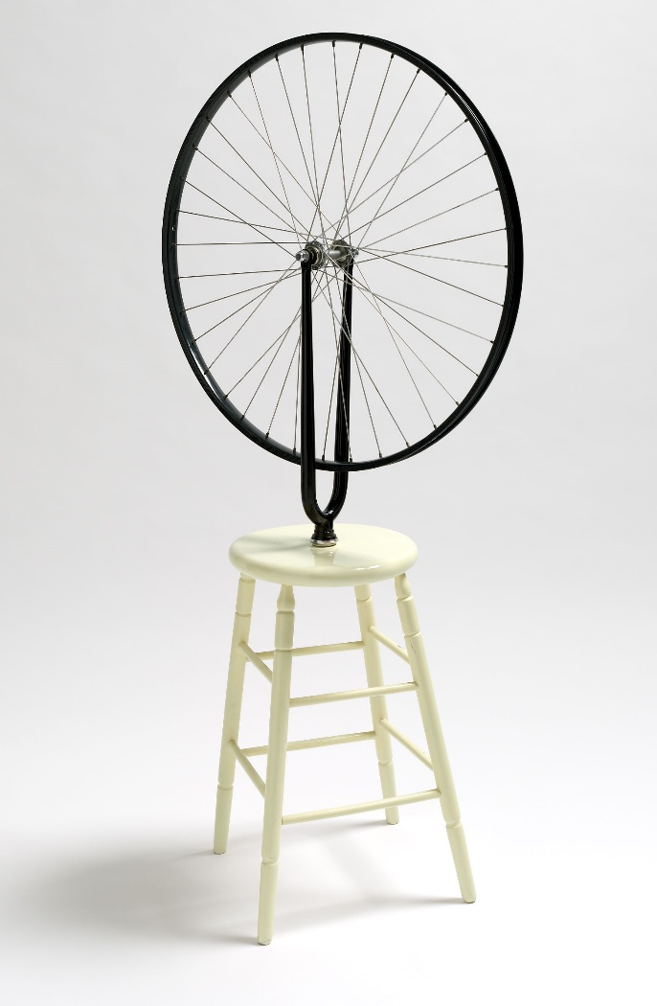
Figure 1: Marcel Duchamp’s Bicycle Wheel (originally 1913 reconstructed 1964
painted wooden stool and bicycle wheel. Impression: 4/8
Galleria Schwarz, accessed from https://artsearch.nga.gov.au/detail.cfm?irn=49305

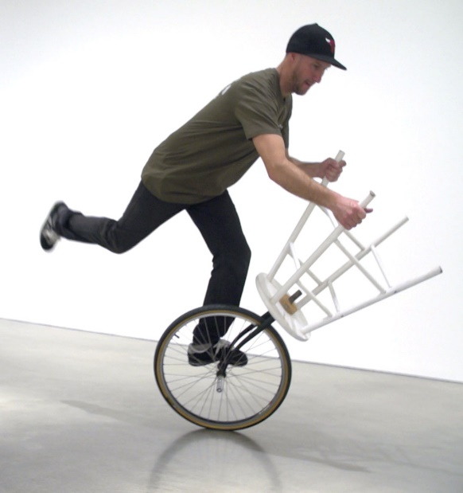

Figure 2: Shaun Gladwell’s Reversed Readymade (Augmented Reality), 2019. Gladwell appropriates Bicycle Wheel back for getting around the gallery 110 years later. But is still a gallery-bound performative act? Accessed from https://www.mca.com.au/artists-works/exhibitions/shaun-gladwell-pacific-undertow/

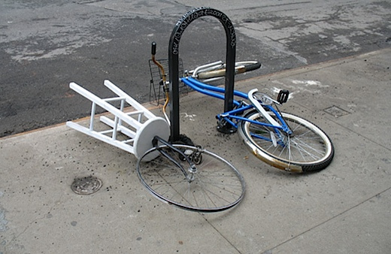

Figure 3: Ji Lee’s Duchamp Reloaded. Finally, Duchamp’s assisted readymade is returned as a mode of transport to the streets of New York. Accessed from https://cyclehistory.wordpress.com/2014/12/03/art-and-cycling-bicycle-wheel-by-marcel-duchamp/

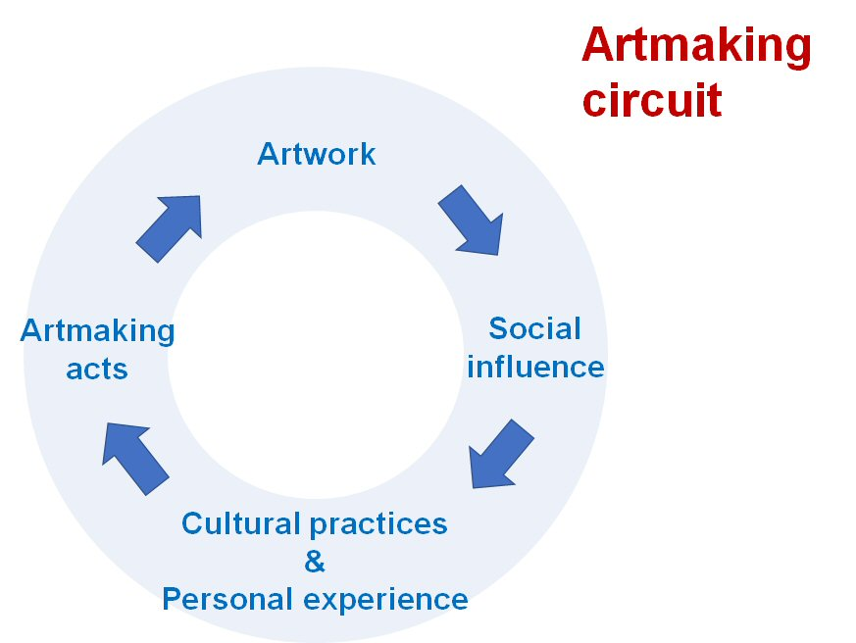
Figure 4: The artmaking circuit enables a time-ordered framework for tracking artmaking enrichment. Adapted from Cultural circuits proposed by Richard Johnson (1986) and Paul DuGay (1997).

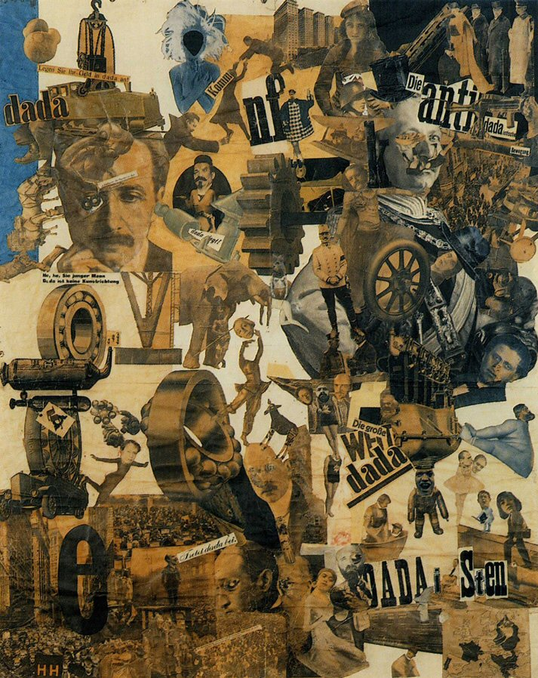
Figure 5a: Hannah Höch, Cut with the Kitchen Knife Dada through the Last Weimar Beer-Belly Cultural Epoch in Germany, 1919-20, photomontage and collage with watercolour, 114 x 90 cm (Staatliche Museen zu Berlin, Nationalgalerie) Accessed from https://smarthistory.org/dada-collage/
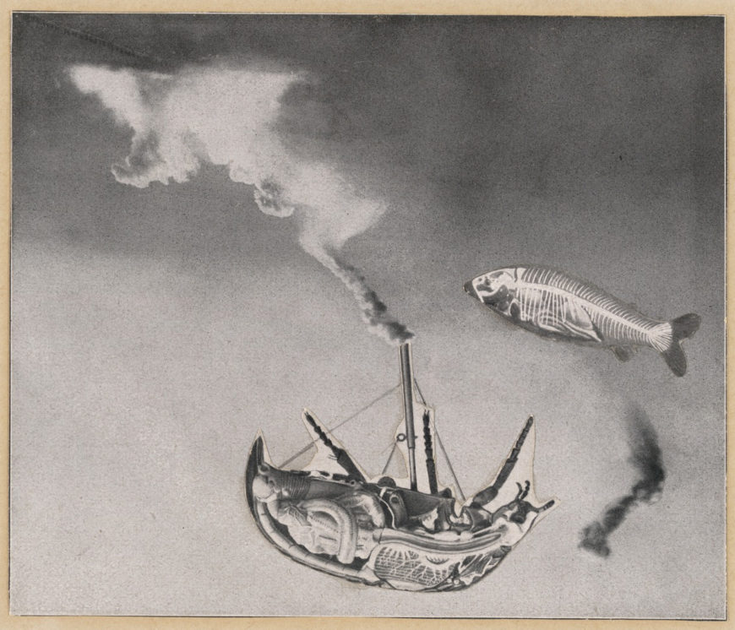
Figure 5b: Max Ernst, Here Everything is Still Floating, 1920, printed paper collage with pencil on cardstock, 6 ½ x 8 ¼ inches (MoMA) Accessed from https://smarthistory.org/surrealist-techniques-collage/
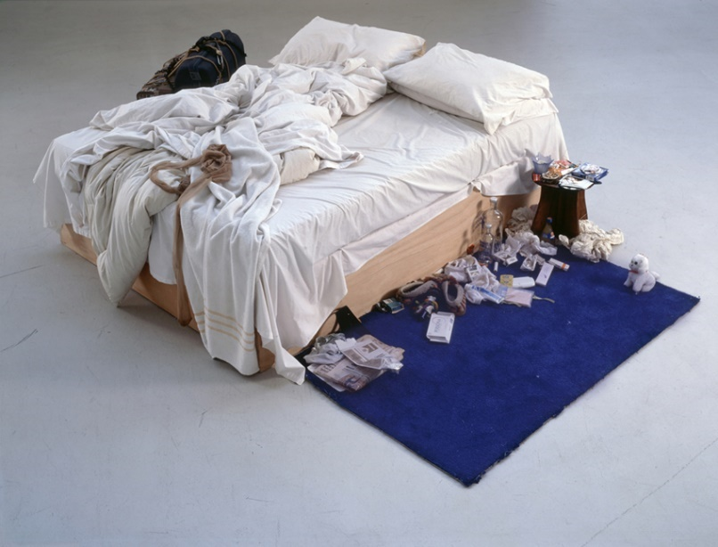
Figure 6: Tracey Emin, My Bed
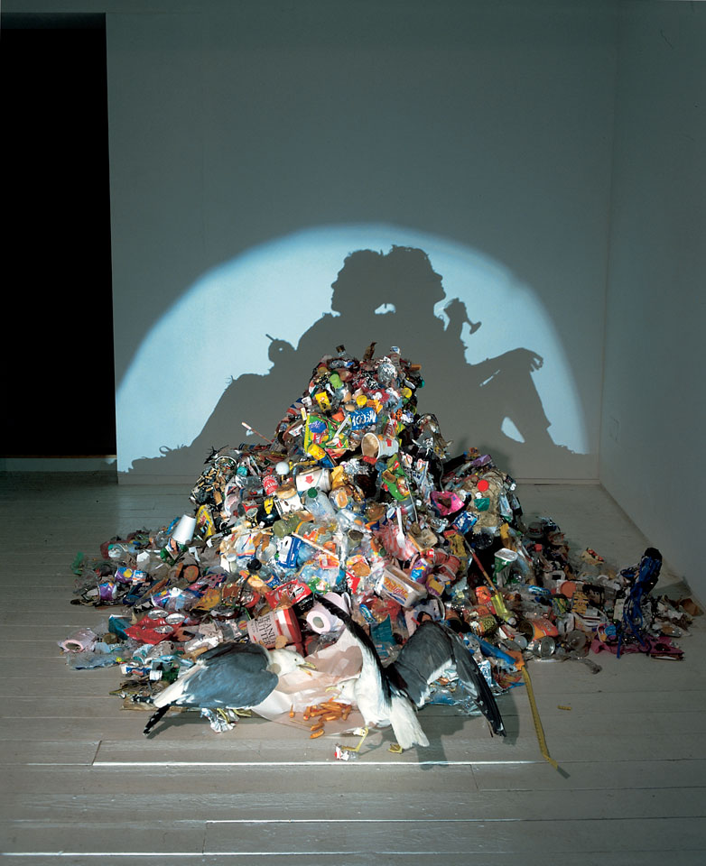

Figure 7: Sue Webster and Tim Noble: Dirty white trash (with gulls), 1998
Six months’ worth of artists’ trash, two taxidermy seagulls, light projector Accessed from http://nialangley.com/blog/projected-shadows-by-tim-noble-sue-webster/

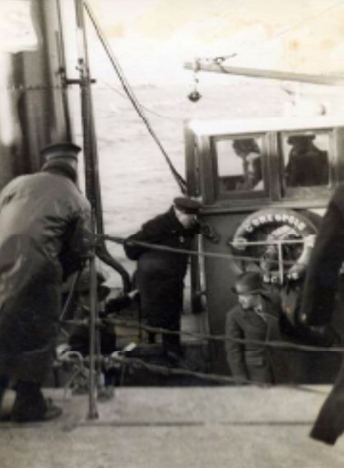
Figure 8: January 1941 family album snapshot of Winston Churchill and Harry Hopkins boarding HMAS Napier with Able Seaman Peter O’Halloran in foreground. Accessed from From Praties to Paddymelons (O'Halloran & Poelsma, 2012)
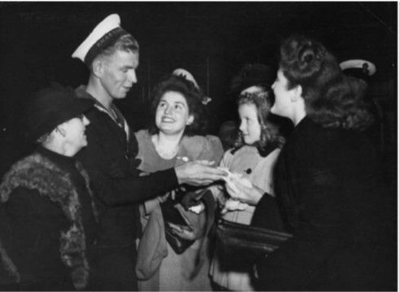
Figure 9: 1942 Argus Newspaper Snapshot of Peter O’Halloran meeting family members after returning from duty at sea on HMAS Napier. Accessed via From Praties to Paddymelons (O'Halloran & Poelsma, 2012).

References
Austin, J. L., & Urmson, J. O. (1962). How to do things with words : the William James Lectures delivered at Harvard University in 1955: Clarendon Press.
Babich, B. (2006). Words in Blood, Like Flowers: Philosophy and Poetry, Music and Eros in Holderlin, Nietzsche, and Heidegger: State University of New York Press.
Barthes, R., & Heath, S. (1987). Image, music, text: Fontana Press.
Barzykowski, K., Radel, R., Niedźwieńska, A., & Kvavilashvili, L. (2019). Why are we not flooded by involuntary thoughts about the past and future? Testing the cognitive inhibition dependency hypothesis. Psychological Research, 83(4), 666-683. doi:10.1007/s00426-018-1120-6
Bresnahan, A. (2020). A philosopher explains why dance can help pandemic-proof your kids The Conversation. https://theconversation.com/a-philosopher-explains-why-dance-can-help-pandemic-proof-your-kids-138398
Brooks, S. K., Webster, R. K., Smith, L. E., Woodland, L., Wessely, S., Greenberg, N., & Rubin, G. J. (2020). The psychological impact of quarantine and how to reduce it: rapid review of the evidence. In (Vol. 395, pp. 912-920).
Brown, S., Gao, X., Tisdelle, L., Eickhoff, S. B., & Liotti, M. (2011). Naturalizing aesthetics: Brain areas for aesthetic appraisal across sensory modalities. Neuroimage, 58(1), 250-258. doi:10.1016/j.neuroimage.2011.06.012
Butler, R. (2004). What is appropriation? : an anthology of critical writings on Australian art in the 1980s and 1990s (2nd ed. ed.): Institute of Modern Art and IMA.
Chatterjee, A., & Vartanian, O. (2014). Neuroaesthetics. Trends in Cognitive Sciences, 18(7), 370-375. doi:10.1016/j.tics.2014.03.003
Cinzia, D. D., & Vittorio, G. (2009). Neuroaesthetics: a review. Current Opinion in Neurobiology, 19(6), 682-687. doi:10.1016/j.conb.2009.09.001
Du Gay, P. (1997). Production of culture/cultures of production: Sage in association with the Open University.
Duchamp, M., Hamilton, G. H., Hamilton, R., & Mitchell, C. (2018, 21 February 2018). A 1959 Interview with Marcel Duchamp: The Fallacy of Art History and the Death of Art. ArtSpace.
Duchamp, M., Sanouillet, M., & Peterson, E. (1973). Salt seller : the writings of Marcel Duchamp: Oxford University Press.
Duchamp, M., Schwarz, A., & Shipe, T. (1997). The complete works of Marcel Duchamp (Rev. and expanded ed. ed.): Thames & Hudson.
Heidegger, M. (1962). Being and time: New York : Harper & Row , 1962.
Heidegger, M. (1975). Poetry, language, thought, Translations and Introduction by Albert Hofstadter: New York ; Sydney : Harper & Row, 1975, c1971.
Jalving, C. (2020). ‘It was just me, Tracey’: Strategies of Self-presentation in the Art of Tracey Emin. In A. Kokoli & D. Cherry (Eds.), Tracey Emin : Art Into Life. London: Bloomsbury Visual Arts.
Johnson, R. (1986). The story so far: and for the transformations. In D. Punter (Ed.), Introduction to contemporary cultural studies. London: Longman.
Judovitz, D. (1995). Unpacking Duchamp : art in transit: University of California Press.
Kant, I. (2005). Critique of Judgement: Oxford University Press.
Kilroy, R. (2017). Marcel Duchamp’s Fountain: One Hundred Years Later (2017 ed.). Abu Dhabi, United Arab Emirates: Palgrave Pivot.
Kokoli, A., & Cherry, D. (2020). Introduction: The last great adventure is me. In A. Kokoli & D. Cherry (Eds.), Tracey Emin : Art Into Life
(pp. 7). London: Bloomsbury Visual Arts.
Levine, S. K. (2005). The Philosophy of Expressive Arts Therapy: Poiesis as aResponse to theWorld. In S. Levine (Ed.), Principles and practice of expressive arts therapy. [electronic resource] : towards a therapeutic aesthetics (1st American pbk. ed. ed.). United States of America: Jessica Kingsley Publishers.
Levy, P. (2020). Why lockdown life is a lot like insomnia – a philosopher of sleep explains. The Conversation. https://theconversation.com/why-lockdown-life-is-a-lot-like-insomnia-a-philosopher-of-sleep-explains-139156
Long, B. (2013). The art of the found object. Retrieved from https://artcenterky.org/2013/12/the-art-of-the-found-object/
Newman, G. E., & Bloom, P. (2012). Art and authenticity: The importance of originals in judgments of value. Journal of Experimental Psychology: General, 141(3), 558-569.
O'Halloran, P., J., & Poelsma, A. (2012). From Praties to Paddymelons. In The Story of the Balranald O'Hallorans. Retrieved from https://www.yumpu.com/en/document/view/31060630/from-praties-to-paddymelons-pdf-56mb-clare-county-library
Punj, R. (2017). Out From the Shadows: A Conversation with Tim Noble and Sue Webster. In (Vol. 36, pp. 50).
Regev, D., & Cohen-Yatziv, L. (2018). Effectiveness of Art Therapy With Adult Clients in 2018-What Progress Has Been Made? In (Vol. 9).
Robert, S. (2013). IT WAS A DARK AND SNOWY NIGHT. Bitch Magazine: Feminist Response to Pop Culture(58), 55-58.
Searle, A. (1999). Arts: Tracey's pants but McQueen's the real pyjamas: Boredom in the bedroom: A laugh in the laundromat: A Las Vegas gamble: A sculpture for film: Adrian Searle surveys the Turner prize shortlist. The Guardian, Australia. Retrieved from https://search.ebscohost.com/login.aspx?direct=true&AuthType=sso&db=edsgin&AN=edsgcl.75872949&site=eds-live&scope=site&custid=s2775460
Seekamp, K. A. (2004). Unmaking the Museum: Marcel Duchamp's Readymades in Context: State University of New York at Binghamton, Department of Art History.
Stolnitz, J. (1961). On the Significance of Lord Shaftesbury in Modern Aesthetic Theory. The Philosophical Quarterly (1950-)(43), 97. doi:10.2307/2960120
Stout, R. (2000). Roosevelt and Churchill: Men of Secrets.
Suprun, M. N. (2019). Lend-Lease and the Northern Convoys in the Allied Strategy During the Second World War. The Journal of Slavic Military Studies, 32(4), 574-580. doi:10.1080/13518046.2019.1684009
Svendsen, L. F. H. (2005). A philosophy of boredom: Reaktion Books.
Tomkins, C., & Duchamp, M. (2013). Marcel Duchamp : the afternoon interviews: Brooklyn, NY : Badlands Unlimited, [2013]
First edition.
VandenBos, G. R. (2009). APA concise dictionary of psychology: American Psychological Association.
Webster, S., & Noble, T. (1998). Dirty White Trash, (with gulls). In (pp. 6 months’ worth of artists’ trash, 2 taxidermy seagulls, light projector, ). USA: Artworks for change.
Weitz, M. (1956). The role of theory in aesthetics. Journal of Aesthetics and Art Criticism, 15(1), 27-35.
Wittgenstein, L., & Anscombe, G. E. M. (1963). Philosophical investigations (Repr. of [2nd ed.] English text. ed.): Blackwell.

Heidegger does not deny that the modernist aesthetic subject-object view of the world forms part of the artwork experience, it is just that a a more fundamental phenomenal connection with artworks provides the opportunities for richer kinds of engagement. A more complex interweaving of subjective self and objective things in the world opens us up to the lived experience of the things we are engaging with. Engaging in this kind of way is what enables artworks to reveal things and transform us. This expands the possibilities of art beyond the merely pleasurable rewards of the beautiful.
I am not proposing it is possible to undo all our coding that makes us who we are and become an earlier version of ourselves. However, it is possible to fundamentally question assumptions we make about who we are and how the world is – decoding these understandings.
A set theoretic version of the Peano axioms defines ‘3’ as s(2) i.e. the set containing one member, the number ‘2’. ‘2’, in turn, is the set containing ‘1’ and ‘1’ is the set containing the null set, ‘φ’, which defines ‘0’ or zero. So 3 = s(s(s(φ))).
Morris Weitz (1956, p. 27) in his seminal review of theories of aesthetics lists six major theories - formalism, voluntarism, emotionalism, intellectualism, intuitionism and organicism which provide distinct constitutive properties for art.
A ready-made is a manufactured object removed from its original intended instrumental use and presented as an artwork with little or no transformation. An assisted readymade comprises more than one manufactured object or manufactured parts removed from their original intended use, reassembled and presented as an artwork.
There is neuro-aesthetic evidence for a pluralist view regarding different ways of engaging with art. Some studies (Brown, Gao, Tisdelle, Eickhoff, & Liotti, 2011; Cinzia & Vittorio, 2009) support the view that people are able to adopt a stance of ‘disinterested pleasure’ towards an artwork consistent with the Kantian modern aesthetic notion (2005). Alternatively, people are equally capable of adopting a stance of being actively engaged with a work more consistent with phenomenalist theories of art engagement (Chatterjee & Vartanian, 2014; Cinzia & Vittorio, 2009). Cognitive psychology findings support the notion that people are capable of confining their ‘gaze’ to the artwork and the artwork alone or broadening it to accommodate performative artmaking acts and the social influence of an artwork (Newman & Bloom, 2012).
The ‘clusters of iconic artworks’ are just a way of describing how Weitz applies Wittgenstein’s family resemblances to understanding the semantic structure of art.
Marcel Duchamp and his Manhattan colleagues famously purchased a standard men’s urinal, upended it and called it Fountain. This work and the associated story became perhaps the most famous art appropriation of the twentieth century (Kilroy, 2017, p. 1).
‘My Bed’ was first shown at the Tate in UK in 1999, but its inaugural exhibition was at the Sagacho Exhibit Space in Tokyo in 1998. Numerous re-compilations have followed.
‘My Bed’/JMW Turner at Turner Contemporary 2017.
These are not your standard family shots however. The first is part of an Australian Navy photographic record and the second featured in the Argus, a Melbourne newspaper of the time (O'Halloran & Poelsma, 2012, p. 470). Nonetheless, family members are subjects of each, and both photographs are treasured parts of the family album.
Noir photography derives from film noir, a term first coined by French critic Nino Frank in 1946 to describe a slew of US criminal detective films released in French cinemas (Robert, 2013, pp. 55-56). According to Robert, the atmosphere defining noir was an all-encompassing dark mood ‘reflected in the literal gloom of the dreary weather that forms its backdrop, the embodiment of the corruption and hopelessness dominating its cynical storylines’.
Peter O’Halloran was the author’s father.
Peter O’Halloran (the author’s brother) and Ann Poelsma drew these two valuable information sources together in their family history of the Balranald O’Hallorans enabling these wartime events to be drawn into a unique biographical narrative.
Reference acoustic trauma Authors personal role in testing Peter as an audiologist. The personal sailors story communication issues butt of jokes etc deeply influenced the author’s own decision to train as an audiologist. More detail re the darkness of total deafness from gun blast – two weeks profoundly deaf followed by gradual and partial recovery - Father direct account – hearing tested confirmed consistency with acoustic trauma and partial recovery (often due to middle ear mechanism physical structures or inner ear structures recovering.
Cover a reference for expanded Lend Lease and how it could be seen negatively embedding US in a militarily entrenched power relation with the rest of the world.

